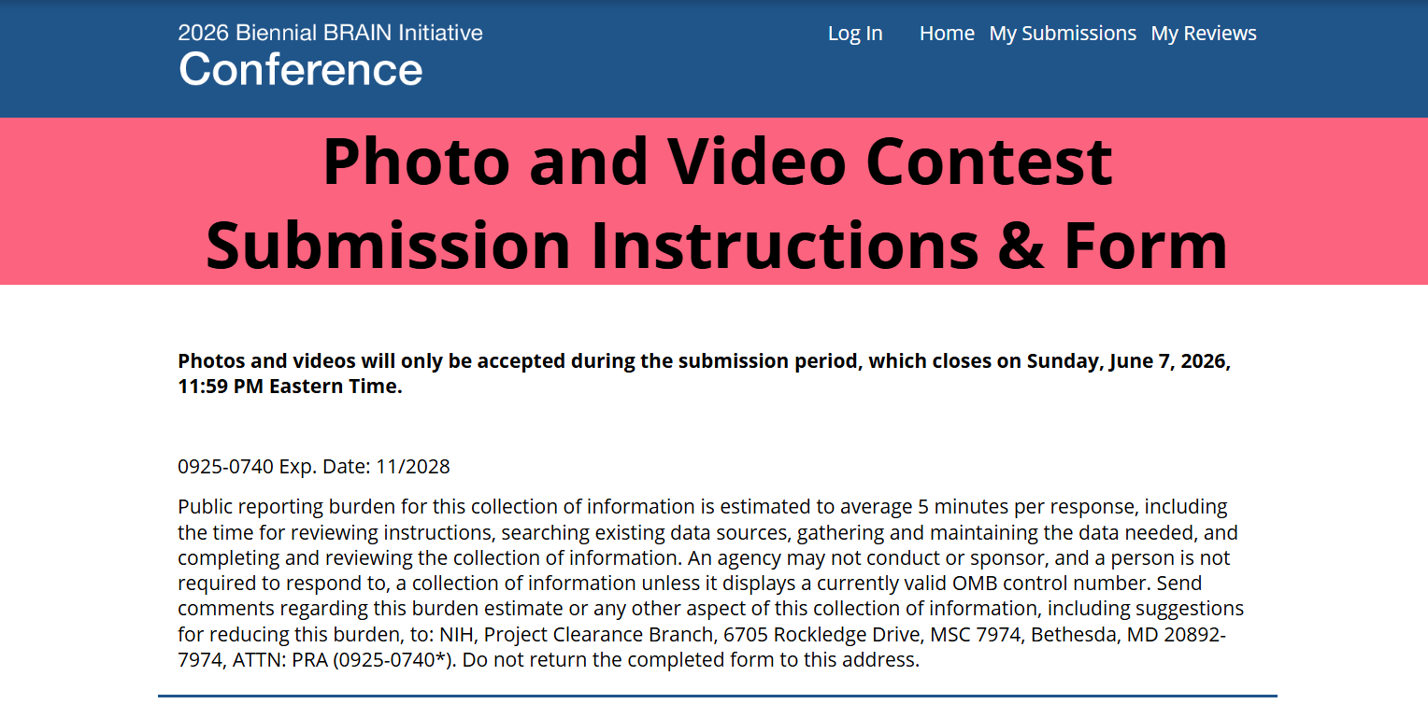
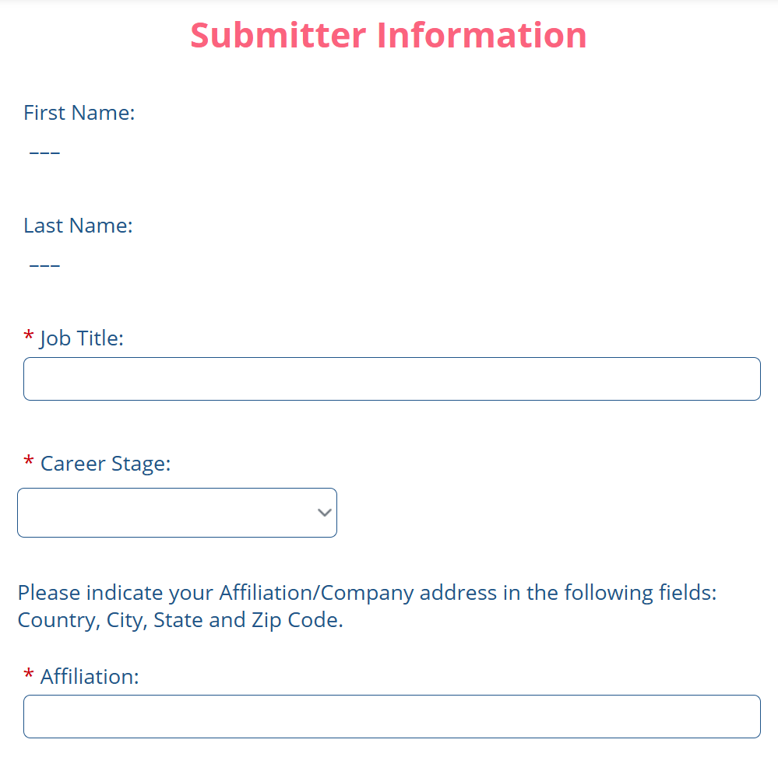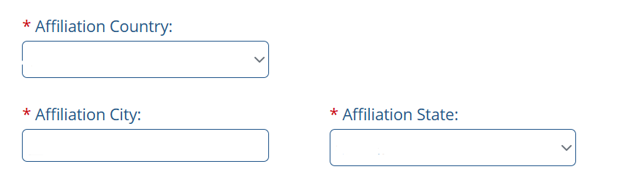
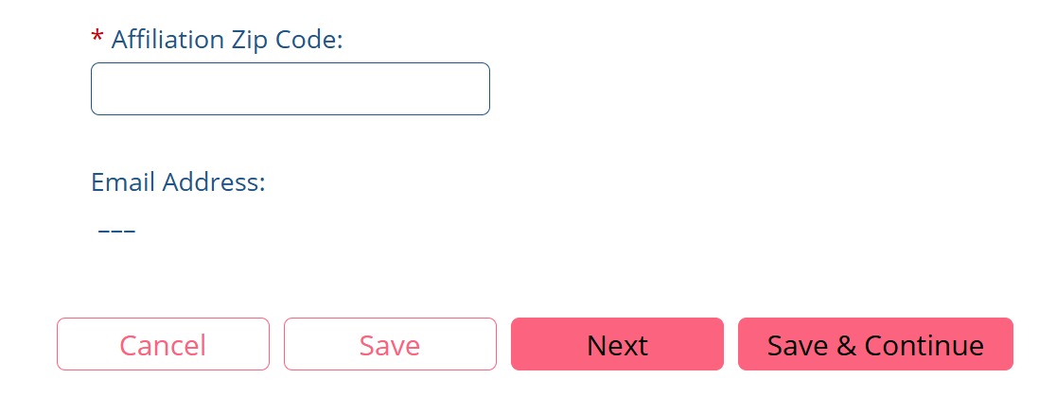

Dropdown Options:
The following screenshots depict the dropdown options from the corresponding screenshots above.

“Career Stage” options include New Assistant Professors, Post-Doctoral Scholars, Medical Residents, Graduate Students, Undergraduate Students, Postbaccalaureate Trainees, and High School Students.
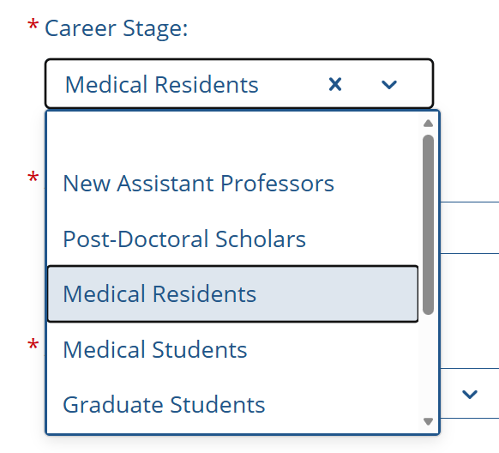

“Affiliation Country” options include a vast amount of countries for registrants to choose from:
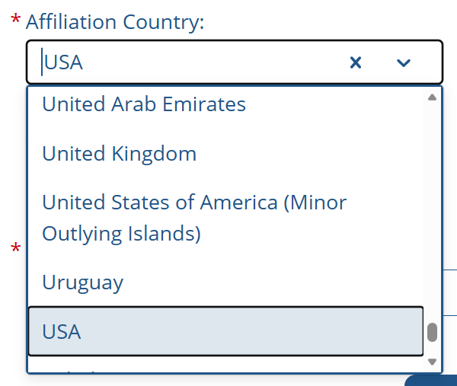
“Affiliation State” options include all 50 states, as well as American Samoa, Armed Forces Americas, Armed Forces Europe, Armed Forces Pacific, Marshall Islands, Micronesia, Northern Mariana Islands, Palau, Puerto Rico, and Virgin Islands:
