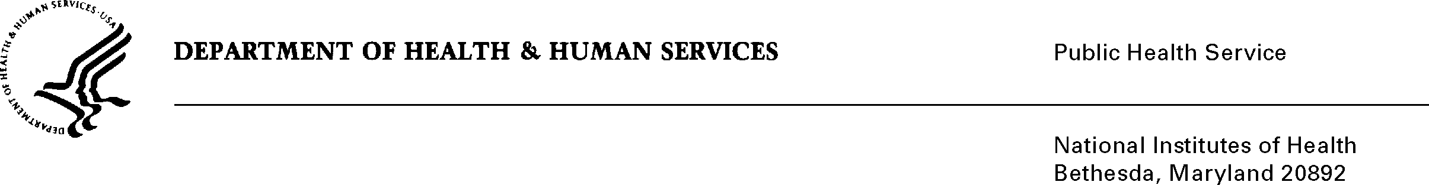

DATE: September 29, 2025

TO: Office of Management and Budget (OMB)

NIH, OIRA Desk Officer

THROUGH: Project Clearance Chief, NIH

Reports Clearance Officer, DHHS

FROM: Andre Schooler & Keondra Watts

NIH Small Business Office

OD/OALM

SUBJECT: Request for Non-Substantive Change to OMB Control,

**Title:** Collection of grant and contract data that may be of interest to Historically Black Colleges and Universities (HBCUs) and small businesses.

**OMB#:** 0925-0767

**Expiration Date:** Mar 31, 2027

On behalf of the National Institutes of Health (NIH) Small Business Office, I am writing to request a non-substantive change to the information collection instrument approved under OMB Control No. 0925-0767.

The NIH Small Business Office respectfully requests OMB’s approval to allow use of the Microsoft Forms link 🡪 [PEI Application Form](https://forms.office.com/g/0pq7NRdmFS?origin=lprLink), as a supplemental collection method in addition to the already approved fillable PDF, which was approved . This will enhance applicant experience and improve NIH’s administrative efficiency without altering the approved content or respondent burden.

We appreciate your timely review of this request, as NIH intends to begin accepting applications for this program on **October 1, 2025**. Please let us know if additional documentation or clarification is needed to facilitate approval.

**Comparison of PEI Application Form Formats**

|  |  |  |
| --- | --- | --- |
| Category | Fillable PDF (Current Approved Format) | MS Forms (Proposed Supplemental Format) |
| Form Content | Identical questions, instructions, and response fields as approved. | Identical questions, instructions, and response fields copied verbatim. |
| OMB Control Number | Displayed on form header/footer. | Displayed on form landing page and within instructions. |
| Burden to Respondent | Estimated burden unchanged (same questions, same completion time). | Estimated burden unchanged (same questions, same completion time). |
| Submission Method | Applicant downloads, completes, and uploads/email-submits the PDF. | Applicant completes directly online in NIH-approved MS Forms platform. |
| Accessibility | Requires PDF reader; manual upload or email submission. | Accessible from web browsers and mobile devices; direct electronic submission. |
| Data Management | Manual entry or file management by NIH staff. | Automatic response capture in NIH MS Forms; exportable for analysis and database development. |
| Security | Secured via NIH-approved email/file submission channels. | Secured within Microsoft 365 NIH environment, compliant with NIH IT policies. |
| OMB PRA Impact | Already approved. | No changes to content, burden, or intent—requesting approval solely for collection format. |

Your full consideration is appreciated.