OMB Control Number: 0938-1310 Expiration Date: XX/XX/20XX

**Transparency in Coverage Reporting by Qualified Health Plan Issuers**

**Appendix D: Health Insurance Oversight System (HIOS) via the Marketplace Plan Management System (MPMS)**

1. Issuers applying for PY2025 QHP certification, including issuers offering off-Exchange SADPs, must submit a Transparency in Coverage URL in MPMS. Although SERFF issuers will submit their Transparency in Coverage Template in SERFF, the Transparency in Coverage URL must be submitted in MPMS.

**Figure 2M-5. MPMS Submission Screen for Transparency in Coverage URL**

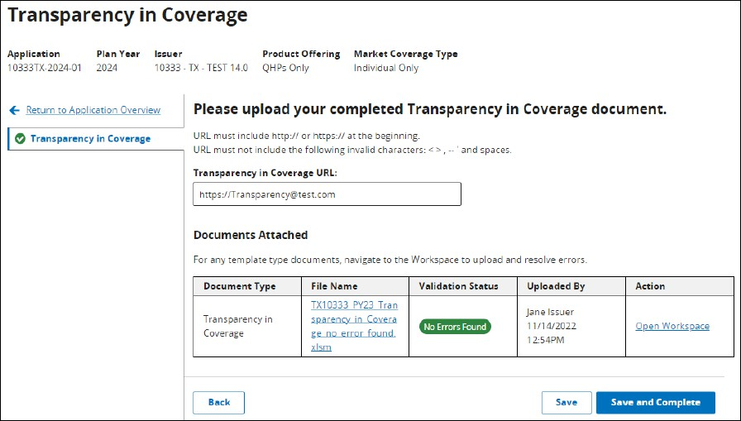

Although a URL submission is required to apply for PY2025 QHP certification, issuers are required to submit an active URL that directs to a compliant claims payment policy website only if they offer on-Exchange QHPs and SADPs.

1. The Transparency in Coverage Section is required as part of all QHP Applications and requires the user to link a Transparency in Coverage template XML to their application, as well as provide a Transparency in Coverage URL.

According to the Paperwork Reduction Act of 1995, no persons are required to respond to a collection of information unless it displays a valid OMB control number. The valid OMB control number for this information collection is 0938-1310. This information collection is for the submission of data related to transparency in coverage by QHP issuers to HHS, the Exchange, and the state insurance commissioner, and also make the information available to the public in plain language. The time required to complete this information collection includes a one-time technical modification estimated to average 11 hours per response for QHP issuers and the time required to complete an annual submission of Transparency in Coverage data estimated to average 44 hours per response for QHP issuers, including the time to review instructions, search existing data resources, gather the data needed, to review and complete the information collection. Pursuant to 45 CFR 156.220, QHP issuers are required to make this information available to consumers and CMS. CMS requires QHP issuers to update transparency in coverage data annually. If you have comments concerning the accuracy of the time estimate(s) or suggestions for improving this form, please write to: CMS, 7500 Security Boulevard, Mail Stop C4-26-05, Baltimore, Maryland 21244-1850 and email Carolyn Sabini at [Carolyn.Sabini@cms.hhs.gov](mailto:Carolyn.Sabini@cms.hhs.gov), Attention: Information Collections Clearance Officer.

**Note**: SERFF Issuers will only be able to edit the Transparency in Coverage URL in this section, and not link to a Transparency in Coverage template XML.

The URL must start with http:// or https:// and may only include alphanumeric characters and the special characters listed below:

* + ~ (Tilde) • + (Addition)
  + ` (Grave) • - (Hyphen or Minus)
  + ! (Exclamation Mark) • = (Equals)
  + # (Pound) • [ ] (Open and Closed Bracket)
  + @ (At Sign) • \ (Backslash)
  + $ (Dollar) • {} (Open and Closed Braces)
  + % (Percentage) • ; (Semicolon)
  + ^ (Carat) • : (Colon)
  + & (Ampersand) • " (Quotation Mark)
  + * (Asterisk) • . (Period)
  + ( ) (Open and Closed Parenthesis) • / (Forward Slash)
  + _ (Underscore) • ? (Question Mark)

Selecting the ‘Save and Complete’ button completes the section and returns the user to Application Overview. *See Figure 8-41.*

**Figure 8-41. Transparency in Coverage Section**

