**To:** Kelsi Feltz

Office of Information and Regulatory Affairs (OIRA)

Office of Management and Budget (OMB)

**From:** Shannon Herboldsheimer

Office of Refugee Resettlement (ORR)

Administration for Children and Families (ACF)

**Date:** March 26, 2024

**Subject:** Non-Substantive Change Request – Placement and Transfer of Unaccompanied Children into ORR Care Provider Facilities (OMB #0970-0554)

This memo requests approval of a non-substantive change to the approved information collection, Placement and Transfer of Unaccompanied Children into ORR Care Provider Facilities (OMB #0970-0554).

The Placement and Transfer of Unaccompanied Children into ORR Care Provider Facilities information collection contains 20 instruments that allow ORR to place unaccompanied children referred to ORR by federal agencies into care provider facilities and to transfer children within the ORR care provider network as required by the Homeland Security Act (6 U.S.C. 279) and the Trafficking Victims Protection Reauthorization Act of 2008 (8 U.S.C. 1232). The collection was last approved by OMB on June 12, 2023 and expires on June 30, 2026.

ORR is proposing revisions to one form in this collection, the Placement Confirmation (Form P-10B).

**BACKGROUND**

The Placement Confirmation form contains a COA/COV (Change of Address/Change of Venue) section that is completed by care provider case managers for children transferring to another care provider program. In addition to completing this section of the form, case managers also file a change of address with the Executive Office for Immigration Review to ensure that the court is aware of the child’s current location during the pendency of their immigration proceedings. However, case managers do not file changes of venue. This function is performed by an entity that is party to the proceedings, typically the child’s legal representative or Immigration and Customs Enforcement, because the decision to file a change of venue may affect the child’s immigration case. A change of venue is filed for cases where a Notice to Appear has been filed.

**PROPOSED REVISIONS**

To avoid potential confusion about who is responsible for filing changes of venue, ORR proposes removing all fields related to changes of venue from the Placement Confirmation form. This includes:

* Renaming the section “COA”
* Removing the “Change Type” field and associated radio buttons
* Removing the “Good cause exits…” field and associated checkboxes

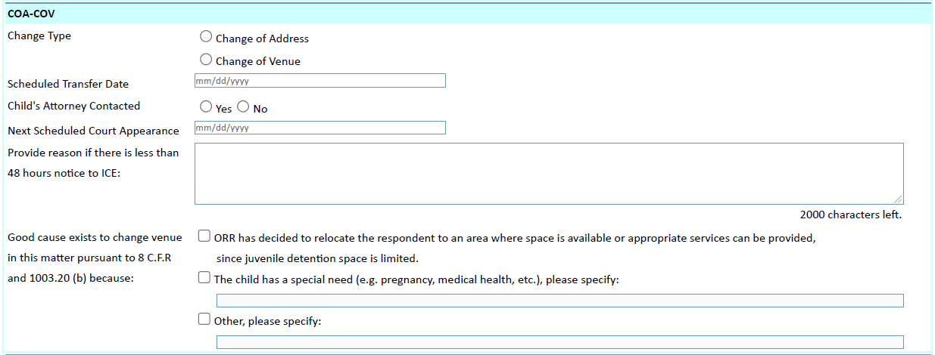

**REMOVE**

**REMOVE**

**REMOVE**