HealthyCompetition.gov
Navigation Links to Mock Pages
- Link to Landing Page
- Link Webform 01
- Link Webform 02
- Link Webform 03
- Link Webform 04
- Link Webform 05
- Link Webform 06
- Link Webform 07
- Link Webform 08

Back to Navigation > Landing Page
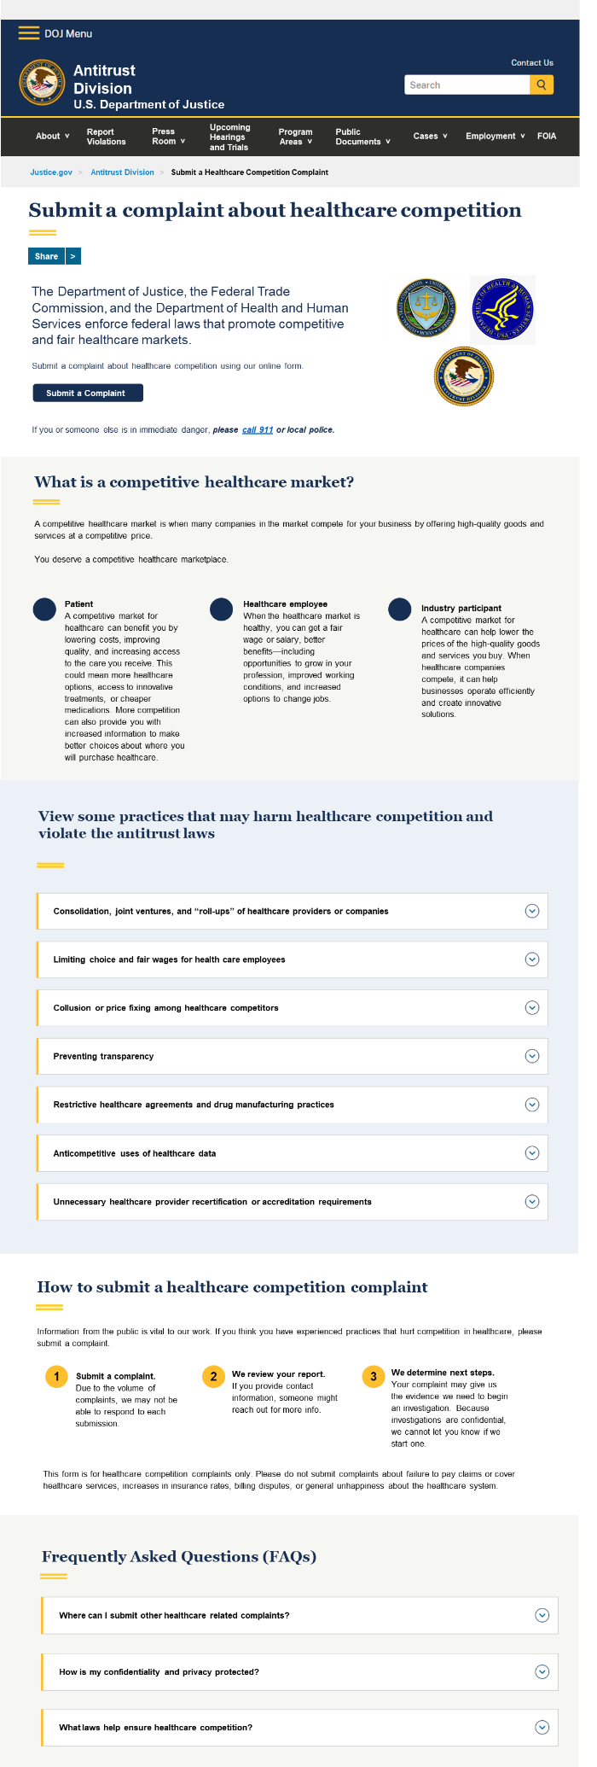

Submit a complaint about anticompetitive or unfair healthcare practices.
The Department of Justice, the Federal Trade Commission, and the Department of Health and Human Services enforce federal laws that promote competitive and fair healthcare markets.
Submit a complaint about healthcare competition using our online form.
Submit a complaint

If you or someone else is in immediate danger, please call 911 or your local police.

What is a competitive healthcare market?
- When many companies in the market compete for your business by offering high-quality goods and services at a fair price.

You deserve a competitive healthcare marketplace.
- Patient - A competitive market for healthcare can benefit you by lowering costs, improving quality, and increasing access to the care you receive. This could mean more healthcare options, access to innovative treatments, or cheaper medications. More competition can also provide you with increased information to make better choices about where you purchase healthcare goods and services.
- Healthcare Employee - When the market for healthcare employment is healthy, you can get a fair wage or salary, better benefits, improved working conditions—including opportunities to grow in your profession—and increased options to change jobs if you want to.
- Healthcare Company - A competitive market for healthcare can help lower the prices of the high-quality goods and services you buy. When healthcare companies compete, it can help businesses operate efficiently and create innovative solutions.

View some practices that may harm healthcare competition and violate the antitrust laws
Consolidation, joint ventures, and “roll-ups” of healthcare providers or companies
- Mergers – When companies that provide the same goods or services combine. Mergers can eliminate competition in the healthcare markets. All types of companies in the healthcare markets can merge, including:
  - pharmaceutical companies;
  - hospitals, physicians, and other providers of healthcare or services;
  - insurers; and
  - more.
- Vertical mergers – When companies along different levels of the supply chain, such as a health insurer and a medical practice, or a hospital and a medical devices supplier, combine. Vertical mergers may harm competition by:
  - increasing the combined company’s ability to raise prices or lower quality of care;
  - lowering incentives to compete;
  - limiting or blocking a competitor’s access to a product, service, or route to market;
  - providing access to a competitor’s non-public, competitively sensitive information; or
  - deterring rivals or potential rivals from investing in the market.
- Joint ventures – When competing companies combine or share resources to achieve a common goal. A joint venture may harm competition if it involves agreements to influence:
  - prices,
  - access to services or goods,
  - quality, or
  - innovation.
- “Roll-ups” (also called serial acquisitions) – When a single company buys multiple small businesses that compete. Roll ups may harm competition if the company that purchased the smaller businesses increases prices or reduces the quality of healthcare provided to patients.
- Cross-market mergers – When companies that provide the same goods or services, but do not directly compete because of the distance between their physical locations, combine. The new company may harm competition if it uses any increased power to negatively affect price, access to healthcare, or quality.
- Partial acquisitions – When a company buys less-than-full control of a competing company. Partial owners of competing companies may harm competition if they:
  - can influence the strategic decisions of the competing company,
  - have decreased incentives to compete, or
  - gain access to non-public, competitively sensitive information.

Limiting choice and fair wages for healthcare employees
Spoken or written agreements among competing healthcare companies to limit or pre-determine the terms of employment for employees (current and potential). Some of these types of agreements include:
- Wage-fixing – When competing employers agree to set wages at the same level or give the same benefits.
- No-poach – When competing employers agree to not hire each other’s employees.
- No-solicitation – When competing employers agree to not recruit each other’s employees.

In certain circumstances, non-compete clauses in employment agreements may unlawfully constrain a company’s decisions about wages or salaries, job mobility, or benefits.

Collusion or price fixing among competitors
Written or spoken agreements not to compete. Some of these types of agreements include:
- Price fixing – When competitors agree to raise, set, or maintain the price of goods or services.
- Bid rigging – When competitors agree in advance on prices or terms of their competitive bids.
- Market allocation – When competitors agree to divide markets among themselves. Market allocation includes agreeing to sell only to specific customers or areas.

Preventing transparency
When healthcare companies prevent patients from knowing the prices charged for their healthcare services or available healthcare options. Some of these practices include when healthcare companies:
- draft contracts to keep patients from knowing prices.
- fail to provide prices in a public, accessible, and easy-to-read format.
- refuse to give patients access to their electronic health information:
  - as allowed under the Health Insurance Portability and Accountability Act of 1996 (HIPAA); and
  - consistent with how the patient wants to access their electronic health information.

Restrictive healthcare agreements and drug manufacturing practices
- Agreements with anti-tiering and anti-steering clauses (also known as anti-innovation, anti-incentive, or anti-discounting clauses) – Clauses in agreements that stop health insurers from giving incentives (such as discounts) or guiding patients to lower cost or higher quality healthcare providers.
- Exclusive contracting – Agreements that prevent buyers from contracting with other sellers.
- Agreements with all-or-nothing clauses – Clauses in agreements that require a health insurer to contract with all the providers in a health system, or none of the providers in the health system. These types of clauses can result in higher prices and less innovation.
- Agreements with commercial price parity clauses – Clauses in agreements that prohibit healthcare suppliers or buyers from offering lower prices or better terms to other buyers or suppliers, respectively. These clauses may facilitate illegal price agreements between competitors. They can also result in higher prices and reduced competition by requiring providers to:
  - guarantee that an insurer will receive contract terms that are better than, or equal to, the contract terms provided to other insurers;
  - certify that their reimbursement rates are the best rates available; or
  - share the reimbursement rates they’ve negotiated with other insurers.
- Practices or tactics that delay introduction of generic drugs: Tactics by brand-name drug manufacturers to delay or block generic competitors from launching lower-priced generic drug alternatives.

Anticompetitive uses of healthcare data
When just a few companies acquire and control large amounts of health-related data, the company may be able to:
- prevent other companies from entering the market; or
- reduce the incentives a competitor may have to innovate.

Despite complying with HIPAA, data transfers may harm competition when competing companies:
- gain access and rights to claims data maintained by their competitors;
- share detailed use or claims data;
- share data in a way that may allow companies to monitor their rivals; or
- use data in other ways that may harm competition.

Unnecessary healthcare provider recertification or accreditation requirements
When certifying bodies or accreditation organizations impose unnecessary recertification or accreditation requirements on healthcare providers. These requirements may:
- raise the cost of your healthcare service or
- decrease the number of healthcare practitioners available to you.

How to submit a healthcare competition complaint
Information from the public is vital to our work. If you think you have experienced practices that hurt competition in healthcare, please submit a complaint.
- Submit a complaint. Due to the volume of complaints, we may not be able to respond to each submission.
- We review your report. If you provided contact information, someone might reach out for more info.
- We determine next steps. Your complaint may give us the evidence we need to begin an investigation. Because investigations are confidential, we cannot let you know if we start one.
This form is for healthcare competition complaints only. Please do not submit complaints about failure to pay claims or cover healthcare services, increases in insurance rates, billing disputes, or general unhappiness about the healthcare system.

Frequently Asked Questions (FAQs)

Where can I submit other healthcare related complaints?
- Medicare or Medicaid fraud, abuse, or misconduct – Visit HHS Office of the Inspector General or call 1-800-HHS-TIPS (1-800-447-8477).
  - In addition, a private citizen may initiate a lawsuit under the False Claims Act (called “qui tam” suits) alleging that conduct resulted in the submission of fraud or false claims to programs such as Medicare, Medicaid, and TRICARE.
- Fraud, scams, and bad business practices – Go to ReportFraud.ftc.gov.
- Allegations of information blocking – Go to Information Blocking | Health IT Feedback and Inquiry Portal, HHS Office of Inspector General’s hotline, or call 1-800-HHS-TIPS (1-800-447-8477).
- For additional information about health insurance, various health conditions, and help with medical bills. – Go to USA.gov/health.

How is my confidentiality and privacy protected?
The Department of Justice and the Federal Trade Commission will protect your confidentiality to the fullest extent possible under the law and also commit to supporting relevant whistleblower protections, including applicable protections for criminal antitrust complainants against unlawful retaliation.
To submit an anonymous complaint, provide the complaint details, but do not enter your contact information.
We will follow our privacy policies to protect any information provided:
- DOJ Privacy Policy
- FTC Privacy Policy
- DOJ Antitrust Division Confidentiality Policy Regarding Complainants

What laws help ensure healthcare competition?
We ensure healthcare competition through these federal laws:
- The Sherman Act - Prohibits certain agreements between companies that harm competition. It also prohibits companies from unlawfully gaining or maintaining monopoly power.
- The Clayton Act - Prohibits mergers that may substantially lessen competition.
- The Federal Trade Commission Act - Prohibits unfair methods of competition. It also prohibits companies from acting in unfair or deceptive ways.
- The Robinson-Patman Act – Prohibits a seller from charging competing buyers different prices for the same good or discriminating compensation for advertising and other services.

Back to Navigation > Webform 01
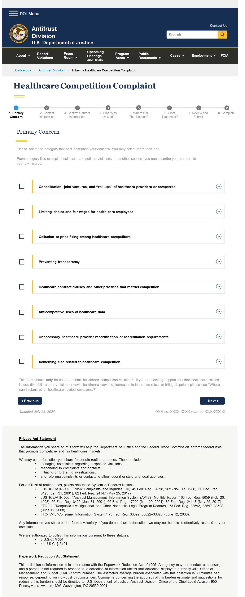

- Primary Concern
Primary Concern
Please select the category that best describes your concern. You may select more than one.
Each category lists example healthcare competition violations. In another section, you can describe your concern in your own words.

Consolidation, joint ventures, and “roll-ups” of healthcare providers or companies
Examples include, but are not limited to:
- A private equity company buys a series of nursing homes or medical practices in the same area. That same company also uses its influence to enter into agreements with other nursing homes or medical practices that it does not own to fix prices.
- A health insurance company buys several competing medical practices. It also prohibits its medical practices from contracting with rival health insurance companies.
- A pharmacy benefit manager buys a series of small independent or specialty pharmacies. It also uses its influence to reimburse its pharmacies more than other pharmacies.
- A hospital system buys other hospitals, outpatient facilities, or medical practices. It also changes how it refers patients to benefit itself more than competing systems.
- After a merger, a hospital system closes some of its facilities or reduces services. This results in higher prices, longer wait times, less access to care, lower quality, or fewer employment opportunities.
- After an acquisition, providers change their coding practices to charge more without making changes in care.
- A hospital system buys part of a competing hospital system but does not control its competitor. As a result of the partial acquisition, the buyer can:
  - appoint board members,
  - watch board meetings,
  - impact operational decisions,
  - veto the competing hospital’s ability to raise capital, or
  - access competitively sensitive information.
- Competing hospital systems start a joint venture. With the joint venture, they share competitively sensitive information or divide markets.

Limiting choice and fair wages for healthcare employees
Examples include, but are not limited to:
- A dominant employer in a geographic area follows a no-rehire policy for employees that leave the job.
- Competing employers agree to:
  - set wages at the same level or give the same benefits
  - not hire or recruit each other’s employees
  - divide employees among themselves
  - share current and future terms and conditions of employment.
- An employer requires an employee to sign an agreement saying they will not
  - compete with the employer after leaving the job
  - work for a competing employer for a specific amount of time or in a specific area
- A health system revokes a physician’s medical staff privileges for having ownership in a competing facility.

Collusion or price fixing among competitors
Examples include, but are not limited to competing health companies, such as providers or pharmaceutical companies:
- Agree to set prices or negotiate reimbursement rates at certain prices or levels.
- Divide customers among themselves.
- Agree to only bid in certain areas or on certain projects.
- Agree to take turns to win bids.
- Agree to allow the same companies to win or lose a bid.
- Agree to stop providing anticipated discounts or rebates.
- Agree to end up winning the same amount of work over a series of bids.
- Agree to not market to customers in each other’s geographies.

Preventing transparency
Examples include, but are not limited to:
- A hospital system or insurer uses their contracts to keep patients from knowing the costs of the services they receive.
- A hospital or insurer does not provide the prices of services in a public and easy-to-read format.
- A healthcare provider or electronic health information/records vendor prevents patients from accessing their electronic health information in ways allowed under HIPAA and consistent with how the patient wants to access their electronic health information.

Restrictive healthcare agreements and drug manufacturing practices
Examples include, but are not limited to:
- Anti-tiering/anti-steering clause
  - A hospital system makes an insurer put all the system’s physicians, hospitals, and facilities:
    - in the most favorable tier, or
    - at the lowest cost-sharing rate.
- Exclusive contracting clause
  - A dominant healthcare provider prevents an insurer from contracting with other competing providers.
  - A dominant health insurer prevents a provider from contracting with other competing insurers.
- All-or-nothing clause
  - When insurer wants to contract with a single hospital, but the hospital system makes them contract with all its facilities at high rates.
- Commercial price parity clause
  - A hospital system guarantees that an insurer will receive better or equal terms as those provided to any other insurer.
  - An insurer requires a provider to
    - certify that the agreed-upon reimbursement rates are the best rates available, or
    - share negotiated reimbursement rates paid by other insurers.
- Generic drug delay tactics
  - Brand drug manufacturers
    - agree to settle patent lawsuits with generic drug manufacturers by paying the generic manufacturer to delay the launch of generic drugs;
    - make new, minor modifications to a brand drug with an expiring patent and decreasing or eliminating production of the original version of the brand drug;
    - improperly list their patents in the Orange Book;
    - prevent generic drug manufacturers from obtaining drug samples for necessary testing; or
    - sell or threaten to sell an authorized generic drug to delay the launch of generic drugs

Anticompetitive uses of healthcare data
Examples include, but are not limited to:
- An insurer acquires a company to gain access and rights to claims data of other competing insurers.
- A hospital or insurer shares detailed use or claims data among competitors.
- An electronic health records vendor prevents competitors from accessing patients’ electronic health information that is consistent with patient preferences and HIPAA.

Unnecessary healthcare provider recertification or accreditation requirements
Examples include, but are not limited to:
- Certifying bodies or accreditation organizations ask physicians to meet unnecessary requirements to stay certified.

Something else related to healthcare competition
The examples above reflect some but not all types of anticompetitive or unfair healthcare practices. Select this option if you don’t see an example that applies to your situation. You will be able to tell us more later.

This form should only be used to submit concerns about healthcare competition. If you are seeking support for other healthcare related issues (like failure to pay claims or cover healthcare services, increases in insurance rates, or billing disputes) please see “Where can I submit other healthcare related complaints?”

Next

Updated Month XX, 202X OMB no. XXXX-XXXX (expires XX/XX/202X)

Privacy Act Statement

The information you share on this form will help the Department of Justice and the Federal Trade Commission enforce federal laws that promote competitive and fair healthcare markets.

We may use information you share for certain routine purposes. These include:
- managing complaints regarding suspected violations;
- responding to complaints and contacts;
- initiating or furthering investigations;
- and referring complaints or contacts to other federal or state and local agencies.

For a full list of routine uses, please see these System of Records Notices:
- JUSTICE/ATR-009, “Public Complaints and Inquiries File,” 45 Fed. Reg. 57898, 902 (Nov. 17, 1980); 66 Fed. Reg. 8425 (Jan. 31, 2001); 82 Fed. Reg. 24147 (May 25, 2017)
- JUSTICE/ATR-006, “Antitrust Management Information System (AMIS) - Monthly Report,” 63 Fed. Reg. 8659 (Feb. 20, 1998), 66 Fed. Reg. 8425 (Jan. 31, 2001), 66 Fed. Reg. 17200 (Mar. 29, 2001), 82 Fed. Reg. 24147 (May 25, 2017)
- FTC-I-1, “Nonpublic Investigational and Other Nonpublic Legal Program Records,” 73 Fed. Reg. 33592, 33597–33598 (June 12, 2008)
- FTC-IV-1, “Consumer Information System,” 73 Fed. Reg. 33592, 33622–33623 (June 12, 2008).
Any information you share on the form is voluntary. If you do not share information, we may not be able to effectively respond to your complaint.
We are authorized to collect this information pursuant to these statutes:
- 5 U.S.C. § 301
- 44 U.S.C. § 3101

Paperwork Reduction Act Statement
This collection of information is in accordance with the Paperwork Reduction Act of 1995. An agency may not conduct or sponsor, and a person is not required to respond to, a collection of information unless that collection displays a currently valid Office of Management and Budget (OMB) control number. The estimated average burden associated with this collection is 30 minutes per response, depending on individual circumstances. Comments concerning the accuracy of this burden estimate and suggestions for reducing this burden should be directed to: U.S. Department of Justice, Antitrust Division, Office of the Chief Legal Advisor, 950 Pennsylvania Avenue, NW, Washington, DC 20530-0001.

Back to Navigation > Webform 02
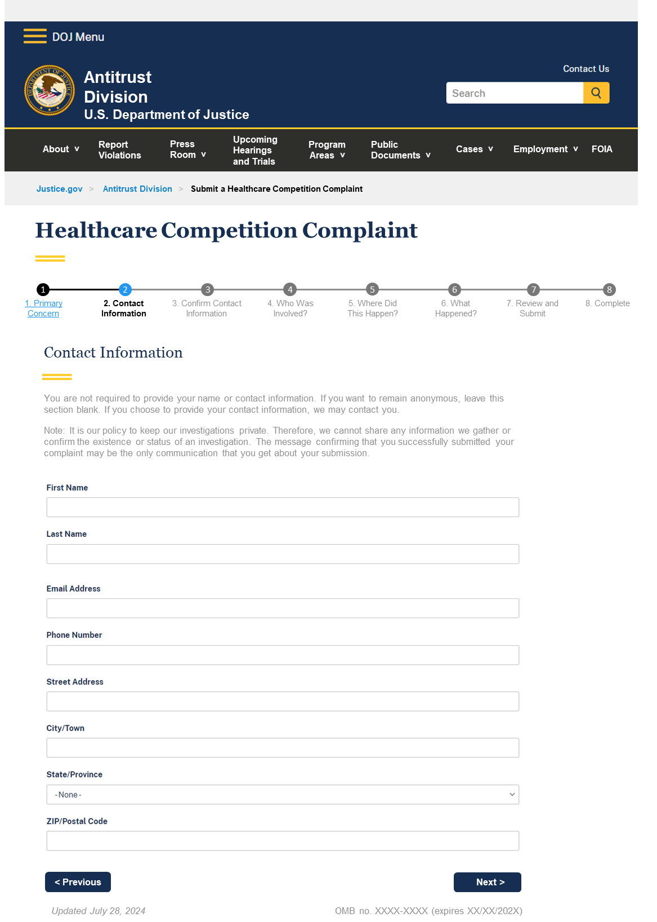

2. Contact Information

Contact Information

You are not required to provide your name or contact information. If you want to remain anonymous, leave this section blank. If you choose to provide your contact information, we may contact you.
Note: It is our policy to keep our investigations private. Therefore, we cannot share any information we gather or confirm the existence or status of an investigation. The message confirming that you successfully submitted your complaint may be the only communication that you get about your submission.

First Name

Last Name

Email Address

Phone Number

Street Address

City/Town

State/Province

ZIP/Postal Code

Previous Next
Updated Month XX, 202X OMB no. XXXX-XXXX (expires XX/XX/202X)

Back to Navigation > Webform 03

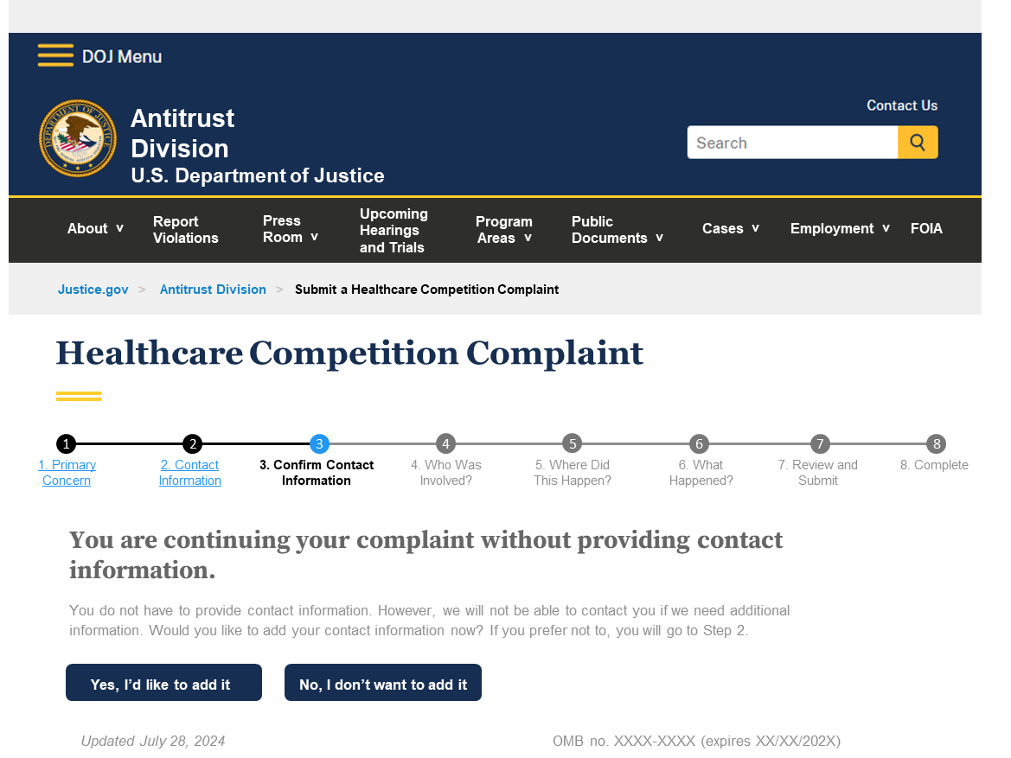

3. Confirm Contact Information

You are continuing your complaint without providing contact information.
You do not have to provide contact information. However, we will not be able to contact you if we need additional information. Would you like to add your contact information now? If you prefer not to, you will go to Step 2.

Yes, I’d like to add it No, I don’t want to add it
Updated Month XX, 202X OMB no. XXXX-XXXX (expires XX/XX/202X)

Back to Navigation > Webform 04

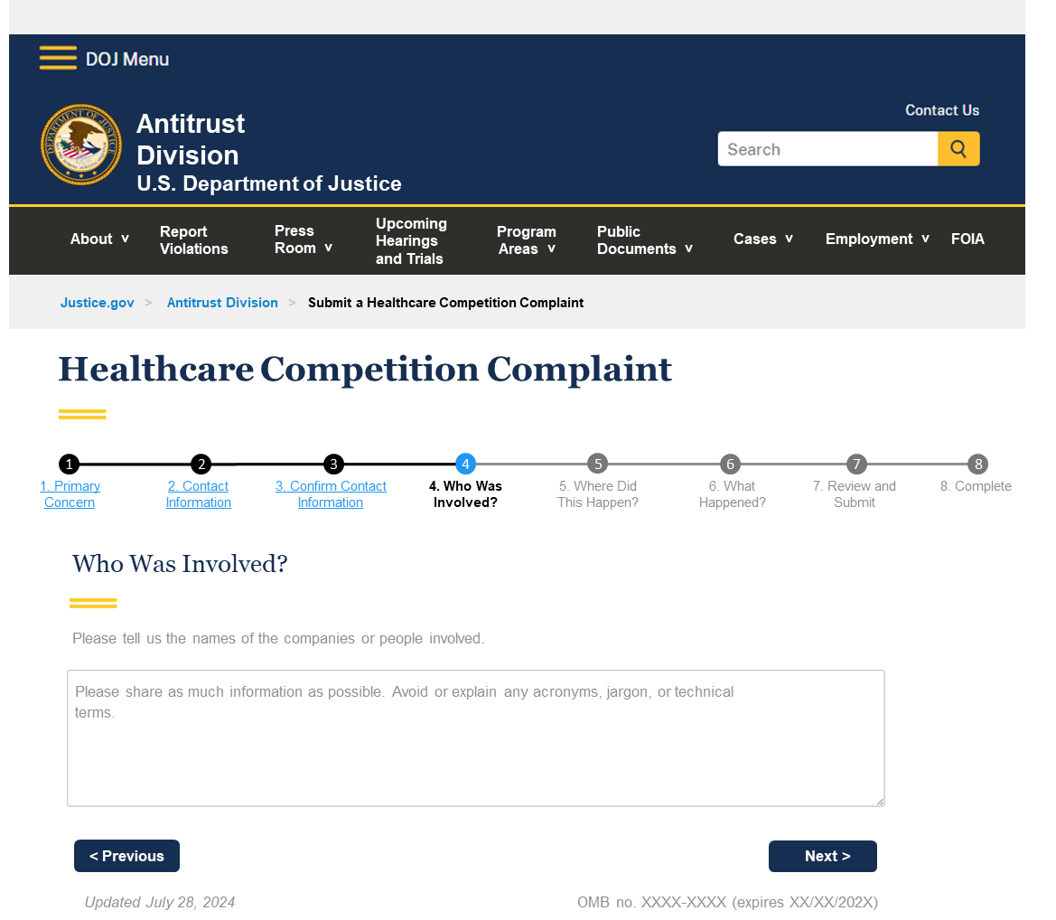

4. Who Was Involved?

Who Was Involved?
Please tell us the names of the companies or people involved.
Please share as much information as possible. Avoid or explain any acronyms, jargon, or technical terms.

Previous Next
Updated Month XX, 202X OMB no. XXXX-XXXX (expires XX/XX/202X)

Back to Navigation > Webform 05
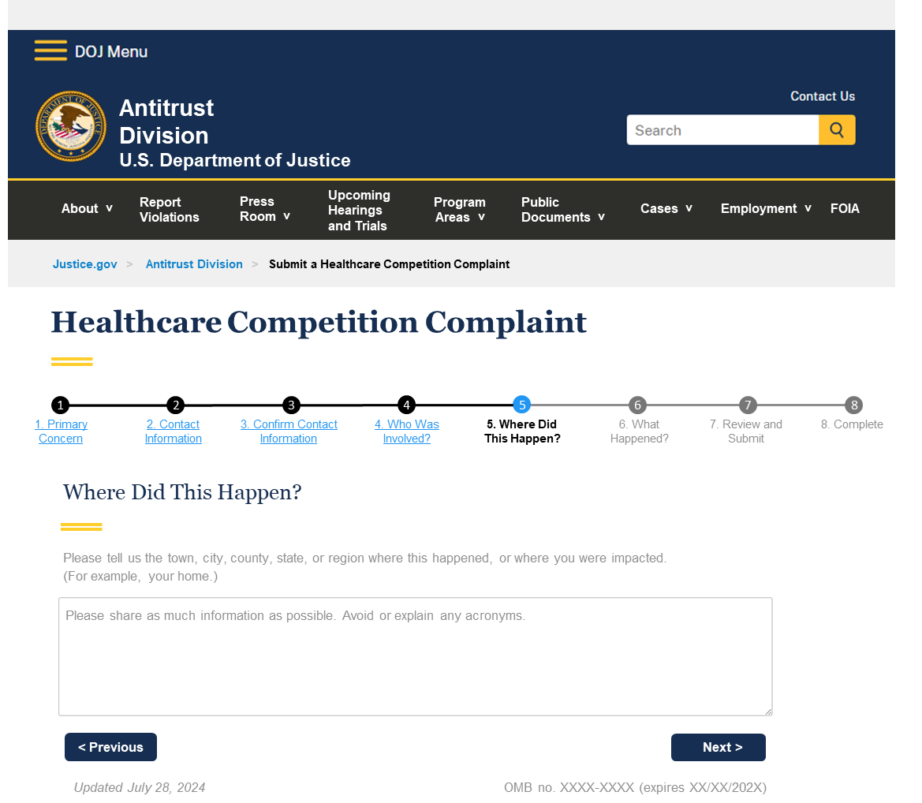

5. Where Did This Happen?

Where Did This Happen?
Please tell us the town, city, county, state, or region where this happened, or where you were impacted.
(For example, your home.)

Please share as much information as possible. Avoid or explain any acronyms.

Previous Next
Updated Month XX, 202X OMB no. XXXX-XXXX (expires XX/XX/202X)

Back to Navigation > Webform 06
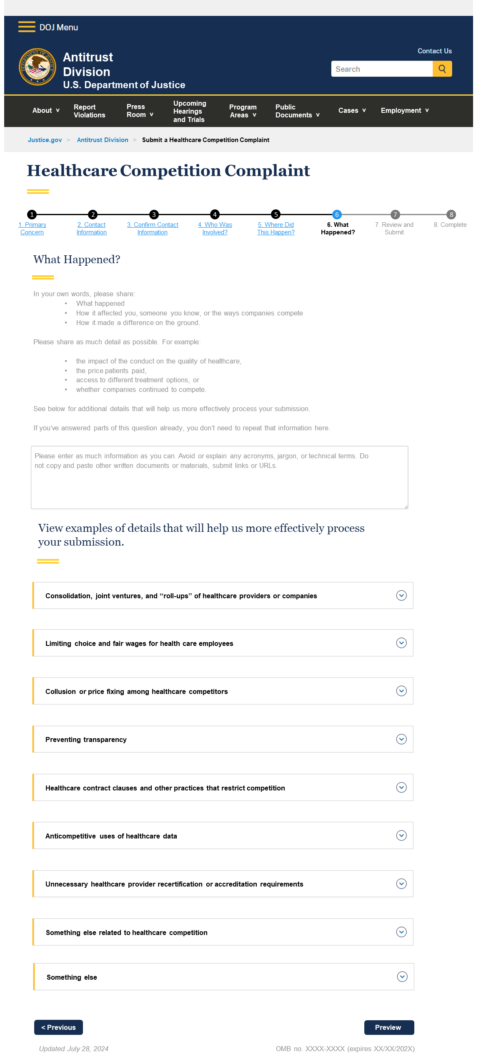

6. What Happened?

What Happened?
In your own words, please share:
- What happened.
- How it affected you, someone you know, or the ways companies compete.
- How it made a difference on the ground.
Please share as much detail as possible. For example:
- the impact of the conduct on the quality of healthcare,
- the price patients paid,
- access to different treatment options, or
- whether companies continued to compete.

See below for additional details that will help us more effectively process your submission.

If you’ve answered parts of this question already, you don’t need to repeat that information here.

Please enter as much information as you can. Avoid or explain any acronyms, jargon, or technical terms. Do not copy and paste other written documents or materials, submit links or URLs.

View details that will help us more effectively process your submission
Consolidation, joint ventures, and “roll-ups” of healthcare providers or companies
- Private equity firm P bought Alpha, Beta, and Gamma medical practices in city Delta in the last 5 years. After the purchase:
  - cost of care increased by $20 for specialty care or by 50%;
  - patients are unable to access care for 60 days, when it used to take 30 days;
  - patients are denied care for 50% of the time, when it used to be 15%; and
  - P reduced the number of physicians from 10 to 5.
- After a merger between Alpha and Beta, provider:
  - is limited to seeing each patient for 20 minutes;
  - sees a trend of more healthy and affluent patients;
  - cannot refer outside of Alpha’s and Beta’s affiliated organizations;
  - must refer to low-cost facilities, like ambulatory care centers; and
  - receives a large bonus if the provider billed each patient for more services than necessary and recorded more expensive diagnoses.

Limiting choice and fair wages for healthcare employees
- Inserting specific contract terms that prevent you from working for your employer’s competitors for at least 5 years in your county.
- Reporting texts among current employer and other potential employers agreeing not to hire a particular individual.

Collusion or price fixing among competitors
- Reporting an email that involves two CFOs of two competing hospitals in your town that shared spreadsheets of past, present, and future reimbursement rates information.
- Reporting a note where competing medical device manufacturers A and B detailed a plan to raise their price for hearing devices by $30 in 2020, and providing receipts that both devices from manufacturers A and B went up by $30 in 2021.
- In Gamma County, the city issues a yearly request for proposal (RFP) to provide veteran care in city X, Y, and Z. Every year, Provider A wins all bids to provide veteran care in city X, and Provider B wins all bids to provide veteran care in city Y, and Z.

Preventing transparency
- Reporting that your previous insurer and primary care provider failed to send medical records to your newly selected insurer and primary care doctor, despite multiple requests. Listing all excuses your prior insurer and primary care provider gave for not sharing your patient records and the dates they provided these excuses.

Restrictive healthcare agreements and drug manufacturing practices
- Providing communications between Provider Alpha and Beta Insurer, where Alpha threatens to back out of Beta’s network if Beta does not place Alpha’s facilities on the highest and most favorable tier, during yearly contract negotiations. Inserting specific contract term that requires this agreement.

Anticompetitive uses of healthcare data
- Reporting that your previous insurer and primary care provider failed to send medical records to your newly selected insurer and primary care doctor, despite multiple requests. Listing all excuses your prior insurer and primary care provider gave for not sharing your patient records and the dates they provided these excuses.

Unnecessary healthcare provider recertification or accreditation requirements
- Reporting that Hospital A required certification from certifying body B. B implemented a new policy, demanding physicians meet additional requirements to remain certified and must pay an additional X amount per year to stay certified. When the policy went into effect, several providers working at Hospital A were unable to meet the new requirements and were forced to resign from Hospital A.

Something else
- Reporting that doctor A received a large bonus because doctor A billed each patient for more services than necessary and recorded inaccurate and more expensive diagnoses.
- Reporting findings from your medical record that your insurer billed for services that never occurred or did not match the service you received.

Previous Next
Updated Month XX, 202X OMB no. XXXX-XXXX (expires XX/XX/202X)

Back to Navigation > Webform 07
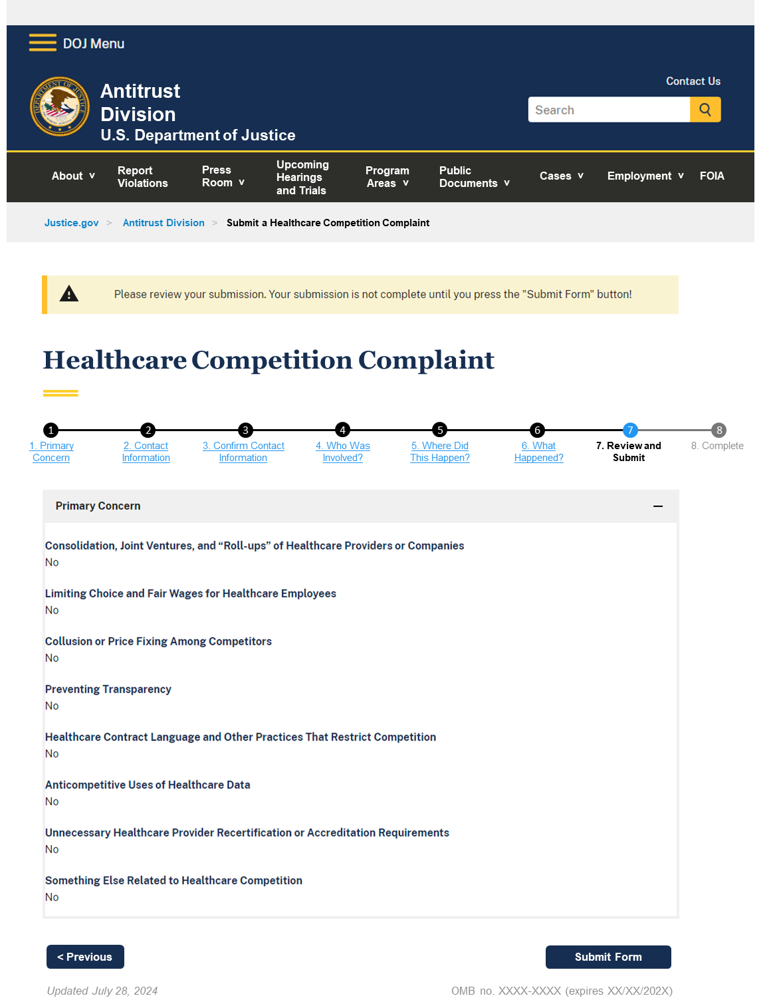

7. Review and Submit

Previous Next
Updated Month XX, 202X OMB no. XXXX-XXXX (expires XX/XX/202X)

Back to Navigation > Webform 08

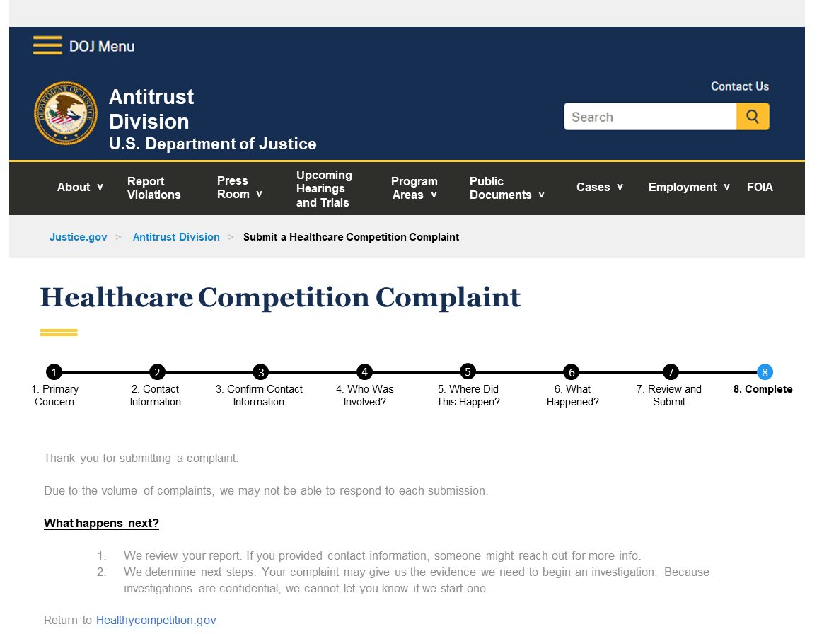

8. Complete

Thank you for submitting a complaint.
Due to the volume of complaints, we may not be able to respond to each submission.
What happens next?
1.We review your report. If you provided contact information, someone might reach out for more info.
2.We determine next steps. Your complaint may give us the evidence we need to begin an investigation. Because investigations are confidential, we cannot let you know if we start one.

Return to HealthyCompetition.gov

