- ITA Login Page
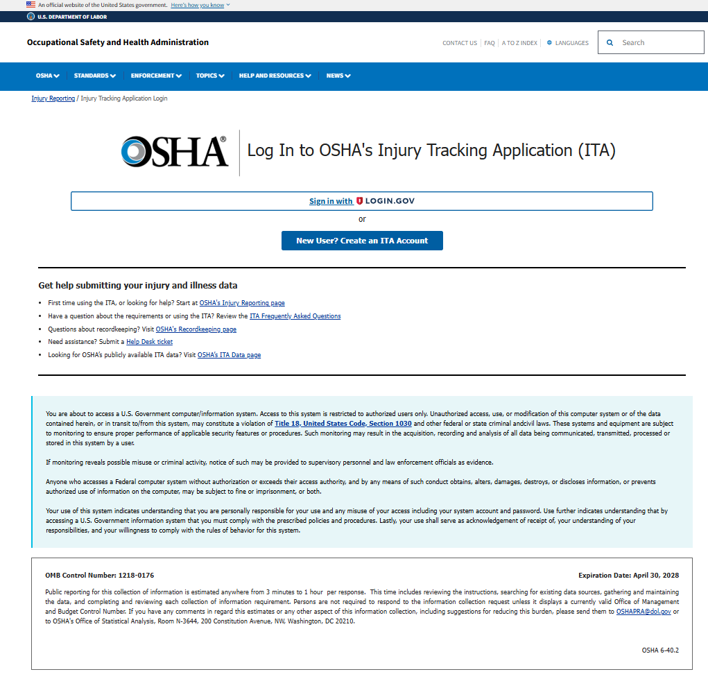

- ITA home page
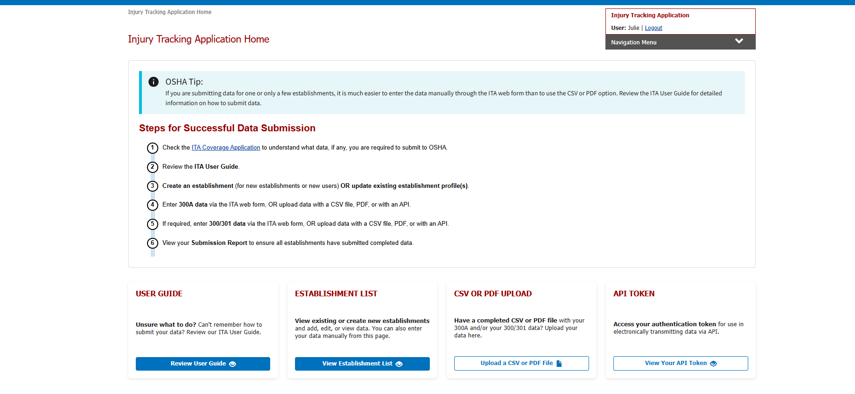
- Create Establishment (aka EIN page)
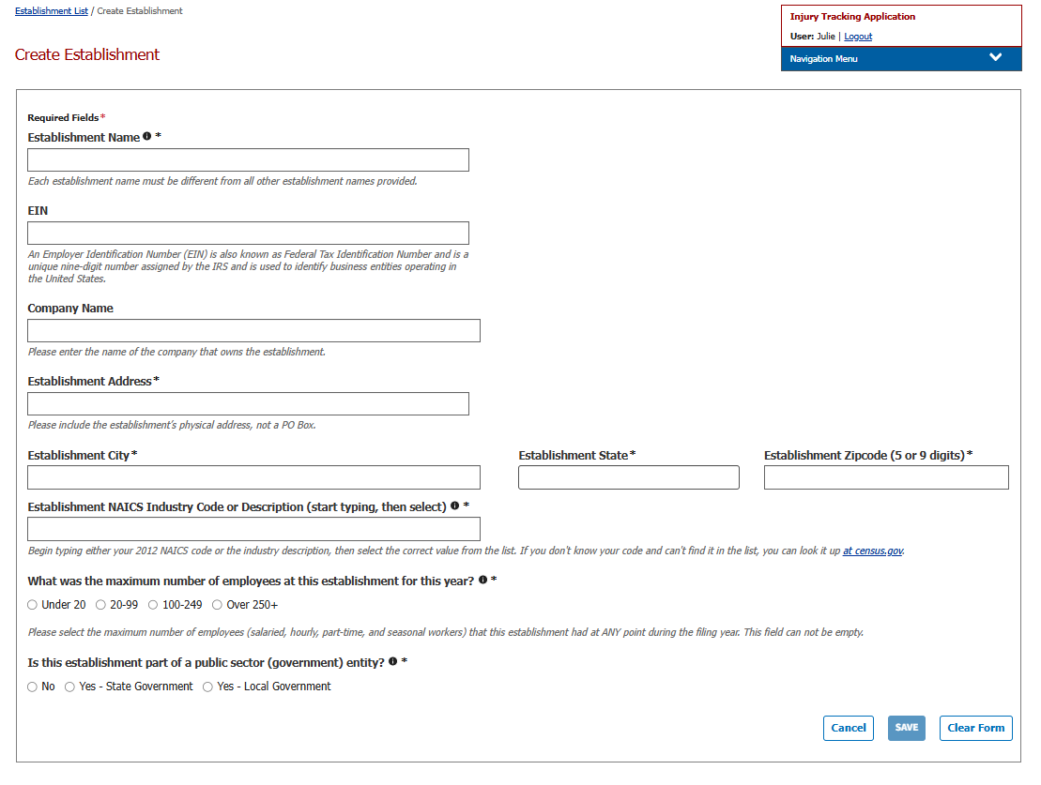

- View establishment
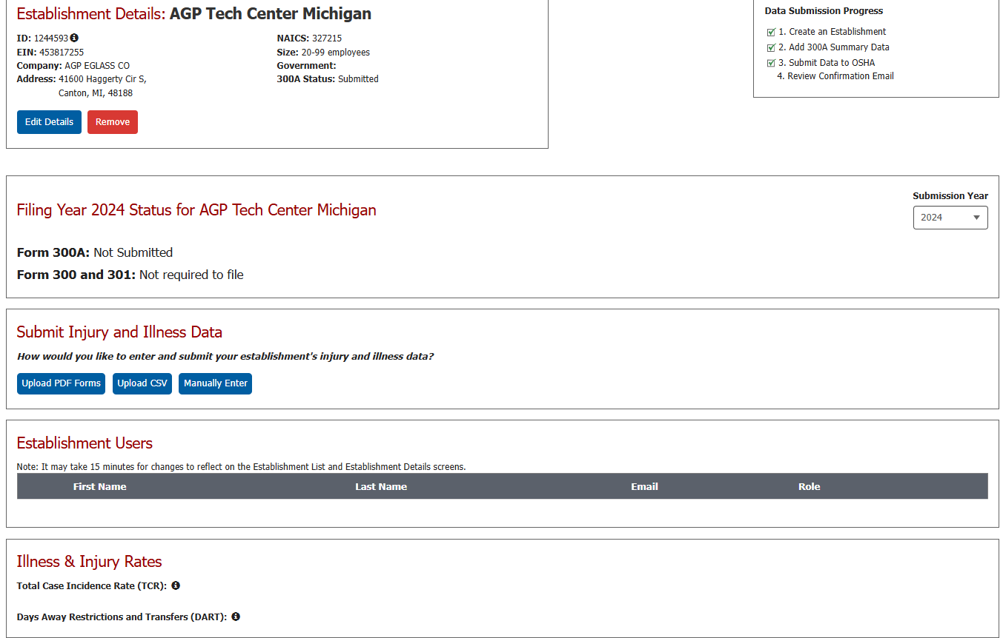

- Upload Injury/Illness file
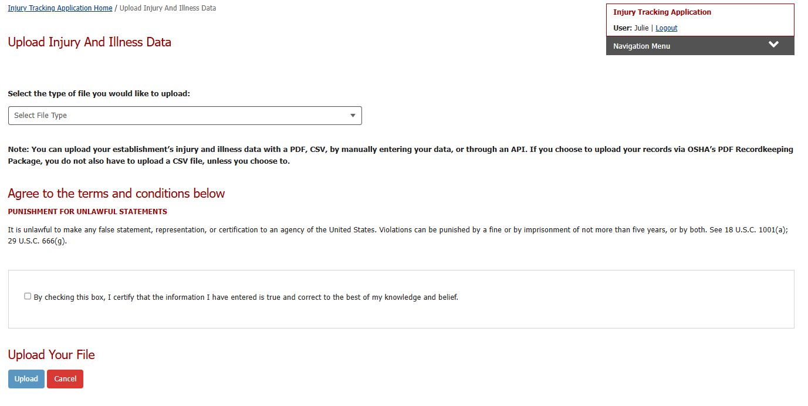

- Check the acknowledgement box that will enable the Upload button
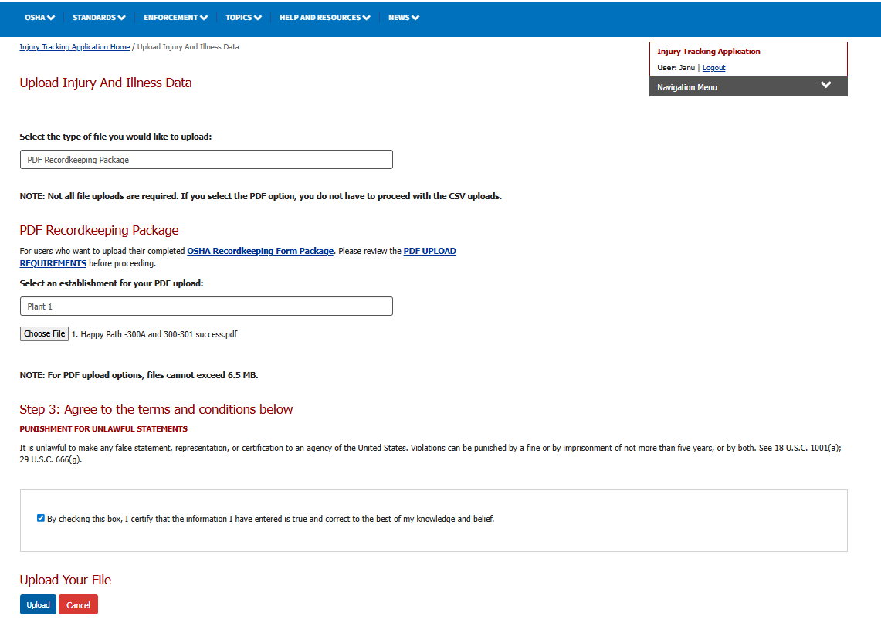

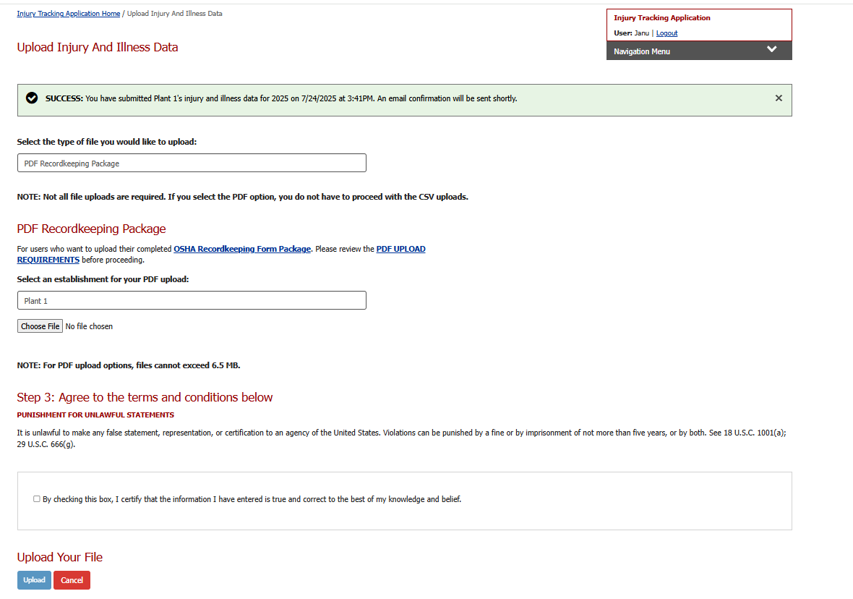
- Once the PDF file is uploaded, the success banner message appears on the screen which says an email confirmation will follow.

