Non-substantive Change Request
ICR 1405-0152
DS-4024e

Justification: The Department developed the Smart Traveler Enrollment Program (STEP) software for U.S. nationals to electronically, securely submit their travel plans and/or subscribe to travel alerts. STEP is intended for use by U.S. nationals who may enroll online prior to or during their overseas travel. The service is available on the Department’s Bureau of Consular Affairs web site http://travel.state.gov/ or at https://step.state.gov/step/. The information received is used to provide timely safety and security information and to facilitate locating and contacting U.S. nationals in the event of a disaster or incident abroad. STEP enables the Department and its embassies and consulates abroad to better assist U.S. nationals as a means of sending targeted messages and alerts to them.

4024d Group Enrollment Non-Substantive Change: The current, approved DS-4024e and DS-4024 provide for individual STEP enrollment. The DS-4024 also provides for group/third party enrollment. The Department of State proposes a non-substantive change to the DS-4024e that allows a user to select an option for Group Enrollment and will process those registrations.
There are three functional, non-substantive enhancements (all pictured below in screenshot):
A ‘Solo’ or ‘Group’ choice that steers the user to the appropriate portion of the approved DS-4024e.
A ‘Group Name’ which allows the registrant to identify this registered travel plan in the user interface.
‘Are you traveling with this group?’ directs the user to register themselves first and then proceed to registering others or skips them straight into registering others. No new substantive fields were added to the DS-4024e for group registration details.
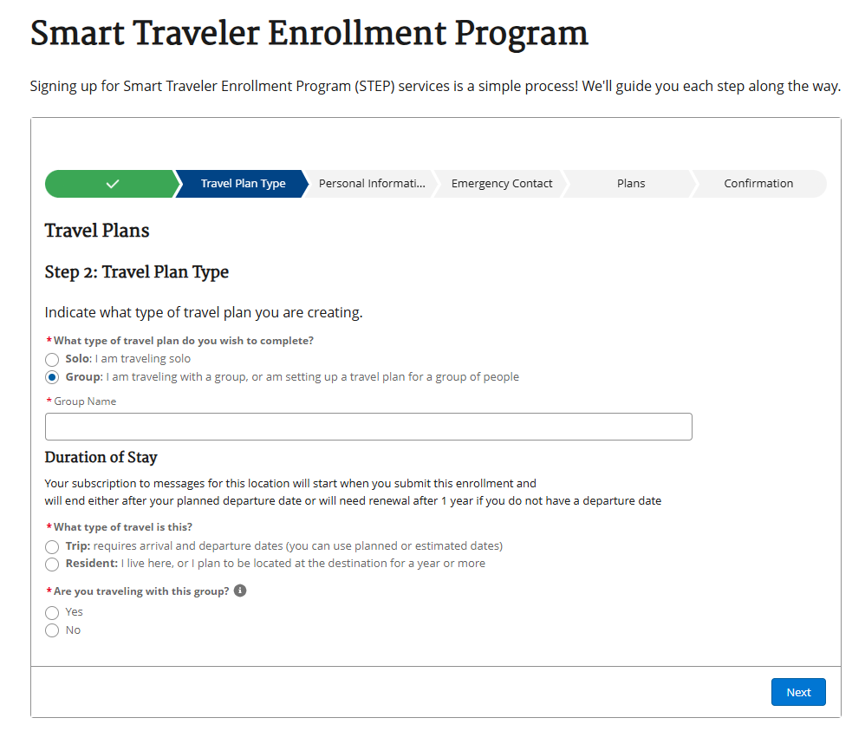
Follow-on Email to Other Named Travelers
Email addresses provided during a group enrollment will receive a confirmation email from the STEP software asking them to confirm enrollment in the group travel plan. This is a functional enhancement to ensure validation of travel registrations. Sample text below.
“Dear XXX,
You were enrolled in the SMART Traveler Enrollment Program (STEP) in the XXX travel plan.
Group Travel Plan Details:
Group Name: XXX
Travel Dates: Arrival XXX - Departure XXX
Number of Travelers: X

[Link will be provided -- “click here to respond” where they confirm that they’re going on the trip]
You should review the Travel Advisory for your trip destination(s).
Destination: XXX
Visit travel.state.gov/destination [travel.state.gov] to read the Travel Advisory and other important travel guidance for your destination.
Need Help
Contact the U.S. State Department, Bureau of Consular Affairs:
888-407-4747 or 202-501-4444
Enroll in Smart Traveler Enrollment Program (STEP) [consularone--dev013.sandbox.my.site.com] to receive security updates
Follow us on Facebook [facebook.com], Instagram [instagram.com], and X [x.com]
If you are a registered customer, you can manage your subscriptions by clicking the link below. Guest subscribers cannot manage subscriptions, but can create a Login.gov [consularone--dev013.sandbox.my.site.com] account to manage future subscriptions.
Manage Your Subscriptions [consularone--dev013.sandbox.my.site.com]”

