NATIONAL CENTER FOR EDUCATION STATISTICS NATIONAL ASSESSMENT OF EDUCATIONAL PROGRESS

National Assessment of Educational Progress (NAEP) 2026

Appendix J3
2024 School Questionnaires Samples

OMB# 1850-0928 v.38

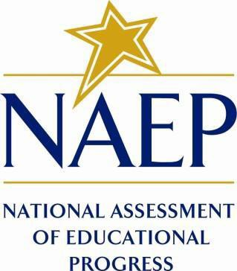

September 2025

Appendix J3 provides the school survey questionnaires that will be administered in 2026, and any changes to the items from the 2024 administration are reflected in summary tables. Please note, some of the numbers of the items may be missing or out of order in these printed versions. This will be corrected in the platform view.

Table of Contents
School Questionnaires
School Administrator Questionnaire Login Screen 3
Appendix J3-1: Summary of Changes Operational Grade 4 (Core) 4
Appendix J3-2: Operational Grade 4 (Core) 15
Appendix J3-3: Summary of Changes Operational Grade 8 (Core) 22
Appendix J3-4: Operational Grade 8 (Core) 33
Appendix J3-5: Summary of Changes Operational Grade 4 (Mathematics) 39
Appendix J3-6: Operational Grade 4 (Mathematics) 43
Appendix J3-7: Summary of Changes Operational Grade 8 (Mathematics) 46
Appendix J3-8: Operational Grade 8 (Mathematics) 52
Appendix J3-9: Summary of Changes Operational Grade 4 (Reading) 57
Appendix J3-10: Operational Grade 4 (Reading) 63
Appendix J3-11: Summary of Changes Operational Grade 8 (Reading) 67
Appendix J3-12: Operational Grade 8 (Reading) 73
Appendix J3-13: Summary of Changes Operational Grade 8 (Social Studies) 77
Appendix J3-14: Operational Grade 8 (Social Studies) 81
Appendix J3-15: Summary of Changes Operational Grade 4 (Charter School) 84
Appendix J3-16: Operational Grade 4 (Charter School) 86
Appendix J3-17: Summary of Changes Operational Grade 8 (Charter School) 89
Appendix J3-18: Operational Grade 8 (Charter School) 91
Appendix J3-19: Pilot Grade 4 (Core) 94
Appendix J3-20: Pilot Grade 12 (Core) 100
Appendix J3-21: Pilot Grade 4 (Mathematics) 109
Appendix J3-22: Pilot Grade 12 (Mathematics) 113
Appendix J3-23: Pilot Grade 4 (Reading) 120
Appendix J3-24: Pilot Grade 12 (Reading) 126
Appendix J3-25: Pilot Grade 4 (Charter School) 133
Appendix J3-25: Pilot Grade 12 (Charter School) 136

School Administrator Questionnaire Login Screen

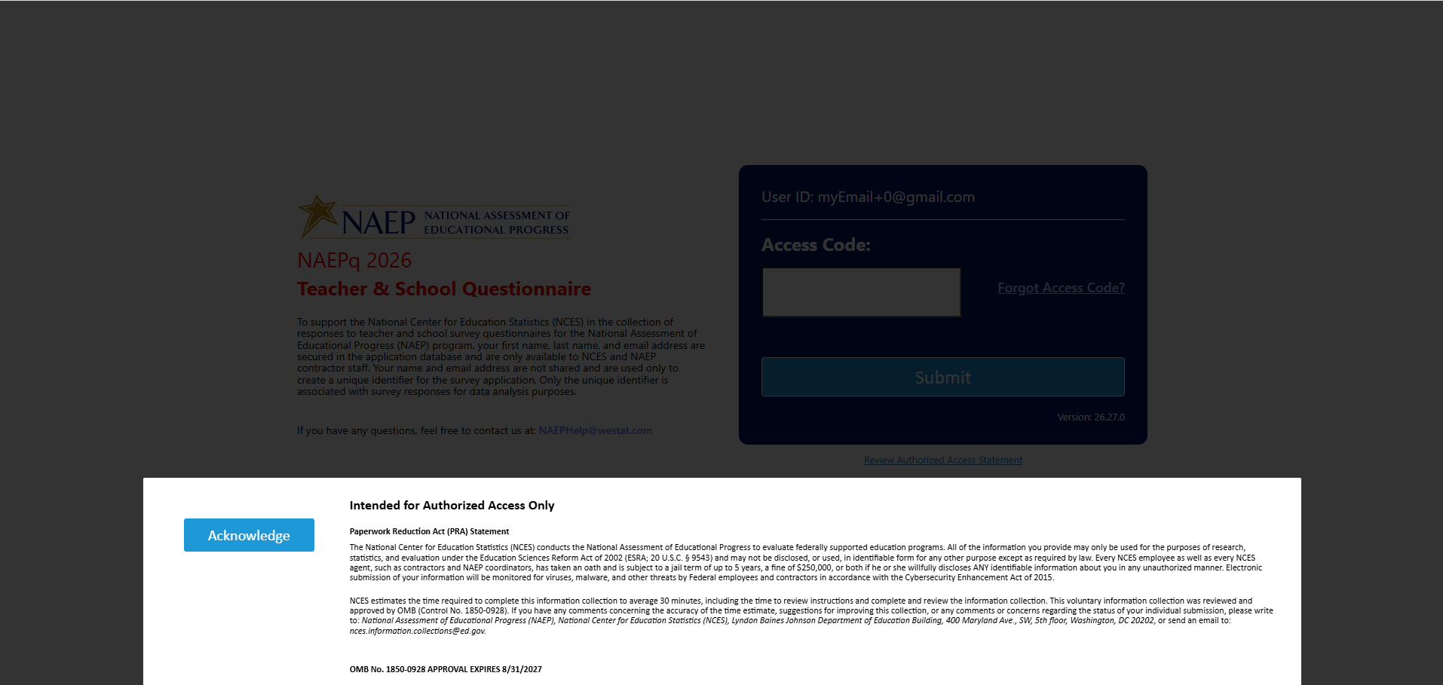

Appendix J3-1: Summary of Changes Operational Grade 4 (Core)
2026 Operational Grade 4 Core School
Previous Item | 2026 Item | D/A/R+ | Rationale
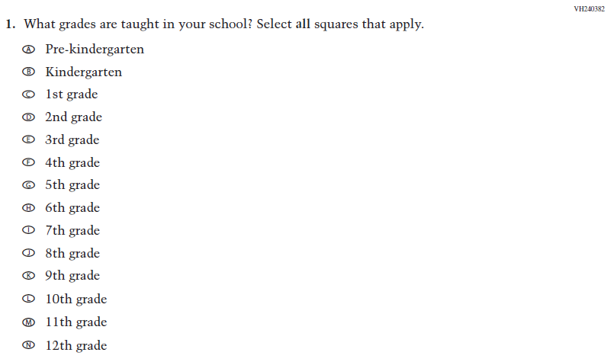  (2024) | 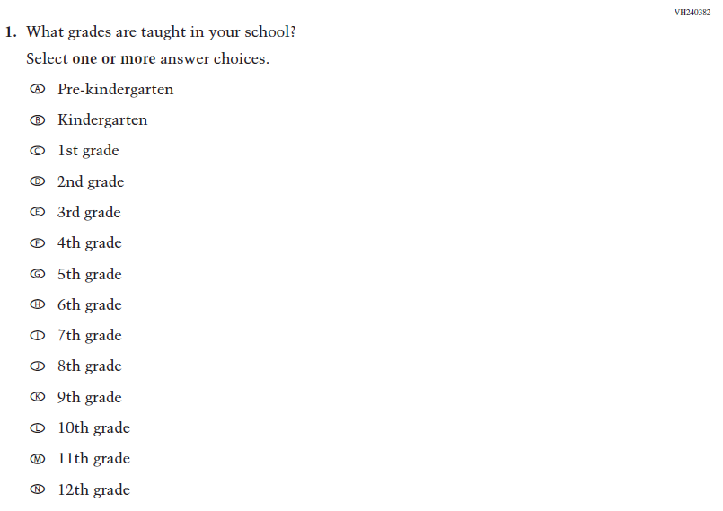  Issue: School Climate | R | For 2026, we have aligned Inline Directions in Teacher and School Items with the Directions currently used in Student Items.
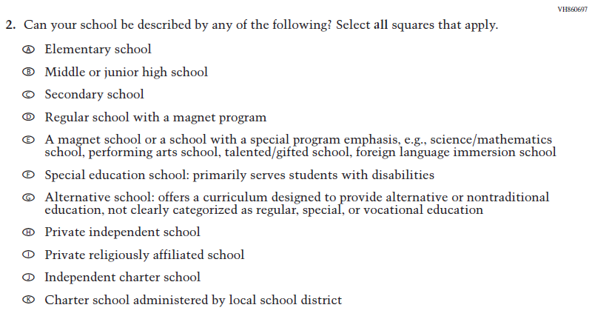  (2024) | 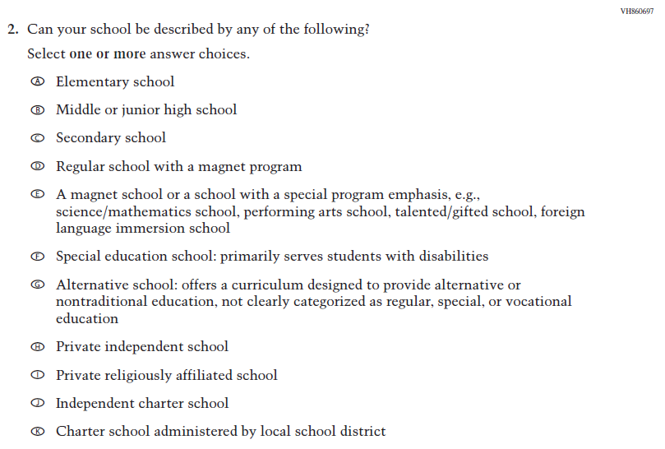  Issue: School Climate | R | For 2026, we have aligned Inline Directions in Teacher and School Items with the Directions currently used in Student Items.

2026 Operational Grade 4 Core School
Previous Item | 2026 Item | D/A/R+ | Rationale
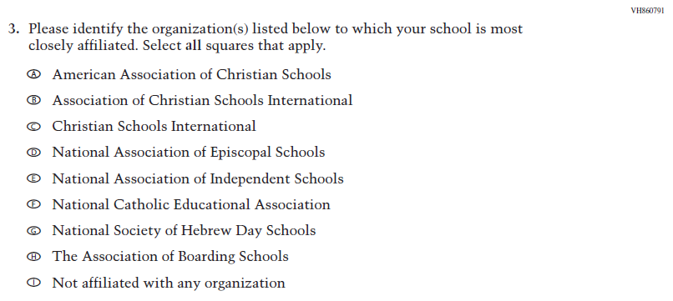  (2024) | N/A | D | This Item was dropped due to low response frequencies and low relevance to the larger NAEP sample.
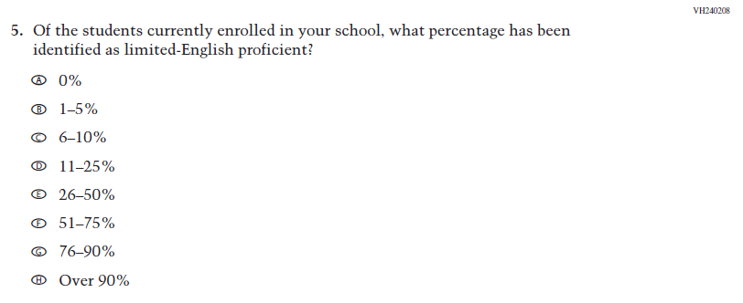  (2024) | 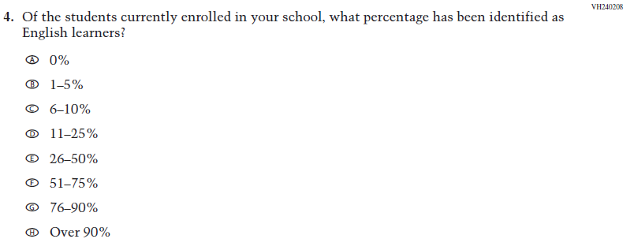  Issue: School Climate | R | This Item was revised to update “limited-English proficient” to “English learners.”
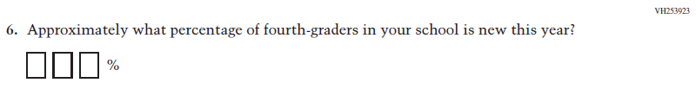  (2024) | 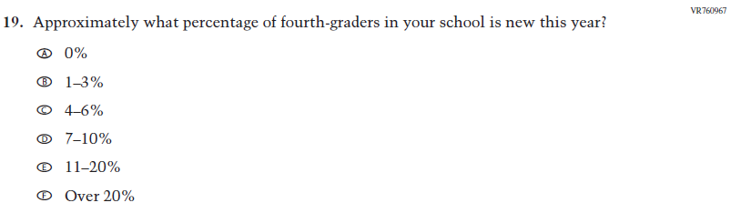  Issue: School Climate | R | This Item was revised to use response options for improved data collection and reporting of student mobility.

2026 Operational Grade 4 Core School
Previous Item | 2026 Item | D/A/R+ | Rationale
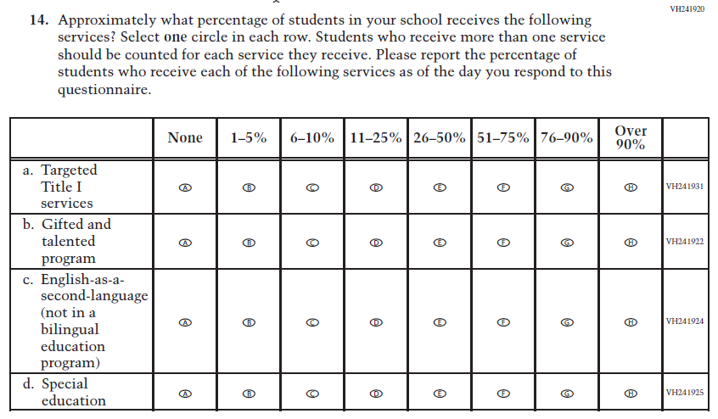  (2024) | 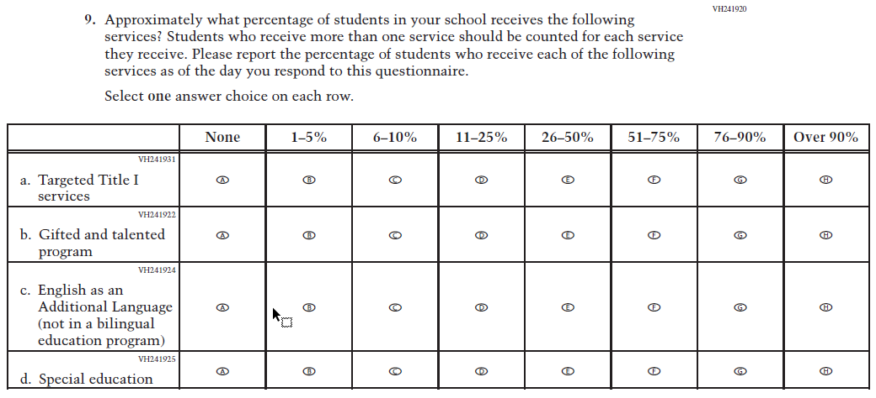  Issue: School Climate | R | For 2026, we have aligned Inline Directions in Teacher and School Items with the Directions currently used in Student Items. Also, in SubItem c. “English-as-a-second-language” was updated to “English as an Additional Language”.
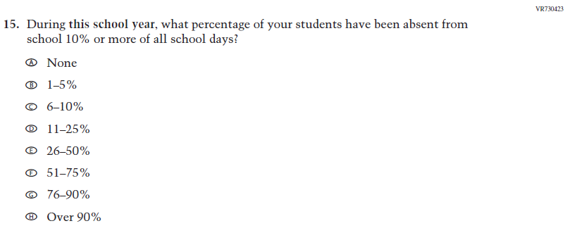  (2024) | N/A | D | Learning Recovery Items were dropped from the 2026 NAEP Assessment.

2026 Operational Grade 4 Core School
Previous Item | 2026 Item | D/A/R+ | Rationale
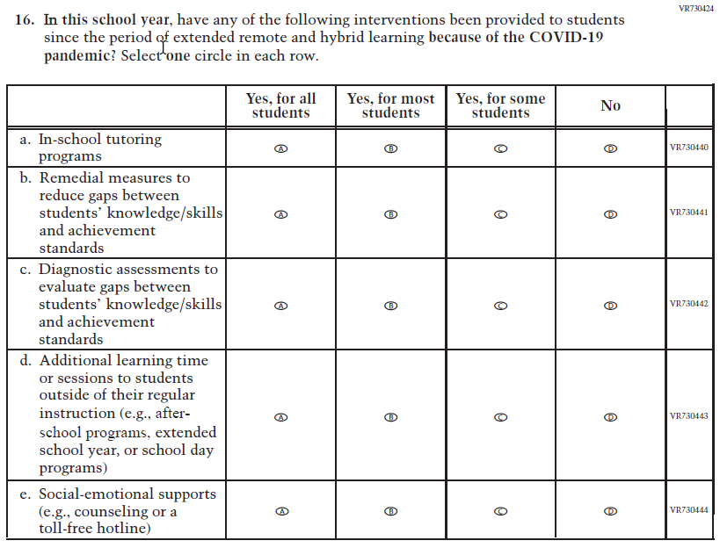  (2024) | N/A | D | Learning Recovery Items were dropped from the 2026 NAEP Assessment.
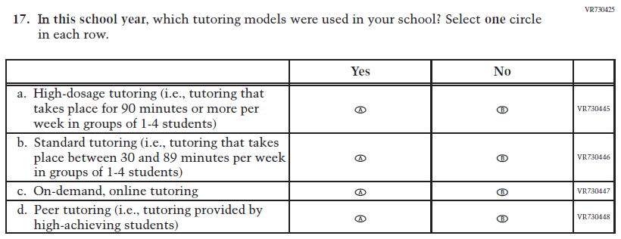  (2024) | N/A | D | Learning Recovery Items were dropped from the 2026 NAEP Assessment.

2026 Operational Grade 4 Core School
Previous Item | 2026 Item | D/A/R+ | Rationale
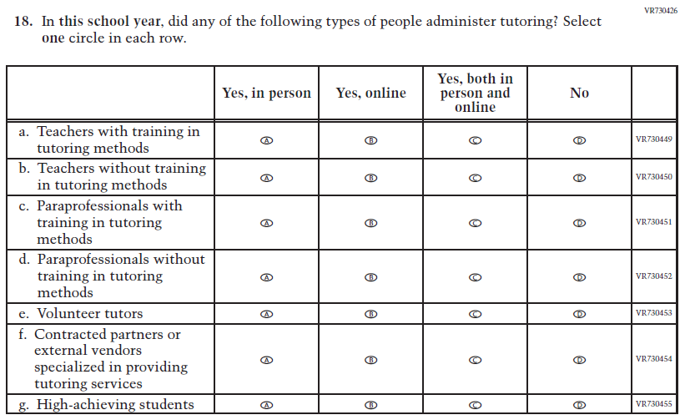  (2024) | N/A | D | Learning Recovery Items were dropped from the 2026 NAEP Assessment.
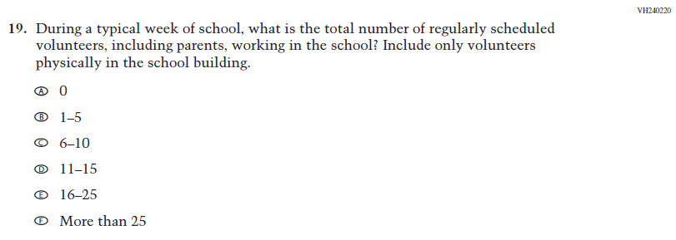  (2024) | N/A | D | This Item was dropped due to lack of insight provided by the question and to prioritize new content.

2026 Operational Grade 4 Core School
Previous Item | 2026 Item | D/A/R+ | Rationale
N/A  (2024) | 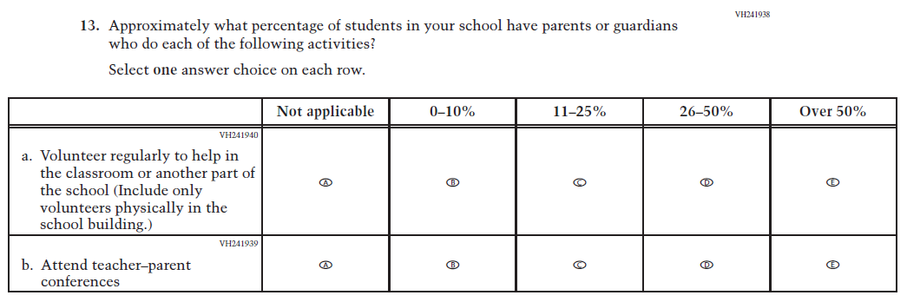  Issue: School Climate | A | This Item was previously administered in the 2022 NAEP Assessment and added in 2026 to measure parental involvement in the school.
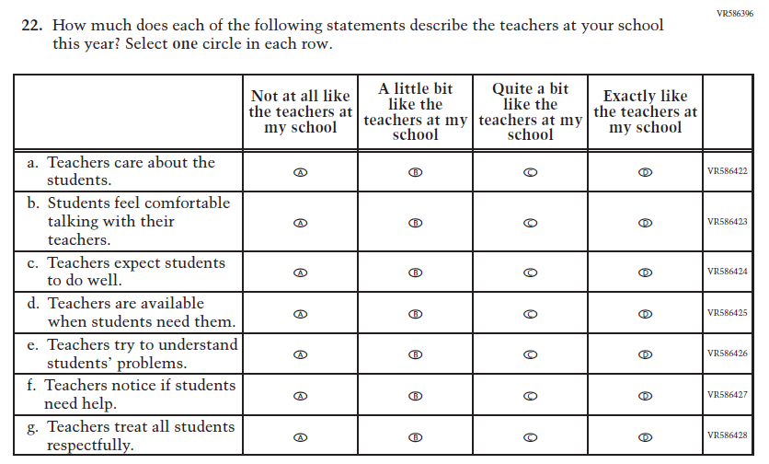  (2024) | 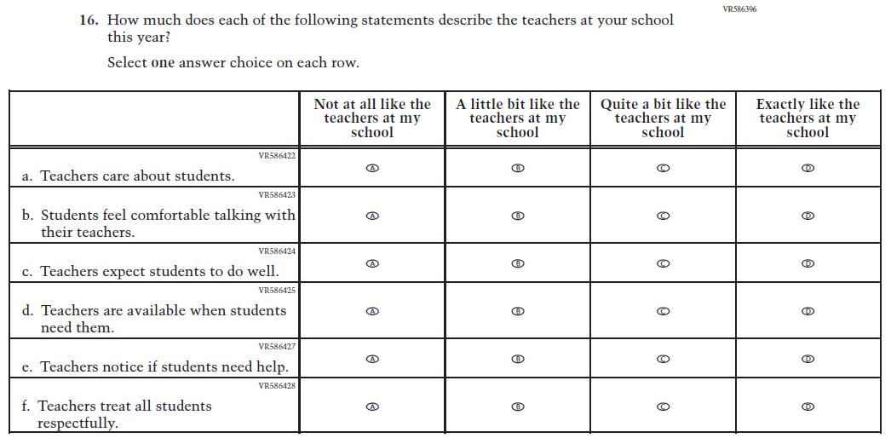  Issue: Learning Environment | R | For 2026, we have aligned Inline Directions in Teacher and School Items with the Directions currently used in Student Items. Also, SubItem e. from 2024 was dropped for 2026.
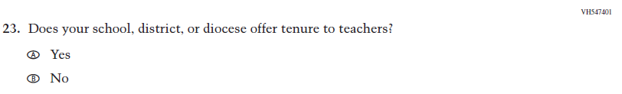  (2024) | N/A | D | This Item was dropped due to lack of insight provided by the question and to prioritize new content.
2026 Operational Grade 4 Core School
Previous Item | 2026 Item | D/A/R+ | Rationale
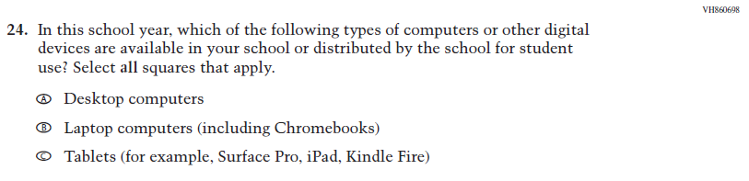  (2024) | N/A | D | This and the related Items were dropped in favor of a more current and concise format for questions on Technology Use.
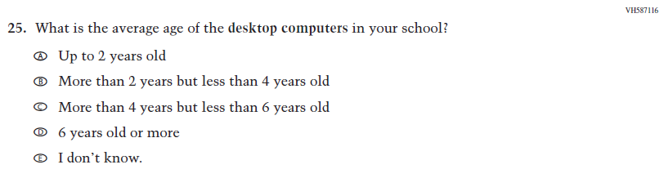  (2024) | N/A | D | This and the related Items were dropped in favor of a more current and concise format for questions on Technology Use.
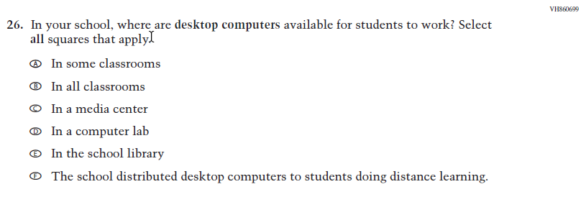  (2024) | N/A | D | This and the related Items were dropped in favor of a more current and concise format for questions on Technology Use.

2026 Operational Grade 4 Core School
Previous Item | 2026 Item | D/A/R+ | Rationale
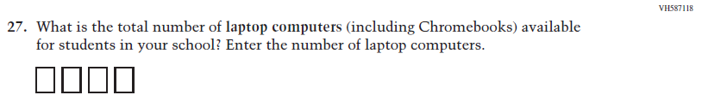  (2024) | N/A | D | This and the related Items were dropped in favor of a more current and concise format for questions on Technology Use.
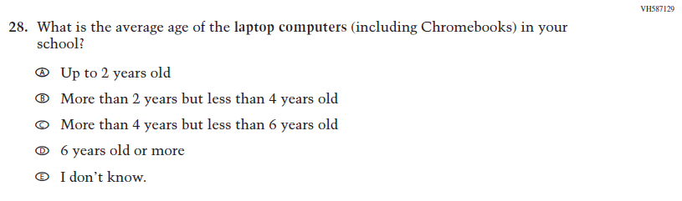  (2024) | N/A | D | This and the related Items were dropped in favor of a more current and concise format for questions on Technology Use.
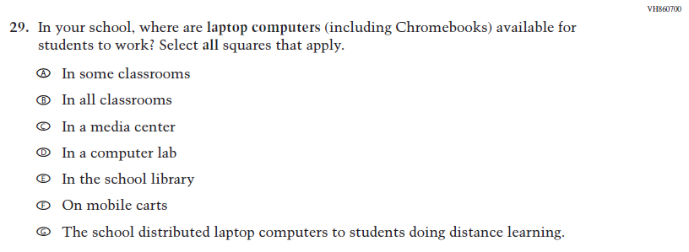  (2024) | N/A | D | This and the related Items were dropped in favor of a more current and concise format for questions on Technology Use.

2026 Operational Grade 4 Core School
Previous Item | 2026 Item | D/A/R+ | Rationale
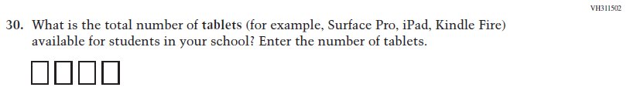  (2024) | N/A | D | This and the related Items were dropped in favor of a more current and concise format for questions on Technology Use.
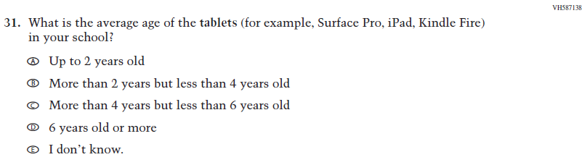  (2024) | N/A | D | This and the related Items were dropped in favor of a more current and concise format for questions on Technology Use.
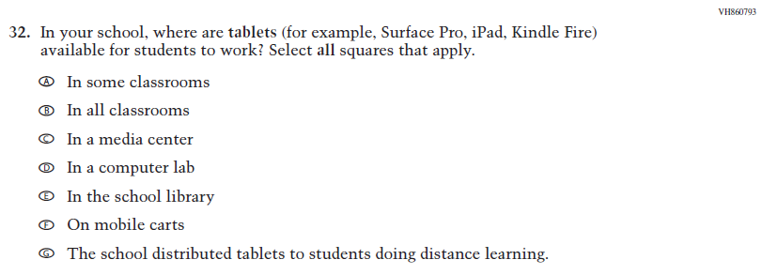  (2024) | N/A | D | This and the related Items were dropped in favor of a more current and concise format for questions on Technology Use.

2026 Operational Grade 4 Core School
Previous Item | 2026 Item | D/A/R+ | Rationale
N/A  (2024) | 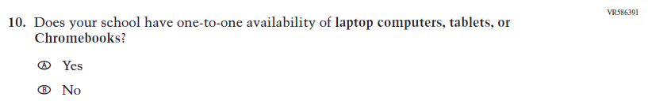  Issue: Technology Use | A | This Item was developed to measure technology use and student access to digital technology for learning.
N/A  (2024) | 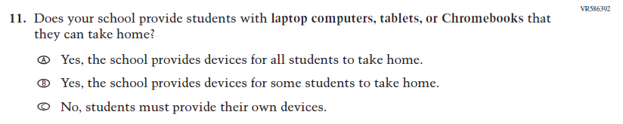  Issue: Technology Use | A | This Item was developed to measure technology use and student access to digital technology for learning.
N/A  (2024) | 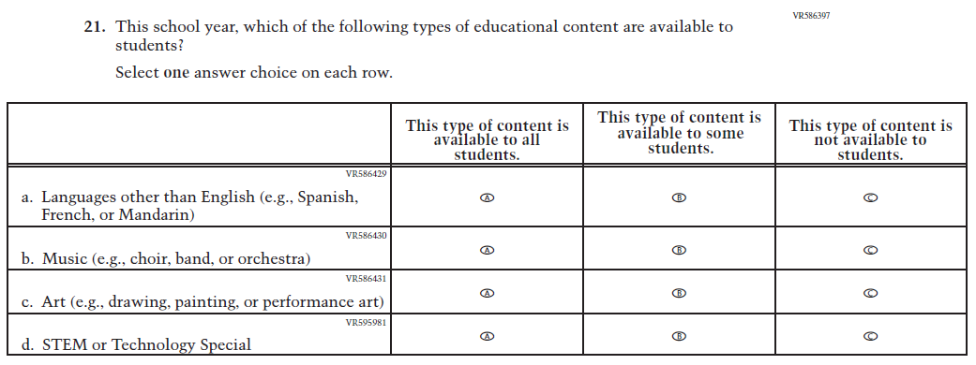  Issue: School Climate | A | This Item was developed to measure students’ learning environments and access to educational content focused on languages, music, art, and STEM.

Appendix J3-2: Operational Grade 4 (Core)
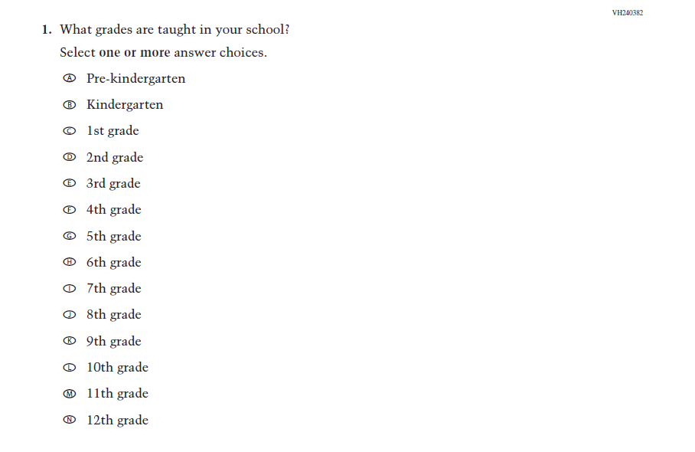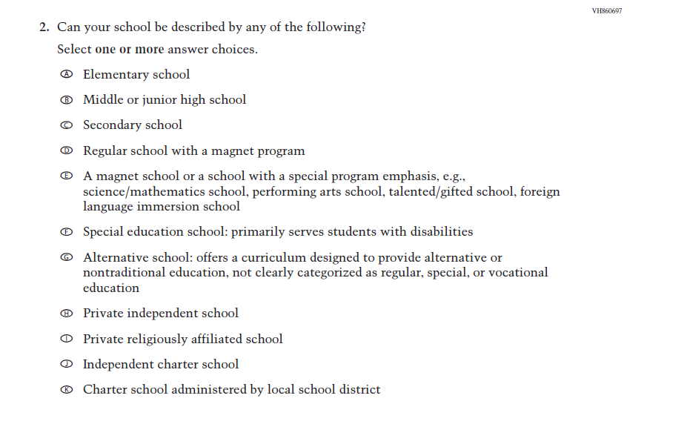

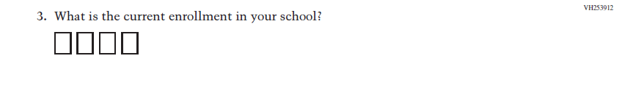
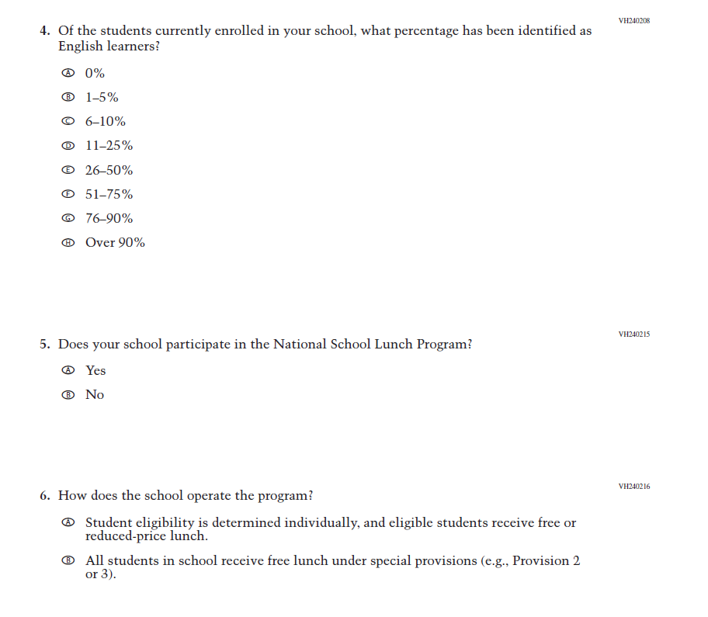
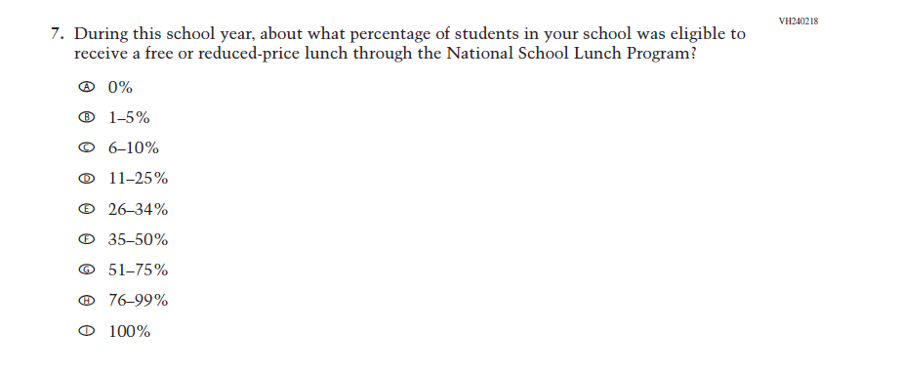
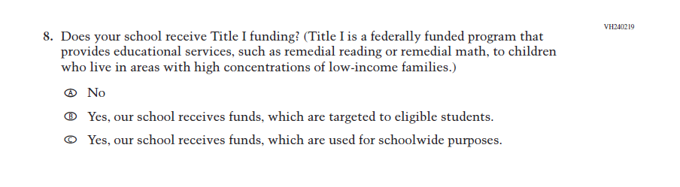
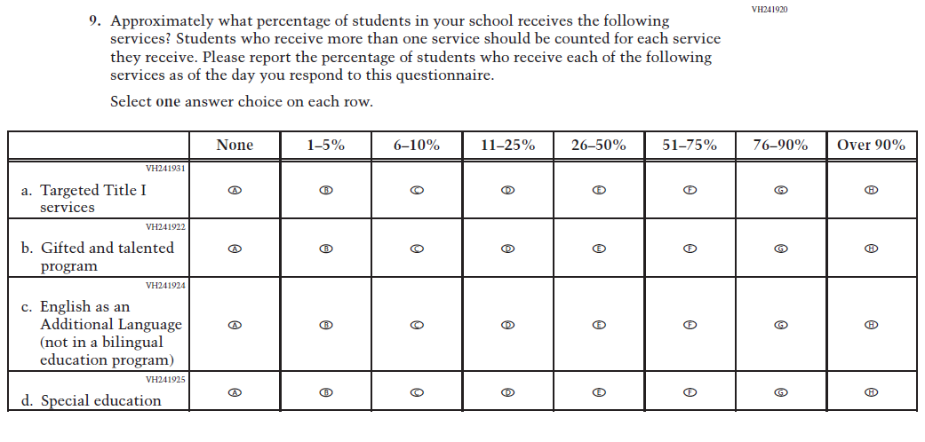
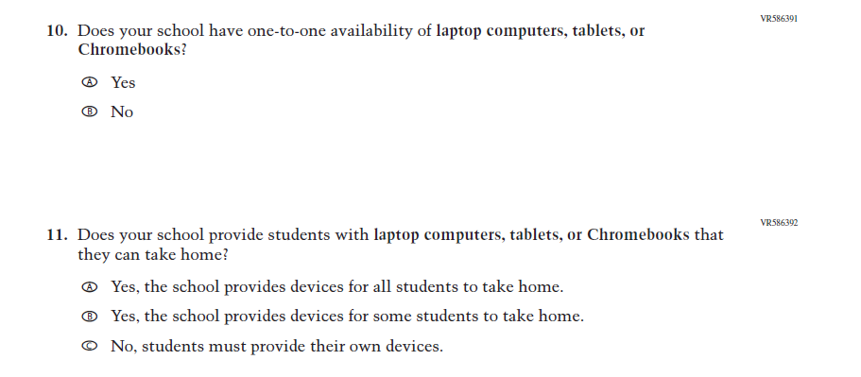
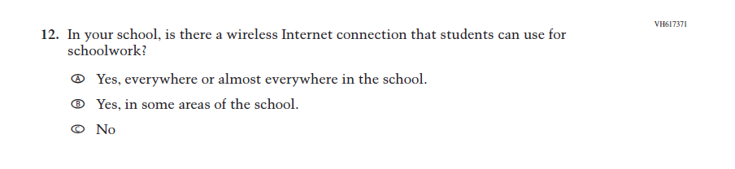
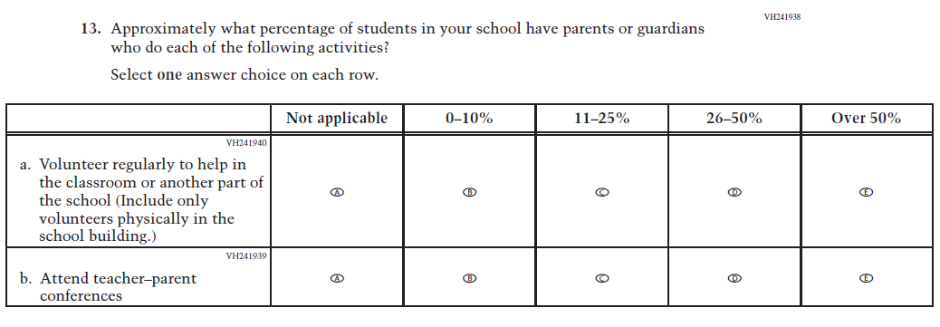
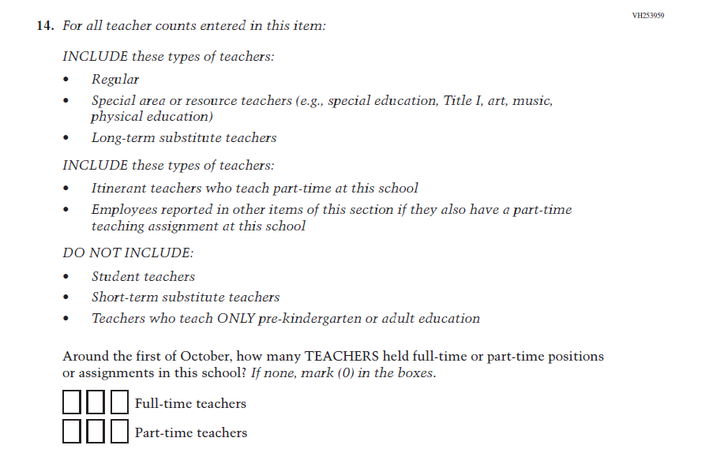
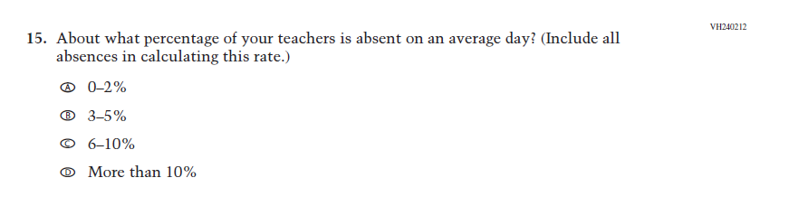
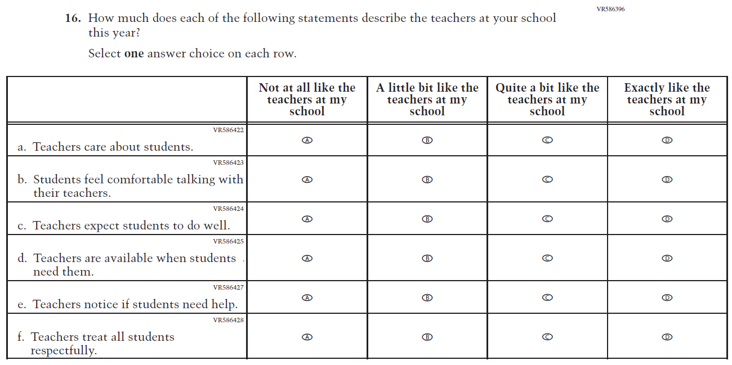
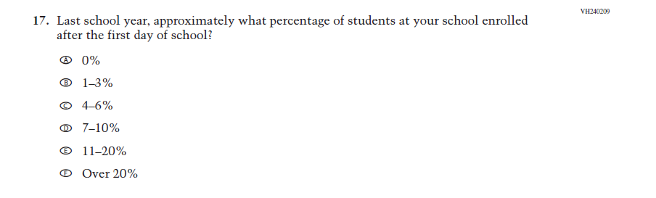
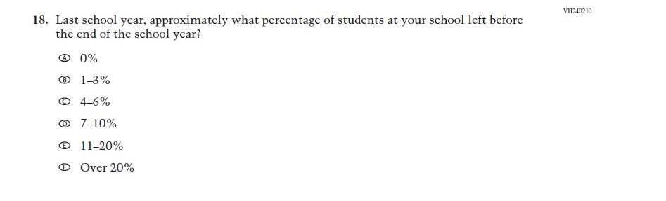
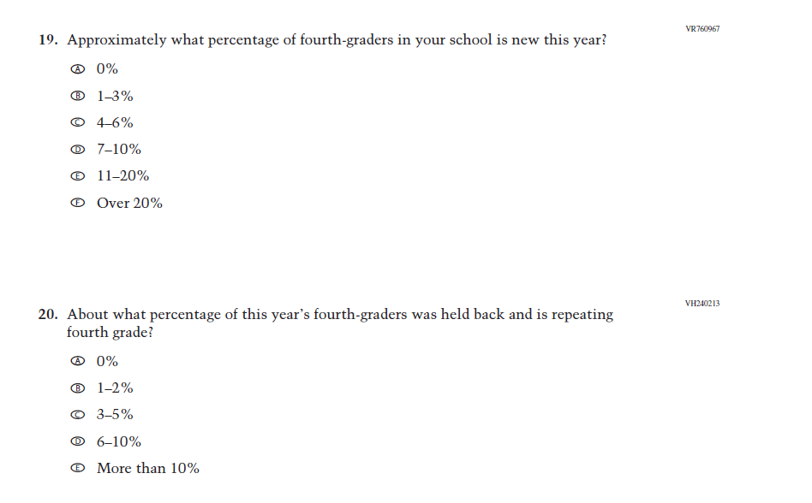
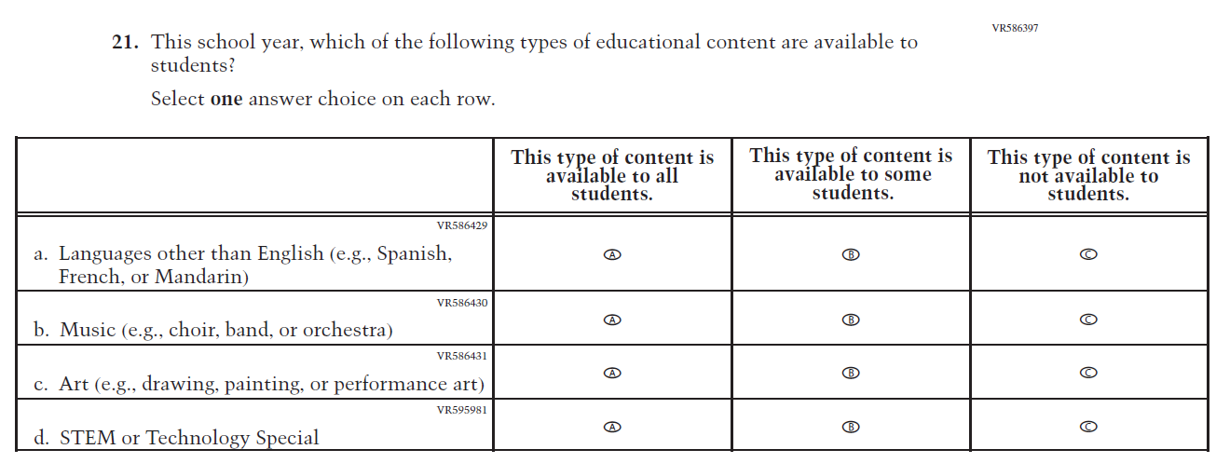

Appendix J3-3: Summary of Changes Operational Grade 8 (Core)
2026 Operational Grade 8 Core School
Previous Item | 2026 Item | D/A/R+ | Rationale
(2024) | Issue: School Climate | R | For 2026, we have aligned Inline Directions in Teacher and School Items with the Directions currently used in Student Items.
(2024) | Issue: School Climate | R | For 2026, we have aligned Inline Directions in Teacher and School Items with the Directions currently used in Student Items.

2026 Operational Grade 8 Core School
Previous Item | 2026 Item | D/A/R+ | Rationale
(2024) | N/A | D | This Item was dropped due to low response frequencies and low relevance to the larger NAEP sample.
(2024) | Issue: School Climate | R | This Item was revised to update “limited-English proficient” to “English learners.”
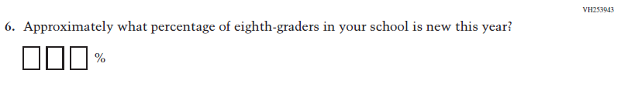  (2024) | 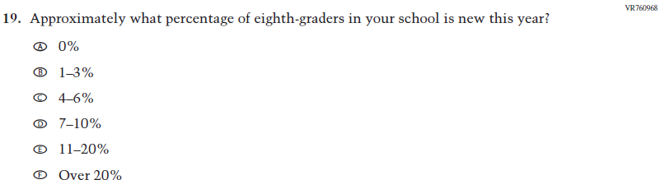  Issue: School Climate | R | This Item was revised to use response options for improved data collection and reporting of student mobility.

2026 Operational Grade 8 Core School
Previous Item | 2026 Item | D/A/R+ | Rationale
(2024) | Issue: School Climate | R | For 2026, we have aligned Inline Directions in Teacher and School Items with the Directions currently used in Student Items. Also, in SubItem c. “English-as-a-second-language” was updated to “English as an Additional Language”.
(2024) | N/A | D | Learning Recovery Items were dropped from the 2026 NAEP Assessment.

2026 Operational Grade 8 Core School
Previous Item | 2026 Item | D/A/R+ | Rationale
(2024) | N/A | D | Learning Recovery Items were dropped from the 2026 NAEP Assessment.
(2024) | N/A | D | Learning Recovery Items were dropped from the 2026 NAEP Assessment.

2026 Operational Grade 8 Core School
Previous Item | 2026 Item | D/A/R+ | Rationale
(2024) | N/A | D | Learning Recovery Items were dropped from the 2026 NAEP Assessment.
(2024) | N/A | D | This Item was dropped due to lack of insight provided by the question and to prioritize new content.

2026 Operational Grade 8 Core School
Previous Item | 2026 Item | D/A/R+ | Rationale
N/A  (2024) | Issue: School Climate | A | This Item was previously administered in the 2022 NAEP Assessment and added in 2026 to measure parental involvement in the school.
(2024) | 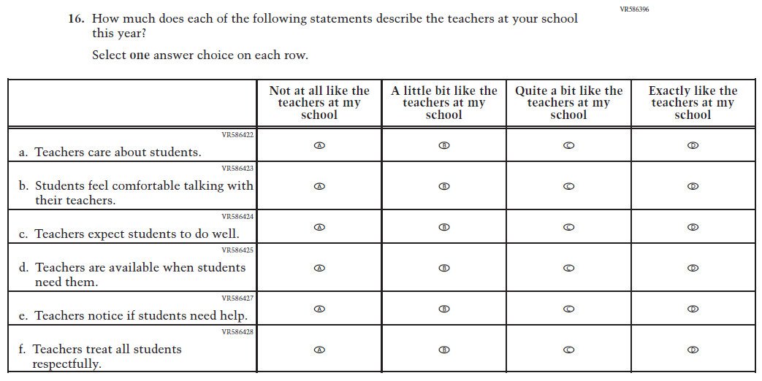  Issue: Learning Environment | R | For 2026, we have aligned Inline Directions in Teacher and School Items with the Directions currently used in Student Items. Also, SubItem e. from 2024 was dropped for 2026.
(2024) | N/A | D | This Item was dropped due to lack of insight provided by the question and to prioritize new content.
2026 Operational Grade 8 Core School
Previous Item | 2026 Item | D/A/R+ | Rationale
(2024) | N/A | D | This and the related Items were dropped in favor of a more current and concise format for questions on Technology Use.
(2024) | N/A | D | This and the related Items were dropped in favor of a more current and concise format for questions on Technology Use.
(2024) | N/A | D | This and the related Items were dropped in favor of a more current and concise format for questions on Technology Use.

2026 Operational Grade 8 Core School
Previous Item | 2026 Item | D/A/R+ | Rationale
(2024) | N/A | D | This and the related Items were dropped in favor of a more current and concise format for questions on Technology Use.
(2024) | N/A | D | This and the related Items were dropped in favor of a more current and concise format for questions on Technology Use.
(2024) | N/A | D | This and the related Items were dropped in favor of a more current and concise format for questions on Technology Use.

2026 Operational Grade 8 Core School
Previous Item | 2026 Item | D/A/R+ | Rationale
(2024) | N/A | D | This and the related Items were dropped in favor of a more current and concise format for questions on Technology Use.
(2024) | N/A | D | This and the related Items were dropped in favor of a more current and concise format for questions on Technology Use.
(2024) | N/A | D | This and the related Items were dropped in favor of a more current and concise format for questions on Technology Use.

2026 Operational Grade 8 Core School
Previous Item | 2026 Item | D/A/R+ | Rationale
N/A  (2024) | Issue: Technology Use | A | This Item was developed to measure technology use and student access to digital technology for learning.
N/A  (2024) | Issue: Technology Use | A | This Item was developed to measure technology use and student access to digital technology for learning.
N/A  (2024) | 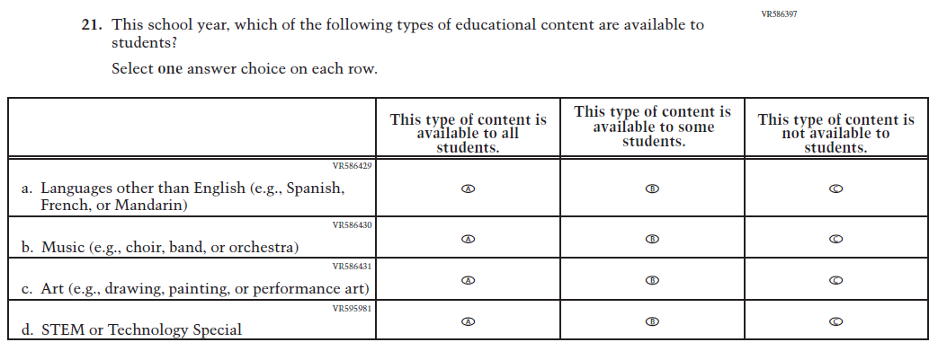  Issue: School Climate | A | This Item was developed to measure students’ learning environments and access to educational content focused on languages, music, art, and STEM.

Appendix J3-4: Operational Grade 8 (Core)
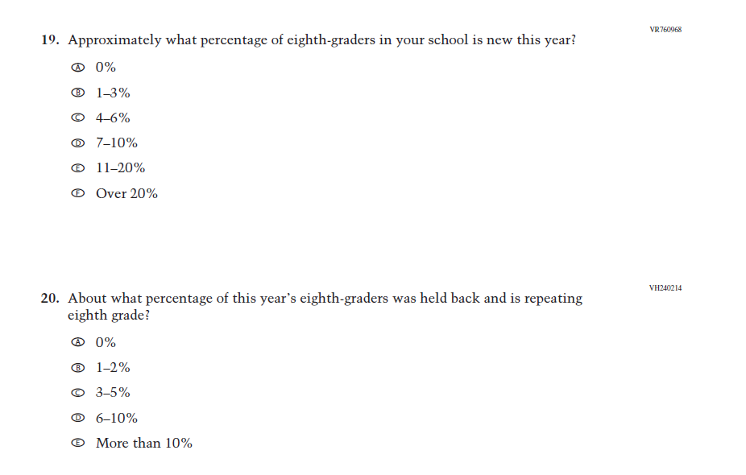

Appendix J3-5: Summary of Changes Operational Grade 4 (Mathematics)
2026 Operational Grade 4 Mathematics School
Previous Item | 2026 Item | D/A/R+ | Rationale
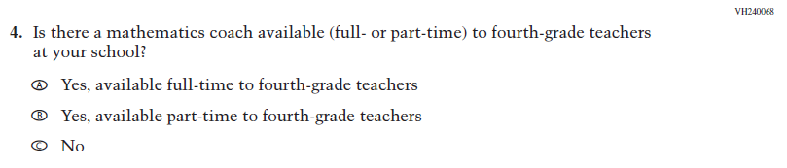  (2024) | 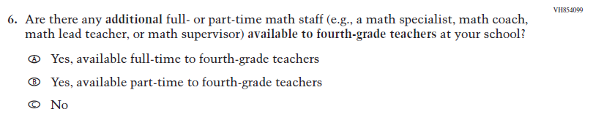  Issue: Teacher Factors | R | This item was revised for clarity.
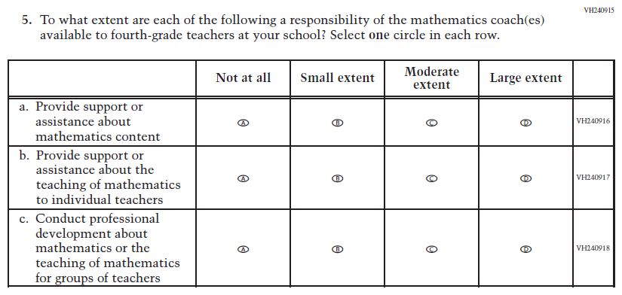  (2024) | 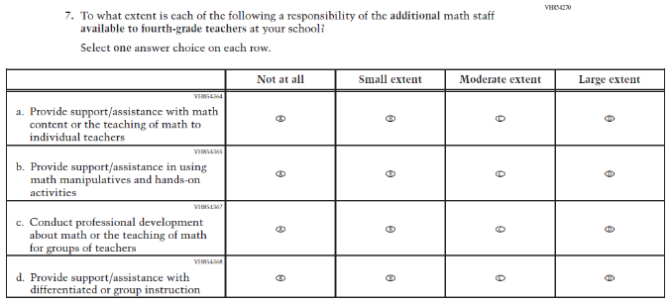  Issue: Instructional Organization and Strategies | R | For 2026, we have aligned Inline Directions in Teacher and School Items with the Directions currently used in Student Items. Subitem d was added to measure content aligned with the new Mathematics framework.

2026 Operational Grade 4 Mathematics School
Previous Item | 2026 Item | D/A/R+ | Rationale
N/A  (2024) | 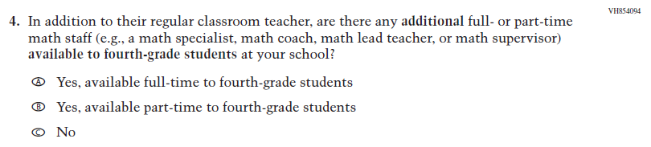  Issue: Mathematical Content and Practices | A | This item was developed to measure content aligned with the new Mathematics framework.
N/A  (2024) | 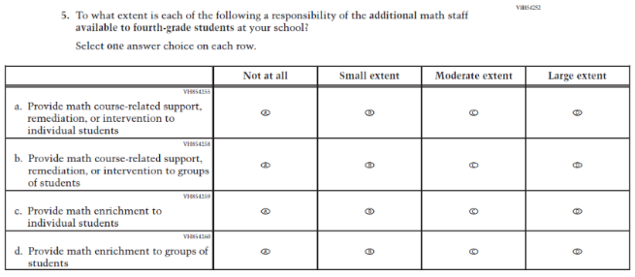  Issue: Instructional Organization and Strategies | A | This item was developed to measure content aligned with the new Mathematics framework.
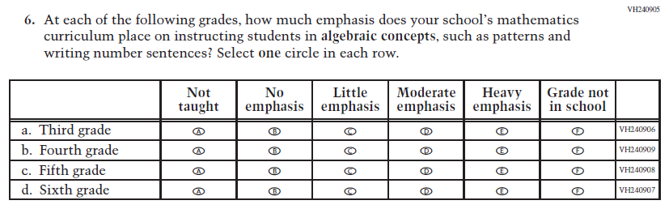  (2024) | 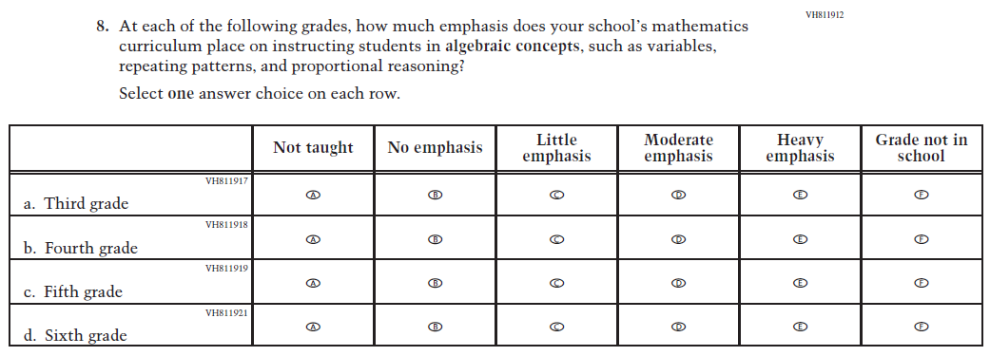  Issue: Mathematical Content and Practices | R | For 2026, we have aligned Inline Directions in Teacher and School Items with the Directions currently used in Student Items. This item was revised for clarity.

2026 Operational Grade 4 Mathematics School
Previous Item | 2026 Item | D/A/R+ | Rationale
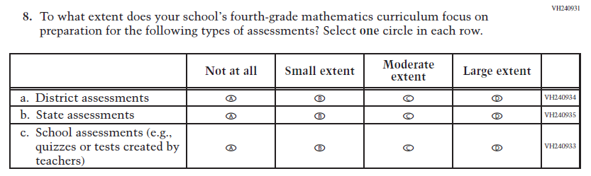  (2024) | 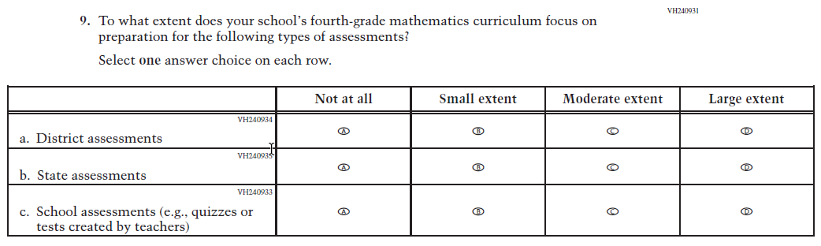  Issue: N/A | R | For 2026, we have aligned Inline Directions in Teacher and School Items with the Directions currently used in Student Items.
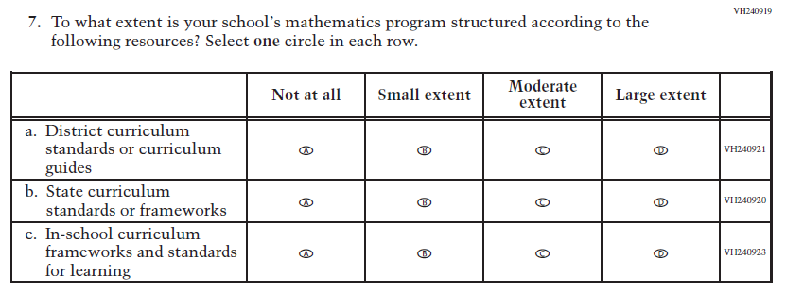  (2024) | 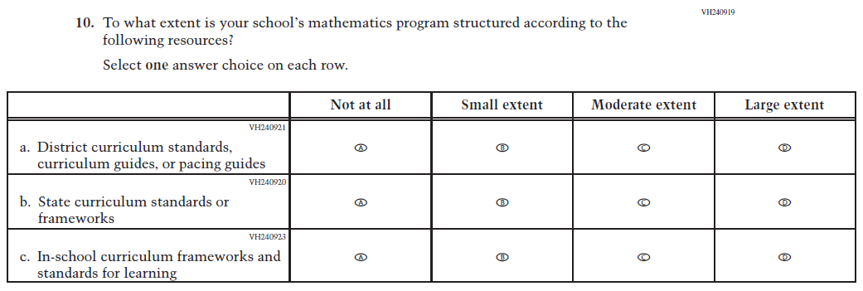  Issue: N/A | R | For 2026, we have aligned Inline Directions in Teacher and School Items with the Directions currently used in Student Items. Subitem a was revised for clarity.

2026 Operational Grade 4 Mathematics School
Previous Item | 2026 Item | D/A/R+ | Rationale
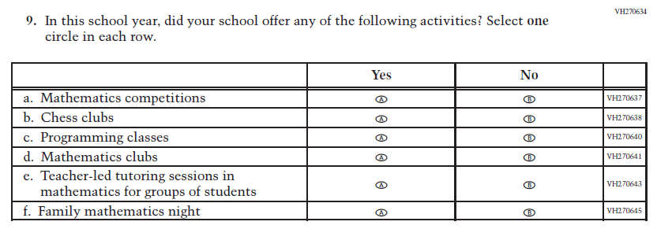  (2024) | 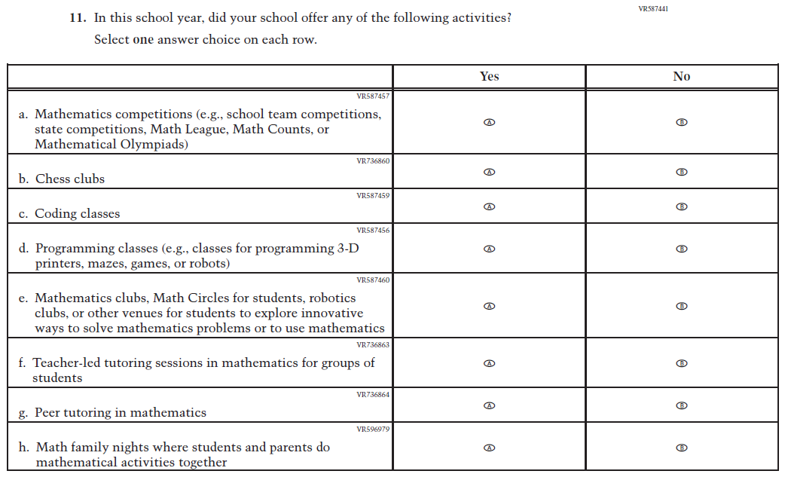  Issue: N/A | R | For 2026, we have aligned Inline Directions in Teacher and School Items with the Directions currently used in Student Items. Subitems a, c, and d were revised for clarity, and new subitems c and g were added to capture activities related with mathematics offered by schools.

Appendix J3-6: Operational Grade 4 (Mathematics)
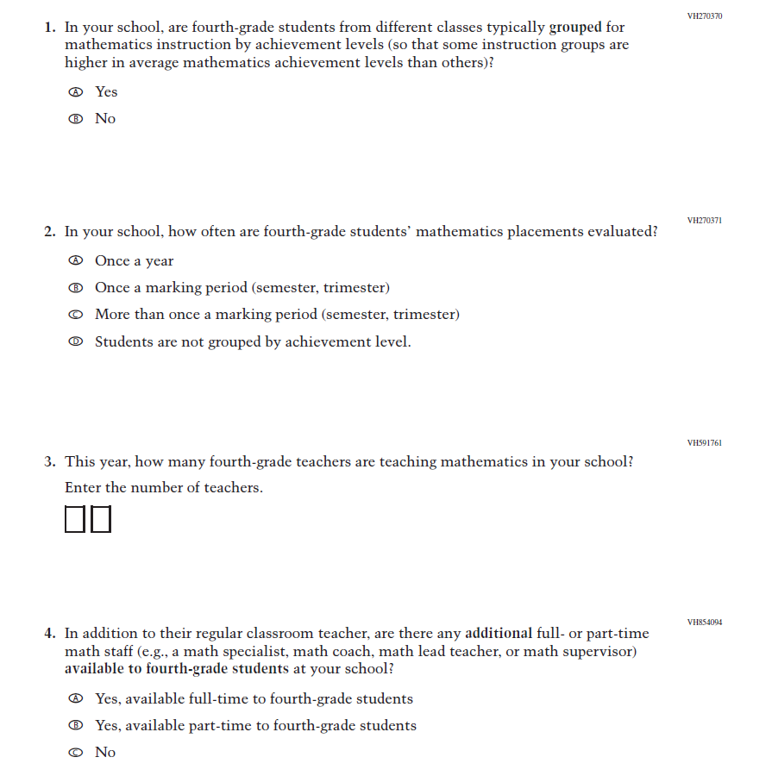
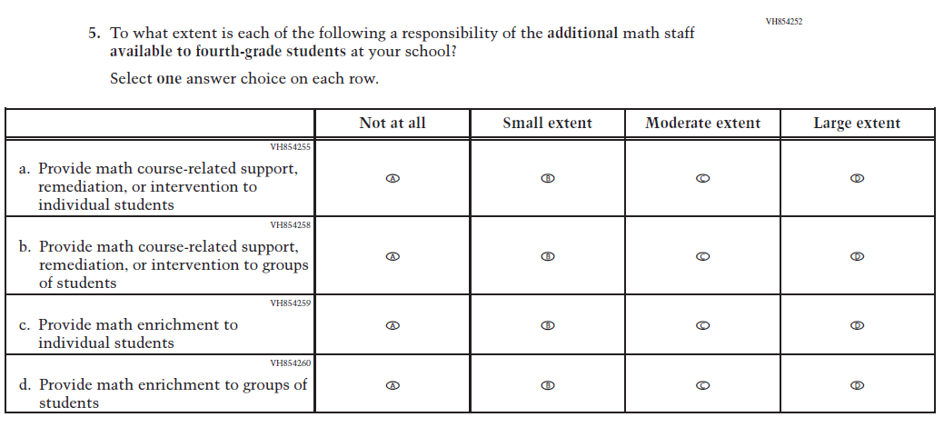
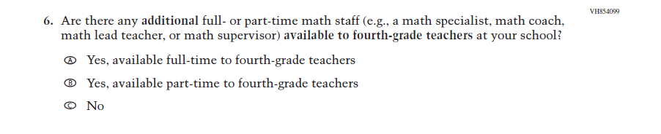
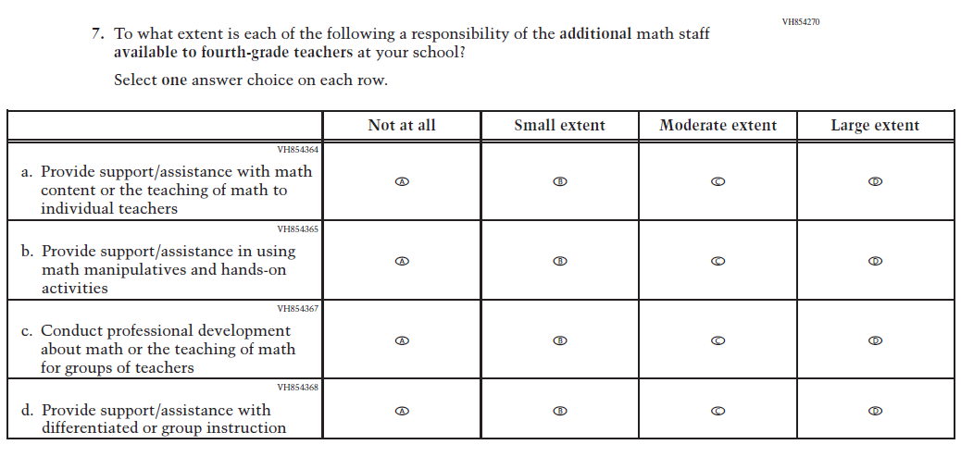
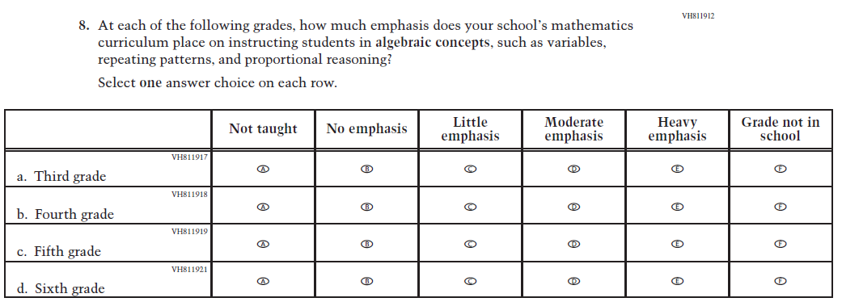
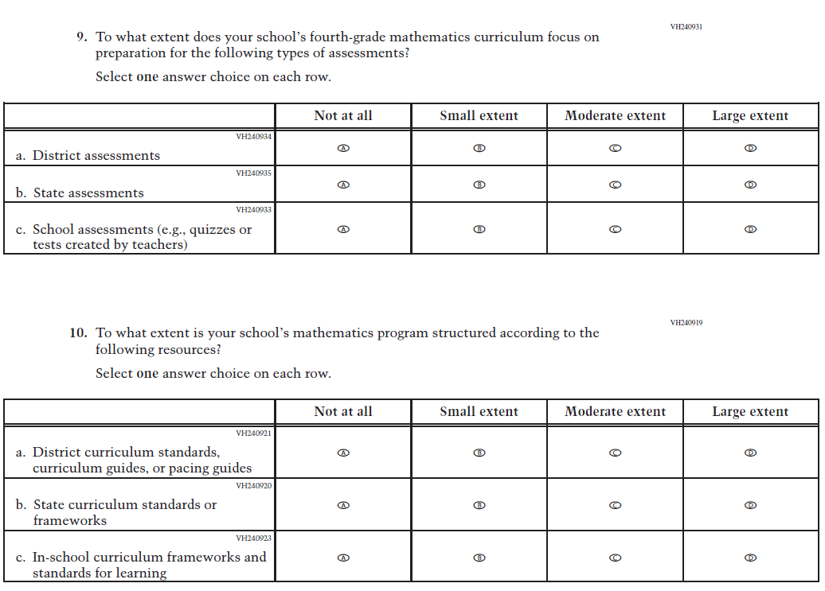
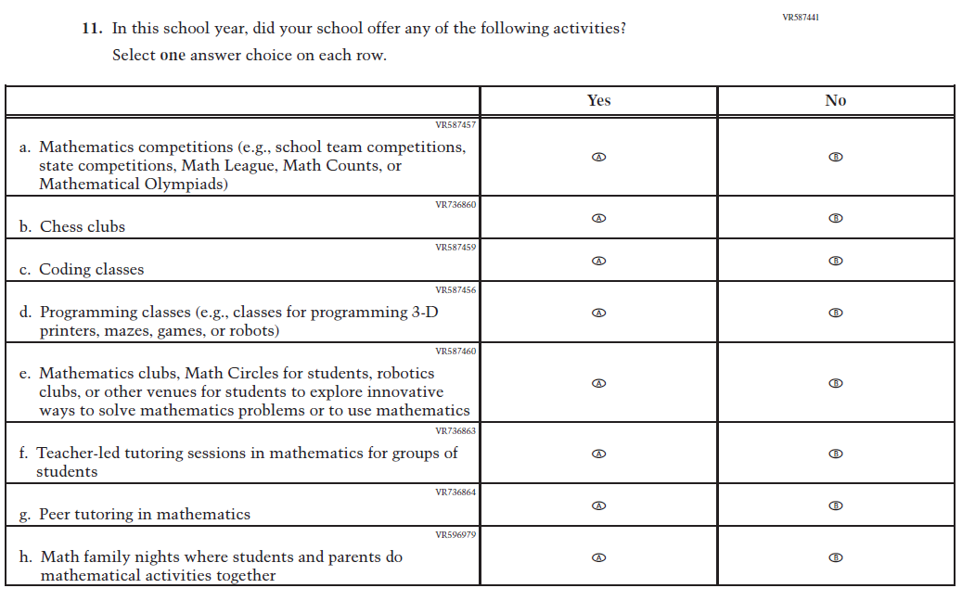

Appendix J3-7: Summary of Changes Operational Grade 8 (Mathematics)
2026 Operational Grade 8 Mathematics School
Previous Item | 2026 Item | D/A/R+ | Rationale
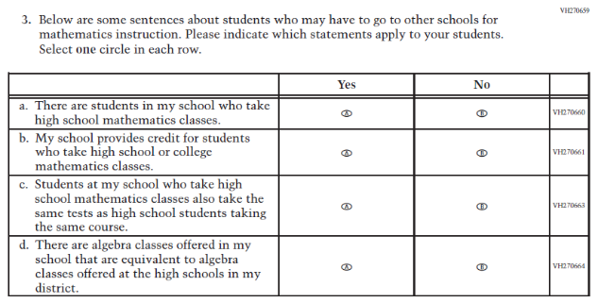  (2024) | 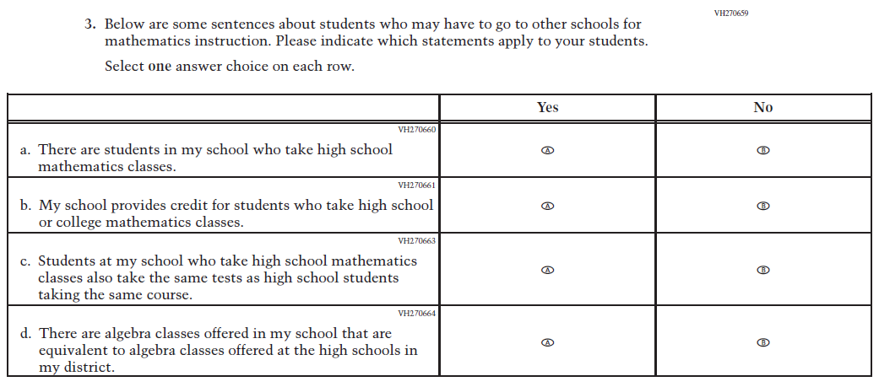  Issue: N/A | R | For 2026, we have aligned Inline Directions in Teacher and School Items with the Directions currently used in Student Items.
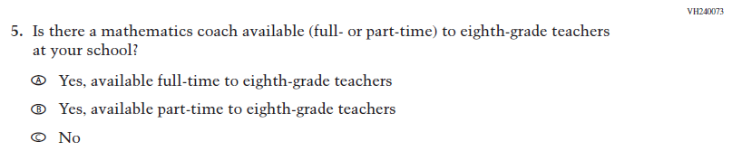  (2024) | 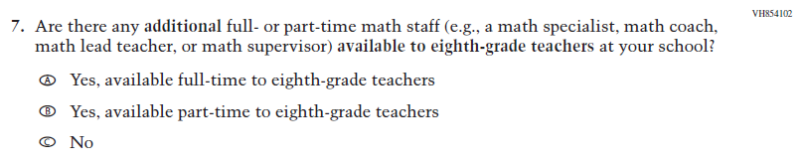  Issue: Teacher Factors | R | This item was revised for clarity.
N/A  (2024) | 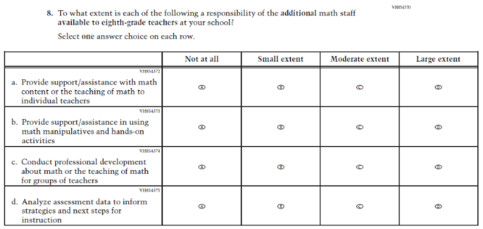  Issue: Teacher Factors | A | This item was developed to measure content aligned with the new Mathematics framework.

2026 Operational Grade 8 Mathematics School
Previous Item | 2026 Item | D/A/R+ | Rationale
N/A  (2024) | 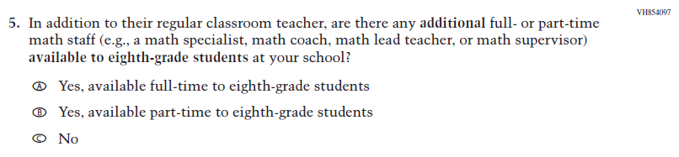  Issue: Mathematical Content and Practices | A | This item was developed to measure content aligned with the new Mathematics framework.
N/A  (2024) | 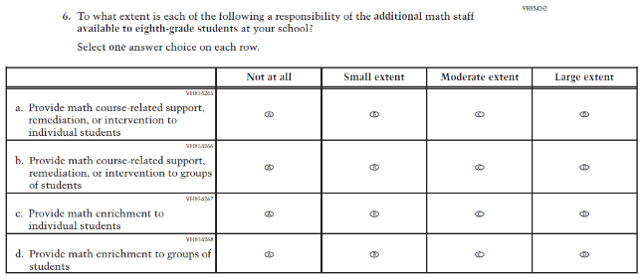  Issue: Instructional Organization and Strategies | A | This item was developed to measure content aligned with the new Mathematics framework.
N/A  (2024) | 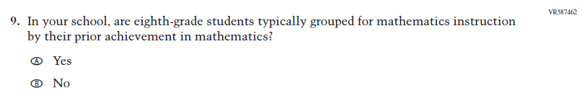  Issue: Instructional Organization and Strategies | A | This item was developed to measure content aligned with the new Mathematics framework.

2026 Operational Grade 8 Mathematics School
Previous Item | 2026 Item | D/A/R+ | Rationale
N/A  (2024) | 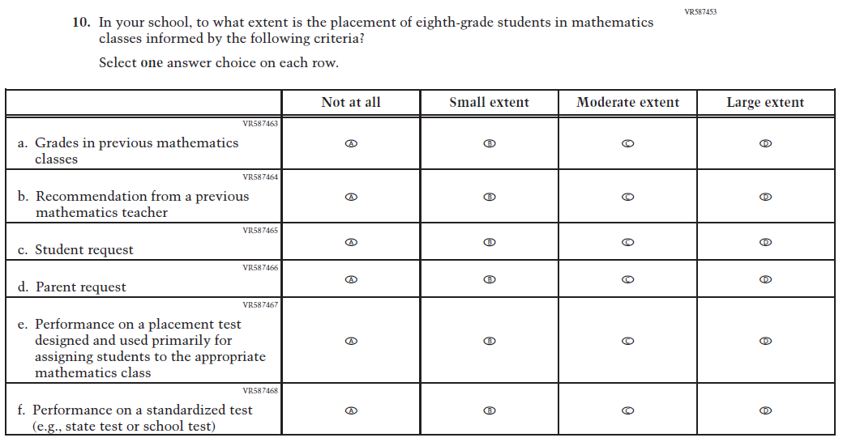  Issue: Instructional Organization and Strategies | A | This item was developed to measure content aligned with the new Mathematics framework.
N/A  (2024) | 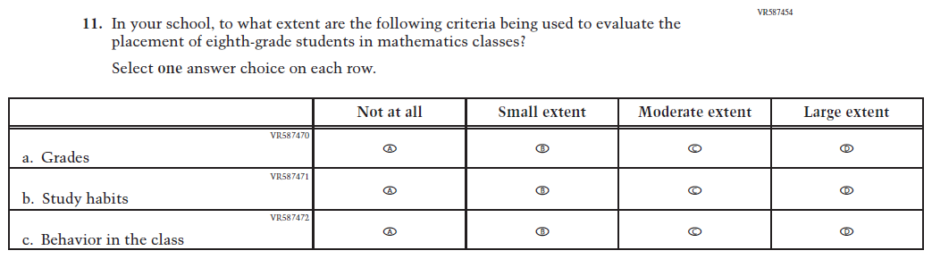  Issue: Instructional Organization and Strategies | A | This item was developed to measure content aligned with the new Mathematics framework.

2026 Operational Grade 8 Mathematics School
Previous Item | 2026 Item | D/A/R+ | Rationale
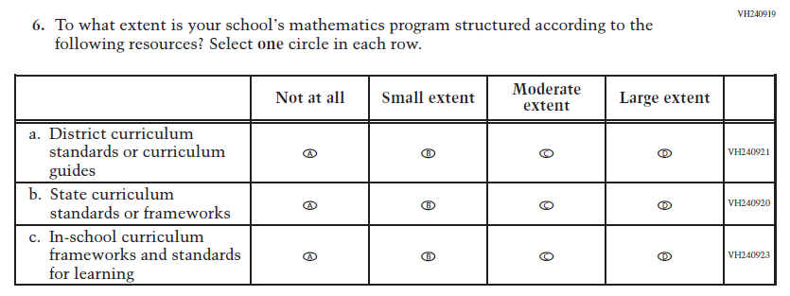  (2024) | 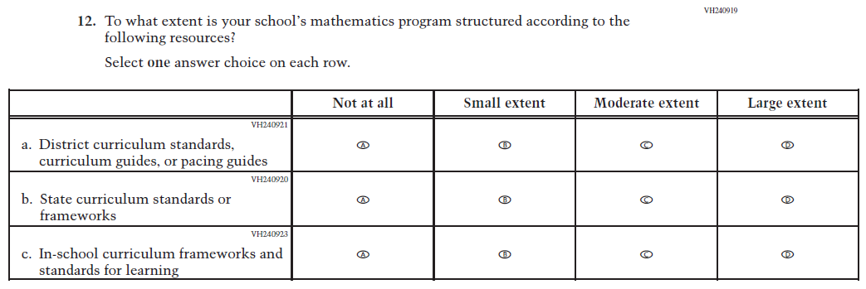  Issue: N/A | R | For 2026, we have aligned Inline Directions in Teacher and School Items with the Directions currently used in Student Items. Subitem a was revised for clarity.
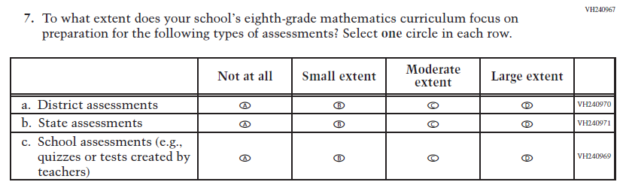  (2024) | 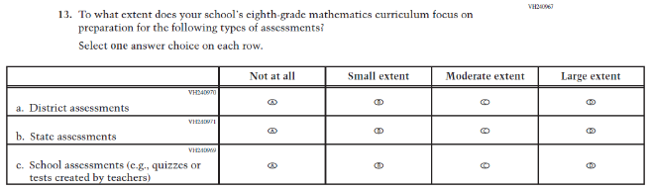  Issue: N/A | R | For 2026, we have aligned Inline Directions in Teacher and School Items with the Directions currently used in Student Items.

2026 Operational Grade 8 Mathematics School
Previous Item | 2026 Item | D/A/R+ | Rationale
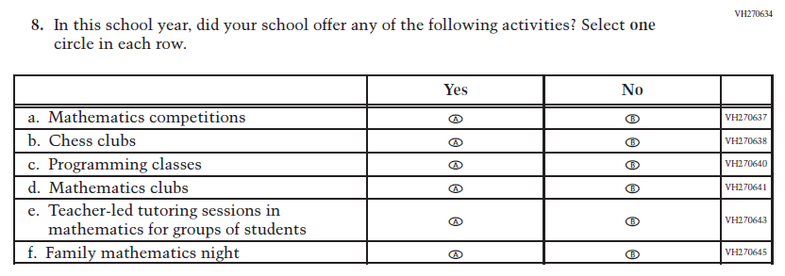  (2024) | 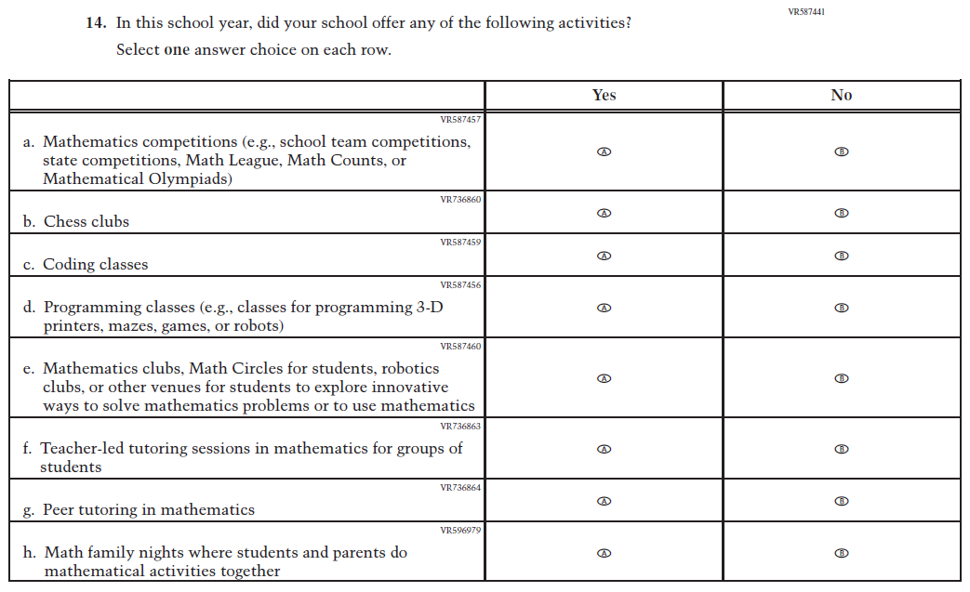  Issue: N/A | R | For 2026, we have aligned Inline Directions in Teacher and School Items with the Directions currently used in Student Items. Subitems a, c, and d were revised for clarity, new Subitems c and g were added to capture activities related to mathematics offered by schools.

Appendix J3-8: Operational Grade 8 (Mathematics)
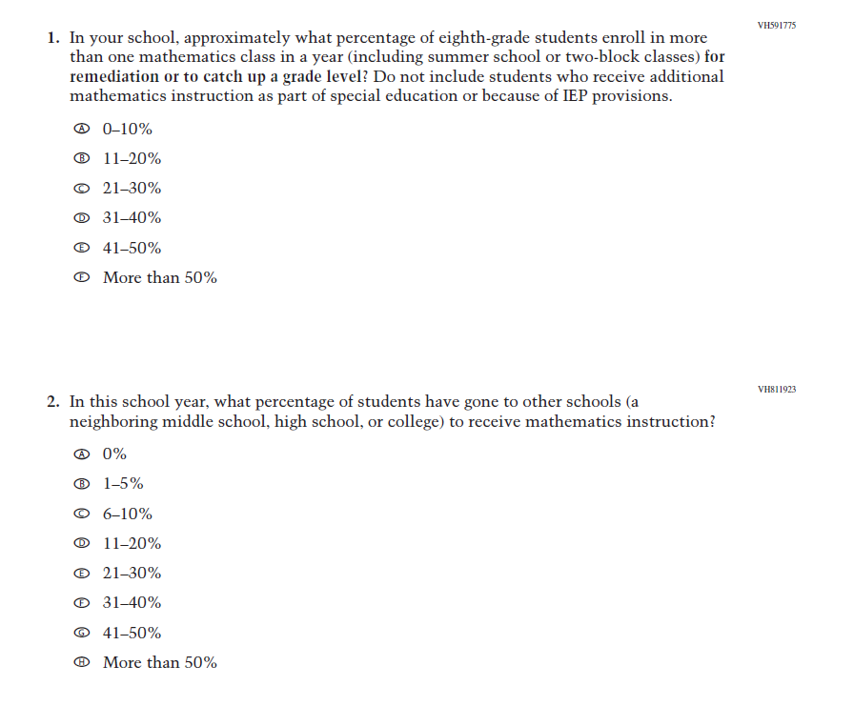
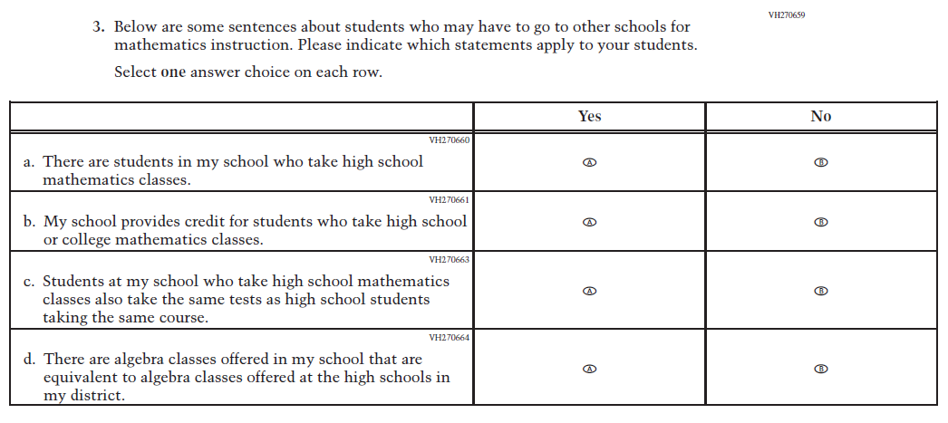
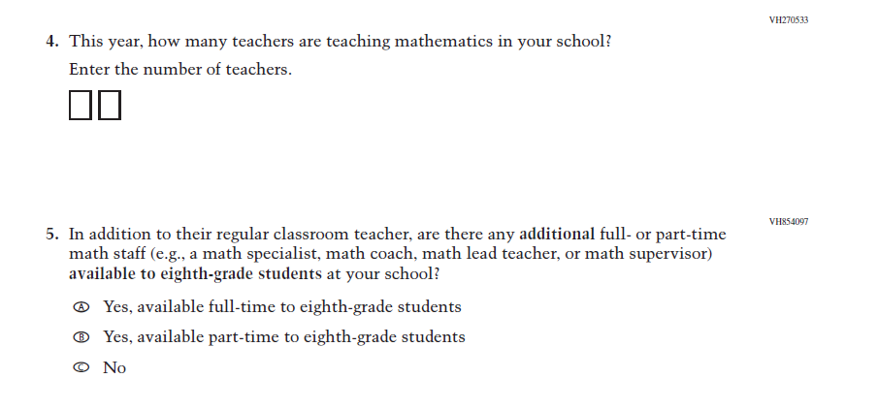
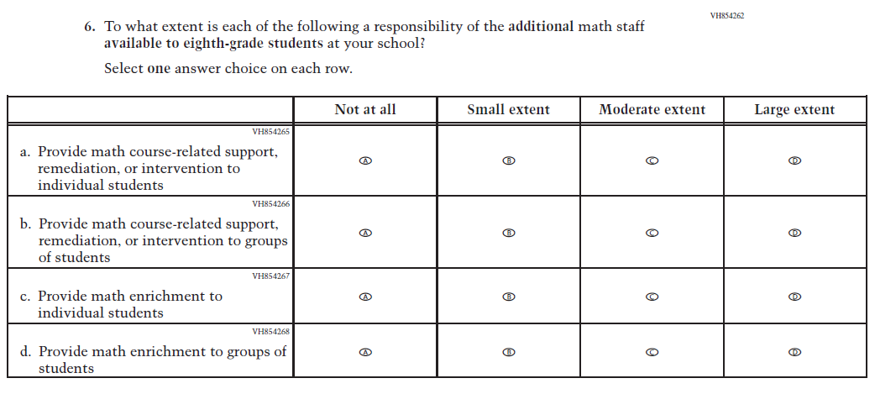
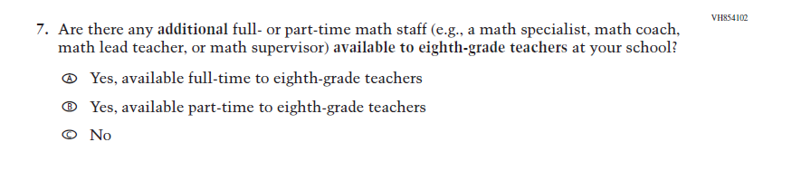
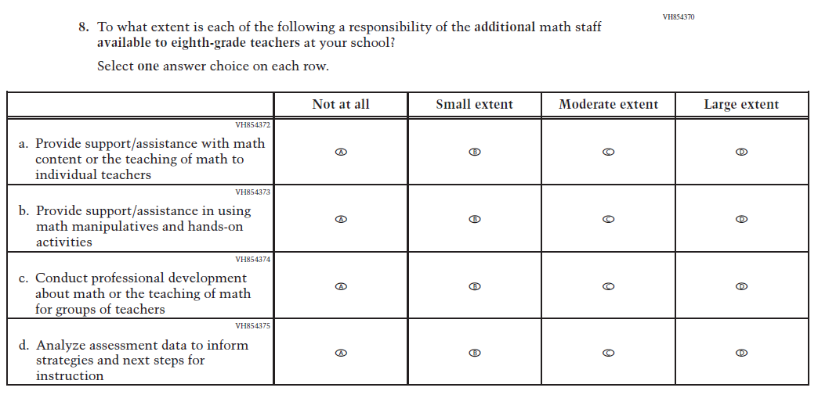
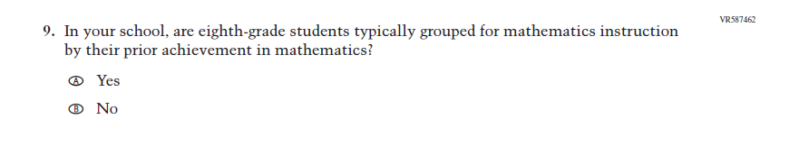
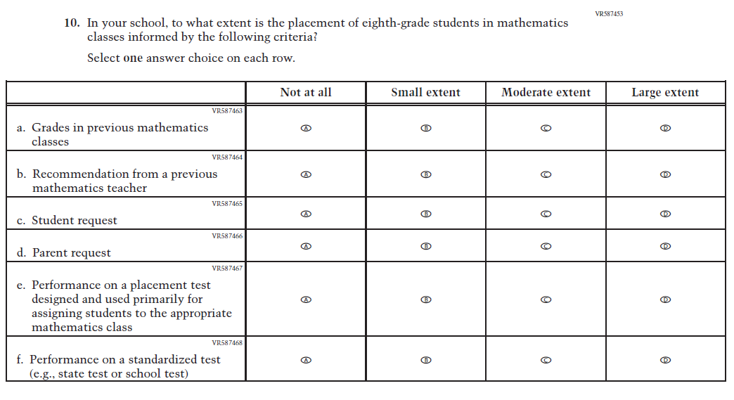
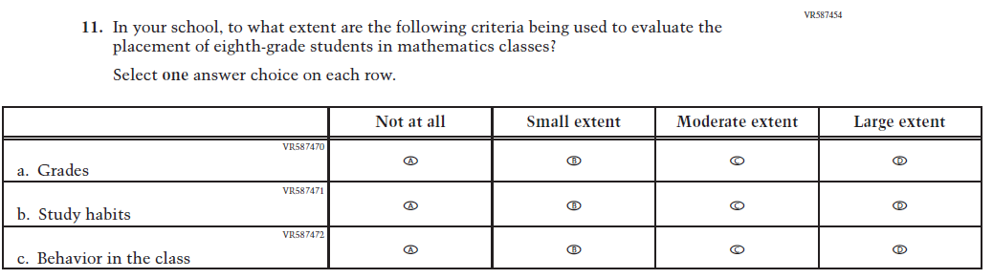
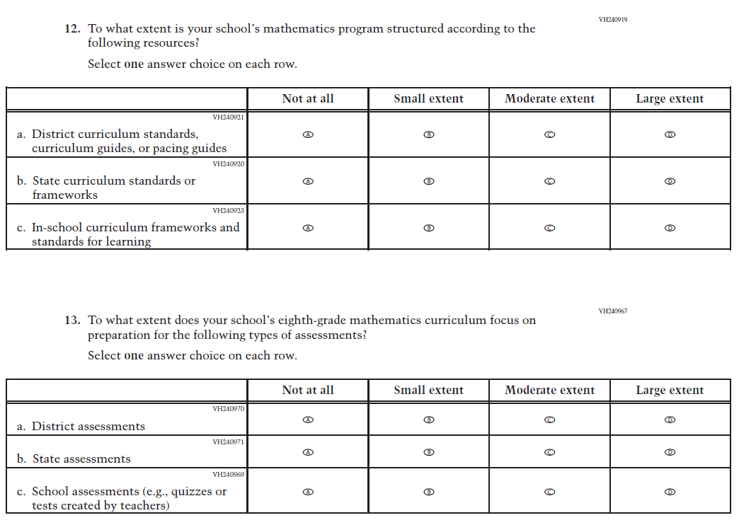
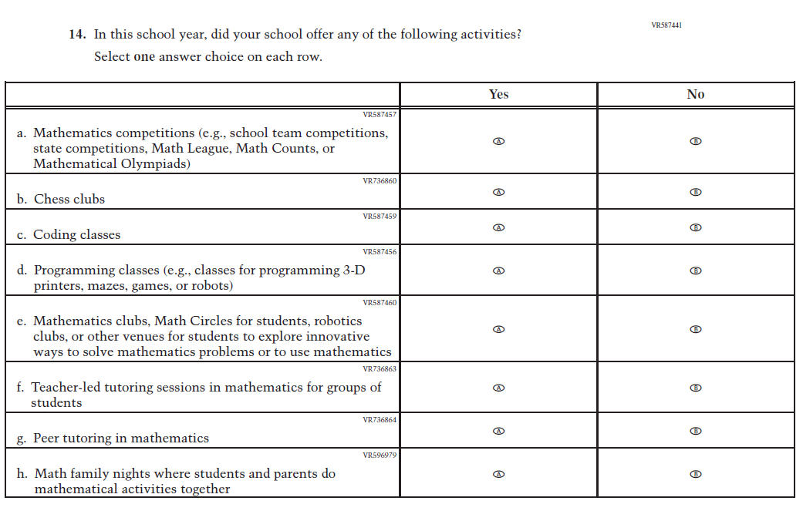

Appendix J3-9: Summary of Changes Operational Grade 4 (Reading)
2026 Operational Grade 4 Reading School
Previous Item | 2026 Item | D/A/R+ | Rationale
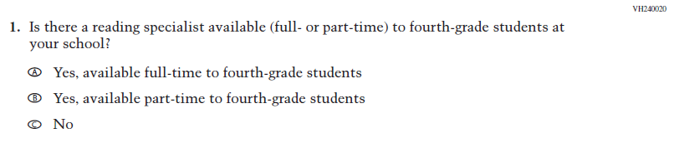  (2024) | 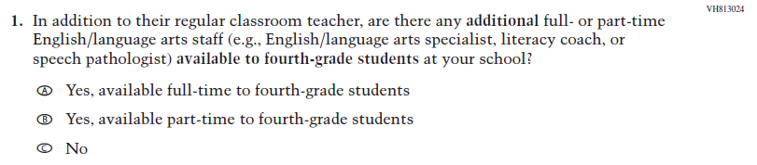  Issue: Teacher, Instructional, and Classroom Supports | R | This item was revised for clarity.
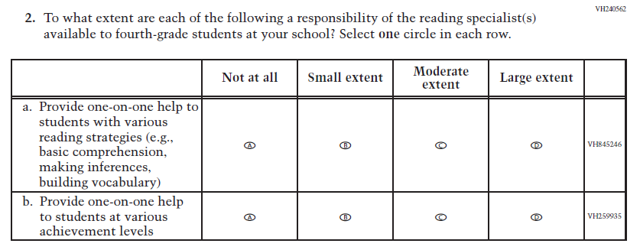  (2024) | 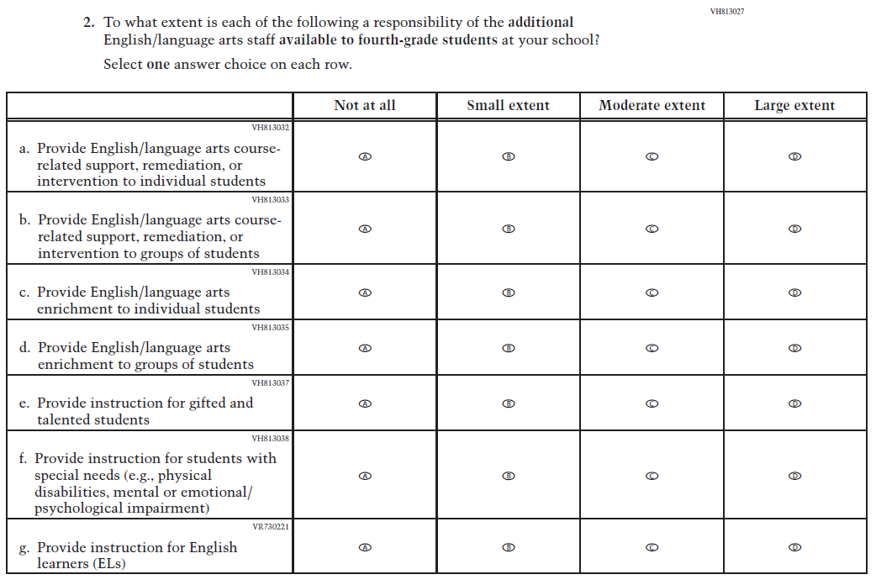  Issue: Teacher, Instructional, and Classroom Supports | R | For 2026, we have aligned Inline Directions in Teacher and School Items with the Directions currently used in Student Items. This item was also revised for clarity, and new subitems were developed to measure content in the new Reading framework.

2026 Operational Grade 4 Reading School
Previous Item | 2026 Item | D/A/R+ | Rationale
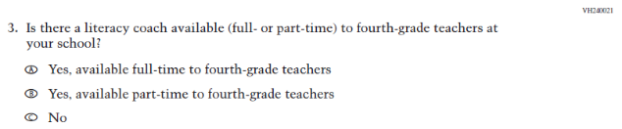  (2024) | 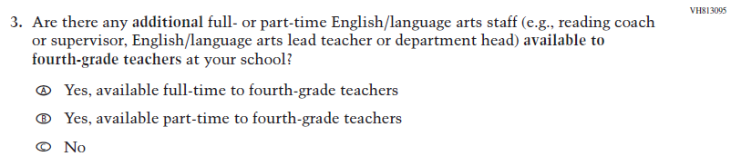  Issue: Teacher, Instructional, and Classroom Supports | R | This item was revised for clarity.
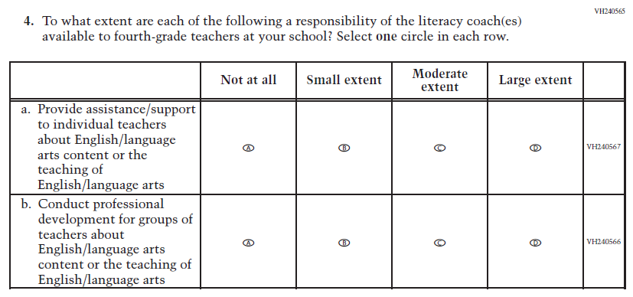  (2024) | 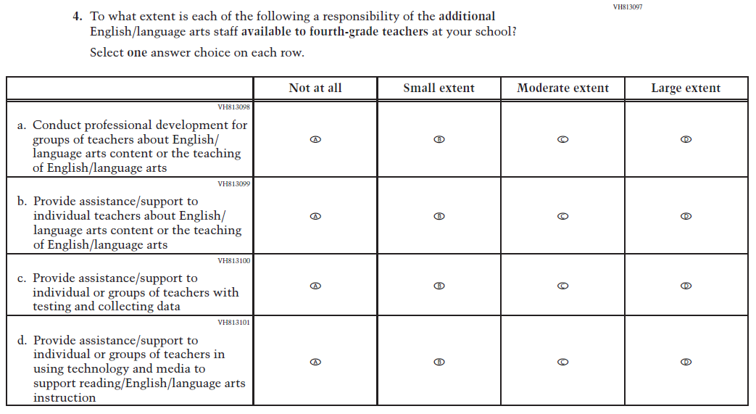  Issue: Teacher, Instructional, and Classroom Supports | R | For 2026, we have aligned Inline Directions in Teacher and School Items with the Directions currently used in Student Items. Subitems c and d were developed to measure content in the new Reading framework.

2026 Operational Grade 4 Reading School
Previous Item | 2026 Item | D/A/R+ | Rationale
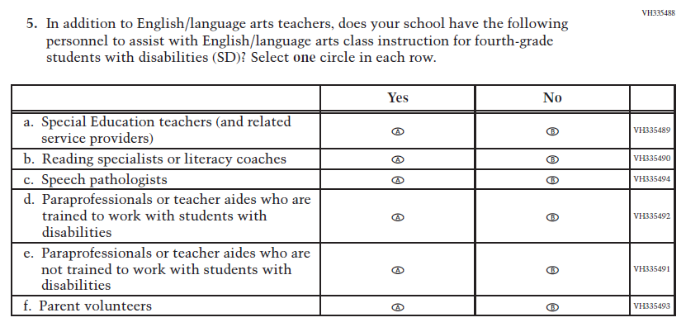  (2024) | 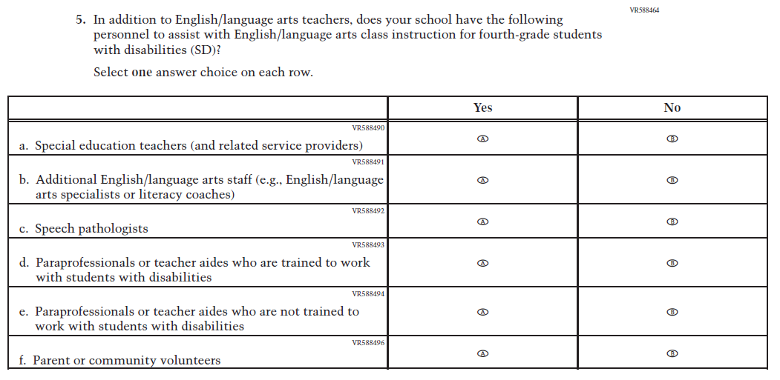  Issue: Teacher, Instructional, and Classroom Supports | R | For 2026, we have aligned Inline Directions in Teacher and School Items with the Directions currently used in Student Items. Subitems b and f were revised for clarity.
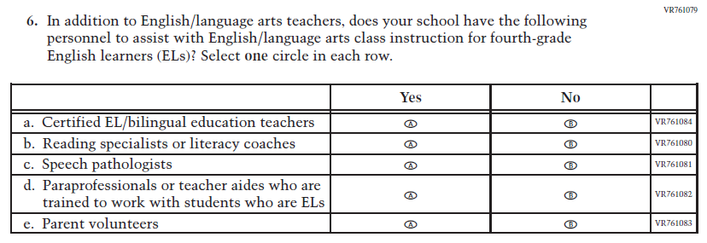  (2024) | 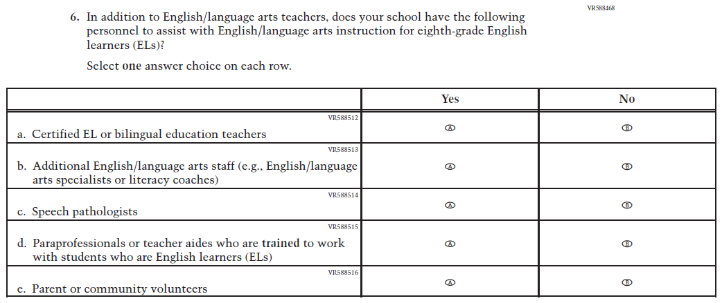  Issue: Teacher, Instructional, and Classroom Supports | R | For 2026, we have aligned Inline Directions in Teacher and School Items with the Directions currently used in Student Items. Subitems a, b, d, and e were revised for clarity.

2026 Operational Grade 4 Reading School
Previous Item | 2026 Item | D/A/R+ | Rationale
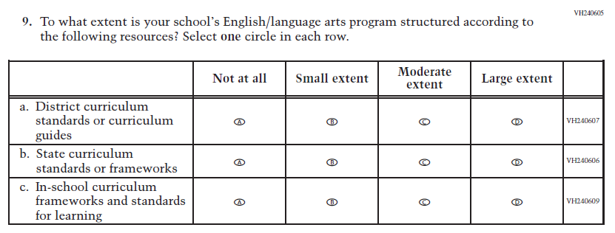  (2024) | 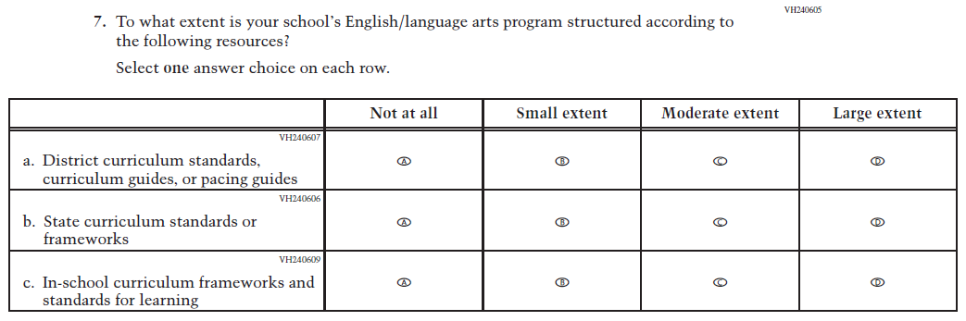  Issue: Teacher, Instructional, and Classroom Supports | R | For 2026, we have aligned Inline Directions in Teacher and School Items with the Directions currently used in Student Items. Subitem a was revised for clarity.
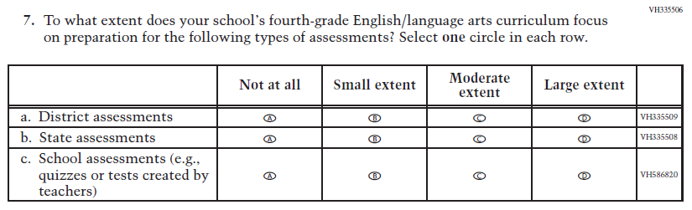  (2024) | 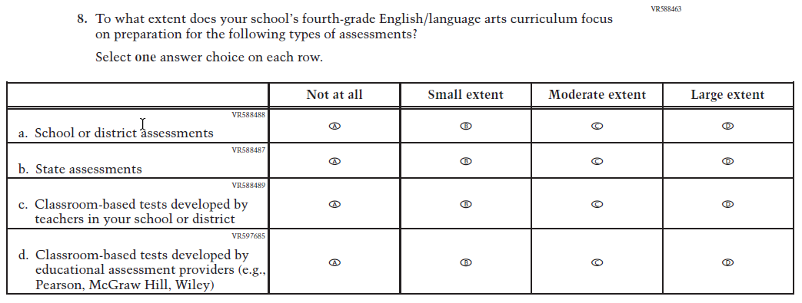  Issue: Teacher, Instructional, and Classroom Supports | R | For 2026, we have aligned Inline Directions in Teacher and School Items with the Directions currently used in Student Items. Subitem d was developed to measure content in the new Reading framework.

2026 Operational Grade 4 Reading School
Previous Item | 2026 Item | D/A/R+ | Rationale
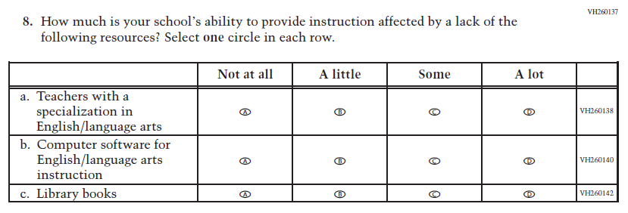  (2024) | 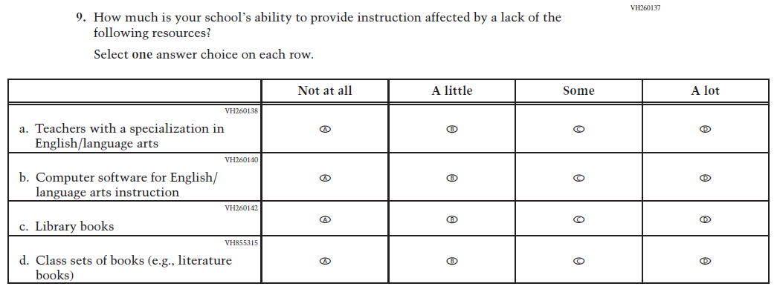  Issue: Teacher, Instructional, and Classroom Supports | R | For 2026, we have aligned Inline Directions in Teacher and School Items with the Directions currently used in Student Items. Subitem d was developed to measure content in the new Reading framework.
N/A  (2024) | 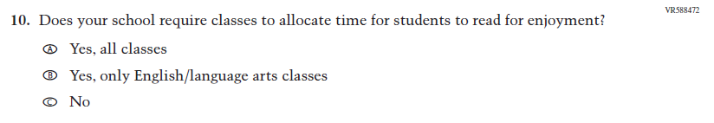  Issue: Engagement and Motivation | A | This item was developed to measure content in the new Reading framework.

Appendix J3-10: Operational Grade 4 (Reading)
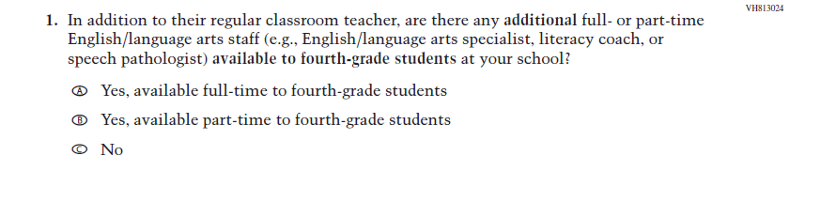
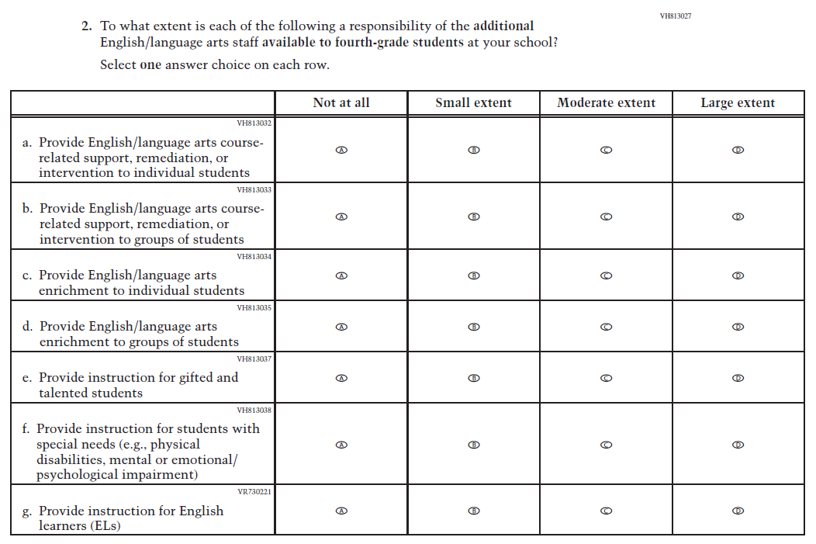
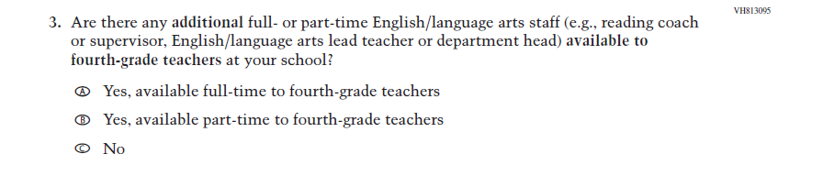
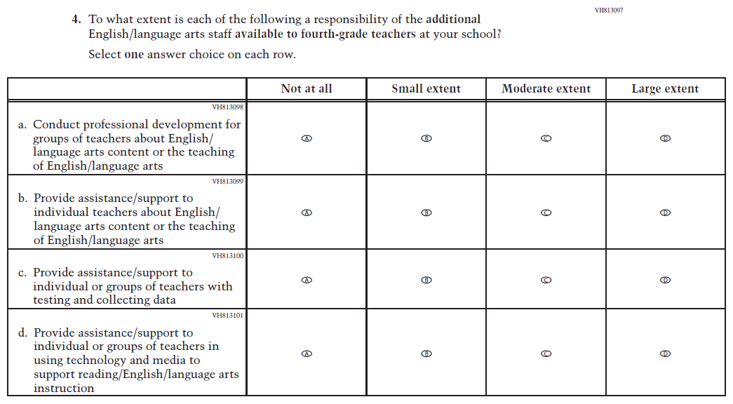
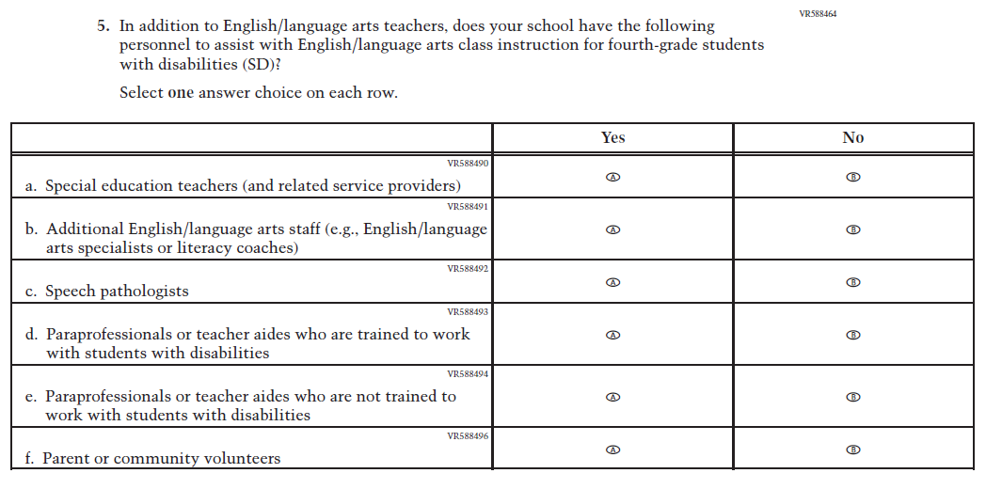
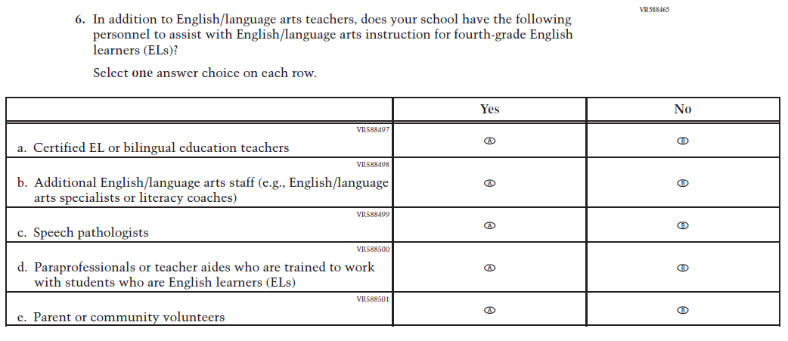
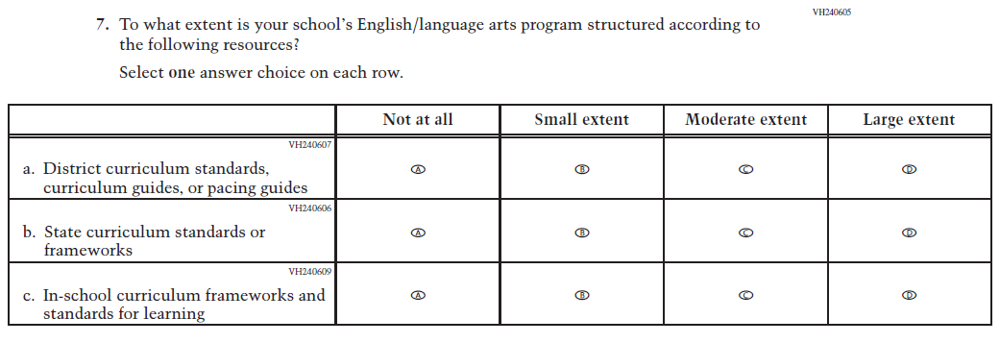
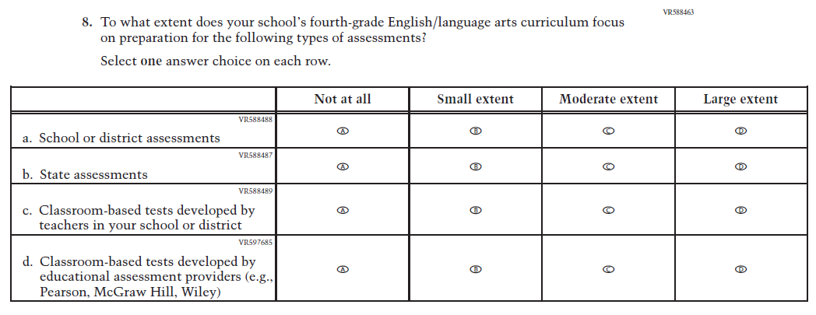
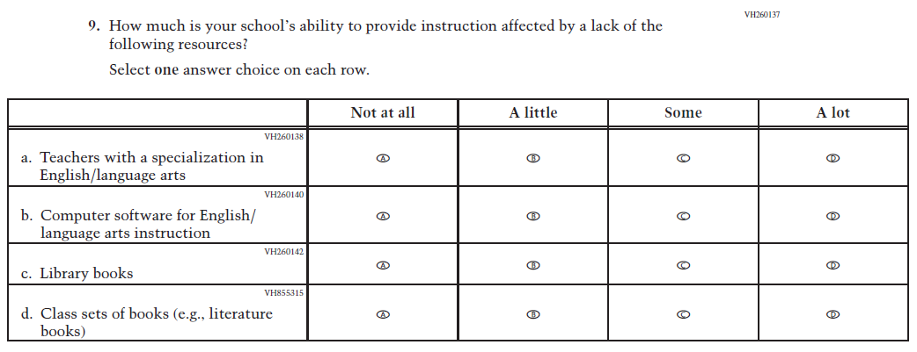
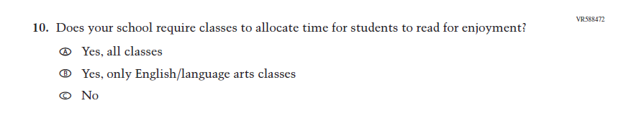

Appendix J3-11: Summary of Changes Operational Grade 8 (Reading)
2026 Operational Grade 8 Reading School
Previous Item | 2026 Item | D/A/R+ | Rationale
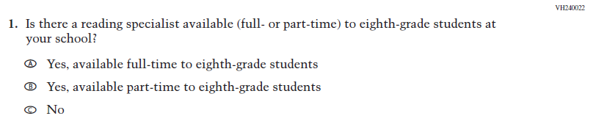  (2024) | 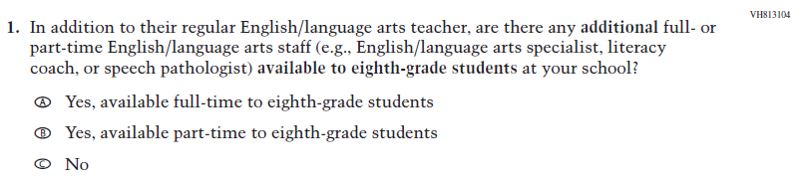  Issue: Teacher, Instructional, and Classroom Supports | R | This Item was revised for clarity.
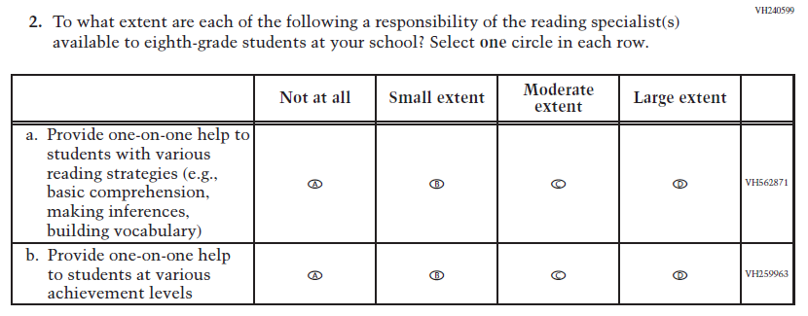  (2024) | 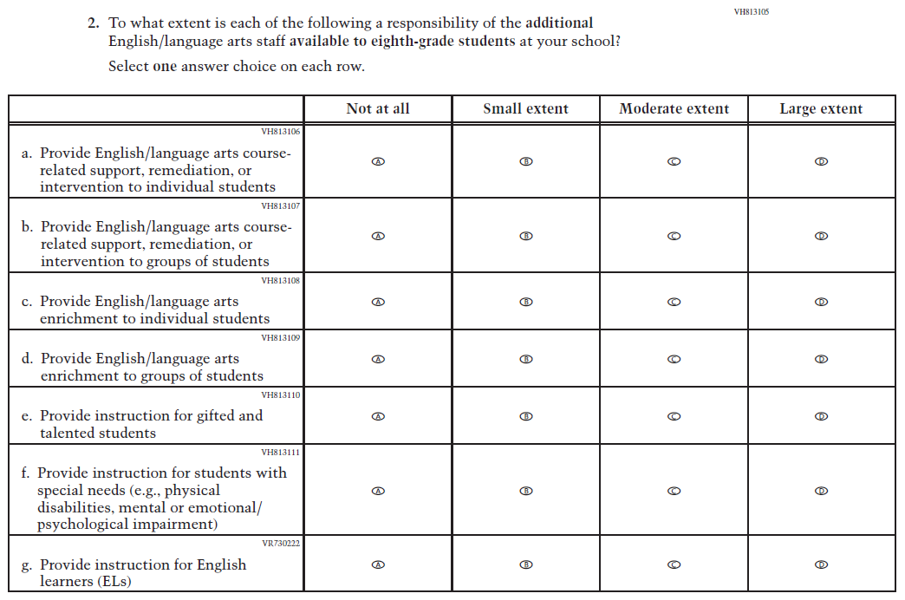  Issue: Teacher, Instructional, and Classroom Supports | R | For 2026, we have aligned Inline Directions in Teacher and School Items with the Directions currently used in Student Items. This Item was revised for clarity, and new subitems were developed to measure content in the new Reading framework.

2026 Operational Grade 8 Reading School
Previous Item | 2026 Item | D/A/R+ | Rationale
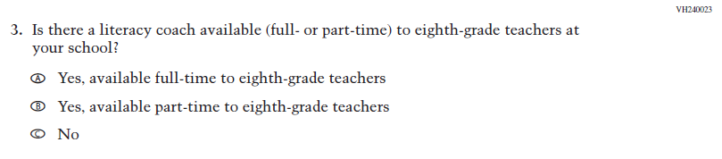  (2024) | 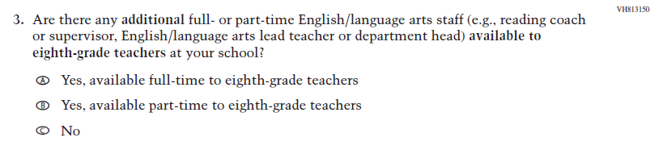  Issue: Teacher, Instructional, and Classroom Supports | R | This item was revised for clarity.
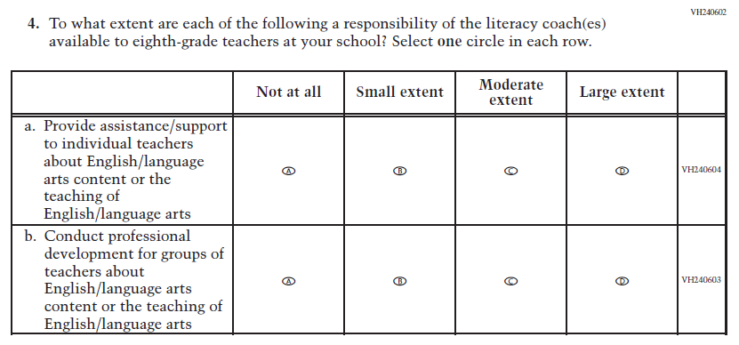  (2024) | 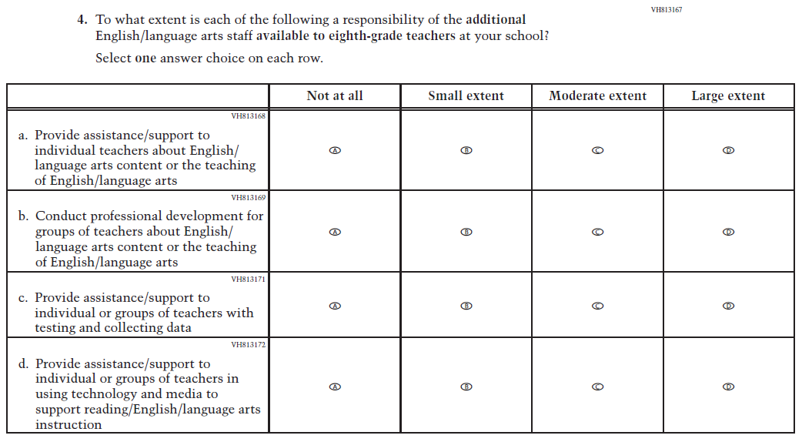  Issue: Teacher, Instructional, and Classroom Supports | R | For 2026, we have aligned Inline Directions in Teacher and School Items with the Directions currently used in Student Items. Subitems c and d were revised for clarity.

2026 Operational Grade 8 Reading School
Previous Item | 2026 Item | D/A/R+ | Rationale
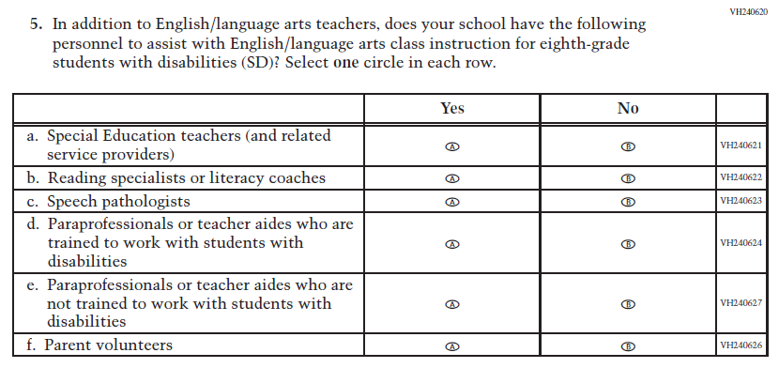  (2024) | 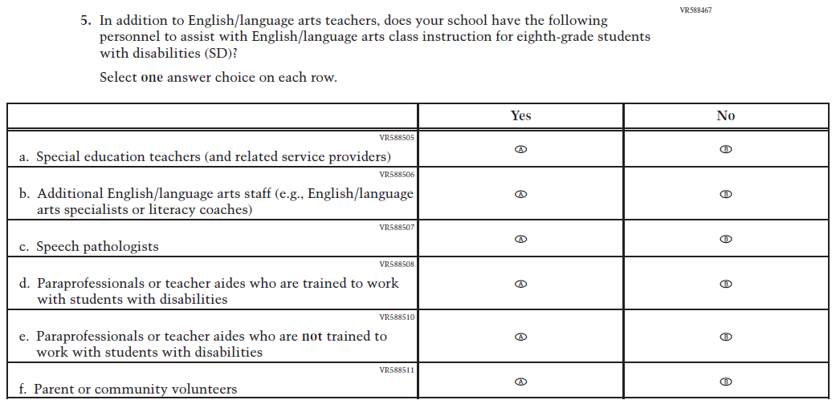  Issue: Teacher, Instructional, and Classroom Supports | R | For 2026, we have aligned Inline Directions in Teacher and School Items with the Directions currently used in Student Items. Subitems b and f were revised for clarity.
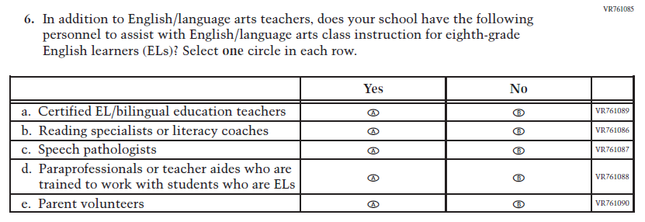  (2024) | Issue: Teacher, Instructional, and Classroom Supports | R | For 2026, we have aligned Inline Directions in Teacher and School Items with the Directions currently used in Student Items. Subitems a, b, d, and e were revised for clarity.

2026 Operational Grade 8 Reading School
Previous Item | 2026 Item | D/A/R+ | Rationale
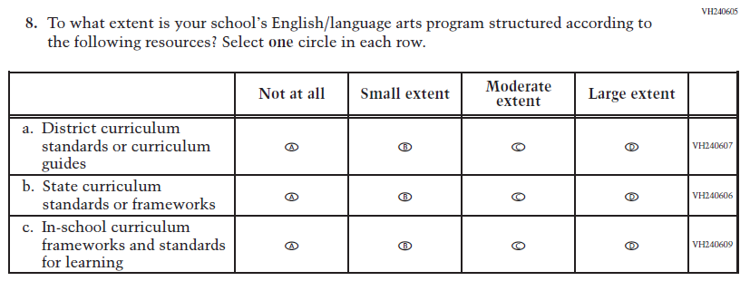  (2024) | 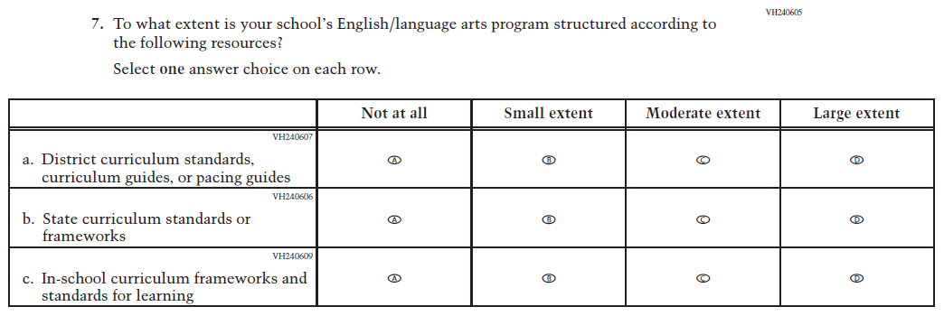  Issue: Teacher, Instructional, and Classroom Supports | R | For 2026, we have aligned Inline Directions in Teacher and School Items with the Directions currently used in Student Items. Subitem a was revised for clarity.
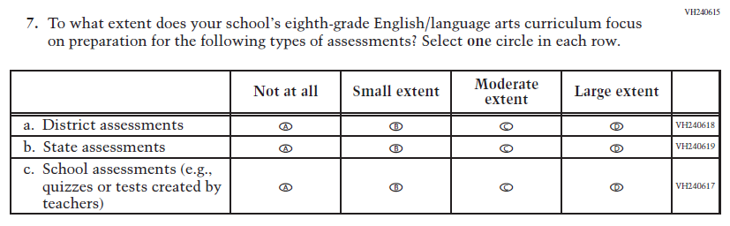  (2024) | 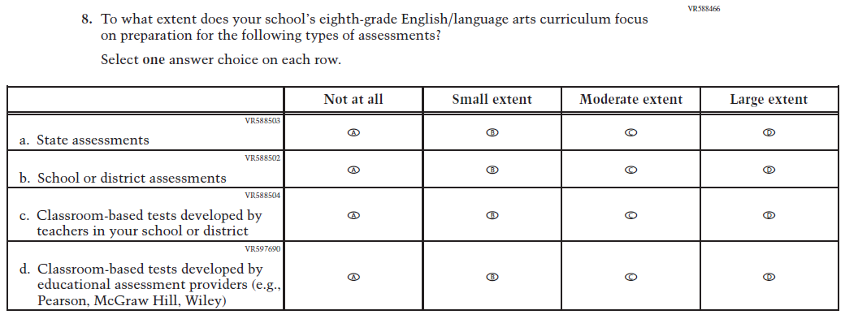  Issue: Teacher, Instructional, and Classroom Supports | R | For 2026, we have aligned Inline Directions in Teacher and School Items with the Directions currently used in Student Items. Subitem d was developed to measure content in the new Reading framework.

2026 Operational Grade 8 Reading School
Previous Item | 2026 Item | D/A/R+ | Rationale
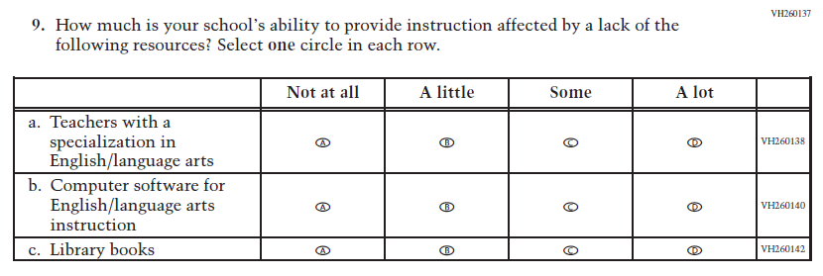  (2024) | Issue: Teacher, Instructional, and Classroom Supports | R | For 2026, we have aligned Inline Directions in Teacher and School Items with the Directions currently used in Student Items. Subitem d was developed to measure content in the new Reading framework.
N/A  (2024) | Issue: Engagement and Motivation | A | This Item was developed to measure content in the new Reading framework.

Appendix J3-12: Operational Grade 8 (Reading)

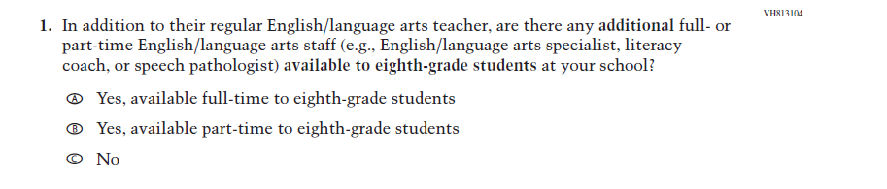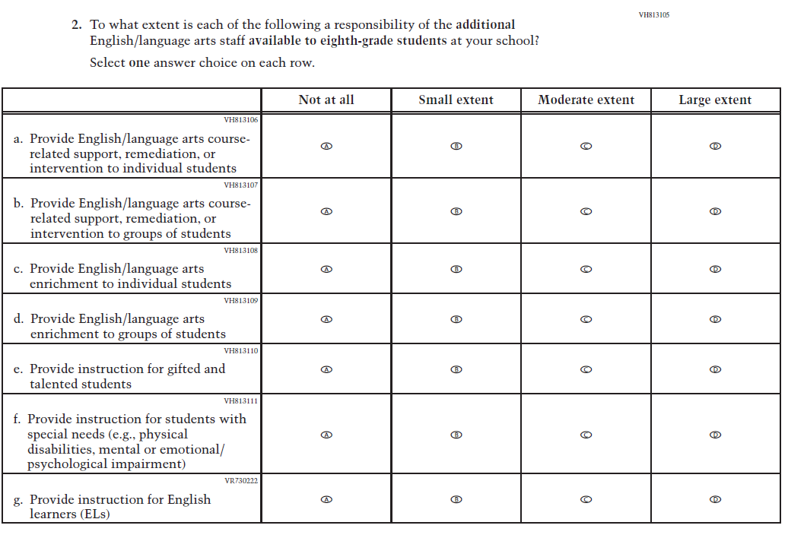
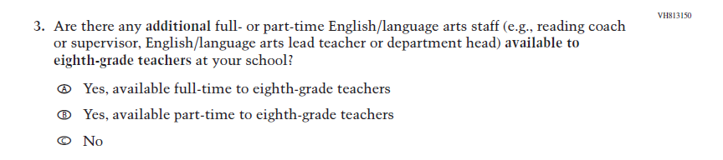
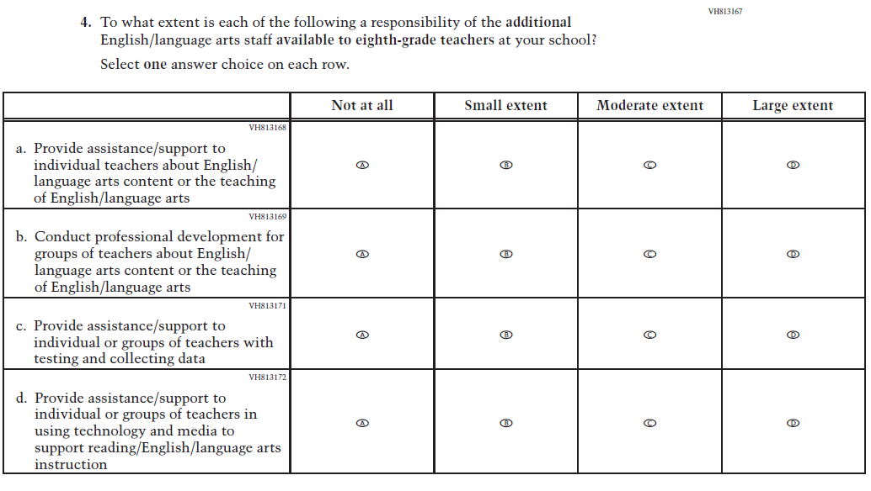
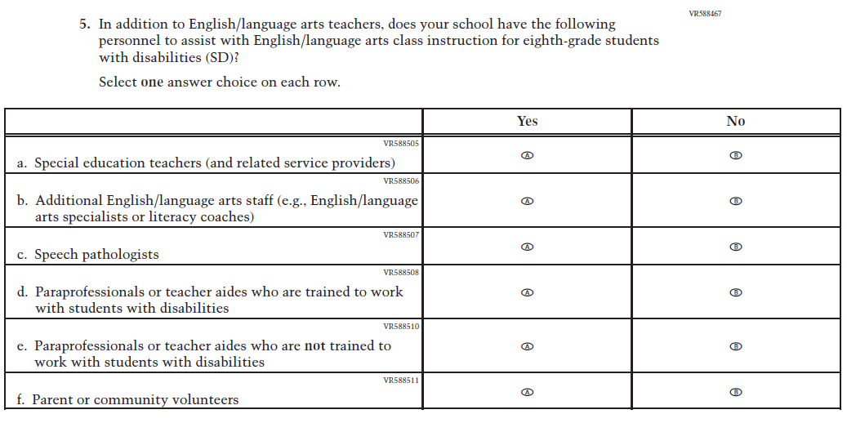
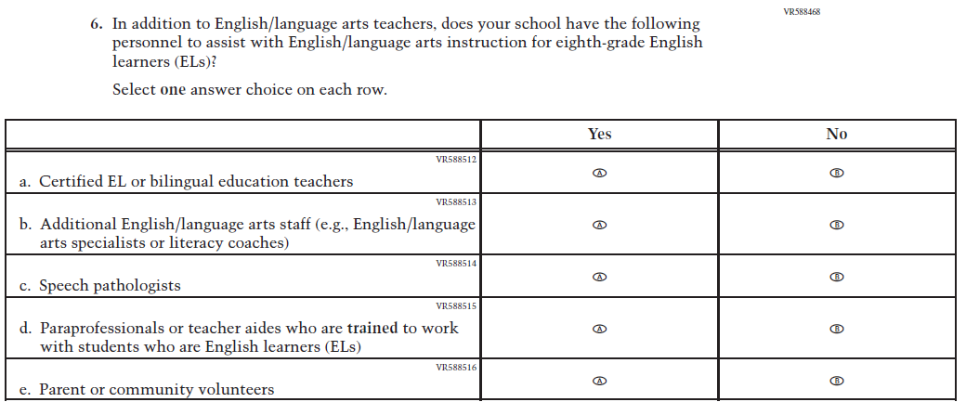
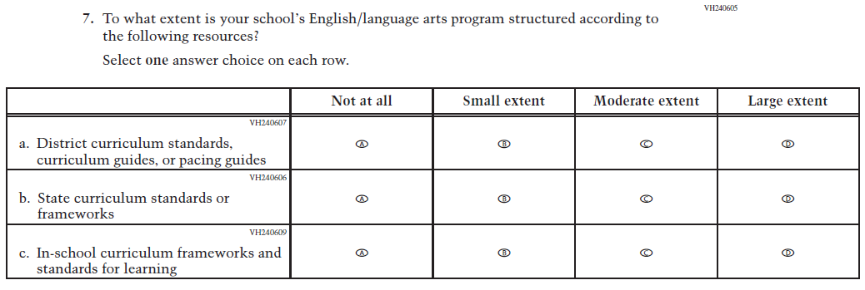
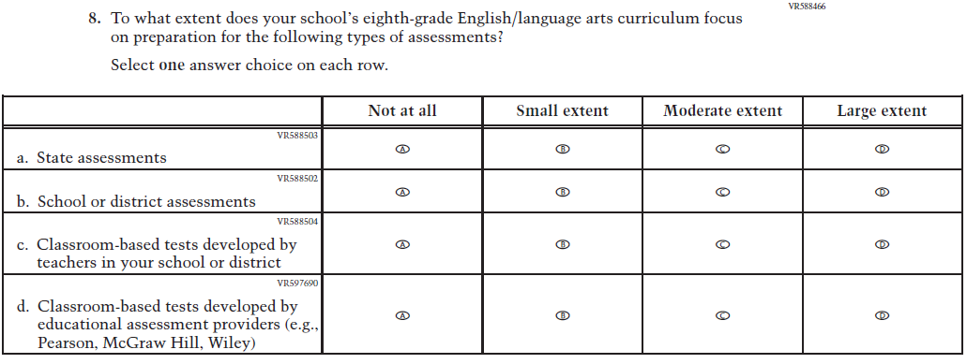
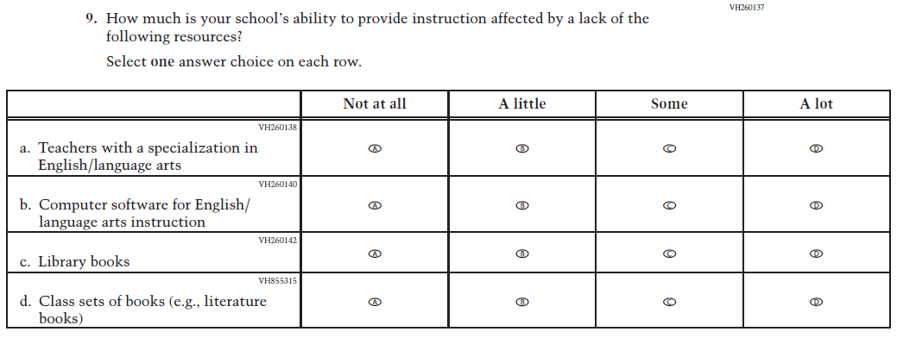
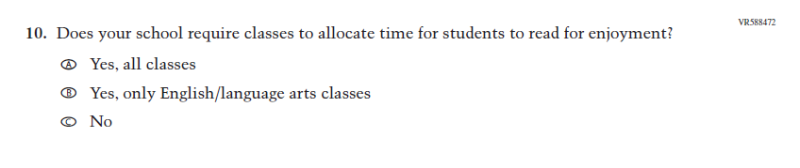

Appendix J3-13: Summary of Changes Operational Grade 8 (Social Studies)
2026 Operational Grade 8 Social Studies School
Previous Item | 2026 Item | D/A/R+ | Rationale
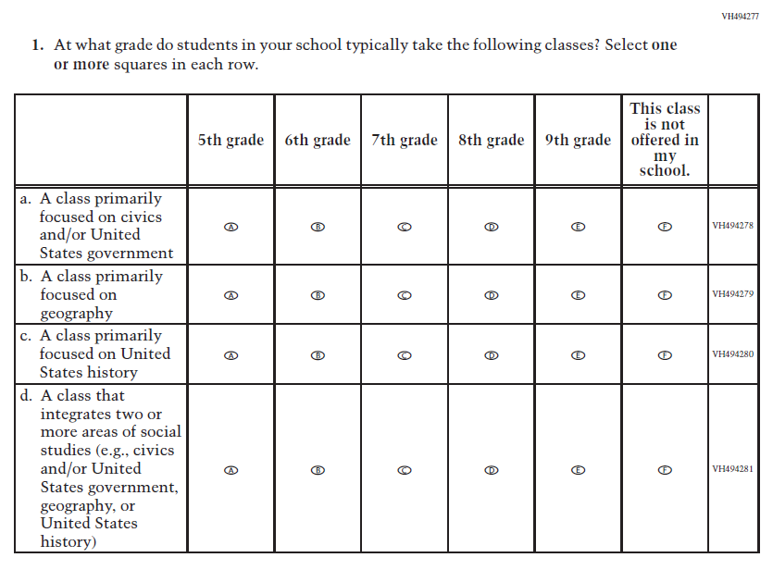  (2022) | 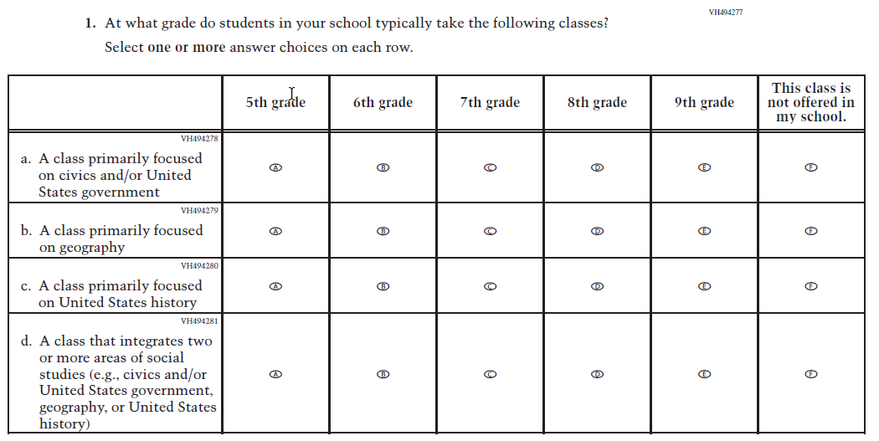  Issue: Organization of Instruction | R | For 2026, we have aligned Inline Directions in Teacher and School Items with the Directions currently used in Student Items.
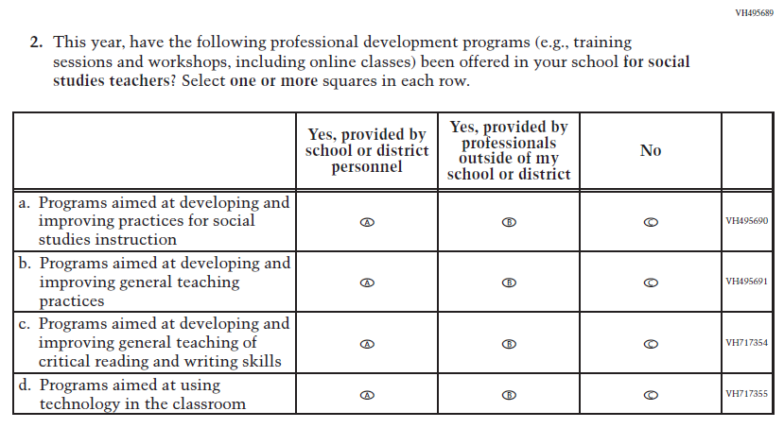  (2022) | 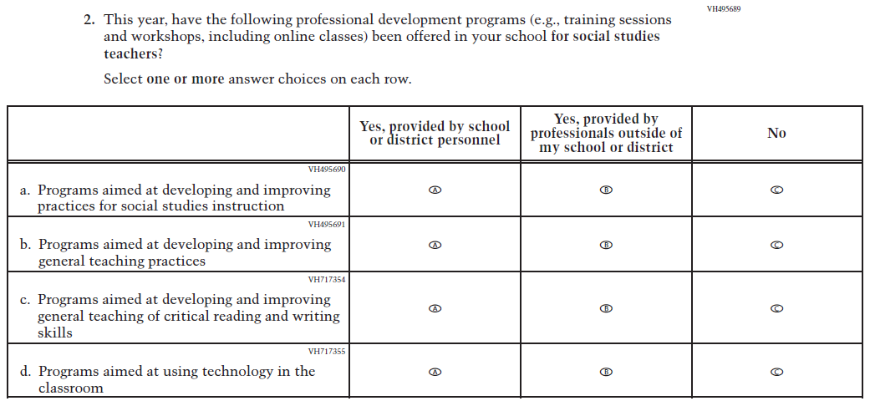  Issue: Teacher Preparation | R | For 2026, we have aligned Inline Directions in Teacher and School Items with the Directions currently used in Student Items.

2026 Operational Grade 8 Social Studies School
Previous Item | 2026 Item | D/A/R+ | Rationale
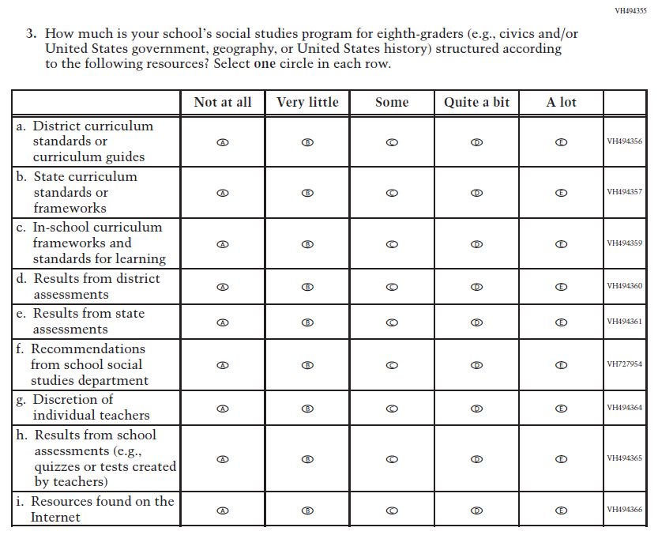  (2022) | 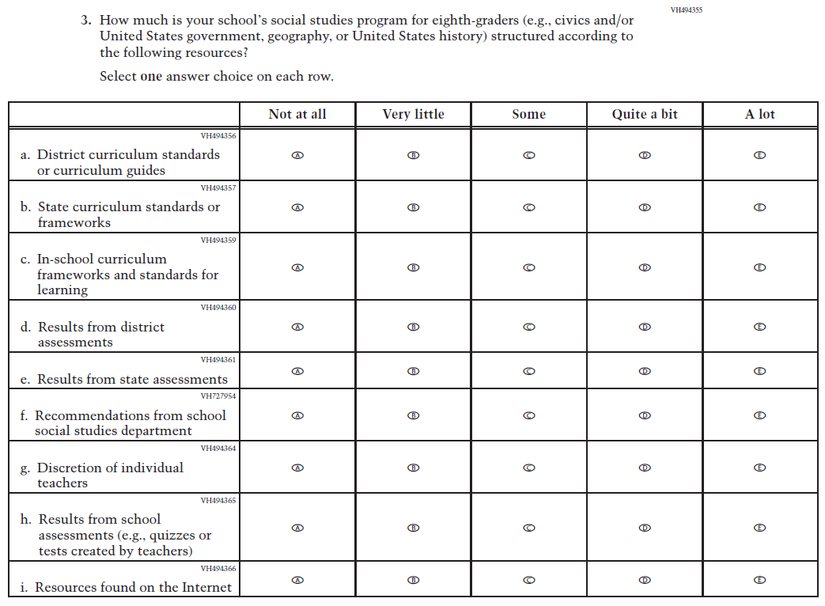  Issue: Organization of Instruction | R | For 2026, we have aligned Inline Directions in Teacher and School Items with the Directions currently used in Student Items.
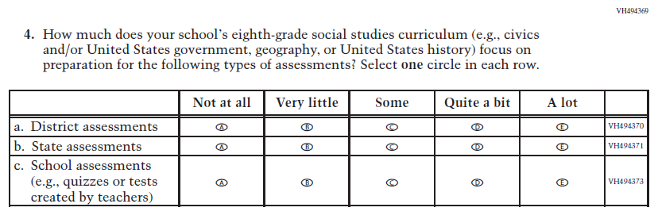  (2022) | 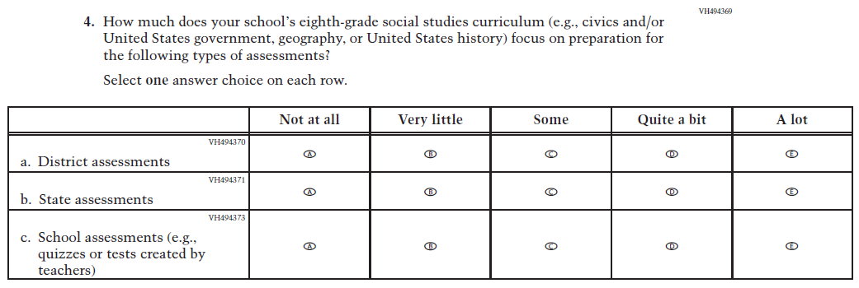  Issue: Organization of Instruction | R | For 2026, we have aligned Inline Directions in Teacher and School Items with the Directions currently used in Student Items.

2026 Operational Grade 8 Social Studies School
Previous Item | 2026 Item | D/A/R+ | Rationale
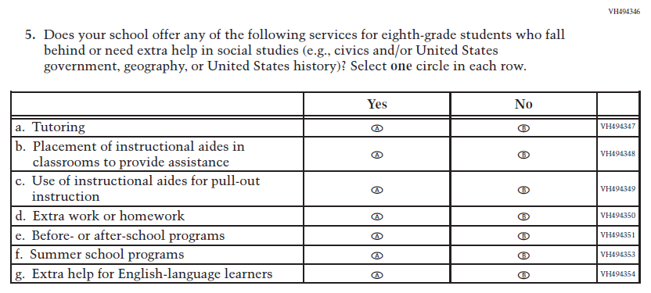  (2022) | 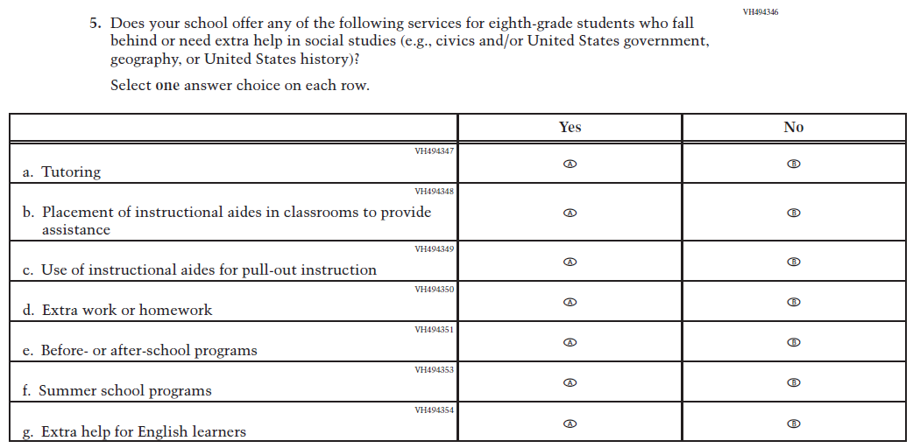  Issue: Resources for Learning and Instruction | R | For 2026, we have aligned Inline Directions in Teacher and School Items with the Directions currently used in Student Items. Also, in SubItem g. “English-language learners” was updated to “English learners” to be consistent with other Items.
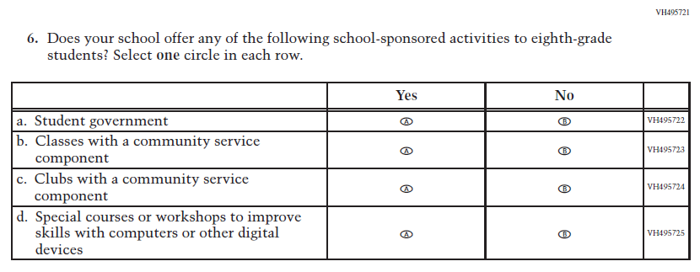  (2022) | 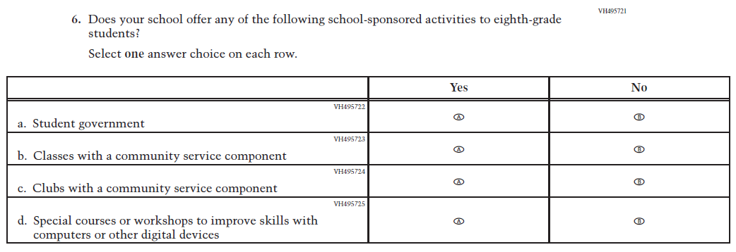  Issue: Student Factors | R | For 2026, we have aligned Inline Directions in Teacher and School Items with the Directions currently used in Student Items.

Appendix J3-14: Operational Grade 8 (Social Studies)
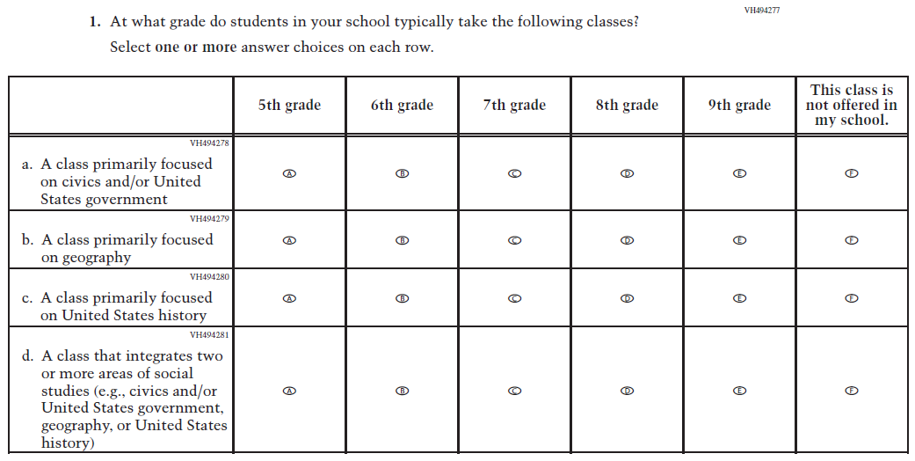
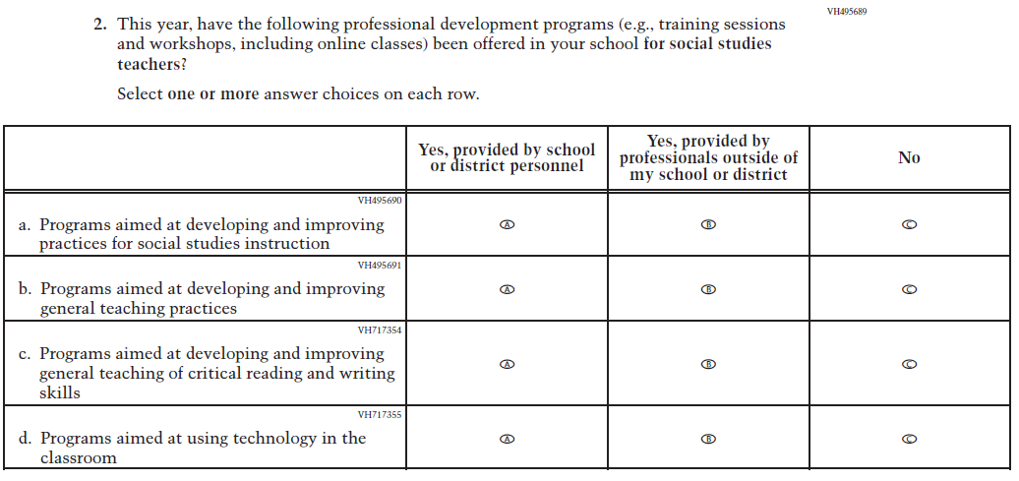
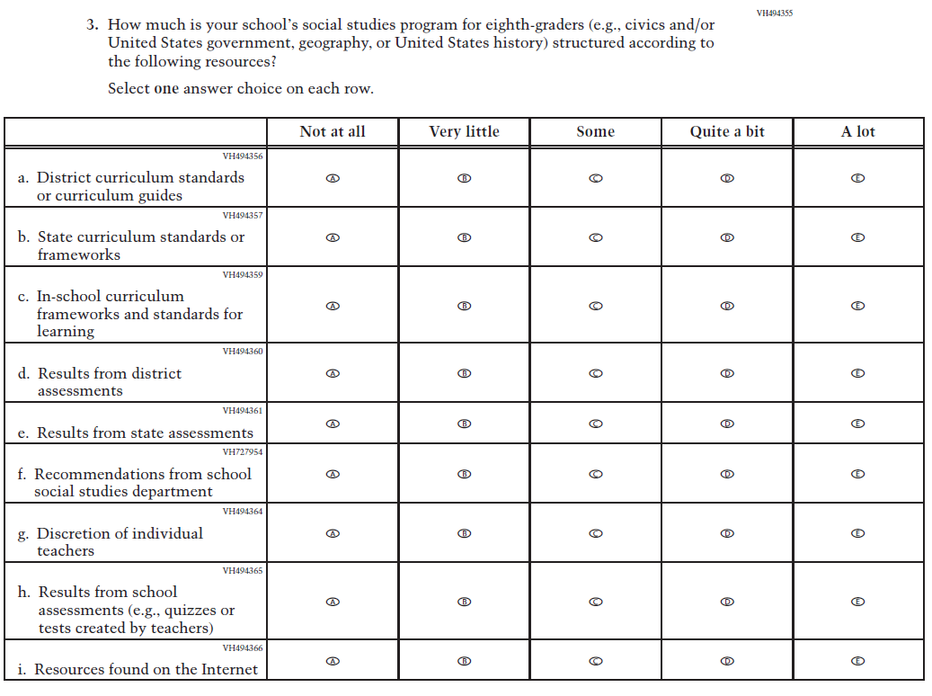
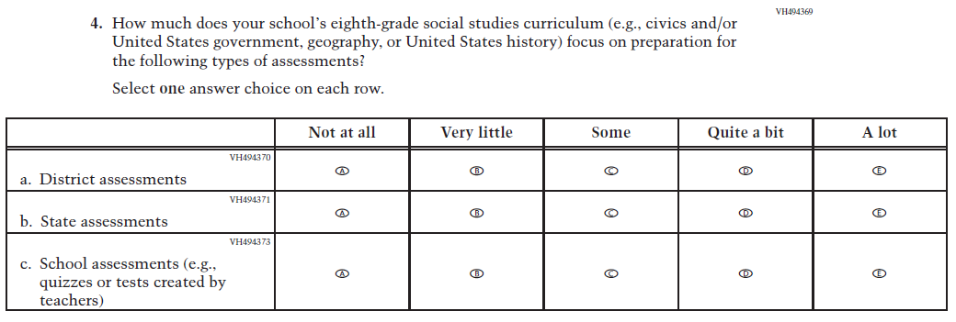
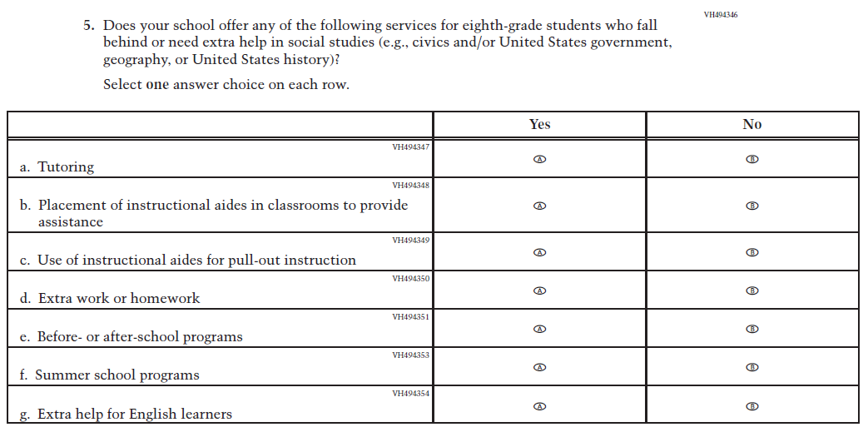
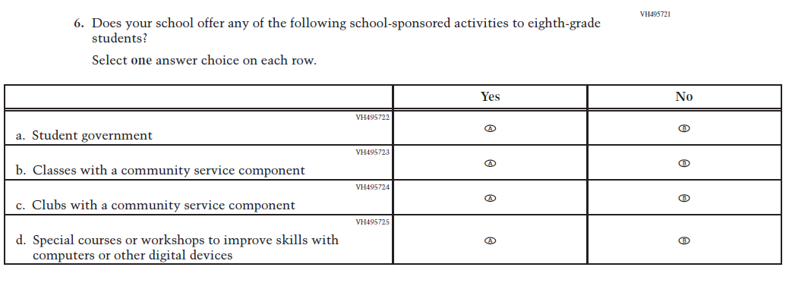

Appendix J3-15: Summary of Changes Operational Grade 4 (Charter School)
2026 Operational Grade 4 Charter School
Previous Item | 2026 Item | D/A/R+ | Rationale
N/A  (2024) | 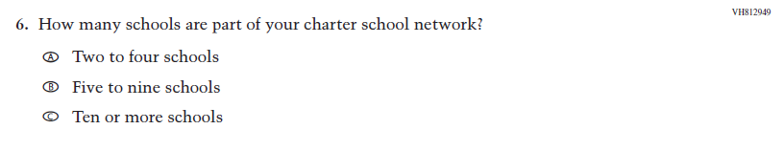  Issue: School Climate | A | This Item was developed to measure characteristics of the charter school environment.
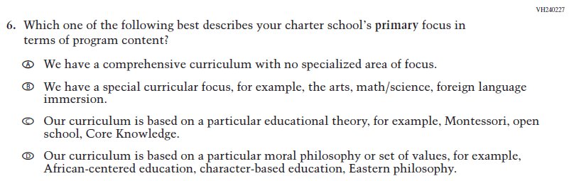  (2024) | 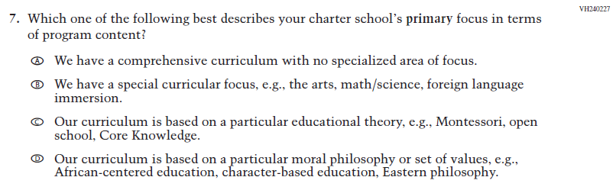  Issue: School Climate | R | In Response Option B, “for example” was revised to “e.g.” for consistency across Items.
N/A  (2024) | 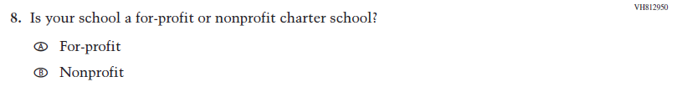  Issue: School Climate | A | This Item was developed to measure characteristics of the charter school environment.

2026 Operational Grade 4 Charter School
Previous Item | 2026 Item | D/A/R+ | Rationale
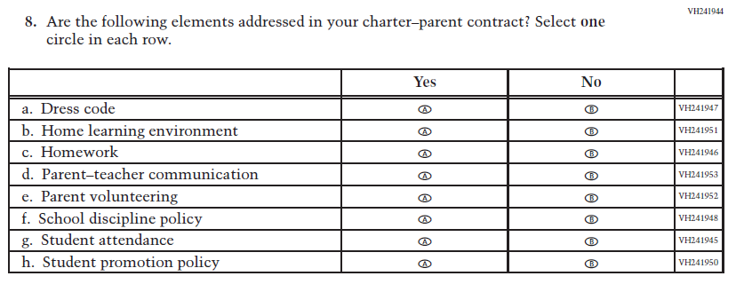  (2024) | 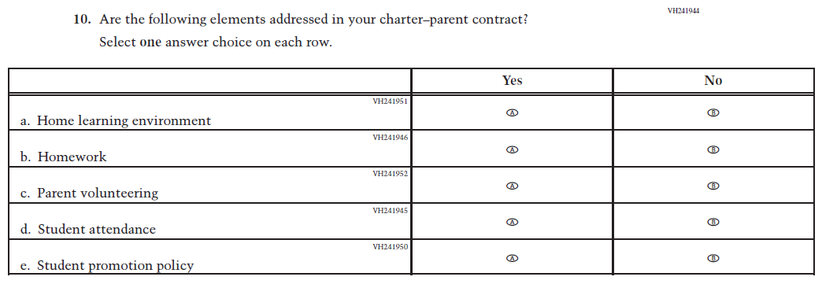  Issue: School Climate | R | For 2026, we have aligned Inline Directions in Teacher and School Items with the Directions currently used in Student Items. Also, SubItems a., d., and f. were dropped.
N/A  (2024) | 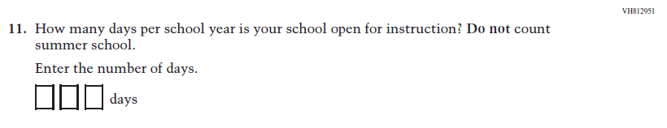  Issue: School Climate | A | This Item was developed to measure characteristics of the charter school environment.
N/A  (2024) | 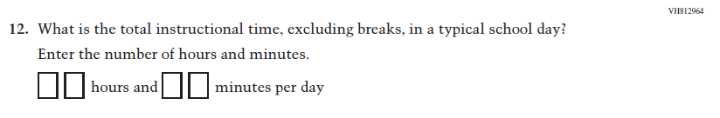  Issue: School Climate | A | This Item was developed to measure characteristics of the charter school environment.

Appendix J3-16: Operational Grade 4 (Charter School)
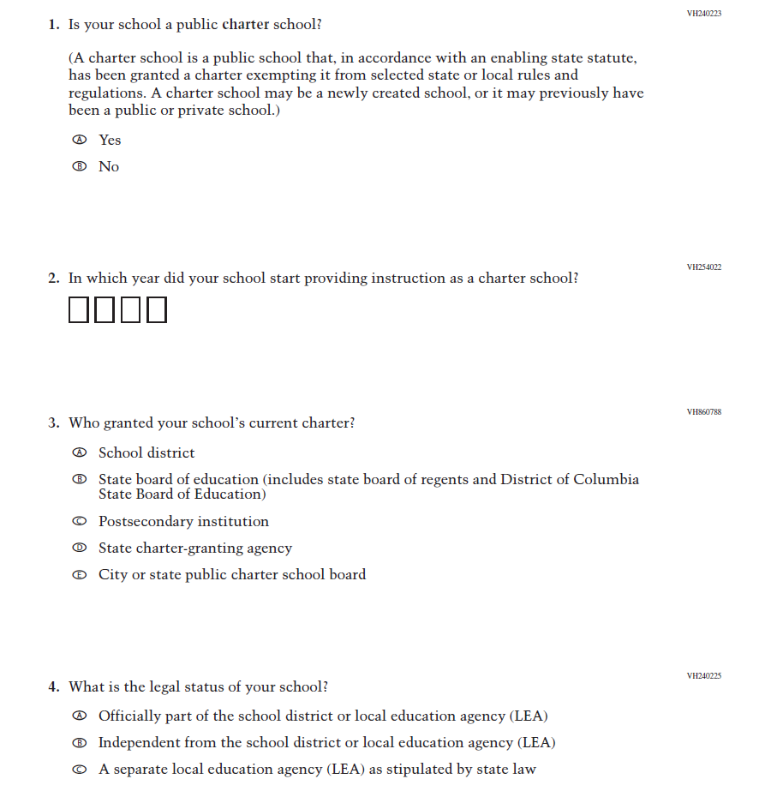
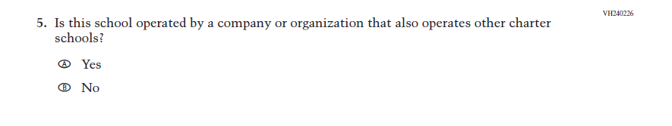
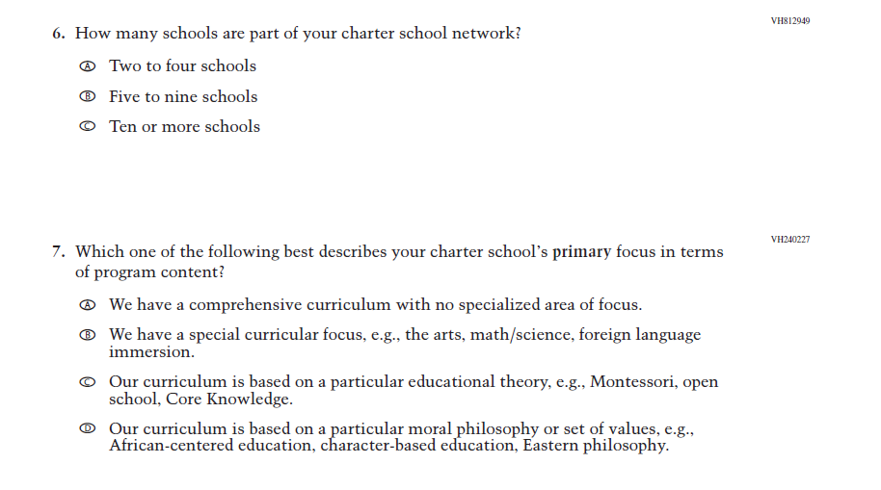
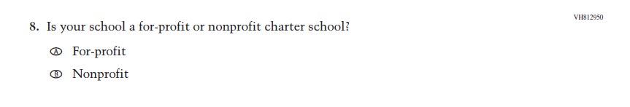
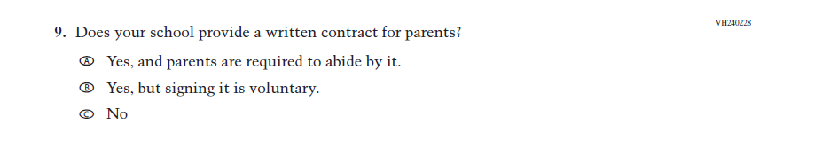
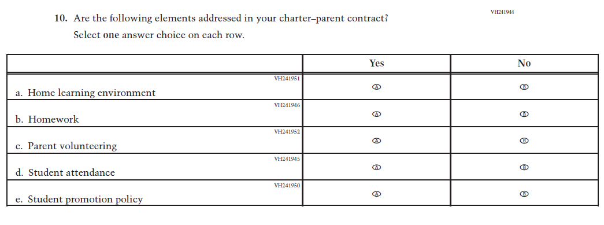
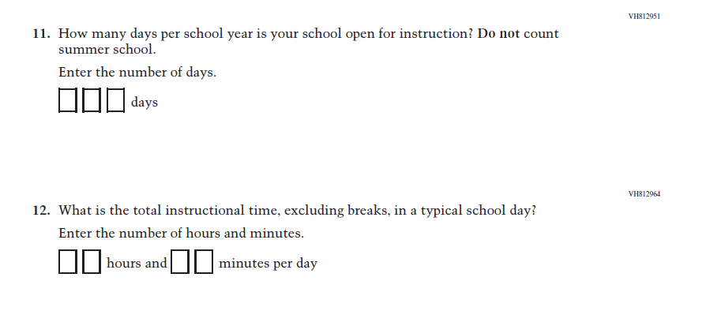

Appendix J3-17: Summary of Changes Operational Grade 8 (Charter School)
2026 Operational Grade 8 Charter School
Previous Item | 2026 Item | D/A/R+ | Rationale
N/A  (2024) | Issue: School Climate | A | This Item was developed to measure characteristics of the charter school environment.
(2024) | Issue: School Climate | R | In Response Option B, “for example” was revised to “e.g.” for consistency across Items.
N/A  (2024) | Issue: School Climate | A | This Item was developed to measure characteristics of the charter school environment.

2026 Operational Grade 8 Charter School
Previous Item | 2026 Item | D/A/R+ | Rationale
(2024) | Issue: School Climate | R | For 2026, we have aligned Inline Directions in Teacher and School Items with the Directions currently used in Student Items. Also, SubItems a., d., and f. were dropped.
N/A  (2024) | Issue: School Climate | A | This Item was developed to measure characteristics of the charter school environment.
N/A  (2024) | Issue: School Climate | A | This Item was developed to measure characteristics of the charter school environment.

Appendix J3-18: Operational Grade 8 (Charter School)

Appendix J3-19: Pilot Grade 4 (Core)

Appendix J3-20: Pilot Grade 12 (Core)
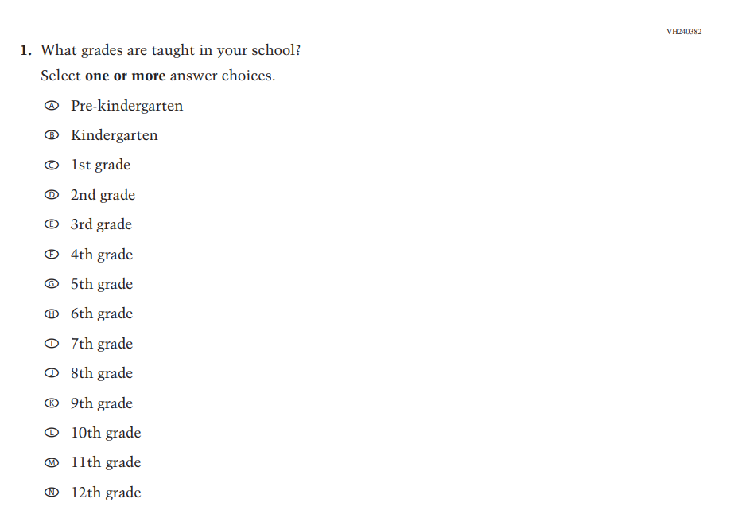
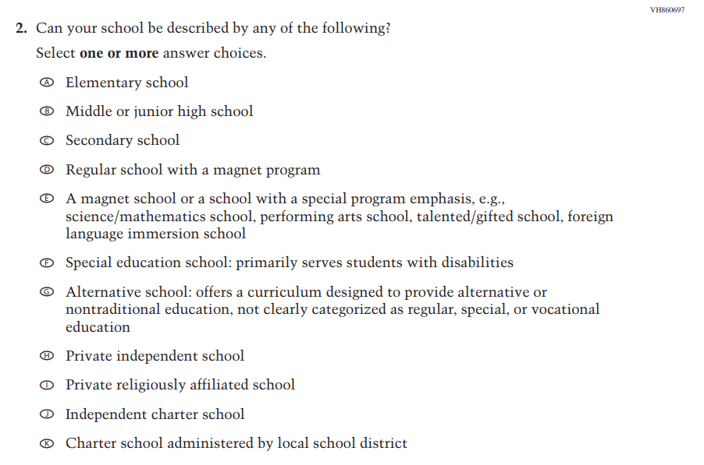
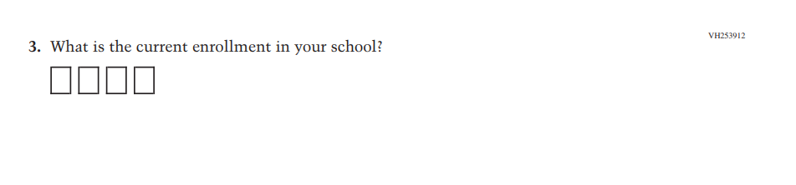
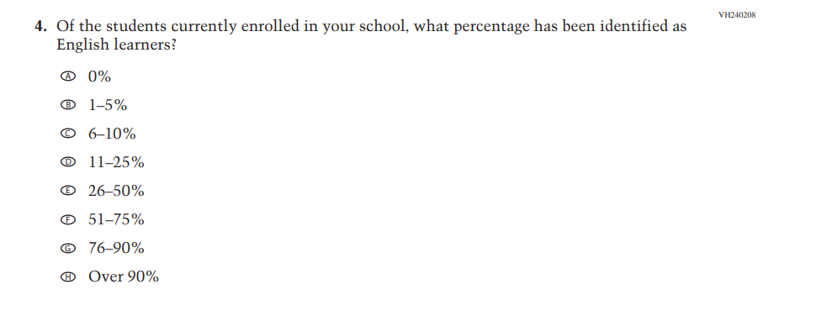
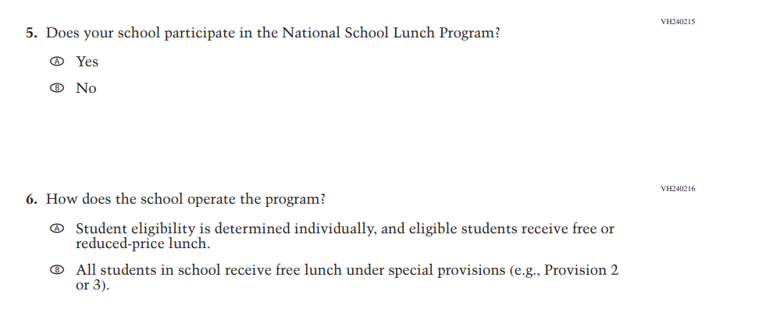

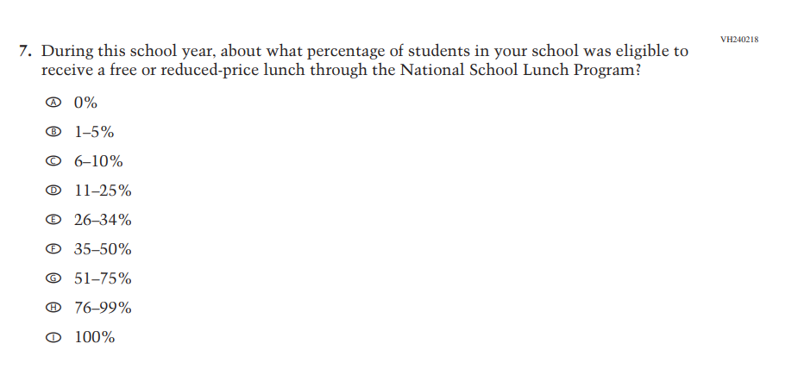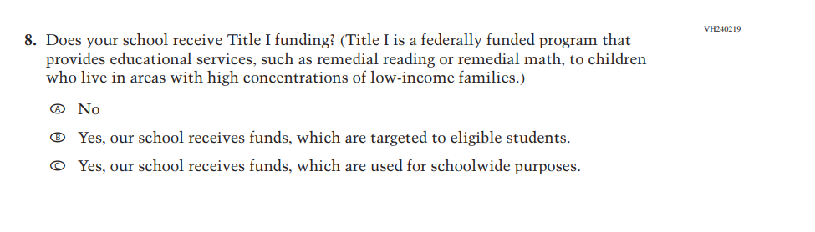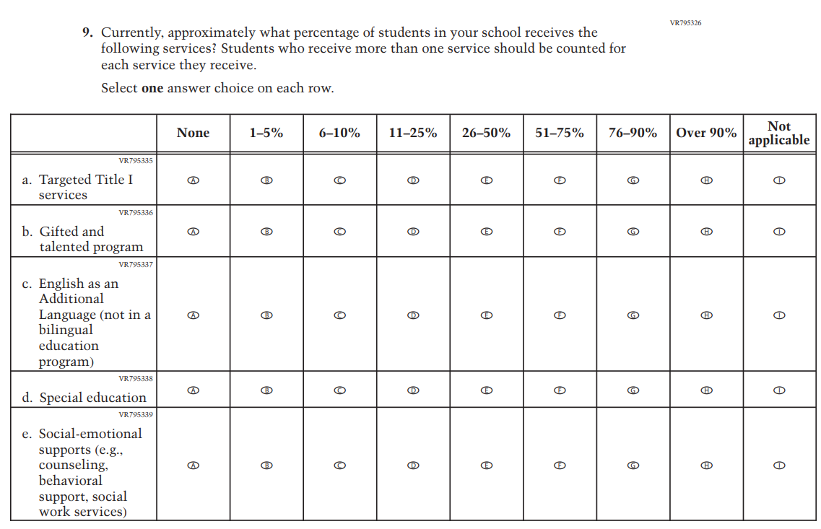
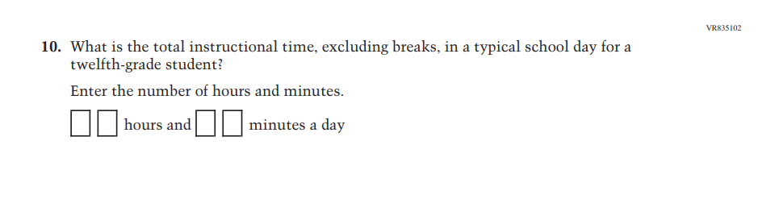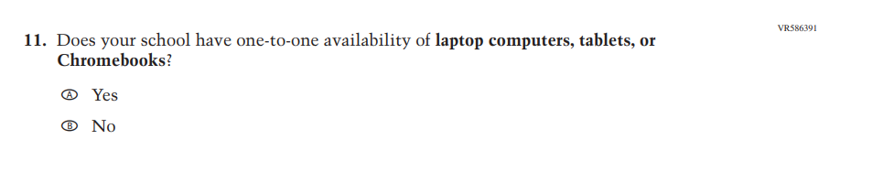

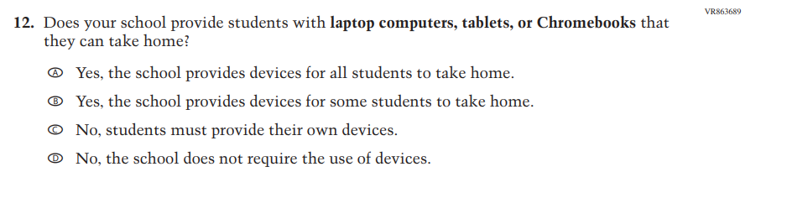
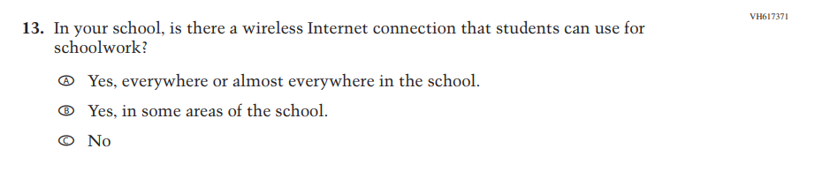
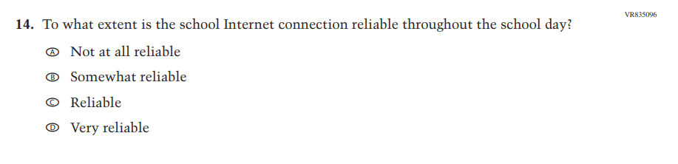
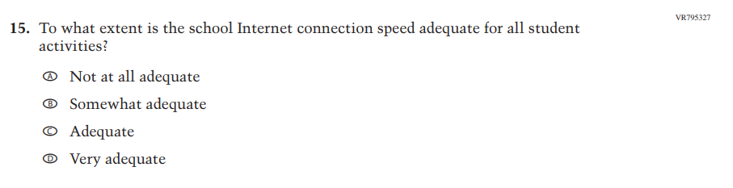
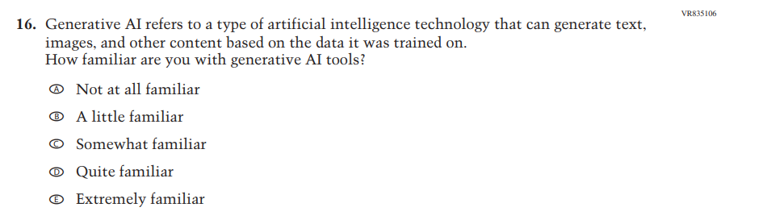
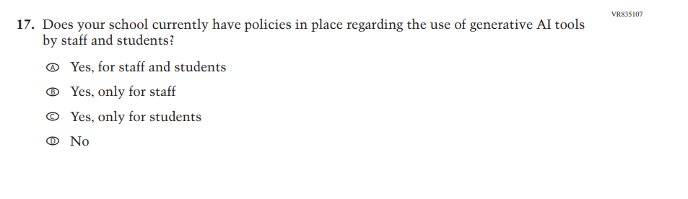
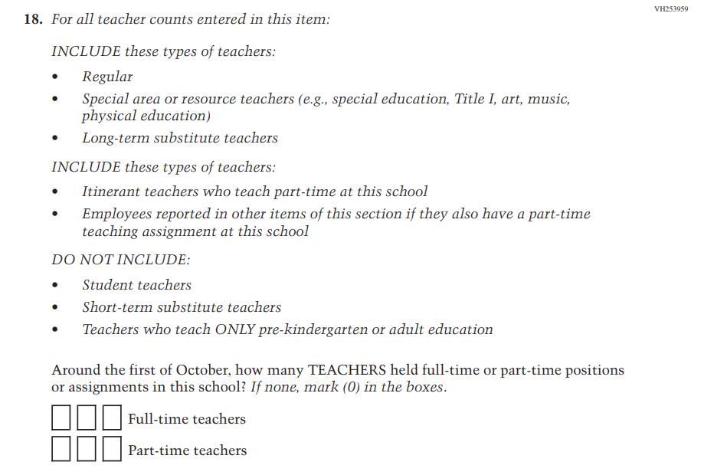
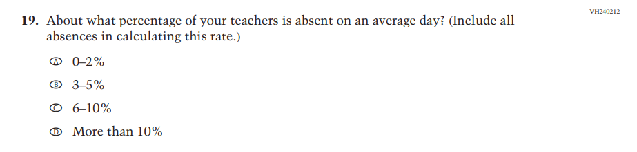

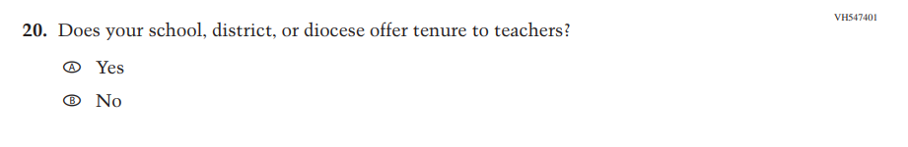
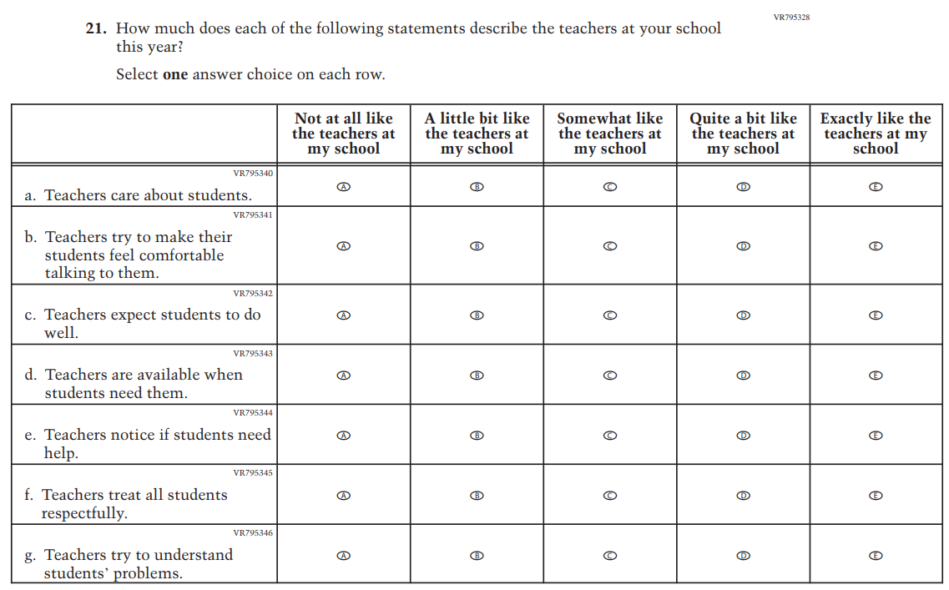

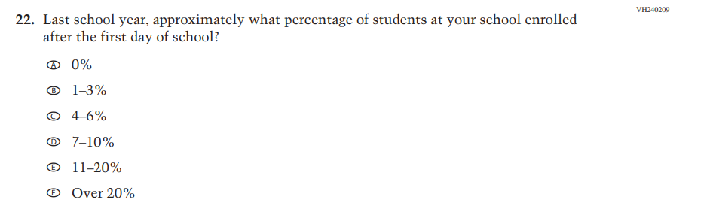

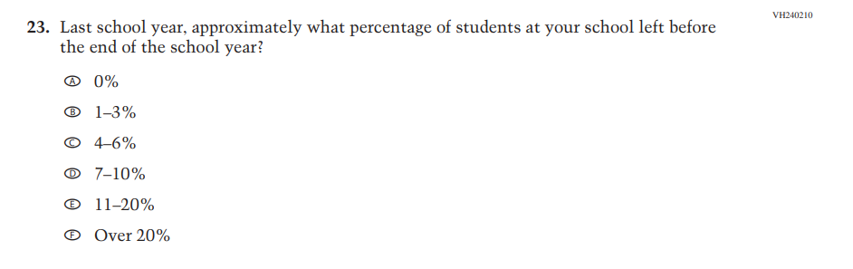
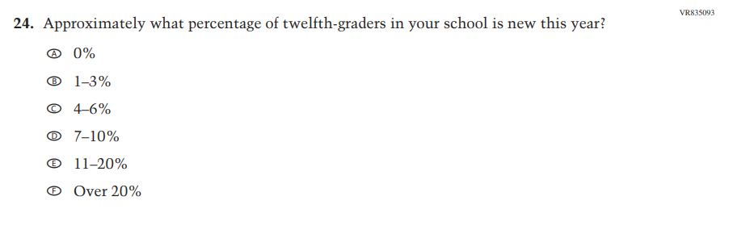
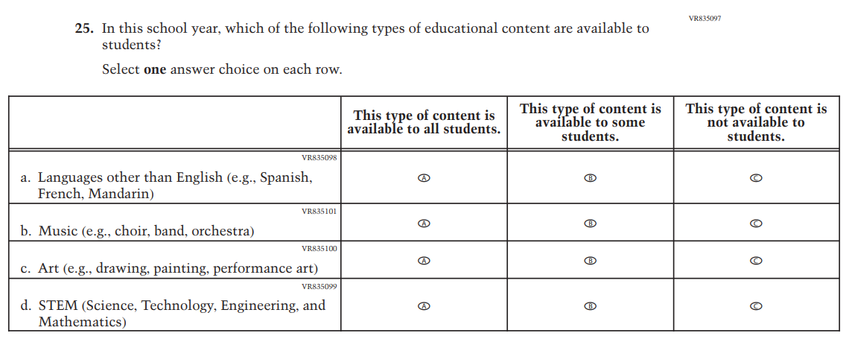

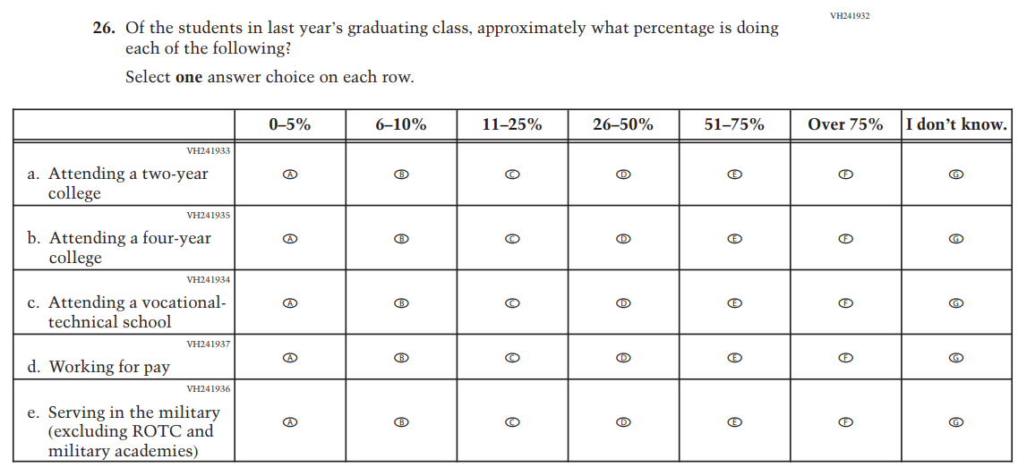
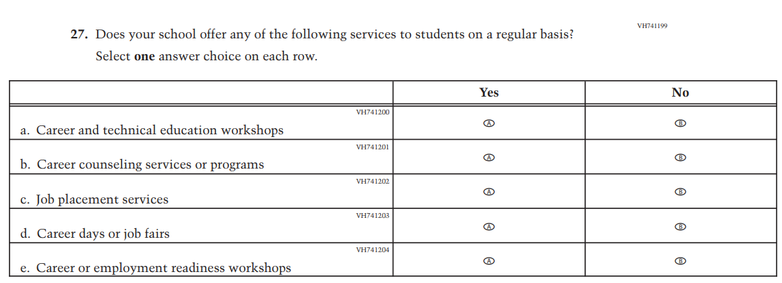

Appendix J3-21: Pilot Grade 4 (Mathematics)

Appendix J3-22: Pilot Grade 12 (Mathematics)
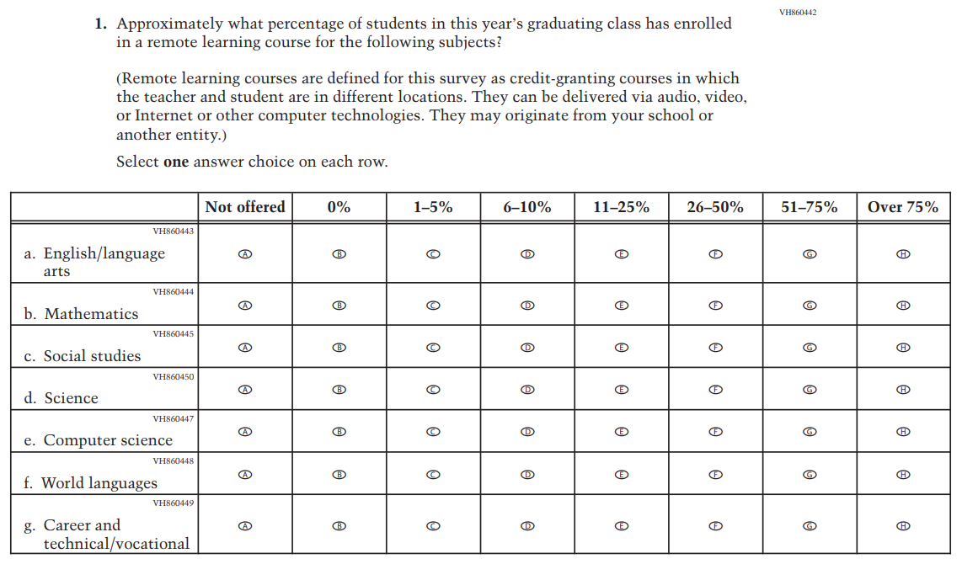

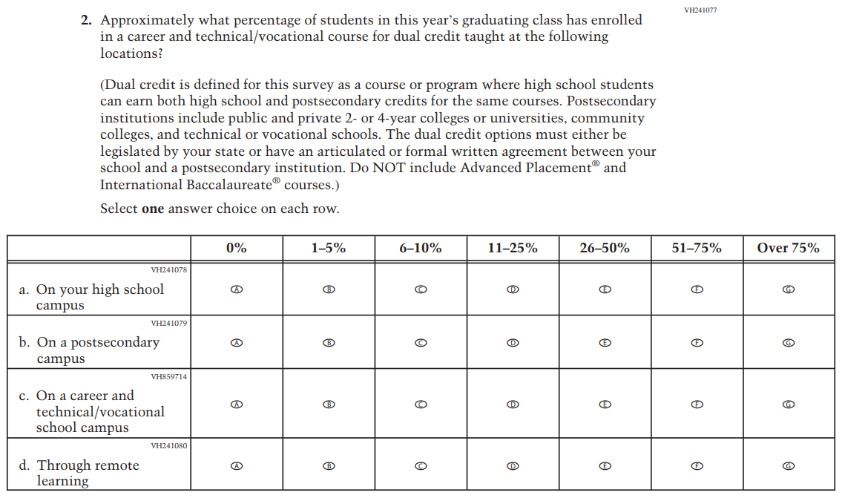

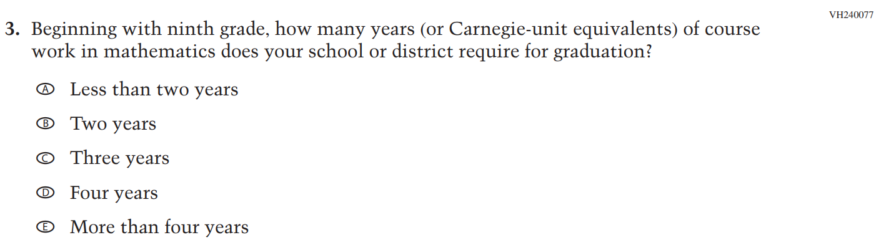

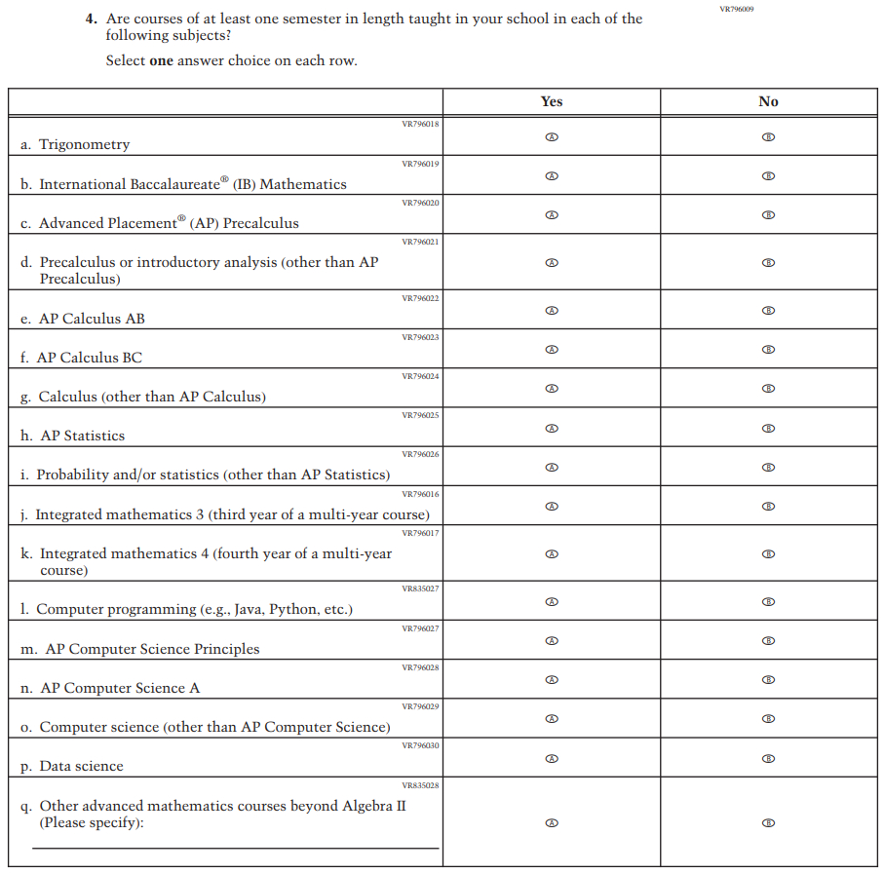
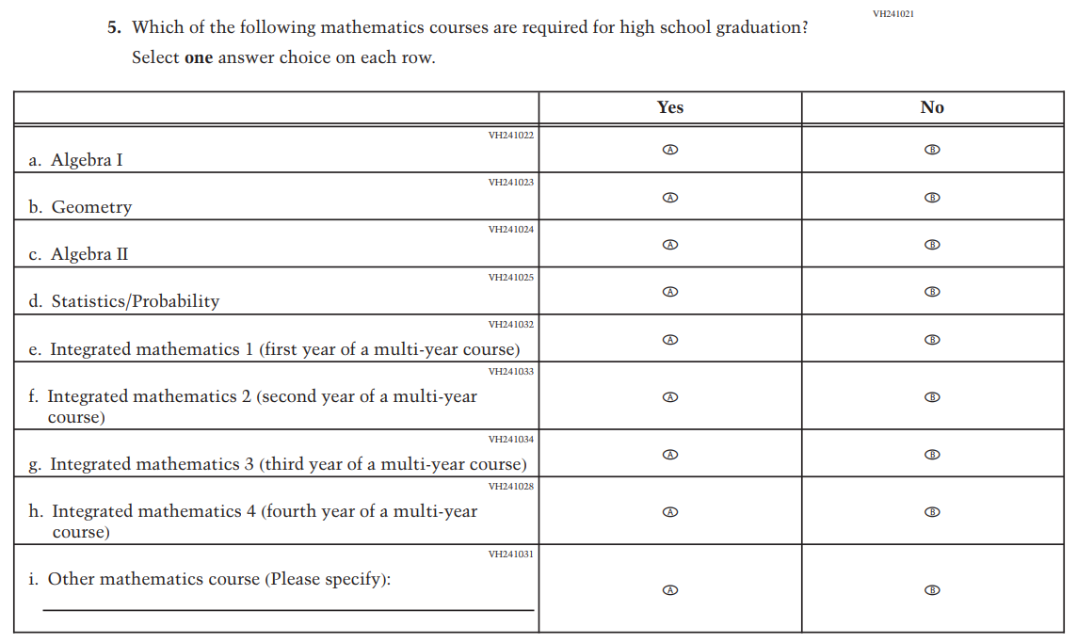

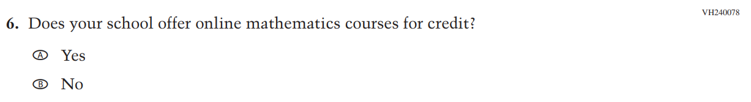

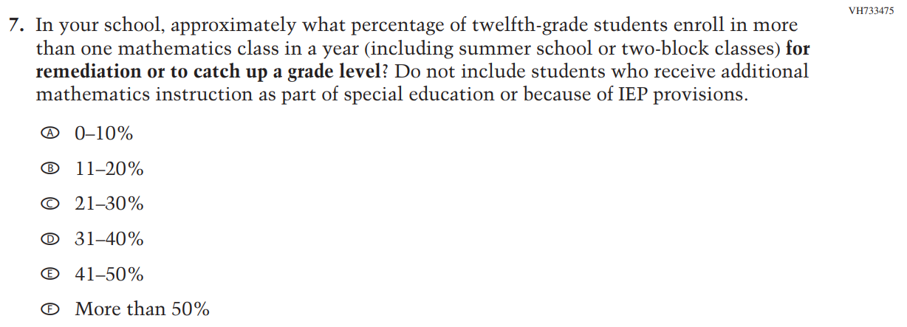

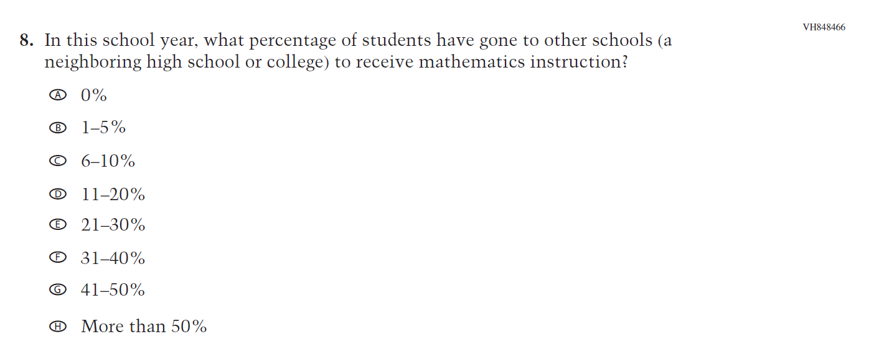

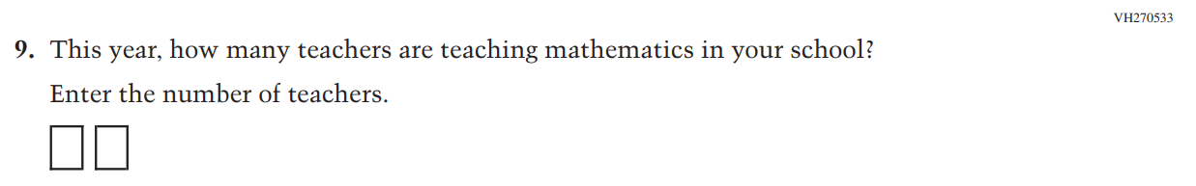

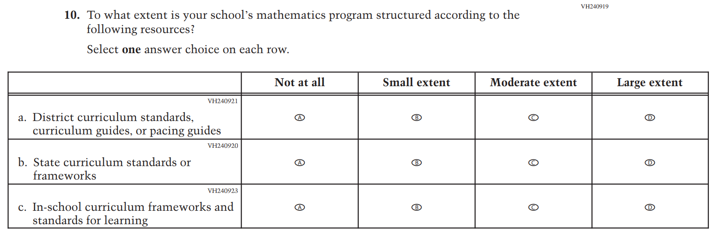

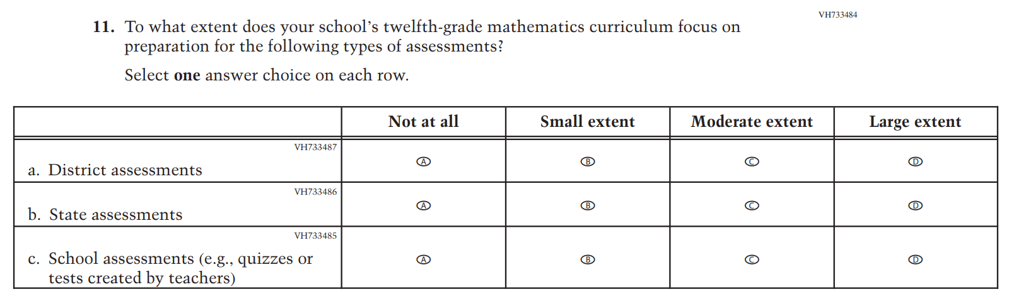

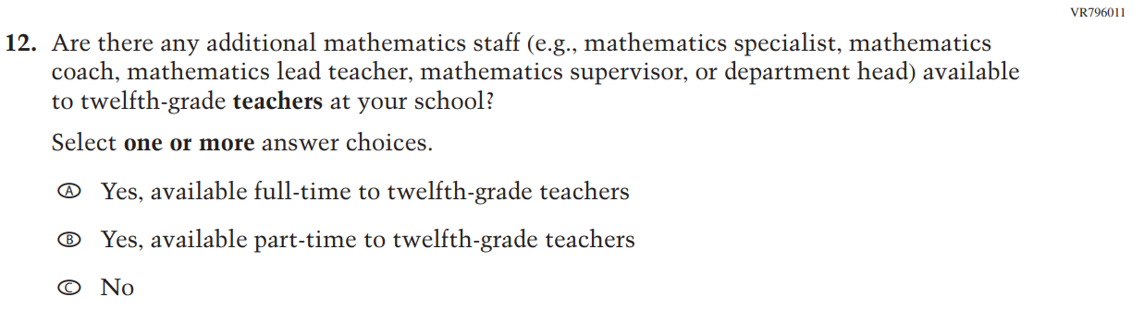

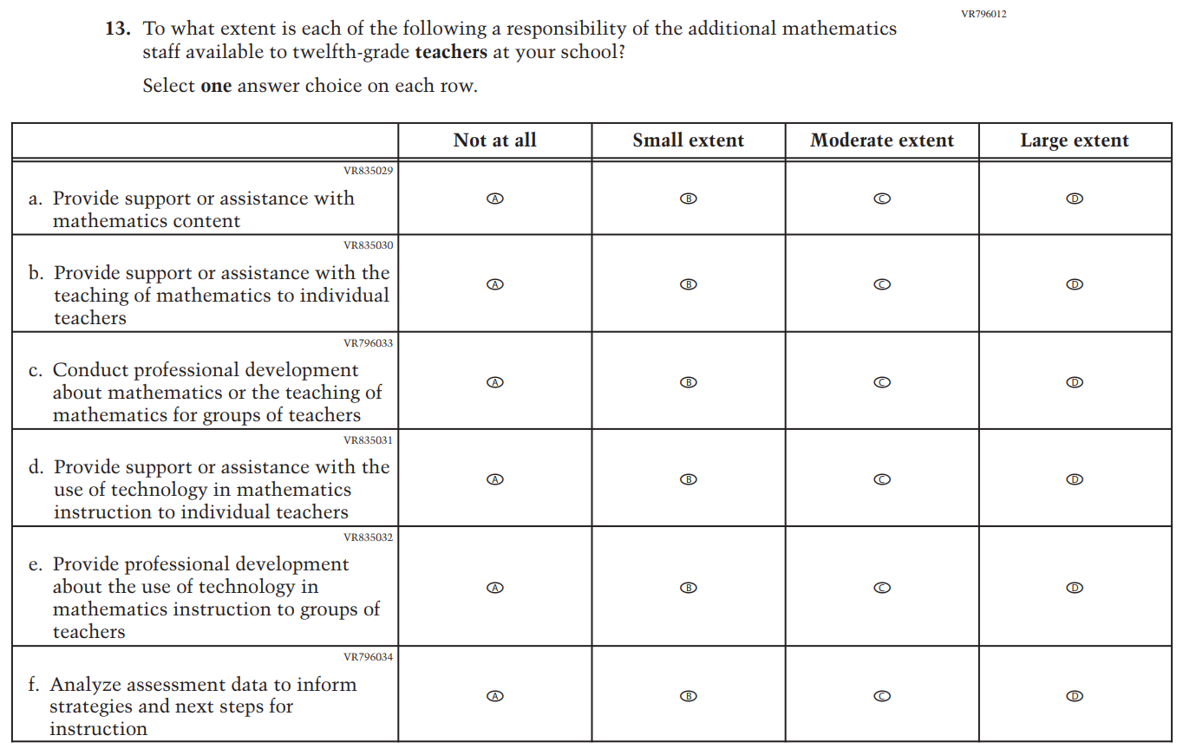
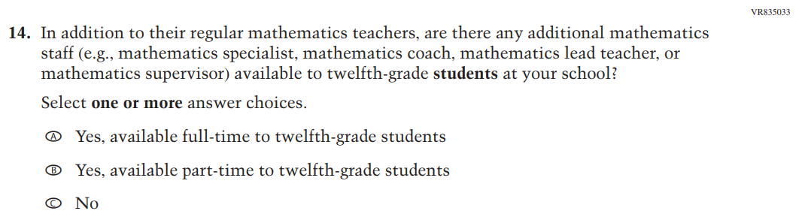

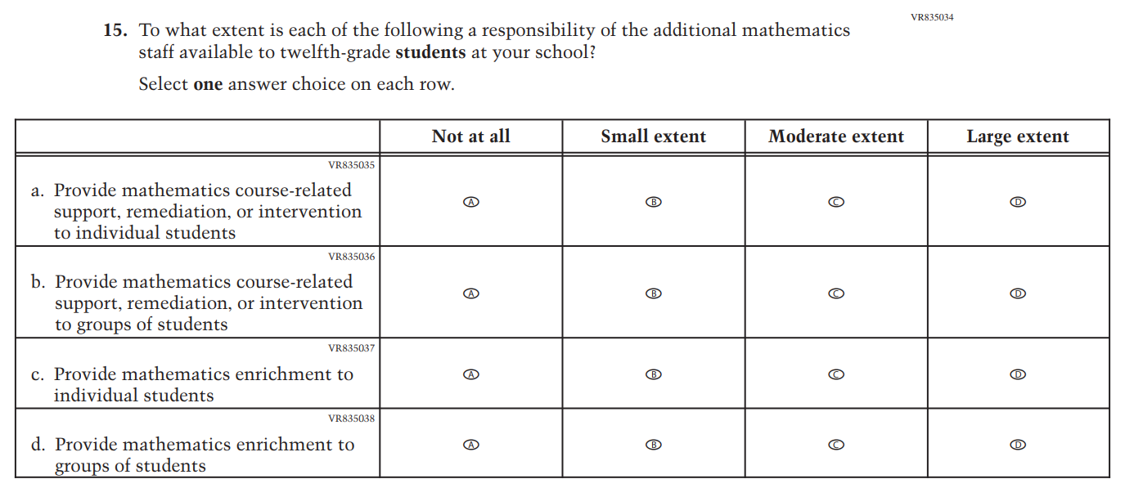

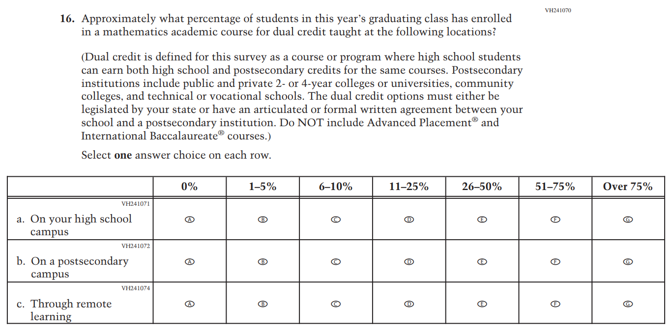

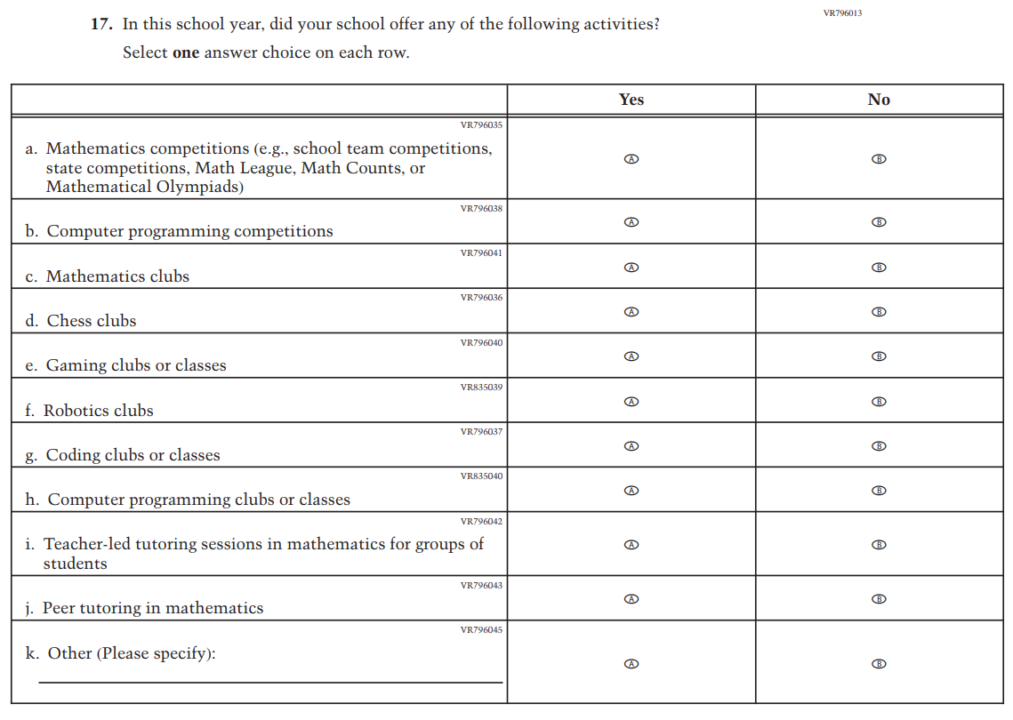

Appendix J3-23: Pilot Grade 4 (Reading)
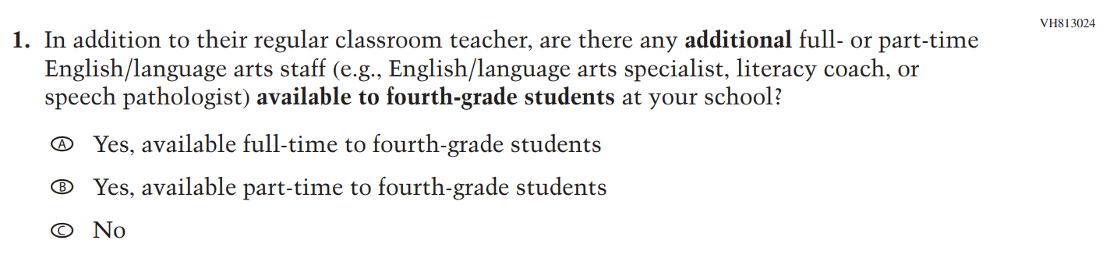

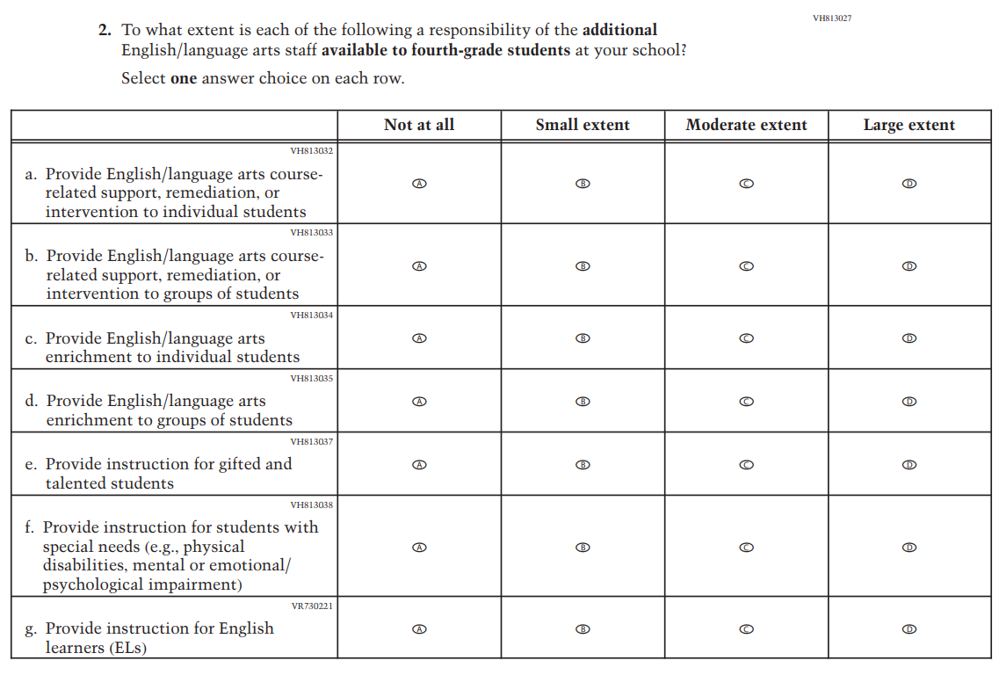

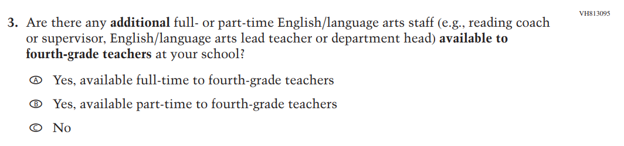

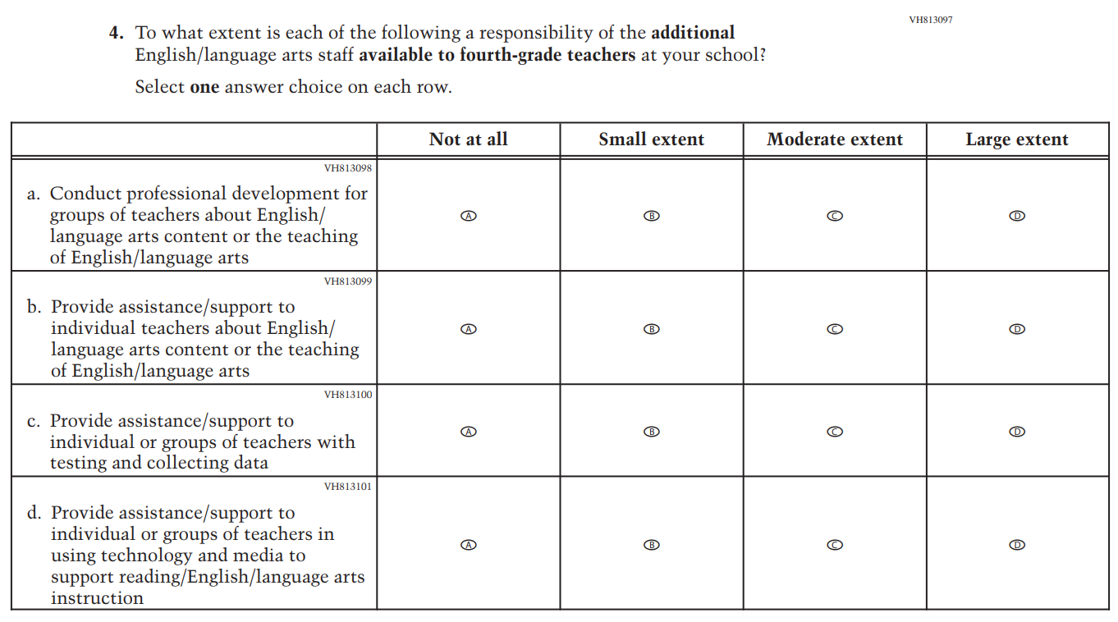

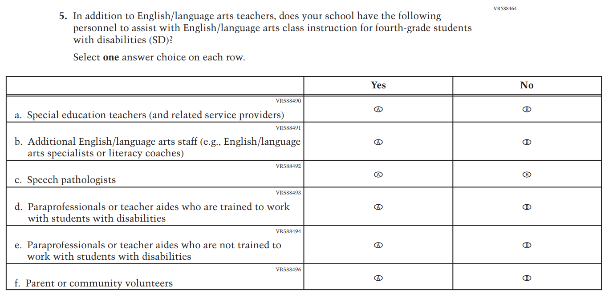

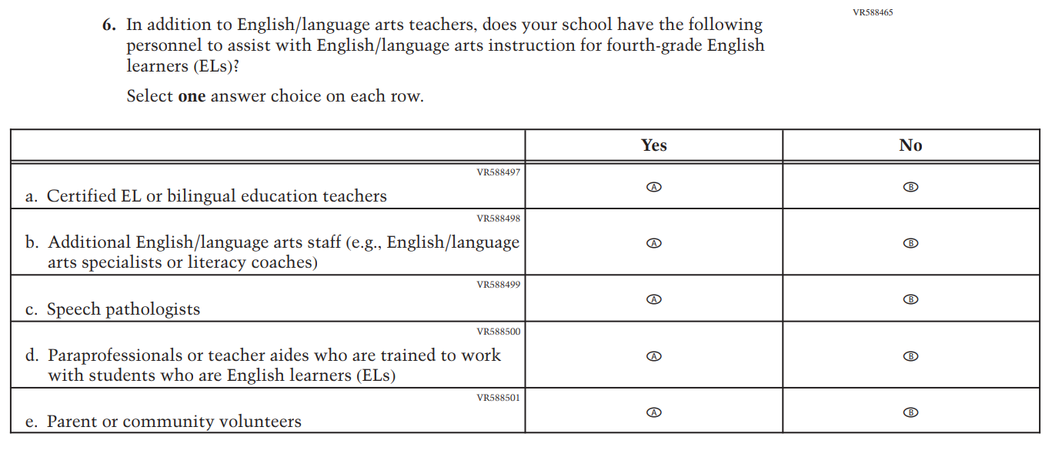

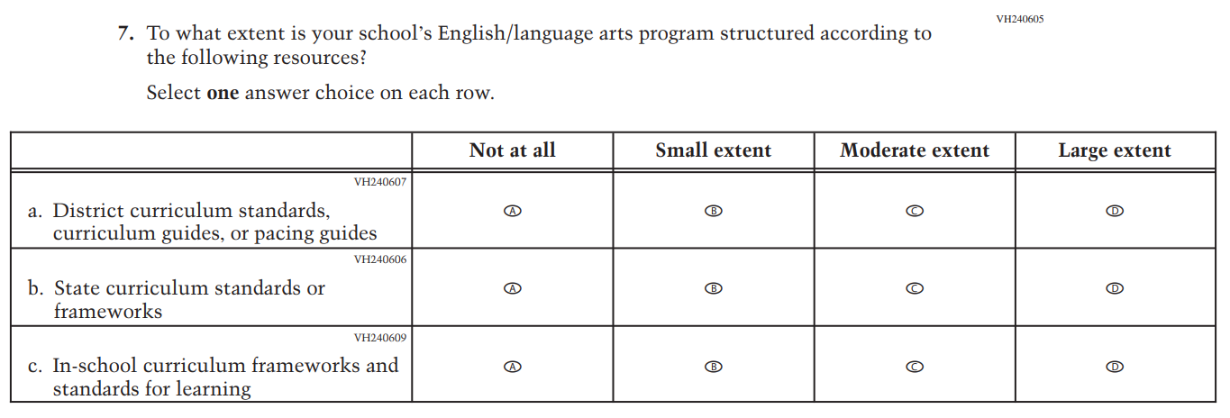

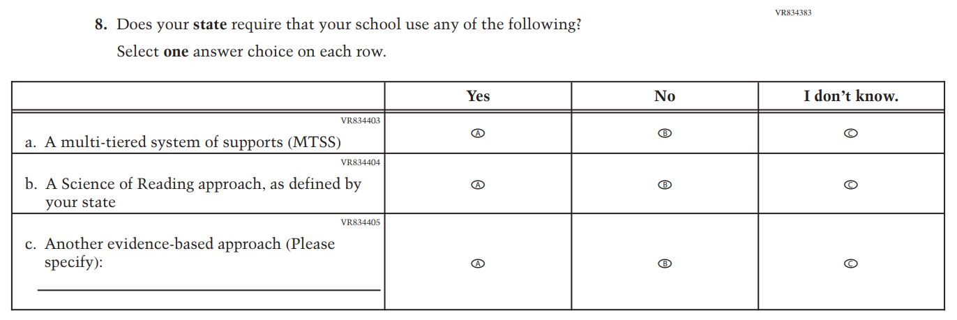

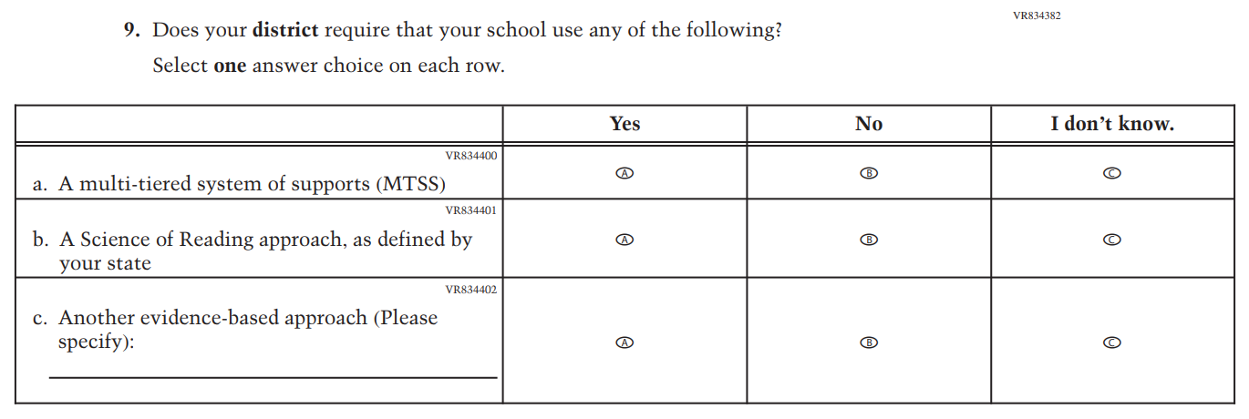

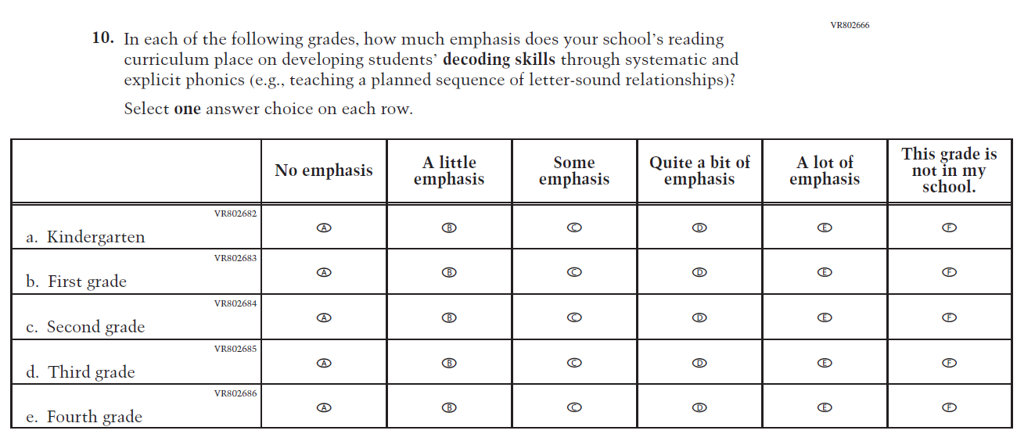

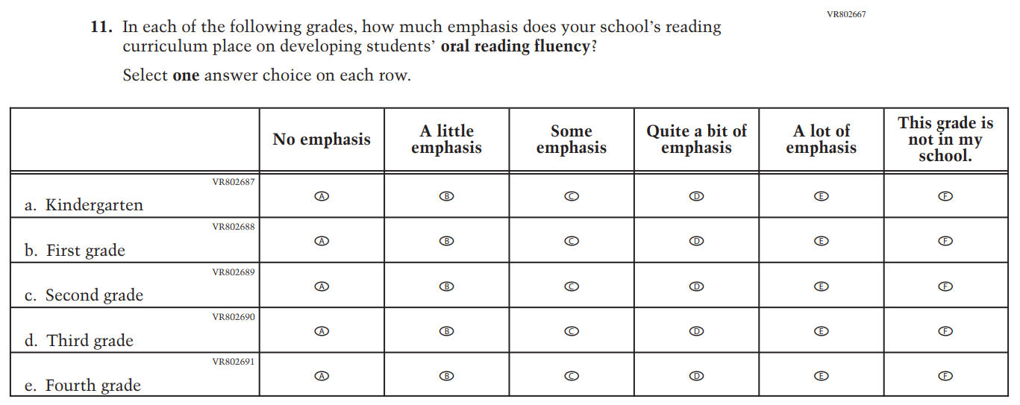

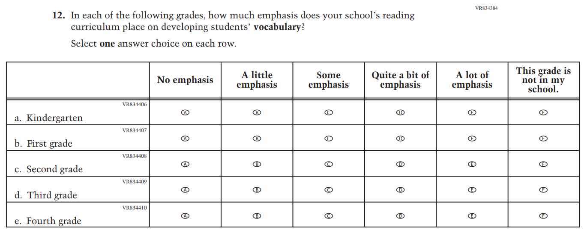

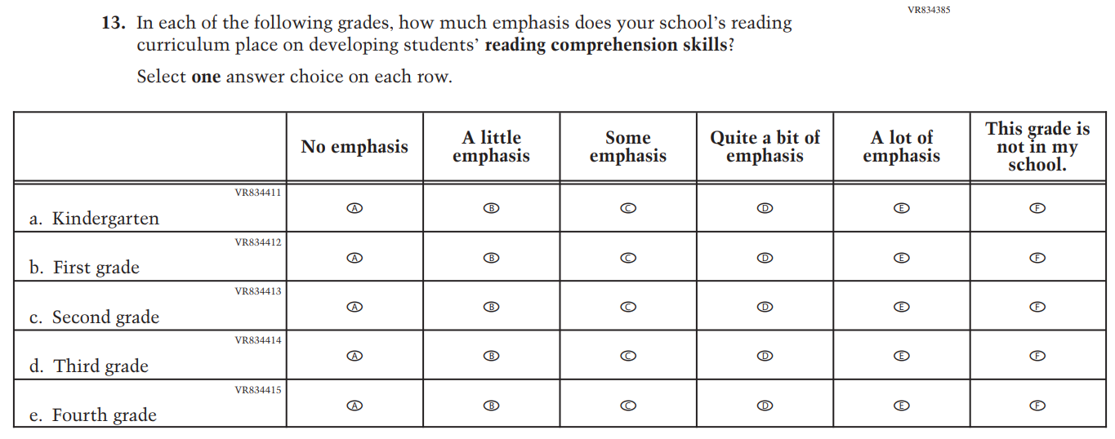

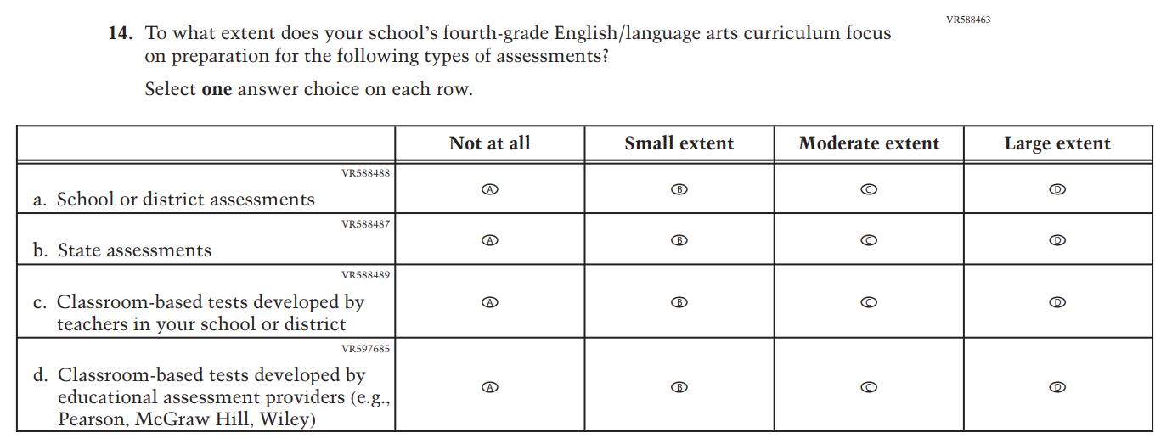

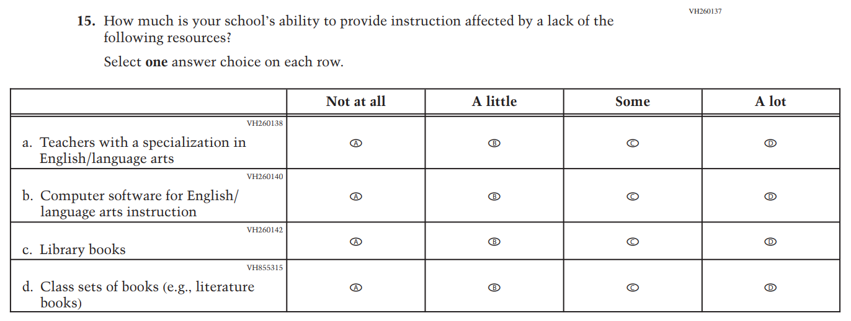

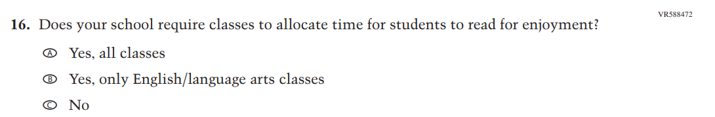

Appendix J3-24: Pilot Grade 12 (Reading)
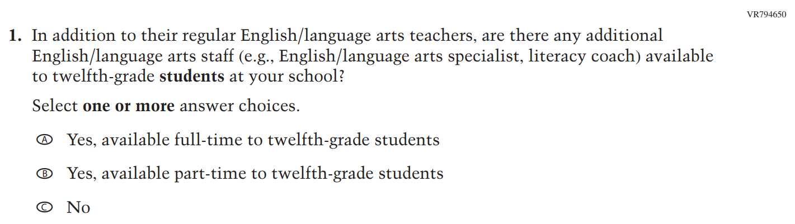

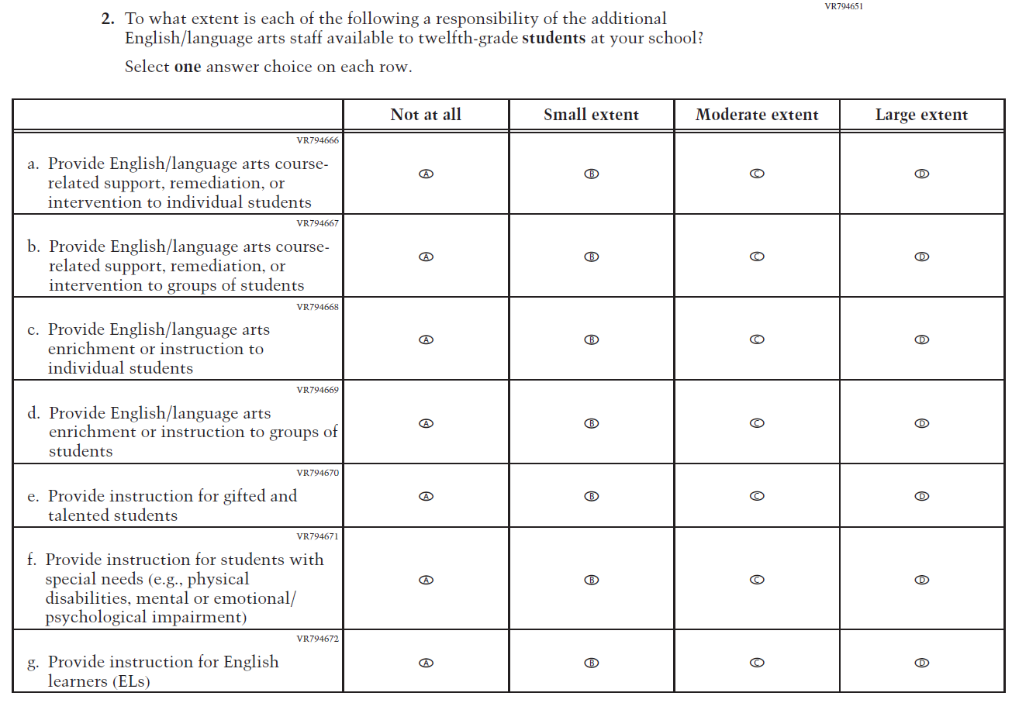

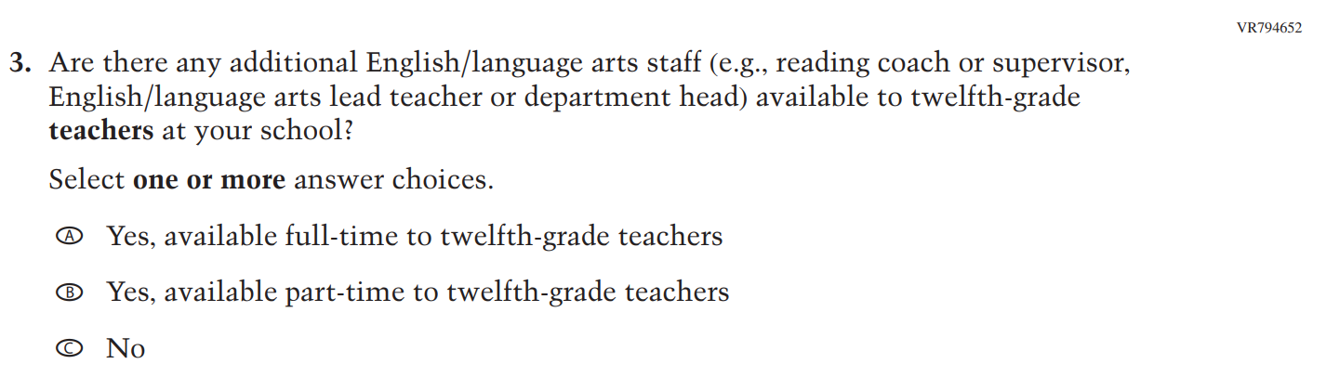

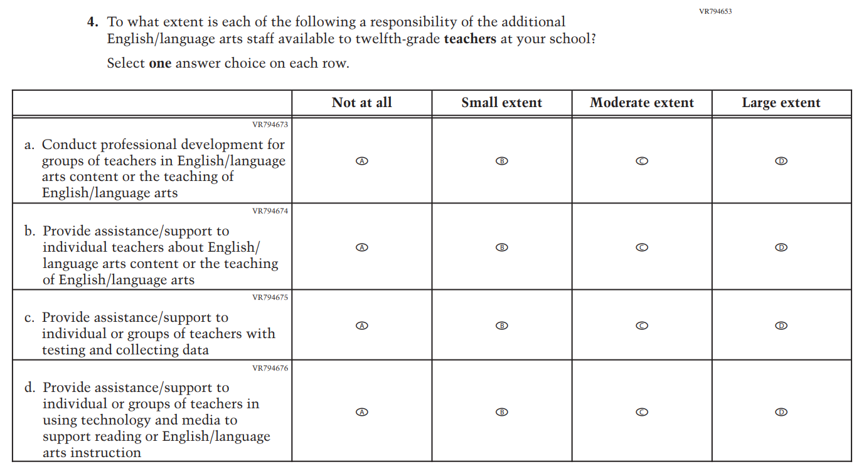

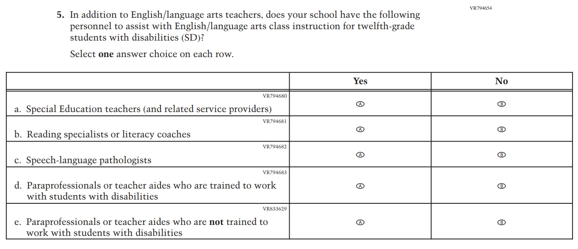

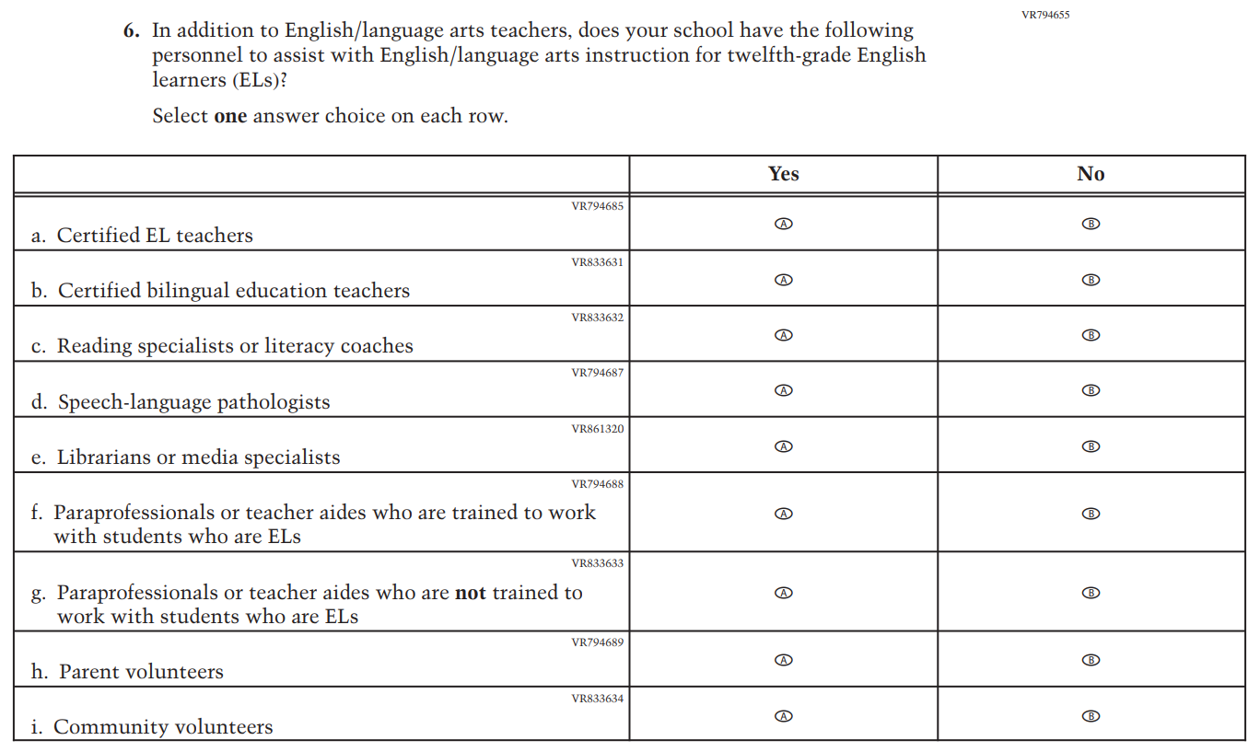

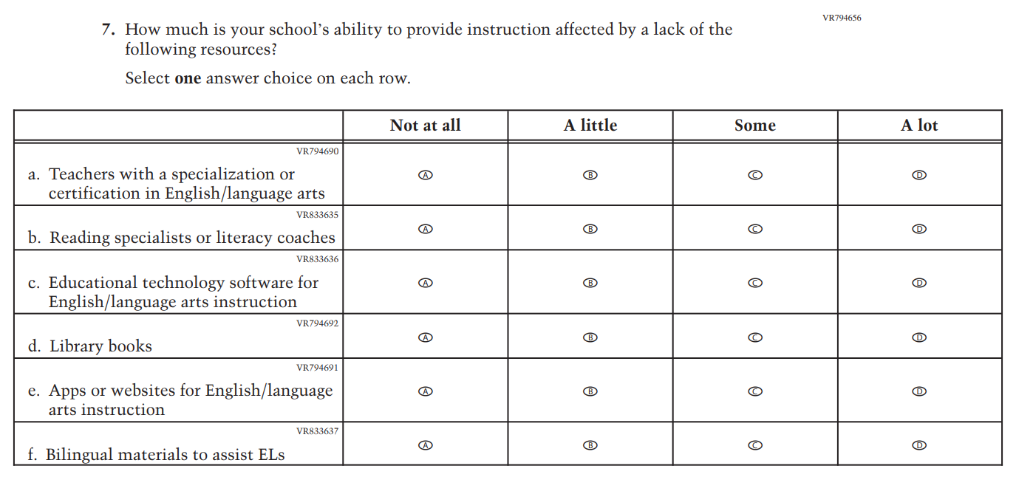

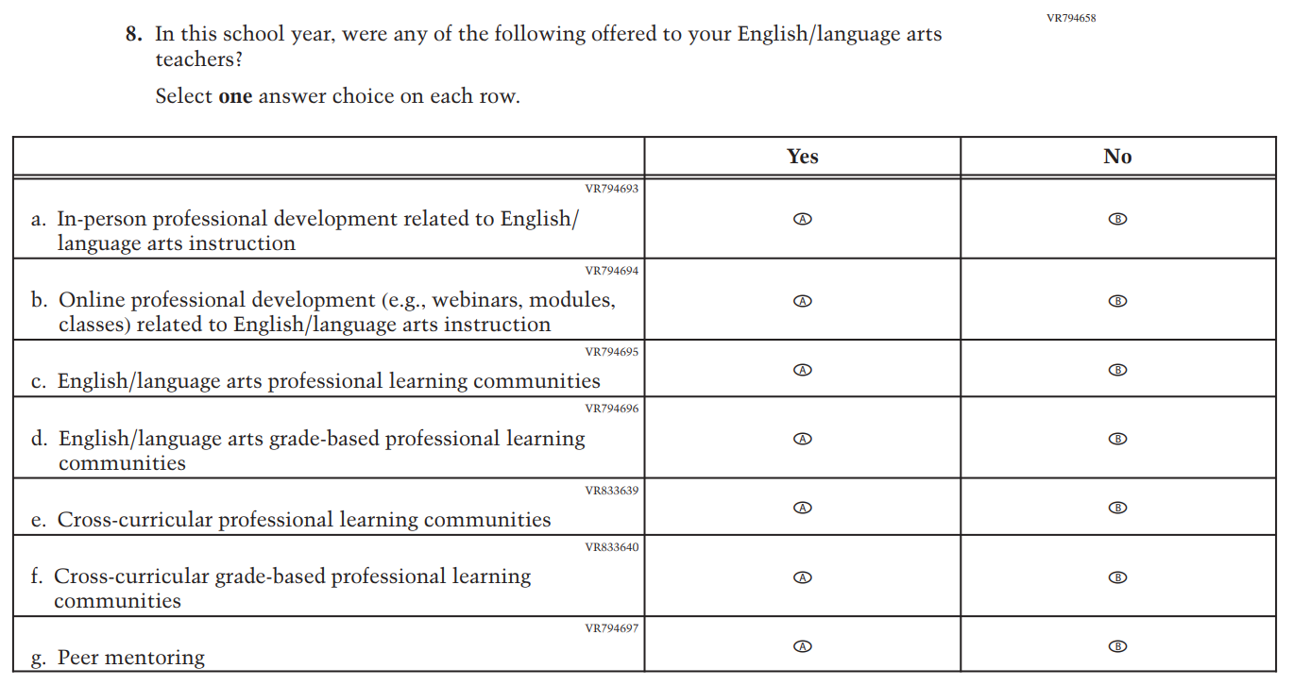

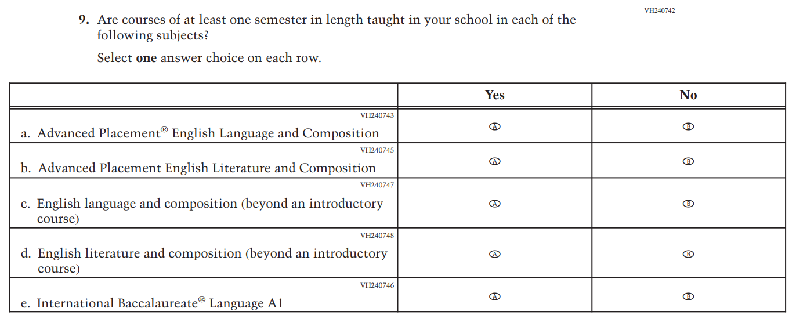

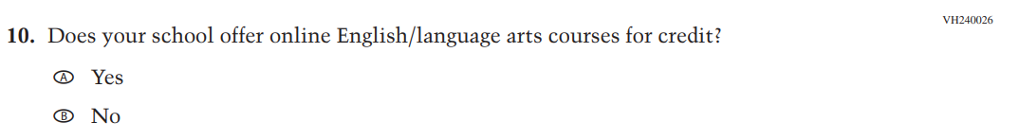

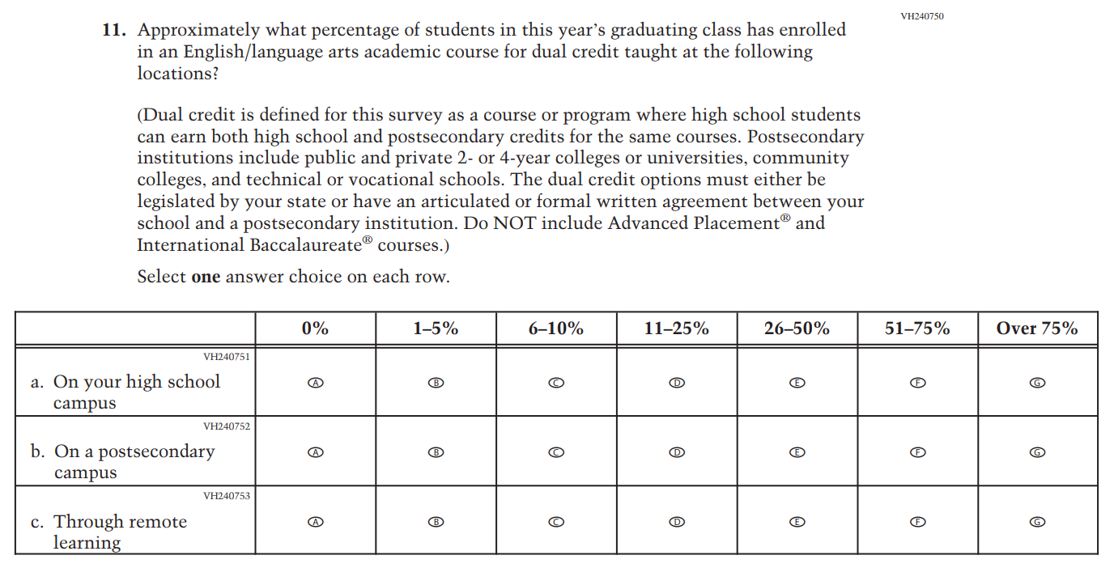

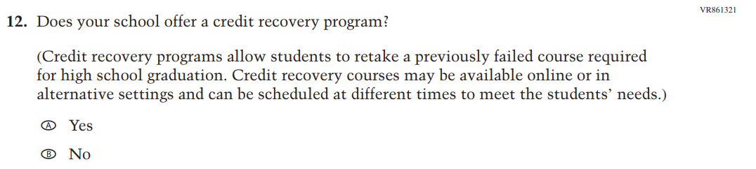

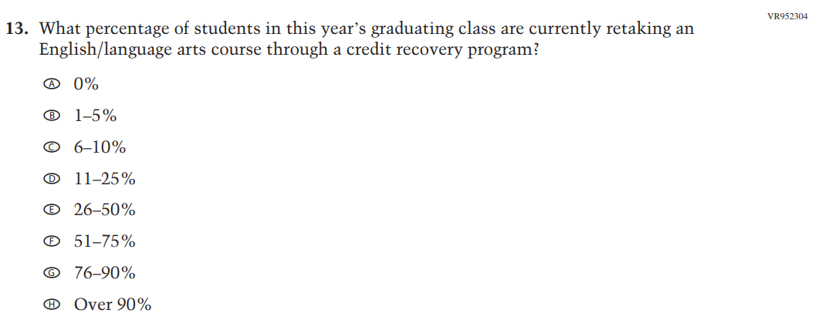

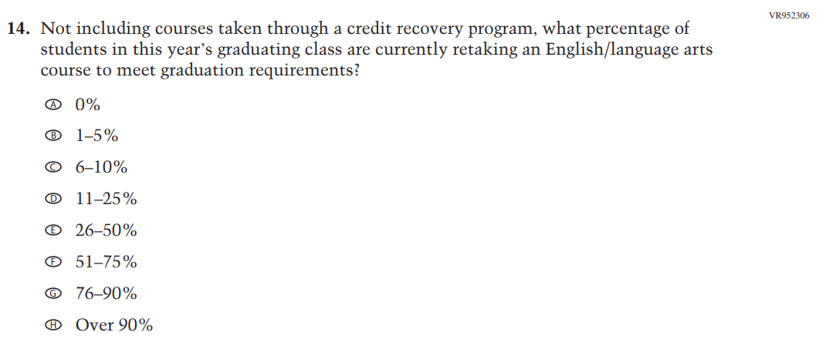

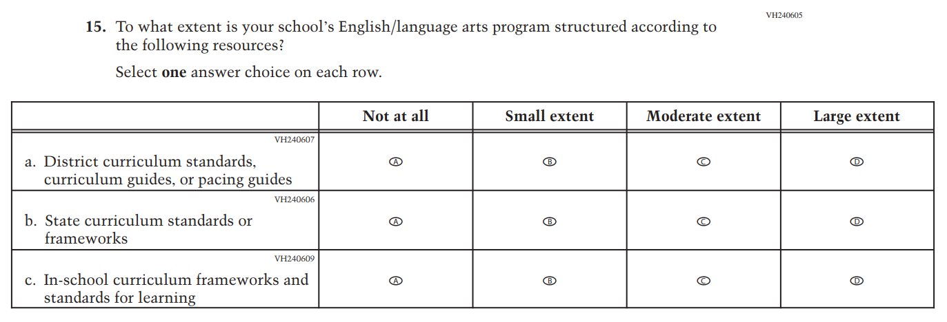

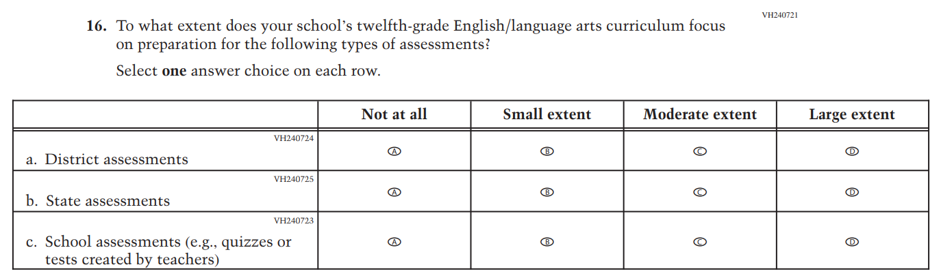

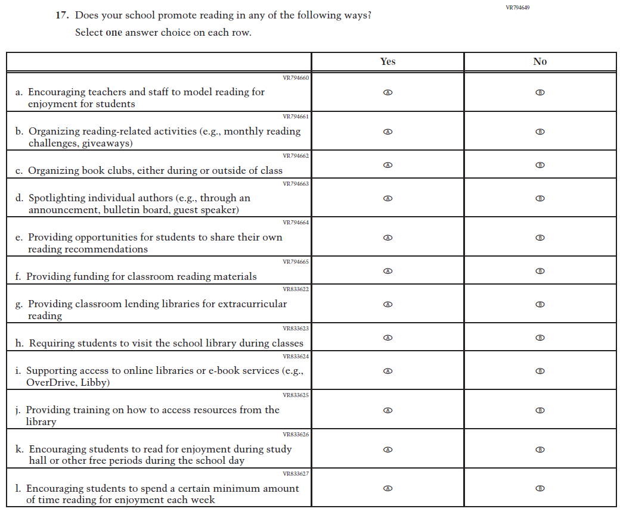

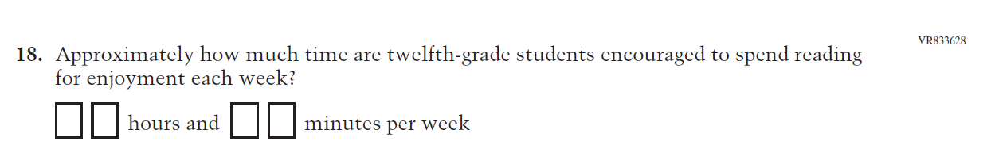

Appendix J3-25: Pilot Grade 4 (Charter School)

Appendix J3-25: Pilot Grade 12 (Charter School)
