Department of Transportation

Federal Motor Carrier Safety Administration

SUPPORTING STATEMENT

**“National Consumer Complaint Database” ICR**

**Renamed to the “FMCSA Complaint Center” ICR**

**OMB Control No. 2126-0067**

**SUMMARY**

* This information collection updates the instruments previously used to collect consumer complaint information. The Federal Motor Carrier Safety Administration (FMCSA) is modernizing its National Consumer Complaint Database (NCCDB) complaint system, now known as the FMCSA Complaint Center, and expanding the program to enhance FMCSA’s ability to centralize the collection, monitor and respond to complaints about Agency programs, establish reasonable procedures to provide timely responses to filers regarding their complaints, and share complaint information with the public as well as Federal and State agencies, as necessary and applicable.
* The six current collection instruments are being combined in one, central collection that can accommodate a total of 12 complaint categories. The estimated annual burden for this information collection is 16,137 hours. FMCSA estimates that the annual burden hours for this information collection have increased by approximately 11,499 hours from the previously approved 4,638 hours. The increase is due to the addition of new complaint categories and the year-over-year expected complaint increase and is consistent with the methodology of the previous information collection request (ICR).

**INTRODUCTION**

The Federal Motor Carrier Safety Administration (FMCSA) submits to the Office of Management and Budget (OMB) its request to modify and renew a currently approved information collection request (ICR) titled “National Consumer Complaint Database” covered by OMB Control Number 2126-0067. This ICR is due to expire on June 25, 2025. The National Consumer Complaint Database (NCCDB), now known as the FMCSA Complaint Center, is an online system to collect, investigate, and monitor complaints related to violations of Federal Motor Carrier Safety Regulations (FMCSRs). These complaints are submitted by consumers, drivers, and others associated with the motor carrier industry. Complaints are evaluated to determine if enforcement actions are applicable and necessary, provide consumers with guidance and alerts to protect their rights, educate the industry to promote compliance, and use complaint data to make Agency improvements.

**Part A. Justification**

1. **CIRCUMSTANCES THAT MAKE THE COLLECTION OF INFORMATION NECESSARY**

The FMCSA maintains online information and resources to assist consumers, drivers, and others associated with the motor carrier industry to help them understand regulatory requirements and consumer protection rights and, if necessary, file a complaint with the Agency. When effectively applied, this information can contribute to safer broker and motor carrier operations on our nation’s highways and improved consumer protection. NCCDB complaint data also provides FMCSA with statistical information regarding brokers and motor carriers, in particular the household goods moving industry. NCCDB data is used to alert consumers of those brokers and motor carriers with a history of complaints related to transporting household goods and helps FMCSA provide guidance to the public on how to avoid being victimized by unscrupulous moving companies. The data also allows FMCSA to identify problematic brokers and motor carriers for enforcement actions and promote compliance. Motor carriers, brokers, and other FMCSA-regulated entities can use NCCDB data to assist with complaint reconciliation.

Since 2016, the NCCDB system, now known as the FMCSA Complaint Center, has been the central repository for motor carrier complaints received by FMCSA; however, responding to complaints has a long-standing Agency regulatory history. Congress first mandated a Safety Violation Hotline Service in Section 4017 of the “Transportation Equity Act of the 21st Century,” Public Law 105–178, 112 Stat. 107 (June 9, 1998). Congress directed DOT to establish, maintain, and promote the use of a nationwide toll-free telephone system to be used by drivers of commercial motor vehicles and others to report potential violations of FMCSRs.

The Motor Carrier Safety Improvement Act of 1999, Public Law 106–159, 113 Stat. 1748 (December 9, 1999), created the Federal Motor Carrier Safety Administration and expanded the Safety Violation Hotline Service to include a 24-hour operation and accept consumer complaints on violations of the commercial regulations previously administered by the Interstate Commerce Commission (i.e., household goods and hostage load complaints).

The Safe, Accountable, Flexible, and Efficient Transportation Equity Act: A Legacy for Users, (SAFETEA–LU), Public Law 109–59, 119 Stat. 1144 (August 10, 2005) required FMCSA to create a system, database, and procedures for filing and logging consumer complaints relating to household goods motor carriers for the purpose of compiling or linking complaint information gathered by FMCSA and the States with regard to such carriers. SAFETEA–LU also required FMCSA to create procedures to allow the public to have access, subject to 5 U.S.C. 552(a), to aggregated complaint information and a process for carriers to challenge duplicate or fraudulent information in the database.

Complaints are also accepted through the NCCDB in connection with other statutory mandates including the protection of drivers against harassment and coercion under sections 32301(b) and 32911, respectively, of the Moving Ahead for Progress in the 21st Century Act, Public Law 112–141, 126 Stat. 405 (July 6, 2012).

FMCSA is in the process of modernizing its NCCDB complaint program and system as well as expanding the program alongside process recommendations submitted by the U.S. Government Accountability Office in September 2023. These recommendations are being implemented to expand and enhance FMCSA’s ability to centralize the collection, monitoring, and response to complaints, establish reasonable procedures to provide timely responses to filers regarding their complaints, and share complaint information with the public as well as Federal and State agencies, as necessary and applicable.

1. **HOW, BY WHOM, AND FOR WHAT PURPOSE IS THE INFORMATION USED**

Consumers may file a complaint with the Agency several ways: 1) by visiting the NCCDB website online where they will be guided through the process of filing a complaint; 2) submitting complaints or make an inquiry by calling the FMCSA’s toll-free number; or 3) submitting information to the FMCSA’s mailing address. Mail submissions are scanned and manually entered in the NCCDB by a customer service agent. The FMCSA may also receive a consumer complaint through a third-party referral such as from a Congressional office or other agencies (e.g., the Office of the Inspector General, State law enforcement) which are also entered in the NCCDB by a customer service agent.

Once submitted, complaints undergo a series of phases where the complaint is first reviewed to ensure completeness/correctness, then vetted to determine whether the complaint falls under an area in which FMCSA has jurisdiction. If so, the complaint is prioritized for investigation and intervention (as necessary and applicable). Complaint information is also used by the Agency to provide guidance to the public on how to avoid being victimized by unscrupulous companies and take enforcement action against companies in accordance with Agency enforcement authority.

1. **EXTENT OF AUTOMATED INFORMATION COLLECTION**

The FMCSA Complaint Center (formerly NCCDB) is being modernized as a case management system that operates on the DOT Salesforce environment, a vendor-provided service and cloud platform. Salesforce is an external, Platform as a Service (PaaS) cloud-based customer relationship management platform offering extensive options for configuring workflows, databases, forms, dashboards and reports, process modeling, and customizable user interfaces. Salesforce enables the FMCSA to quickly and efficiently build secure applications that automate manual business processes such as:

* Collection and use of data via phone, web forms, chats, or email allowing the FMCSA to quickly connect and solve consumer cases or complaints;
* Ability to automate helpdesk ticket resolution, escalate consumer concerns and complaints to the right Agency office(s), and resolve consumer issues and concerns;
* Standardized data collection methods and processes, such as standardizing the format of mailing addresses and customization of form fields, to collect the same type and amount of data to reduce duplicative and incorrect information; and
* Letter generation services to automate the creation of letters via pre-approved templates that are easily importable into mailing printing and postage machines or notifications that can be e-mailed automatically.

1. **EFFORTS TO IDENTIFY DUPLICATION**

There are no similar filings made with any other Federal agency or within the Department of Transportation which would result in duplication of this information.

1. **EFFORTS TO MINIMIZE THE BURDEN ON SMALL BUSINESSES**

The FMCSA evaluated the number of complaint types as well as commonalities among complaint collection and developed a single web-based form to collect the basic amount of complaint information needed for evaluation. This new form does not change the burden hours for collection, rather it offers a streamlined, easier customer experience using the Agency's new Salesforce customer relationship management product. This change also added new complaint categories that were collected via other Agency programs, thus reducing confusion or duplicated efforts if a complaint falls under more than one category. Complaint categories in the NCCDB update include:

* **Moving Company.** Complaint alleging a violation against a moving company, moving broker or auto hauler that was hired for a personal household move across state lines where the company failed to provide services, conducted deceptive business practices, does not have required operating authority or the right type/amount of required insurance on file.
* **Drug and Alcohol Service Agents.** Complaint alleging a violation against a Collection Site, Medical Review Officer (MRO), Substance Abuse Professional (SAP), or Consortium Third Party Administrator (CTPA) who failed to provide the required reporting, eligibility, or testing information in the Drug and Alcohol Clearinghouse.
* **Electronic Logging Device Provider.** Complaint alleging a violation against an Electronic Logging Device (ELD) technology provider who has failed to respond to a service request in a timely manner or is unable or unwilling to resolve the identified issue with the device.
* **Entry Level Driver Training/Training Provider.** Complaint alleging a violation against a training provider who is in violation of requirements for entry level driver training. This could include failing to use the required curriculum or instructor materials, instructors not certified, not using facilities/vehicles that are safe and proper, or issuing fraudulent commercial driver's licenses.
* **Hazardous Materials Transportation.** Complaint against a hazardous materials motor carrier or shipper alleging improper loading and securement, improper/missing placards, labels, markings, or papers, improper or no FMCSA registration or insurance. This category also overlaps with motorist complaints where allegations also include improper parking, unattended vehicle when attendance is required, employee not trained, leaking, or package defect.
* **Intermodal Equipment Provider.** Complaint against an intermodal equipment provider alleging that the entity does not appropriately mark, inspect, repair, or maintain equipment, make equipment available for interchange, have procedures in place, and provide sufficient space for drivers to perform a pre-trip inspection of tendered intermodal equipment. Also includes allegations of inadequate procedures to repair any equipment damage, defects, or deficiencies identified as part of a pre-trip inspection, or replace the equipment, prior to the driver's departure as well as operating without appropriate FMCSA registration.
* **Motorist Safety.** Complaint against a truck, bus, or hazardous materials carrier alleging safety concern(s) such as truck speeding, driving recklessly, or a cargo tank leaking or not properly secured. Filers may also file a complaint that the company does not have required operating authority or the right type/amount of required insurance on file.
* **Truck Company.** Complaint alleging a safety violation against a truck company for safety concern(s) such as truck speeding and driving recklessly.
* **Occupational Safety and Health Administration.** Complaint alleging a violation against an employer for harassment, discrimination, coercion, wrongful termination, or the company failing to adhere to requirements (e.g., operating authority, safety, hazardous materials, insurance, electronic device logging, testing or training). Complaints received by FMCSA that are within the regulatory jurisdiction of the U.S. Department of Labor are referred to the Occupational Safety and Health Administration (Directorate of Whistleblower Protection Programs) or the Equal Employment Opportunity Commission.
* **Bus Company.** Complaint alleging a violation against a bus company for inadequate service during the trip or ticketing process, unsafe riding conditions, discrimination, no operating authority or the right type/amount of required insurance on file; alleging a violation against an FMCSA-regulated bus operator specific to an Americans with Disabilities Act violation.
* **Property Broker.** Complaint against a property broker alleging a violation for not maintaining transaction records or financial accounts with the required information, failing to maintain FMCSA registration or insurance, misrepresenting services, or conducting improper rebating or compensation practices.
* **Registration-Related Fraud and Identity Theft.** Complaints against an entity or individual alleging that registration information has been used for unauthorized purposes, obtained under false pretenses, or contains false or misleading information on a registration application (new or change request). Also includes instances where an entity or individual has engaged in aggressive marketing, phishing, or other such tactic to obtain unauthorized access to a registration account.

1. **IMPACT OF LESS FREQUENT COLLECTION OF INFORMATION**

FMCSA is not able to consider less frequent collection of information as the Agency is not requiring the submission of information at specified intervals. The information collection is driven by the filers, and filers file complaints when they believe violations have occurred. Fewer complaints would mean less information that the Agency can use to form the basis for investigations, which could lead to fewer investigations/discoveries of regulatory violations.

1. **SPECIAL CIRCUMSTANCES**

There are no special circumstances related to this ICR.

1. **COMPLIANCE WITH 5 CFR 1320.8**:

On January 3, 2025, FMCSA published a notice in the Federal Register (90 FR 382) with a 60-day public comment period to announce its intention to submit this ICR to OMB for renewal. FMCSA received four comments in response to the published notice.

One comment was received from the American Trucking Associations (ATA) and its Moving and Storage Conference (MSC), expressing strong support for modernizing the National Consumer Complaint Database (NCCDB). The commenters emphasized the NCCDB’s role in consumer protection and fraud detection, endorsed GAO’s 2023 recommendations, and called for improvements such as clearer branding, enhanced staffing, and data analytics to detect repeat offenders.

FMCSA reviewed the comment submitted by ATA and MSC and finds the recommendations and considerations listed above are not directly applicable to requesting OMB review and approval of this ICR. However, FMCSA will consider these comments as it takes advantage of the new, enhanced technology and system design, adds fraud prevention and security measures, simplifies a complex application process, and improves data quality and safety.

One comment was received from the Transportation Intermediaries Association (TIA), urging FMCSA to modernize the NCCDB in light of rising freight fraud, including identity theft and double brokering. TIA supported GAO’s recommendations and proposed improvements such as automated complaint tracking, expanded reporting categories, and public access to complaint outcomes.

FMCSA reviewed the comment submitted by TIA and finds that not all suggestions are directly applicable to the specific burden and information collection elements under review by OMB. However, FMCSA recognizes the importance of addressing freight fraud and will take these comments into account during broader system development and enforcement improvement efforts. As part of the NCCDB modernization, FMCSA intends to conduct usability testing in a future development phase to help ensure the complaint submission process is intuitive, efficient, and minimizes filer burden. FMCSA is also evaluating the feasibility of expanding reporting categories, automating compliance tracking, and enhancing analytics to improve the collection’s effectiveness. In addition, FMCSA plans to make aggregated complaint information available to the public through the new complaint search feature. The Agency will also implement an outreach plan to increase public awareness of the complaint process and will use complaint data analytics to identify patters of noncompliance, guide enforcement priorities, and supports program evaluation.

One comment was received jointly from the Truck Safety Coalition (TSC), Citizens for Reliable and Safe Highways (CRASH), and Parents Against Tired Truckers (PATT), emphasizing the need for the NCCDB to better support safety enforcement. They cited increased truck crash fatalities and recommended more transparency, timely complaint handling, and integration of safety complaints into FMCSA oversight activities.

FMCSA reviewed the comment submitted by TSC, CRASH, and PATT. While the concerns raised are not directly applicable to the current ICR, FMCSA will consider these recommendations as it modernizes the NCCDB to enhance public trust, accountability, and carrier oversight.

One comment was received from the Small Business in Transportation Coalition (SBTC), criticizing FMCSA for failing to follow through on its 2013 commitment to accept complaints against unauthorized brokerage activity through the NCCDB. SBTC noted that FMCSA had pledged to gather such complaints, collaborate with industry, and implement an enforcement program—none of which have materialized over the past decade. The commenter urged current leadership to address this oversight and implement long-promised protections.

FMCSA reviewed the comment submitted by SBTC and finds that the concerns raised are not applicable to the current request for OMB review and approval of this ICR. However, FMCSA acknowledges the issue of unregistered brokerage activity and will consider the comment as it evaluates broader enforcement priorities and potential enhancements to complaint intake and tracking functions.

1. **PAYMENT OF GIFTS TO RESPONDENT**

There are no payments or gifts to respondents for this information collection.

1. **ASSURANCE OF CONFIDENTIALITY**

The collection of information will be kept private to the extent allowed under the Freedom of Information Act, the Privacy Act, and any other applicable Federal law.

1. **JUSTIFICATION FOR COLLECTION OF SENSITIVE INFORMATION**

The information requested and collected is not of a sensitive nature.

1. **ESTIMATE OF BURDEN HOURS FOR INFORMATION REQUESTED**

Complaints are filed voluntarily using the toll-free number or through the system website. Filers are asked to provide name and contact information (though neither is required) and selectable options associated with their complaint type to refine which one(s) of the allegations applies. Next, the filer is prompted to provide a narrative description of their issue and the proposed resolution in a free-form text box. The NCCDB also provides an option for the consumer to upload documentation to support their complaint. The documentation that a consumer chooses to upload may contain pictures, invoices, correspondence, and other evidence that supports the complaint allegation.

|  |  |  |
| --- | --- | --- |
| **FMCSA Complaint Center Complaint Information Collection Update**  **(ICR Reference Number: 202112-2126)** | | |
| **No.** | **NCCDB Collection Field Name** | **NCCDB Field Description & Purpose** |
| 1 | First Name, Last Name of the Complaint Filer | Option for the filer to have an individual submit a complaint on their behalf or mark that they wish to remain anonymous |
| 2 | E-mail Address | Address that will be used to send complaint correspondence and notification updates |
| 3 | Telephone Number | Number used by FMCSA investigators/program office staff to schedule an interview to request additional information |
| 4 | Mailing Address (Street, City, Zip) | Address for mailing documents if required by Agency regulations; otherwise, e-mail will be the primary source of communication |
| 5 | Privacy Option | Yes/No selection to have the complaint information sent to the entity by FMCSA and if the filer wishes to have their contact information be released (or redacted) |
| 6 | USDOT Number and/or Legal Name of the entity who committed the alleged violation | System functionality allows filer to search the FMCSA database to select the correct USDOT Number and/or Legal Name |
| 7 | Employee Selection | Check-mark system feature for the filer to select if they are an employee of the entity who committed the violation |
| 8 | Complaint and Allegation Type Selections | Series of check-mark boxes for the filer to select the complaint types and any/all complaint type allegations that apply |
| 9 | Date of the Alleged Incident | Calendar date feature for the filer to select the date of the incident |
| 10 | Location of Incident | Where the incident occurred, only applicable to the motorist complaint type |
| 11 | Origin City/State & Destination City/State | The route that the filer was on when the incident occurred, applicable to bus service, bus ADA complaints, and transportation of household goods shipments |
| 12 | Narrative description of the incident | 700-word limit, with a sample template available for viewing |
| 13 | Uploaded document evidence and/or additional complaint information | Website "drag and drop" feature to easily add photos or pdf documents that support the chosen allegations |
| 14 | Certification Statement | Check-mark system acknowledgement to affirm that the complaint information is true, accurate and complete |

Online Complaint Form Version

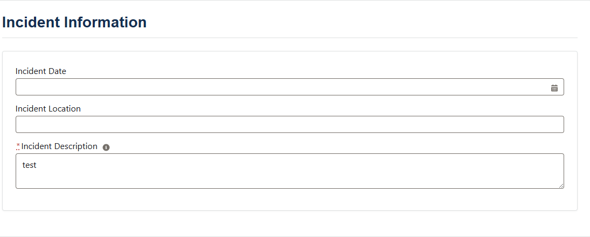

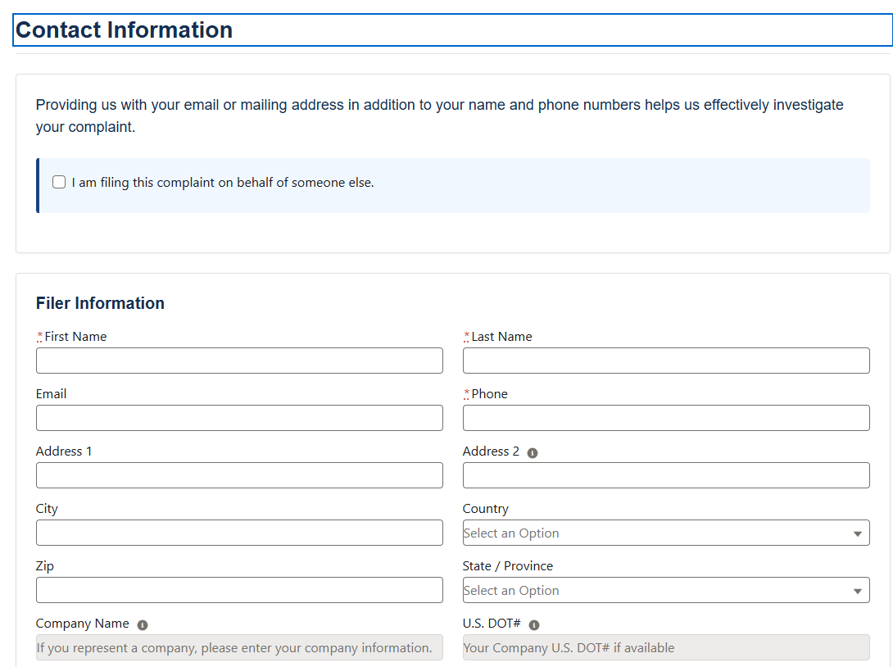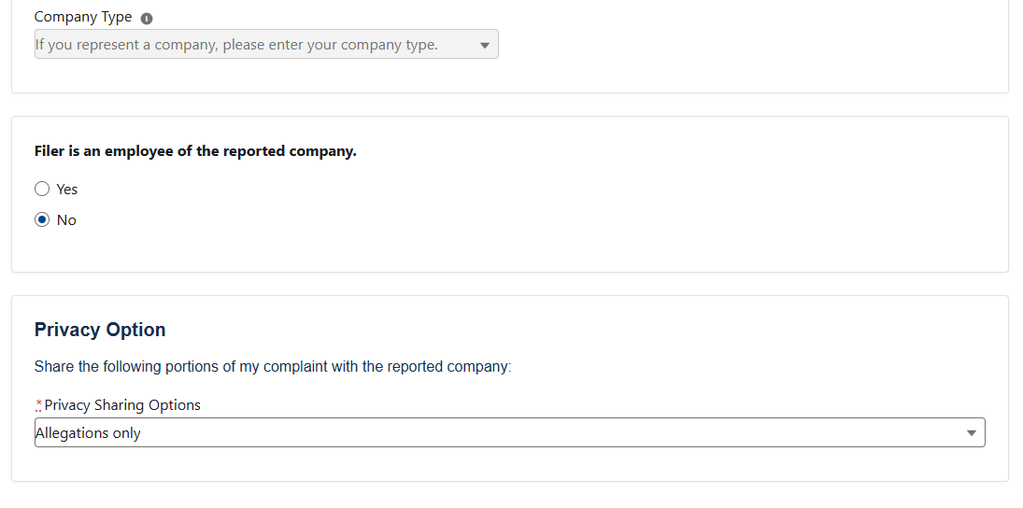

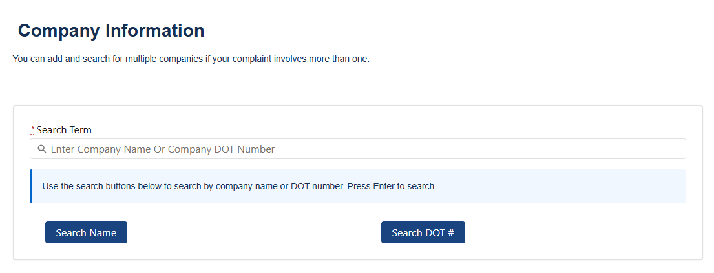

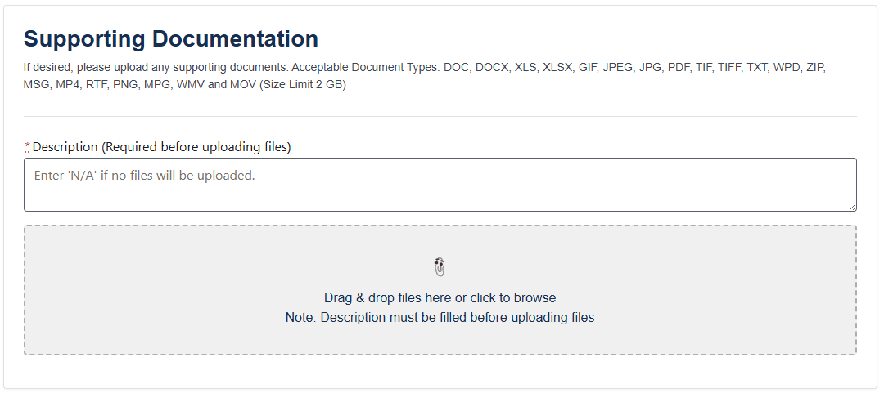

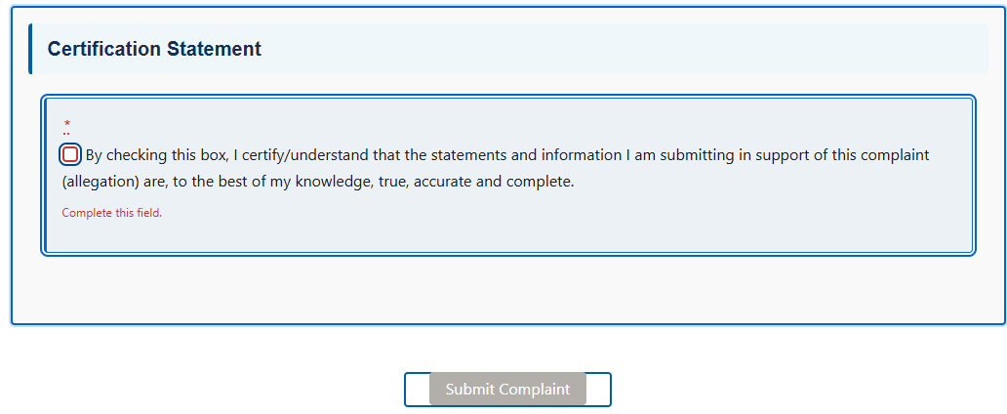

To calculate annual filer hourly burden and cost estimates, FMCSA compiled complaint volume data for each complaint category reported. The following assumptions are made for each category:

* One complaint will be filed by a single filer. [1]
* The number of responses filed will increase 20% year-over-year. This is based on previous year-over-year increases.
* The average hourly cost to respondents is $46.14 per hour, which includes $31.72 in wages and salary and $14.41 in total benefits. [2]

Details of how annual burden hours and associated costs are calculated are broken out in the following sections.

IC-1: Moving Company

During CY 2024, the NCCDB recorded 9,473 Moving Company complaints. Based on an expected 20% year-to-year increase, FMCSA estimates that in 2025 11,368 Moving Company responses will be filed on behalf of 11,368 respondents. Each respondent will spend 15 minutes, or 0.25 hours completing a response, resulting in a total of 2,842 burden hours (11,368 respondents × 0.25 hours = 2,842 hours). During the first year, the total annual respondent cost is $131,125 ($46.14 per hour × 2,842 hours = $131,125).

**Table 1. Moving Company Burden Hour Estimates**

|  |  |  |  |  |  |
| --- | --- | --- | --- | --- | --- |
| **Year** | **Number of Responses** | **Number of Respondents** | **Average Burden per Response** | **Total Burden Hours** | **Total**  **Respondent Cost** |
|  | **(a)** | **(a × 1 = b)** | **©** | **(b × c = d)** | **(d × $46.14=e)** |
| Year 1 (2025) | 11,368 | 11,368 | 0.25 | 2,842 | $131,125 |
| Year 2 (2026) | 13,641 | 13,641 | 0.25 | 3,410 | $157,350 |
| Year 3 (2027) | 16,369 | 16,369 | 0.25 | 4,092 | $188,820 |
| **Total** | **41,378** | **41,378** | **-** | **10,345** | ***$477,296*** |
| ***Annualized*** | ***13,793*** | ***13,793*** | ***-*** | ***3,448*** | ***$159,099*** |
| Estimates may not total due to rounding. | | | | | |

As shown in Table 1, the Moving Company information collection is expected to result in 13,793 average annual responses filed on behalf of 13,793 respondents, resulting in 3,448 average annual burden hours costing respondents $159,099 annually.

IC-2: Drug and Alcohol Service Agents

During CY 2024, the NCCDB recorded 2,523 Drug and Alcohol Service Agents complaints. Based on an expected 20% year-to-year increase, FMCSA estimates that in 2025 3,028 Drug and Alcohol Service Agents responses will be filed on behalf of 3,028 respondents. Each respondent will spend 15 minutes, or 0.25 hours completing a response, resulting in a total of 757 burden hours (3,028 respondents × 0.25 hours = 757 hours). During the first year, the total annual respondent cost is $34,923 ($46.14 per hour × 757 hours = $34,923).

Table 2*.* Drug and Alcohol Service Agents Respondents and Burden Hour Estimates

|  |  |  |  |  |  |
| --- | --- | --- | --- | --- | --- |
| **Year** | **Number of Responses** | **Number of Respondents** | **Average Burden per Response** | **Total Burden Hours** | **Total**  **Respondent Cost** |
|  | **(a)** | **(a / 1 = b)** | **(c)** | **(b × c = d)** | **(d × $46.14=e)** |
| Year 1 (2025) | 3,028 | 3,028 | 0.25 | 757 | $34,923 |
| Year 2 (2026) | 3,085 | 3,085 | 0.25 | 771 | $35,587 |
| Year 3 (2027) | 3,144 | 3,144 | 0.25 | 786 | $36,263 |
| **Total** | **9,256** | **9,256** | **-** | **2314** | **$106,773** |
| ***Annualized*** | ***3,085*** | ***3,085*** | ***-*** | ***771*** | ***$35,591*** |
| Estimates may not total due to rounding. | | | | | |

As shown in Table 2, the Drug and Alcohol Service Agents information collection is expected to result in 3,085 average annual responses filed on behalf of 3,085 respondents, resulting in 771 average annual burden hours costing respondents $35,591 annually.

IC-3: Electronic Logging Device Provider

During CY 2024, the NCCDB recorded 82 Electronic Logging Device Provider complaints. Based on an expected 20% year-to-year increase, FMCSA estimates that in 2025 98 Electronic Logging Device Provider responses will be filed on behalf of 98 respondents. Each respondent will spend 15 minutes, or 0.25 hours completing a response, resulting in a total of 25 burden hours (98 respondents × 0.25 hours = 25 hours). During the first year, the total respondent cost for year 1 is $1,135 ($46.14 per hour × 25 hours = $1,135).

**Table 3. Electronic Logging Device Provider Respondents and Burden Hour Estimates**

|  |  |  |  |  |  |
| --- | --- | --- | --- | --- | --- |
| **Year** | **Number of Responses** | **Number of Respondents** | **Average Burden per Response** | **Total Burden Hours** | **Total**  **Respondent Cost** |
|  | **(a)** | **(a / 1 = b)** | **(c)** | **(a × c = d)** | **(d × $46.14=e)** |
| Year 1 (2025) | 98 | 98 | 0.25 | 25 | $1,135 |
| Year 2 (2026) | 118 | 118 | 0.25 | 30 | $1,362 |
| Year 3 (2027) | 142 | 142 | 0.25 | 35 | $1,634 |
| **Total** | **358** | **358** | **-** | **90** | **$4,132** |
| ***Annualized*** | ***119*** | ***119*** | ***-*** | ***30*** | ***$1,377*** |
| Estimates may not total due to rounding. | | | | | |

As shown in Table 3, the Electronic Logging Device Provider information collection is expected to result in 119 average annual responses filed on behalf of 119 respondents, resulting in 30 average annual burden hours costing respondents $1,377 annually.

IC-4: Entry Level Driver Training/Training Provider

During CY 2024, the NCCDB recorded 291 Entry Level Driver Training/Training Provider complaints. Based on an expected 20% year-to-year increase, FMCSA estimates that in 2025 349 Entry Level Driver Training/Training Provider responses will be filed on behalf of 349 respondents. Each respondent will spend 15 minutes, or 0.25 hours completing a response, resulting in a total of 87 burden hours (349 respondents × 0.25 hours = 87 hours). During the first year, the total annual respondent cost is $4,028 ($46.14 per hour × 87 hours = $4,028).

**Table 4. Entry Level Driver Training/Training Provider Burden Hour Estimates**

|  |  |  |  |  |  |
| --- | --- | --- | --- | --- | --- |
| **Year** | **Number of Responses** | **Number of Respondents** | **Average Burden per Response** | **Total Burden Hours** | **Total**  **Respondent Cost** |
|  | **(a)** | **(a × 1 = b)** | **(c)** | **(b × c = d)** | **(d × $46.14=e)** |
| Year 1 (2025) | 349 | 349 | 0.25 | 87 | $4,028 |
| Year 2 (2026) | 419 | 419 | 0.25 | 105 | $4,834 |
| Year 3 (2027) | 503 | 503 | 0.25 | 126 | $5,800 |
| **Total** | **1,271** | **1,271** | **-** | **318** | ***$14,662*** |
| ***Annualized*** | ***424*** | ***424*** | ***-*** | ***106*** | ***$4,887*** |
| Estimates may not total due to rounding. | | | | | |

As shown in Table 4, the Entry Level Driver Training/Training Provider information collection is expected to result in 424 annual responses filed on behalf of 424 respondents, resulting in 106 annual burden hours costing respondents $4,887 annually.

IC-5: Hazardous Materials Transportation

During CY 2024, the NCCDB recorded 613 Hazardous Materials Transportation complaints. Based on an expected 20% year-to-year increase, FMCSA estimates that in 2025 736 Hazardous Materials Transportation responses will be filed on behalf of 736 respondents. Each respondent will spend 15 minutes, or 0.25 hours completing a response, resulting in a total of 184 burden hours (736 respondents × 0.25 hours = 184 hours). During the first year, the total annual respondent cost is $8,485 ($46.14 per hour × 184 hours = $8,485).

**Table 5. Hazardous Materials Transportation Burden Hour Estimates**

|  |  |  |  |  |  |
| --- | --- | --- | --- | --- | --- |
| **Year** | **Number of Responses** | **Number of Respondents** | **Average Burden per Response** | **Total Burden Hours** | **Total**  **Respondent Cost** |
|  | **(a)** | **(a × 1 = b)** | **(c)** | **(b × c = d)** | **(d × $46.14=e)** |
| Year 1 (2025) | 736 | 736 | 0.25 | 184 | $8,485 |
| Year 2 (2026) | 883 | 883 | 0.25 | 221 | $10,182 |
| Year 3 (2027) | 1059 | 1059 | 0.25 | 265 | $12,219 |
| **Total** | **2678** | **2678** | **-** | **669** | **$30,886** |
| ***Annualized*** | ***893*** | ***893*** | ***-*** | ***223*** | ***$10,295*** |
| Estimates may not total due to rounding. | | | | | |

As shown in Table 5, the Hazardous Materials Transportation information collection is expected to result in 893 average annual responses filed on behalf of 893 respondents, resulting in 223 average annual burden hours costing respondents $10,295 annually.

IC-6: Intermodal Equipment Provider

During CY 2024, the NCCDB recorded 45 Intermodal Equipment Provider complaints. Based on an expected 20% year-to-year increase, FMCSA estimates that in 2025 54 Intermodal Equipment Provider responses will be filed on behalf of 54 respondents. Each respondent will spend 15 minutes, or 0.25 hours completing a response, resulting in a total of 14 burden hours (54 respondents × 0.25 hours = 14 hours). During the first year, the total annual respondent cost is $623 ($46.14 per hour × 14 hours = $623).

**Table 6. Intermodal Equipment Provider Burden Hour Estimates**

|  |  |  |  |  |  |
| --- | --- | --- | --- | --- | --- |
| **Year** | **Number of Responses** | **Number of Respondents** | **Average Burden per Response** | **Total Burden Hours** | **Total**  **Respondent Cost** |
|  | **(a)** | **(a × 1 = b)** | **(c)** | **(b × c = d)** | **(d × $46.14=e)** |
| Year 1 (2025) | 54 | 54 | 0.25 | 14 | $623 |
| Year 2 (2026) | 65 | 65 | 0.25 | 16 | $747 |
| Year 3 (2027) | 78 | 78 | 0.25 | 20 | $897 |
| **Total** | **197** | **197** | **-** | **50** | ***$2,267*** |
| ***Annualized*** | ***66*** | ***66*** | ***-*** | ***17*** | ***$756*** |
| Estimates may not total due to rounding. | | | | | |

As shown in Table 6, the Intermodal Equipment Provider information collection is expected to result in 66 average annual responses filed on behalf of 66 respondents, resulting in 17 average annual burden hours costing respondents $756 annually.

IC-7: Motorist Safety

During CY 2024, the NCCDB recorded 6,001 Motorist Safety complaints. Based on an expected 20% year-to-year increase, FMCSA estimates that in 2025 7,201 Motorist Safety responses will be filed on behalf of 7,201 respondents. Each respondent will spend 15 minutes, or 0.25 hours completing a response, resulting in a total of 1,800 burden hours (7,201 respondents × 0.25 hours = 1,800 hours). During the first year, the total annual respondent cost is $83,052 ($46.14 per hour × 1,800 hours = $83,052).

**Table 7. Motorist Safety Burden Hour Estimates**

|  |  |  |  |  |  |
| --- | --- | --- | --- | --- | --- |
| **Year** | **Number of Responses** | **Number of Respondents** | **Average Burden per Response** | **Total Burden Hours** | **Total**  **Respondent Cost** |
|  | **(a)** | **(a × 1 = b)** | **(c)** | **(b × c = d)** | **(d × $46.14=e)** |
| Year 1 (2025) | 7,201 | 7,201 | 0.25 | 1,800 | $83,052 |
| Year 2 (2026) | 8,641 | 8,641 | 0.25 | 2,160 | $99,662 |
| Year 3 (2027) | 10,369 | 10,369 | 0.25 | 2,592 | $119,595 |
| **Total** | **26,211** | **26,211** | **-** | **6,552** | ***$302,309*** |
| ***Annualized*** | ***8,737*** | ***8,737*** | ***-*** | ***2,184*** | ***$100,770*** |
| Estimates may not total due to rounding. | | | | | |

As shown in Table 7, the Motorist Safety information collection is expected to result in 8,737 average annual responses filed on behalf of 8,737 respondents, resulting in 2,184 average annual burden hours costing respondents $100,770 annually.

IC-8: Truck Company

During CY 2024, the NCCDB recorded 17,913 Truck Company complaints. Based on an expected 20% year-to-year increase, FMCSA estimates that in 2025 21,496 Truck Company responses will be filed on behalf of 21,496 respondents. Each respondent will spend 15 minutes, or 0.25 hours completing a response, resulting in a total of 5,374 burden hours (21,496 respondents × 0.25 hours = 5,374 hours). During the first year, the total annual respondent cost is $247,956 ($46.14 per hour × 5,374 hours = $247,956).

**Table 8. Truck Company Burden Hour Estimates**

|  |  |  |  |  |  |
| --- | --- | --- | --- | --- | --- |
| **Year** | **Number of Responses** | **Number of Respondents** | **Average Burden per Response** | **Total Burden Hours** | **Total**  **Respondent Cost** |
|  | **(a)** | **(a × 1 = b)** | **(c)** | **(b × c = d)** | **(d × $46.14=e)** |
| Year 1 (2025) | 21,496 | 21,496 | 0.25 | 5,374 | $247,956 |
| Year 2 (2026) | 25,795 | 25,795 | 0.25 | 6,449 | $297,557 |
| Year 3 (2027) | 30,954 | 30,954 | 0.25 | 7,739 | $357,078 |
| **Total** | **78,245** | **78,245** | **-** | **19,562** | ***$902,591*** |
| ***Annualized*** | ***26,082*** | ***26,082*** | ***-*** | ***6,521*** | ***$300,864*** |
| Estimates may not total due to rounding. | | | | | |

As shown in Table 8, the Truck Company information collection is expected to result in 26,082 average annual responses filed on behalf of 26,082 respondents, resulting in 6,521 average annual burden hours costing respondents $300,864 annually.

IC-9: Occupational Safety and Health Administration

During CY 2024, the NCCDB recorded 2,819 Occupational Safety and Health Administration complaints. Based on an expected 20% year-to-year increase, FMCSA estimates that in 2025 3,383 Occupational Safety and Health Administration responses will be filed on behalf of 3,383 respondents. Each respondent will spend 15 minutes, or 0.25 hours completing a response, resulting in a total of 846 burden hours (3,383 respondents × 0.25 hours = 846 hours). During the first year, the total annual respondent cost is $39,021 ($46.14 per hour × 846 hours = $39,021).

**Table 9. Occupational Safety and Health Administration Burden Hour Estimates**

|  |  |  |  |  |  |
| --- | --- | --- | --- | --- | --- |
| **Year** | **Number of Responses** | **Number of Respondents** | **Average Burden per Response** | **Total Burden Hours** | **Total**  **Respondent Cost** |
|  | **(a)** | **(a × 1 = b)** | **(c)** | **(b × c = d)** | **(d × $46.14=e)** |
| Year 1 (2025) | 3,383 | 3,383 | 0.25 | 846 | $39,021 |
| Year 2 (2026) | 4,059 | 4,059 | 0.25 | 1,015 | $46,825 |
| Year 3 (2027) | 4,871 | 4,871 | 0.25 | 1,218 | $56,190 |
| **Total** | **12,313** | **12,313** | **-** | **3,078** | ***$142,035*** |
| ***Annualized*** | ***4,104*** | ***4,104*** | ***-*** | ***1,026*** | ***$47,345*** |
| *Estimates may not total due to rounding. | | | | | |

As shown in Table 9, the Occupational Safety and Health Administration information collection is expected to result in 4,104 average annual responses filed on behalf of 4,104 respondents, resulting in 1,026 average annual burden hours costing respondents $47,345 annually.

IC-10: Bus Company

During Calendar Year (CY) 2024 the NCCDB recorded 1,040 Bus Company complaints. Based on an expected 20% year-to-year increase FMCSA estimates that in 2025 1,248 Bus Company responses will be filed on behalf of 1,248 respondents. Each respondent will spend 15 minutes, or 0.25 hours completing a response, resulting in a total of 312 burden hours (1,248 respondents × 0.25 hours = 312 hours). During the first year, the total annual respondent cost is $14,396 ($46.14 per hour × 312 hours = $14,396).

Table 10*.* Bus Company Respondents and Burden Hour Estimates*

|  |  |  |  |  |  |
| --- | --- | --- | --- | --- | --- |
| **Year** | **Number of Responses** | **Number of Respondents** | **Average Burden per Response** | **Total Burden Hours** | **Total**  **Respondent Cost** |
|  | **(a)** | **(a × 1 = b)** | **(c)** | **(a × c = d)** | **(d × $46.14=e)** |
| Year 1 (2025) | 1,248 | 1,248 | 0.25 | 312 | $14,396 |
| Year 2 (2026) | 1,498 | 1,498 | 0.25 | 374 | $17,275 |
| Year 3 (2027) | 1,797 | 1,797 | 0.25 | 449 | $20,730 |
| **Total** | **4,543** | **4,543** | **-** | **1,136** | **$52,400** |
| ***Annualized*** | ***1,514*** | ***1,514*** | ***-*** | ***379*** | ***$17,467*** |
| * Estimates may not total due to rounding. | | | | | |

As shown in Table 10, the Bus Company information collection is expected to result in 1,514 average annual responses filed on behalf of 1,514 respondents, resulting in 379 average annual burden hours at a cost of $17,467 annually.

IC-11: Property Broker

During CY 2024, the NCCDB recorded 2,572 Property Broker complaints. Based on an expected 20% year-to-year increase, FMCSA estimates that in 2025 3,086 Property Broker responses will be filed on behalf of 3,086 respondents. Each respondent will spend 15 minutes, or 0.25 hours completing a response, resulting in a total of 772 burden hours (3,086 respondents × 0.25 hours = 772 hours). During the first year, the total annual respondent cost is $35,602 ($46.14 per hour × 772 hours = $35,602).

**Table 11. Property Broker Burden Hour Estimates**

|  |  |  |  |  |  |
| --- | --- | --- | --- | --- | --- |
| **Year** | **Number of Responses** | **Number of Respondents** | **Average Burden per Response** | **Total Burden Hours** | **Total**  **Respondent Cost** |
|  | **(a)** | **(a × 1 = b)** | **(c)** | **(b × c = d)** | **(d × $46.14=e)** |
| Year 1 (2025) | 3,086 | 3,086 | 0.25 | 772 | $35,602 |
| Year 2 (2026) | 3,704 | 3,704 | 0.25 | 926 | $42,722 |
| Year 3 (2027) | 4,444 | 4,444 | 0.25 | 1,111 | $51,266 |
| **Total** | **11,234** | **11,234** | **-** | **2,809** | ***$129,590*** |
| ***Annualized*** | ***3,745*** | ***3,745*** | ***-*** | ***936*** | ***$43,197*** |
| *Estimates may not total due to rounding. | | | | | |

As shown in Table 11, the Property Broker information collection is expected to result in 3,745 average annual responses filed on behalf of 3,745 respondents, resulting in 936 average annual burden hours costing respondents $43,197 annually.

IC-12: Registration-Related Fraud and Identity Theft

During CY 2024, the NCCDB recorded 1,362 Registration-Related Fraud and Identity Theft complaints. Based on an expected 20% year-to-year increase, FMCSA estimates that in 2025 1,634 Registration-Related Fraud and Identity Theft responses will be filed on behalf of 1,634 respondents. Each respondent will spend 15 minutes, or 0.25 hours completing a response, resulting in a total of 409 burden hours (1,634 respondents × 0.25 hours = 409 hours). During the first year, the total annual respondent cost is $18,853 ($46.14 per hour × 409 hours = $18,853).

**Table 12. Registration-Related Fraud and Identity Theft Burden Hour Estimates**

|  |  |  |  |  |  |
| --- | --- | --- | --- | --- | --- |
| **Year** | **Number of Responses** | **Number of Respondents** | **Average Burden per Response** | **Total Burden Hours** | **Total**  **Respondent Cost** |
|  | **(a)** | **(a × 1 = b)** | **(c)** | **(b × c = d)** | **(d × $46.14=e)** |
| Year 1 (2025) | 1,634 | 1,634 | 0.25 | 409 | $18,853 |
| Year 2 (2026) | 1,961 | 1,961 | 0.25 | 490 | $22,623 |
| Year 3 (2027) | 2,354 | 2,354 | 0.25 | 588 | $27,148 |
| **Total** | **5,949** | **5,949** | **-** | **1,487** | ***$68,624*** |
| ***Annualized*** | ***1,983*** | ***1,983*** | ***-*** | ***496*** | ***$22,875*** |
| *Estimates may not total due to rounding. | | | | | |

As shown in Table 12, the Registration-Related Fraud and Identity Theft information collection is expected to result in 1,983 average annual responses filed on behalf of 1,983 respondents, resulting in 496 average annual burden hours costing respondents $22,875 annually.

Summary

We estimate the 12 information collections covered by this ICR will result in an average annual total of 64,545 responses filed by 64,545 respondents. The 16,137 average annual burden hours will cost respondents $744,523 (Table 12).

**Table 12*.* Summary Table: Total Respondents and Burden Hour Estimates\***

|  |  |  |  |  |  |
| --- | --- | --- | --- | --- | --- |
| **IC No.** | **Complaint Category** | **Number of Responses** | **Number of Respondents** | **Total Burden Hours** | **Total Respondent Cost** |
|  | **3-year average** |
| IC-1 | Moving Company | 13,793 | 13,793 | 3448 | $159,099 |
| IC-2 | Drug and Alcohol Service Agents | 3,085 | 3,085 | 771 | $35,591 |
| IC-3 | Electronic Logging Device Provider | 119 | 119 | 30 | $1,377 |
| IC-4 | Entry Level Driver Training/Training Provider | 424 | 424 | 106 | $4,887 |
| IC-5 | Hazardous Materials Transportation | 893 | 893 | 223 | $10,295 |
| IC-6 | Intermodal Equipment Provider | 66 | 66 | 17 | $756 |
| IC-7 | Motorist Safety | 8,737 | 8,737 | 2,184 | $100,770 |
| IC-8 | Truck Company | 26,082 | 26,082 | 6,521 | $300,864 |
| IC-9 | Occupational Safety and Health Administration | 4,104 | 4,104 | 1,026 | $47,345 |
| IC-10 | Bus Company | 1,514 | 1,514 | 379 | $17,467 |
| IC-11 | Property Broker | 3,745 | 3,745 | 936 | $43,197 |
| IC-12 | Registration-Related Fraud and Identity Theft | 1,983 | 1,983 | 496 | $22,875 |
|  | **Total** | ***64,545*** | ***64,545*** | ***16,137*** | ***$744,523*** |

* Estimates may not total due to rounding.

**Estimated Total Annual Responses:** 64,545 responses.

**Estimated Total Annual Respondents:** 64,545 respondents.

**Estimated Total Annual Burden Hours:** 16,137 hours.

**Estimated Total Annual Burden Costs:** $744,523.

1. **ESTIMATE OF TOTAL ANNUAL COSTS TO RESPONDENTS**

FMCSA does not anticipate non-labor costs (i.e., fees, mailing costs, capital costs, maintenance costs, and/or record keeping costs) to respondent that exceed the cost associated with routine business practices.

1. **ESTIMATE OF COST TO THE FEDERAL GOVERNMENT**

FMCSA has engaged a contractor to assist it in administering the NCCDB. It utilizes a Firm Fixed Price Contract for the contractor’s services. The total price of the contract which includes a base year, and 4 option years is 4,122,721.[3] The total per-year cost to the government is $824,544. The cost to the Federal government includes overhead cost, labor cost, and other direct costs.

In addition to the cost of the contract, FMCSA employs a GS-13 or GS-14 employee to serve as the Contracting Officer Representative (COR). The COR spends, on average, approximately 4 hours per week for 52 weeks per year to manage the contract, totaling 208 annual hours. The average hourly wage for a GS-13 and GS-14 is $70.91. [4] In addition to hourly wages, the federal government incurs overhead and benefits costs per employee. Consistent with other ICRs, this represents government load factor of 1.28. This results in a loaded labor cost to the federal government of $90.76 per hour ($70.91 × 1.28 = $90.76). The total cost for the federal government to manage the contract is $18,878 ($90.76 × 208 = $18,878).

**Estimate of Annual Cost to Federal Government:** $843,422 [$4,122,721 for Firm Fixed Price Contract for the NCCDB ÷ 5-year timeframe = $824,544 + $18,878 = $843,422].

1. **EXPLANATION OF PROGRAM CHANGES OR ADJUSTMENTS**

The current iteration of this ICR reported 18,546 responses, 18,546 respondents, and 4,638 estimated annual burden hours with an estimated annual cost of $179,014. This ICR has an estimated 64,545 responses, 64,545 respondents, which results in 16,137 estimated annual burden hours with an estimated annual cost of $744,523. The increase is due to the year-over-year expected complaint increase, due to the addition of six complaint categories. Table 13 displays the changes in burden.

|  |  |  |  |  |
| --- | --- | --- | --- | --- |
| **Table 13. Changes in Burden from approved collection** | | | | |
| **Information Collection Version** | **Annual Number of Responses** | **Annual Number of Respondents** | **Annual Burden Hours** | **Annual Cost Burden** |
| Currently Approved under OMB Control Number 2126-0067 | 18,546 | 18,546 | 4,638 | $179,014 |
| Revised Estimates | 64,545 | 64,545 | 16,137 | $744,523 |
| **Total Change in Burden from the Currently Approved Collection of Information** | **45,999** | **45,999** | **11,499** | **$565,509** |

The cost to the Federal Government increased by 14% from $728,276 to $843,422 per year. This change is a result of adjusting for inflation and adding the cost to administer the contract.

1. **PUBLICATION OF RESULTS OF DATA COLLECTION**

The complaint data may be used for analytical, statistical, enforcement and other necessary internal and external purposes, including rulemaking. The new complaint platform will also include a public compliant search feature. This feature will allow users to view the number of complaints associated with specific company, updated periodically, through the FMCSA website, while ensuring that personally identifiable and sensitive business information is protected. The published information will consist of aggregate complaint counts only, updated at regular intervals, and will not include any personally identifiable or sensitive business information. FMCSA will use these data to support enforcement actions, identify complaint trends, and evaluate program effectiveness.

1. **APPROVAL FOR NOT DISPLAYING THE EXPIRATION DATE OF OMB APPROVAL**

FMCSA is not seeking approval to not display the expiration date for OMB approval of the information.

1. **EXCEPTIONS TO CERTIFICATION STATEMENT**

There are no exceptions to the certification statement.

**ATTACHMENTS:**

1. Section 4017 of the “Transportation Equity Act of the 21st Century,” Pub. L. 105-178, 112 Stat. 107, June 9, 1998.
2. Section 213 of “The Motor Carrier Safety Improvement Act of 1999,” Pub. L. 106-159, 113 Stat. 1748, December 9, 1999.
3. Section 4214 of the Safe, Accountable, and Flexible, Efficient Transportation Equity Act: A Legacy for Users, (SAFETEA-LU), Public Law 109-59, 119 Stat. 1144, August 10, 2005.
4. 60-day Comment Request Federal Register Notice, 90 FR 382, January 3, 2025.
5. 30-day Comment Request Federal Register Notice, 90 FR 24190, June 6, 2025

1. One individual may file more than one complaint. For the purposes of this ICR, we assume each complaint represents one filer.
2. Bureau of Labor Statistics. Employer Costs for Employee Compensation—March 2024, [[Employer Costs for Employee Compensation – March 2024 (bls.gov)](https://www.bls.gov/news.release/pdf/ecec.pdf).](https://www.bls.gov/news.release/archives/ecec_03182021.pdf#:~:text=Employer%20costs%20for%20employee%20compensation%20for%20civilian%20workers,%2412.07%20and%20accounted%20for%20the%20remaining%2031.3%20percent.) Accessed August 18, 2024. $46.14 per hour is based on *employer costs for employee compensation* for all *civilian workers*, with *wages and salaries’* cost to employers at $31.72, and benefits cost at $14.41. Since anyone in the public can submit a complaint, the best estimate is the total aggregate average of all civilian workers.
3. Note previous iteration of this ICR, approved on June 28, 2022, stated the contract cost at $3,558,407, which was based on 2021 dollars. For this iteration, FMCSA uses the same number but adjusts to 2024 dollars using the Federal Reserve Bank of Minneapolis, Inflation Calculator available at: <https://www.minneapolisfed.org/about-us/monetary-policy/inflation-calculator> (accessed July 25, 2024).
4. Office of Personnel Management. Salary Table 2024-DCB for the Locality Pay Area of Washington, Baltimore, Arlington, DC-MD-VA-WV-PA. Available at [SALARY TABLE 2024-DCB (opm.gov)](https://www.opm.gov/policy-data-oversight/pay-leave/salaries-wages/salary-tables/pdf/2024/DCB_h.pdf). Accessed August 18, 2024.