Paperwork Reduction Act Statement: A federal agency may not conduct or sponsor, and a person is not required to respond to, nor shall a person be subject to a penalty for failure to comply with, a collection of information subject to the requirements of the Paperwork Reduction Act unless that collection of information displays a current valid OMB Control Number (listed below). Please send comments regarding this burden estimate or any other aspect of this collection of information, including suggestions for reducing this burden to: Information Collection Clearance Officer, National Highway Traffic Safety Administration, 1200 New Jersey Ave, S.E., Room W45-205, Washington, DC, 20590.

Table of Contents
Data Collection Forms – Gloves 2
Data Collector Initial Observations 2
Consent Process 4
Bike Type & Riding Information 5
Anthropometric Measurements for Motorcycle Gloves 13
Motorcycle Gloves Fit Assessment 17
New Gear Assessment 18
Demographics 42

Data Collection Forms – Gloves
Note: These surveys involve skip logic. Skip logic points and survey logistics are highlighted in Boldface Red Text.

Data Collector Initial Observations
(The Data Collector will complete the following section)
Data Collector ID: ___________ (Auto fill)
- Potential participant gear worn (Heat Spot selection on electronic tablet form. Researcher selects observed gear by tapping on the corresponding image. Each selected gear type, indicated by a green highlighted box, will open an image library of that gear’s subtypes. Non-selected gear will be skipped.)
(Note: Green example highlighting on right is for clarification purposes only. Example highlighting shown on rightmost image will not appear in data form until after the researcher selects it.)
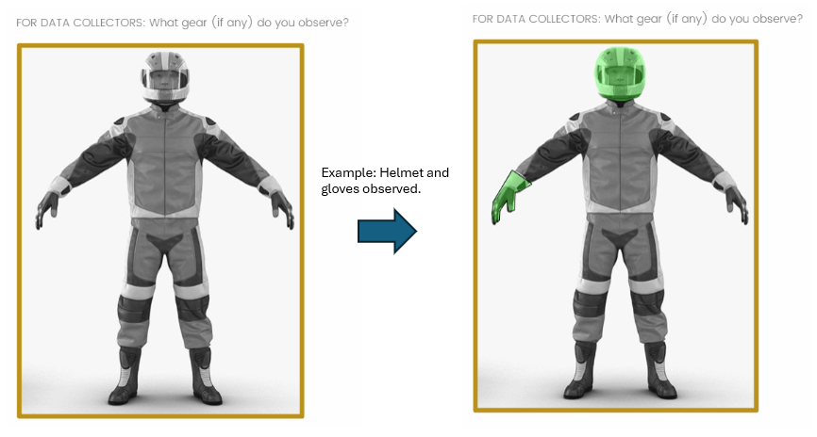

1a. (Complete if “Helmet” was selected as observed, otherwise skip)
The helmet is:
- A protective motorcycle helmet (DOT label observed)
- A protective motorcycle helmet (DOT label not visible)
- A protective non-motorcycle helmet
- Not protective
- Could not determine
1b. (Complete if “Jacket” was selected as observed, otherwise skip)
The jacket is:
- A protective motorcycle jacket
- A protective non-motorcycle jacket
- Not protective
- Could not determine

1c. (Complete if “Pants” was selected as observed, otherwise skip)
The pants are:
- Protective motorcycle pants
- Protective non-motorcycle pants
- Not protective
- Could not determine

1d. (Complete if “Gloves” was selected as observed, otherwise skip)
The gloves are:
- Protective motorcycle gloves
- Protective non-motorcycle gloves
- Not protective
- Could not determine

1e. (Complete if “Footwear” was selected as observed, otherwise skip)
The footwear is:
- Protective motorcycle footwear
- Protective non-motorcycle footwear
- Not protective
- Could not determine

- Weather conditions (check all that apply)
- Sunny / Clear
- Cloudy
- Foggy
- Windy
- Rainy

2a. Approximate temperature: _______ °F
3. Age
  - Under 18
  - 18-35
  - 36-55
  - 56-64
  - 65+
  - Could not determine

4. Sex
  - Female
  - Male
  - Could not determine

5. Race and/or ethnicity (select all that apply)
- American Indian or Alaska Native
- Asian
- Black or African American
- Hispanic or Latino
- Middle Eastern or North African
- Native Hawaiian or Pacific Islander
- White
- Could not determine

6. The observed rider:
  - Was not contacted
  - Learned about the study and was not interested in participating
  - Learned about the study and began consent process

Consent Process
See other forms for eligibility and consent forms

Bike Type & Riding Information
(The participant will self-report the following information)
The following questions ask about your bike and riding habits.

7. What type of bike are you riding today?
  - Standard
  - Touring
  - Cruiser
  - Sport
  - Scooter
  - Other (please specify): __________________

- Make / Model: ______________________________

- Model year: _____________________________

- How long have you been riding?
  - Less than 1 year
  - 1 – 5 years
  - 6 – 10 years
  - 11 – 25 years
  - 26 – 40 years
  - More than 40 years

- Check the appropriate box below to indicate how often you ride for each of the following reasons:
 | Never | A few times per season | A few times per month | A few times per week | Daily
Commuting | □ | □ | □ | □ | □
Leisure / Short Recreational Trips | □ | □ | □ | □ | □
Traveling /  Long Distance Trips | □ | □ | □ | □ | □
Other  (please describe):  _______________ | □ | □ | □ | □ | □

- Check the appropriate box below to indicate how often you ride in each of the following scenarios:
 | None of my rides | Some of my rides | About half of my rides | Most of my rides | All of my rides
Solo | □ | □ | □ | □ | □
With a passenger on your bike | □ | □ | □ | □ | □
With one other bike | □ | □ | □ | □ | □
In a group with two to five bikes | □ | □ | □ | □ | □
In a group with five or more bikes | □ | □ | □ | □ | □

- Are you or have you been a member of any motorcycle organization(s)?
  - Yes
    - List up to five of the most recent organization(s) you have been a member of, if you feel comfortable doing so.
1. ________________
2. ________________
3. ________________
4. ________________
5. ________________
  - No (Skip to question 15)

- (This question will appear up to five times with the embedded text from Question 13)
How does being a member of [embedded text from previous answer] influence your decision to wear protective gear?
Much less likely to wear protective gear | Somewhat less likely to wear protective gear | No influence on my decision to wear protective gear | Somewhat more likely to wear protective gear | Much more likely to wear protective gear
□ | □ | □ | □ | □

- How did you learn to ride? (Check all that apply)
  - Completed a basic motorcycle training course
  - Completed an advanced motorcycle training course
  - Completed a free online motorcycle training course
  - Completed a paid online motorcycle training course
  - Watched free motorcycle training videos online (e.g., YouTube)
  - From a friend or relative
  - From someone in my riding group, club, or association
  - Other (please specify): _________________________________________________

Protective Gear
The following questions ask about any protective motorcycle gear you wear.
For the next few questions, motorcycle gear refers to specialized clothing designed for crash injury protection, weather protection, or temperature regulation while riding.

- Do you own/possess a motorcycle helmet?
  - Yes
  - No

16a.
 | None of my rides | Some of my rides | About half of my rides | Most of my rides | All of my rides
How often do you wear a motorcycle helmet? | □ | □ | □ | □ | □

- Do you own/possess a motorcycle jacket?
  - Yes
  - No

17a.
 | None of my rides | Some of my rides | About half of my rides | Most of my rides | All of my rides
How often do you wear a motorcycle jacket? | □ | □ | □ | □ | □

- Do you own/possess motorcycle pants?
  - Yes
  - No

18a.
 | None of my rides | Some of my rides | About half of my rides | Most of my rides | All of my rides
How often do you wear motorcycle pants? | □ | □ | □ | □ | □

- Do you own/possess motorcycle footwear?
  - Yes
  - No

19a.
 | None of my rides | Some of my rides | About half of my rides | Most of my rides | All of my rides
How often do you wear motorcycle footwear? | □ | □ | □ | □ | □

- Do you own/possess motorcycle gloves?
  - Yes
  - No

20a.
 | None of my rides | Some of my rides | About half of my rides | Most of my rides | All of my rides
How often do you wear motorcycle gloves? | □ | □ | □ | □ | □

- How does wearing motorcycle gloves affect each of the following for you? (Items will be randomized)
 | Significantly decreases | Somewhat decreases | No change | Somewhat increases | Significantly increases
Riding comfort | □ | □ | □ | □ | □
Finger/hand movement | □ | □ | □ | □ | □
Ability to operate hand pedals | □ | □ | □ | □ | □

(Question will be displayed to the participant if they answered “Yes” to Question 20)
- Indicate how much you agree/disagree with the following statements regarding your motorcycle gloves. (Items will be randomized)
My gloves (are):
 | Strongly disagree | Somewhat disagree | Neutral | Somewhat agree | Strongly agree
Comfortable | □ | □ | □ | □ | □
Allow for breathability / air flow | □ | □ | □ | □ | □
Stay in position while riding | □ | □ | □ | □ | □
Protective | □ | □ | □ | □ | □
Well designed for my body | □ | □ | □ | □ | □
Easy to put on | □ | □ | □ | □ | □
Easy to take off | □ | □ | □ | □ | □
Provide adequate range of motion | □ | □ | □ | □ | □

- Indicate how the following factors influence your motorcycle glove usage. (Items will be randomized)
 | Influences to wear LESS | No influence | Influences to  Wear MORE
Increased risk of injury and fatality | □ | □ | □
Friends who I ride with | □ | □ | □
My riding community | □ | □ | □
Social media | □ | □ | □
News coverage about motorcycle safety | □ | □ | □
Family/loved one’s concerns | □ | □ | □
High cost of motorcycle gloves | □ | □ | □
Personal near miss/close call | □ | □ | □
Witnessing a crash | □ | □ | □
Learning about injuries among riders not wearing motorcycle gloves | □ | □ | □
Advice from a motorcycle professional | □ | □ | □
Advice from a medical professional | □ | □ | □
Other (please specify):  _________________ | □ | □ | □

- How important is the fit of motorcycle gloves to you?
Extremely unimportant | Somewhat unimportant | Neutral | Somewhat important | Extremely important
□ | □ | □ | □ | □

- How important is the comfort of motorcycle gloves to you?
Extremely unimportant | Somewhat unimportant | Neutral | Somewhat important | Extremely important
□ | □ | □ | □ | □

- How important is having highly protective motorcycle gloves to you?
Extremely unimportant | Somewhat unimportant | Neutral | Somewhat important | Extremely important
□ | □ | □ | □ | □

- What are the top three things you consider when purchasing motorcycle gloves?
  - 1. ________________________
  - 2. ________________________
  - 3. ________________________

Anthropometric Measurements for Motorcycle Gloves
(Data Collector will ask participant the following questions and record the answers)
(Data collector reads the following to the participant): “Place hand flat on table, palm side up, relaxed.”

- (Data collector observes) Hand length: ________ centimeters

- (Data collector measures) Hand circumference: _______ centimeters

- (Data collector observes) Did the participant wear motorcycle gloves to the event?
  - Yes (Continue to Question 31)
  - No (Skip to Question 45)

Gloved Rider Questions

- (Data collector asks) Are these your usual motorcycle gloves?
  - Yes
  - No

- (Data collector asks) How did you obtain these gloves?
  - Bought new in-store, tried on
  - Bought new in-store, did not try on
  - Bought new online
  - Bought used online
  - Bought new from a friend
  - Bought used from a friend
  - Bought used in-store, tried on
  - Bought used in-store, did not try on
  - Borrowed from a friend
  - Received as a gift
  - Other (please specify): _________________________

- (Data collector asks) Did someone help fit you for these gloves?
  - Yes (please specify): ________________
  - No

- (Data collector observes) Glove type:
- Textile
- Leather
- Mesh textile
- Mixed
- Other (please specify): __________________________
- Unknown

- (Data collector observes) Primary / Most prominent color(s) (check all that apply):
  - Black
  - White
  - Brown
  - Red
  - Orange
  - Yellow / Neon
  - Green
  - Blue
  - Purple
  - Pink
  - Tan
  - Silver / Grey
  - Mixed / Graphic
  - Other (please specify): ________________

- (Data collector observes) Glove manufacturer:
- Alpinestars
- BILT
- Biltwell
- Dainese
- Fox Racing
- Joe Rocket
- Klim
- Hotwired
- Icon
- REAX
- REV’IT
- Scorpion
- Sedici
- Other (please specify): __________
- Unknown

- (Data collector observes) Model: ____________________________
  - Could not determine

- (Data collector observes) Size: ______________________________
  - Could not determine

- (Data collector asks) Have you made any modifications to these gloves? (Check all that apply)
  - Added cosmetic accessories (please list): _________
    - Makes less protective
    - No change in protection
    - Makes more protective
    - Could not determine
  - Added “safety” accessories (please list): _________
    - Makes less protective
    - No change in protection
    - Makes more protective
    - Could not determine
  - None present

- (Data collector asks) Have you added any retroreflective features to these gloves?
  - Yes, after-market / accessory added after purchase
  - No, accessory OEM / factory installed
  - No, none present

Motorcycle Gloves Fit Assessment
(Data collector reads the following to the participant) “I’m going make some observations to see how well your motorcycle gloves fit. (If not already wearing their gloves) Please put your motorcycle gloves on as you normally would when riding. (If applicable) Please also put on your motorcycle jacket as you normally would. As best you can, please simulate the riding position you would normally take while riding your own bike.”

- (Data collector observes) Are there fasteners, buckles, Velcro, or straps to adjust fit present on these gloves?
- Yes
- No

- (Data collector reads the following to the participant) “Partially open and close your hands as if you were holding on to your control handles.” (Data collector observes if participant has adequate range of motion)
  - Cannot move hands
  - Somewhat able to move hands
  - Easily able to move hands

- (Data collector observes) Do these gloves adequately cover the wrist to the motorcycle jacket (if present) or do these gloves fully cover the wrist when the participant is seated in the simulated riding position?
- Yes
- No

- (Data collector asks) When wearing these gloves for 30 minutes or longer, do you begin to experience pain or discomfort? If so, please point to those areas now. (Data collector observes areas the participant points to and selects corresponding area on the image below, and checks all that apply)
- Back of the hand(s)
- Bottom of palm(s)
- Center of palm(s)
- Fingertip(s)
- Knuckle(s)
- Top of palm(s)
- Wrist(s)
- Other (please specify):__________________
- None

New Gear Assessment
(The participant will complete the following section)
In this section, you will be asked for your opinions about different types of gloves. There is a picture and description of each item to help you evaluate it. For each item, assume the gloves fit, would come in the color you want and at an affordable cost.
(Note: Order of gloves will be randomized for each participant. The questions below will be shown with each gear choice.)

- Please select the type of gear you typically wear. If unsure, please select the type of gear you are currently wearing.
- Women’s (Go to Question 46)
- Men’s (Go to Question 52)
- Unisex (Go to Question 52)

If “Women’s” was selected for Question 45

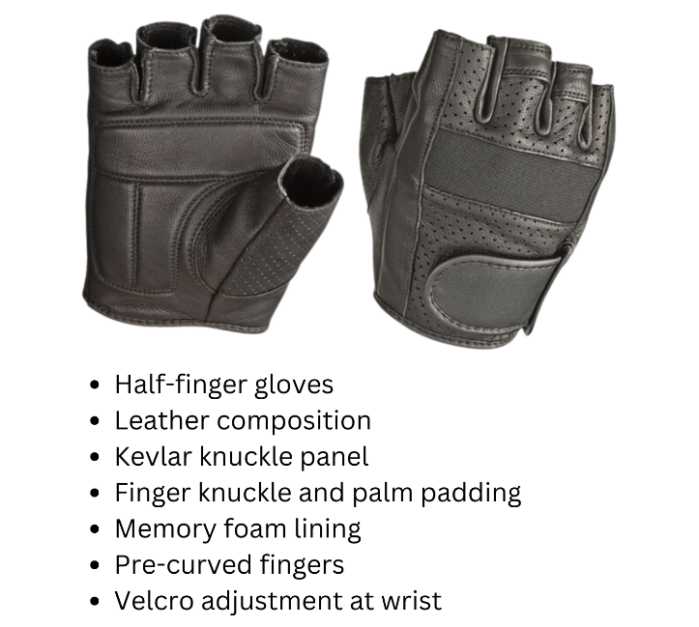

 | Extremely unprotective | Somewhat unprotective | Neutral | Somewhat protective | Extremely protective
How protective do you think these gloves are? | □ | □ | □ | □ | □

 | Extremely unlikely | Somewhat unlikely | Neutral | Somewhat likely | Extremely  likely
How likely would you be to wear these gloves while riding? | □ | □ | □ | □ | □

 | Extremely unlikely | Somewhat unlikely | Neutral | Somewhat likely | Extremely  likely
How likely would you be to purchase these gloves? | □ | □ | □ | □ | □

 | Extremely poorly | Somewhat poorly | Neutral | Somewhat well | Extremely  well
How well do you think you would be able to operate the hand controls with these gloves? | □ | □ | □ | □ | □

 | Extremely low  quality | Low  quality | Neutral | High  quality | Extremely  high  quality
What is the overall quality of these gloves? | □ | □ | □ | □ | □

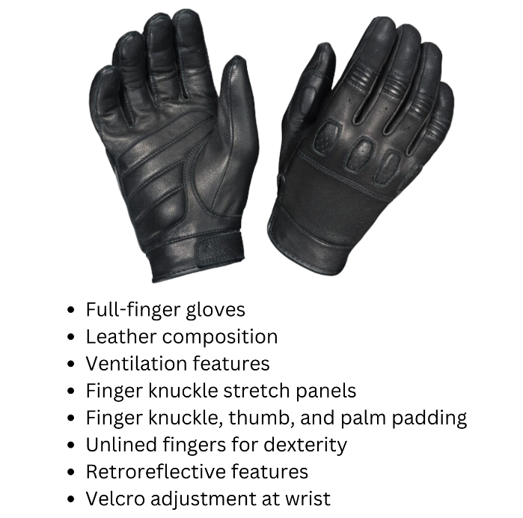

 | Extremely unprotective | Somewhat unprotective | Neutral | Somewhat protective | Extremely protective
How protective do you think these gloves are? | □ | □ | □ | □ | □

 | Extremely unlikely | Somewhat unlikely | Neutral | Somewhat likely | Extremely  likely
How likely would you be to wear these gloves while riding? | □ | □ | □ | □ | □

 | Extremely unlikely | Somewhat unlikely | Neutral | Somewhat likely | Extremely  likely
How likely would you be to purchase these gloves? | □ | □ | □ | □ | □

 | Extremely poorly | Somewhat poorly | Neutral | Somewhat well | Extremely  well
How well do you think you would be able to operate the hand controls with these gloves? | □ | □ | □ | □ | □

 | Extremely low  quality | Low  quality | Neutral | High  quality | Extremely  high  quality
What is the overall quality of these gloves? | □ | □ | □ | □ | □

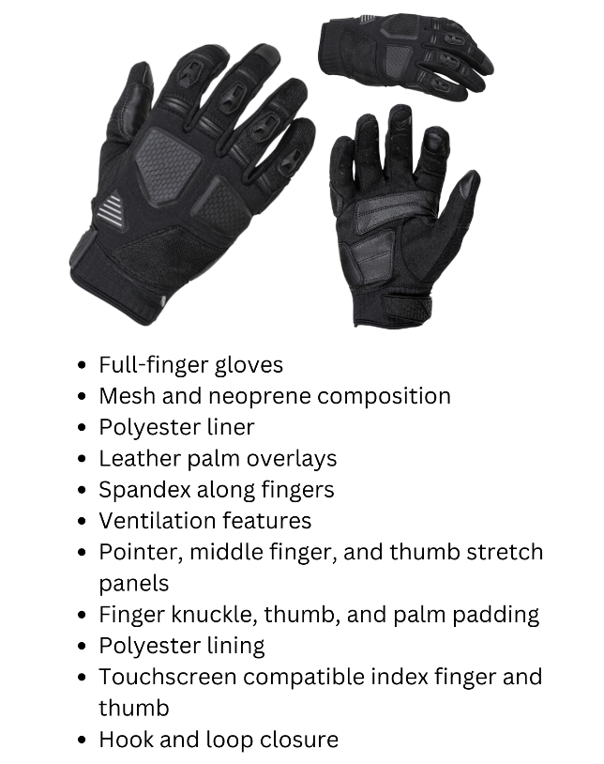

 | Extremely unprotective | Somewhat unprotective | Neutral | Somewhat protective | Extremely protective
How protective do you think these gloves are? | □ | □ | □ | □ | □

 | Extremely unlikely | Somewhat unlikely | Neutral | Somewhat likely | Extremely  likely
How likely would you be to wear these gloves while riding? | □ | □ | □ | □ | □

 | Extremely unlikely | Somewhat unlikely | Neutral | Somewhat likely | Extremely  likely
How likely would you be to purchase these gloves? | □ | □ | □ | □ | □

 | Extremely poorly | Somewhat poorly | Neutral | Somewhat well | Extremely  well
How well do you think you would be able to operate the hand controls with these gloves? | □ | □ | □ | □ | □

 | Extremely low  quality | Low  quality | Neutral | High  quality | Extremely  high  quality
What is the overall quality of these gloves? | □ | □ | □ | □ | □

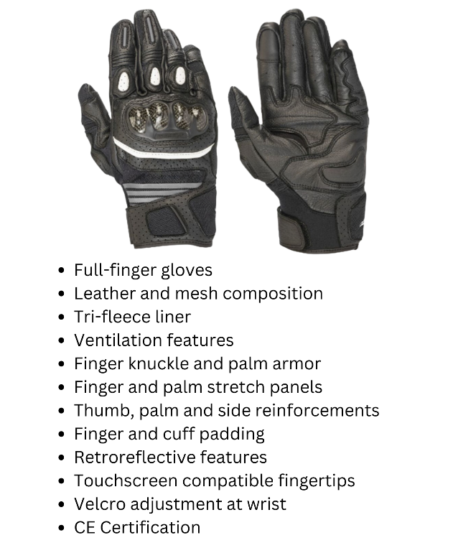

 | Extremely unprotective | Somewhat unprotective | Neutral | Somewhat protective | Extremely protective
How protective do you think these gloves are? | □ | □ | □ | □ | □

 | Extremely unlikely | Somewhat unlikely | Neutral | Somewhat likely | Extremely  likely
How likely would you be to wear these gloves while riding? | □ | □ | □ | □ | □

 | Extremely unlikely | Somewhat unlikely | Neutral | Somewhat likely | Extremely  likely
How likely would you be to purchase these gloves? | □ | □ | □ | □ | □

 | Extremely poorly | Somewhat poorly | Neutral | Somewhat well | Extremely  well
How well do you think you would be able to operate the hand controls with these gloves? | □ | □ | □ | □ | □

 | Extremely low  quality | Low  quality | Neutral | High  quality | Extremely  high  quality
What is the overall quality of these gloves? | □ | □ | □ | □ | □

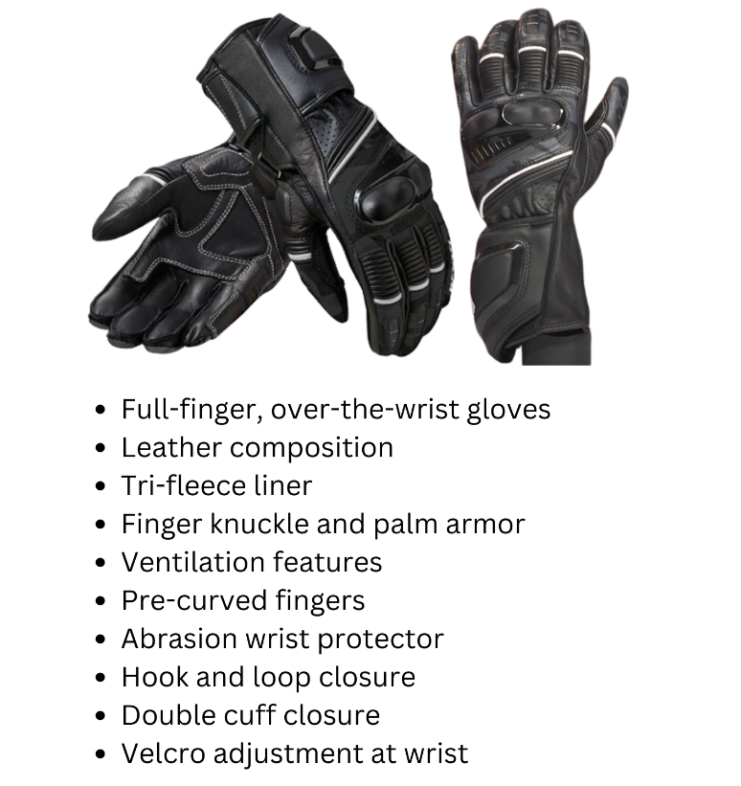

 | Extremely unprotective | Somewhat unprotective | Neutral | Somewhat protective | Extremely protective
How protective do you think these gloves are? | □ | □ | □ | □ | □

 | Extremely unlikely | Somewhat unlikely | Neutral | Somewhat likely | Extremely  likely
How likely would you be to wear these gloves while riding? | □ | □ | □ | □ | □

 | Extremely unlikely | Somewhat unlikely | Neutral | Somewhat likely | Extremely  likely
How likely would you be to purchase these gloves? | □ | □ | □ | □ | □

 | Extremely poorly | Somewhat poorly | Neutral | Somewhat well | Extremely  well
How well do you think you would be able to operate the hand controls with these gloves? | □ | □ | □ | □ | □

 | Extremely low  quality | Low  quality | Neutral | High  quality | Extremely  high  quality
What is the overall quality of these gloves? | □ | □ | □ | □ | □

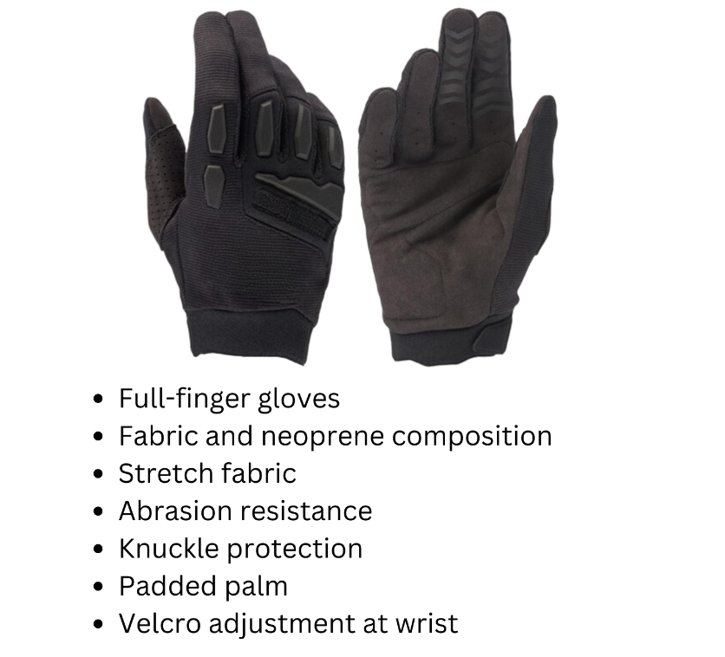

 | Extremely unprotective | Somewhat unprotective | Neutral | Somewhat protective | Extremely protective
How protective do you think these gloves are? | □ | □ | □ | □ | □

 | Extremely unlikely | Somewhat unlikely | Neutral | Somewhat likely | Extremely  likely
How likely would you be to wear these gloves while riding? | □ | □ | □ | □ | □

 | Extremely unlikely | Somewhat unlikely | Neutral | Somewhat likely | Extremely  likely
How likely would you be to purchase these gloves? | □ | □ | □ | □ | □

 | Extremely poorly | Somewhat poorly | Neutral | Somewhat well | Extremely  well
How well do you think you would be able to operate the hand controls with these gloves? | □ | □ | □ | □ | □

 | Extremely low  quality | Low  quality | Neutral | High  quality | Extremely  high  quality
What is the overall quality of these gloves? | □ | □ | □ | □ | □

If “Men’s” was selected for Question 45

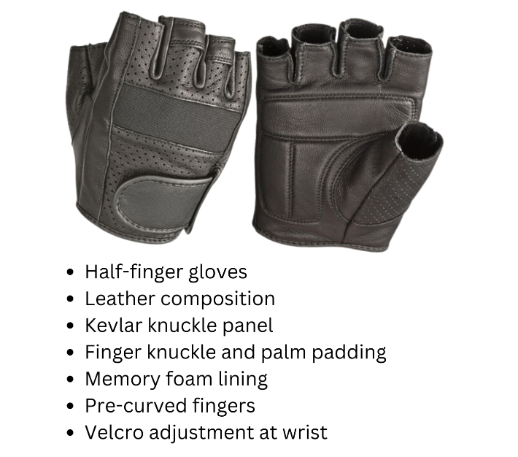

 | Extremely unprotective | Somewhat unprotective | Neutral | Somewhat protective | Extremely protective
How protective do you think these gloves are? | □ | □ | □ | □ | □

 | Extremely unlikely | Somewhat unlikely | Neutral | Somewhat likely | Extremely  likely
How likely would you be to wear these gloves while riding? | □ | □ | □ | □ | □

 | Extremely unlikely | Somewhat unlikely | Neutral | Somewhat likely | Extremely  likely
How likely would you be to purchase these gloves? | □ | □ | □ | □ | □

 | Extremely poorly | Somewhat poorly | Neutral | Somewhat well | Extremely  well
How well do you think you would be able to operate the hand controls with these gloves? | □ | □ | □ | □ | □

 | Extremely low  quality | Low  quality | Neutral | High  quality | Extremely  high  quality
What is the overall quality of these gloves? | □ | □ | □ | □ | □

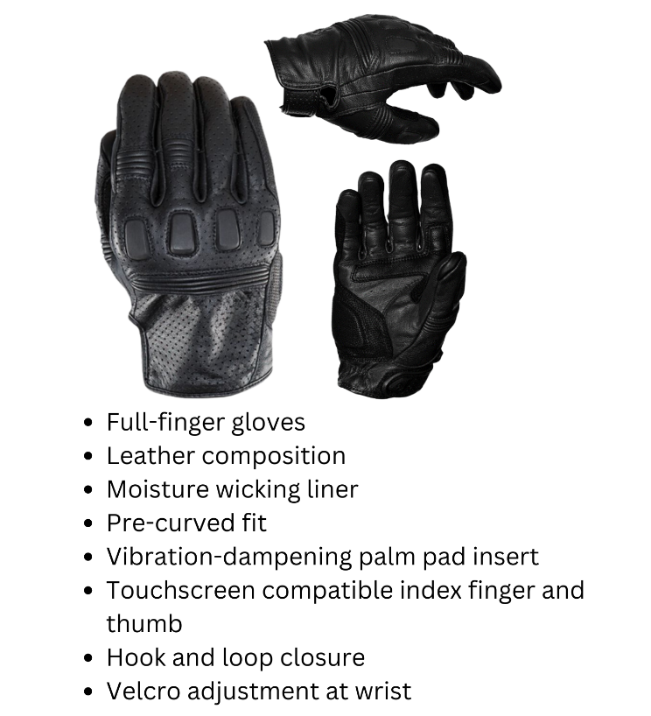

 | Extremely unprotective | Somewhat unprotective | Neutral | Somewhat protective | Extremely protective
How protective do you think these gloves are? | □ | □ | □ | □ | □

 | Extremely unlikely | Somewhat unlikely | Neutral | Somewhat likely | Extremely  likely
How likely would you be to wear these gloves while riding? | □ | □ | □ | □ | □

 | Extremely unlikely | Somewhat unlikely | Neutral | Somewhat likely | Extremely  likely
How likely would you be to purchase these gloves? | □ | □ | □ | □ | □

 | Extremely poorly | Somewhat poorly | Neutral | Somewhat well | Extremely  well
How well do you think you would be able to operate the hand controls with these gloves? | □ | □ | □ | □ | □

 | Extremely low  quality | Low  quality | Neutral | High  quality | Extremely  high  quality
What is the overall quality of these gloves? | □ | □ | □ | □ | □

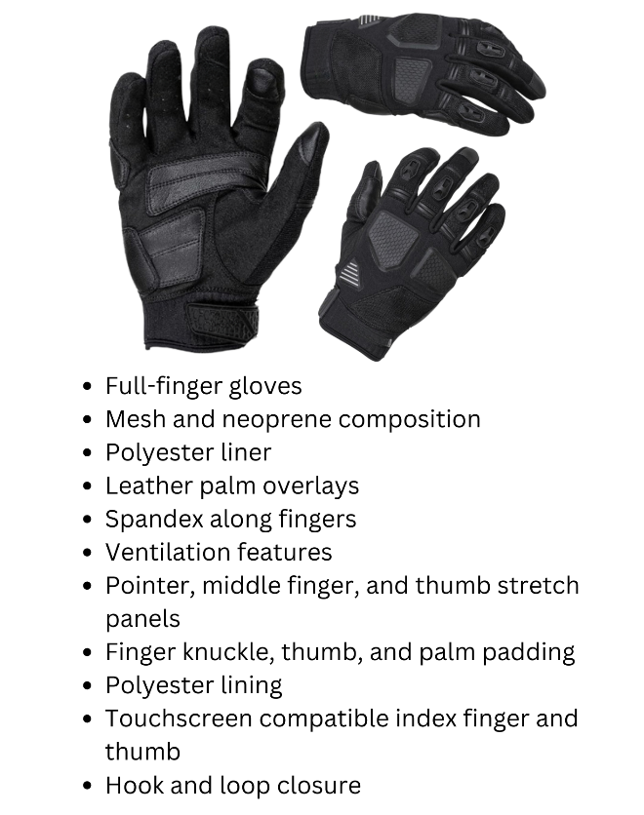

 | Extremely unprotective | Somewhat unprotective | Neutral | Somewhat protective | Extremely protective
How protective do you think these gloves are? | □ | □ | □ | □ | □

 | Extremely unlikely | Somewhat unlikely | Neutral | Somewhat likely | Extremely  likely
How likely would you be to wear these gloves while riding? | □ | □ | □ | □ | □

 | Extremely unlikely | Somewhat unlikely | Neutral | Somewhat likely | Extremely  likely
How likely would you be to purchase these gloves? | □ | □ | □ | □ | □

 | Extremely poorly | Somewhat poorly | Neutral | Somewhat well | Extremely  well
How well do you think you would be able to operate the hand controls with these gloves? | □ | □ | □ | □ | □

 | Extremely low  quality | Low  quality | Neutral | High  quality | Extremely  high  quality
What is the overall quality of these gloves? | □ | □ | □ | □ | □

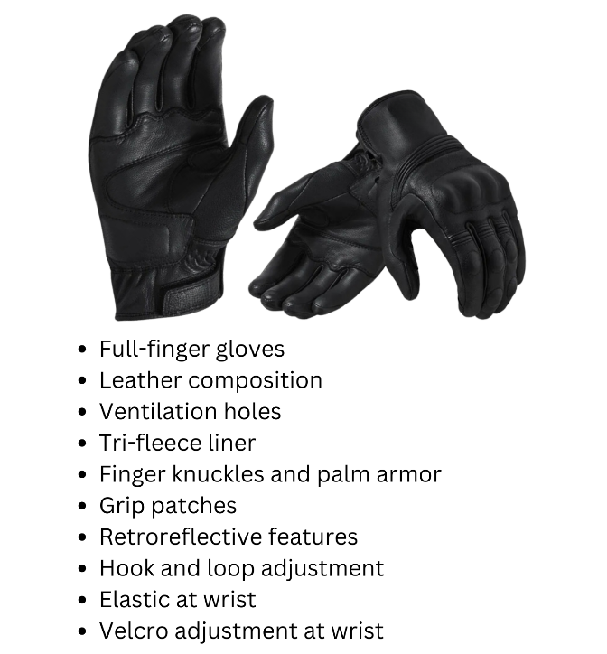

 | Extremely unprotective | Somewhat unprotective | Neutral | Somewhat protective | Extremely protective
How protective do you think these gloves are? | □ | □ | □ | □ | □

 | Extremely unlikely | Somewhat unlikely | Neutral | Somewhat likely | Extremely  likely
How likely would you be to wear these gloves while riding? | □ | □ | □ | □ | □

 | Extremely unlikely | Somewhat unlikely | Neutral | Somewhat likely | Extremely  likely
How likely would you be to purchase these gloves? | □ | □ | □ | □ | □

 | Extremely poorly | Somewhat poorly | Neutral | Somewhat well | Extremely  well
How well do you think you would be able to operate the hand controls with these gloves? | □ | □ | □ | □ | □

 | Extremely low  quality | Low  quality | Neutral | High  quality | Extremely  high  quality
What is the overall quality of these gloves? | □ | □ | □ | □ | □

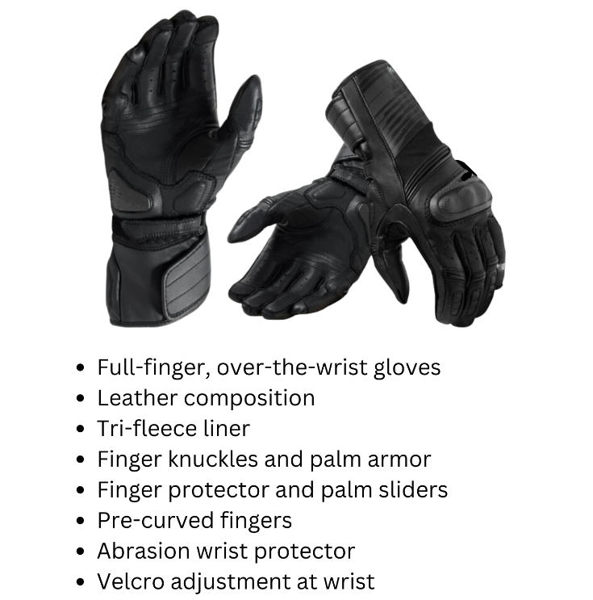

 | Extremely unprotective | Somewhat unprotective | Neutral | Somewhat protective | Extremely protective
How protective do you think these gloves are? | □ | □ | □ | □ | □

 | Extremely unlikely | Somewhat unlikely | Neutral | Somewhat likely | Extremely  likely
How likely would you be to wear these gloves while riding? | □ | □ | □ | □ | □

 | Extremely unlikely | Somewhat unlikely | Neutral | Somewhat likely | Extremely  likely
How likely would you be to purchase these gloves? | □ | □ | □ | □ | □

 | Extremely poorly | Somewhat poorly | Neutral | Somewhat well | Extremely  well
How well do you think you would be able to operate the hand controls with these gloves? | □ | □ | □ | □ | □

 | Extremely low  quality | Low  quality | Neutral | High  quality | Extremely  high  quality
What is the overall quality of these gloves? | □ | □ | □ | □ | □

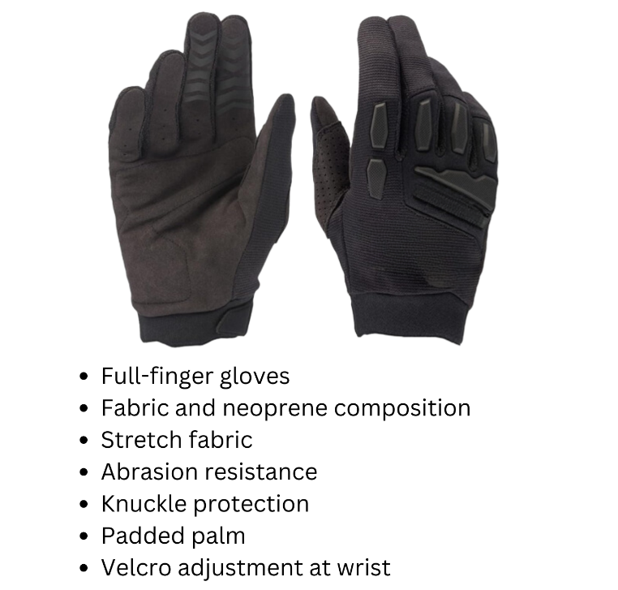
 | Extremely unprotective | Somewhat unprotective | Neutral | Somewhat protective | Extremely protective
How protective do you think these gloves are? | □ | □ | □ | □ | □

 | Extremely unlikely | Somewhat unlikely | Neutral | Somewhat likely | Extremely  likely
How likely would you be to wear these gloves while riding? | □ | □ | □ | □ | □

 | Extremely unlikely | Somewhat unlikely | Neutral | Somewhat likely | Extremely  likely
How likely would you be to purchase these gloves? | □ | □ | □ | □ | □

 | Extremely poorly | Somewhat poorly | Neutral | Somewhat well | Extremely  well
How well do you think you would be able to operate the hand controls with these gloves? | □ | □ | □ | □ | □

 | Extremely low  quality | Low  quality | Neutral | High  quality | Extremely  high  quality
What is the overall quality of these gloves? | □ | □ | □ | □ | □

Demographics
(The participant will self-report the following information)
- In what State do you currently live? _______________________________________

- What license type(s) do you currently have? (Check all that apply)
  - Motorcycle endorsement
  - Motorcycle-only license
  - Motorcycle learner’s permit
  - Driver’s license
  - Commercial license
  - None of the above

- What is your age? _______________ years

- What is your sex?
  - Female
  - Male

- What is your race and/or ethnicity? (Select all that apply and enter additional details in the spaces below)
- American Indian or Alaska Native
(If selected) Provide details below:

Enter, for example, Navajo Nation, Blackfeet Tribe of the Blackfeet Indian Reservation of Montana, Native Village of Inupiat Traditional Government, Nome Eskimo Community, Aztec, Maya, etc.:
_____________________________________________________________________
- Asian
(If selected) Provide details below:
  - Chinese
  - Asian Indian
  - Filipino
  - Vietnamese
  - Korean
  - Japanese
  - Another group (For example, Pakistani, Hmong, Afghan, etc.):
_______________________________________________________________

- Black or African American
(If selected) Provide details below:
  - African American
  - Jamaican
  - Haitian
  - Nigerian
  - Ethiopian
  - Somali
  - Another group (For example, Trinidadian and Tobagonian, Ghanian, Congolese, etc.): ________________________________________________________________
- Hispanic or Latino
(If selected) Provide details below:
  - Mexican
  - Puerto Rican
  - Salvadoran
  - Cuban
  - Dominican
  - Guatemalan
  - Another group (For example, Colombian, Honduran, Spaniard, etc.): __________________________________________________________________
- Middle Eastern or North African
(If selected) Provide details below:
  - Lebanese
  - Iranian
  - Egyptian
  - Syrian
  - Iraqi
  - Israeli
  - Another group (For example, Moroccan, Yemeni, Kurdish, etc.):
________________________________________________________________
- Native Hawaiian or Pacific Islander
(If selected) Provide details below:
  - Native Hawaiian
  - Samoan
  - Chamorro
  - Tongan
  - Fijian
  - Marshallese
  - Another group (For example, Chuukese, Palauan, Tahitian, etc.):
________________________________________________________________

- White
(If selected) Provide details below:
  - English
  - German
  - Irish
  - Italian
  - Polish
  - Scottish
  - Another group (For example, French, Swedish, Norwegian, etc.):
____________________________________________________________________

