Paperwork Reduction Act Statement: A federal agency may not conduct or sponsor, and a person is not required to respond to, nor shall a person be subject to a penalty for failure to comply with, a collection of information subject to the requirements of the Paperwork Reduction Act unless that collection of information displays a current valid OMB Control Number (listed below). Please send comments regarding this burden estimate or any other aspect of this collection of information, including suggestions for reducing this burden to: Information Collection Clearance Officer, National Highway Traffic Safety Administration, 1200 New Jersey Ave, S.E., Room W45-205, Washington, DC, 20590.

Table of Contents
Data Collection Forms – Helmet 2
Data Collector Initial Observations 2
Consent Process 4
Bike Type & Riding Information 5
Anthropometric Measurements for Motorcycle Helmet 13
Motorcycle Helmet Fit Assessment 17
New Gear Assessment 19
Demographics 33

Data Collection Forms – Helmet
Note: These surveys involve skip logic. Skip logic points and survey logistics are highlighted in Boldface Red Text.

Data Collector Initial Observations
(The Data Collector will complete the following section)
Data Collector ID: ___________ (Auto fill)
- Potential participant gear worn (Heat Spot selection on electronic tablet form. Researcher selects observed gear by tapping on the corresponding image. Each selected gear type, indicated by a green highlighted box, will open an image library of that gear’s subtypes. Non-selected gear will be skipped.)
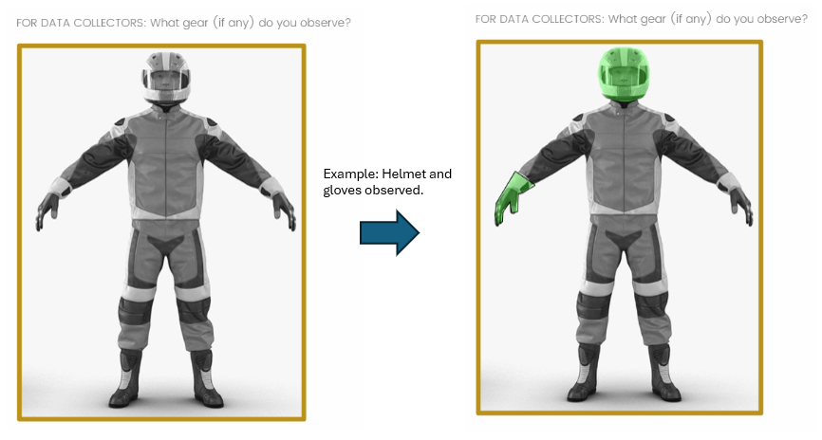
(Note: Green example highlighting on right is for clarification purposes only. Example highlighting shown on rightmost image will not appear in data form until after the researcher selects it.)

1a. (Complete if “Helmet” was selected as observed, otherwise skip)
The helmet is:
- A protective motorcycle helmet (DOT label observed)
- A protective motorcycle helmet (DOT label not visible)
- A protective non-motorcycle helmet
- Not protective
- Could not determine

1b. (Complete if “Jacket” was selected as observed, otherwise skip)
The jacket is:
- A protective motorcycle jacket
- A protective non-motorcycle jacket
- Not protective
- Could not determine

1c. (Complete if “Pants” was selected as observed, otherwise skip)
The pants are:
- Protective motorcycle pants
- Protective non-motorcycle pants
- Not protective
- Could not determine

1d. (Complete if “Gloves” was selected as observed, otherwise skip)
The gloves are:
- Protective motorcycle gloves
- Protective non-motorcycle gloves
- Not protective
- Could not determine

1e. (Complete if “Footwear” was selected as observed, otherwise skip)
The footwear is:
- Protective motorcycle footwear
- Protective non-motorcycle footwear
- Not protective
- Could not determine

- Weather conditions (check all that apply)
- Sunny / Clear
- Cloudy
- Foggy
- Windy
- Rainy

2a. Approximate temperature: _______ °F

3. Age
  - Under 18
  - 18-35
  - 36-55
  - 56-64
  - 65+
  - Could not determine

4. Sex
  - Female
  - Male
  - Could not determine

5. Race and/or ethnicity (select all that apply)
- American Indian or Alaska Native
- Asian
- Black or African American
- Hispanic or Latino
- Middle Easten or North African
- Native Hawaiian or Pacific Islander
- White
- Could not determine

6. The observed rider:
  - Was not contacted
  - Learned about the study and was not interested in participating
  - Learned about the study and began consent process

Consent Process
See other forms for eligibility and consent forms

Bike Type & Riding Information
(The participant will self-report the following information)
The following questions ask about your bike and riding habits.

7. What type of bike are you riding today?
  - Standard
  - Touring
  - Cruiser
  - Sport
  - Scooter
  - Other (please specify): __________________

- Make / Model: ______________________________

- Model year: _____________________________

- How long have you been riding?
  - Less than 1 year
  - 1 – 5 years
  - 6 – 10 years
  - 11 – 25 years
  - 26 – 40 years
  - More than 40 years

- Check the appropriate box below to indicate how often you ride for each of the following reasons:
 | Never | A few times per season | A few times per month | A few times per week | Daily
Commuting | □ | □ | □ | □ | □
Leisure / Short Recreational Trips | □ | □ | □ | □ | □
Traveling /  Long Distance Trips | □ | □ | □ | □ | □
Other  (please describe):  _______________ | □ | □ | □ | □ | □

- Check the appropriate box below to indicate how often you ride in each of the following scenarios:
 | None of my rides | Some of my rides | About half of my rides | Most of my rides | All of my rides
Solo | □ | □ | □ | □ | □
With a passenger on your bike | □ | □ | □ | □ | □
With one other bike | □ | □ | □ | □ | □
In a group with two to five bikes | □ | □ | □ | □ | □
In a group with five or more bikes | □ | □ | □ | □ | □

- Are you or have you been a member of any motorcycle organization(s)?
  - Yes
    - List up to five of the most recent organization(s) you have been a member of, if you feel comfortable doing so.
1. ________________
2. ________________
3. ________________
4. ________________
5. ________________
  - No (Skip to question 15)

- (This question will appear up to five times with the embedded text from Question 13)
How does being a member of [embedded text from previous answer] influence your decision to wear protective gear?
Much less likely to wear protective gear | Somewhat less likely to wear protective gear | No influence on my decision to wear protective gear | Somewhat more likely to wear protective gear | Much more likely to wear protective gear
□ | □ | □ | □ | □

- How did you learn to ride? (Check all that apply)
  - Completed a basic motorcycle training course
  - Completed an advanced motorcycle training course
  - Completed a free online motorcycle training course
  - Completed a paid online motorcycle training course
  - Watched free motorcycle training videos online (e.g., YouTube)
  - From a friend or relative
  - From someone in my riding group, club, or association
  - Other (please specify): _________________________________________________

Protective Gear
The following questions ask about any protective motorcycle gear you wear.
For the next few questions, motorcycle gear refers to specialized clothing designed for crash injury protection, weather protection, or temperature regulation while riding.

- Do you own/possess a motorcycle helmet?
  - Yes
  - No

16a.
 | None of my rides | Some of my rides | About half of my rides | Most of my rides | All of my rides
How often do you wear a motorcycle helmet? | □ | □ | □ | □ | □

- Do you own/possess a motorcycle jacket?
  - Yes
  - No

17a.
 | None of my rides | Some of my rides | About half of my rides | Most of my rides | All of my rides
How often do you wear a motorcycle jacket? | □ | □ | □ | □ | □

- Do you own/possess motorcycle pants?
  - Yes
  - No

18a.
 | None of my rides | Some of my rides | About half of my rides | Most of my rides | All of my rides
How often do you wear motorcycle pants? | □ | □ | □ | □ | □

- Do you own/possess motorcycle footwear?
  - Yes
  - No

19a.
 | None of my rides | Some of my rides | About half of my rides | Most of my rides | All of my rides
How often do you wear motorcycle footwear? | □ | □ | □ | □ | □

- Do you own/possess motorcycle gloves?
  - Yes
  - No

20a.
 | None of my rides | Some of my rides | About half of my rides | Most of my rides | All of my rides
How often do you wear motorcycle gloves? | □ | □ | □ | □ | □

- How does wearing a motorcycle helmet affect each of the following for you? (Items will be randomized)
 | Significantly decreases | Somewhat decreases | No change | Somewhat increases | Significantly increases
Riding comfort | □ | □ | □ | □ | □
Head movement | □ | □ | □ | □ | □
Visibility | □ | □ | □ | □ | □
Hearing | □ | □ | □ | □ | □

(Question will be displayed to the participant if they answered “Yes” to Question 16)
- Indicate how much you agree/disagree with the following statements regarding your motorcycle helmet. (Items will be randomized)
My helmet (is):
 | Strongly disagree | Somewhat disagree | Neutral | Somewhat agree | Strongly agree
Comfortable | □ | □ | □ | □ | □
Allows for breathability / air flow | □ | □ | □ | □ | □
Stays in position while riding | □ | □ | □ | □ | □
Protective | □ | □ | □ | □ | □
Well designed for my body | □ | □ | □ | □ | □
Easy to put on | □ | □ | □ | □ | □
Easy to take off | □ | □ | □ | □ | □

- Indicate how the following factors influence your motorcycle helmet usage. (Items will be randomized)
 | Influences to wear LESS | No influence | Influences to  Wear MORE
Helmet laws of the State I live in | □ | □ | □
Increased risk of injury and fatality | □ | □ | □
Friends who I ride with | □ | □ | □
My riding community | □ | □ | □
Social media | □ | □ | □
Possibility of getting a ticket | □ | □ | □
News coverage about motorcycle safety | □ | □ | □
Family/loved one’s concerns | □ | □ | □
High cost of motorcycle helmets | □ | □ | □
Riding through a State with a mandatory helmet use law | □ | □ | □
Personal near miss/close call | □ | □ | □
Witnessing a crash | □ | □ | □
Learning about injuries among riders not wearing a helmet | □ | □ | □
Advice from a motorcycle professional | □ | □ | □
Advice from a medical professional | □ | □ | □
Other (please specify):  _________________ | □ | □ | □

- How important is the fit of a motorcycle helmet to you?
Extremely unimportant | Somewhat unimportant | Neutral | Somewhat important | 5  Extremely important
□ | □ | □ | □ | □

- How important is the comfort of a motorcycle helmet to you?
Extremely unimportant | Somewhat unimportant | Neutral | Somewhat important | Extremely important
□ | □ | □ | □ | □

- How important is having a highly protective motorcycle helmet to you?
Extremely unimportant | Somewhat unimportant | Neutral | Somewhat important | Extremely important
□ | □ | □ | □ | □

- What are the top three things you consider when purchasing a motorcycle helmet?
  - 1. ________________________
  - 2. ________________________
  - 3. ________________________

Anthropometric Measurements for Motorcycle Helmet
(Data Collector will ask participant the following questions and record the answers)
- (Data collector observes) Head shape assessment:
 | Head Shape | Description
□ | ROUND OVAL   | - Least common head shape  - Head is more spherical than their more oval counterparts  - Front to back/ear to ear measurements are nearly the same
□ | INTERMEDIATE OVAL  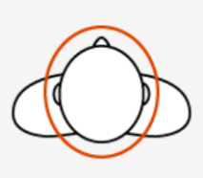 | - The most common head shape  - Head is slightly thinner than it is long  - Front to back measurement is slightly longer than ear to ear
□ | LONG OVAL  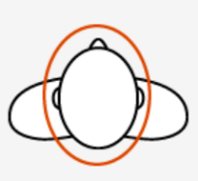 | - Less common head shape  - Head is substantially thinner than it is long  - Front to back measurement is longer than ear to ear

- (Data collector measures) Head circumference: ____________ centimeters

- (Data collector measures) Head breadth: __________________ centimeters
- (Data collector measures) Head length: ___________________ centimeters

- (Data collector observes) Did the participant wear a motorcycle helmet to the event?
  - Yes (Continue to Question 33)
  - No (Skip to Question 51)

Helmeted Rider Questions

- (Data collector asks) Is this your usual motorcycle helmet?
  - Yes
  - No

- (Data collector asks) How did you obtain this helmet?
  - Bought new in-store, tried on
  - Bought new in-store, did not try on
  - Bought new online
  - Bought used online
  - Bought new from a friend
  - Bought used from a friend
  - Bought used in-store, tried on
  - Bought used in-store, did not try on
  - Borrowed from a friend
  - Received as a gift
  - Other (please specify): _________________________

- (Data collector asks) Did someone help fit you for this helmet?
  - Yes (please specify): ________________
  - No

- (Data collector observes) Helmet type:
  - Full-face
  - Modular
  - Open or 3/4-face
  - Half-face
  - Dual sport
  - Novelty
  - Other (please specify): _________________________
  - Unknown

- (Data collector observes) Primary / Most prominent color(s) (check all that apply):
  - Black
  - White
  - Brown
  - Red
  - Orange
  - Yellow / Neon
  - Green
  - Blue
  - Purple
  - Pink
  - Tan
  - Silver / Grey
  - Mixed / Graphic
  - Other (please specify): ________________

- (Data collector observes) Helmet manufacturer:
  - AGV
  - Arai
  - Bell
  - HJC
  - Icon
  - Klim
  - LS2
  - Nolan
  - Schuberth
  - Scorpion
  - Sedici
  - Shark
  - Shoei
  - Other (please specify): _______________________________
  - Unknown

- (Data collector observes) Model: ____________________________
  - Could not determine

- (Data collector observes) Size: ______________________________
  - Could not determine

- (Data collector observes) Manufacture month and year: _________________________
  - Could not determine

- (Data collector observes) Safety labels (check all that apply):
  - DOT (meets or exceeds DOT FMVSS 218)
  - Snell (certification year): _____________
  - ECE
  - CE
  - Other (please specify): _________________
  - None present

- (Data collector asks) Have you made any modifications to this helmet? (Check all that apply)
  - Face shield:
    - Makes less protective
    - No change in protection
    - Makes more protective
    - Could not determine
  - Bluetooth / communication device:
    - Makes less protective
    - No change in protection
    - Makes more protective
    - Could not determine
  - Liner(s):
    - Makes less protective
    - No change in protection
    - Makes more protective
    - Could not determine
  - High visibility stickers, decals, etc.:
    - Makes less protective
    - No change in protection
    - Makes more protective
    - Could not determine
  - None present

- (Data collector asks) Have you added any retroreflective features to this helmet?
  - Yes, after-market / accessory added after purchase
  - No, accessory OEM / factory installed
  - No, none present

Motorcycle Helmet Fit Assessment
(Data collector reads the following to the participant) “I’m going to gently attempt to move the motorcycle helmet and make some other observations to see how well it fits. (If not already wearing their helmet) Please put your motorcycle helmet on as you normally would when riding.”
- (Data collector observes) The chinstrap:
  - Is buckled
  - Is unbuckled (Skip to Question 47)
  - Is not present (Skip to Question 47)

- (Data collector observes) Chinstrap fit:
  - Very loose (hanging with large visible gap)
  - Somewhat loose (hanging with visible gap)
  - Snug / just right
  - Somewhat tight (visibly tight under chin)
  - Very tight (visibly digging into or pinching skin under chin)

- (Data collector observes) The cheek pad fit has:
  - No pressure
  - A little pressure
  - Snug / Just right
  - A little too much pressure
  - Way too much pressure
  - Not applicable (open-face helmet or skull cap)

- (Data collector reads the following to the participant) “I am going to hold your motorcycle helmet still, and I want you to attempt to move your head up and down while I am holding it. Please attempt to move your head up and down a few times.” (Data collector grasps helmet to prevent it from moving and observes)
  - Cannot move head
  - Barely able to move head
  - Easily able to slide head
  - Head “rattles”

- (Data collector reads the following to the participant) “I am going to hold your motorcycle helmet still, and I want you to attempt to move your head side to side while I am holding it. Please attempt to move your head side to side a few times.” (Data collector grasps helmet to prevent it from moving and observes)
  - Cannot move head
  - Barely able to move head
  - Easily able to slide head
  - Head “rattles”

- (Data collector asks) When wearing this helmet for 30 minutes or longer, do you begin to experience any pain or discomfort? If so, please point to those areas now. (Data collector observes areas the participant points to and selects corresponding area on the image below, and checks all that apply)
  - Back of head
  - Brow bone(s)
  - Cheek(s)
  - Chin
  - Ear(s)
  - Forehead
  - Jaw
  - Neck
  - Side(s) of head
  - Temple(s)
  - Top of head
  - Other (please describe): __________________
  - None

New Gear Assessment
(The participant will complete the following section)
In this section, you will be asked for your opinions about different types of helmets. There is a picture and description of each item to help you evaluate it. For each item, assume the helmet fits, would come in the color you want and at an affordable cost.
(Note: Order of helmets will be randomized for each participant. The questions below will be shown with each gear choice.)

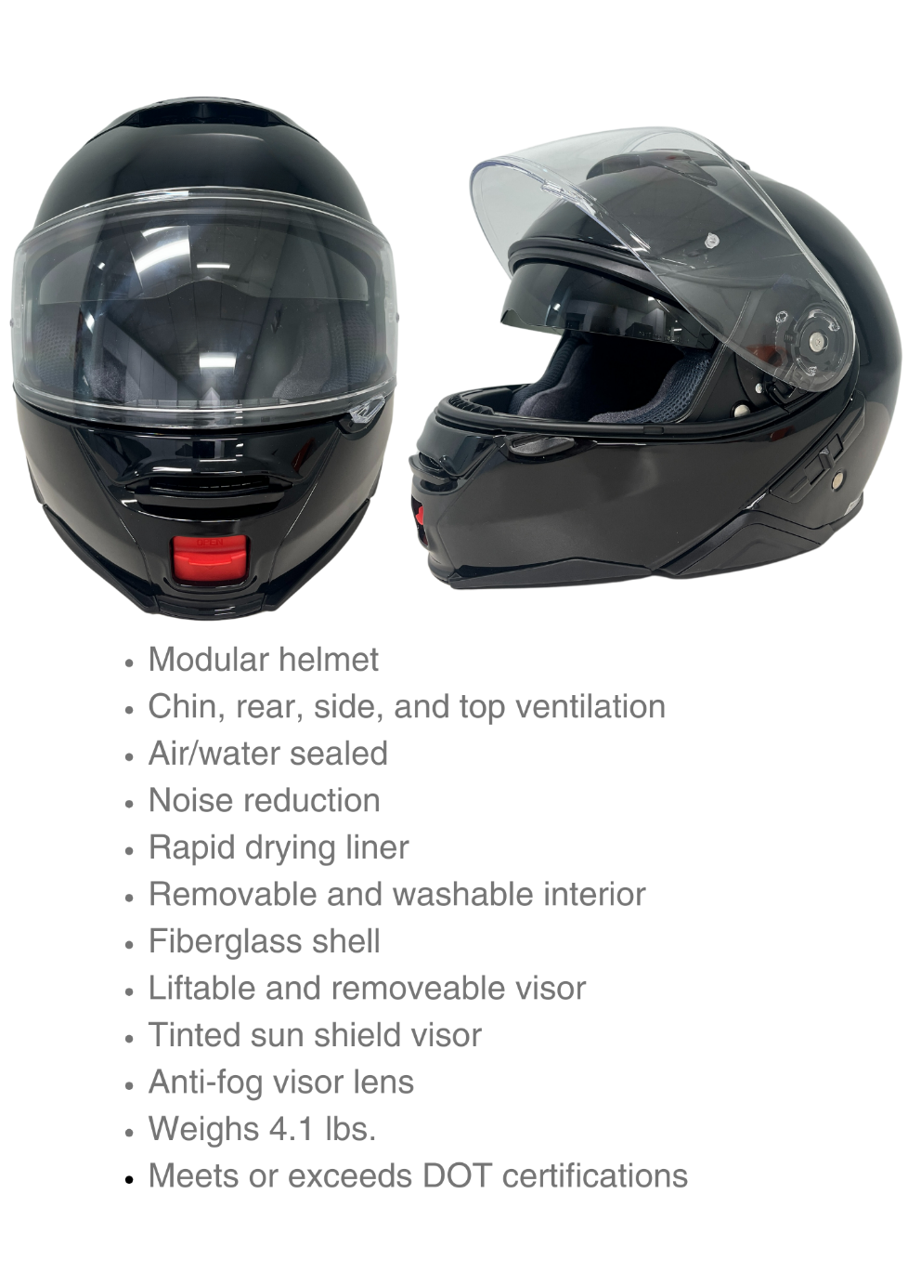

 | Extremely unprotective | Somewhat unprotective | Neutral | Somewhat protective | Extremely protective
How protective do you think this helmet is? | □ | □ | □ | □ | □

 | Extremely unlikely | Somewhat unlikely | Neutral | Somewhat likely | Extremely  likely
How likely would you be to wear this helmet while riding? | □ | □ | □ | □ | □

 | Extremely unlikely | Somewhat unlikely | Neutral | Somewhat likely | Extremely  likely
How likely would you be to purchase this helmet? | □ | □ | □ | □ | □

 | Extremely poorly | Somewhat poorly | Neutral | Somewhat well | Extremely  well
How well would you be able to see out of this helmet? | □ | □ | □ | □ | □

 | Extremely low  quality | Low  quality | Neutral | High  quality | Extremely  high  quality
What is the overall quality of this helmet? | □ | □ | □ | □ | □

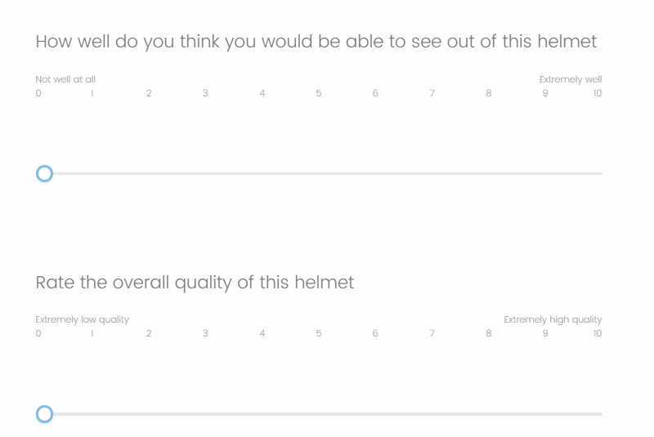
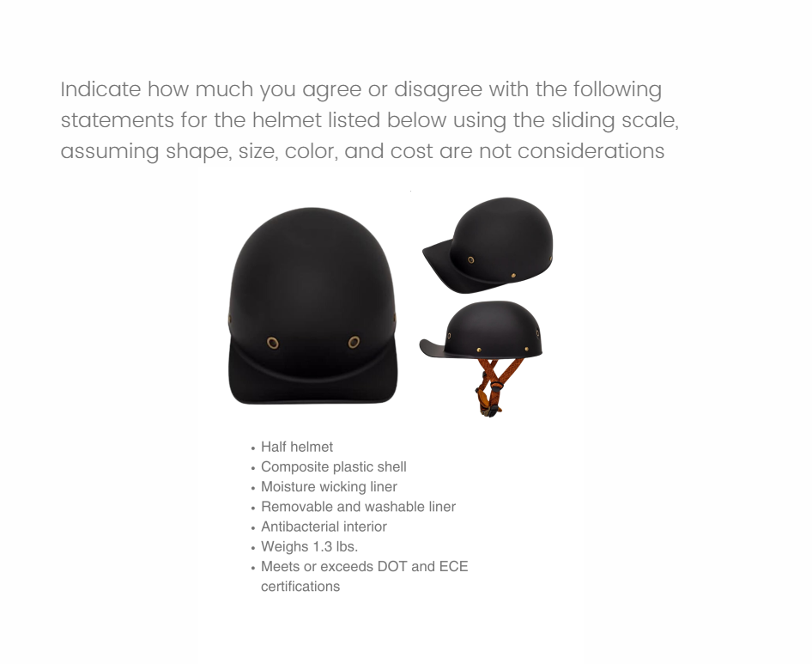

 | Extremely unprotective | Somewhat unprotective | Neutral | Somewhat protective | Extremely protective
How protective do you think this helmet is? | □ | □ | □ | □ | □

 | Extremely unlikely | Somewhat unlikely | Neutral | Somewhat likely | Extremely  likely
How likely would you be to wear this helmet while riding? | □ | □ | □ | □ | □

 | Extremely unlikely | Somewhat unlikely | Neutral | Somewhat likely | Extremely  likely
How likely would you be to purchase this helmet? | □ | □ | □ | □ | □

 | Extremely poorly | Somewhat poorly | Neutral | Somewhat well | Extremely  well
How well would you be able to see out of this helmet? | □ | □ | □ | □ | □

 | Extremely low  Quality | Low  quality | Neutral | High  quality | Extremely  high  quality
What is the overall quality of this helmet? | □ | □ | □ | □ | □

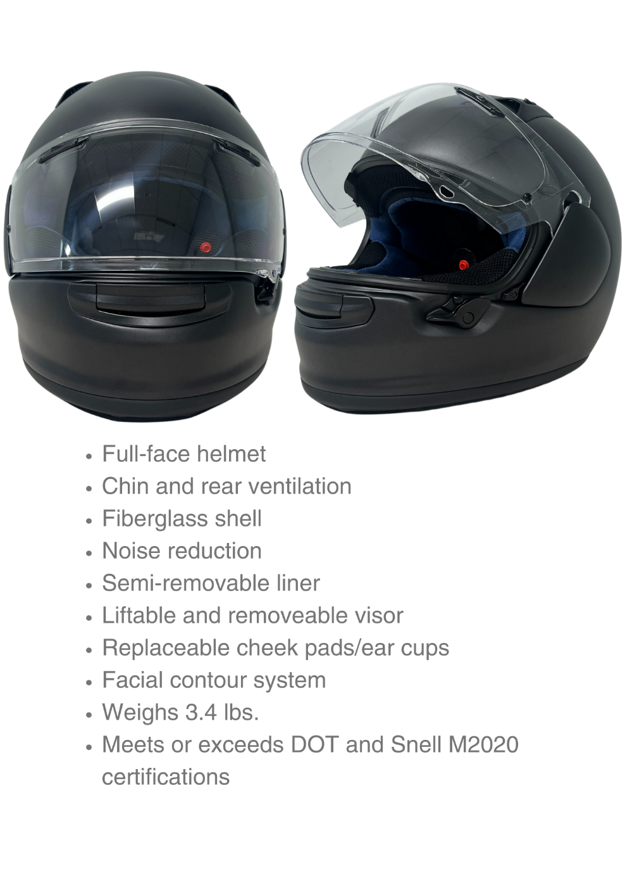
 | Extremely unprotective | Somewhat unprotective | Neutral | Somewhat protective | Extremely protective
How protective do you think this helmet is? | □ | □ | □ | □ | □

 | Extremely unlikely | Somewhat unlikely | Neutral | Somewhat likely | Extremely  likely
How likely would you be to wear this helmet while riding? | □ | □ | □ | □ | □

 | Extremely unlikely | Somewhat unlikely | Neutral | Somewhat likely | Extremely  likely
How likely would you be to purchase this helmet? | □ | □ | □ | □ | □

 | Extremely poorly | Somewhat poorly | Neutral | Somewhat well | Extremely  well
How well would you be able to see out of this helmet? | □ | □ | □ | □ | □

 | Extremely low  quality | Low  quality | Neutral | High  quality | Extremely  high  quality
What is the overall quality of this helmet? | □ | □ | □ | □ | □

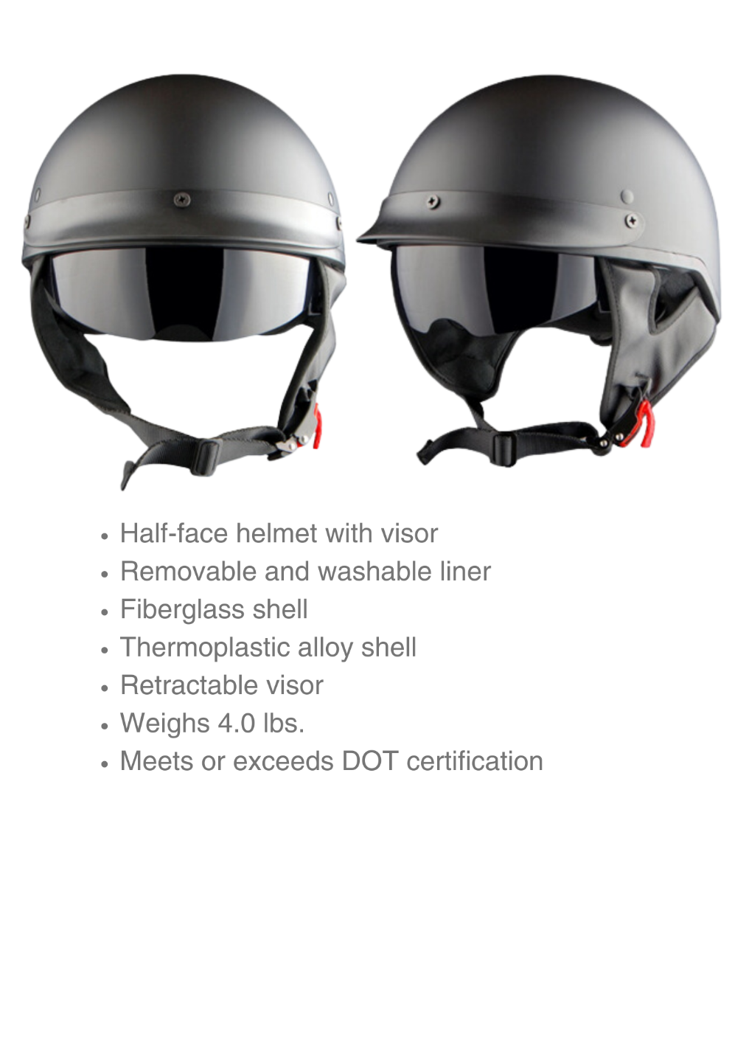
 | Extremely unprotective | Somewhat unprotective | Neutral | Somewhat protective | Extremely protective
How protective do you think this helmet is? | □ | □ | □ | □ | □

 | Extremely unlikely | Somewhat unlikely | Neutral | Somewhat likely | Extremely  likely
How likely would you be to wear this helmet while riding? | □ | □ | □ | □ | □

 | Extremely unlikely | Somewhat unlikely | Neutral | Somewhat likely | Extremely  likely
How likely would you be to purchase this helmet? | □ | □ | □ | □ | □

 | Extremely poorly | Somewhat poorly | Neutral | Somewhat well | Extremely  well
How well would you be able to see out of this helmet? | □ | □ | □ | □ | □

 | Extremely low  quality | Low  quality | Neutral | High  quality | Extremely  high  quality
What is the overall quality of this helmet? | □ | □ | □ | □ | □

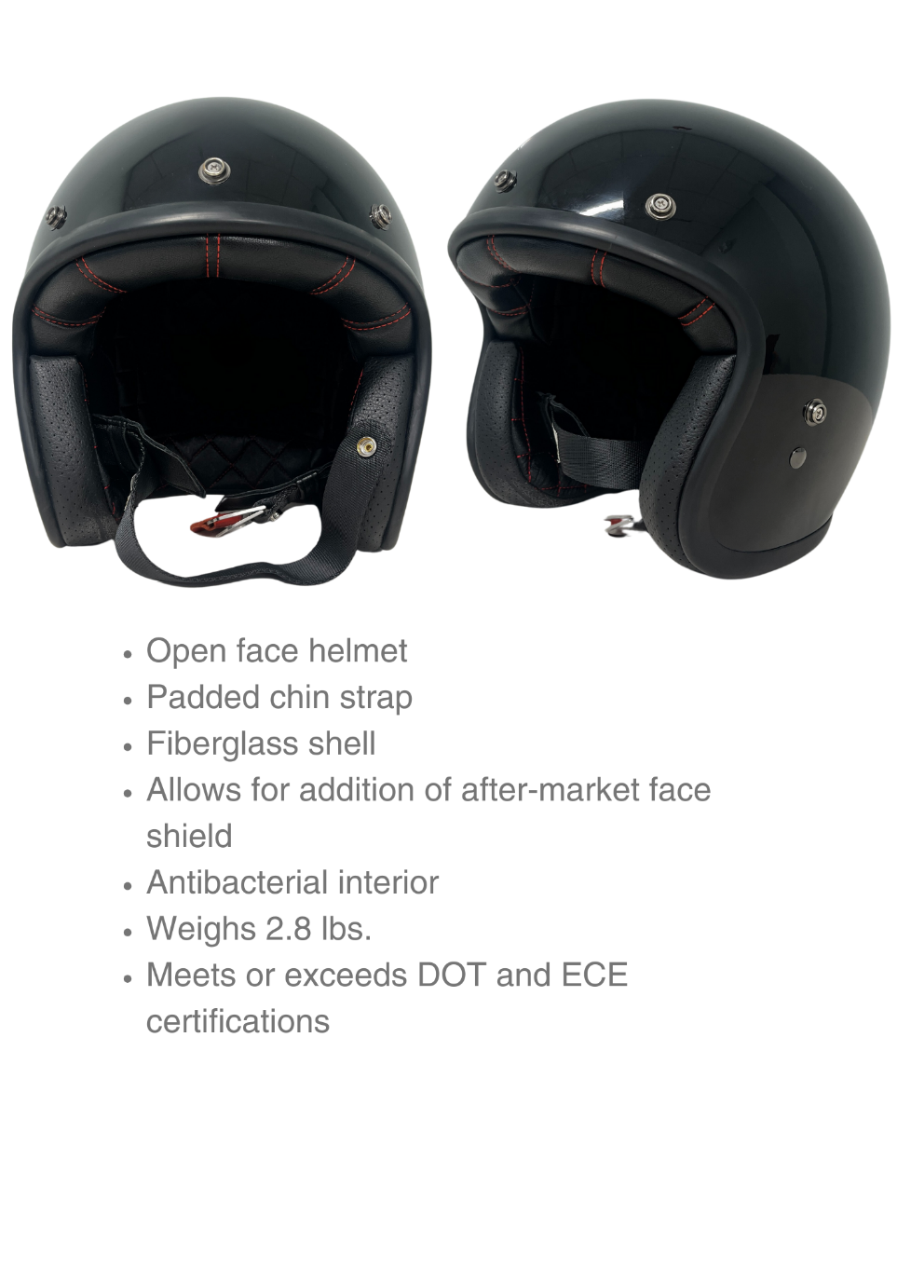
 | Extremely unprotective | Somewhat unprotective | Neutral | Somewhat protective | Extremely protective
How protective do you think this helmet is? | □ | □ | □ | □ | □

 | Extremely unlikely | Somewhat unlikely | Neutral | Somewhat likely | Extremely  likely
How likely would you be to wear this helmet while riding? | □ | □ | □ | □ | □

 | Extremely unlikely | Somewhat unlikely | Neutral | Somewhat likely | Extremely  likely
How likely would you be to purchase this helmet? | □ | □ | □ | □ | □

 | Extremely poorly | Somewhat poorly | Neutral | Somewhat well | Extremely  well
How well would you be able to see out of this helmet? | □ | □ | □ | □ | □

 | Extremely low  quality | Low  quality | Neutral | High  quality | Extremely  high  quality
What is the overall quality of this helmet? | □ | □ | □ | □ | □

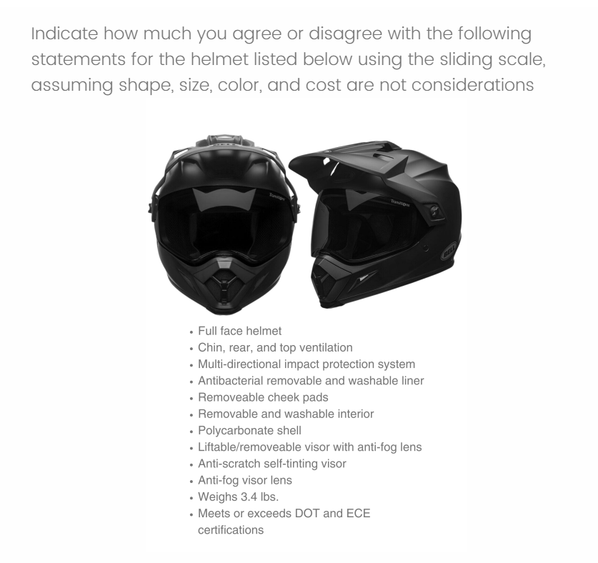

 | Extremely unprotective | Somewhat unprotective | Neutral | Somewhat protective | Extremely protective
How protective do you think this helmet is? | □ | □ | □ | □ | □

 | Extremely unlikely | Somewhat unlikely | Neutral | Somewhat likely | Extremely  likely
How likely would you be to wear this helmet while riding? | □ | □ | □ | □ | □

 | Extremely unlikely | Somewhat unlikely | Neutral | Somewhat likely | Extremely  likely
How likely would you be to purchase this helmet? | □ | □ | □ | □ | □

 | Extremely poorly | Somewhat poorly | Neutral | Somewhat well | Extremely  well
How well would you be able to see out of this helmet? | □ | □ | □ | □ | □

 | Extremely low  quality | Low  quality | Neutral | High  quality | Extremely  high  quality
What is the overall quality of this helmet? | □ | □ | □ | □ | □

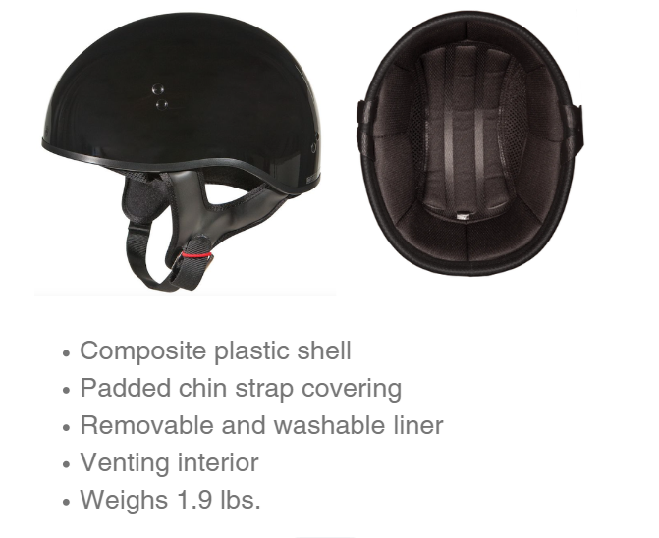

 | Extremely unprotective | Somewhat unprotective | Neutral | Somewhat protective | Extremely protective
How protective do you think this helmet is? | □ | □ | □ | □ | □

 | Extremely unlikely | Somewhat unlikely | Neutral | Somewhat likely | Extremely  likely
How likely would you be to wear this helmet while riding? | □ | □ | □ | □ | □

 | Extremely unlikely | Somewhat unlikely | Neutral | Somewhat likely | Extremely likely
How likely would you be to purchase this helmet? | □ | □ | □ | □ | □

 | Extremely poorly | Somewhat poorly | Neutral | Somewhat well | Extremely  well
How well would you be able to see out of this helmet? | □ | □ | □ | □ | □

 | Extremely low  quality | Low  quality | Neutral | High  quality | Extremely  high  quality
What is the overall quality of this helmet? | □ | □ | □ | □ | □

Demographics
(The participant will self-report the following information)
- In what State do you currently live? _______________________________________

- Which license type(s) do you currently have? (Check all that apply)
  - Motorcycle endorsement
  - Motorcycle-only license
  - Motorcycle learner’s permit
  - Driver’s license
  - Commercial license
  - None of the above

- What is your age? _______________ years

- What is your sex?
  - Female
  - Male

- What is your race and/or ethnicity? (Select all that apply and enter additional details in the spaces below)
- American Indian or Alaska Native
(If selected) Provide details below:

Enter, for example, Navajo Nation, Blackfeet Tribe of the Blackfeet Indian Reservation of Montana, Native Village of Inupiat Traditional Government, Nome Eskimo Community, Aztec, Maya, etc.:
_____________________________________________________________________
- Asian
(If selected) Provide details below:
  - Chinese
  - Asian Indian
  - Filipino
  - Vietnamese
  - Korean
  - Japanese
  - Another group (For example, Pakistani, Hmong, Afghan, etc.):
__________________________________________________________________

- Black or African American
(If selected) Provide details below:
  - African American
  - Jamaican
  - Haitian
  - Nigerian
  - Ethiopian
  - Somali
  - Another group (For example, Trinidadian and Tobagonian, Ghanian, Congolese, etc.): ________________________________________________________________
- Hispanic or Latino
(If selected) Provide details below:
  - Mexican
  - Puerto Rican
  - Salvadoran
  - Cuban
  - Dominican
  - Guatemalan
  - Another group (For example, Colombian, Honduran, Spaniard, etc.): __________________________________________________________________
- Middle Eastern or North African
(If selected) Provide details below:
  - Lebanese
  - Iranian
  - Egyptian
  - Syrian
  - Iraqi
  - Israeli
  - Another group (For example, Moroccan, Yemeni, Kurdish, etc.):
________________________________________________________________
- Native Hawaiian or Pacific Islander
(If selected) Provide details below:
  - Native Hawaiian
  - Samoan
  - Chamorro
  - Tongan
  - Fijian
  - Marshallese
  - Another group (For example, Chuukese, Palauan, Tahitian, etc.): ________________________________________________________________

- White
(If selected) Provide details below:
  - English
  - German
  - Irish
  - Italian
  - Polish
  - Scottish
  - Another group (For example, French, Swedish, Norwegian, etc.):
_________________________________________________________________

