Sample Real Estate Closing Disclosure
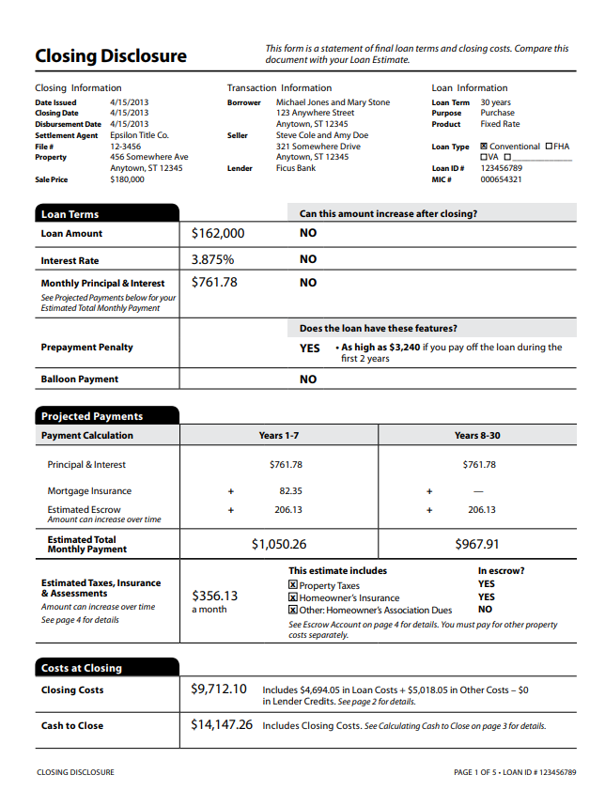

Sample property tax statement
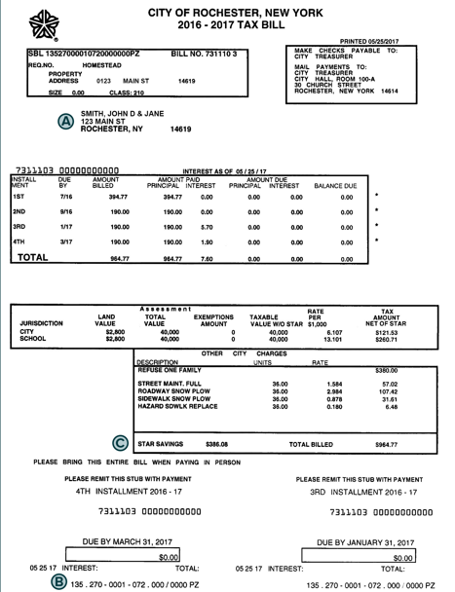

Sample Mortgage Statement
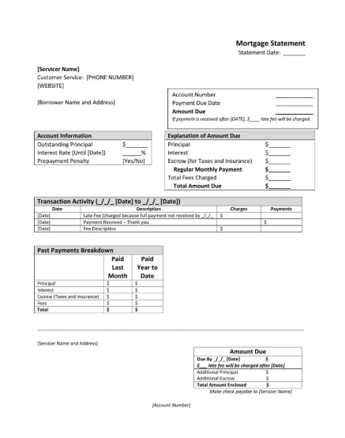

Minimum Property Requirement(s) Waiver request
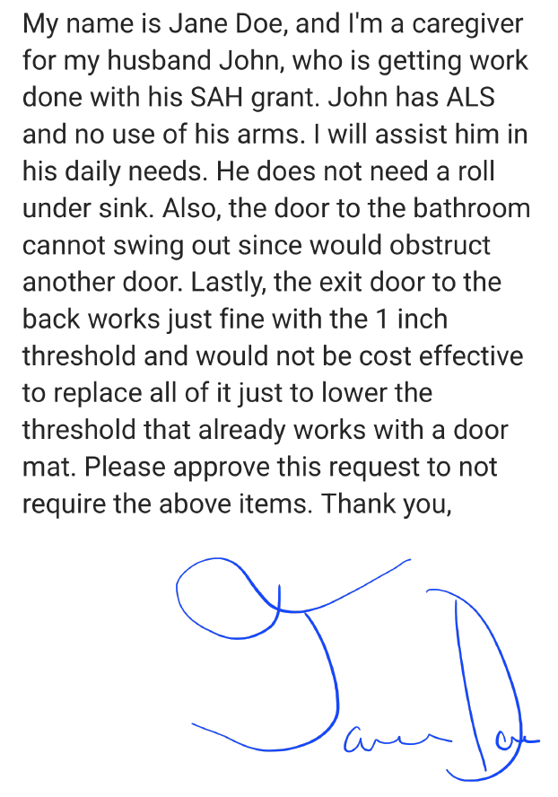

Sample Proposed construction bid
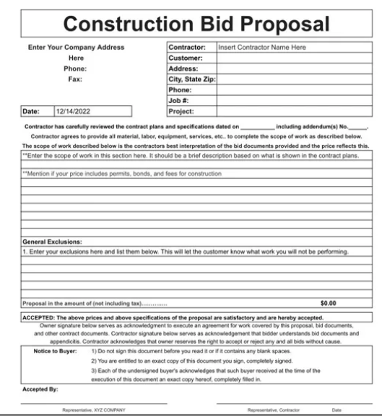

Request to waive additional construction bids
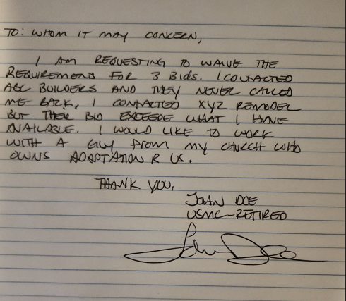

Construction Contract concurrence and signature
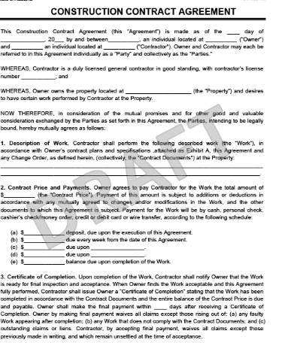

Sample Building Plans concurrence and signature.
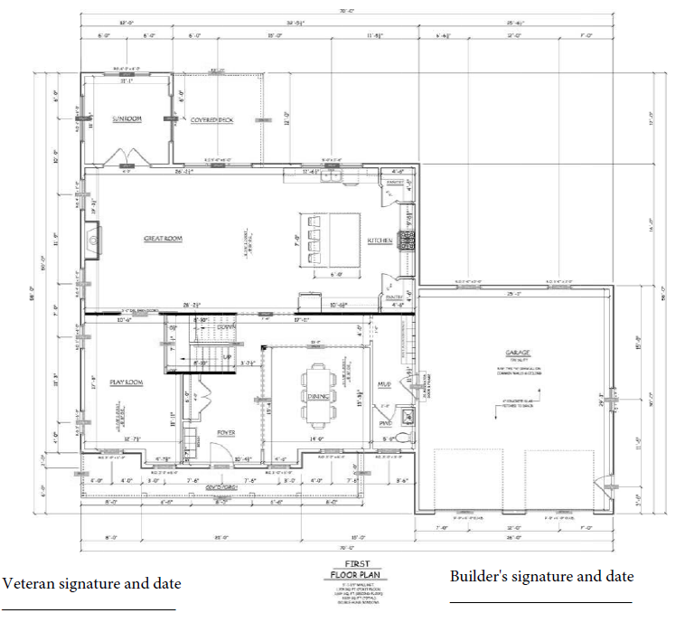

Sample Description of Material concurrence and signature.
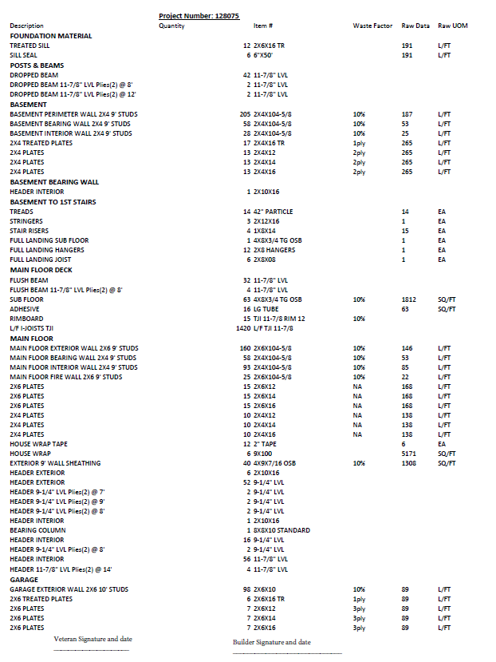
Sample Manufacturer Specification sheets concurrence and signature 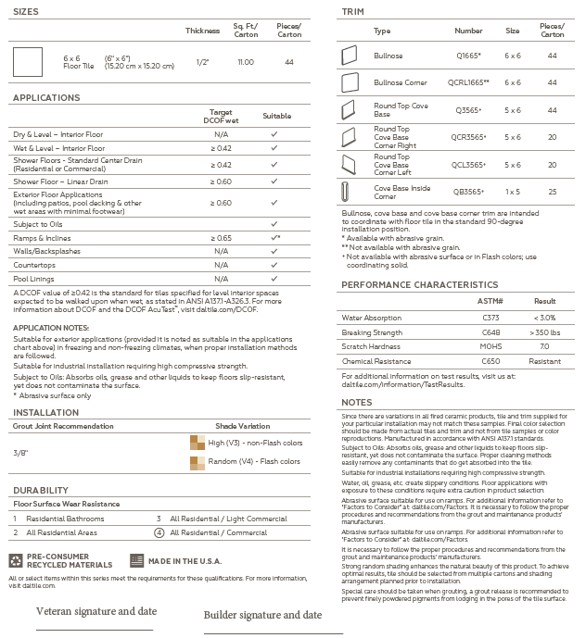.

Sample Cost Breakdown concurrence and signature.
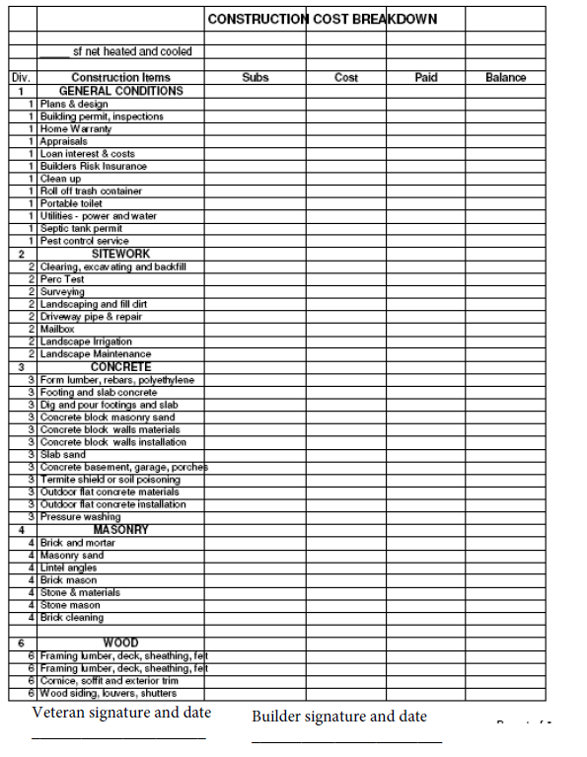

Sample High Cost acknowledgement from Veteran
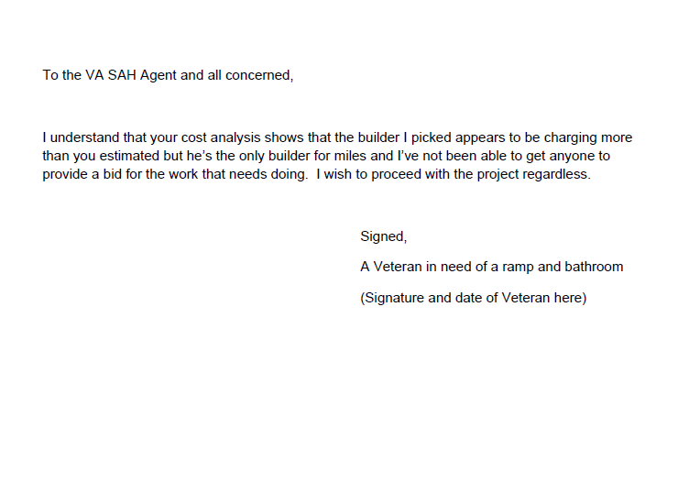

Sample Undercharging acknowledgment
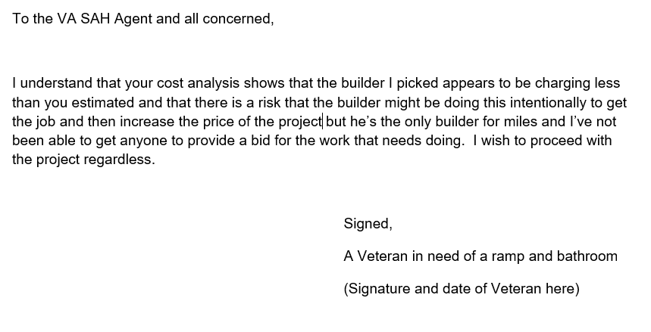

Samples of Home Structural Improvement and Alteration (HISA grant) documentation
Typically includes plans and specifications similar to those already described along with a formal letter of approval furnished by the VA Health Administration which bears the Veterans’ name and address.

Sample Loan documents - Commitment Letter
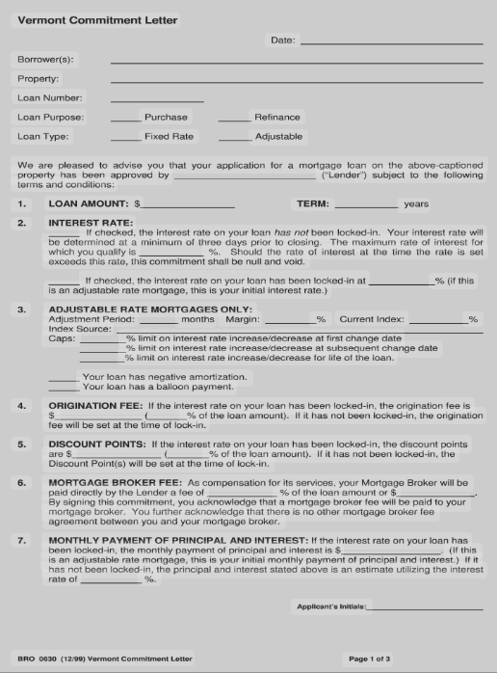

Sample Loan real estate appraisal
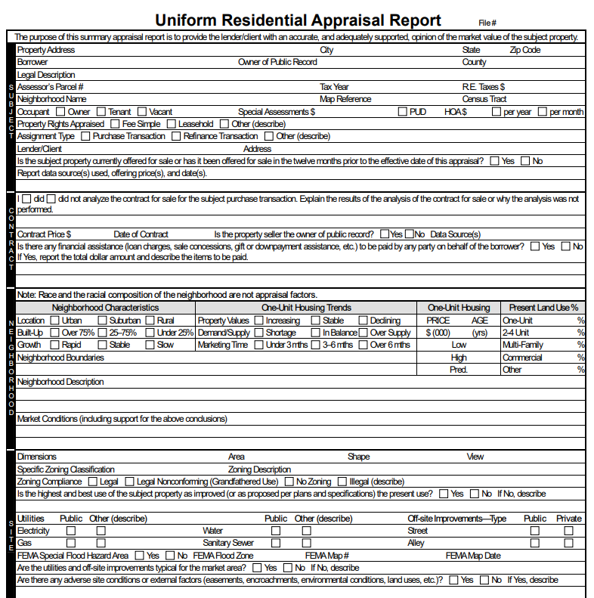

Sample Loan Analysis
The information may be provided as a completed VA Form 26-6393 (OMB control number 2900-0523) or a similar form provided by a private lender. Not all Veteran homes are VA guaranteed loans thus not all submissions will be on the VA form.

Sample Bank statement
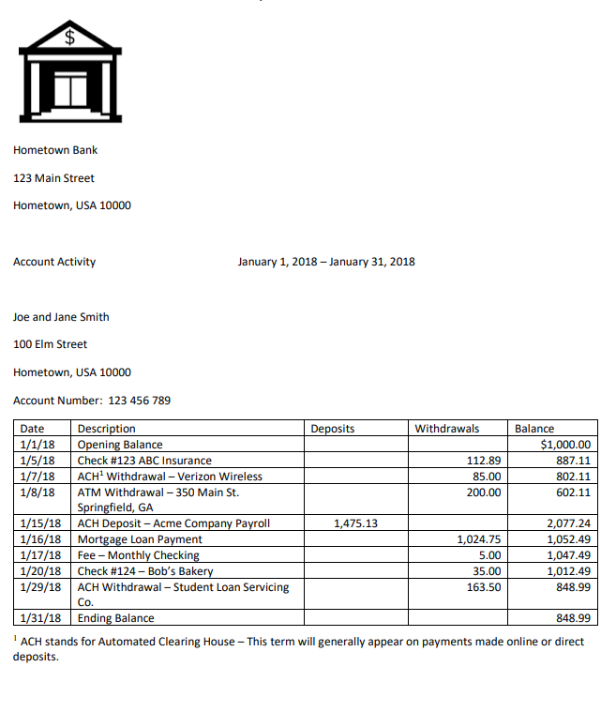

Sample Power of Attorney (note typically several pages long and will always require signatures)
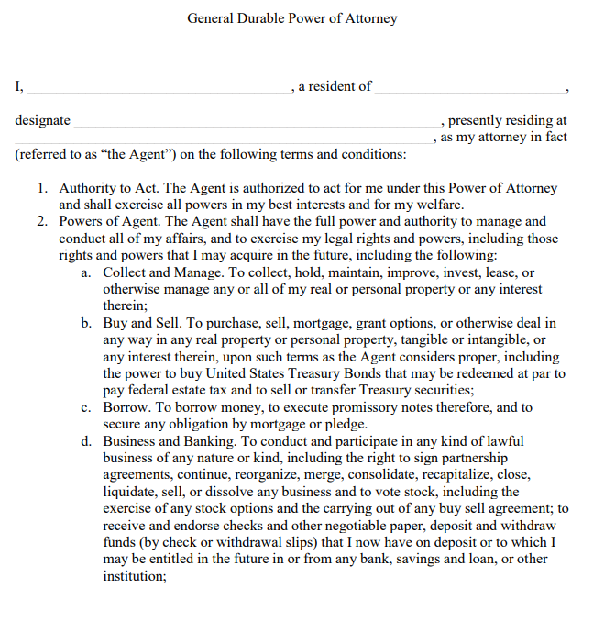

Sample Proof of purchase cost/affidavit
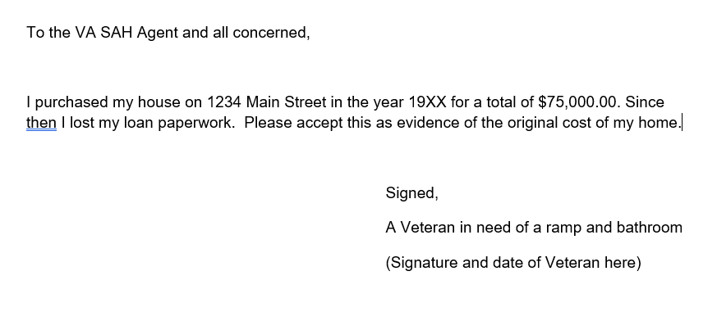

Evidence of condo registration with local emergency personnel
No common sample available. Issued on local Fire/EMS letterhead, the letter identifies the Veteran’s name, address and verifies that they are aware that a disabled person resides at that location and confirms that they will be able to effectuate a rescue in the event of an emergency. Special circumstances regarding living in a high-rise structure egress are addressed.

Sample Adaptation Request
