I4. Class Participation Form
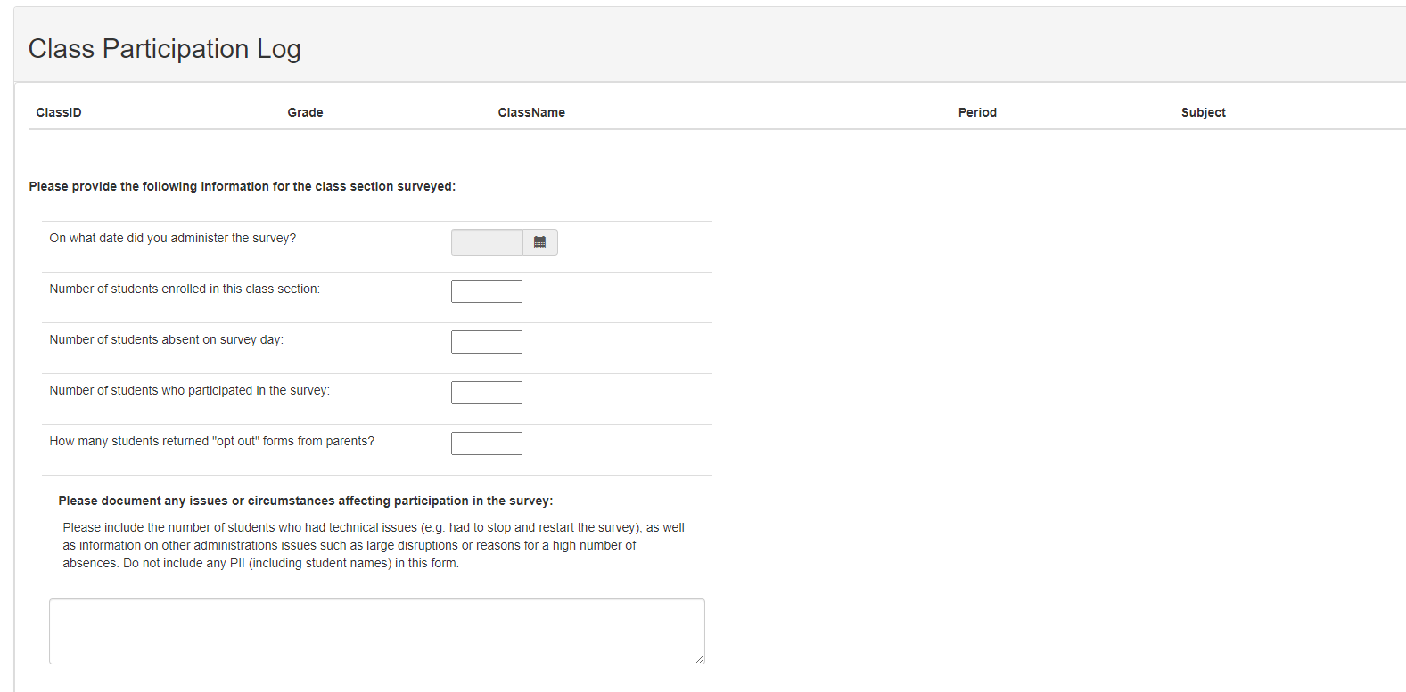

Public reporting burden for this collection of information is estimated to average 15 minutes per survey, including time for reviewing instructions, searching existing data sources, gathering and maintaining the data needed, and completing and reviewing the collection of information. An agency may not conduct or sponsor, and a person is not required to respond to, a collection of information unless it displays a currently valid OMB control number. Send comments regarding this burden estimate or any other aspect of this collection of information, including suggestions for reducing this burden to: Office of Operations, Food and Drug Administration, Three White Flint North, 10A-12M, 11601 Landsdown St., North Bethesda, MD 20852, PRAStaff@fda.hhs.gov, ATTN: PRA (0910-0932).

