Trends in International Mathematics and Science Study (TIMSS 2027)
Main Study Sampling, Recruitment, and Data Collection

OMB #1850-0695 v.21

Appendix A
Recruitment Materials

Submitted by
National Center for Education Statistics
U.S. Department of Education

October 2025

Appendix A
TIMSS 2027 Main Study Recruitment Materials
Contents
Appendix A1 State TIMSS 2027 Letter 3
Appendix A2 Endorsement Letter Template 4
Appendix A3 Request for Letter of Support from Endorsing Organizations 5
Appendix A4 TIMSS 2027 School District TIMSS Main Study Letter 6
Appendix A5 TIMSS 2027 Main Study School Letter 8
Appendix A6 TIMSS School Reminder Email – Grade 4 9
Appendix A7 TIMSS School Reminder Email – Grade 8 10
Appendix A8 School Web-Enabled Agreement Emails 11
Appendix A9 TIMSS 2027 Main Study FAQ 13
Appendix A10 Summary of School Activities: TIMSS 2027 Main Study 15
Appendix A11 Email reminders to districts and schools 16
Appendix A12a TIMSS 2027 Website Main Page 21
Appendix A12b TIMSS 2027 Website: Resources, Newsletters & Reports, and Contact Us Pages 22
Appendix A12c TIMSS 2027 Website: Online Questionnaire Login Screen Text 24
Appendix A13. School Coordinator (SC) Email to Provide School Information 25
Appendix A14 Login instructions to create a TIMSS Account 27
Appendix A15 Login Instructions/Screenshots to Create TIMSS Account 28
Appendix A16 TIMSS 2027 Login and Provide School Information Guide 33
Appendix A17 Automated Email for all TIMSS 2027 registrants 36
Appendix A18 Automated Email for TIMSS 2027 School Coordinator registrant 37
Appendix A19a TIMSS 2027 Portal: Home Page 38
Appendix A19b TIMSS 2027 Portal: Provide School Information Page 39
Appendix A19c TIMSS 2027 Portal: Web-Enabled Agreement 41
Appendix A19d TIMSS 2027 Portal: Documents Page 42
Appendix A20 Email to School Coordinator to Submit the Class Listing Form– Grade 4 – 43
Appendix A21 Instructions for Submitting Class Lists – Grade 4 44
Appendix A22 Email to School Coordinator to Submit Student-Teacher Linkage Form (STLF) – Grade 4 46
Appendix A23 Instructions for Submitting Student-Teacher Linkage Forms – Grade 4 – 47
Appendix A24 Email to School Coordinator to Submit the Class Listing Form – Grade 8 50
Appendix A25 Instructions for Submitting Class Lists – Grade 8 51
Appendix A26 Email to School Coordinator to Submit Student-Teacher Linkage Form – Grade 8 53
Appendix A27 Instructions for Submitting Student-Teacher Linkage Forms – Grade 8 – 54
Appendix A28 TIMSS 2027 School Posters 57

Appendix A1 State TIMSS 2027 Letter
<Title First Name Last Name> <Date>
<National Education Organization Official’s Title>
<National Education Organization>
<Address>
<City, State Zip>
Dear <Name>:
The United States is participating in an important international study: Trends in International Mathematics and Science Study 2027 (TIMSS). Over the past 32 years, TIMSS has measured U.S. students’ science and mathematics achievement in an international context. TIMSS’ high quality, internationally comparative trend data provide critical information to inform education policy discussions within and across countries.
TIMSS data can help identify student misunderstandings of key math and science principles. Findings can also be used to identify attitudes and characteristics of high-performing and especially resilient students.
Schools in your state have been selected to participate in TIMSS 2027 which will occur in the spring of 2027.
Please partner with us by learning more about TIMSS and encouraging participation of your states’ districts and schools that are selected to represent the U.S. in this study. Your support shows how important this research is and can increase participation and success of the study.
Next steps: Please carefully review the <TIMSS FAQs> to learn more about TIMSS. Help promote TIMSS by providing a letter of support and sharing information about the study with your sampled districts and schools.
We are in contact with your state assessment director and NAEP State Coordinator to keep them informed about TIMSS 2027. You may contact RTI International project staff with questions at 833-870-0485 or TIMSS@rti.org. You may also contact TIMSS Project Officer [NCES Representative] at the National Center for Educational Statistics at [email]@ed.gov.
Thank you for your support of this research and your help to ensure that the United States has a representative sample of participating schools across the country.
Sincerely,
[NCES Representative]
[NCES Representative’s Title]
cc: <State assessment director> <NAEP State Coordinator>

The National Center for Education Statistics (NCES) is authorized to conduct this study under the Education Sciences Reform Act of 2002 (ESRA 2002, 20 U.S.C. §9543), and to collect students’ education records from educational agencies or institutions for the purpose of evaluating federally supported education programs under the Family Educational Rights and Privacy Act (FERPA, 34 CFR §§ 99.31(a)(3)(iii) and 99.35). All of the information you provide may be used only for statistical purposes and may not be disclosed, or used, in identifiable form for any other purpose except as required by law (20 U.S.C. §9573 and 6 U.S.C. §151). In the United States, TIMSS is conducted by NCES, part of the U.S. Department of Education, and the data are being collected by RTI International. The U.S. Office of Management and Budget has approved the data collection under OMB #1850-0695.

Appendix A2 Endorsement Letter Template
State Department of Education/ National Education Organization Letterhead
<Date>
<State CSSO/Executive Director/CEO Name>
<Title>
<Organization Name>
<Address>
<City, State Zip>

Dear <Organization Members>:
On behalf of the <INSERT STATE EDUCATION AGENCY OR ORGANIZATION> we are pleased to support the Trends in International Mathematics and Science Study 2027 (TIMSS) being conducted by the National Center for Education Statistics (NCES) within the Institute of Education Sciences (IES) of the U.S. Department of Education (ED). We understand it is the NCES’ goal in conducting this study to provide valuable comparative information about the U.S. population’s educational performance, competencies, and skills in an international context.
This study compliments our <vision/mission/goal> of_____________________________________________ ________________________________________________________________________________________.
TIMSS assesses mathematics and science knowledge and skills at grades 4 and 8 and is designed to align broadly with curricula in the participating countries. The results, therefore, suggest the degree to which students have learned concepts and skills likely to have been taught in school. Data compiled and collected from TIMSS 2027 allows for evidence-based decisions to be made for the purposes of educational improvement.
Collection of these data is not possible without the participation of selected school districts and schools. By participating in the study, you are providing trend information about student achievement in mathematics and science relative to other countries, as well as indicators that show how this achievement relates to educational context.
We strongly encourage your participation in TIMSS 2027. <STATE ED AGENCY: We are confident that schools in our state will understand the importance of this international study and will accept the invitation to participate if selected.> <NATIONAL ED ORGANIZATION: We are confident that our members and partners, and state and local education leadership will understand the importance of this national study and will accept the invitation to participate if selected.>
Should you have any questions, please call the TIMSS information number, (833) 870-0485, or send an email to TIMSS@rti.org. You may also contact [NCES Representative] at NCES at [email]@ed.gov for more information.
Thank you for your dedication to education research and your help in making TIMSS 2027 a success.
Sincerely,
<Name>
Education Commissioner/Superintendent/Executive Director
State Education Agency/ Organization Name

The National Center for Education Statistics (NCES) is authorized to conduct this study under the Education Sciences Reform Act of 2002 (ESRA 2002, 20 U.S.C. §9543), and to collect students’ education records from educational agencies or institutions for the purpose of evaluating federally supported education programs under the Family Educational Rights and Privacy Act (FERPA, 34 CFR §§ 99.31(a)(3)(iii) and 99.35). All of the information you provide may be used only for statistical purposes and may not be disclosed, or used, in identifiable form for any other purpose except as required by law (20 U.S.C. §9573 and 6 U.S.C. §151). In the United States, TIMSS is conducted by NCES, part of the U.S. Department of Education, and the data are being collected by RTI International. The U.S. Office of Management and Budget has approved the data collection under OMB #1850-0695.

Appendix A3 Request for Letter of Support from Endorsing Organizations
<Date>
Dear Executive Director:
We are writing to request support from your organization for the Trends in International Mathematics and Science Study 2027 (TIMSS), which in the United States is conducted by the National Center for Education Statistics (NCES) within the Institute of Education Sciences (IES) of the U.S. Department of Education (ED).
Over the past 32 years, TIMSS has measured U.S. students‘ science and mathematics achievement in an international context. TIMSS’ high quality, internationally comparative trend data provide critical information to inform education policy discussions within and across countries.
Use of TIMSS data can help identify how students are misunderstanding key math and science principles. Findings can be used to enhance curriculum of foundational items to improve student understanding nationally.
Please partner with us by learning more about TIMSS and encouraging participation of schools that are selected to represent the U.S. in this study. Your support and a letter of endorsement shows how important this research is and can increase participation and success of the study. Without school participation, the validity of national estimates is at risk.
Next steps: Support TIMSS by lending your logo and name, providing a letter of endorsement, and sharing information about the study with your members and partners.
Results from TIMSS will give policymakers, researchers, and educators information they need to chart national progress against international standards and inform national discussions about international competitiveness.
Should you have any questions please call the TIMSS information number, 833-870-0485, or send an email to TIMSS@rti.org. You may also contact [NCES Representative] at NCES at [email] @ed.gov. Thank you for your support of this research and your partnership in helping us to advance the quality of education for all our students.
Sincerely,

[NCES Representative]
[NCES Representative’s Title]
Links: TIMSS Frequently Asked Questions (FAQs) sheet

The National Center for Education Statistics (NCES) is authorized to conduct this study under the Education Sciences Reform Act of 2002 (ESRA 2002, 20 U.S.C. §9543), and to collect students’ education records from educational agencies or institutions for the purpose of evaluating federally supported education programs under the Family Educational Rights and Privacy Act (FERPA, 34 CFR §§ 99.31(a)(3)(iii) and 99.35). All of the information you provide may be used only for statistical purposes and may not be disclosed, or used, in identifiable form for any other purpose except as required by law (20 U.S.C. §9573 and 6 U.S.C. §151). In the United States, TIMSS is conducted by NCES, part of the U.S. Department of Education, and the data are being collected by RTI International. The U.S. Office of Management and Budget has approved the data collection under OMB #1850-0695.

Appendix A4 TIMSS 2027 School District TIMSS Main Study Letter

<Date>
One time data collection: spring 2027
On average, 2 classrooms per school are selected.
Choice of using school or study- provided equipment for student data collection.
TIMSS 2027 SNAPSHOT
<DistrictName>
<Address>
<CitySTZip>

Dear <Superintendent>,

The United States is participating in an important international study: Trends in International Mathematics and Science Study 2027 (TIMSS). Over the past 32 years, TIMSS has measured U.S. students’ science and mathematics achievement in an international context. TIMSS’ high quality, internationally comparative trend data provide critical information to inform education policy discussions within and across countries.
One or more schools in your <district/diocese> has been selected to represent the United States in TIMSS to occur in spring 2027 (see below for school list).
Benefits of TIMSS 2027 include:
- Schools will receive <$200/$800> or nonmonetary equivalent value
- If allowed, teachers will receive monetary compensation for completing a web-based survey
- A certificate of service from the U.S. Department of Education for participating students and staff.
Within a few days study materials will be sent to selected schools in your <district/diocese>, and our contractor RTI International will contact them to participate. <Name>, your NAEP State Coordinator, may contact your staff with additional information.

If you have any questions, please do not hesitate to call 833-870-0485 or send an email to TIMSS@rti.org or the U.S. National Research Coordinator: [email]@ed.gov.

Sincerely,

<State CSSO> or
<[NCES Representative],
[NCES Representative’s Title]>

Links to Study Materials: <TIMSS Frequently Asked Questions (FAQs) sheet, State Letter of Endorsement (if provided)>

The National Center for Education Statistics (NCES) is authorized to conduct this study under the Education Sciences Reform Act of 2002 (ESRA 2002, 20 U.S.C. §9543), and to collect students’ education records from educational agencies or institutions for the purpose of evaluating federally supported education programs under the Family Educational Rights and Privacy Act (FERPA, 34 CFR §§ 99.31(a)(3)(iii) and 99.35). All of the information you provide may be used only for statistical purposes and may not be disclosed, or used, in identifiable form for any other purpose except as required by law (20 U.S.C. §9573 and 6 U.S.C. §151). In the United States, TIMSS is conducted by NCES, part of the U.S. Department of Education, and the data are being collected by RTI International. The U.S. Office of Management and Budget has approved the data collection under OMB #1850-0695.

Please partner with us by encouraging participation of your schools that are selected to represent the U.S. in TIMSS. Your support can show the importance of this mission critical research.
Within the next few days, a representative of RTI International will contact the following school or schools in your <district/diocese> that have been selected for TIMSS 2027.

School name

<IF APPLICABLE: We may also contact <LIST REPLACEMENT SCHOOLS HERE>
School name

Appendix A5 TIMSS 2027 Main Study School Letter

<Principal name> <Date>
<school name>
Monetary incentive for school, school coordinator, and teachers (when allowed)

Token of appreciation and certificate of service for students

Interactive webinar for eligible district and school staff on timely topics

School-level report for schools with sufficient participation
Benefits of Participation
<address>
<city> <state> <zip>

Dear <Principal Name>,

The United States is participating in an important international study: Trends in International Mathematics and Science Study 2023 (TIMSS). Over the past 32 years, TIMSS has measured U.S. students’ science and mathematics achievement in an international context. TIMSS’ high quality, internationally comparative, trend data provide critical information to inform education policy discussions within and across countries.
Your school has been randomly selected to represent schools across the United States by participating in TIMSS to occur in spring 2027. Please plan for TIMSS to be administered on one day between March and June 2027. TIMSS measures trends in academic achievement at grades 4 and 8 in countries around the world. Students will take the assessment digitally on equipment supplied by the U.S. TIMSS team.
Your district has been notified of your selection. Within the next few weeks, [Name of representative], a representative from TIMSS, will contact you to discuss your participation and obtain the name of your school coordinator (SC).

Next Steps:
- Review the study materials <TIMSS Frequently Asked Questions (FAQs)>, <State Letter of Endorsement (if provided)>
- Write down the name and email address of your school coordinator (SC) and be prepared to provide their name and email address.
- You will receive a call in the next few days to discuss the study and provide the name of your SC.
- If you prefer to contact us first, we can be reached at 833-870-0485 or TIMSS@rti.org.

Your participation in TIMSS 2027 is very important to its success. To meet the rigorous standard of TIMSS data, we need to ensure that students in schools like yours are represented in our evaluation of assessment items and questionnaires. Thank you for your time and for supporting this important international study.
Sincerely,

<NAEP State Coordinator or [NCES Representative], [NCES Representative’s Title]>
cc: <District Test Coordinator>

The National Center for Education Statistics (NCES) is authorized to conduct this study under the Education Sciences Reform Act of 2002 (ESRA 2002, 20 U.S.C. §9543), and to collect students’ education records from educational agencies or institutions for the purpose of evaluating federally supported education programs under the Family Educational Rights and Privacy Act (FERPA, 34 CFR §§ 99.31(a)(3)(iii) and 99.35). All of the information you provide may be used only for statistical purposes and may not be disclosed, or used, in identifiable form for any other purpose except as required by law (20 U.S.C. §9573 and 6 U.S.C. §151). In the United States, TIMSS is conducted by NCES, part of the U.S. Department of Education, and the data are being collected by RTI International. The U.S. Office of Management and Budget has approved the data collection under OMB #1850-0695.

Appendix A6 TIMSS School Reminder Email – Grade 4
Dear Principal:
Earlier this year, <<our team/<NSC> from <SEA>> communicated with you regarding your participation in the Trends in International Mathematics and Science Study (TIMSS) 2027. TIMSS assesses mathematics and science knowledge and skills at grades 4 and 8 and is designed to align broadly with curricula in the participating countries. This is a friendly reminder that RTI International will be contacting you in the coming weeks to coordinate your school’s data collection logistics.
If you have already identified who will serve as your School Coordinator (SC), and communicated the information to us, thank you very much. If not, we will ask for this when we contact you. If you haven’t already registered to participate, you may click this <Insert web agreement link> to register and provide SC information online, or email TIMSS@rti.org to provide your SC’s name and contact information. RTI will do all that we can to minimize the burden on school staff and resources.
We realize your school may be asked to participate in multiple studies during your school year, and we are very aware how this may interrupt schools’ plans to deliver meaningful learning experiences. We are reaching out to you now with the expectation that TIMSS will take place on-campus, in classroom settings between March and June 2027. We have multiple ways to conduct the student assessment to be responsive to each school’s unique instruction schedule.

Students in about two of your 4th grade math classes will be selected to participate, with TIMSS scheduled to take place on <Date/on one day in Spring 2027>. If this date is not convenient for your school, RTI will work with you to find an alternate date. Also, one school administrator and the math teacher(s) of the selected classroom(s) will be asked to complete a web-based questionnaire.

As a token of appreciation for participating in TIMSS, your school will receive <$200/$800>. Students who participate in TIMSS will receive a small gift as a token of appreciation. Your school’s TIMSS SC, (the staff person you designate to liaise with TIMSS project staff) will receive $100 for his or her time and effort coordinating TIMSS activities. Selected teachers will receive $25 for completing a brief questionnaire.
If you have any questions, please do not hesitate to contact the U.S. TIMSS team at 833-870-0485 or email: TIMSS@rti.org. Further information about TIMSS may be found by visiting the TIMSS website at https://surveys.nces.ed.gov/TIMSS.
Thank you for your time and for supporting this important international study.
Sincerely,
Debbie Herget
TIMSS 2027 Project Director, RTI International

The National Center for Education Statistics (NCES) is authorized to conduct this study under the Education Sciences Reform Act of 2002 (ESRA 2002, 20 U.S.C. §9543), and to collect students’ education records from educational agencies or institutions for the purpose of evaluating federally supported education programs under the Family Educational Rights and Privacy Act (FERPA, 34 CFR §§ 99.31(a)(3)(iii) and 99.35). All of the information you provide may be used only for statistical purposes and may not be disclosed, or used, in identifiable form for any other purpose except as required by law (20 U.S.C. §9573 and 6 U.S.C. §151). In the United States, TIMSS is conducted by NCES, part of the U.S. Department of Education, and the data are being collected by RTI International. The U.S. Office of Management and Budget has approved the data collection under OMB #1850-0695.

Appendix A7 TIMSS School Reminder Email – Grade 8

Dear Principal:
Earlier this year, <<our team/<NSC> from <SEA>> communicated with you regarding your participation in the Trends in International Mathematics and Science Study (TIMSS) 2027. TIMSS assesses mathematics and science knowledge and skills at grades 4 and 8 and is designed to align broadly with curricula in the participating countries. This is a friendly reminder that RTI International will be contacting you in the coming weeks to coordinate your school’s data collection logistics.
If you have already identified who will serve as your School Coordinator (SC), and communicated the information to us, thank you very much. If not, we will ask for this when we contact you. If you haven’t already registered to participate, you may click this <Insert web agreement link> to register provide SC information online, or email TIMSS@rti.org to provide your school and SC information. RTI will do all that we can to minimize the burden on school staff and resources.
We realize your school may be asked to participate in multiple studies during your school year, and we are very aware how this may interrupt schools’ plans to deliver meaningful learning experiences. We are reaching out to you now with the expectation that TIMSS will take place in on-campus classroom settings between March and June 2027. We have multiple ways to conduct the student assessment to be responsive to each school’s unique instruction schedule.
Students in about two of your 8th grade math classes will be selected to participate, with TIMSS scheduled to take place on <Date>/on a date Spring 2027>. If these dates are not convenient for your school, RTI will work with you to find an alternate date. The math teacher(s) of the selected classroom(s) will be asked to complete a web-based questionnaire. One school administrator and science teachers of participating students will also be asked to complete online questionnaires.
As a token of appreciation for participating in TIMSS, your school will receive <$200/$800>. Students who participate in TIMSS will receive a small gift as a token of appreciation. Your school’s TIMSS SC (the staff person you designate to liaise with TIMSS project staff) will receive $100 for his or her time and effort coordinating TIMSS activities. Selected teachers will receive $25 for completing a brief questionnaire.
If you have any questions, please do not hesitate to contact the U.S. TIMSS team at 833-870-0485 or email: TIMSS@rti.org. Further information about TIMSS may be found by visiting the TIMSS website at https://surveys.nces.ed.gov/TIMSS.
Thank you for your time and for supporting this important international study.
Sincerely,
Debbie Herget
TIMSS 2027 Project Director, RTI International

The National Center for Education Statistics (NCES) is authorized to conduct this study under the Education Sciences Reform Act of 2002 (ESRA 2002, 20 U.S.C. §9543), and to collect students’ education records from educational agencies or institutions for the purpose of evaluating federally supported education programs under the Family Educational Rights and Privacy Act (FERPA, 34 CFR §§ 99.31(a)(3)(iii) and 99.35). All of the information you provide may be used only for statistical purposes and may not be disclosed, or used, in identifiable form for any other purpose except as required by law (20 U.S.C. §9573 and 6 U.S.C. §151). In the United States, TIMSS is conducted by NCES, part of the U.S. Department of Education, and the data are being collected by RTI International. The U.S. Office of Management and Budget has approved the data collection under OMB #1850-0695.

Appendix A8 School Web-Enabled Agreement Emails

Web Enabled Agreement Email 1
Dear Principal,
We hope this email finds you well! Your school was selected to participate in the Trends in International Mathematics and Science Study (TIMSS) 2027 taking place in spring of 2027. We haven’t been able to reach you by phone and would like to learn the name of your selected School Coordinator (SC). Please follow this < link> to add your SC and we will follow up with them in the next few days.
Incentives are available for your school as a thank you for participating. If you have any questions, please give us a call at 833-870-0485 or email TIMSS@rti.org. We look forward to working with your staff and students!
Sincerely,
The U.S. TIMSS Team

Web Enabled Agreement Email 2
Dear Principal,
Did you know that the U.S. is one of approximately 70 countries participating in the Trends in International Mathematics and Science Study (TIMSS)? TIMSS is a cornerstone assessment for measuring U.S. student achievement in an international context. Your school was selected for TIMSS 2027, taking place in the Spring of 2027.
Please follow this <link> below to reserve your space in TIMSS and designate your School Coordinator (SC). Incentives are available to your school as a thank you. If you have any questions, please reach out to us at 833-870-0485 or TIMSS@rti.org.
Thanks again,
The U.S. TIMSS Team

Web Enabled Agreement Email 3
Dear Principal,
The Trends in International Mathematics and Science Study (TIMSS) occurs only once every four years; our continual participation has opened a window into the educational systems of other countries and revealed new possibilities for U.S. education. The participation of your school is critical in TIMSS, which is taking place in spring 2027.
Please follow this< link> to register your school in TIMSS and designate your School Coordinator (SC). Our team will reach out to your SC in the next few days; you may also contact us if you have any questions at 833-870-0485 or TIMSS@rti.org. Thank you for your partnership!
With appreciation,
The U.S. TIMSS Team

Web Enabled Agreement Email 4
Dear Principal,

Thank you for all that you do for students! We know how busy you are, so we are reaching out with a simplified way to communicate with the Trends in International Mathematics and Science Study (TIMSS) Team. As you know, your school was selected to represent the U.S. in TIMSS taking place in spring 2027. Please follow this <link> to designate your School Coordinator (SC).

We will contact your SC in the next few days; if you have any questions, we are available at 833-870-0485 or TIMSS@rti.org. We look forward to working with your staff and students!

With sincere thanks,

The U.S. TIMSS Team

Appendix A9 TIMSS 2027 Main Study FAQ

Trends in International Mathematics and Science Study
Frequently Asked Questions
TIMSS 2027 will occur in the spring of 2027.

What is TIMSS?
The Trends in International Mathematics and Science Study (TIMSS) is an international assessment and research project designed to measure trends in mathematics and science achievement at the fourth- and eighth-grade levels as well as school and teacher practices related to instruction. Since 1995, TIMSS has been administered every 4 years. TIMSS 2027, the ninth study in the series, will involve students from approximately 70 countries, including the United States. TIMSS 2027 will be administered digitally.

Why was my school selected for participation?
Your school was randomly selected to participate and represent our country in the study. The U.S. sample includes both public and private school representative of the nation at grade 4 and grade 8.

Why should my school and students participate?
TIMSS provides a unique opportunity to compare trends in U.S. students’ math and science knowledge and skills at the fourth- and eighth-grade levels with that of their peers in countries around the world. TIMSS complements what we learn from national assessments by providing valuable benchmark information on how U.S. students compare to students around the world and contributing critical information to inform education policy discussions for all students.

Will all our fourth- or eighth-grade students be asked to participate?
In schools with only one or two such classrooms, all students will be asked to participate. In schools with more than two such classrooms, two randomly selected classrooms will typically be asked to participate. If class sizes are small, it’s possible that more than two classes are selected. In addition, some students with special needs or limited English proficiency may be excused from the assessment.

Who conducts the TIMSS assessment?
The National Center for Education Statistics (NCES), within the U.S. Department of Education, is authorized to conduct this study under the Education Sciences Reform Act of 2002 (ESRA 2002, 20 U.S.C. §9543), and approval of the U.S. Office of Management and Budget under OMB# 1850-0695. The entire assessment process will be administered on behalf of NCES by trained staff from RTI International, a research organization under contract with NCES.

How are the school and teacher questionnaires administered?
The teacher and school questionnaires are administered online from a secure website. Teacher questionnaires take about 35 minutes to complete, and ask teachers questions about their experience, available resources, and instructional practices. School questionnaires take about 30 minutes to complete and ask about school practices and resources.

Do schools need to provide computer equipment for TIMSS?
Your school may choose to use your school’s computers and internet, or RTI can provide Chromebooks and an internet network for the TIMSS student assessment.

Do teachers need to help administer the assessment?
No, RTI International field staff will visit the school on the day of the assessment, bringing with them all the materials required. These field staff will administer the assessments to students.

When will TIMSS be conducted?
TIMSS 2027 will be conducted in March through June 2027. RTI International will work with each school to identify a convenient assessment date in that time period.

Where will TIMSS be conducted?
The student session will be conducted in the schools that are selected to participate.

How long does the student session take?
The session will take approximately 2 ½ hours to complete. This includes time for directions, the assessment, and a questionnaire that students complete about themselves.

What will happen with the collected data?
All of the information provided by school staff and students may be used only for statistical purposes and may not be disclosed, or used, in identifiable form for any other purpose except as required by law (20 U.S.C. §9573 and 6 U.S.C. §151). Reports of the findings from the study will not identify participating districts, schools, students, or individual staff. Individual responses will be combined with those of other participants to produce summary statistics and reports.

Where can I find more information about TIMSS?
Visit the TIMSS 2027 website at https://surveys.nces.ed.gov/TIMSS.

For additional information about TIMSS 2027, contact the TIMSS U.S. home office at 833-870-0485 or email TIMSS@rti.org.

Appendix A10 Summary of School Activities: TIMSS 2027 Main Study
Summary of School Activities: TIMSS 2027
 | August 2026- February 2027 | September 2026-May 2027  Prior to assessment day | March-June 2027  Assessment day | Benefits
Principal | - Designate a school coordinator |  | - Support assessment day activities  - Encourage students to participate and do their best on the assessment  - Complete a brief web-based School Questionnaire on the characteristics of the school, its enrollment, resources, policies, and learning environment. Share the importance of participation in the study with school staff | - Represent other similar U.S. schools  - Receive <$200/$800> check for the school  - Eligible staff may register for a no-cost webinar on timely topics <subjects TBD>  - Receive a school-level report (with sufficient participation)
School coordinator | - Confirm an assessment date convenient for your school | - Provide class lists and student lists through the TIMSS portal  - Arrange/confirm date and location for student session  - Notify teachers, selected students, and students’ parents of the study and benefit of participating  - Work with study staff to identify students with special needs  - Coordinate the completion of the school questionnaire and teacher questionnaires (online)  - Distribute and track parental permission forms  - Collect parental consent forms where required and submit to TIMSS staff | - Confirm space for assessment is problem-free  - Ensure all sampled students attend the assessment session  - Meet with assessment staff and provide feedback about the assessment process | - If permitted, receive a $100 check or gift card for school supplies
Selected Math & Science Teachers |  |  | - Complete a brief web-based survey on teacher classroom practices, mathematics and science topics taught, and use of technology | - If permitted, receive $25 or gift card for school supplies
Selected Students |  |  | - Attend the assessment sessions, complete the assessment and student questionnaire | - Receive a small thank-you gift and certificate of appreciation for participation
RTI International assessment staff | - Work with the school to set an assessment date  - Help school coordinator with assessment details and logistics  - Protect school and student information | - Select classroom sample and notify school of selected classes  - Call the school coordinator to discuss assessment day location and student participation  - Confirm internet/security set up/access. | - Administer student session  - Furnish all equipment  - Conduct a brief debriefing interview with the school coordinator at the end of the session  - Maintain security of all materials | - Ensure quality, uniformity and security of data collected across the United States
For additional information, go to https://surveys.nces.ed.gov/TIMSS.

Appendix A11 Email reminders to districts and schools

District and School Engagement Email 1
Did you know that changes in TIMSS evolve gradually? More than half the items are maintained in common from cycle to cycle to monitor trends in students’ achievement, but no items are kept for more than three assessments, so that the entire assessment is being refreshed continually. Visit the TIMSS 2027 Frameworks <insert URL> to see what’s new.
Be sure to check current U.S. participation status for TIMSS 2027 on the study website (https://surveys.nces.ed.gov/TIMSS). We look forward to working with your students and will be in touch with you soon!

The U.S. TIMSS Team
833-870-0485
TIMSS@rti.org

The National Center for Education Statistics (NCES) is authorized to conduct this study under the Education Sciences Reform Act of 2002 (ESRA 2002, 20 U.S.C. §9543), and to collect students’ education records from educational agencies or institutions for the purpose of evaluating federally supported education programs under the Family Educational Rights and Privacy Act (FERPA, 34 CFR §§ 99.31(a)(3)(iii) and 99.35). All of the information you provide may be used only for statistical purposes and may not be disclosed, or used, in identifiable form for any other purpose except as required by law (20 U.S.C. §9573 and 6 U.S.C. §151). In the United States, TIMSS is conducted by NCES, part of the U.S. Department of Education, and the data are being collected by RTI International. The U.S. Office of Management and Budget has approved the data collection under OMB #1850-0695.
District and School Engagement Email 2 (Grade 4)
We are writing to say THANK YOU! By participating in research studies like the Trends in International Mathematics and Science Study (TIMSS) you are contributing information that will help our country understand how students are learning to apply math and science. This knowledge will inform policymakers, researchers, and educators at all levels to improve outcomes for youth today and for years to come.
Did you know…
U.S. fourth graders’ average mathematics score was 18 points lower in 2023 than in 2019, but was not significantly different from the score in 1995 (when TIMSS was first administered.) .
Here are some math resources you may be interested in. Check out https://ies.ed.gov/ncee/wwc/Math/

The U.S. TIMSS Team
833-870-0485
TIMSS@rti.org

The National Center for Education Statistics (NCES) is authorized to conduct this study under the Education Sciences Reform Act of 2002 (ESRA 2002, 20 U.S.C. §9543), and to collect students’ education records from educational agencies or institutions for the purpose of evaluating federally supported education programs under the Family Educational Rights and Privacy Act (FERPA, 34 CFR §§ 99.31(a)(3)(iii) and 99.35). All of the information you provide may be used only for statistical purposes and may not be disclosed, or used, in identifiable form for any other purpose except as required by law (20 U.S.C. §9573 and 6 U.S.C. §151). In the United States, TIMSS is conducted by NCES, part of the U.S. Department of Education, and the data are being collected by RTI International. The U.S. Office of Management and Budget has approved the data collection under OMB #1850-0695.
District and School Engagement Email 3 (Grade 8)
We are writing to say THANK YOU! By participating in research studies like the Trends in International Mathematics and Science Study (TIMSS) you are contributing information that will help our country understand how students are learning to apply math and science. This knowledge will inform policymakers, researchers, and educators at all levels to improve outcomes for youth today and for years to come.
Did you know…
At the eighth grade, U.S. students’ average TIMSS mathematics score in 2023 was 27 points lower than in 2019 but was not measurably different from the score in 1995.
Here are some math resources you may be interested in. Check out https://ies.ed.gov/ncee/wwc/Math/.

The U.S. TIMSS Team
833-870-0485
TIMSS@rti.org

The National Center for Education Statistics (NCES) is authorized to conduct this study under the Education Sciences Reform Act of 2002 (ESRA 2002, 20 U.S.C. §9543), and to collect students’ education records from educational agencies or institutions for the purpose of evaluating federally supported education programs under the Family Educational Rights and Privacy Act (FERPA, 34 CFR §§ 99.31(a)(3)(iii) and 99.35). All of the information you provide may be used only for statistical purposes and may not be disclosed, or used, in identifiable form for any other purpose except as required by law (20 U.S.C. §9573 and 6 U.S.C. §151). In the United States, TIMSS is conducted by NCES, part of the U.S. Department of Education, and the data are being collected by RTI International. The U.S. Office of Management and Budget has approved the data collection under OMB #1850-0695.

District and School Engagement Email 4
This is just a quick email to say THANK YOU! By participating in research like the Trends in International Mathematics and Science Study (TIMSS) in the spring of 2027, you are helping to improve the condition of education for students today and years to come. To learn more about the current condition of education, check out the link below.
Here is “The Report on the Condition of Education” 2024 report:
nces.ed.gov/pubs2024/2024144.pdf

We look forward to talking with you again soon!

The U.S. TIMSS Team
833-870-0485
TIMSS@rti.org

The National Center for Education Statistics (NCES) is authorized to conduct this study under the Education Sciences Reform Act of 2002 (ESRA 2002, 20 U.S.C. §9543), and to collect students’ education records from educational agencies or institutions for the purpose of evaluating federally supported education programs under the Family Educational Rights and Privacy Act (FERPA, 34 CFR §§ 99.31(a)(3)(iii) and 99.35). All of the information you provide may be used only for statistical purposes and may not be disclosed, or used, in identifiable form for any other purpose except as required by law (20 U.S.C. §9573 and 6 U.S.C. §151). In the United States, TIMSS is conducted by NCES, part of the U.S. Department of Education, and the data are being collected by RTI International. The U.S. Office of Management and Budget has approved the data collection under OMB #1850-0695.

District and School Engagement Email 5
We are writing to say THANK YOU! By participating in international research like the Trends in International Mathematics and Science (TIMSS), our country can continue to take part and learn about emerging issues in content and the contexts for learning.
Be sure to check current U.S. participation status on the study website https://surveys.nces.ed.gov/TIMSS. We look forward to working with your students in spring of 2027.

Thank you for your time and contribution.

The U.S. TIMSS Team
833-870-0485
TIMSS@rti.org

The National Center for Education Statistics (NCES) is authorized to conduct this study under the Education Sciences Reform Act of 2002 (ESRA 2002, 20 U.S.C. §9543), and to collect students’ education records from educational agencies or institutions for the purpose of evaluating federally supported education programs under the Family Educational Rights and Privacy Act (FERPA, 34 CFR §§ 99.31(a)(3)(iii) and 99.35). All of the information you provide may be used only for statistical purposes and may not be disclosed, or used, in identifiable form for any other purpose except as required by law (20 U.S.C. §9573 and 6 U.S.C. §151). In the United States, TIMSS is conducted by NCES, part of the U.S. Department of Education, and the data are being collected by RTI International. The U.S. Office of Management and Budget has approved the data collection under OMB #1850-0695.

Appendix A12a TIMSS 2027 Website Main Page

(TIMSS 2027 Login page screenshot)
https://surveys.nces.ed.gov/TIMSS 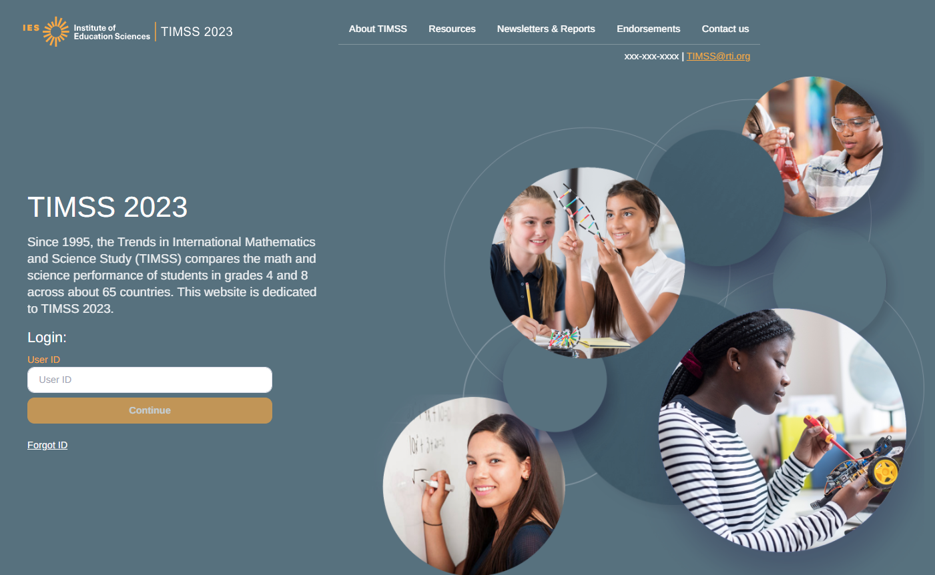
Data collected by RTI International
The National Center for Education Statistics (NCES) is authorized to conduct this study under the Education Sciences Reform Act of 2002 (ESRA 2002, 20 U.S.C. §9543), and to collect students’ education records from educational agencies or institutions for the purpose of evaluating federally supported education programs under the Family Educational Rights and Privacy Act (FERPA, 34 CFR §§ 99.31(a)(3)(iii) and 99.35). All of the information you provide may be used only for statistical purposes and may not be disclosed, or used, in identifiable form for any other purpose except as required by law (20 U.S.C. §9573 and 6 U.S.C. §151). In the United States, TIMSS is conducted by NCES, part of the U.S. Department of Education, and the data are being collected by RTI International. The U.S. Office of Management and Budget has approved the data collection under OMB #1850-0695.
According to the Paperwork Reduction Act of 1995, no persons are required to respond to a collection of information unless such collection displays a valid OMB control number. The valid OMB control number for this voluntary information collection is 1850-0695. The time required to complete this information collection and participate in study activities is estimated to average 30 minutes per school administrator, 35 minutes per teacher, and 240 minutes per school coordinator, including the time to review instructions, search existing data resources, gather the data needed, and complete and review the information collection. If you have any comments or concerns regarding the accuracy of the time estimate(s), suggestions for improving the form, or questions about the status of your individual submission of this form, write directly to: Trends in International Mathematics and Science Study (TIMSS), National Center for Education Statistics, Potomac Center Plaza, 550 12th Street, SW, 4th floor, Washington, DC 20202.
OMB No. 1850-0695, Approval Expires xx/xx/20xx.

Appendix A12b TIMSS 2027 Website: Resources, Newsletters & Reports, and Contact Us Pages

Resources: (Screen shot of the planned resources available on the public facing TIMSS 2027 website. The website, and its screenshots, currently reflect TIMSS 2023. For TIMSS 2027, TIMSS 2019 reports will be replaced with TIMSS 2023 reports and references to the field test will be removed. The NAEP letter from 2022 will be updated, if applicable.)
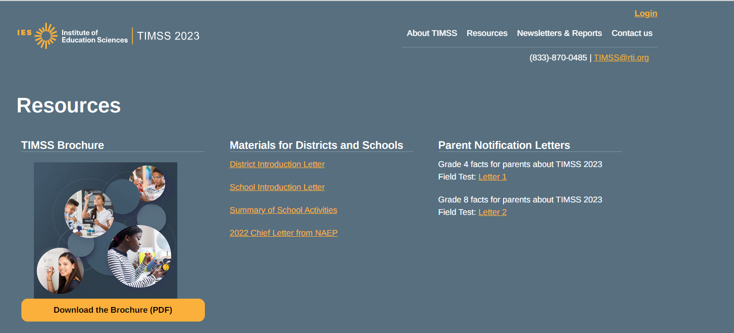
Newsletters & Reports
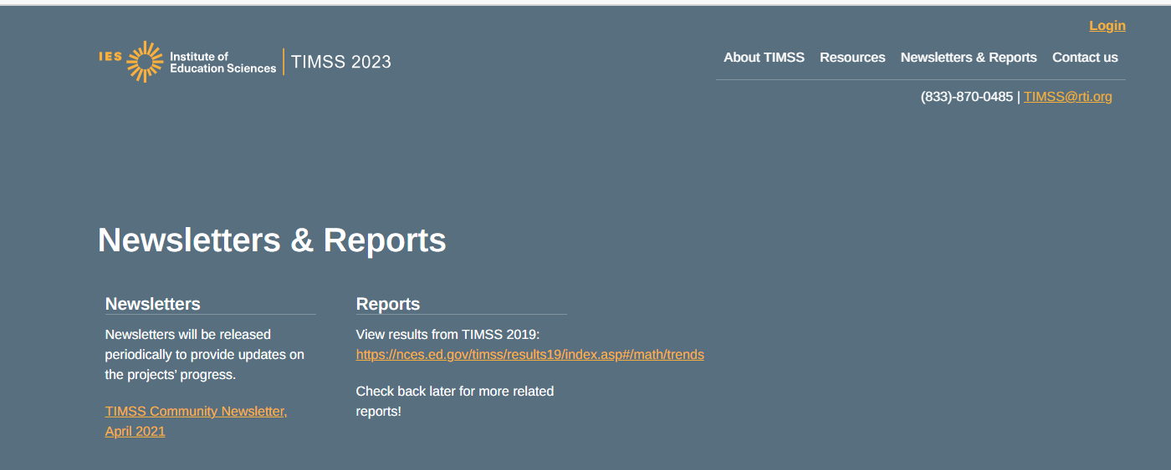

Contact us Page: 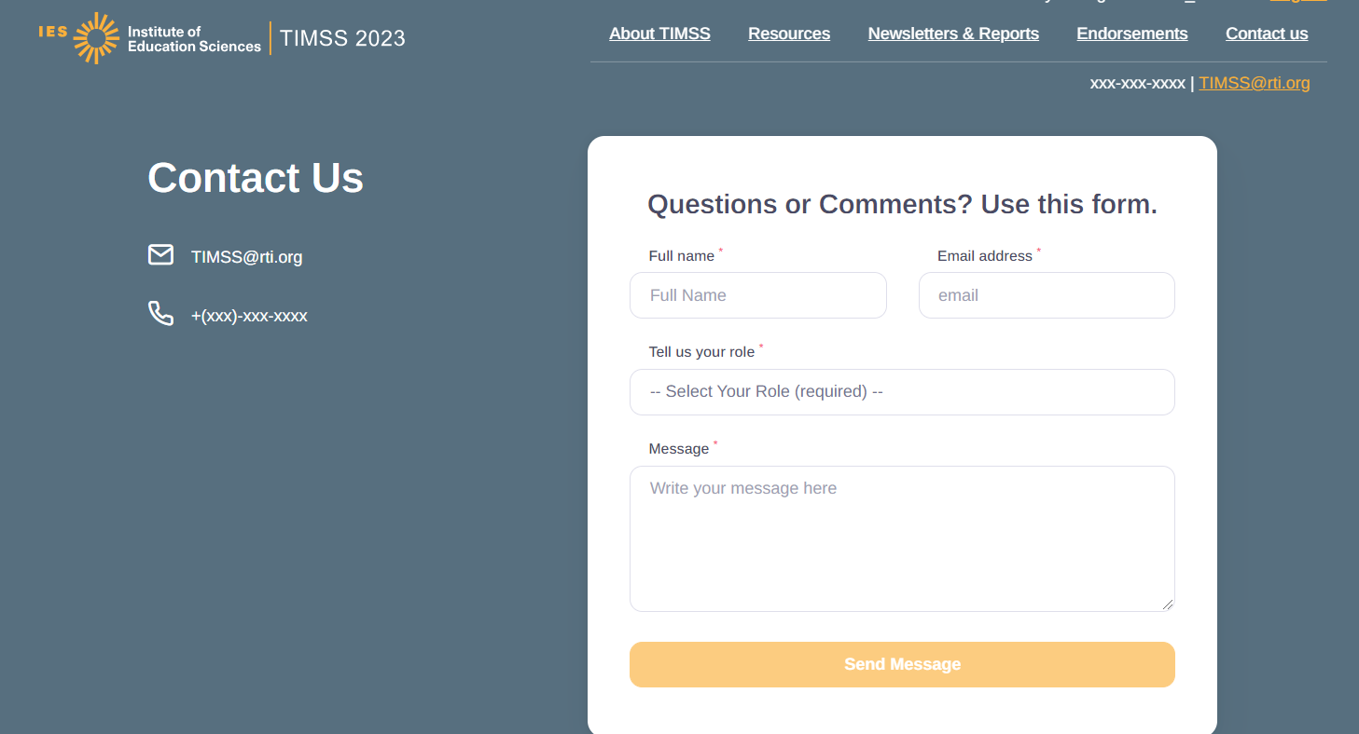
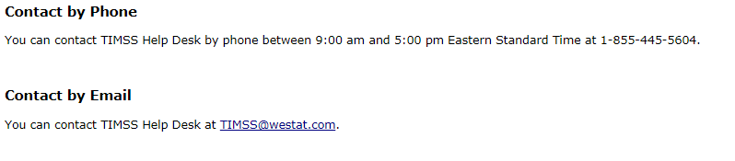

Appendix A12c TIMSS 2027 Website: Online Questionnaire Login Screen Text
(for the Principal, Teachers, and Students)

TIMSS 2027 - English (United States)
You are not logged in.

Welcome to the IEA - DPC SurveySystem
Online Questionnaires

Please enter your user ID and password (Checksum).
User ID:
Password:

The National Center for Education Statistics (NCES) is authorized to conduct this study under the Education Sciences Reform Act of 2002 (ESRA 2002, 20 U.S.C. §9543), and to collect students’ education records from educational agencies or institutions for the purpose of evaluating federally supported education programs under the Family Educational Rights and Privacy Act (FERPA, 34 CFR §§ 99.31(a)(3)(iii) and 99.35). All of the information you provide may be used only for statistical purposes and may not be disclosed, or used, in identifiable form for any other purpose except as required by law (20 U.S.C. §9573 and 6 U.S.C. §151). In the United States, TIMSS is conducted by NCES, part of the U.S. Department of Education, and the data are being collected by RTI International. The U.S. Office of Management and Budget has approved the data collection under OMB #1850-0695.
According to the Paperwork Reduction Act of 1995, no persons are required to respond to a collection of information unless such collection displays a valid OMB control number. The valid OMB control number for this voluntary information collection is 1850-0695. The time required to complete this information collection is estimated to average 30 minutes per principal, 35 minutes per teacher, and 30 minutes per student, including the time to review instructions, search existing data resources, gather the data needed, and complete and review the information collection. If you have any comments or concerns regarding the accuracy of the time estimate(s), suggestions for improving the form, or questions about the status of your individual submission of this form, write directly to: Trends in International Mathematics and Science Study (TIMSS), National Center for Education Statistics, Potomac Center Plaza (PCP), 550 12th St., SW, 4th floor, Washington, DC 20202.
OMB No. 1850-0695, Approval Expires xx/xx/xxxx.

© IEA Online SurveySystem <<20XX>> - Help

Appendix A13. School Coordinator (SC) Email to Provide School Information

Dear <School Coordinator Name>,
We hope that this finds you well and enjoying another terrific school year! We are following up with you to remind you to put the Trends in International Mathematics and Science Study (TIMSS) 2027 assessment date on your school calendar at <school name>. We appreciate your commitment to TIMSS, and we know your students will be excited and proud to represent U.S. students in this important international assessment. The U.S. TIMSS team looks forward to working with you to coordinate TIMSS in your school.
A sample of your grade <4/8> classes will be taking TIMSS. In most schools, TIMSS will randomly select about two <IF GRADE 8: math> classes to participate in the assessment.
We ask that you complete several activities critical to making TIMSS a success.
- The Summary of School Activities <link> lists your responsibilities and timelines.
- The TIMSS website (https://surveys.nces.ed.gov/TIMSS) will assist you with these responsibilities and provide information about the assessment.
- Finally, the TIMSS Registration and Provide School Information (PSI) Guide <link> will assist you through the immediate next steps.
A complete <School Coordinator Manual link> with TIMSS Standard Operating Procedures is also available for your use.
Your user ID to login is: <SCHOOL_ID> The first time you login an email will be sent to you to create your password.
Once you have logged in, please make sure to complete the Provide School Information section of the Task Menu.
The timeline below provides an overview of these activities:
- Today – Login to TIMSS and complete tasks labeled ‘Input Needed’ on the task menu page.
- August through April of 2027 –
- Prepare and provide a list of classes on the Submit Class List page in the TIMSS portal, or by phone (833-870-0485) or email (TIMSS@rti.org). Once classes are submitted, TIMSS staff will inform you of the selected classes and will email you to submit the list of students in selected classes on the Student-Teacher Linkage Form page of TIMSS. The U.S. TIMSS team will contact you in at the beginning of the 2026/2027 school year with directions for submitting the class and Student-Teacher Linkage Forms.
  - January through April of 2027 –
- Receive a packet of TIMSS materials, including a TIMSS Parent FAQ and sample parent/guardian notification letters. These materials will also be available on the TIMSS portal.
- Review lists of students and teachers.
- An assigned TIMSS representative will contact you to discuss assessment logistics and accommodations for students with disabilities or English language learners.
- Notify parents/guardians that their children have been selected for the assessment. A sample parent/guardian notification letter will be available on the TIMSS portal for you to customize and print on your school letterhead.

- One week before the session – <IF GRADE 8: Distribute student appointment cards mailed to you prior to the session and> notify teachers in advance so they know when to release students and remind them to complete an online TIMSS Teacher Questionnaire, which should have been emailed to them by the U.S. TIMSS team. Request that the school principal complete the TIMSS School Questionnaire as well.
Thank you in advance for your cooperation and effort in helping to coordinate this important study. As a reminder, you will receive $100 at the end of the study as a thank you for your time. If you have any questions, please feel free to contact the TIMSS information hotline at 833-870-0483 or TIMSS@rti.org. You may also get more information about this study by visiting the TIMSS website at https://surveys.nces.ed.gov/TIMSS.
Sincerely,
<Debbie Herget, TIMSS 2027 Project Director, RTI International/ or NAEP State Coordinator>

The National Center for Education Statistics (NCES) is authorized to conduct this study under the Education Sciences Reform Act of 2002 (ESRA 2002, 20 U.S.C. §9543), and to collect students’ education records from educational agencies or institutions for the purpose of evaluating federally supported education programs under the Family Educational Rights and Privacy Act (FERPA, 34 CFR §§ 99.31(a)(3)(iii) and 99.35). All of the information you provide may be used only for statistical purposes and may not be disclosed, or used, in identifiable form for any other purpose except as required by law (20 U.S.C. §9573 and 6 U.S.C. §151). In the United States, TIMSS is conducted by NCES, part of the U.S. Department of Education, and the data are being collected by RTI International. The U.S. Office of Management and Budget has approved the data collection under OMB #1850-0695.

Appendix A14 Login instructions to create a TIMSS Account

Dear TIMSS Participant,
Welcome to Trends in International Mathematics and Science Study (TIMSS) 2027. We are excited to work with you and your school in this very important study.
Below are instructions/credentials to log into the TIMSS portal and create your personal account. (Instructions with screen shots are located here: <link to Instructions on Pub Images Appendix. A15.>
Instructions for logging in for the FIRST TIME/Creating account:
- Go to the TIMSS Website: https://surveys.nces.ed.gov.TIMSS
- To access the portal, type in your User ID: [User ID here] into the User ID Login field, press Continue.
- You will receive a message that a code has been sent to your email. This is your two-factor security authentication. (*Please note, this code may take a few minutes to arrive; thank you for your patience).
- Go to your email inbox, find the email sent from no-reply@ed.gov – Subject: TIMSS Data Portal website security code. (Sometimes these messages are routed to spam or junk folders, so please check there if you don’t see the email in your inbox.)
- Copy/paste or type the code that you received in the email into the Code field.
- Set up your password for the first time. This is the password you will use each time you log into the TIMSS portal. Please follow the password convention rules listed on the page. If any of the fields have data in them, you must CLEAR the data and enter your unique User ID provided in the Current User field.
- Create your unique password in the New Password field, then re-enter the same password in the Confirm New Password field.
- Click on the CREATE PASSWORD link and you will see the Website Welcome Screen. Congratulations!

Instructions for logging in each time after you have created your account:
- Go to the TIMSS Website: https://surveys.nces.ed.gov/TIMSS
- To access the portal, enter your User ID. This is the same ID that you will use every time you log in.
- Input the password you created the first time you logged in.
- You will receive a message that a code has been sent to your email. This two-factor authentication code, required to maintain data security in the portal, is unique and will be regenerated each log in attempt.
- Last, enter in the code that is sent to your email.
- You will see the welcome screen and you are in the portal. Congratulations!

If you have questions or problems logging in, please contact the TIMSS Help Desk at TIMSS@rti.org / 833-870-0485.

Appendix A15 Login Instructions/Screenshots to Create TIMSS Account
TIMSS Portal Login Instructions
TIMSS Website: https://surveys.nces.ed.gov/timss
Your User ID: <UserID>
First time log in instructions
Go to the TIMSS Website URL Above and you will see the login screen for the portal:
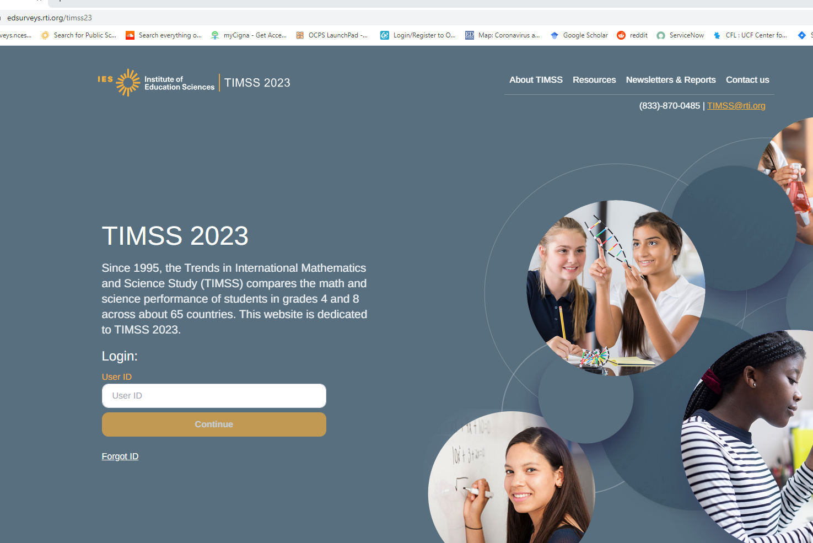

Type in your unique user ID:
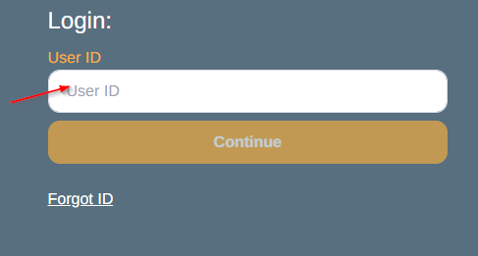
You will receive a message that a code has been sent to your email. This is your two-factor authentication.
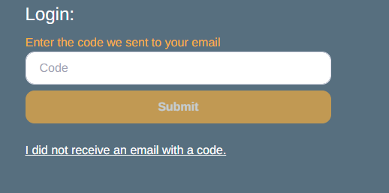
Go to your email and copy the code that you received and paste it into the portal. The email will be sent from no-reply@ed.gov. PLEASE NOTE- THE CODE CAN TAKE SEVERAL SECONDS OR A FEW MINUTES TO ARRIVE IN YOUR INBOX. PATIENCE IS REQUESTED BEFORE CONTACTING THE HELP DESKS FOR ASSISTANCE.
Sometimes these messages are routed to spam or junk folders, so please check there if you don’t see the email in your inbox.

TIMSS Data Portal Website Security Code
-----Original Message-----
From: no-reply@ed.gov <no-reply@ed.gov>
Sent: {DAY, MONTH, YEAR TIME}
To: YOUR EMAIL
Subject: TIMSS Data Portal website security code

EXTERNAL: This email originated from outside of the organization. Do not click links or open attachments unless you recognize the sender and know the content is safe.

Thank you for beginning the log-in process at the NCES TIMSS Portal. Please enter the 6-digit security code shown below on the website to finish logging in. The code expires in 30 minutes.

<A 6-digit code will appear here.>

NCES TIMSS Portal
TIMSS@rti.org

Note: The email address this was sent from cannot accept replies. If you encounter any difficulty, please call 1-(833)-870-0485 or email TIMSS@rti.org.

Here you set up your password for the first time. Please note the password convention rules.
PLEASE NOTE- if any of the fields are preloaded, please clear what is in the fields and ENTER YOUR unique ID given to you in the Current User ID field, create your unique password in the New Password field, and confirm New Password, enter the same password.
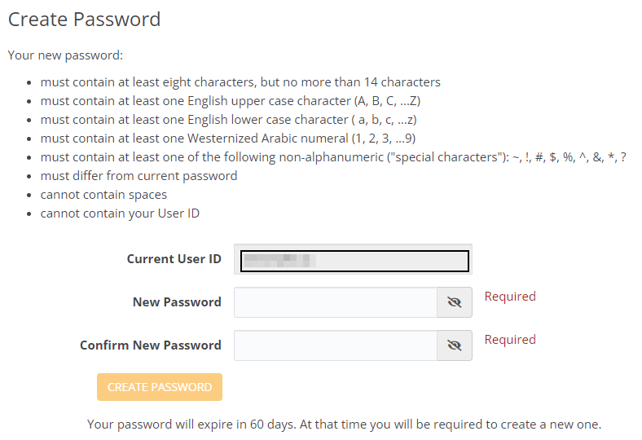
Once you click the ‘create password’ box, you will be logged in to the Website and at the welcome screen.
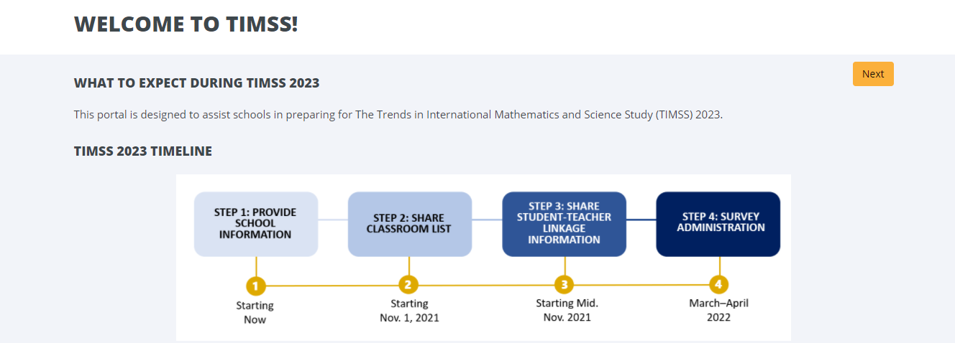
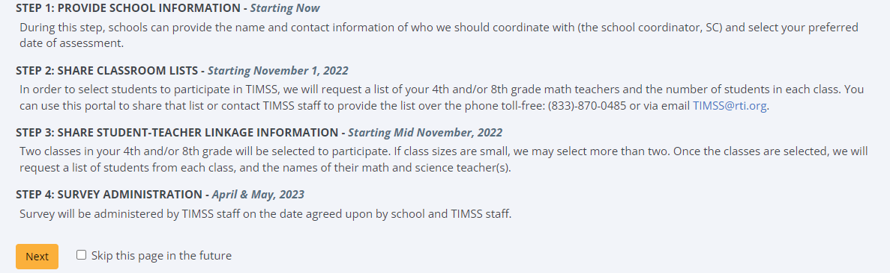

Instructions for logging in after the first time
When you return to the portal, you will need your User ID and the password you created. The login will be slightly different.
First you will enter in your User ID. This is the same ID that you will use every time you log in.

Next you will input the password you created the first time you logged in.
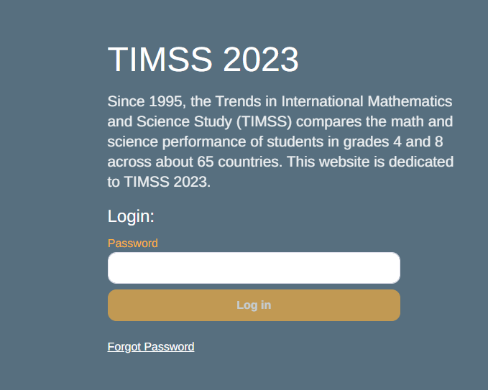
Last, enter in the code that is sent to your email. This two-factor authentication code, required to maintain data security in the Websites, is unique and will be regenerated each log in attempt. The email with the security code will look the same as the email you received the first time you logged in.
Once you successfully enter the code, you will see the welcome screen and you are in the portal. Congratulations!

Appendix A16 TIMSS 2027 Login and Provide School Information Guide
To prepare for TIMSS in grades 4 or 8, log in to the TIMSS portal available on the TIMSS website: (https://surveys.nces.ed.gov/TIMSS).
If you have never logged in to the website and cannot find the User ID number provided to you by your NAEP state coordinator or TIMSS Staff, please contact your state coordinator or the TIMSS hotline at TIMSS@rti.org / 833-870-0485.
- Once you have your User ID, go to the TIMSS website (https://surveys.nces.ed.gov/TIMSS)
- Enter your User ID and click “Continue.”
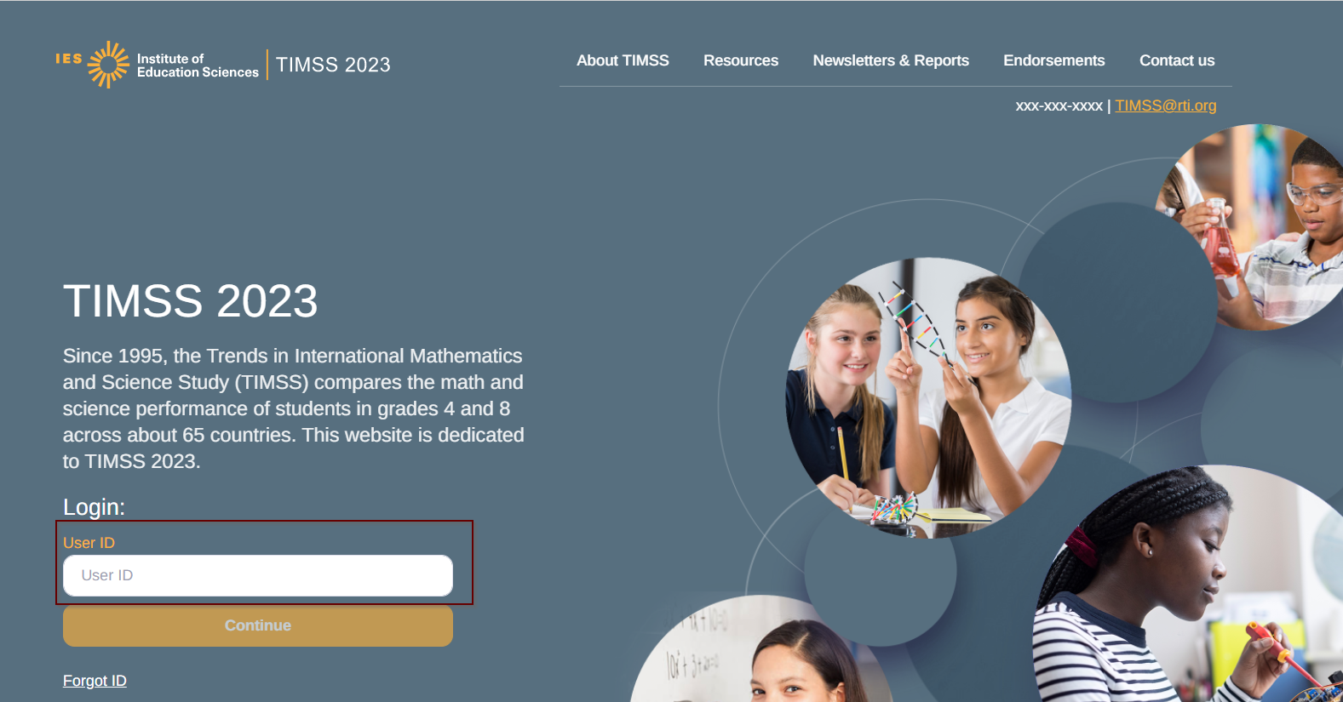
- You will then receive an email with instructions on creating a password. After your initial login you will not need to do this step again.
- On your first login you will see the ‘what to expect page’ which gives a brief overview of the TIMSS 2027 process, then click next.
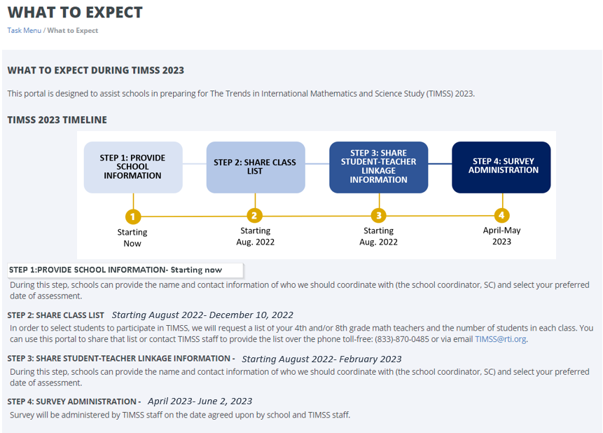

- You will then be taken to the task menu page, that will show you the tasks you can complete (labeled as ‘In Progress”). Make sure to confirm the district and school name shown at the top of the page are correct.

Then click on the ‘initial step’ and complete the necessary information.
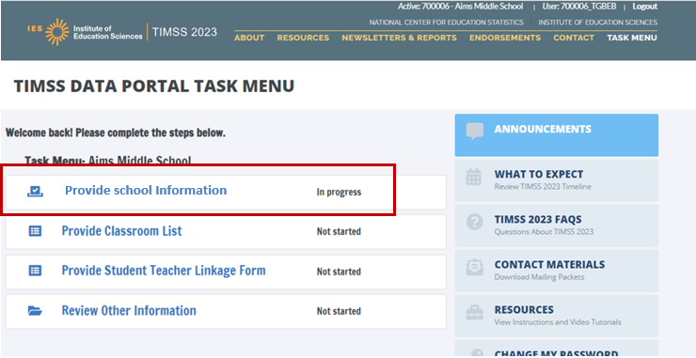

Provide School Information (PSI)
The first step in TIMSS is to complete the Provide School Information (PSI) Task. Click the Provide School Information link, which is the first option on the Task Menu.
On the PSI page, there are multiple sections for which you will need to either confirm the information or enter current information available for your school. Please make updates in these sections: School Address, School Principal, School Coordinator, School Assessment Date, and other Key Dates. Be sure to click submit once you fill in information for each section.
Note: You will see status: Input Needed until all required fields are filled out completely:
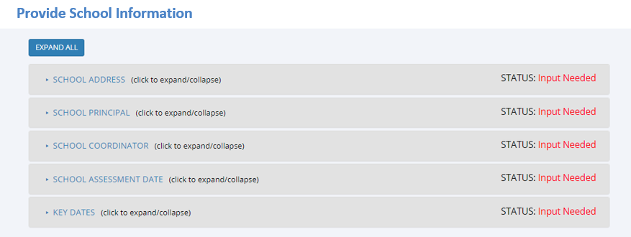

In the fall of 2026, we will email you instructions for submitting class lists and Student-Teacher Linkage Forms.
Thank you for your school’s participation in TIMSS 2027!
The U.S. TIMSS Team
833-870-0485
TIMSS@rti.org

Appendix A17 Automated Email for all TIMSS 2027 registrants
Thank you for creating an account in the Trends in International Mathematics and Science Study 2027 (TIMSS) portal. To access TIMSS, go to https://surveys.nces.ed.gov/TIMSS and enter your USER_ID and password.
User ID: <USER_ID>
Password information: You created your own password the first time you logged in. Use the "Forgot Password" links on TIMSS login page if needed. You will be prompted to change your password after 120 days.
TIMSS is a secure site that contains confidential information, so it is important to remember your User ID and password.
If you have questions or need help accessing the website, please contact the TIMSS hotline at TIMSS@rti.org or at 833-870-0485 Monday through Friday between 9 a.m. and 5:00 p.m. ET.
Sincerely,
The U.S. TIMSS Team
The National Center for Education Statistics (NCES) is authorized to conduct this study under the Education Sciences Reform Act of 2002 (ESRA 2002, 20 U.S.C. §9543), and to collect students’ education records from educational agencies or institutions for the purpose of evaluating federally supported education programs under the Family Educational Rights and Privacy Act (FERPA, 34 CFR §§ 99.31(a)(3)(iii) and 99.35). All of the information you provide may be used only for statistical purposes and may not be disclosed, or used, in identifiable form for any other purpose except as required by law (20 U.S.C. §9573 and 6 U.S.C. §151). In the United States, TIMSS is conducted by NCES, part of the U.S. Department of Education, and the data are being collected by RTI International. The U.S. Office of Management and Budget has approved the data collection under OMB #1850-0695.

Appendix A18 Automated Email for TIMSS 2027 School Coordinator registrant

Dear <school coordinator>,
Thank you for creating an account on the Trends in International Mathematics and Science Study (TIMSS) portal. The TIMSS website provides access to a secure portal for sharing information and files related to your school’s participation in TIMSS 2027. The portal’s "What To Expect" page will guide you through the upcoming TIMSS activities and “Task Menu” will show what information you can provide.
The first step is to complete the Provide School Information page. If you have not already done so, please go to https://surveys.nces.ed.gov/TIMSS, and click on the Task Menu to view activities that need to be completed at this time.
Before data collection begins, we will ask you to provide a complete and current list of all of your school’s <fourth-grade classes/eighth-grade mathematics classes> on the Class Listing Form-(CLF) for the TIMSS team to randomly select a minimum of two classes to participate in the TIMSS 2027.
Once you are notified of the sampled classes, you will then be asked to submit the following information on a Student Teacher Linkage Form (STLF):
- Student Names, DOB, sex, (exclusion status if applicable) of all students in the selected classes
- Grade 4: Confirm names of the sampled class math teacher and science teacher if different than the math teacher.
- Grade 8: For each sampled student confirm math teacher name selected and course name and provide the science teachers and course names for students in that class.
- Provide teacher email address and phone numbers for all those teachers listed.
We will email you in the fall with instructions about how to submit the Class Listing Form (CLF), Student-Teacher Linkage Form (STLF) through data portal on the TIMSS Website: https://surveys.nces.ed.gov/TIMSS.
Please use the link to the :<Summary of School Activities> for a complete list of activities associated with your school’s participation in TIMSS 2027.
Thank you very much for participating in TIMSS, and for playing a key role in making the assessment a success at <school name>!
Sincerely,
The U.S. TIMSS Team
The National Center for Education Statistics (NCES) is authorized to conduct this study under the Education Sciences Reform Act of 2002 (ESRA 2002, 20 U.S.C. §9543), and to collect students’ education records from educational agencies or institutions for the purpose of evaluating federally supported education programs under the Family Educational Rights and Privacy Act (FERPA, 34 CFR §§ 99.31(a)(3)(iii) and 99.35). All of the information you provide may be used only for statistical purposes and may not be disclosed, or used, in identifiable form for any other purpose except as required by law (20 U.S.C. §9573 and 6 U.S.C. §151). In the United States, TIMSS is conducted by NCES, part of the U.S. Department of Education, and the data are being collected by RTI International. The U.S. Office of Management and Budget has approved the data collection under OMB #1850-0695.

Appendix A19a TIMSS 2027 Portal: Home Page
Welcome to TIMSS 2027!
This portal is designed to assist schools in preparing for the Trends in International Mathematics and Science Study (TIMSS) 2027.
TIMSS 2027 TIMELINE
STEP 1: PROVIDE SCHOOL INFORMATION: Starting Now
During this step, schools can provide the name and contact information of who we should coordinate with (the school coordinator, SC) and select your preferred date of assessment.
STEP 2: PROVIDE CLASS LIST- Starting Fall 2026- through April 2027
We will request a list of your <4th grade classrooms/8th grade math classes> and the number of students in each class. You may provide this via the portal or contact us to provide the list by phone 833-870-0485 or email TIMSS@rti.org.
STEP 3: PROVIDE STUDENT-TEACHER LINKAGE INFORMATION- Starting August 2027- through April 2027
Two classes in your 4th and/or 8th grade will be selected to participate. If class sizes are small, we may select more than two. Once the classes are selected, we will ask that you complete the student-teacher linkage form for each class, which collects information on the students in each class and their math and science teachers.
STEP 4: SURVEY ADMINISTRATION- March through June 2027
Survey will be administered by TIMSS staff on the date agreed upon by school and TIMSS staff.
Main Study screen shot:

Appendix A19b TIMSS 2027 Portal: Provide School Information Page
(screenshot)

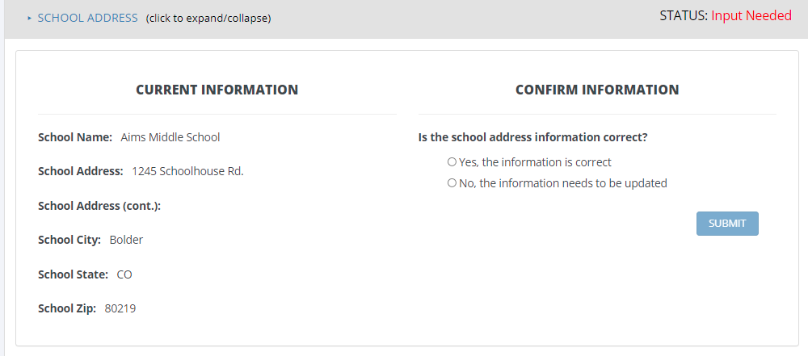
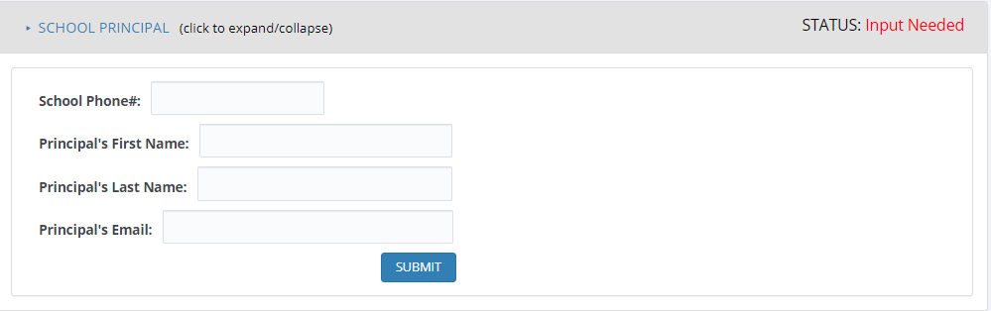
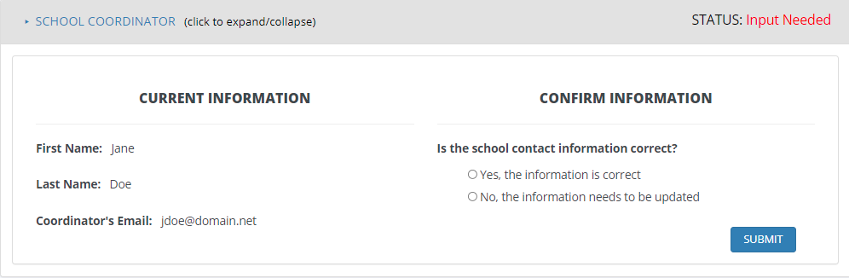
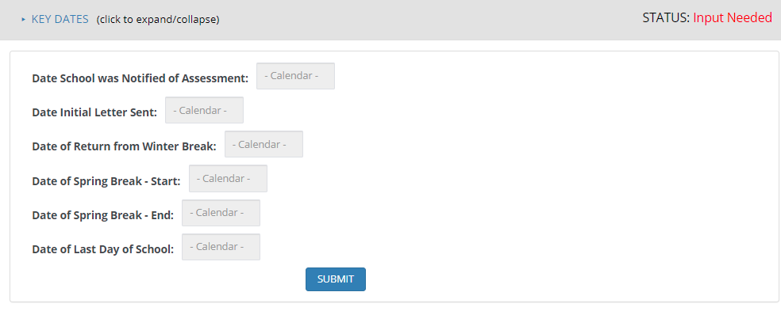
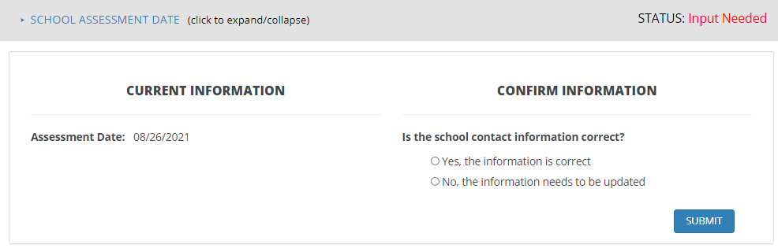

Appendix A19c TIMSS 2027 Portal: Web-Enabled Agreement

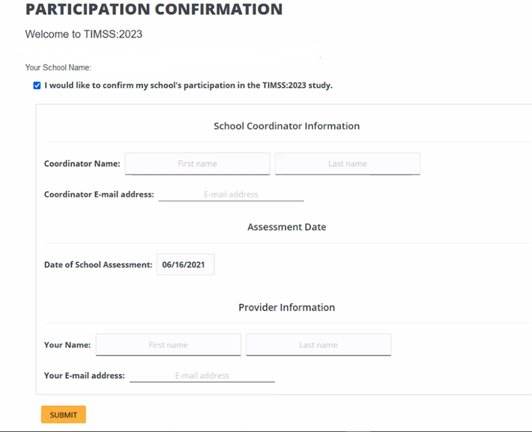

Appendix A19d TIMSS 2027 Portal: Documents Page

General TIMSS Information
Brochure
Frequently Asked Questions (FAQ)
TIMSS Login and Provide School Information Guide
Parent FAQ
List of Endorsing Agencies
District and School Letters
Letter sent to District Superintendents
Letter sent to School Principals
Letter sent to School Coordinators
Parent Notification Letters
Sample Parent/Guardian Notification Letter
Sample Parent/Guardian Notification Letter (Spanish)
Class List and Student-Teacher Linkage Forms
Email to SC for providing class list (4th & 8th grade)
Instructions for providing class list (4th & 8th grade)
Class List Template
Email to SC for providing STLF (4th & 8th grade)
Instructions for TIMSS 2027 Student Tracking Form (4th & 8th grade)
STLF template
(Grade 4 example below)
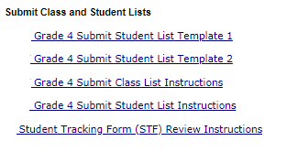

Appendix A20 Email to School Coordinator to Submit the Class Listing Form– Grade 4 –

Dear <School Coordinator>,

You have been designated as the TIMSS 2027 School Coordinator. We look forward to working with you and appreciate your assistance.
We ask that you complete a Class Listing Form (SLF) to provide a list of your school’s 4th-grade classrooms. The CLF is used to randomly sample classes to participate in the TIMSS student session. Typically, two classes are sampled in each school, and all students in the selected classes will be asked to participate in TIMSS. If your class sizes are small, we may select more than 2 classes.
To complete the CLF, first log in to the TIMSS portal at https://surveys.nces.ed.gov/TIMSS. Download the CLF, save it to your computer, and fill out the form. Please save it so you will have a copy.
We have 3 options for you to provide this information:
- Log back into the portal and upload the completed form. (If you have forgotten your User ID please contact the TIMSS helpdesk at TIMSS@rti.org or 1-833-870-0485. If you have forgotten your password, you can request a new password on the login page.);
- Email your class list to TIMSS@rti.org; or
- Call your assigned school liaison or the TIMSS help desk at 833-870-0485 to provide the information by phone.
Click <here> or visit the Documents section of https://surveys.nces.ed.gov/TIMSS to access the CLF and instructions for submitting the form. PLEASE DO NOT PUT STUDENT NAMES OR STUDENT INFORMATION ON THE CLASS LISTING FORM. We are only collecting class-level information at this time. Once the CLF is received, the TIMSS team will enter the information into the TIMSS sampling software which will randomly select classrooms for participation. We will then contact you to request information about the students in the selected classrooms.

Please provide your class list within 5 working days. We will process your submission and select the fourth-grade classes for TIMSS. You will be informed of the classes selected within a few weeks of submitting your lists, at which time we will request information about the students enrolled in the selected classrooms and their teachers. If you have any questions about submitting your list, please email the TIMSS Help Desk at TIMSS@rti.org or call: 1-833-870-0485

Thank you very much for participating in TIMSS, and for submitting your school's CLF!

Sincerely,

The U.S. TIMSS Team

The National Center for Education Statistics (NCES) is authorized to conduct this study under the Education Sciences Reform Act of 2002 (ESRA 2002, 20 U.S.C. §9543), and to collect students’ education records from educational agencies or institutions for the purpose of evaluating federally supported education programs under the Family Educational Rights and Privacy Act (FERPA, 34 CFR §§ 99.31(a)(3)(iii) and 99.35). All of the information you provide may be used only for statistical purposes and may not be disclosed, or used, in identifiable form for any other purpose except as required by law (20 U.S.C. §9573 and 6 U.S.C. §151). In the United States, TIMSS is conducted by NCES, part of the U.S. Department of Education, and the data are being collected by RTI International. The U.S. Office of Management and Budget has approved the data collection under OMB #1850-0695.

Appendix A21 Instructions for Submitting Class Lists – Grade 4
TIMSS 2027: Instructions for Grade 4 Submit Class List

This document provides instructions to prepare and submit a complete and current list of your school’s fourth-grade classes, from which two classes will be selected to participate in TIMSS. All students in the selected classes will be asked to participate. If your class sizes are small, we may select more than 2 classes.

To complete the Class Listing Form (CLF), first log in to the TIMSS portal at https://surveys.nces.ed.gov/TIMSS. Download the CLF, save it to your computer, and fill out the form. Please save it so you will have a copy.
We have 3 options for you to provide this information:
- Log back into the portal and upload the completed form. (If you have forgotten your User ID please contact the TIMSS helpdesk at TIMSS@rti.org or 1-833-870-0485. If you have forgotten your password, you can request a new password on the login page.);
- Email your class list to TIMSS@rti.org or
- Call your assigned school liaison or the TIMSS help desk at 833-870-0485 to provide the information by phone.

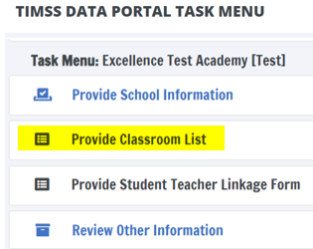

Website CLASS List Form (CLF) Grade 4 Example:

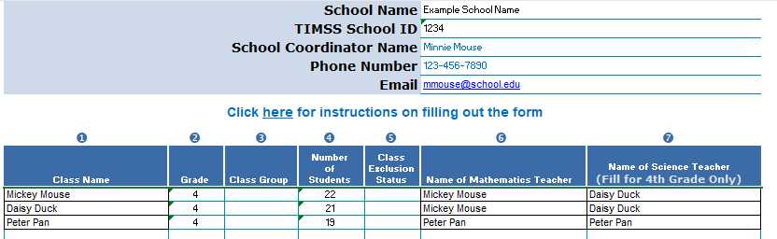

Data elements needed for submission:
- Class Name or Homeroom Teacher Name (Each class must have a unique name)
- Grade (4)
- Class group (Low, Average, High)
- Number of 4th grade students in the class
- Class Exclusion Status*
  - 1= all students in class have functional disabilities
  - 2= students with intellectual disability
  - 3= non-native language class
- Name of Math Teacher for that class (May be the same as class name/homeroom teacher)
- Name of Science Teacher for that class (May be the same as class name/homeroom teacher)

Example: Table format to email or call in to the U.S. TIMSS team:

Class Name or Homeroom Teacher | Grade | Class Group | Number of  4th grade students in that class | Class Exclusion Status* | Name of Math Teacher for that class  (may be the same as the class name/homeroom teacher) | Name of Science Teacher for that class  (may be the same as the class name/homeroom teacher)
Mickey Mouse | 4 |  | 22 |  | Mickey Mouse | Daisy Duck
Daisy Duck | 4 |  | 21 |  | Mickey Mouse | Daisy Duck
Peter Pan | 4 |  | 19 |  | Peter Pan | Peter Pan

Additional tips for submitting information about your fourth-grade classes:
After you have entered information for each class,

- Refer to the important definitions on the form provided.
- Record the Class Name that is typically used by your school to refer to the class.
- For classes with students from more than one grade level, include in Number of Students only those students in grade 4. For example, if the class has 5 third-graders, 6 fourth-graders, and 4 fifth-graders, enter “6” as the Number of Students in this class.
- Use the most current enrollment information.
- Include all classes, even if they typically are excluded from your state testing program, or all students take alternate assessments. You can indicate information about the class in Class Exclusion Status.
- Name of 4th grade mathematics teacher and name of 4th grade science teacher may be the same.
- Keep a list of the classes you included for your future reference.

If you need assistance, email TIMSS@rti.org or call 833-870-0485.

Appendix A22 Email to School Coordinator to Submit Student-Teacher Linkage Form (STLF) – Grade 4

Dear <School Coordinator>,

Thank you for providing the complete list of 4th grade classrooms on your TIMSS Class Listing Form (CLF); we appreciate your time. We have sampled <fill number of classrooms> of your school’s 4th grade classrooms.
Sampled Classrooms
- <fill classroom 1>
- <fill classroom 3>
- <fill classroom 5>
We will now need the Student-Teacher Linkage Form (STLF) for these sampled classrooms. On this form, you will provide the student and teacher information for the selected classes.
To ensure data security, this information needs to be submitted through our secure portal.
Log in to https://surveys.nces.ed.gov/TIMSS to complete and submit your 4th grade STLF. If you have forgotten your login USER ID please contact the TIMSS helpdesk at TIMSS@rti.org or 1-833-870-0485. If you have forgotten your password, you can request a new password on the TIMSS login page.
Instructions for completing and submitting the STLF are <HERE: LINK>. These instruction sheets and templates can also be found in the Documents section of https://surveys.nces.ed.gov/TIMSS.

If you have any questions about submitting your list, please email the TIMSS Help Desk at TIMSS@rti.org
or call 1-833-870-0485. ​

Please provide your STLF within 5 working days. TIMSS will process your submission and will be in touch to finalize any outstanding logistics for your student session.

Thank you very much for participating in TIMSS, and for submitting your school's STLFs!

Sincerely,

The U.S. TIMSS Team

NCES is authorized to conduct this study under the Education Sciences Reform Act of 2002 (ESRA 2002, 20 U.S.C. §9543). All of the information you provide may be used only for statistical purposes and may not be disclosed, or used, in identifiable form for any other purpose except as required by law (20 U.S.C. §9573 and 6 U.S.C. §151). The National Center for Education Statistics (NCES) is authorized to conduct this study under the Education Sciences Reform Act of 2002 (ESRA 2002, 20 U.S.C. §9543), and to collect students’ education records from educational agencies or institutions for the purpose of evaluating federally supported education programs under the Family Educational Rights and Privacy Act (FERPA, 34 CFR §§ 99.31(a)(3)(iii) and 99.35). All of the information you provide may be used only for statistical purposes and may not be disclosed, or used, in identifiable form for any other purpose except as required by law (20 U.S.C. §9573 and 6 U.S.C. §151). In the United States, TIMSS is conducted by NCES, part of the U.S. Department of Education, and the data are being collected by RTI International. The U.S. Office of Management and Budget has approved the data collection under OMB #1850-0695.

Appendix A23 Instructions for Submitting Student-Teacher Linkage Forms – Grade 4 –
TIMSS 2027: Instructions for Grade 4 - Submit Student-Teacher Linkage Form
Dear [NAME]
Thank you for providing the Class Listing Form (CLF) for your school. We appreciate your time and support. We have sampled [# CLASSROOMS] of your school’s classrooms.
Sampled Classrooms
<CLASS NAMES: SAMPLED CLASSES>
This document provides instructions to complete and submit the Student-Teacher Linkage Form (STLF) for these sampled classrooms. To ensure data security and protect student PII, this information needs to be submitted through our secure portal. Additional instructions can also be found in the School Coordinator manual (link): (https://edsurveys.rti.org/pubimages/TIMSS/SupportDocs/TIMSS_2027_School_Coordinator_Manual.pdf)
To complete the STLF,

- Log into the TIMSS portal, available from the TIMSS website: https://surveys.nces.ed.gov/TIMSS. Your user ID is [UserID].
- Navigate to the ‘PROVIDE STUDENT TEACHER LINKAGE FORM’ page from the task menu. ** YOU MUST REVIEW THE EXAMPLE FORM IN STEP 1, BEFORE YOU CAN ACCESS THE TEMPLATE.** Once you open & review the example form, on the top of the form, please select the Green link that states: " I HAVE CAREFULLY REVIEWED THIS TEMPLATE." This will open the remaining steps to complete the STLFs.

- Download the STLF template files for each selected class by clicking the download button for each form. There is one file for each sampled class.

- Save the templates to your desktop and fill in the requested information.
• Please note- the names of each student's Math & Science teachers need to be entered on this form. IF THE MATH TEACHER IS ALSO THE SCIENCE TEACHER- THE NAME WILL APPEAR ONE TIME ONLY. Indicate with an 'X' in each student's row if they take the math class whose name is preloaded AND if there is a different science teacher, provide science teacher information and mark with an 'X' in each student's row for any/all science classes they take. Place science teacher information in the columns next to the preloaded Math teacher information.

- Once the teacher’s name, course name and subject code is provided, a second tab will automatically populate next to the completed STLF. This tab will have the information for each teacher prefilled and there will be a blank column for you to enter each teacher’s email address. The email addresses will be used to prompt each teacher to complete their online teacher survey.
TIMSS_STLF_FORM | Teacher_Email_Phone_Info

Optional information requested: teacher’s personal cell phone numbers. When it comes to prompting teachers to complete their surveys, we can help reduce that burden from you by sending periodic text reminders. If you would like us to text teachers in addition to sending email with information about the teacher survey, please provide teachers’ cell phone number in the column next to the email address to use for this purpose. This is optional, and teachers would have the ability to opt out of text reminders if desired.
- Once you have filled out the forms, please add 'complete' to the end of the file name so you know which ones to upload back to the portal. (This is to help prevent you from uploading the blank templates back to us)
- Once you saved the completed STLF; log back into the portal and navigate to ‘Provide Student Teacher Linkage Form’.
- Upload the completed STLFs using the ‘select file/upload file’ buttons in the ‘Step 2: Upload File’ section. After you upload your completed files: Please hit the SUBMIT button at bottom of page to transmit the files back to us for review.
Option 2: You may provide a file in a different format from your system with the same information. If you cannot submit your student data with this information in the TIMSS file format or upload your own file, please call or email the TIMSS Help Desk at TIMSS@rti.org or 1-833-870-0485.

If you need assistance, please contact the TIMSS Help Desk at TIMSS@rti.org or 1-833-870-0485.

4th grade STLF Example 1: School with the same Mathematics and Science Teacher for each class
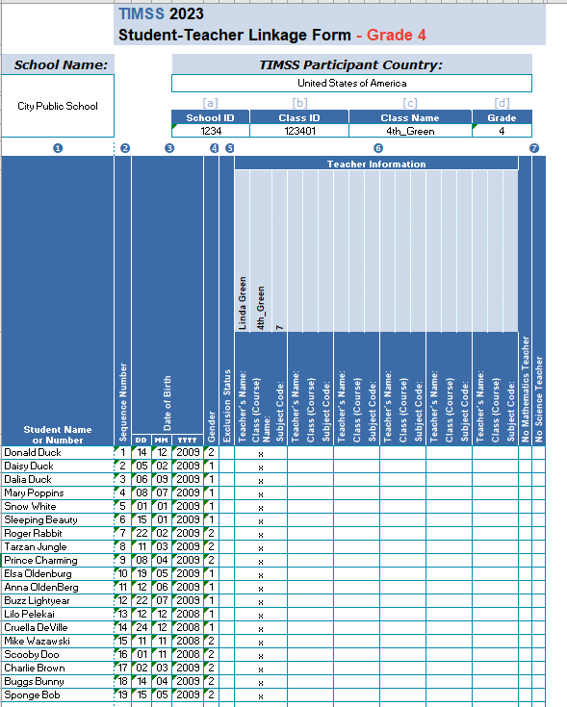
Sex

4th grade STLF Example 2: School with different Mathematics and Science Teacher
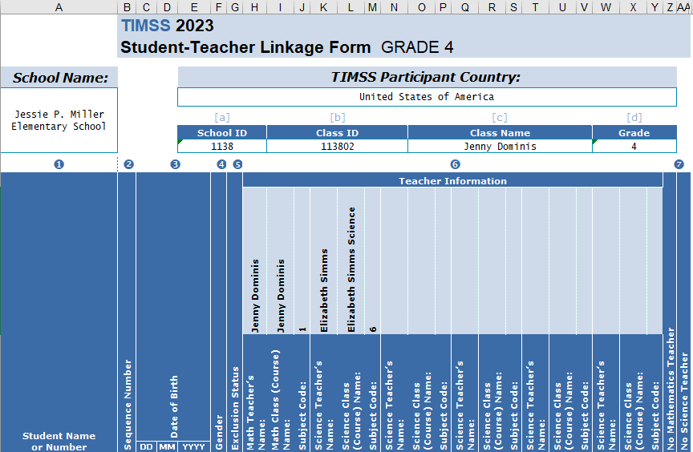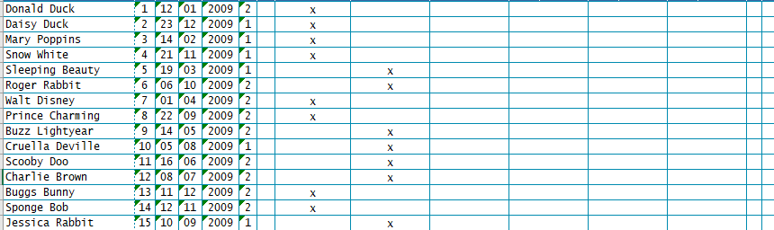
Sex

Appendix A24 Email to School Coordinator to Submit the Class Listing Form – Grade 8

Dear <School Coordinator>,

You have been designated as the TIMSS 2027 School Coordinator. We look forward to working with you and appreciate your assistance.
We ask that you complete a Class Listing Form (SLF) to provide a list of your school’s 8th-grade mathematics classes. The CLF is used to randomly sample classes to participate in the TIMSS student session. Typically, two classes are sampled in each school, and all students in the selected classes will be asked to participate in TIMSS. If your class sizes are small, we may select more than 2 classes.
To complete the CLF, first log in to the TIMSS portal at https://surveys.nces.ed.gov/TIMSS. Download the CLF, save it to your computer, and fill out the form. Please save it so you will have a copy.
We have 3 options for you to provide this information:
- Log back into the portal and upload the completed form. (If you have forgotten your User ID please contact the TIMSS helpdesk at TIMSS@rti.org or 1-833-870-0485. If you have forgotten your password, you can request a new password on the login page.);
- Email your class list to TIMSS@rti.org; or
- Call your assigned school liaison or the TIMSS help desk at 833-870-0485 to provide the information by phone.
Click <here> or visit the Documents section of https://surveys.nces.ed.gov/TIMSS to access the CLF and instructions for submitting the form. PLEASE DO NOT PUT STUDENT NAMES OR STUDENT INFORMATION ON THE CLASS LISTING FORM. We are only collecting class-level information at this time. Once the CLF is received, the U.S. TIMSS team will enter the information into the TIMSS sampling software which will randomly select classrooms for participation. We will then contact you to request information about the students in the selected classrooms.

Please provide your class list within 5 working days. We will process your submission and select the eighth-grade classes for TIMSS. You will be informed of the classes selected within a few weeks of submitting your lists, at which time we will request information about the students enrolled in the selected classrooms and their teachers. If you have any questions about submitting your list, please email the TIMSS Help Desk at TIMSS@rti.org or call: 1-833-870-0485

Thank you very much for participating in TIMSS, and for submitting your school's CLF!
Sincerely,
The U.S. TIMSS Team
The National Center for Education Statistics (NCES) is authorized to conduct this study under the Education Sciences Reform Act of 2002 (ESRA 2002, 20 U.S.C. §9543), and to collect students’ education records from educational agencies or institutions for the purpose of evaluating federally supported education programs under the Family Educational Rights and Privacy Act (FERPA, 34 CFR §§ 99.31(a)(3)(iii) and 99.35). All of the information you provide may be used only for statistical purposes and may not be disclosed, or used, in identifiable form for any other purpose except as required by law (20 U.S.C. §9573 and 6 U.S.C. §151). In the United States, TIMSS is conducted by NCES, part of the U.S. Department of Education, and the data are being collected by RTI International. The U.S. Office of Management and Budget has approved the data collection under OMB #1850-0695.

Appendix A25 Instructions for Submitting Class Lists – Grade 8
TIMSS 2027: Instructions for Grade 8 Submit Class List

This document provides instructions to prepare and submit a complete and current list of your school’s eighth-grade mathematics classes, from which two classes will be selected to participate in TIMSS. All students in the selected classes will be asked to participate. If your class sizes are small, we may select more than 2 classes.

To complete the CLF, first log in to the TIMSS portal at https://surveys.nces.ed.gov/TIMSS. Download the CLF, save it to your computer, and fill out the form. Please save it so you will have a copy.
We have 3 options for you to provide this information:
- Log back into the portal and upload the completed form. (If you have forgotten your User ID please contact the TIMSS helpdesk at TIMSS@rti.org or 1-833-870-0485. If you have forgotten your password, you can request a new password on the login page.);
- Email your class list to TIMSS@rti.org or
- Call your assigned school liaison or the TIMSS help desk at 833-870-0485 to provide the information by phone.

Data elements needed for submission:
- Class Name (Each class must have a unique name)
- Grade (8)
- Class group (Low, Average, High)
- # of 8th grade students in that class
- Class Exclusion Status*
  - 1= all students in class have functional disabilities
  - 2= students with intellectual disability
  - 3= non-native language class
- Name of Math Teacher for that class

Example: Table format to email or call into the U.S. TIMSS team:

Class Name/Homeroom Teacher | Grade | Class group | Number of  8th grade students in that class | Class Exclusion Status* | Name of Math Teacher for that class  (may be the same as the class name/homeroom teacher)
Math 1 | 8 |  | 32 |  | Alexander Hamilton
Business Math | 8 |  | 27 |  | Ben Franklin
Math 2 | 8 |  | 29 |  | James Madison
Intro to Algebra | 8 |  | 30 |  | Betsy Ross
Early Numeracy | 8 |  | 10 | 2 | Clara Barton
(*Class exclusions Status: 1- all students in class have functional disabilities, 2- students with intellectual disability, and 3-non-native language class.)

If you need assistance, email TIMSS@rti.org or call 1-833-870-0485.

Appendix A26 Email to School Coordinator to Submit Student-Teacher Linkage Form – Grade 8

Dear <<School Coordinator>>,

Thank you for providing the complete list of 8th grade mathematics classrooms on your TIMSS Class Listing Form (CLF); we appreciate your time. We have sampled <fill number of classrooms> of your school’s 8th grade classrooms.
Sampled Classrooms
- <fill classroom 1>
- <fill classroom 3>
- <fill classroom 5>
We will now need the Student-Teacher Linkage Form (STLF) for these sampled classrooms. On this form, you will provide the student and teacher information for the selected classes.
To ensure data security, this information needs to be submitted through our secure portal.
Log in to https://surveys.nces.ed.gov/TIMSS to complete and submit your 8th grade STLF. If you have forgotten your login USER ID please contact the TIMSS helpdesk at TIMSS@rti.org or 1-833-870-0485. If you have forgotten your password, you can request a new password on the TIMSS login page.
Instructions for completing and submitting the STLF are <HERE: LINK>. These instruction sheets and templates can also be found in the Documents section of https://surveys.nces.ed.gov/TIMSS.

If you have any questions about submitting your list, please email the TIMSS Help Desk at TIMSS@rti.org
or call 1-833-870-0485. ​

Please provide your STLF within 5 working days. TIMSS will process your submission and will be in touch to finalize any outstanding logistics for your student session.

Thank you very much for participating in TIMSS, and for submitting your school's STLFs!

Sincerely,

The U.S. TIMSS Team

NCES is authorized to conduct this study under the Education Sciences Reform Act of 2002 (ESRA 2002, 20 U.S.C. §9543). All of the information you provide may be used only for statistical purposes and may not be disclosed, or used, in identifiable form for any other purpose except as required by law (20 U.S.C. §9573 and 6 U.S.C. §151). The National Center for Education Statistics (NCES) is authorized to conduct this study under the Education Sciences Reform Act of 2002 (ESRA 2002, 20 U.S.C. §9543), and to collect students’ education records from educational agencies or institutions for the purpose of evaluating federally supported education programs under the Family Educational Rights and Privacy Act (FERPA, 34 CFR §§ 99.31(a)(3)(iii) and 99.35). All of the information you provide may be used only for statistical purposes and may not be disclosed, or used, in identifiable form for any other purpose except as required by law (20 U.S.C. §9573 and 6 U.S.C. §151). In the United States, TIMSS is conducted by NCES, part of the U.S. Department of Education, and the data are being collected by RTI International. The U.S. Office of Management and Budget has approved the data collection under OMB #1850-0695.

Appendix A27 Instructions for Submitting Student-Teacher Linkage Forms – Grade 8 –

TIMSS 2027: Instructions for Grade 8 Submit Student-Teacher Linkage Form

Thank you for providing the Class Listing Form (CLF) for your school. We appreciate your time and support. We have sampled [# CLASSROOMS] of your school’s classrooms.
Sampled Classrooms
<CLASS NAMES: SAMPLED CLASSES>
This document provides instructions to complete and submit the Student-Teacher Linkage Form (STLF) for these sampled classrooms. To ensure data security and protect student PII, this information needs to be submitted through our secure portal. Additional instructions can also be found in the School Coordinator manual (link): (https://edsurveys.rti.org/pubimages/TIMSS/SupportDocs/TIMSS_2027_School_Coordinator_Manual.pdf)
To complete the STLF,

- Log into the TIMSS portal, available from the TIMSS website: https://surveys.nces.ed.gov/TIMSS. Your user ID is [UserID].
- Navigate to the ‘PROVIDE STUDENT TEACHER LINKAGE FORM’ page from the task menu. ** YOU MUST REVIEW THE EXAMPLE FORM IN STEP 1, BEFORE YOU CAN ACCESS THE TEMPLATE.** Once you open & review the example form, on the top of the form, please select the Green link that states: " I HAVE CAREFULLY REVIEWED THIS TEMPLATE." This will open the remaining steps to complete the STLFs.
- Download the STLF template files for each selected class by clicking the download button for each form. There is one file for each sampled class.
- The first teacher’s name and class information will be the MATH teacher PRE-FILLED from your Class listing form.
- In columns 1-5 on the form, please provide student information for each student enrolled in that class:
  - Column (1) Last name, First name
  - Column (2) is pre-loaded with a sequence #
  - Column (3) is Date of Birth for the student
  - Column (4) is student sex (1=Female, 2= Male)
  - Column (5) is exclusion status. The three possible exclusion statuses are below and described in the SC manual. If ALL students in a class belong to one of the 3 exclusion status categories AND they ALL do not participate in standardized testing, the class may be given an exclusion code. Here you will record exclusion codes for students and your Test Administrator will discuss whether we can provide accommodations so that the student may participate.
    - students with functional disabilities;
    - students with intellectual disabilities;
    - non-native language speakers.
- While the math teacher names are prefilled, the science teacher names, course names and subject codes are not. In all the columns after the Pre-filled Math Teacher information, you will enter SCIENCE TEACHER NAMES, COURSE NAMES AND SUBJECT CODES for each student. (Refer to your TIMSS:2027 SC manual for subject codes). The completed Student-Teacher Linkage Forms also should include all teachers teaching mathematics and/or science to all or some students in the selected class. The linkage between the students and teachers will be indicated by placing an ‘X’ in the corresponding cells showing that a student is taught by a particular teacher.
- Once the teacher’s name, course name and subject code is provided, a second tab will automatically populate next to the completed STLF. This tab will have the information for each teacher prefilled and there will be a blank column for you to enter each teacher’s email address. The email addresses will be used to prompt each teacher to complete their online teacher survey.
TIMSS_STLF_FORM | Teacher_Email_Phone_Info

Optional information requested: teacher’s personal cell phone numbers. When it comes to prompting teachers to complete their surveys, we can help reduce that burden from you by sending periodic text reminders. If you would like us to text teachers in addition to sending email with information about the teacher survey, please provide teachers’ cell phone number in the column next to the email address to use for this purpose. This is optional, and teachers would have the ability to opt out of text reminders if desired.
- Once you have filled out the forms, please add 'complete' to the end of the file name so you know which ones to upload back to the portal. (This is to help prevent you from uploading the blank templates back to us)
- Once you saved the completed STLF; log back into the portal and navigate to ‘Provide Student Teacher Linkage Form’.
- Upload the completed STLFs using the ‘select file/upload file’ buttons in the ‘Step 2: Upload File’ section of this page. After you upload your completed files: Please hit the SUBMIT button at bottom of page to transmit the files back to us for review.
- Once you have submitted the forms back through TIMSS Portal, they will be reviewed and the U.S. TIMSS team will reach back out to you if there are any questions.

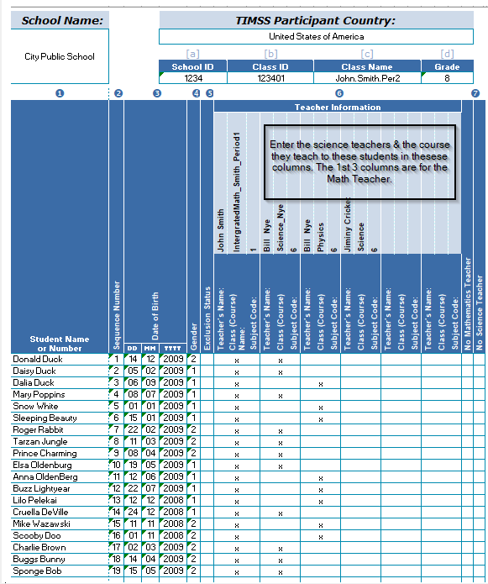
Sex

If you need assistance, please contact the TIMSS File Help Desk at TIMSS@rti.org or 833-870-0485.

Appendix A28 TIMSS 2027 School Posters
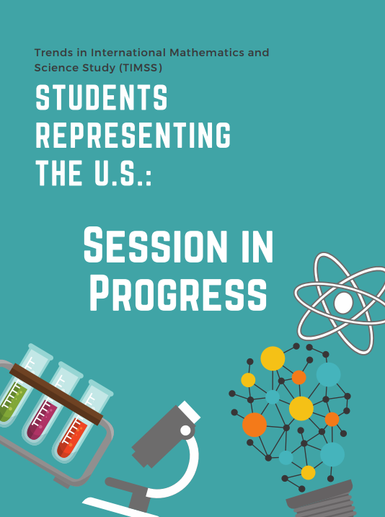
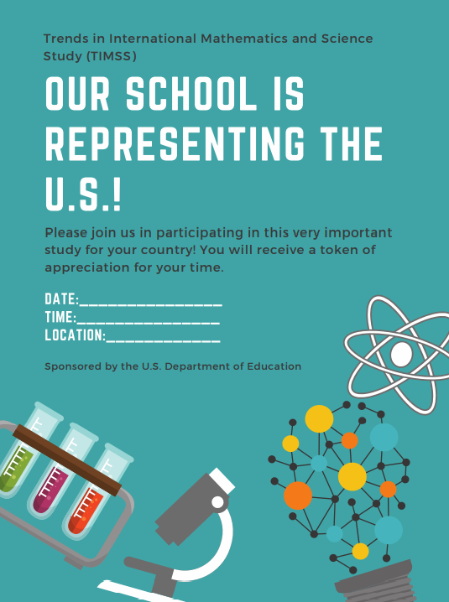

http://timssandpirls.bc.edu/timss2015/international-results/timss2015/wp-content/uploads/2016/T15-20-years-of-TIMSS.pdf
https://nces.ed.gov/timss/results23/index.asp#/math/trends

