Justification for No Material or Non-substantive Change to Currently Approved Collection

AGENCY: Pension Benefit Guaranty Corporation (PBGC)

TITLE: Locating and Paying Participants

STATUS: OMB control number 1212-0055; expires June 30, 2027

CONTACT: Monica O’Donnell (202-229-5507)

The Pension Benefit Guaranty Corporation (PBGC) is making non-material changes to forms approved under OMB control number 1212-0055. This collection of information, Locating and Paying Participants, enables PBGC to pay participants’ benefits under title IV of the Employee Retirement Income Security Act of 1974 (ERISA).

Executive Order 14247 (“Modernizing Payments To and From America’s Bank Account”), signed on March 25, 2025, requires the transition to electronic payments for all Federal disbursements and collections by digitizing payments to the extent permissible under the law. To comply with Executive Order 14247, PBGC is revising some of its forms in the Locating and Paying Participants information collection to remove the option of participants selecting that payments be mailed to them. The following forms are being updated: section 5 of Form 700, Participant Application for Pension Benefits; section 5 of Form 703RBD, Application for Elective Lump-Sum Payment, post RBD ; section 5 of Form 703RBD-MP, Application for Elective Lump-Sum Payment, post RBD; section 3 of Form 705, Beneficiary Application for Pension Benefits; section 4 of Form 706, Beneficiary Application for Pension Benefits - OF; and section 2 of Form 721T, Application for Payment Not Eligible for Rollover.

Each of these forms require participants to provide certain information to receive benefit payments. In response to Executive Order 14247, PBGC is modifying Form 700, Form 703RBD, Form 703RBD-MP, Form 705, and Form 706 to ask only for bank or financial institution information for receiving benefit payments. PBGC is changing each relevant section heading from “Method of Receiving Benefit Payments” to “Bank or Financial Institution Information” and removing the field where participants could select receiving payments via mail. Form 721T is used for a one-time payment, which PBGC has previously sent through the mail. PBGC is modifying this form to add a section that would mirror the Bank or Financial Institution Information sections on other forms in this series.

The change is as follows. Note that the section number will be different depending on the form.

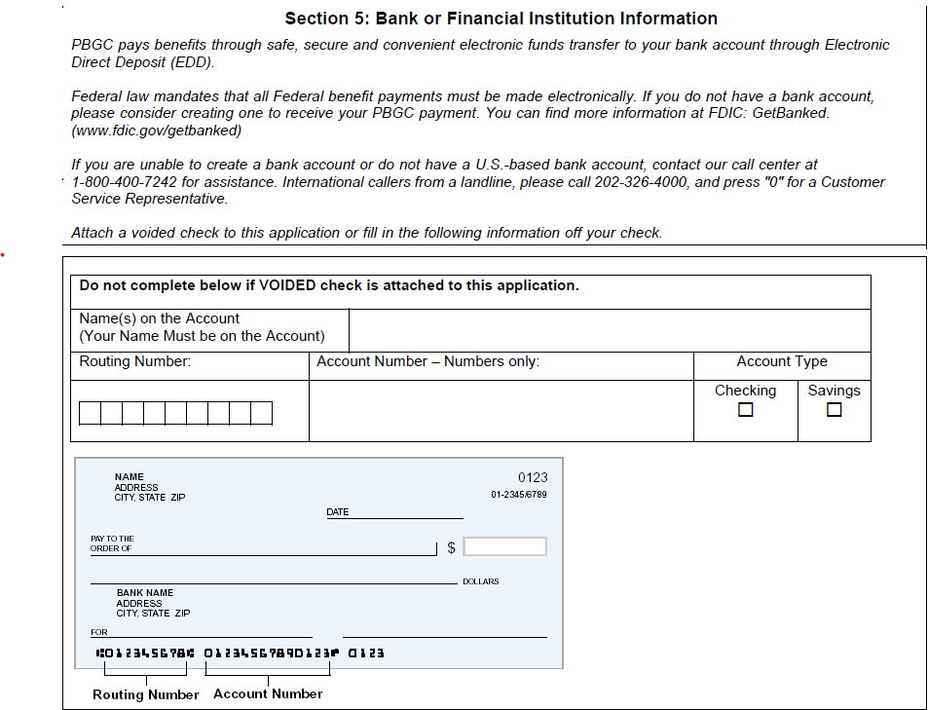

The changes made to the filings will not increase the hour or cost burden for this information collection.

