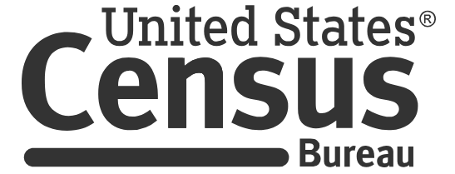

[Example Consent Form for 0607-0725]

Each year the Census Bureau conducts many different surveys. The Census Bureau routinely tests the questions used on these surveys in order to produce the best information possible.

By signing this document, you consent to take part in a study to improve the questions that will be used in [fill with the survey name]. In order to have a complete record of all comments, the interview session will be video and/or audiotaped. The Census Bureau plans to use the recordings to improve the questionnaire. Staff directly involved in the questionnaire design research project will have access to the recordings. Participation is voluntary and answers will remain strictly confidential.

This research interview is being conducted under the authority of [fill with authorities relative to the study being tested]. Federal law requires that your answers are kept confidential (13 U.S. C. Section 9), and protects your privacy under the Privacy Act (5 U.S.C. Section 552a). Only research staff from the U.S. Census Bureau will know your answers and/or comments from the interview. The Census Bureau can use your responses only to produce statistics, and is not permitted to publicly release your responses in a way that could identify you, your business, organization, or institution.

Additionally, per the Federal Cybersecurity Enhancement Act of 2015, your data are protected from cybersecurity risks through screening of the systems that transmit your data. Your information is secured by strictly adhering to the provisions of the Privacy Act, and other regulations and policies to protect the privacy and confidentiality of the information.

This collection has been approved by the Office of Management and Budget (OMB). This eight-digit OMB approval number, 0607-0725, confirms this approval and expires on 12/31/2025. Without this approval, we could not conduct this study. We estimate that completing this interview will take [FILL, such as: 60/20] minutes on average. You may send comments regarding this estimate or any other aspect of this survey, including suggestions for reducing the time it takes to complete this survey to [FILL, such as: adrm.pra@census.gov].

I have read and understand the statements above. I have agreed to participate in this Census Bureau questionnaire design study, and I give permission for my recordings to be used for the purposes stated above.

Participant’s Name: ______________________________________

Participant's Signature: _______________________________ Date: __________

