Below are screenshots of the NHSC and Nurse Corps Interest Capture Form, which can be accessed on the HRSA website at https://bhw.hrsa.gov/about-us/ask-question.

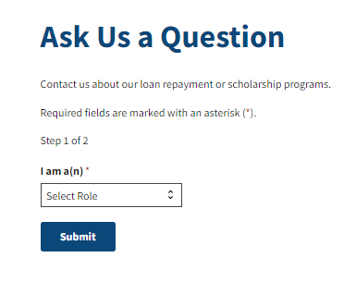

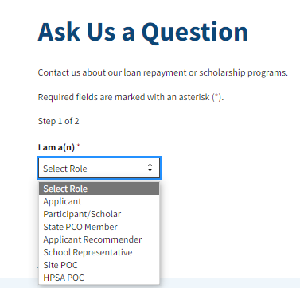

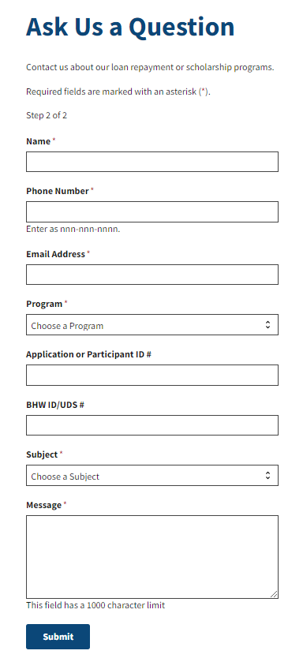
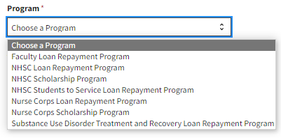

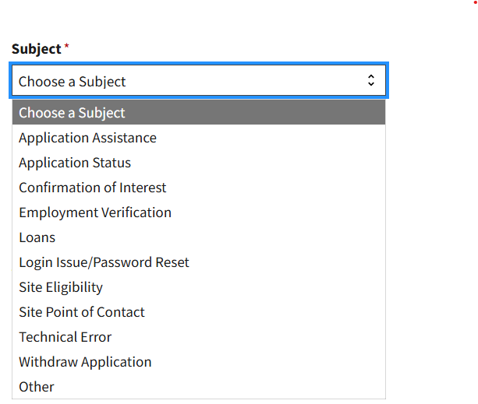

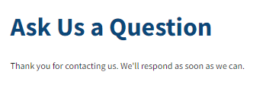
The purpose of this information collection is to obtain data from inquires for the following: Prospective HRSA program participants. In addition, these data will facilitate the ability to share resources regarding BHW discretionary programs and nurse loan repayment assistance programs. An agency may not conduct or sponsor, and a person is not required to respond to, a collection of information unless it displays a currently valid OMB control number. The OMB control number for this information collection is 0915-0337 and it is valid until xx/xx/20xx. This information collection is voluntary. Public reporting burden for this collection of information is estimated to average xx hours per response, including the time for reviewing instructions, searching existing data sources, and completing and reviewing the collection of information. Send comments regarding this burden estimate or any other aspect of this collection of information, including suggestions for reducing this burden, to HRSA Reports Clearance Officer, 5600 Fishers Lane, Room 13N82, Rockville, Maryland, 20857.

