OMB # 0925-0417
Expiration Date: 6/30/2025
At. 3

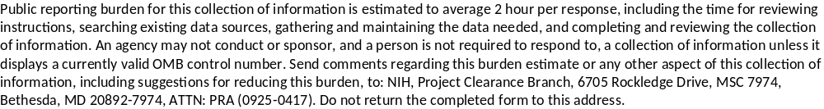
45 CFR 50.605(b)(1) and (b)(3) for grants and cooperative agreements
(b) Reporting of financial conflicts of interest.
(1) Prior to the Institution's expenditure of any funds under a PHS-funded research project, the Institution shall provide to the PHS Awarding Component an FCOI report regarding any Investigator's significant financial interest found by the Institution to be conflicting and ensure that the Institution has implemented a management plan in accordance with this subpart. In cases in which the Institution identifies a financial conflict of interest and eliminates it prior to the expenditure of PHS-awarded funds, the Institution shall not submit an FCOI report to the PHS Awarding Component.
(3) Any FCOI report required under paragraphs (b)(1) or (b)(2) of this section shall include sufficient information to enable the PHS Awarding Component to understand the nature and extent of the financial conflict, and to assess the appropriateness of the Institution's management plan. Elements of the FCOI report shall include, but are not necessarily limited to the following:
(i) Project number;
(ii) PD/PI or Contact PD/PI if a multiple PD/PI model is used;
(iii) Name of the Investigator with the financial conflict of interest;
(iv) Name of the entity with which the Investigator has a financial conflict of interest;
(v) Nature of the financial interest (e.g., equity, consulting fee, travel reimbursement, honorarium);
(vi) Value of the financial interest (dollar ranges are permissible: $0-$4,999; $5,000-$9,999; $10,000-$19,999; amounts between $20,000-$100,000 by increments of $20,000; amounts above $100,000 by increments of $50,000), or a statement that the interest is one whose value cannot be readily determined through reference to public prices or other reasonable measures of fair market value;
(vii) A description of how the financial interest relates to the PHS-funded research and the basis for the Institution's determination that the financial interest conflicts with such research; and
(viii) A description of the key elements of the Institution's management plan, including:
(A) Role and principal duties of the conflicted Investigator in the research project;
(B) Conditions of the management plan;
(C) How the management plan is designed to safeguard objectivity in the research project;
(D) Confirmation of the Investigator's agreement to the management plan;
(E) How the management plan will be monitored to ensure Investigator compliance; and
(F) Other information as needed.

SCREEN SHOTS OF eRA COMMONS FCOI MODULE INCLUDES THE INTITIAL OR ORIGINAL REPORT AND THE “SUBSEQUENT REPORTS” OR THE MITIGATION REPORT (42 CFR 50.605[a][3][iii] and [b][2]) for grants and cooperative agreements from awardees.

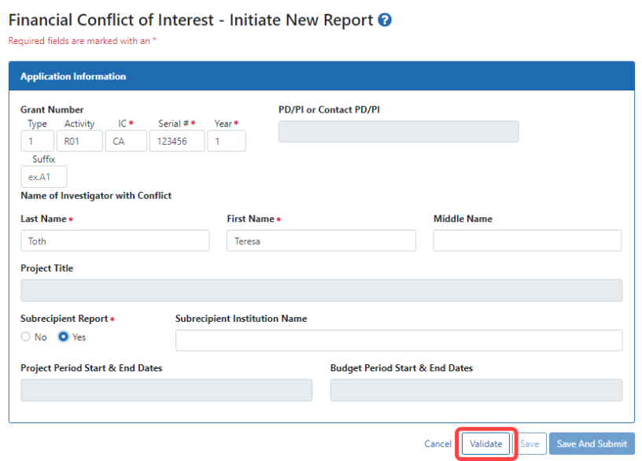
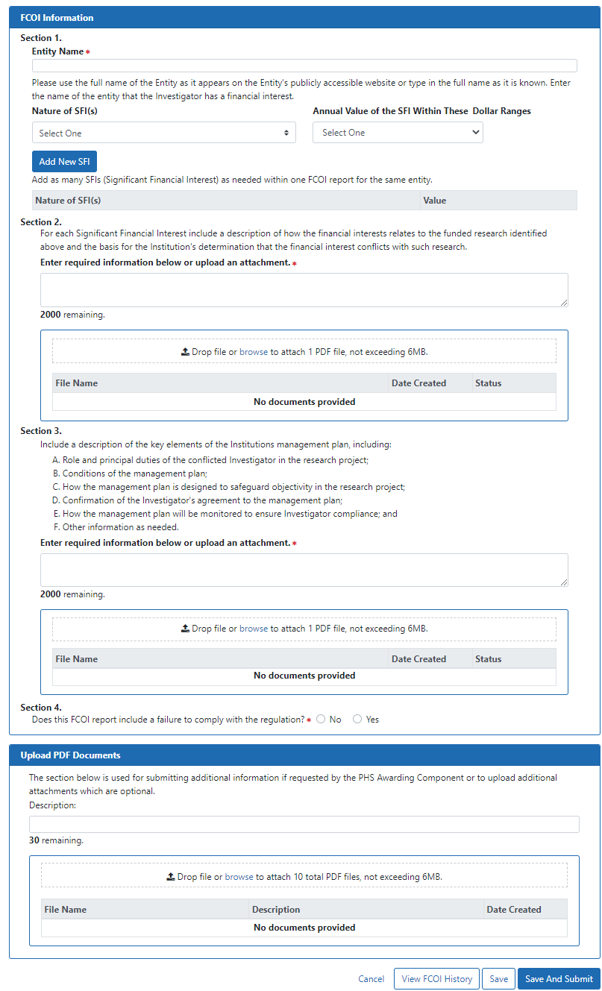
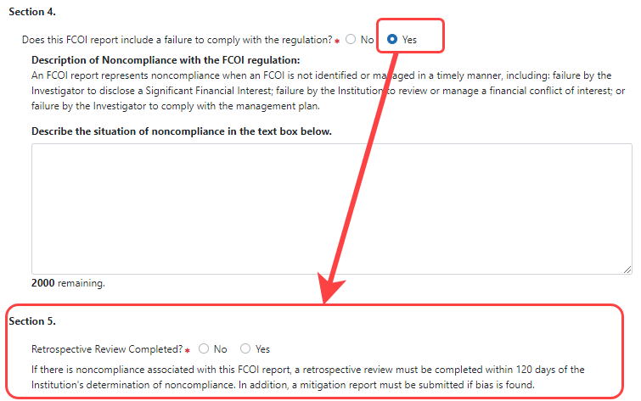
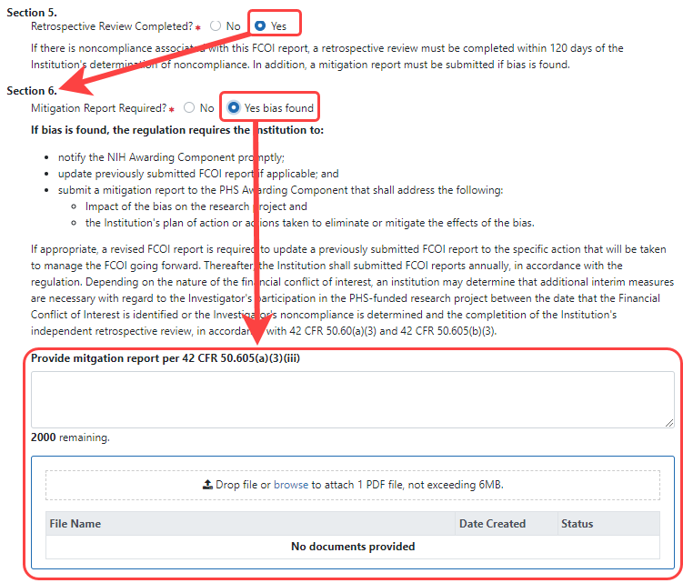
45 CFR 94.5(b)(1) and (b)(3) for research contracts
(b) Reporting of financial conflicts of interest.
(1) Prior to the Institution's expenditure of any funds under a PHS-funded research project, the Institution shall provide to the PHS Awarding Component an FCOI report regarding any Investigator's significant financial interest found by the Institution to be conflicting and ensure that the Institution has implemented a management plan in accordance with this part. In cases in which the Institution identifies a financial conflict of interest and eliminates it prior to the expenditure of PHS-awarded funds, the Institution shall not submit an FCOI report to the PHS Awarding Component.
(3) Any FCOI report required under paragraphs (b)(1) or (b)(2) of this section shall include sufficient information to enable the PHS Awarding Component to understand the nature and extent of the financial conflict, and to assess the appropriateness of the Institution's management plan. Elements of the FCOI report shall include, but are not necessarily limited to the following:
(i) Project/Contract number;
(ii) PD/PI or Contact PD/PI if a multiple PD/PI model is used;
(iii) Name of the Investigator with the financial conflict of interest;
(iv) Name of the entity with which the Investigator has a financial conflict of interest;
(v) Nature of the financial interest (e.g., equity, consulting fee, travel reimbursement, honorarium);
(vi) Value of the financial interest (dollar ranges are permissible: $0-$4,999; $5,000-$9,999; $10,000-$19,999; amounts between $20,000-$100,000 by increments of $20,000; amounts above $100,000 by increments of $50,000), or a statement that the interest is one whose value cannot be readily determined through reference to public prices or other reasonable measures of fair market value;
(vii) A description of how the financial interest relates to the PHS-funded research and the basis for the Institution's determination that the financial interest conflicts with such research; and
(viii) A description of the key elements of the Institution's management plan, including:
(A) Role and principal duties of the conflicted Investigator in the research project;
(B) Conditions of the management plan;
(C) How the management plan is designed to safeguard objectivity in the research project;
(D) Confirmation of the Investigator's agreement to the management plan;
(E) How the management plan will be monitored to ensure Investigator compliance; and
(F) Other information as needed.

