At. 5
Public reporting burden for this collection of information is estimated to average 1 hour per response, including the time for reviewing
instructions, searching existing data sources, gathering and maintaining the data needed, and completing and reviewing the collection of information. An agency may not conduct or sponsor, and a person is not required to respond to, a collection of information unless it
displays a currently valid OMB control number. Send comments regarding this burden estimate or any other aspect of this collection of
information, including suggestions for reducing this burden, to: NIH, Project Clearance Branch, 6705 Rockledge Drive, MSC 7974,
Bethesda, MD 20892-7974, ATTN: PRA (0925-0417). Do not return the completed form to this address.

Annual FCOI Report - Recipients Must Report on the Status of the FCOI During Award.
42 CFR 50.605(b)(4) for grants and cooperative agreements
(b) Reporting of financial conflicts of interest.
(4) For any financial conflict of interest previously reported by the Institution with regard to an ongoing PHS-funded research project, the Institution shall provide to the PHS Awarding Component an annual FCOI report that addresses the status of the financial conflict of interest and any changes to the management plan for the duration of the PHS-funded research project. The annual FCOI report shall specify whether the financial conflict is still being managed or explain why the financial conflict of interest no longer exists. The Institution shall provide annual FCOI reports to the PHS Awarding Component for the duration of the project period (including extensions with or without funds) in the time and manner specified by the PHS Awarding Component.
eRA Commons FCOI Module Reporting Tool for grants and cooperative agreements: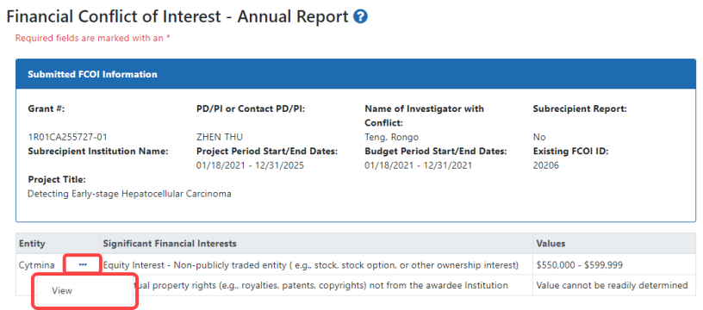
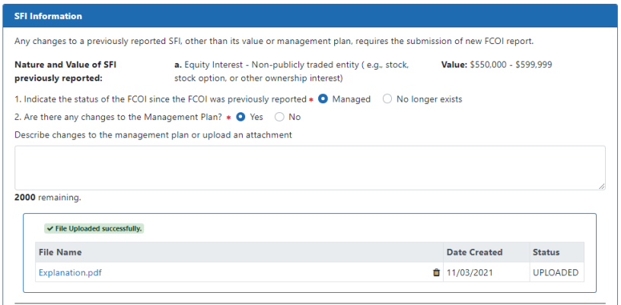
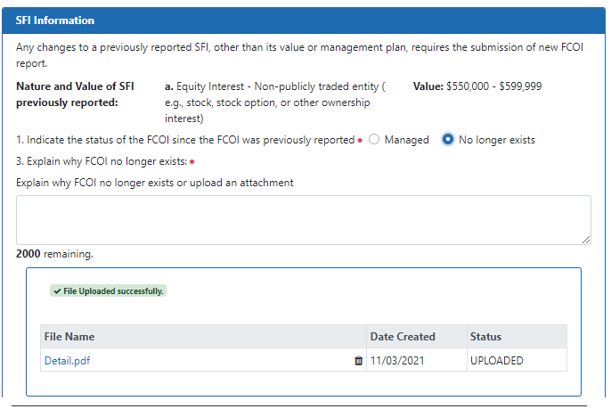

45 CFR 94.5(b)(4) for research contracts
(b) Reporting of financial conflicts of interest.
(4) For any financial conflict of interest previously reported by the Institution with regard to an ongoing PHS-funded research project, the Institution shall provide to the PHS Awarding Component an annual FCOI report that addresses the status of the financial conflict of interest and any changes to the management plan for the duration of the PHS-funded research project. The annual FCOI report shall specify whether the financial conflict is still being managed or explain why the financial conflict of interest no longer exists. The Institution shall provide annual FCOI reports to the PHS Awarding Component for the duration of the project period (including extensions with or without funds) in the time and manner specified by the PHS Awarding Component.

