
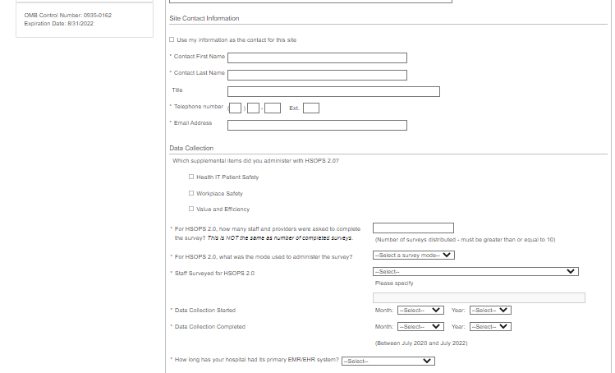
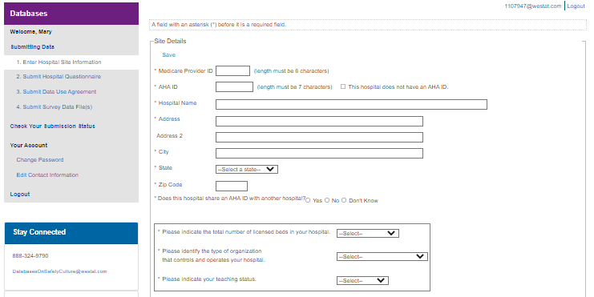
(Between July 2024 and July 2026)

Public reporting burden for this collection of information is estimated to average 5 minutes per response, the estimated time required to complete the survey. An agency may not conduct or sponsor, and a person is not required to respond to, a collection of information unless it displays a currently valid OMB control number. Send comments regarding this burden estimate or any other aspect of this collection of information, including suggestions for reducing this burden, to: AHRQ Reports Clearance Officer Attention: PRA, Paperwork Reduction Project (0935-XXXX) AHRQ, 5600 Fishers Lane, Rockville, MD 20857.

Dropdown options for bed size:
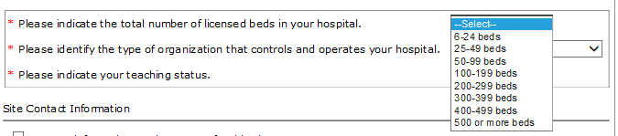
Ownership and control:
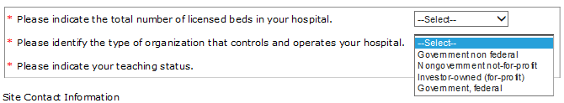
Teaching status:
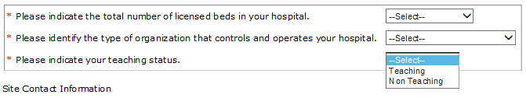
To whom the survey was administered:
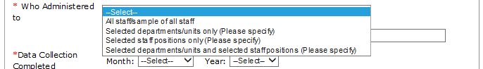
Survey mode:
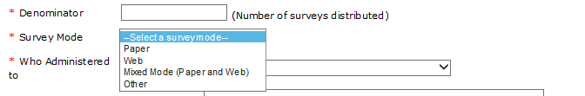

Length of time had EHR system:
