
Medicare Part B Average Sales Price (ASP) Module

Certifier User Guide
Version 2.0
Date: August 29, 2025

Table of Contents
1. Purpose 1
2. Logging in Using MFA 2
3. ASP Homepage Menu Tabs 9
3.1 One Time Password (OTP) Verification 9
3.2 Compliance Summary 11
3.2.1 Missing 12
3.2.2 Pending 12
3.2.3 Certified 15
3.2.4 New 18
3.2.5 Off Cycle 19
3.2.6 Expired 20
3.3 Assumptions 21
3.3.1 Create Assumption 22
3.3.2 Upload Assumption File 24
3.4 Drug Certification 27
3.4.1 Direct Employee 30
3.4.2 Contractor 32
3.4.3 Drug Data Pending Certification 34
3.4.4 All Drugs in Period 37
4. Technical Support Contact Information 39
Appendix A: Field Definitions 40
Appendix B: Revision History 44
Appendix C: Glossary 45
Appendix D: Figures and Tables 47

Purpose
The purpose of this user guide is to provide guidance and instructions to financial executives of drug manufacturing companies as they certify their federally required Medicare Part B drug Average Sales Price (ASP) data for the Centers for Medicare & Medicaid Services (CMS). CMS uses the Fee-for-Service Data Collection System (FFSDCS) to house various Fee-for-Service modules.
The ASP Data Collection System, referred to within this user guide as the ASP Module, is one of the modules under the FFSDCS system, and offers the following:
- Provides users with an online-based software application for automating the collection, editing, and processing of drug product pricing data drug manufacturers submit on a quarterly basis.
- Establishes a relationship between the manufacturers’ reported data and the billing codes Medicare providers use to calculate a weighted average sales price for each billing code.
- Establishes prices for billing codes to determine payment limits of Part B drugs on certain Medicare claims.
- Eliminates data entry errors, data formatting errors, and incomplete submitted data, and greatly reduces the process cycle and resource time needed to provide the pricing to contractors through automation of the manually intensive processes.
- Accepts, stores, validates, and calculates drug pricing on Medicare Part B drug data received for the Center for Medicare Management (CMM) stakeholders.
Section 303 (b) and (c) of the Medicare Modernization Act (MMA) of 2003 revised the payment methodology for the majority of Part B-covered drugs and biologicals that are not priced on a cost or prospective payment basis (hereafter referred to as drugs).
CMS applies the ASP methodology to the data drug manufacturers have submitted to the ASP Module. Per the MMA, ASP methodology determines the payment limit for these drugs. Local contractors calculate pricing for compounded drugs.

Logging in Using MFA
First time users must register and create an account in the CMS Enterprise Portal. Refer to the Resource Library on the Education and Outreach page to view the ASP Module Registration User Guide for registration steps.
Once registration is complete, follow these steps to log into the Module as a Certifier using Multi-Factor Authentication (MFA):
- Navigate to the CMS Enterprise Portal main page.
The ASP Module Login Page opens. Refer to Figure 1.
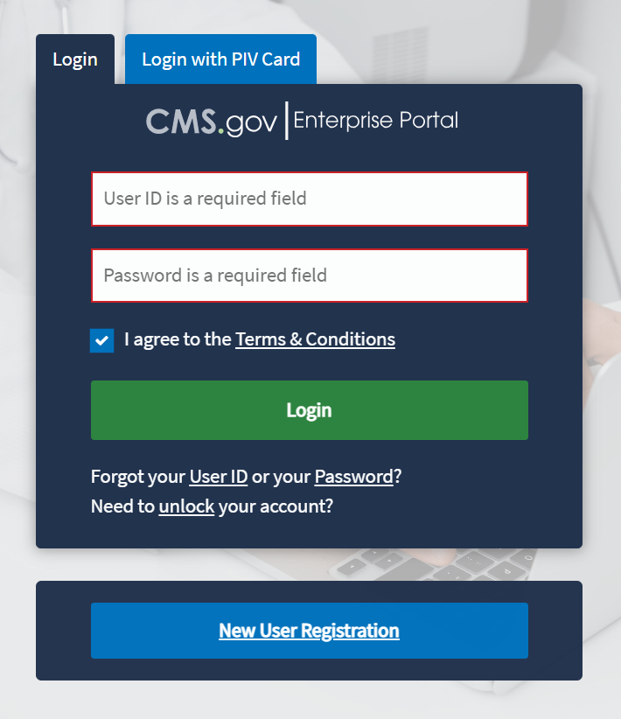
Figure 1: Logging in Using MFA - ASP Module Login
- Enter your login information into the required User ID and Password fields.
- Click the Terms & Conditions hyperlink and review the text in the pop-up window; close the window to move on to the next step.
- Review the terms and conditions and select the I agree to the Terms & Conditions checkbox.
Note: By selecting this checkbox, you certify that you read and consent to monitoring while accessing and using the ASP Module. The terms and conditions link provides additional hyperlinks to the HHS Rules of Behavior and the CMS Privacy Act Statement.
- Click Login.
Note: If you forget your user ID or password, click the Forgot your User ID or your Password? hyperlink under the Login button and follow the provided instructions. If you still cannot access your account and need to unlock it, click the Need to unlock your account? hyperlink under Login button.
The Multi-Factor Authentication page opens. Refer to Figure 2.
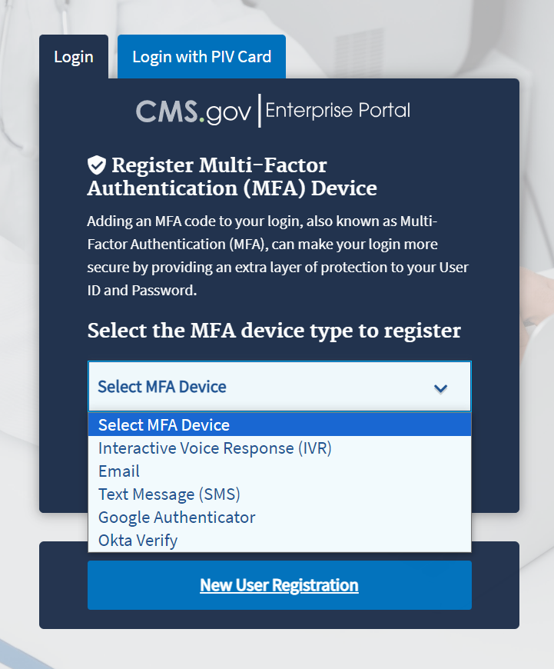
Figure 2: Logging in Using MFA - Select MFA Device Type Drop-Down
To ensure the security of high value data submitted to the ASP Module, you must authenticate your identity using an MFA process. The first time you attempt to log in, you must choose an authentication method. Users have various authentication options, including Interactive Voice Response (IVR), Email, Text Message (Short Message Service (SMS)), Google Authenticator and Okta Verify.
- Click the Select MFA Device drop-down menu; select your preferred MFA device type from the list. Refer to Figure 3. Whenever you log back into the Module through this process, your preferred method of MFA reloads automatically.
Note: Figure 3 demonstrates MFA registration using IVR as the selected option.
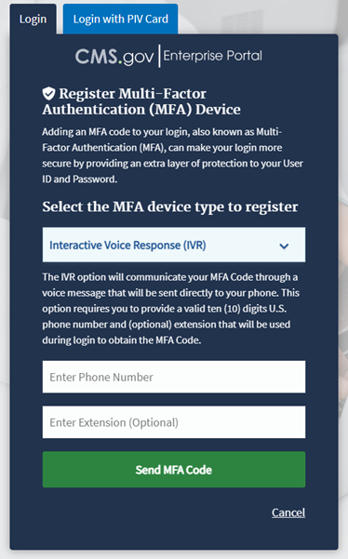
Figure 3: Logging in Using MFA - Multi-Factor Authentication - (IVR) Example
- Enter your phone number in the Phone Number field; enter your extension in the Extension field, if necessary.
- Click the Send MFA Code button to receive a six-digit code via your chosen contact method.
- Record and enter the six-digit code you received into the Enter MFA Code field. Refer to Figure 4.
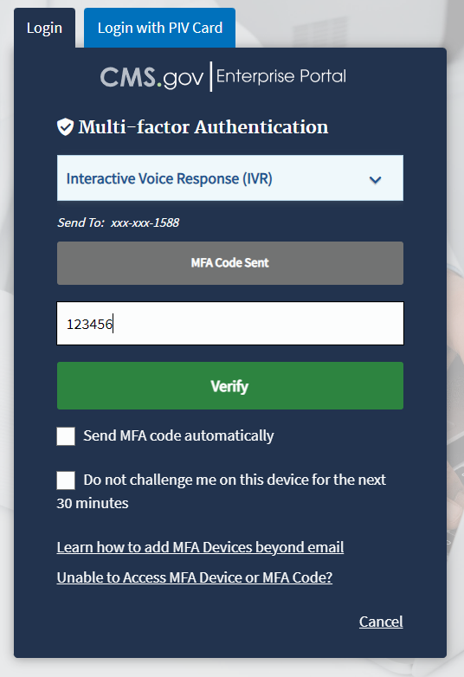
Figure 4: Logging in Using MFA - Multi-Factor Authentication - Verify MFA Code
- Check the Send MFA code automatically and Do not challenge me on this device for the next 30 minutes checkboxes depending on your preference.
Note: If you need help, click the Learn how to add MFA Devices beyond email and Unable to Access MFA Devices or MFA Code? hyperlinks.
- Click the Verify button to confirm your identity and enter the ASP Module.
The My Portal landing page opens. Refer to Figure 5.
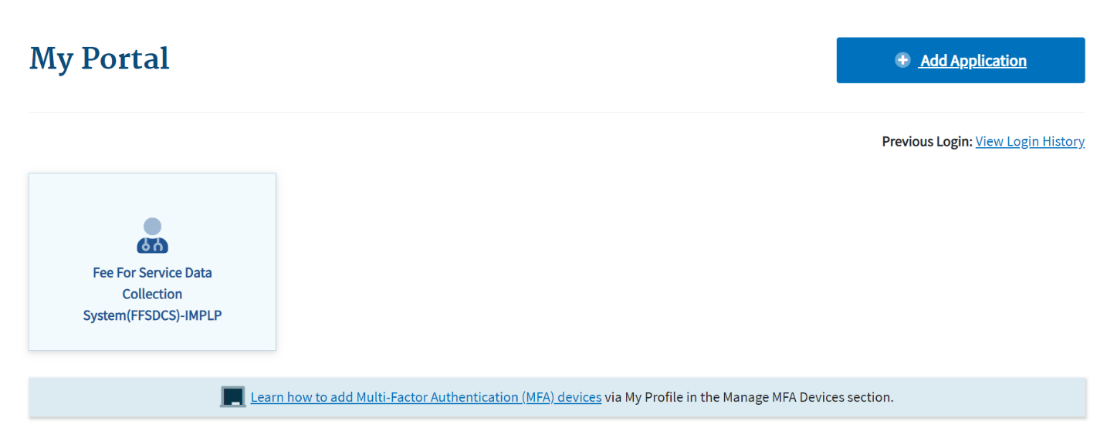
Figure 5: My Portal Landing Page
Note: Other CMS applications you have access to may display on the My Portal landing page.
- Click the Fee For Service Data Collection System (FFSDCS) box.
A Fee for Service Data Collection System (FFSDCS) drop-down menu opens. Refer to Figure 6.
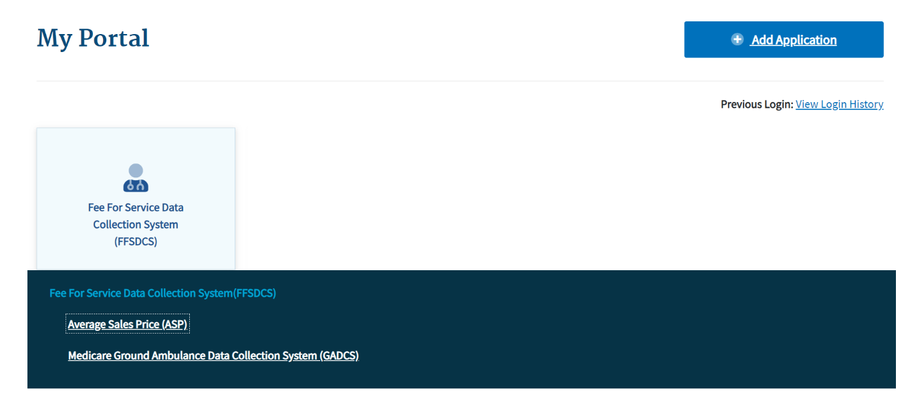
Figure 6: My Portal Landing Page - FFSDCS Drop-down
- Click the Average Sales Price (ASP) hyperlink.
A full-page statement displays, titled ASP Data for Drugs and Biologics Covered Under Medicare Part B. The statement details recent statutory requirements stated in the Social Security Act (the Act), and the Consolidated Appropriations Act (CAA), 2021.These requirements hold that manufacturers must report their ASP data to CMS with precision on a quarterly basis without errors or miscalculations. Refer to Figure 7.
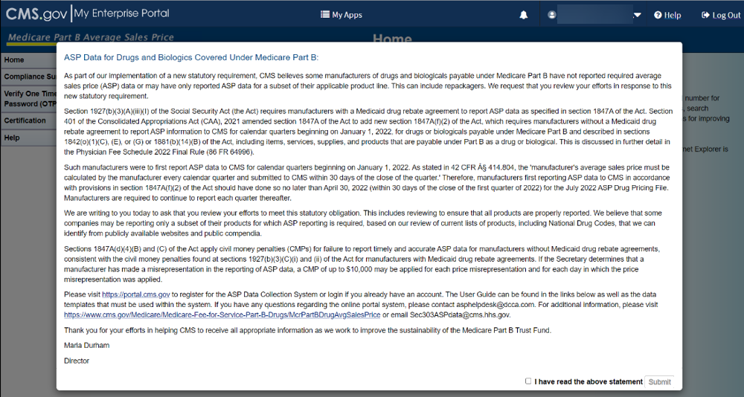
Figure 7: ASP Data for Drugs and Biologics Under Medicare Part B
- Read the statement; select the I have read the above statement checkbox and click Submit.
The Medicare Part B Average Sales Price homepage opens. Refer to Figure 8.
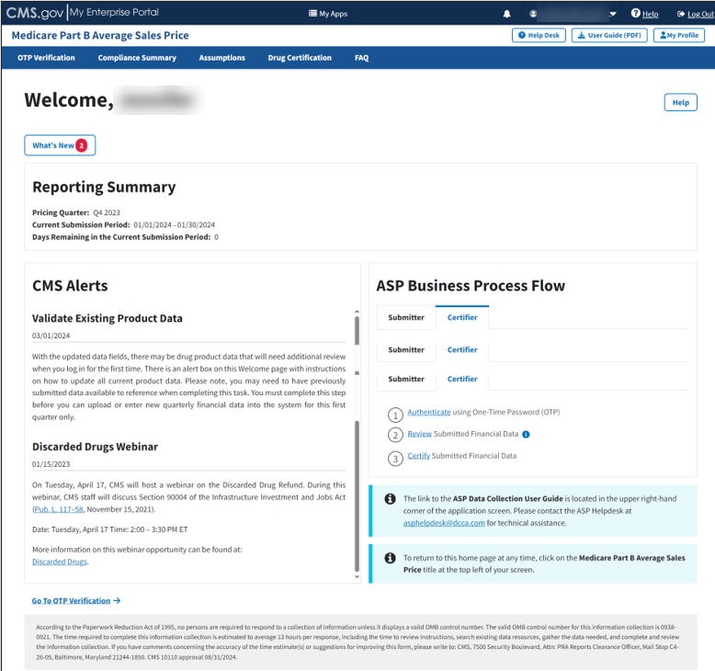
Figure 8: Medicare Part B Average Sales Price Homepage

ASP Homepage Menu Tabs
The following sections describe the functionality of each menu tab on the ASP homepage, including OTP Verification, Compliance Summary, Assumptions, and Drug Certification.

One Time Password (OTP) Verification
Once the Submitter has completed and submitted product data, the Submitter must share the one-time password (OTP) with the Certifier to establish a relationship within the system. Note the following about OTPs:
- This step only occurs once as long as the people in both roles remain the same.
- A new OTP should only be generated if the person in either role changes.
- An OTP is valid for seven days. After seven days, the Submitter must generate a new OTP.
- Once the Submitter generates and provides the OTP to the Certifier, the Certifier must verify the OTP to continue.
- If the OTP is misplaced or lost, the Certifier must contact the Submitter to generate another OTP.
Follow these steps to verify the OTP:
- From the Medicare Part B Average Sales Price homepage, click the OTP Verification tab.
The OTP Verification page opens. Refer to Figure 9.
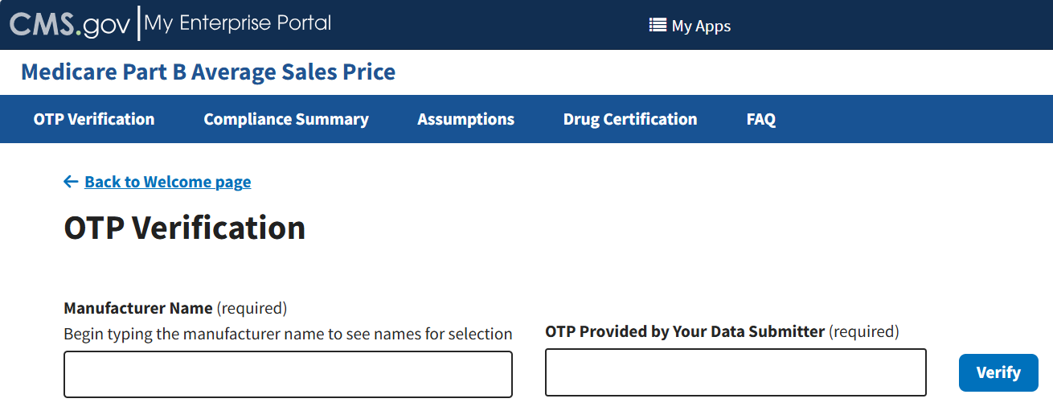
Figure 9: OTP Verification
- In the Manufacturer Name (required) field, begin typing the manufacturer name to narrow down names for selection; select the appropriate manufacturer name. Refer to Figure 10.
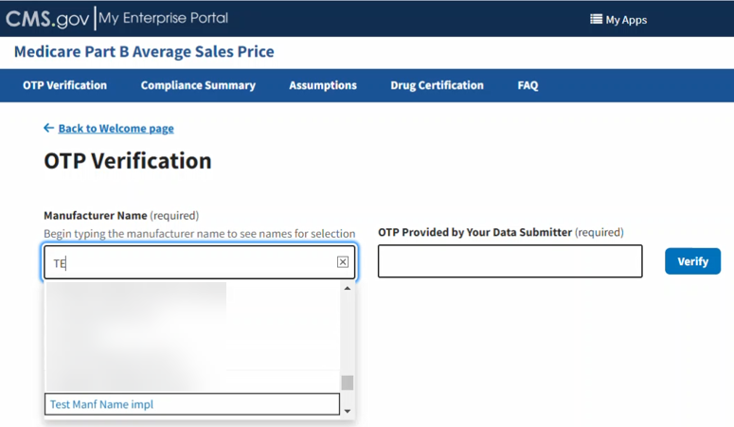
Figure 10: OTP Verification - Manufacturer Name
- Enter the OTP code from the Submitter in the OTP Provided by Your Data Submitter (required) field. Refer to Figure 11.
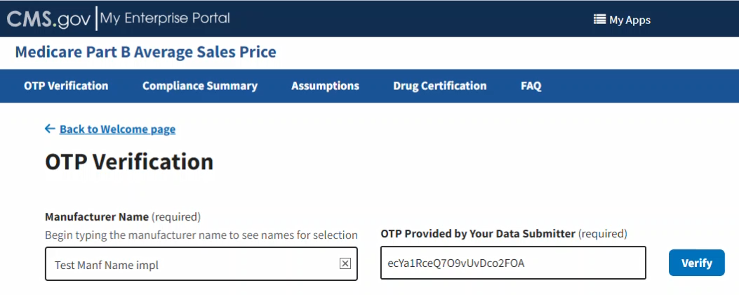
Figure 11: OTP Verification - OTP Provided by Your Data Submitter
- Click Verify to confirm the OTP.
A message displaying confirming you have successfully verified the OTP. Refer to Figure 12.

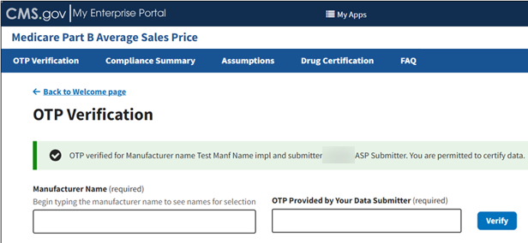
Figure 12: OTP Verification Successful

Compliance Summary
The features in the Compliance Summary section allow drug manufacturers to determine if their products meet the current submission reporting requirements.
The Compliance Summary consists of the following sections:
- Missing: Displays drug products that are missing financial data for the selected reporting period.
- Pending: Displays drug products that are both pending certification and pending restatement certification, combined under one tab.
- Certified: Displays previously certified drug products for the selected reporting period.
Note: Financial data will be suppressed for prior quarters.
- New: Displays drug products with a first marketing date in the same reporting period.
- Off Cycle: Displays drug products added on or after the first day of the submission window of the current quarter.
- Expired: Displays drug products that have an expired date of final lot sold which is prior to the reporting period selected. A drug product that expired in an earlier quarter will continue to show in subsequent quarters.
Follow these steps to navigate the Compliance Summary section:
- From the Medicare Part B Average Sales Price homepage, click the Compliance Summary tab.
The Compliance Summary page opens. The page displays the status for each submitted drug product regarding the drug manufacturer’s compliance for the selected reporting period. The page automatically defaults to the Missing tab. Refer to Figure 13.
Note: Figure 13 shows an alert message under Reporting Period stating that there are drug products in need of attention.
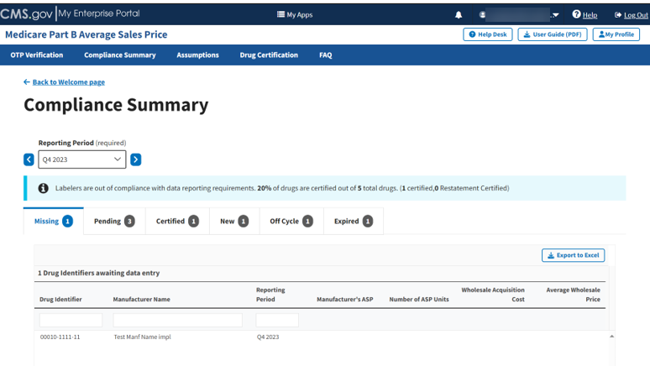
Figure 13: Compliance Summary
Note: Click the Reporting Period (required) tab in the top left to scroll through previous quarters. Use the drop-down to navigate to a previous quarter starting with the most recent, or the next quarter.

Missing
Follow these steps to review your data in the Missing tab of the Compliance Summary:
- Under Drug Identifiers waiting for data entry, review and identify the missing financial information to address with the Submitter.
The Module organizes the full list by Drug Identifier and Manufacturer Name, and includes Reporting Period, Manufacturer’s ASP, Number of ASP Units, Wholesale Acquisition Cost, and Average Wholesale Price fields.
Note: Click the Export to Excel button to download all products under the Missing tab.
- Inform the Submitter of any missing financial information to ensure the inclusion of all data collected in the Module.
- Click the Pending tab to move on to the next page.

Pending
Follow these steps to review the Pending tab of the Compliance Summary:
- From the default Compliance Summary page, click the Pending tab.
The Pending page displays. Refer to Figure 14.
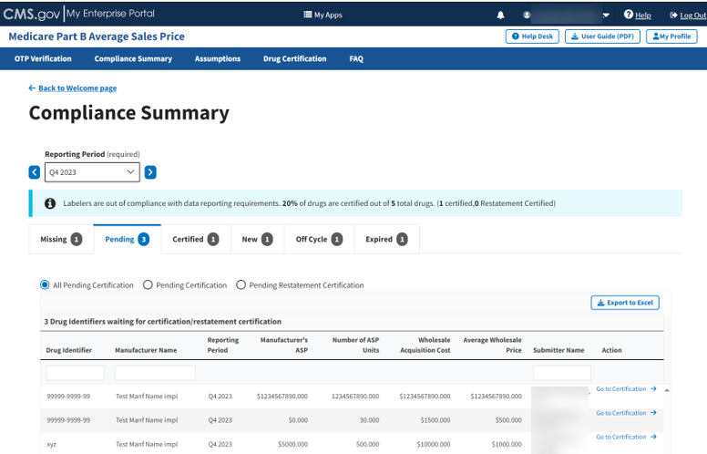
Figure 14: Compliance Summary - All Pending Certification
The Module automatically selects the All Pending Certification radio button, and the page displays the drug identifiers waiting for certification/restatement certification.
Note: Click the Export to Excel button to download all products under the Pending tab.
- Review the drug information under Drug Identifiers Waiting for Certification/Restatement Certification.
The Module organizes the full list by Drug Identifier and Manufacturer Name, and includes Reporting Period, Manufacturer’s ASP, Number of ASP Units, Wholesale Acquisition Cost, Average Wholesale Price, and Action fields.
- Under Action, click the Go to Certification hyperlink to navigate to Drug Certification. (Refer to Section 3.4 - Drug Certification.)
- Click the Pending Certification radio button to filter only for drugs pending certification. Refer to Figure 15.
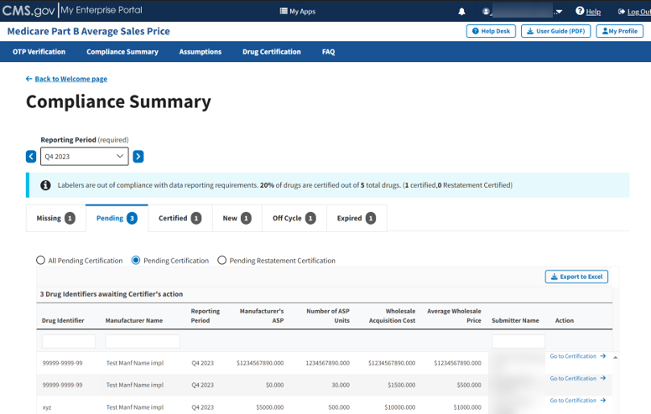
Figure 15: Compliance Summary - Pending Certification
Note: Click the Export to Excel box to download all products under the Pending tab.
- Review the submitted drug information.
The Module organizes the full list by Drug Identifier and Manufacturer Name, and includes Reporting Period, Manufacturer’s ASP, Number of ASP Units, Wholesale Acquisition Cost, Average Wholesale Price, and Action fields.
- Under Action, click the Go to Certification hyperlink to navigate to Drug Certification. (Refer to Section 3.4 - Drug Certification.)
- Click the Pending Restatement Certification radio button to filter only for drugs that are pending restatement certification. Refer to Figure 16.
- Under Action, click the Go to Certification hyperlink to navigate to Drug Certification. (Refer to Section 3.4 - Drug Certification.)
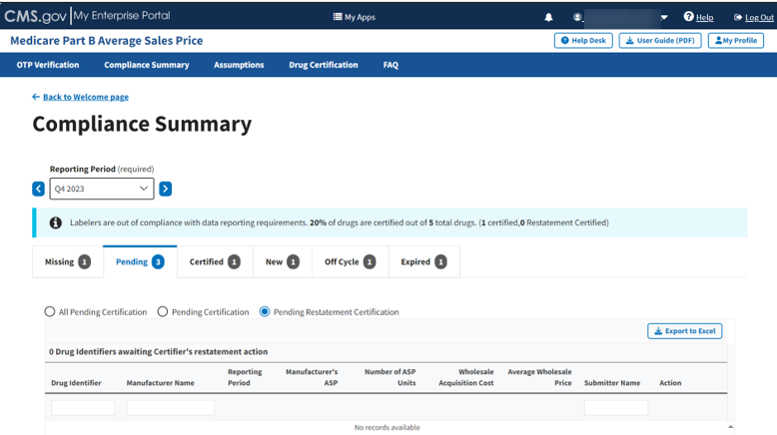
Figure 16: Compliance Summary - Pending Restatement Certification
Note: Click the Export to Excel box to download all products under the Pending tab.
- Review the submitted drug information.
The Module organizes the full list by Drug Identifier and Manufacturer Name, and includes Reporting Period, Manufacturer’s ASP, Number of ASP Units, Wholesale Acquisition Cost, Average Wholesale Price, and Action fields.
- Under Action, click the Go to Certification hyperlink to navigate to Drug Certification. (Refer to Section 3.4 - Drug Certification.)
- Click the Certified tab to move on to the next page.

Certified
Follow these steps to review your data in the Certified tab of the Compliance Summary:
- From the default Compliance Summary page, click the Certified tab.
The Certified page displays. Refer to Figure 17.
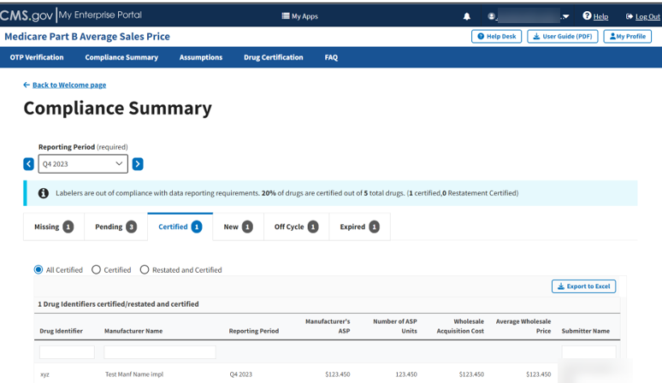
Figure 17: Compliance Summary - Certified
The Module automatically selects the All Certified radio button, and the page displays the certified/restated drug identifiers.
Note: Click the Export to Excel button to download all products under the Certified tab.
- Review the submitted drug information.
The Module organizes the full list by Drug Identifier and Manufacturer Name, and includes Reporting Period, Manufacturer’s ASP, Number of ASP Units, Wholesale Acquisition Cost, and Average Wholesale Price.
- Click the Certified radio button to filter only for certified drugs. Refer to Figure 18.
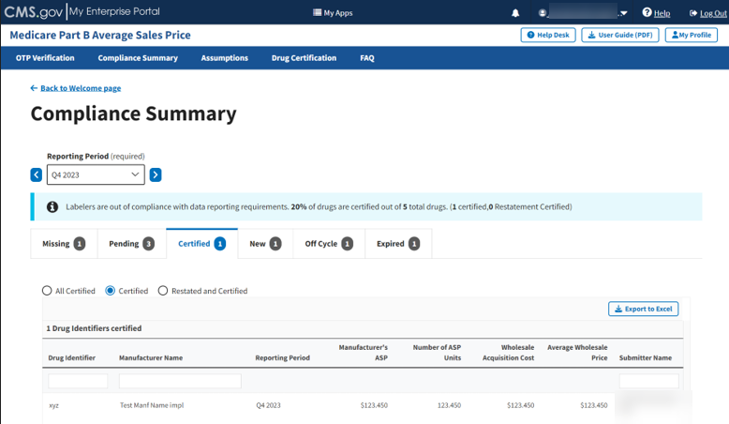
Figure 18: Compliance Summary - Certified
Note: Click the Export to Excel button to download all products under the Certified tab.
- Review the submitted drug information.
The Module organizes the full list by Drug Identifier and Manufacturer Name, and includes Reporting Period, Manufacturer’s ASP, Number of ASP Units, Wholesale Acquisition Cost, and Average Wholesale Price.
- Click the Restated and Certified radio button to filter only for certified drugs that were restated. Refer to Figure 19.
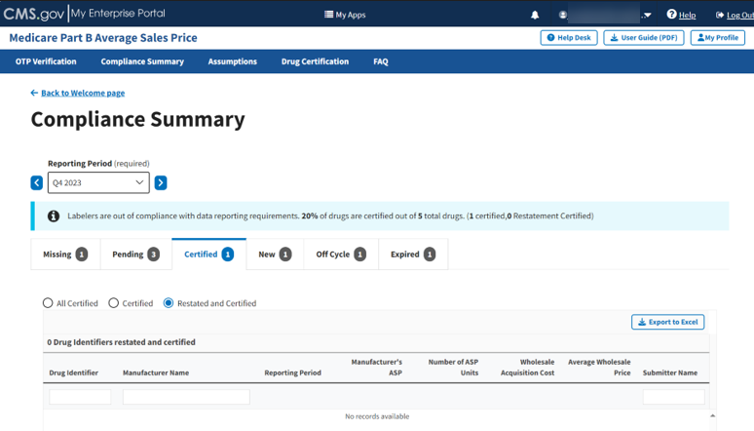
Figure 19: Compliance Summary - Restated and Certified
Note: Click the Export to Excel button to download all products under the Certified tab.
- Review the submitted drug information.
The Module organizes the full list by Drug Identifier and Manufacturer Name, and includes Reporting Period, Manufacturer’s ASP, Number of ASP Units, Wholesale Acquisition Cost, and Average Wholesale Price.
- Click the New tab to move on to the next page.

New
Follow these steps to review data in the New tab of the Compliance Summary:
- From the default Compliance Summary page, click the New tab.
The New page displays. Refer to Figure 20.
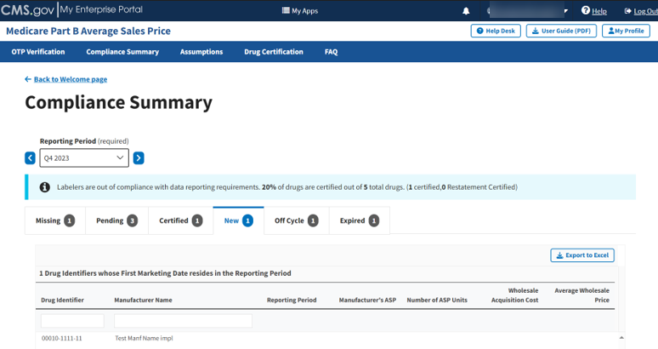
Figure 20: Compliance Summary - New
Note: Click the Export to Excel button to download all products under the New tab.
- Review the submitted drug information.
The Module organizes the full list by Drug Identifier and Manufacturer Name, and includes Reporting Period, Manufacturer’s ASP, Number of ASP Units, Wholesale Acquisition Cost, and Average Wholesale Price.
- Click the Off Cycle tab to move on to the next page.

Off Cycle
Follow these steps to review data in the Off Cycle tab of the Compliance Summary:
- From the default Compliance Summary page, click the Off Cycle tab.
The Off Cycle page displays. Refer to Figure 21.
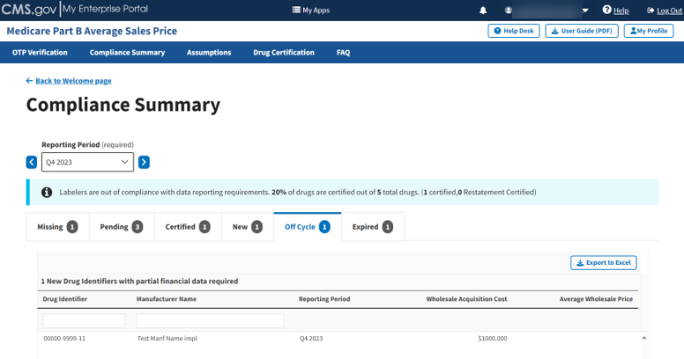
Figure 21: Compliance Summary - Off Cycle
Note: Click the Export to Excel button to download all products under the Off Cycle tab.
- Review the submitted drug information.
The Module organizes the full list by Drug Identifier and Manufacturer Name, and includes Reporting Period, Wholesale Acquisition Cost, and Average Wholesale Price.
- Click the Expired tab to move on to the next page.

Expired
Follow these steps to review data in the Expired tab of the Compliance Summary:
- From the default Compliance Summary page, click the Expired tab.
The Expired page displays. Refer to Figure 22.
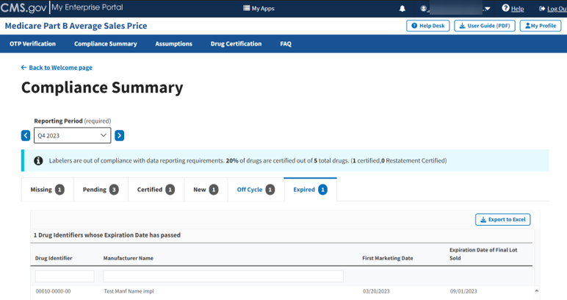
Figure 22: Compliance Summary - Expired
Note: Click the Export to Excel button to download all products under the Expired tab.
- Review the submitted drug information.
The Module organizes the full list by Drug Identifier and Manufacturer Name and includes First Marketing Date and Expiration Date of Final Lost Sold.

Assumptions
Drug manufacturers can submit comments regarding their certifications to CMS via the Assumptions tab. Each quarter, manufacturers will submit these comments for the current reporting period, or they may submit assumptions for any previous quarters they are restating and resubmitting.

Reasonable Assumptions
Follow these steps to create an assumption:
Note: Certifiers cannot finalize the certification process until the Reasonable Assumptions Form is complete. If a drug manufacturer does not have additional information for the required response fields, please enter “N/A”.
- From the Medicare Part B Average Sales Price homepage, click the Assumptions tab.
The Assumptions page opens, and defaults to the current quarter and year. Select the appropriate reporting period before clicking the Reasonable Assumptions (Required) tab. Refer to Figure 23.

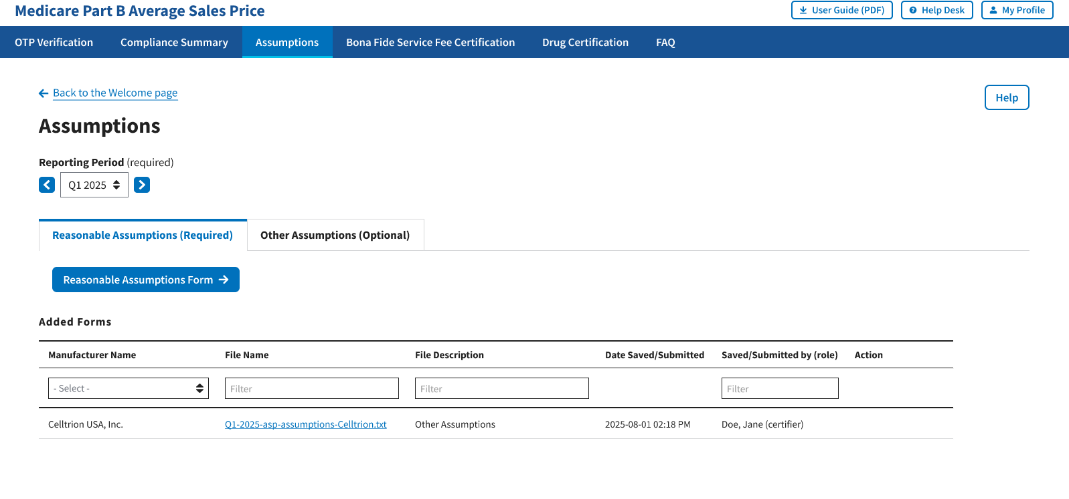
Figure 23: Assumptions
Note: Click the Reporting Period (Required) tab in the top left to scroll through previous quarters.
- Click the Reasonable Assumptions Form button.
The Reasonable Assumption Form window displays. The Module automatically defaults to the Reporting Period selected on the Assumptions default page with a Manufacturer Name (required) drop-down menu and empty required response fields.
Refer to Figure 24.

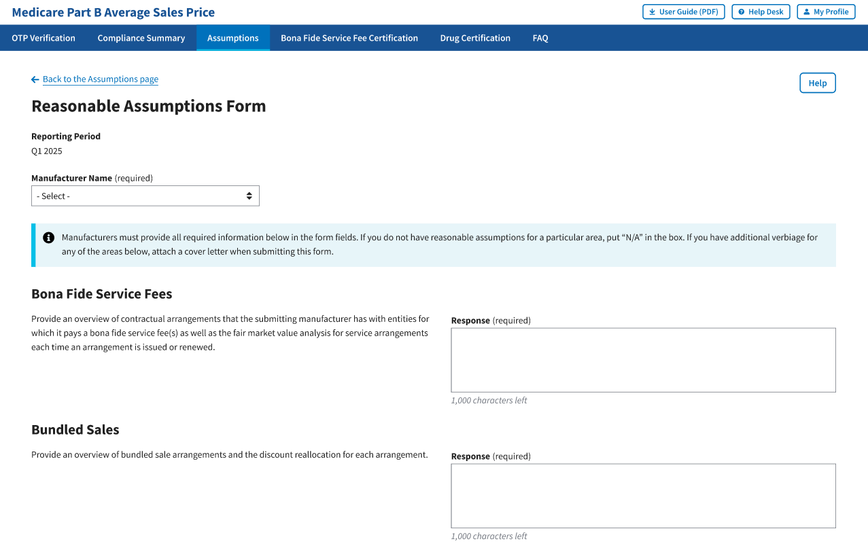
Figure 24: Reasonable Assumptions Form
- From the Manufacturer Name (required) drop-down menu, click the -Select- drop-down menu to expand the list and select the manufacturer name.
Click “View All” to view all the required response fields. Refer to Figure 25.
- Bona Fide Service Fees
- Bundled Sales
- Price Concessions and Discounts
- Reporting of Products with Zero, Negative, or False Positive ASPs
- Sales Excluded from Best Price
- Sales to U.S. Territories
- Time Value of Money
- Free Goods Not Contingent on a Purchase Requirement
- Value-Based Purchasing Agreements
- Sales to 340B Covered Entities
- Returned Goods
- Billing Corrections
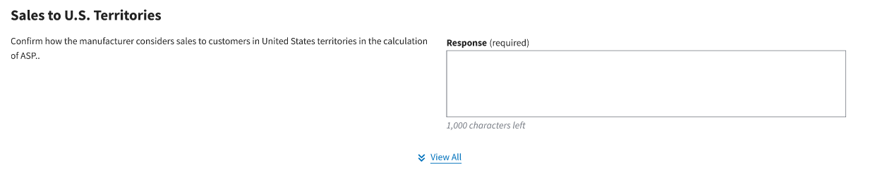
Figure 25: “View All” Required Response Fields
Note: For drug manufacturers with contractual agreements, please enter comments in the Reasonable Assumptions form and complete the Bona Fide Service Fee Certification. Refer to Section 3.4 for instructions.

- Complete all the required fields. Enter “N/A” if reasonable assumptions are not available for a particular field.
Note: Each required field allows for 1,000 characters of text to provide a summary of the assumption. If a response exceeds the character limit, please submit or upload the additional verbiage on the Other Assumptions tab. Refer to Section 3.3.2 for instructions.
- Click the Save Form button located at the bottom of the form. Refer to Figure 26.
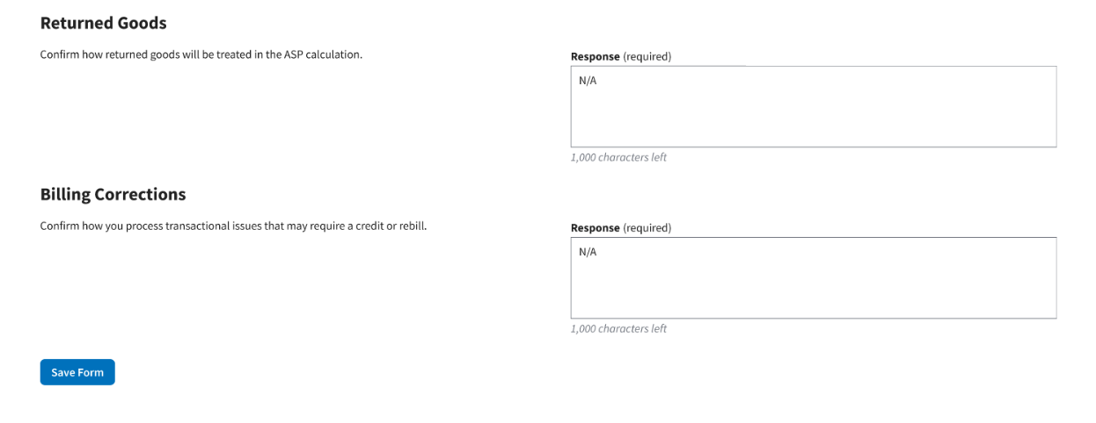
Figure 26: Save Reasonable Assumptions Form

A message displays confirming you have successfully created your Reasonable Assumptions. The Module lists saved forms under Added Forms. Refer to Figure 27.
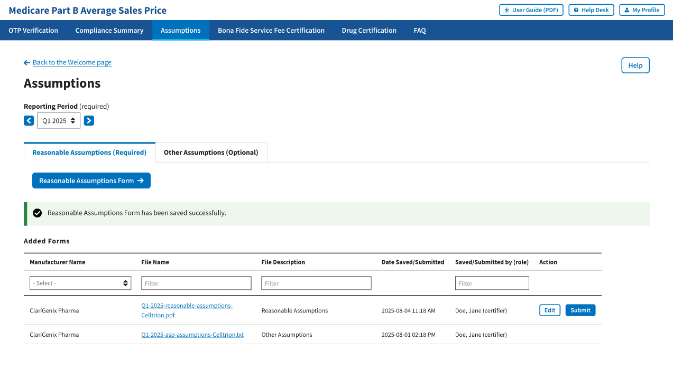
Figure 27: New Assumption Successfully Saved
- To make any necessary revisions before submitting, click the Edit button.
- If the submission does not require additional revisions, click the Submit button.
A message displays confirming you have successfully submitted your Reasonable Assumptions. Refer to Figure 28.
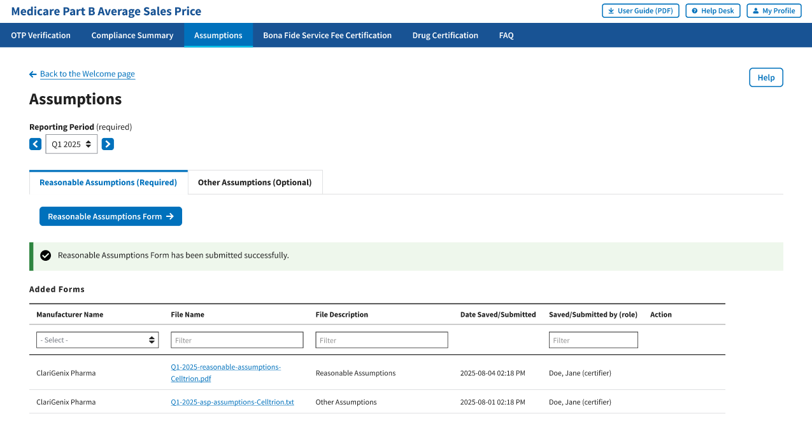
Figure 28: Reasonable Assumptions Successfully Submitted

Other Assumptions (Optional)
This section provides instructions on how drug manufacturers can submit comments regarding their certifications to CMS via Create Assumptions or Upload Assumptions.

Create Assumptions
Follow these steps to submit certification assumptions CMS:
- From the Medicare Part B Average Sales Price homepage, click the Assumptions tab. The Module automatically defaults to the Reasonable Assumptions (Required) Tab. Click the Other Assumptions (Optional) tab. Refer to Figure 29.
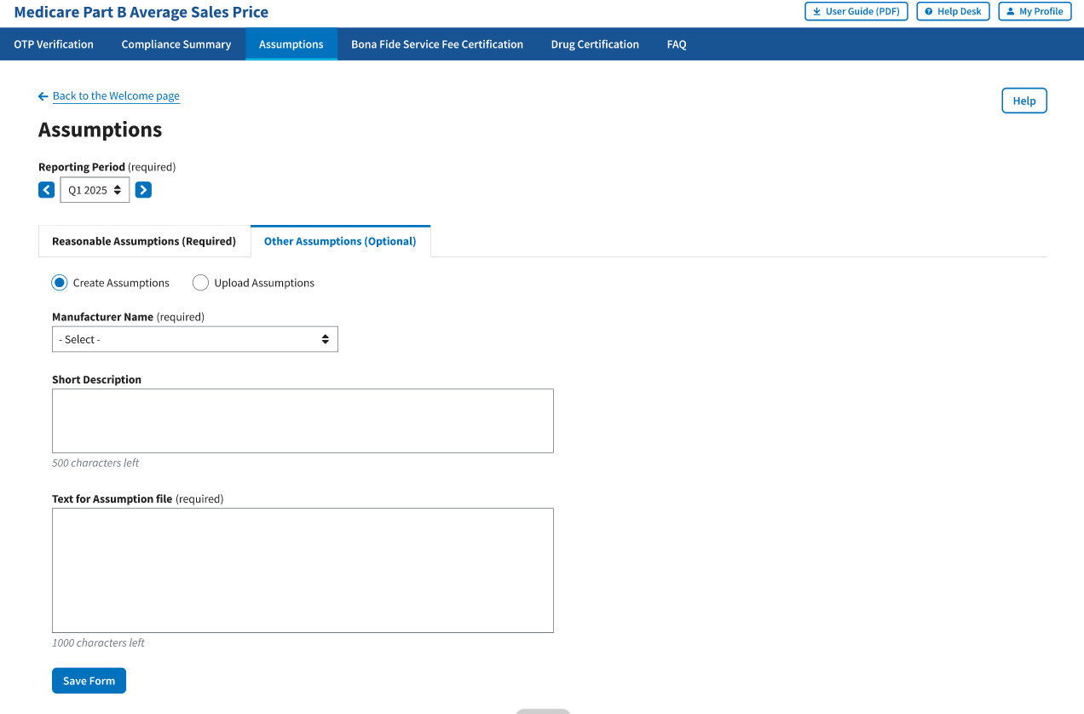
Figure 29: Create Other Assumptions
Note: Click the Reporting Period (required) tab in the top left to view previous quarters. Use the drop-down menu to navigate to select the appropriate quarter.
- The Module automatically defaults to the Create Assumption radio button with a Manufacturer Name (required) drop-down menu and empty Short Description and Text for Assumption file (required) fields. Refer to Figure 29.
- From the Manufacturer Name (required) drop-down menu, click the -Select- drop-down menu to expand the list and select the manufacturer name.
- Complete the Short Description and Text for Assumption file fields.
Note: The Short Description field is optional and allows 500 characters of text to provide a summary of the complete assumption you are submitting to CMS. The Text for Assumption file field is required and allows for 1,000 characters to provide as much detail as possible related to the selected period’s financial submission.
- Click the Save Form button.
A message displays confirming you have successfully created your Assumption. Refer to Figure 30.
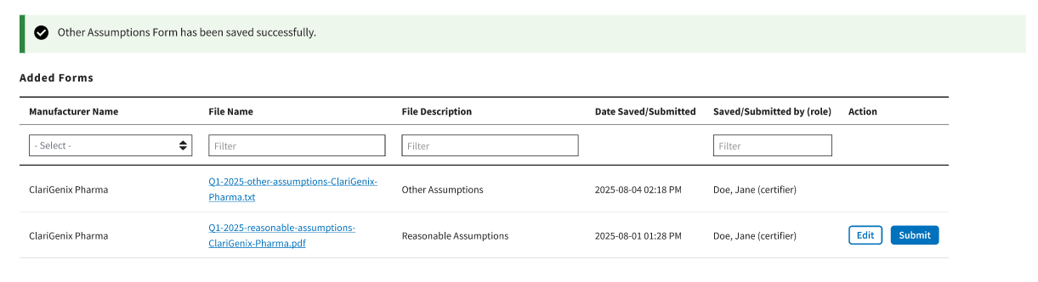
Figure 30: Other Assumptions Saved Successfully

Upload Assumption File
Follow these steps to upload an assumption file to the Module:
- Click the Other Assumptions (Optional) file tab.
The Create Assumption or Upload Assumption File window displays. The Module automatically defaults to the Create Assumption radio button.
- Select the Upload Assumption File radio button.
A Manufacturer Name (required) drop-down menu and empty File Description (required) field display. Refer to Figure 31.
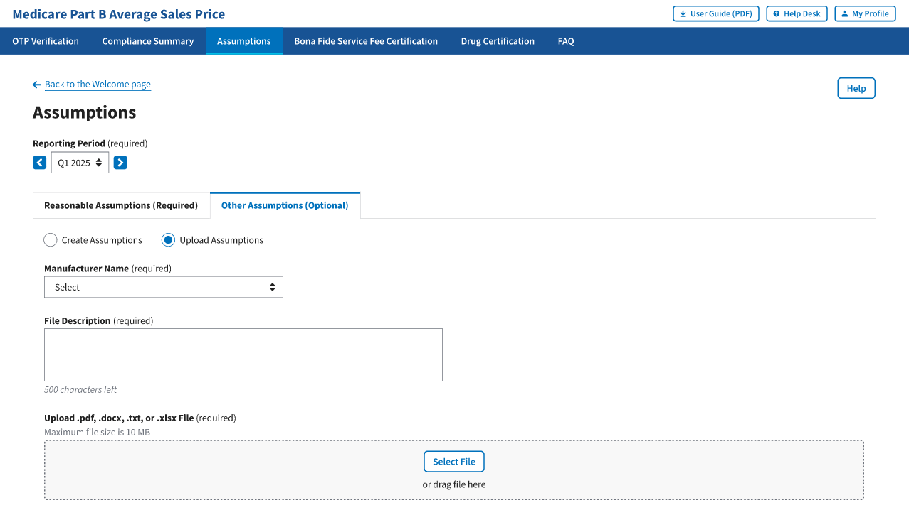

Figure 31: Upload Assumptions
- From the Manufacturer Name (required) drop-down menu, click the -Select- drop-down menu to expand the list and select the manufacturer name.

- In the File Description field, enter your assumption about a data submission. You have 500 characters of total text to comment about your submission in this section.

- Click Select File to browse your desktop and upload your Assumption File to the Module. You may also drag your Assumption File into the Select File box. A message opens to confirm you have successfully uploaded your assumption file. Refer to Figure 34.

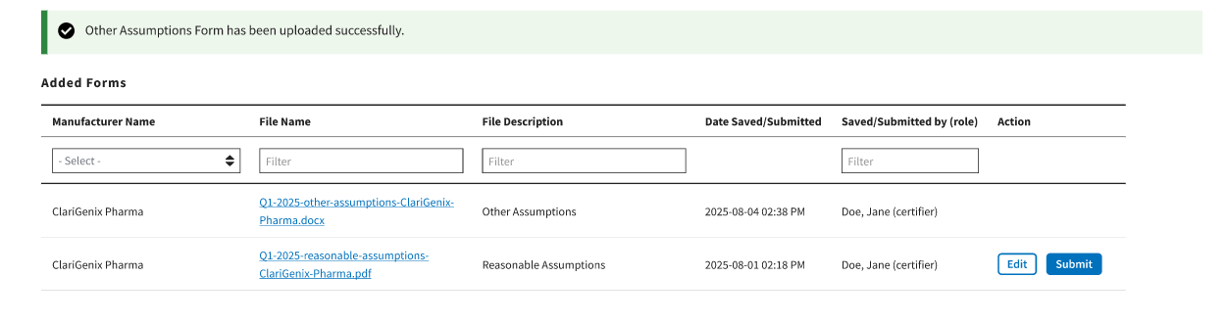
Figure 34: Upload Assumption File - Successfully Added

Bona Fide Service Fee Certification
Follow these steps to submit a Bona Fide Service Fee Certification to CMS:
- From the Medicare Part B Average Sales Price homepage, click the Bona Fide Service Fee Certification tab. The Bona Fide Service Fee Certification page opens and defaults to the current quarter and year. Refer to Figure 35.

- The Module automatically defaults to the current reporting period. Select the accurate reporting period before proceeding.

- Select the Manufacturer Name in the drop-down menu.

- Download, complete, and sign the Bona Fide Service Fee Certification Form.

The fields to complete are as follows:

Section 1: Enter all drug and manufacturer information associated with the bona fide service fee
- Drug Name(s):
- HCPCS code(s):
- Manufacturer name:
- Manufacturer address:

Section 2: Recipient of BFSF information
- Name and title of certifying individual:
- Organization or entity name:
- Organization or entity address:
- Bona fide service:
- Bona fide service fee amount (if the fee varies based on certain metrics, describe the conditions of the fee and how it is determined):

Section 3.: Certification Statement
- I certify that the fee is not passed on in whole or in part to an affiliate, client, or customer of an entity.
- Manufacturer Signature:
- Fee Recipient Signature:

- Save the completed form to your computer. Upload the form once completed.
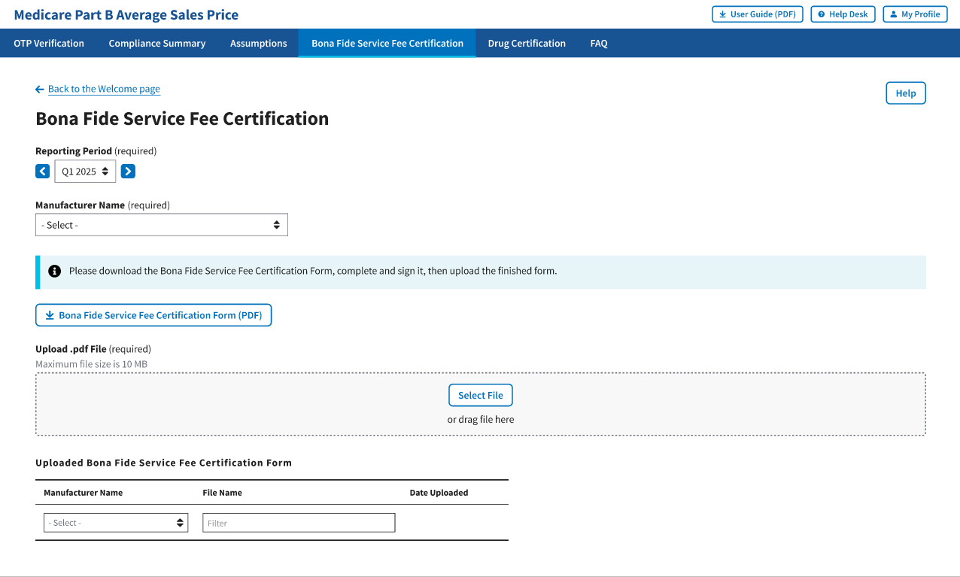
Figure 35: Bona Fide Service Fee Certification Submission

Drug Certification
Drug certification is the process in which a drug manufacturer certifies the accuracy of submitted drug data. This process marks data for immediate certification or pending certification to be completed later. Selection may include one drug product item, a list of drugs, or all items pending certification for a manufacturer.
The Submitter gathers the required quarterly drug data and submits it to the Module. Once the Submitter has successfully submitted the data, they will notify the Certifier to log in to the system to review and certify their submission.
Follow these steps to certify drug product data:
- From the Medicare Part B Average Sales Price homepage, select Drug Certification tab from the Certification tab. Refer to Figure 30.
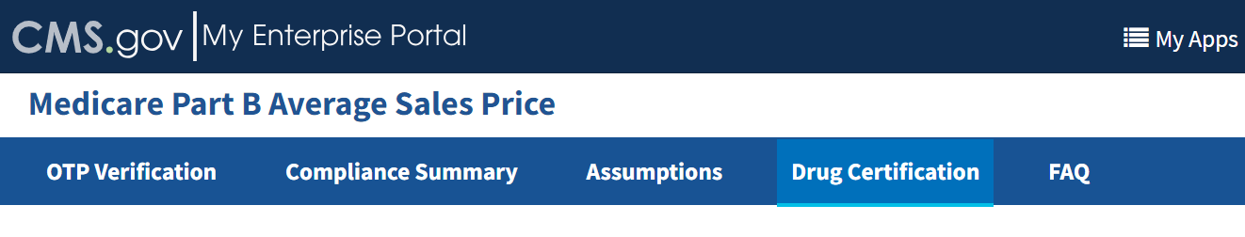
Figure 36: Certification - Drop-down
The Drug Certification page opens. Refer to Figure 31.
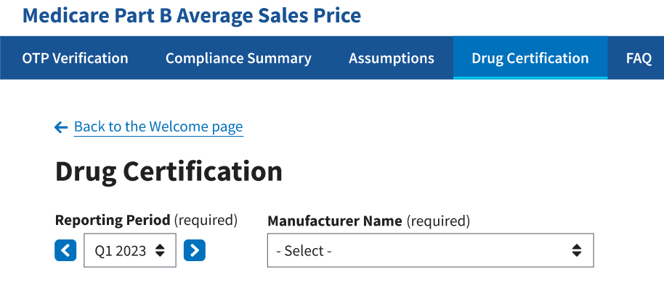
Figure 37: Drug Certification
Note: Click the Reporting Period (required) tab in the top left to scroll through previous quarters. Use the drop-down menu to navigate to a previous quarter starting with the most recent quarter.
- Click the -Select- box under Manufacturer Name (required) to expand the list. Refer to Figure 32.
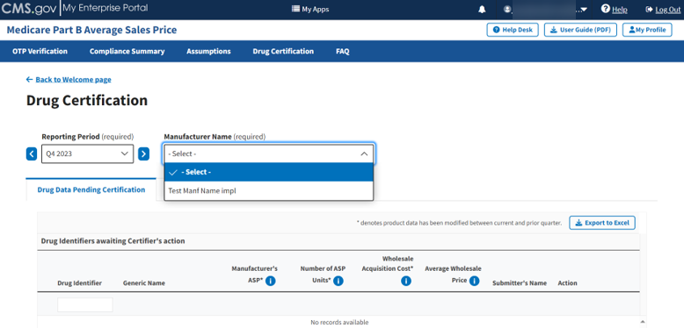
Figure 38: Drug Certification - Manufacturer Name
- Select the appropriate manufacturer name.
The page displays two new radio buttons asking you to confirm if you are certifying as a direct employee or contractor. Refer to Figure 33.
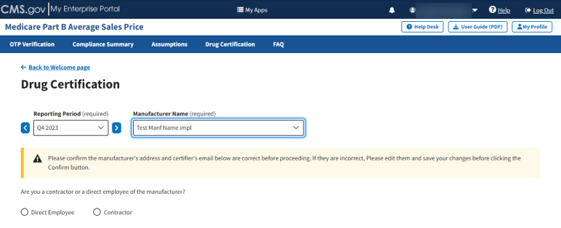
Figure 39: Drug Certification - Direct Employee or Contractor
Note: In the updated ASP Data Collection System, CMS requests verification of your contact information prior to certifying data.
The following sections describe how to complete the drug certification process as a direct employee or contractor.

Direct Employee
Follow these steps to complete the drug certification process as a direct employee:
- Click the Direct Employee radio button.
New fields display asking for more information about the manufacturer’s address and contact information.
- Enter or select the required information as follows:
- Enter the street address in the Street Address (required) field.
- Enter the street address in the Street Address Line 2 (optional) field, if necessary.
- Enter the city in the City (required) field.
- Enter the state in the State (required) field.
- Enter the ZIP code in the ZIP Code (required) field.
- Enter the name in the Name (required) field.
- Enter the email address in the Email Address (required) field.
- Enter the phone number in the Phone Number (required) field.
- Click the Edit button under Manufacturer’s Address and Certifier’s Contact Info if you need to correct information already populated in a field. Refer to Figure 34.
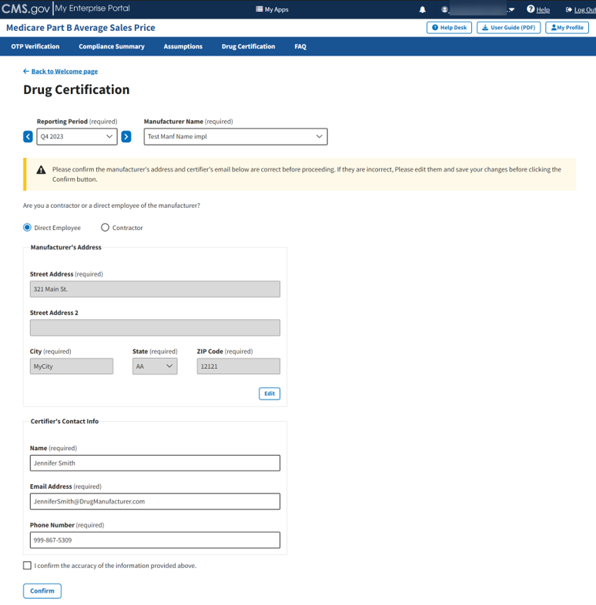
Figure 40: Drug Certification - Direct Employee - Fields Populated
- Once you complete the fields, select the I confirm the accuracy of the information provided above checkbox; click Confirm and Save.
A message displays confirming you have successfully confirmed the manufacturer’s address and certifier’s email address. Refer to Figure 35.
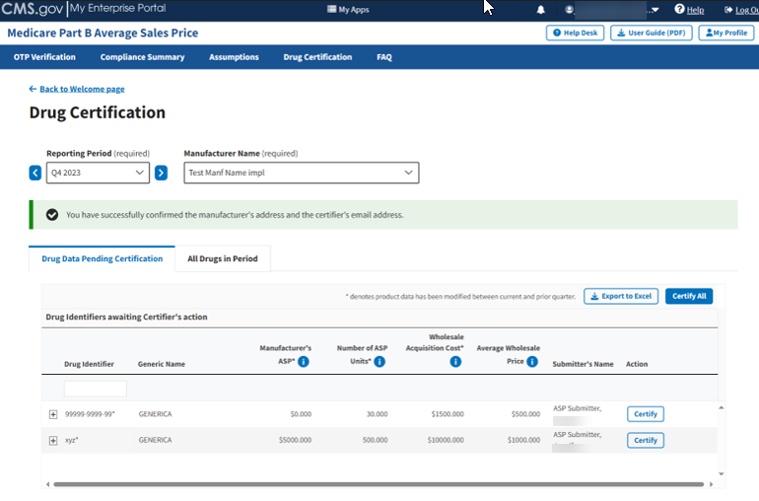
Figure 41: Drug Certification - Direct Employee Confirmation

Contractor
Follow these steps to complete the drug certification process as a contractor:
- Click the Contractor radio button.
New fields display asking for more information about the manufacturer’s address, your manufacturer’s point of contact (POC), and your contact information.
- Enter or select the required information as follows:
- Enter the street address in the Street Address (required) field.
- Enter the street address in the Street Address Line 2 (optional) field, if necessary.
- Enter the city in the City (required) field.
- Enter the state in the State (required) field.
- Enter the ZIP code in the ZIP Code (required) field.
- Enter the point of contact name in the Point of Contact’s Name (required) field.
- Enter the point of contact email address in the Point of Contact’s Email Address (required) field.
- Enter the point of contact phone number in the Point of Contact’s Phone Number (required) field.
- Enter the certifier name in the Certifier’s Name (required) field.
- Enter the certifier email address in the Certifier’s Email Address (required) field.
- Enter the certifier phone number in the Certifier’s Phone Number (required) field.
- Click the Edit button under Manufacturer’s Address, Point of Contact Info, and Certifier’s Contact Info if you need to correct information already populated in a field. Refer to Figure 36.
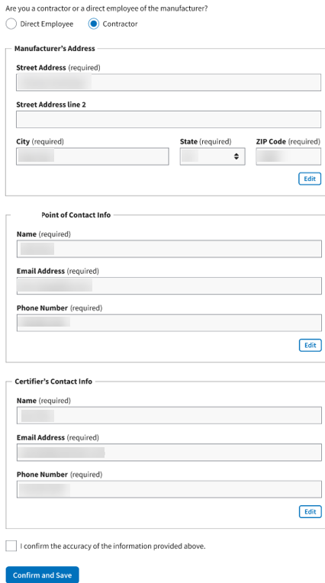
Figure 42: Drug Certification - Contractor - Fields Populated
- Once you complete the fields, select the I confirm the accuracy of the information provided above checkbox; click Confirm and Save.
A message displays confirming you have successfully confirmed the manufacturer’s address and certifier’s email address. Refer to Figure 37.
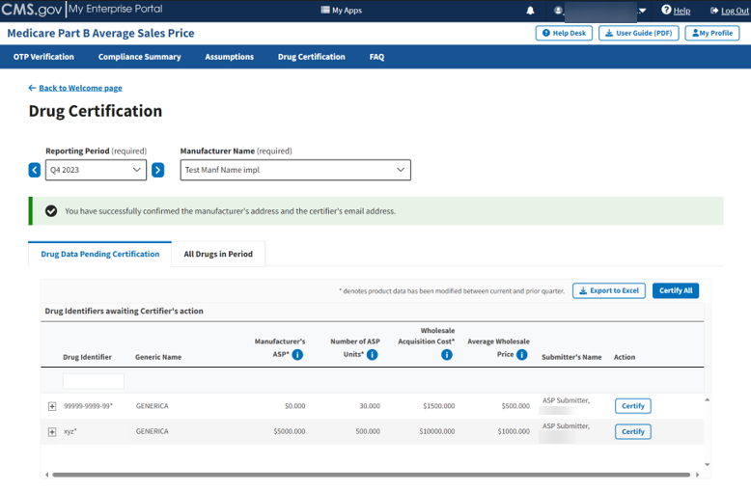
Figure 43: Drug Certification - Contractor Confirmation

Drug Data Pending Certification
Follow these steps to complete the drug data certification process and certify your products:
- Confirm that your preferred drug product is selected under Manufacturer Name (required) field on the Drug Certification homepage. Refer to Figure 37 and Figure 38.
Note: Click the Reporting Period (required) tab in the top left to scroll through previous quarters. Use the drop-down to navigate to a previous quarter starting with the most recent quarter.
The Module displays the Drug Data Pending Certification tab by default. (Click the tab if the Module does not automatically open the page to the default setting.)
This page also lists all drug products by Drug Identifier and Generic Name as well as Manufacturer’s ASP, Number of ASP Units, Wholesale Acquisition Cost, Average Wholesale Price, and Action. Refer to Figure 38.
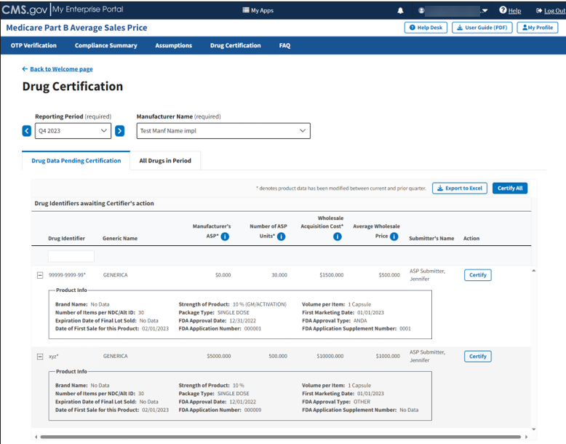
Figure 44: Drug Data Pending Certification
Note: Click the Export to Excel box to download the information on this page into an Excel file.
- Click the plus symbol on each row of the table to expand each product’s information and view additional drug product fields, such as Brand Name, First Marketing Date, Volume per Item, and all other information the Submitter previously reported. Refer to Figure 38.
- Select the drug product and click the Certify box to open a new Data Certification Statement. Refer to Figure 39.
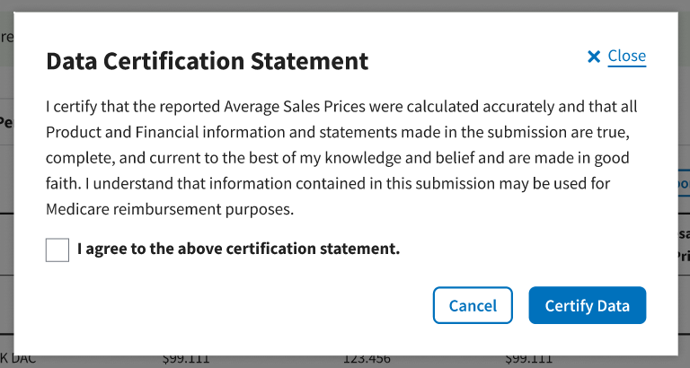
Figure 45: Data Certification Statement
- Read the statement; select the I agree to the above certification statement checkbox and select Certify Data to confirm approval of the submitted data.
A message displays confirming you have successfully certified the drug data. Refer to Figure 40.
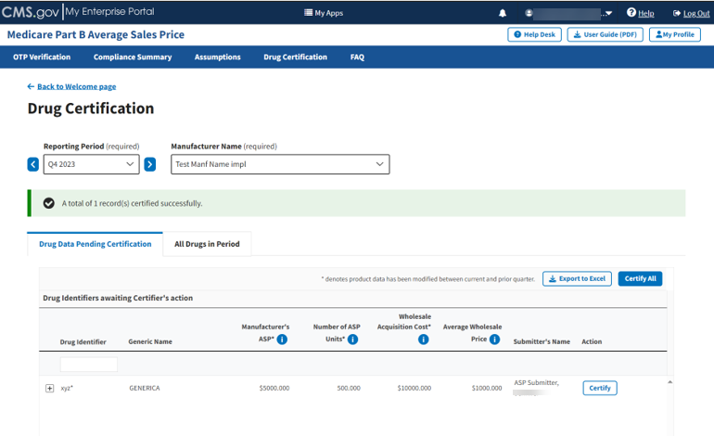
Figure 46: Data Certification - Confirmation Message
Note: Click the Export to Excel box to download the information on this page into an Excel file.
- Continue this process for each individual drug product until all your products have been certified. Click Certify All to certify all products at the same time.

All Drugs in Period
Follow these steps to review all drug products and biologicals for the current reporting period:
- From the Drug Certification homepage, click the All Drugs in Period tab.
The All Drugs in Period page opens. Refer to Figure 41.
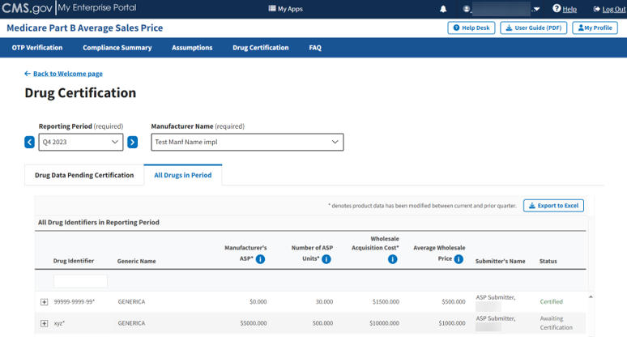
Figure 47: Drug Certification - All Drugs in Period
This page lists all drug products the Submitter entered for the current reporting period. The Module organizes the full list by Drug Identifier and Generic Name, the Manufacturer’s ASP, the Number of ASP Units, the Wholesale Acquisition Cost, the Average Wholesale Price, and Status.
Note: Click the Export to Excel box to download the information on this page into an Excel file.
- Click the plus symbol on each row of the table to expand each product’s information and view additional Drug Product data fields, such as Brand Name, First Marketing Date, Volume per Item, and all other information the Submitter previously reported.
- Review the information for accuracy.
- Return to the Compliance Summary tab to review your certified products after they have undergone drug certification. Refer to Section 3.2.3 - Certified.

Technical Support Contact Information
Contact the FFSDCS (ASP) Application Helpdesk for issues such as:
- Account unlock
- Password reset
- Registration process questions
- System availability escalations
Table 1 provides contact information for technical support.
Table 1: Technical Support Contacts
Email Address | Phone Number | Hours
ASPHelpDesk@dcca.com | 1-844-876-0765 | 9:00 a.m. to 6:00 p.m. Eastern Standard Time (EST), Monday through Friday

Appendix A: Field Definitions
Table 2 provides an overview of field definitions for this document.
Table 2: Field Definitions
Column/Field Name | Format | Allowed/Sample Values | Required/Optional | Notes
Manufacturer Name | Alphanumeric | Maximum of 250 characters | Required | - When entering product data for the same Manufacturer more than once, be sure the spelling matches.  - Special characters (comma, dash, period) allowed.
NDC1 | 5-digit number | e.g., 12345 | Required | - First segment of the National Drug Code (NDC) that identifies the labeler. Products that do not have an NDC should only use the Alternate ID column.  - Not required if the product has an Alternate ID.  - Leading zero allowed.
NDC2 | 4-digit number | e.g., 1234 | Required | - Not required if the product has an Alternate ID.  - The NDC2 is the sixth through the ninth digits of the 11-digit NDC that identifies the product.
NDC3 | 2-digit number | e.g., 12 | Required | - Not required if the product has an Alternate ID.  - The NDC3 is the last two digits of the 11-digit NDC that identify the package size.
Alternate ID | alphanumeric | maximum of 23 characters | Required | - Not required if the product has an NDC. Must match product ID exactly as listed publicly on the manufacturer’s website.  - Special characters (colon, dash, period) allowed.
Alternate ID Website URL | NA | e.g., http://www.medicare.gov | NA | Must have http:// or https:// prefix.
Brand Name | Alphanumeric | Maximum of 250 characters | Optional | Enter strength and package size in their respective fields unless it is a part of the registered brand name.
Generic Name | Alphanumeric | Maximum of 250 characters | Required | Refer to valid values in Generic Name.
Volume Per Item | Numeric | NA | Required | For Alternate ID, report the volume amount in one item. (For instance, enter 10 for 10 ml in one vial, and enter 1 for powders, sheets, or patches.)
Unit for Volume per Item | NA | NA | NA | See valid value in Unit of Volume per Item. For example, for Alternate ID, select EACH for powders, sheets, or patches.
Number of Items Per NDC or Alternate ID | Numeric | Maximum of 9 digits and 2 decimal places | Required | - For NDCs: Indicates the number units within the NDC package (for instance, enter 5 for 5 vials in a package).  - For Alternate IDs: Indicates the number of units within the Alternate ID. (for instance, enter 5 for 5 grafts in a package).
Package Type | Alphanumeric | 2 characters | Required | Enter SD, MD, or NA. (SD = Single dose, MD = Multi dose, NA = Not Applicable)
Strength | Numeric | e.g., 300 | Required | NA
Unit for Strength | NA | NA | NA | See valid values in Unit for Strength
FDA Application Number/Registration Number | Alphanumeric | Maximum of 6 characters | Required | - Enter FDA Application Number for NDCs and Registration Number for Alternate IDs.  - Enter Facility Registration Number for Human Cells, Tissues, and Cellular and Tissue-Based Products (HCT/Ps).
FDA Application Supplement Number | Alphanumeric | Maximum of 9 characters | Optional | NA
Additional FDA Application Number #1 | Alphanumeric | Maximum of 6 characters | Optional | NA
Additional FDA Application Supplement Number #1 | Alphanumeric | Maximum of 9 characters | Optional | NA
Additional FDA Application Number #2 | Alphanumeric | Maximum of 6 characters | Optional | NA
Additional FDA Application Supplement Number #2 | Alphanumeric | Maximum of 9 characters | Optional | NA
FDA Approval/Registration Date | MM/DD/YYYY | e.g., 01/01/2023 | Required | Must be prior to the current submission period start date.
FDA Approval Type | NA | NA | Required | Refer to valid values in FDA Approval Type.
First Marketing Date | MM/DD/YYYY | e.g., 01/01/2023 | Required | - Must be on or after the FDA Approval Date.  - Must be prior to the current submission period start date. If the date is after the current submission period start date, it must be submitted as an off-cycle submission.  - NDC: For drugs marketed under an FDA-approved application (e.g., Abbreviated New Drug Application (ANDA), Biologics License Application (BLA), New Drug Application (NDA)), the earliest date the drug was first marketed under the application number by any labeler. If a drug was purchased or otherwise acquired from another labeler, the First Marketing Date should be equal to the First Marketing Date of the original product.
First Marketing Date (continued) | MM/DD/YYYY | e.g., 01/01/2023 | Required | - Alternate ID: For products marketed under an FDA-approved application/registration (e.g., 510(k), HCT/P, Premarket Approval (PMA)), the earliest date the product was first marketed under the application/registration number by any labeler. If a product was purchased or otherwise acquired from another labeler, the date should be equal to the First Marketing Date of the original product.
Date of First Sale for this Product | MM/DD/YYYY | e.g., 01/01/2023 | Required | - Must be after the First Marketing Date.  - Must be prior to the current submission reporting period start date unless it is an off-cycle submission.  - NDC: The date of first sale of individual NDCs.  - Alternate ID: The date of first sale of individual Alternate IDs.

Appendix B: Revision History
Table 3 provides a revision history for this document.
Table 3: Revision History
Version Number | Date | Author/Editor | Description of Change
1.0 | 03/15/2024 | Index Analytics/DCCA | Initial version of ASP Data Collection System Certifier User Guide
2.0 | 08/08/2025 | Index Analytics/DCCA | - Updated Figure 9 and Figure 12 based on updates to the ASP Data Collection System.  - Made various font, grammatical, punctuation, shading, formatting, date, version, pagination, glossary, and alignment corrections.

Appendix C: Glossary
Table 4 presents a list of terms, acronyms, and definitions in this document.
Table 4: Glossary
Expanded Form | Acronym/Term | Definition
510(k) | NA | A 510(k) submission is the mechanism through which the majority of medical devices obtain U.S. marketing clearance. Such devices include catheters, contact lenses, and absorbable sutures.
Abbreviated New Drug Application | ANDA | An ANDA is an application for a U.S. generic drug approval for an existing licensed medication or approved drug. Authorized generics do not require ANDAs.
Average Sales Price | ASP | ASP refers to the price at which an organization typically sells a certain class of good or service. CMS uses manufacturer-reported ASPs, based on manufacturers’ actual quarterly drug sales, to calculate provider payment amounts for these drugs. Federal law defines the price.
Biologics License Application | BLA | A BLA is used to request permission to introduce or deliver a biologic product into interstate commerce.
Center for Medicare Management | CMM | The CMM oversees the fee-for-service Medicare program.
Centers for Medicare & Medicaid Services | CMS | CMS is a federal agency within the U.S. Department of Health and Human Services that administers the Medicare program and works in partnership with state governments to administer Medicaid, the State Children’s Health Insurance Program, and health insurance portability standards.
Consolidated Appropriations Act, 2021 | CAA | The CAA establishes protections for consumers related to surprise billing and transparency in health care. The No Surprises Act (NSA) is part of the CAA.
Eastern Standard Time | EST | EST is the standard time in the 5th time zone west of Greenwich, reckoned at the 75th meridian. This time zone is in the eastern part of the United States.
Fee-for-Service Data Collection System | FFSDCS | The FFSDCS is an instrument to collect cost, revenue, utilization, and other information for FFS claims.
Human Cells, Tissues, and Cellular Products | HCT/P | HCT/Ps include human cells or tissue intended for implantation, transplantation, infusion, or transfer into a human recipient. The FDA Center for Biologics Evaluation and Research (CBER) regulates HCT/Ps.
Interactive Voice Response | IVR | IVR is a technology that allows a computer to detect voice and DTMF keypad inputs.
Medicare | NA | Medicare is the federal system of health insurance for people over 65 years of age and for certain younger people with disabilities.
Medicare Part B | NA | Medicare Part B is the part of Medicare that covers doctor services, outpatient hospital care, and other medical services that Part A does not cover such as physical and occupational therapy, X-rays, medical equipment, or limited ambulance service.
Multifactor Authentication | MFA | MFA is a security system that implements more than one form of authentication to verify the legitimacy of a transaction.
National Drug Code | NDC | The NDC is a code set that identifies the vendor (manufacturer), product, and package size of all drugs and biologics the FDA recognizes.
New Drug Application | NDA | An NDA is the vehicle through which drug sponsors formally propose that the FDA approve a new pharmaceutical drug for sale and marketing.
Okta | NA | Okta is an enterprise-grade, identity management service, built for the cloud, but compatible with many on-premises applications.
One-Time Password | OTP | An OTP is a password that is valid for only one login session or transaction.
Point of Contact | POC | The POC identifies the key person or group serving as the coordinator on a given project.
Premarket Approval | PMA | PMA is the FDA process of scientific and regulatory review to evaluate the safety and effectiveness of Class III medical devices. Such devices include implants, ventilators, and pacemakers.
Short Message Service | SMS | SMS is a text messaging service component of phone, web, or mobile communication systems. It uses standardized communication protocols to allow fixed-line or mobile phone devices to exchange short text messages.
Social Security Act | SSA | The SSA is a law that provides income to retired workers aged 65 or older.

Appendix D: Figures and Tables
List of Figures
Figure 1: Logging in Using MFA - ASP Module Login 2
Figure 2: Logging in Using MFA - Select MFA Device Type Drop-Down 3
Figure 3: Logging in Using MFA - Multi-Factor Authentication - (IVR) Example 4
Figure 4: Logging in Using MFA - Multi-Factor Authentication - Verify MFA Code 5
Figure 5: My Portal Landing Page 6
Figure 6: My Portal Landing Page - FFSDCS Drop-down 6
Figure 7: ASP Data for Drugs and Biologics Under Medicare Part B 7
Figure 8: Medicare Part B Average Sales Price Homepage 8
Figure 9: OTP Verification 9
Figure 10: OTP Verification - Manufacturer Name 10
Figure 11: OTP Verification - OTP Provided by Your Data Submitter 10
Figure 12: OTP Verification Successful 11
Figure 13: Compliance Summary 12
Figure 14: Compliance Summary - All Pending Certification 13
Figure 15: Compliance Summary - Pending Certification 14
Figure 16: Compliance Summary - Pending Restatement Certification 15
Figure 17: Compliance Summary - Certified 16
Figure 18: Compliance Summary - Certified 17
Figure 19: Compliance Summary - Restated and Certified 18
Figure 20: Compliance Summary - New 19
Figure 21: Compliance Summary - Off Cycle 20
Figure 22: Compliance Summary - Expired 21
Figure 23: Assumptions 22
Figure 24: Assumptions - Create Assumption or Upload Assumption File 23
Figure 25: New Assumption Successfully Created 24
Figure 26: Upload Assumption File 25
Figure 27: Upload Assumption File - Expanded Fields 26
Figure 28: Upload Assumption File - Uploading Files From Desktop 27
Figure 29: Upload Assumption File - Successfully Added 27
Figure 30: Certification - Drop-down 28
Figure 31: Drug Certification 28
Figure 32: Drug Certification - Manufacturer Name 29
Figure 33: Drug Certification - Direct Employee or Contractor 29
Figure 34: Drug Certification - Direct Employee - Fields Populated 31
Figure 35: Drug Certification - Direct Employee Confirmation 32
Figure 36: Drug Certification - Contractor - Fields Populated 33
Figure 37: Drug Certification - Contractor Confirmation 34
Figure 38: Drug Data Pending Certification 35
Figure 39: Data Certification Statement 36
Figure 40: Data Certification - Confirmation Message 37
Figure 41: Drug Certification - All Drugs in Period 38

List of Tables
Table 1: Technical Support Contacts 39
Table 2: Field Definitions 40
Table 3: Revision History 44
Table 4: Glossary 45

