
Medicare Part B Average Sales Price (ASP) Module

Registration Guide
Version 2.0
Date: August 29, 2025
Table of Contents
1. Purpose 1
2. New User Registration 1
3. Logging in Using MFA 7
4. Select User Role/Application Request 11
5. Technical Support Contact Information 18
Appendix A: Revision History 19
Appendix B: Glossary 20
Appendix C: Figures and Tables 22

Purpose
The purpose of this user guide is to provide instructions for registering as a new user in the Centers for Medicare & Medicaid Services (CMS) Identity Management (IDM) system to request access to the Fee-for-Service Data Collection System (FFSDCS) Average Sales Price (ASP) Module.
CMS requires an automated data collection system that can collect and synthesize large amounts of data related to products falling under the Fee-for-Service (FFS) payment mechanisms.
CMS supplies the Medicare FFS claims processing contractors with the drug pricing files for Medicare Part B. CMS uses the FFSDCS to house various FFS platforms, including the ASP Module.
Before you can log in to any FFSDCS Module, you must verify your identity through the IDM portal and then create a new user account in the FFSDCS Module. All FFSDCS Module users, regardless of their role, must complete the new user registration steps in the following section.

New User Registration
You must have an IDM username and password to access the ASP Module.
Note: CMS uses Experian as their external authentication service provider for identity verification purposes only; credit is not a factor in the authentication process.
Follow these steps to register with IDM and receive your credentials:
- Navigate to the CMS Enterprise Portal main page.
The FFSDCS Module Login Page opens. Refer to Figure 1.
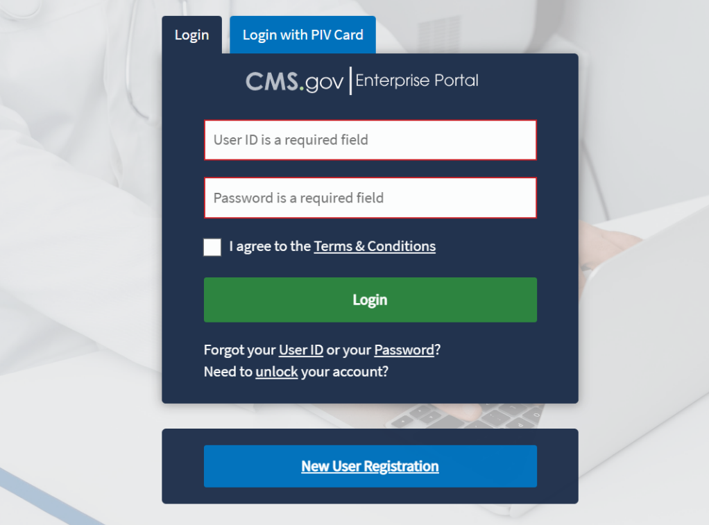
Figure 1: CMS Enterprise Portal - Login Page
- Click the New User Registration button.
The Select Your Application page opens. Refer to Figure 2.
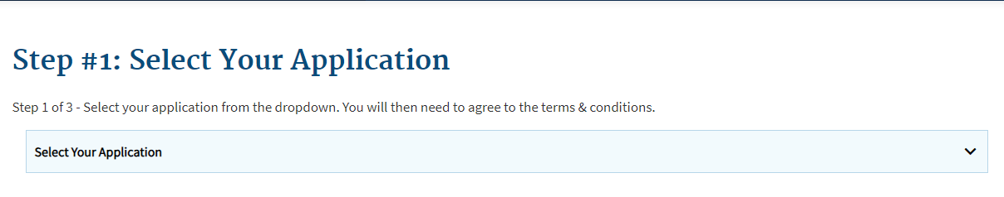
Figure 2: New User Registration - Select Your Application Drop-down
- Click the Select Your Application drop-down; select FFSDCS from the list of applications.
The Step #1: Terms and Conditions page opens. Refer to Figure 3.
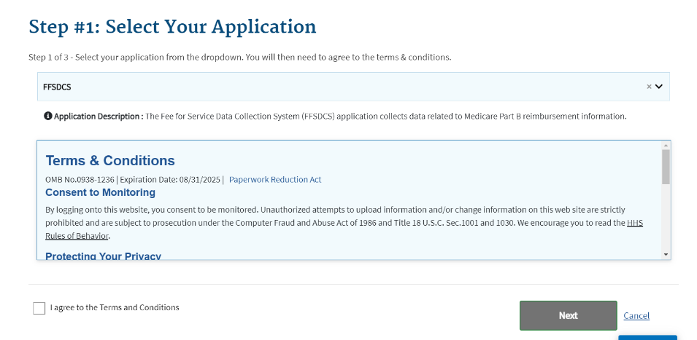
Figure 3: New User Registration - Terms & Conditions
- Read the Terms & Conditions. If you agree, select the I agree to the Terms & Conditions checkbox; click Next.
Note: By selecting this checkbox, you certify that you read and consent to monitoring while accessing and using the portal. The terms and conditions describe why the application collects personally identifiable information (PII), which is to identify the unique, new user who is registering to use the application.
The terms and conditions link provides additional hyperlinks to the HHS Rules of Behavior and the CMS Privacy Act Statement.
The Step #2: Register Your Information page opens. Refer to Figure 4.
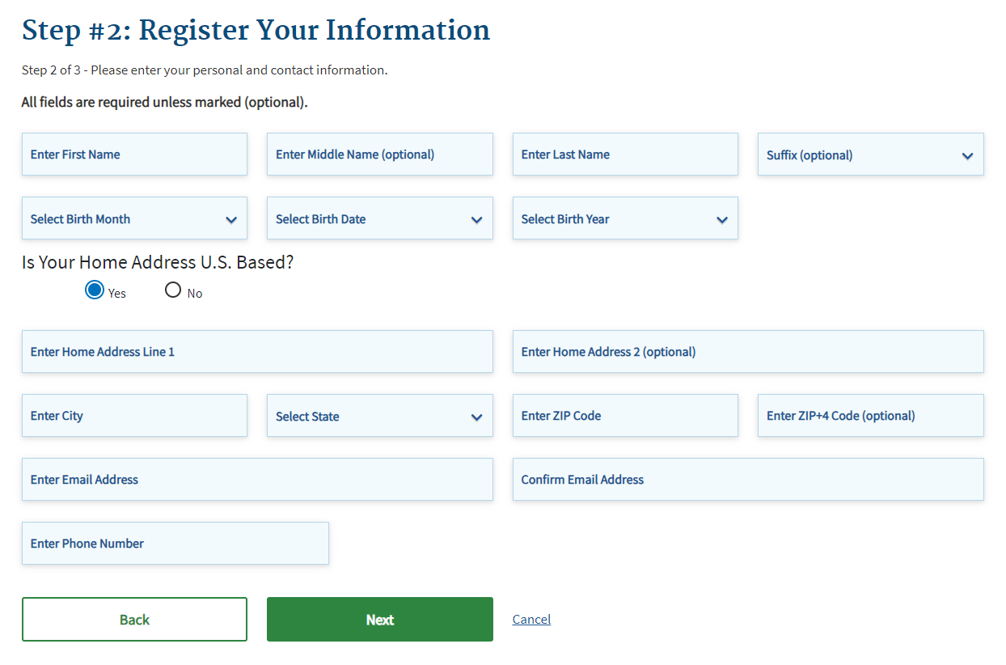
Figure 4: New User Registration - Step #2 Register Your Information
- Enter your personal information in each of the required fields; click Next.
Note: The application requires you to complete all fields unless marked as optional. The information you provide should be your personal information for identity verification purposes. You can update your contact information to business information, if needed, after the system confirms your identity.
The Step #3: Create User ID, Password & Security Question/Answer page opens. Refer to Figure 5.
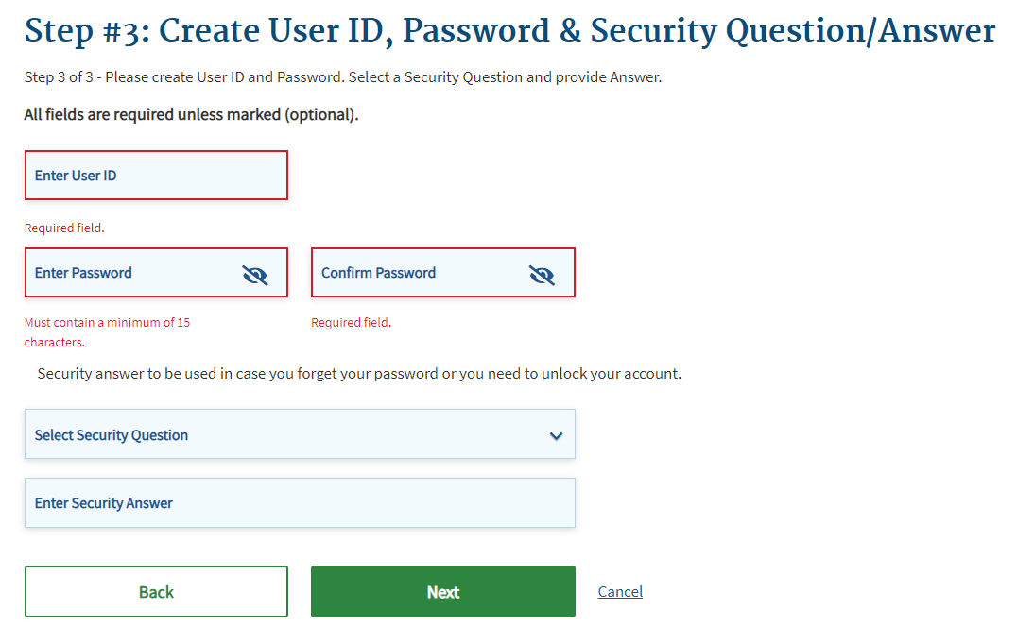
Figure 5: New User Registration - Step #3 Create User ID & Password
- Type your desired user identification in the User ID field.
Note: Per the User ID Requirements, your user ID must:
- Consist of a minimum of six (6) alphanumeric characters and cannot exceed seventy-four (74) characters.
- Contain at least one (1) uppercase or lowercase letter.
- Contain one (1) special character. You may use hyphens (-), underscores (_), apostrophes (‘), and periods (.).
- Not have a special character as the first or last letter of your user ID.
- Not contain eight (8) consecutive numbers.

- Type your desired password in the Password field; then re-type your password in the Confirm Password field. Passwords must match before you move onto the next step.
Note: Your password must conform to the CMS Acceptable Risk Safeguards (ARS) Password Policy. You may only change your password once every 24 hours. Per the password policy, your password must:
- Consist of a minimum of fifteen (15) alphanumeric characters and cannot exceed sixty (60) characters.
- Contain at least one (1) uppercase and one (1) lowercase letter.
- Contain at least one (1) number.
- Not contain part of your user ID, first name, last name, or common passwords.
- Be different from your previous six (6) passwords.
Note: Special characters are optional in your password. The system accepts the following special characters: (‘), (“), (!), (#), ($), (%), (&), ((), ()), (*), (+), (,), (-), (.), (/), (:), (;), (<), (>), (=), (?), (@), ([), (]), (^), (_), (`), (~).
- Select a security question from the Security Question drop-down; enter your answer in the Security Answer field. Refer to Figure 6.
Note: The system requires your security answer to reset your password or unlock your account. Per the security answer requirements, your security answers:
- Must contain at least four (4) alphanumeric characters.
- Cannot contain part of your security question.
- Can contain spaces.
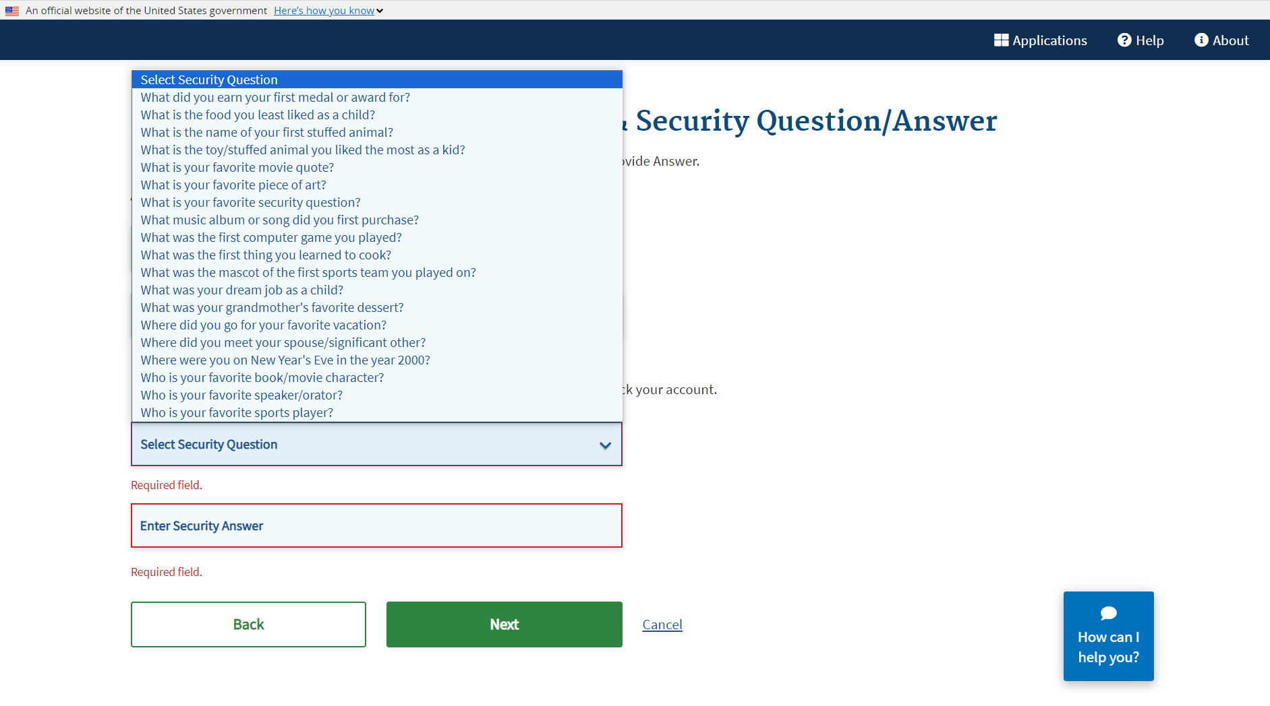
Figure 6: New User Registration - Security Question/Answer Page
- Click Next to complete the registration process.
The New User Registration Summary page opens. Refer to Figure 7.
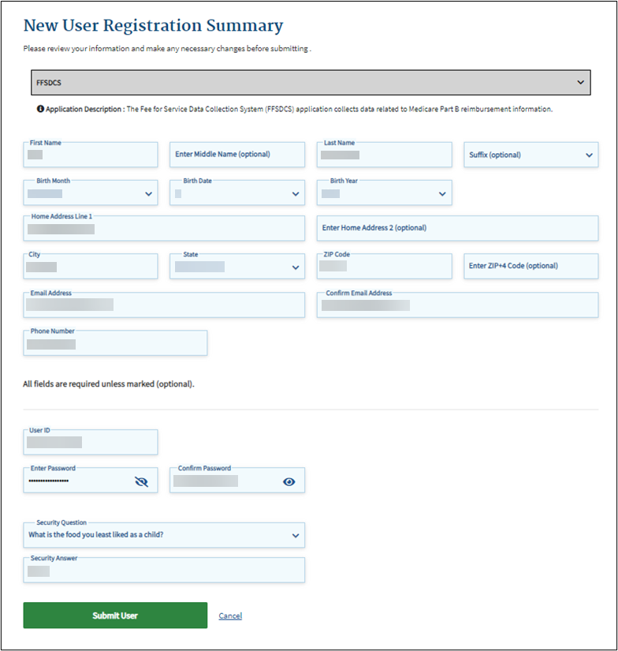
Figure 7: New User Registration - Summary
Note: You may click the Cancel button to exit out of the registration process; however, the system does not save any of the changes you entered.
- Review the New User Registration Summary page; make necessary changes.
- Click the Submit User button to complete the registration process.
A Confirmation message displays. Refer to Figure 8.
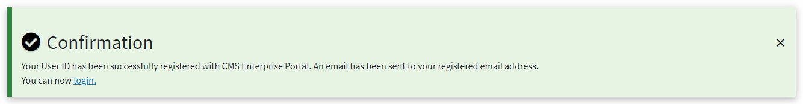
Figure 8: New User Registration Confirmation
- Click the login hyperlink to return to the main login page.
Note: Wait at least five minutes before logging in to the FFSDCS Module with your new User ID and Password.

Logging in Using MFA
Following registration, use these steps to log in to the FFSDCS Module:
- Navigate to the CMS Enterprise Portal main page.
The FFSDCS Module Login Page opens. Refer to Figure 9.
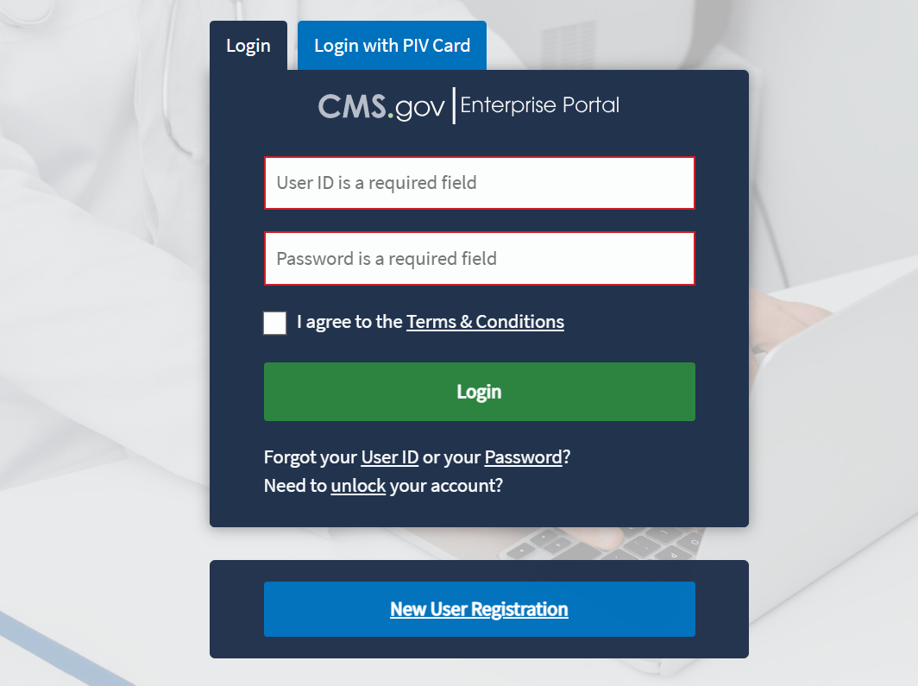
Figure 9: Logging in Using MFA - FFSDCS Module Login Page
- Type your user ID and password in the User ID and Password fields.
- Click the Terms & Conditions hyperlink and review the text in the pop-up window; close the window.
- Read the terms and conditions. If you agree, select the I agree to the Terms & Conditions checkbox.
Note: By selecting this checkbox, you certify that you read and consent to monitoring while accessing and using the portal. Additionally, the terms and conditions provide hyperlinks to the HHS Rules of Behavior and the CMS Privacy Act Statement.
- Click Login.
Note: If you forget your user ID or password, click the appropriate hyperlinked text in Forgot your User ID or your Password? under the Login button and follow the provided instructions. If you are still not able to access your account and need to unlock your account, click the hyperlinked unlock text under Need to unlock your account?
To confirm the security of the FFSDCS Module, as well as your data, you must authenticate your identity using a multifactor authentication (MFA) process. Users have various authentication options, including Interactive Voice Response (IVR), Email, Text Message (Short Message Service (SMS)), or Okta Verify.
- Click the Select MFA Device drop-down; select your preferred MFA device type from the list. Whenever you log back into the ASP Module through this process, your preferred method of MFA reloads automatically. Refer to Figure 10.
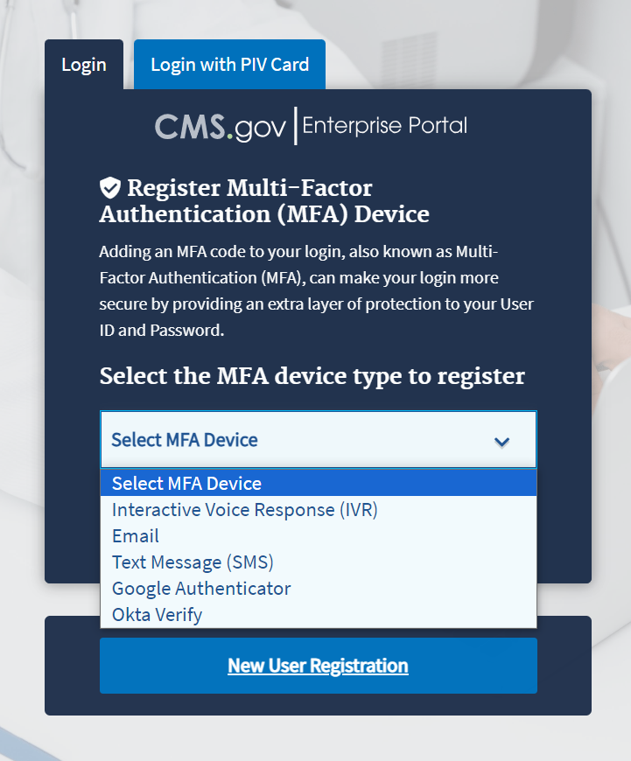
Figure 10: Logging in Using MFA - Select MFA Device Type Drop-Down
- Click the Send MFA Code green button to receive a one-time phone call, email, text message, or other communication to confirm registration of your identity with the FFSDCS Module. This user guide demonstrates email as the chosen MFA method. Refer to Figure 11.
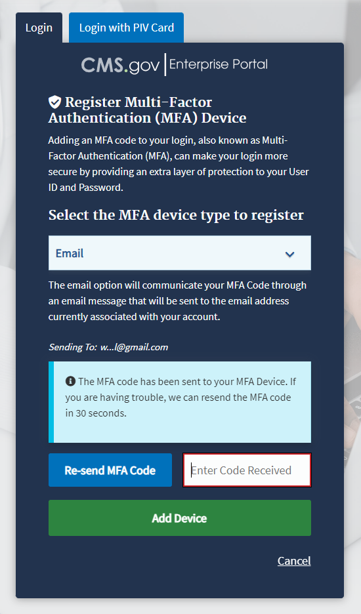
Figure 11: Logging in Using MFA - MFA Code
The Module sends an email with a six-digit code to confirm your identity. Refer to Figure 12.
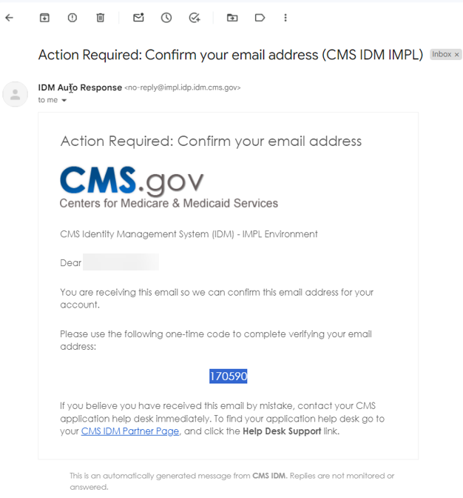
Figure 12: Logging in Using MFA - Confirmation Code in Email
- Record and type the six-digit code into the Enter MFA Code field. Click the Add Device button to confirm your identity and enter the FFSDCS Module.
The My Portal landing page opens, displaying a Welcome to CMS Enterprise Portal message. Refer to Figure 13.
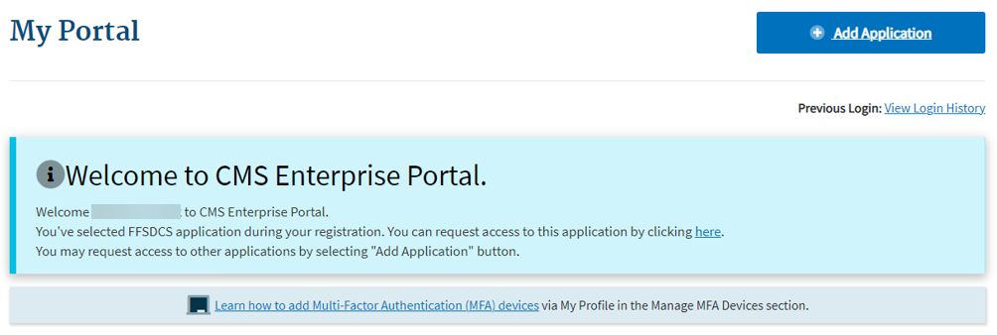
Figure 13: Logging in Using MFA - My Portal Landing Page

Select User Role/Application Request
The Medicare ASP Data Collection System is a role-based system. This means that certain system functions link to specific user role profiles. When a new user receives access, the approved role provides access to the specific functions the user needs.
As noted above, the two roles are:
Submitter: This role is designated for the person who gathers the required Medicare Part B drug data to enter and submit into the system. Once this person has completed and submitted the data, they generate a one-time password (OTP) to send to the Certifier to establish a relationship within the system. This step only happens once to initiate the relationship and only needs to happen again if the person in either role changes. A Submitter can be any individual the manufacturer chooses, including a third-party contractor.
Certifier: This role is designated for the person who reviews the information the Submitter reports to ensure it is correct and complete. The Certifier then certifies the submission of the reported data. If the Certifier requires changes to the originally submitted data reported in the system, the Certifier must notify the Submitter to update and submit the revised data. As stated in 42 CFR 414.804(a)(7), the Certifier must be the manufacturer’s Chief Executive Officer (CEO) or Chief Financial Officer (CFO) or an individual who has delegated authority to sign for, and who reports directly to, the manufacturer’s CEO or CFO.
It is at the discretion of each organization who to designate as Submitter and Certifier. These individuals require access to financial data and must have a strong working knowledge of how the organization operates. The Submitter and Certifier must be two different authorized representatives from the Drug Manufacturer. The manufacturer’s CEO or CFO assumes responsibility for the information entered into the system.
Follow these steps to request access to an application and establish your role in the application:
- Click the Add Application button.
The Request Application Access page opens. Refer to Figure 14.
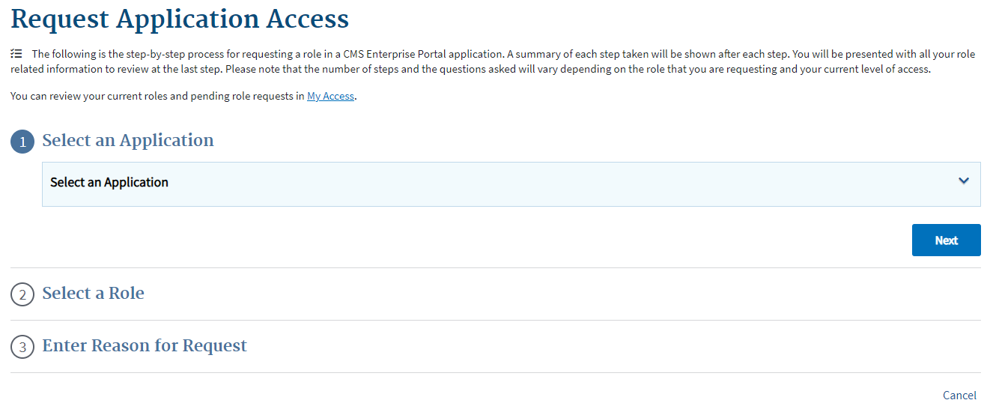
Figure 14: Select User Role/Application Request - Request Application Access
- Click the Select an Application drop-down; scroll or search for your application. Refer to Figure 15.
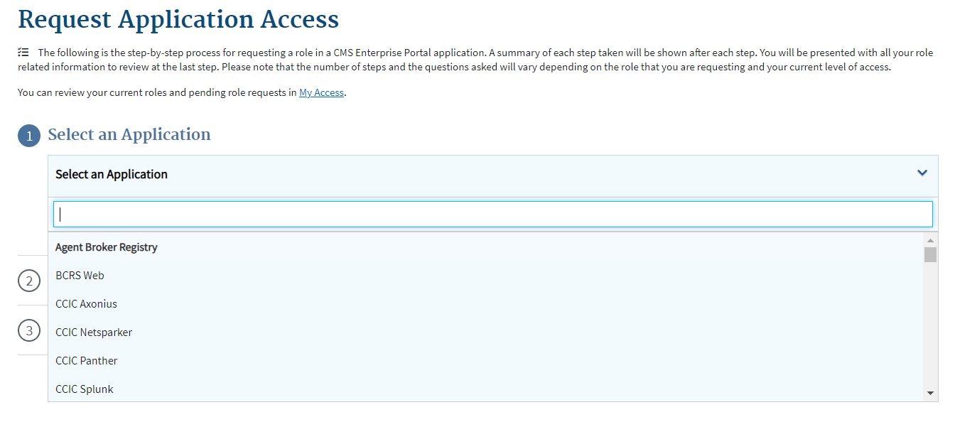
Figure 15: Select User Role/Application Request - Select an Application Drop-down
- Select FFSDCS from the drop-down menu. To be a Submitter or Certifier, you must register for the role on the FFSDCS Module.
The Request Application Access page opens. Refer to Figure 16.
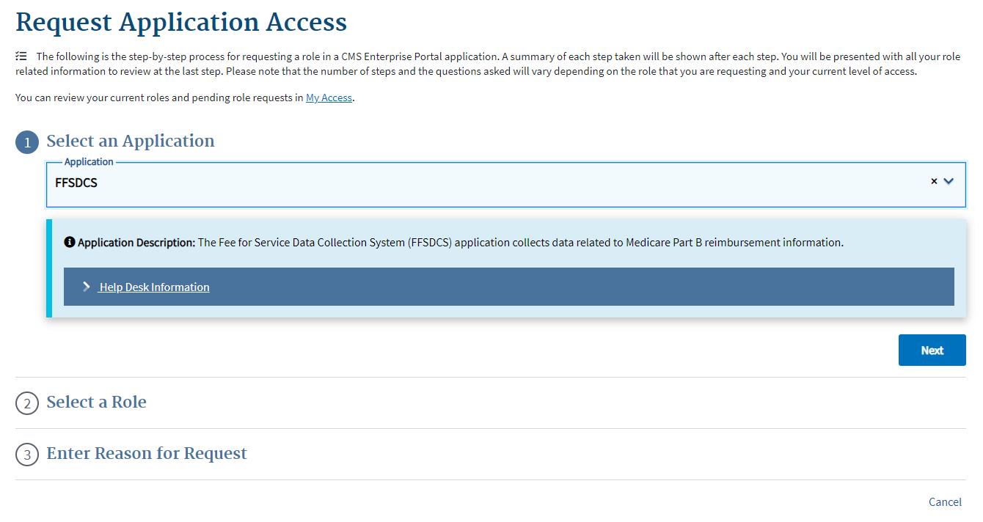
Figure 16: Select User Role/Application Request - Select an Application
- Click the Next button.
A checkmark displays next to FFSDCS; the application automatically moves you to the Select a Role section. Refer to Figure 17.
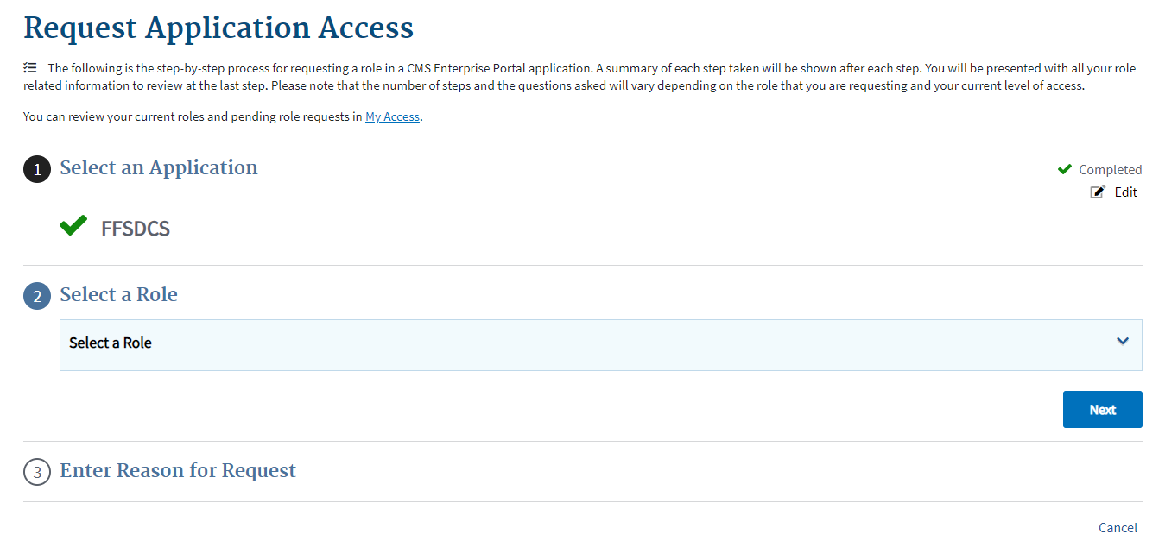
Figure 17: Select User Role/Application Request - Select a Role
- Click the Select a Role drop-down; scroll or search for your application. Refer to Figure 18.
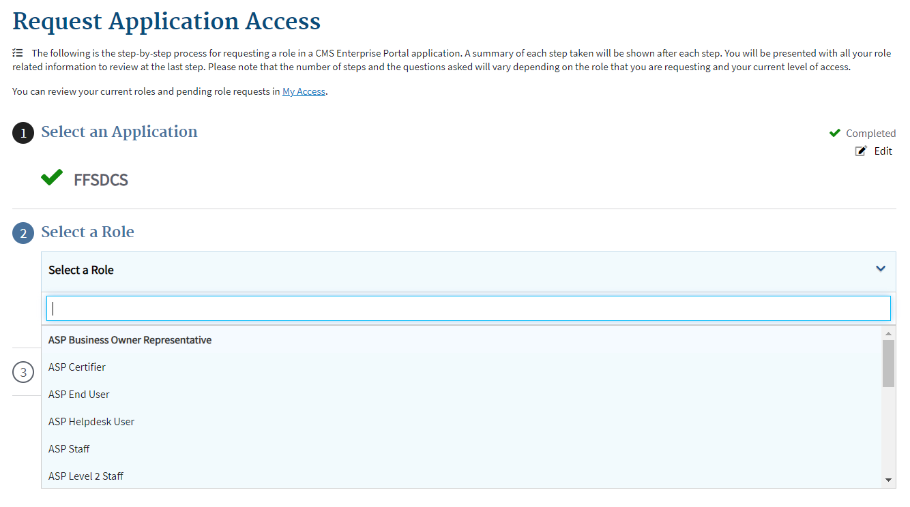
Figure 18: Select User Role/Application Request - Select a Role Drop-down
- Select the correct role for the application. For example:
- If you are an ASP Submitter, click the Role drop-down and select ASP End User as your role. ASP Submitters can only submit data.
- If you are an ASP Certifier, click the Role drop-down and select ASP Certifier. ASP Certifiers can only certify data.
For example, the user has selected the ASP End User (Submitter) role in Figure 19.
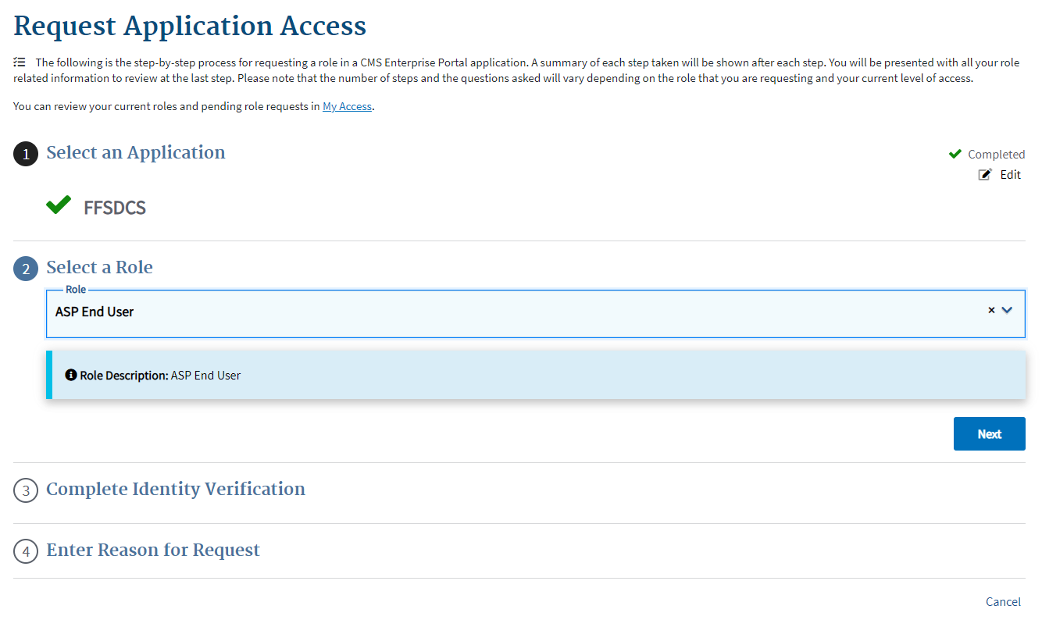
Figure 19: Select User Role/Application Request - Selected Role as ASP End User
- Click the Next button to confirm your role.
A checkmark displays next to your selected role; the application automatically moves you to the Complete Identity Verification section. Refer to Figure 20.
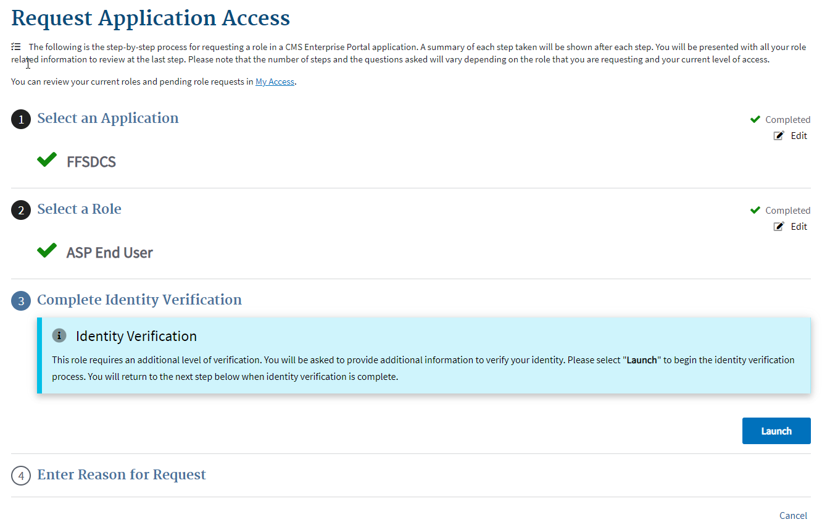
Figure 20: Select User Role/Application Request - Complete Identity Verification
- Click the Launch button.
The Step #1: Identity Verification Overview page opens. Refer to Figure 21.
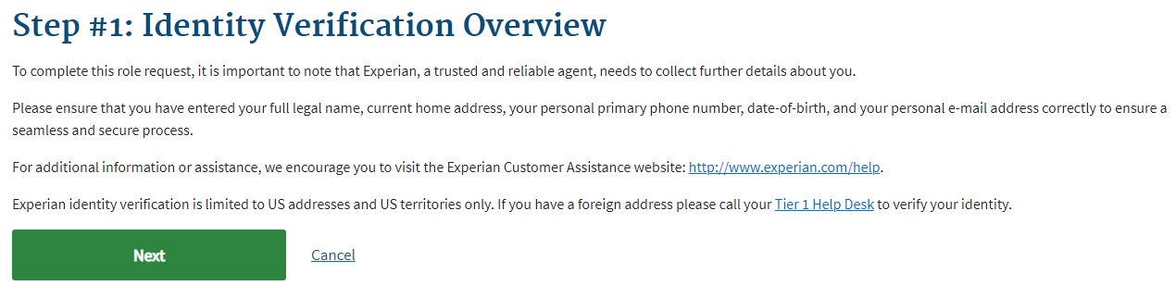
Figure 21: Select User Role/Application Request - Step #1: Identity Verification Overview
- Read the Identity Verification Overview to gain an understanding of your privacy as well as the process Experian Credit Bureau uses to accurately confirm the identity of users; click Next.
The Step #2: Accept Terms & Conditions page opens. Refer to Figure 22.
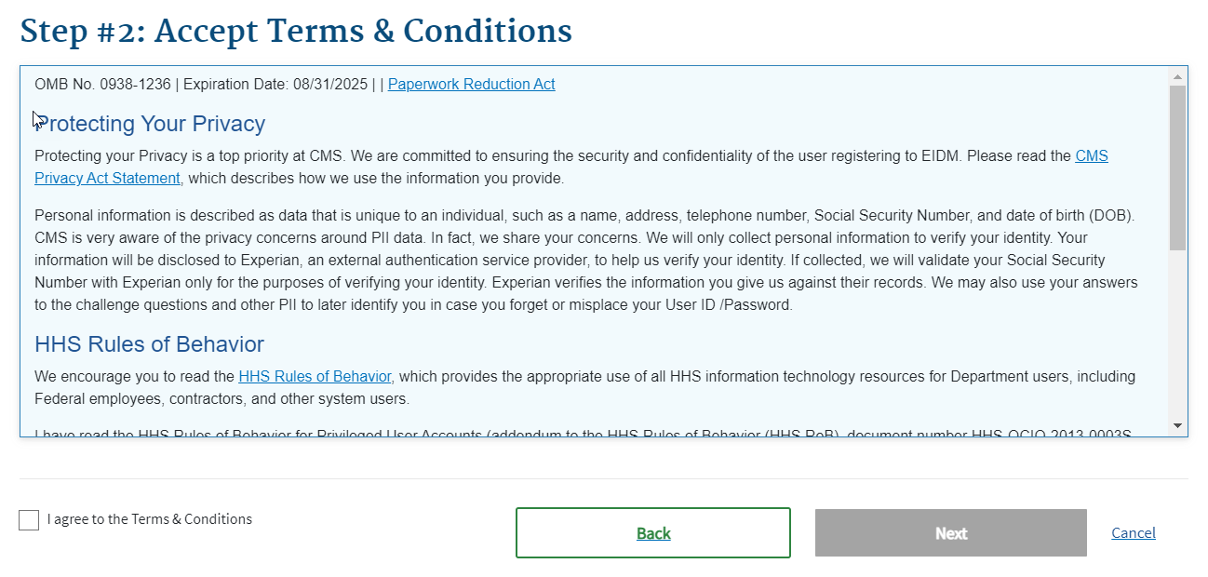
Figure 22: Select User Role/Application Request - Step #2: Accept Terms & Conditions
- Read the terms and conditions derived from the Paperwork Reduction Act of 1995, consisting of three sections: Protecting Your Privacy, HHS Rules of Behavior, and Identity Verification.
- If you agree to the terms and conditions, select the I agree to the Terms & Conditions checkbox; click Next.
The Step #3: Enter Your Information page opens. Refer to Figure 23.
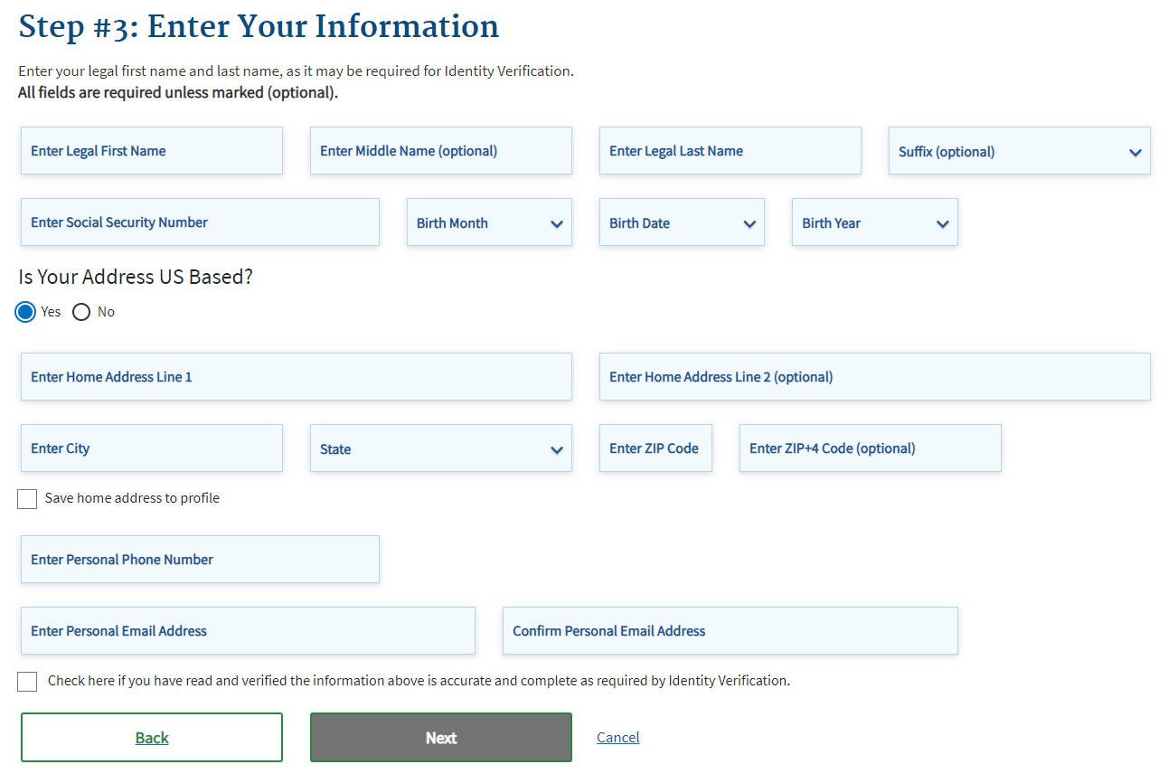
Figure 23: Select User Role/Application Request - Enter Your Information
- Enter your information in all required fields.
Note: Once you complete all fields, ensure the checkmark is present at the bottom of the page before moving on.
- Click Next.
The Multi-Factor Authentication Information page opens. Refer to Figure 24.
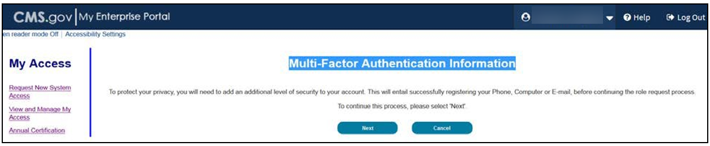
Figure 24: Select User Role/Application Request - MFA Information
- Read the message about MFA information; click Next to continue.
The Register Your Phone, Computer, or Email page opens. Refer to Figure 25.
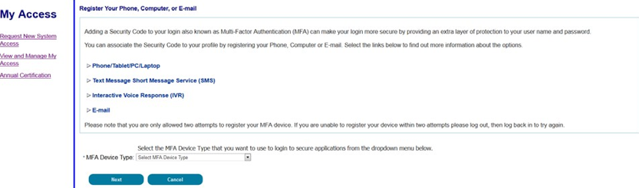
Figure 25: Select User Role/Application Request - Register Your Phone, Computer, or Email
- Select a device from the MFA Device Type drop-down. Enter any required information requested for the selected device; click Next.
A message opens indicating the system successfully registered your device. Refer to Figure 26.
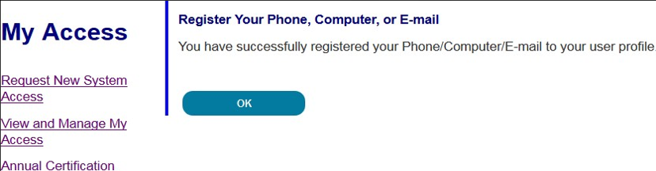
Figure 26: Select User Role/Application Request - Successfully Registered MFA Device
- Click OK.
A Request Acknowledgement page opens. Refer to Figure 27.
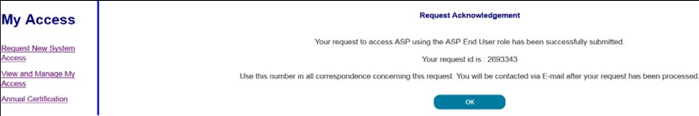
Figure 27: Select User Role/Application Request - Request Acknowledgement
- Read the Request Acknowledgement statement; click OK.
Note: Following submission of your Portal Application role request, you can view or cancel any pending re quests via the My Access menu options. The appropriate personnel will review your request; you will receive a notification once they approve or reject the request. It may take up to 72 hours (three days) to receive an email notification.

Technical Support Contact Information
Contact the FFSDCS (ASP) Application Helpdesk for issues such as:
- Account unlock
- Password reset
- Registration process questions
- System availability escalations
Table 1 provides contact information for technical support.
Table 1: Technical Support Contacts
Email Address | Phone Number | Hours
ASPHelpDesk@dcca.com | 1-844-876-0765 | 9:00 a.m. to 6:00 p.m. Eastern Standard Time (EST), Monday through Friday

Appendix A: Revision History
Table 2 provides a revision history for this document.
Table 2: Revision History
Version Number | Date | Author/Editor | Description of Change
1.0 | 03/15/2024 | Index Analytics/DCCA | Initial version of ASP Data Collection System Registration User Guide
2.0 | 08/08/2025 | Index Analytics/DCCA | - Updated based on updates to the ASP Data Collection System.  - Made various font, grammatical, punctuation, shading, formatting, date, version, pagination, glossary, and alignment corrections.
3.0 | 08/29/2025 | Index Analytics/DCCA | Updated CMS Portal Link

Appendix B: Glossary
Table 3 provides a list of terms, acronyms, and definitions in this document.
Table 3: Glossary
Expanded Form | Acronym/Term | Definition
Average Sales Price | ASP | ASP refers to the price at which an organization typically sells a certain class of good or service. CMS uses manufacturer-reported ASPs, based on manufacturers’ actual quarterly drug sales, to calculate provider payment amounts for these drugs. Federal law defines the price.
Centers for Medicare & Medicaid Services | CMS | CMS is a federal agency within the U.S. Department of Health and Human Services that administers the Medicare program and works in partnership with state governments to administer Medicaid, the State Children’s Health Insurance Program, and health insurance portability standards.
Chief Executive Officer | CEO | A CEO is the highest-ranking officer or Administrator in charge of management with a corporation.
Chief Financial Officer | CFO | A CFO is the corporate executive having financial authority to make appropriations and authorize expenditures for a firm.
Eastern Standard Time | EST | EST is the standard time in the 5th time zone west of Greenwich, reckoned at the 75th meridian. This time zone is in the eastern part of the United States.
Experian | NA | Experian is a global credit information group.
Fee-for-Service Data Collection System | FFSDCS | The FFSDCS is an instrument to collect cost, revenue, utilization, and other information for FFS claims.
Identity Management | IDM | IDM is the process of managing user access to data.
Interactive Voice Response | IVR | IVR is a technology that allows a computer to detect voice and DTMF keypad inputs.
Medicare | NA | Medicare is the federal system of health insurance for people over 65 years of age and for certain younger people with disabilities.
Medicare Modernization Act | MMA | The MMA, or Medicare Prescription Drug, Improvement, and Modernization Act, is a federal law.
Medicare Part B | NA | Medicare Part B is the part of Medicare that covers doctor services, outpatient hospital care, and other medical services that Part A does not cover such as physical and occupational therapy, X-rays, medical equipment, or limited ambulance service.
Multifactor Authentication | MFA | MFA is a security system that implements more than one form of authentication to verify the legitimacy of a transaction.
Okta | NA | Okta is an enterprise-grade, identity management service, built for the cloud, but compatible with many on-premises applications.
One-Time Password | OTP | An OTP is a password that is valid for only one login session or transaction.
Personally Identifiable Information | PII | PII is information that identifies or describes an individual, including but not limited to name, address, telephone number, Social Security Number, credit card number, and personal characteristics that make individual identity easily discoverable.
Short Message Service | SMS | SMS is a text messaging service component of phone, web, or mobile communication systems. It uses standardized communication protocols to allow fixed-line or mobile phone devices to exchange short text messages.

Appendix C: Figures and Tables
List of Figures
Figure 1: CMS Enterprise Portal - Login Page 1
Figure 2: New User Registration - Select Your Application Drop-down 2
Figure 3: New User Registration - Terms & Conditions 2
Figure 4: New User Registration - Step #2 Register Your Information 3
Figure 5: New User Registration - Step #3 Create User ID & Password 3
Figure 6: New User Registration - Security Question/Answer Page 5
Figure 7: New User Registration - Summary 6
Figure 8: New User Registration Confirmation 7
Figure 9: Logging in Using MFA - FFSDCS Module Login Page 7
Figure 10: Logging in Using MFA - Select MFA Device Type Drop-Down 8
Figure 11: Logging in Using MFA - MFA Code 9
Figure 12: Logging in Using MFA - Confirmation Code in Email 10
Figure 13: Logging in Using MFA - My Portal Landing Page 10
Figure 14: Select User Role/Application Request - Request Application Access 11
Figure 15: Select User Role/Application Request - Select an Application Drop-down 12
Figure 16: Select User Role/Application Request - Select an Application 12
Figure 17: Select User Role/Application Request - Select a Role 13
Figure 18: Select User Role/Application Request - Select a Role Drop-down 13
Figure 19: Select User Role/Application Request - Selected Role as ASP End User 14
Figure 20: Select User Role/Application Request - Complete Identity Verification 14
Figure 21: Select User Role/Application Request - Step #1: Identity Verification Overview 15
Figure 22: Select User Role/Application Request - Step #2: Accept Terms & Conditions 15
Figure 23: Select User Role/Application Request - Enter Your Information 16
Figure 24: Select User Role/Application Request - MFA Information 16
Figure 25: Select User Role/Application Request - Register Your Phone, Computer, or Email 17
Figure 26: Select User Role/Application Request - Successfully Registered MFA Device 17
Figure 27: Select User Role/Application Request - Request Acknowledgement 17

List of Tables
Table 1: Technical Support Contacts 18
Table 2: Revision History 19
Table 3: Glossary 20

