Attachment D: Mock-Up of MyPeST Interface
[Grab your reader’s attention with a great quote from the document or use this space to emphasize a key point. To place this text box anywhere on the page, just drag it.]

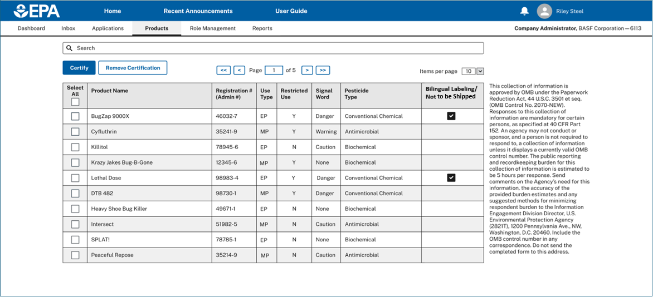
Provisioal Form No. 8500-31
Paperwork Reduction Notice: This collection of information is approved by OMB under the Paperwork Reduction Act, 44 U.S.C. 3501 et seq. (OMB Control No. 2070-NEW). Responses to this collection of information are mandatory for certain persons, as specified at 40 CFR 152. An agency may not conduct or sponsor, and a person is not required to respond to, a collection of information unless it displays a currently valid OMB control number. The public reporting and recordkeeping burden for this collection of information is estimated to be 5 hours per response. Send comments on the Agency’s need for this information, the accuracy of the provided burden estimates and any suggested methods for minimizing respondent burden to the Data & Enterprise Programs Division Deputy Director, U.S. Environmental Protection Agency (2821T), 1200 Pennsylvania Ave., NW, Washington, D.C. 20460. Include the OMB control number in any correspondence. Do not send the completed form to this address

OMB Control No. 2070-NEW
Expiration Date: XX/XX/XXXXNEW
Certification Statement: I certify that the selected products comply with bilingual labeling requirements (labels include Spanish translations or a link to translations via scannable technology or other electronic methods, or where permitted a link to Safety Data Sheets in Spanish; or the products will not be released for shipment in this calendar year).

