OMB Approval No. 2503-0033 (Exp. XX/XX/XXXX)

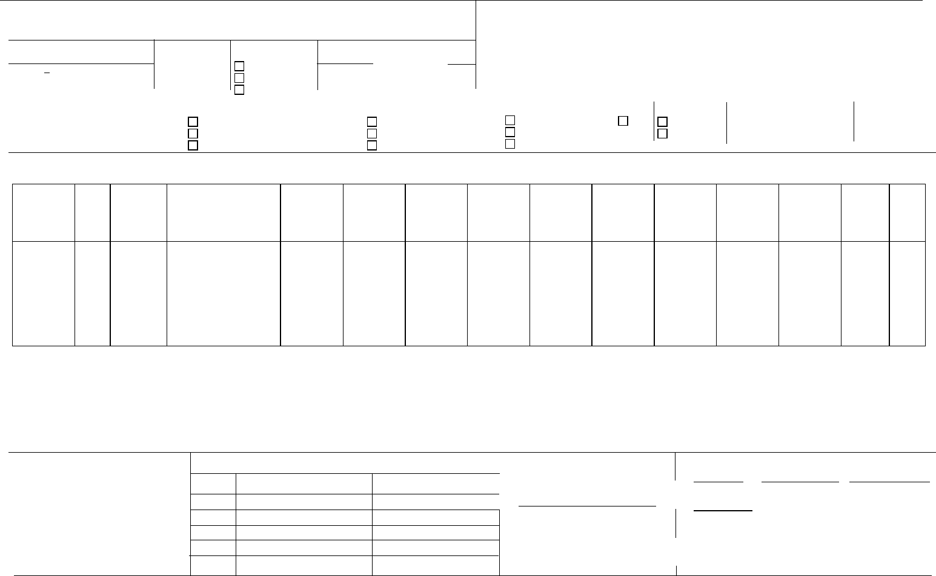
Weighted Average
Interest Rate
Schedule of Pooled Mortgages U.S. Department of Housing
and Urban Development
Government National Mortgage Association
Interest Rate of Mortgages
Highest ______% Lowest ______%
Term of Mortgages years % Recertification
Public reporting burden for this collection of information is estimated to average 5 minutes per response, including the time for reviewing instructions, searching existing data sources, gathering, and maintaining the data needed, and completing and reviewing the collection of information. This agency may not collect this information, and you are not required to complete this form, unless it displays a currently valid OMB control number.
The information requested is required by Sec. 306(g) of the National Housing Act or by Ginnie Mae Handbook 5500.3, Rev. 1.
Initial Certification Final Certification
Name of Issuer Single Family Level Payment Loans (SF/FS) Growing Equity Loans (GA/GD) Manufactured Home Loans (MH)
Graduated Payment Loans (GP/GT) Adjustable-Rate Loans (ARM) Buydown Loans (BD)
Project Loans (PL/PN/LM/RX/LS) Construction Loans (CL/CS) Serial Note (SN) Other
Security/Mortgage Change Date
Ginnie Mae I
Ginnie Mae II
Issuer ID Number
Issuer’s  Loan  Number and  MIN | MOM | Name of  Mortgagor | Address of Property/Site  Address (Street, City State  and Zip Code | FHA-VA-RD  184 Case  Number | Interest Rate | Mortgage  Margin  (ARM) | Loan  Origination  Date | Date of First  Payment | Interest Rate Change Date | Maturity  Date | Monthly  Constant  (P&I)  $ | Original  Principal  Balance  $ | Unpaid  Balance  of  Mortgage  $ | Type  of  Loan

Continue Loan Level reporting on page 2
Distribution of All Loans in Pool
Number Amount |  |  |  | Total Amount P & I | For Adjustable-Rate Pools/Loan Packages Only:
 |  |  |  |  | Index Type: Acceptable Range: Type of ARM Note:
FHA
VA |  |  | $ |  | Cap Structure
RD |  |  |  |  | Initial (+/-) Interest Rate Cap:
§184 |  |  |  |  | Subsequent Annual (+/-) Interest Rate Cap:
Other |  |  |  |  | Lifetime (+/-) Interest Rate Cap:
Total |  |  |  |  | Lookback Period: ⠀ 30 Day Look Back ⠀ 45 Day Look Back

Ginnie Mae Pool/Loan Package Number
Security Issue Date

Previous editions are obsolete; replaces form HUD-11706-M which is obsolete Page ( 1 ) of ( 4 ) ref. Ginnie Mae Handbook 5500.3, Rev.1. form HUD-11706 (1/2015)
Schedule of Pooled Mortgages Ginnie Mae Pool/Loan Package Number

Name of  Mortgagor | Credit  Score | Social  Security  Number | Co-borrower  #1  Full Name | Co-borrower  #2  Full Name | Co-borrower  #3  Full Name | Lockout  Term | Lockout  End Date | Prepayme  nt  Premium  Period | Prepay ment End Date | Loan  Type  Code | Loan Purpose | Living  Units | Down  Payment  Assistance | Loan  Buydown  Code | Upfront  MIP  Amount | Annual  MIP  Amount | Loan to  Value

Continue Loan Level reporting on page 3
Previous editions are obsolete; replaces form HUD-11706-M which is obsolete Page ( 2 ) of ( 4 ) ref. Ginnie Mae Handbook 5500.3, Rev.1. form HUD-11706 (1/2015)

Schedule of Pooled Mortgages | Ginnie Mae Pool/Loan Package Number

Name of  Mortgagor | Combined LTV Ratio Percent | Total Debt Expense Ratio Percent | Refinance Type | Last Paid Installment Due Date | Pre-Modification First Installment Due Date | Pre-Modification Original Principal Balance (OPB) Amount | Pre-Modification Interest Rate Percent | Pre-Modifcation Loan Maturity Date | First Time Homebuyer Indicator | Third-Party Origination Type | FHA UpfrontMIP Rate | FHA  Annual MIP Rate

Previous editions are obsolete; replaces form HUD-11706-M which is obsolete Page ( 3 ) of ( 4 ) ref. Ginnie Mae Handbook 5500.3, Rev.1. form HUD-11706 (1/2015)

Schedule of Pooled Mortgages | Ginnie Mae Pool/Loan Package Number

Instructions for Custodian
The custodian will review each mortgage or loan file in accordance with the applicable sections of the Ginnie Mae MBS Guide, Rev. 1 to determine that all required documents have been properly executed and received and that such documents relate to the mortgages identified on the front of this form. Purpose: To provide a means of identifying and controlling the mortgages that collateralize the designated MBS pools or loan packages. Also provides a certification from the document custodian that certain required mortgage documents are being held by the document custodian on behalf of Ginnie Mae.
Upon completion of each examination, an authorized official of the custodian will sign the original and the required copies of this form in the space provided and forward the original to Ginnie Mae’s pool processing agent (either directly or through the issuer) and provide a signed copy to the issuer. Pursuant to the following, certification may be completed in two stages, “initial” and “final”, except for PL, PN, LM, LS, CL, and CS pools, which are only final certified.
Custodian’s Certification (Initial Certification)
The documents referenced in the applicable sections indicated below, pertaining to the mortgages listed on the front of this form, have been received and have been determined to satisfy the requirements of the Ginnie Mae MBS Guide, Rev. 1.
For SF, FS, AR, AQ, AT, AF, FT, AS, AX, BD, GP, GT, GA, GD, and SN pools and loan packages: Section 13-4(A) of the Ginnie Mae MBS Guide, Rev. 1.
For MH Pools: Sections 13-4(A) and 30-4(A)(1) of the Ginnie Mae MBS Guide, Rev. 1.
Custodian’s Certification (Final Certification)
The documents referenced in the applicable sections indicated below, pertaining to the mortgages listed on the front of this form, have been received and have been determined to satisfy the requirements of the Ginnie Mae MBS Guide, Rev. 1.
For SF, FS, AR, AQ, AT, AF, FT, AS, AX, BD, GP, GT, GA, GD, and SN pools and loan packages: Section 13-4(B) of the Ginnie Mae MBS Guide, Rev. 1.
For MH Pools: Sections 13-4(B) and 30-4(A)(2) of the Ginnie Mae MBS Guide, Rev. 1.
For PL, PN, LM, and LS pools: Sections 13-4(B) and 31-10 of the Ginnie Mae MBS Guide, Rev. 1 (final certification). For CL and CS pools: Sections 13-4(B) and 32-8 of the Ginnie Mae MBS Guide, Rev. 1 (final certification).
Custodian Name and Address (including Zip Code)(Please Type) | Custodian No. |  | Custodian Name and Address (including Zip Code)(Please Type) | Custodian No.
Authorized Signature |  |  | Authorized Signature
Name (Please Type) |  |  | Name (Please Type)
Title (Please Type) |  | Date of Initial Certification | Title (Please Type) |  | Date of Final Certification

Recertification Using an Updated List of Loans for the Referenced Pool
Issuer ID No. | Current Issuer: (Name of Buyer)

Issuer ID No.
Prior Issuer: (Name of Seller)
The attached list of pooled loans represents the pool or loan package principal and the total number of mortgages reported by the Issuer. The month of transfer The Issuer certifies that the remaining loan balances conform to the balances reported via the Reporting and Feedback System Monthly Issuer Report of Pool and Loan data.
The Document Custodian certifies to the following: (1) It has received the related documents for the loans listed on the attached. (2) It has verified that the loans on the attached were included on the original Schedule of Pooled Mortgages, if available. If not available, the Document Custodian must obtain from the Issuer a written explanation why the original Schedule is missing. The Document Custodian must maintain a copy of the original Schedule or the written explanation for the missing Schedule in the Pool Master File with the recertification.
The Document Custodian will not be required to maintain or reconcile the form HUD-11708 for loans liquidated prior to and not reported as active loans.
Authorized Signature of current Issuer |  | Custodian Name and Address (including Zip Code) (Please Type) | Custodian No. | Authorized Signature of Current Custodian
 |  |  |  | Name of Custodian (Please Type)
Name (Please Type)
 |  |  |  | Title of Custodian (Please Type)
Title (Please Type) | Date
Title (Please Type) | Date |  |  | Date

Previous editions are obsolete; replaces form HUD-11706-M which is obsolete Page ( 4 ) of ( 4 ) ref. Ginnie Mae Handbook 5500.3, Rev.1. form HUD-11706 (1/2015)

