Summary of Changes from Previously Approved Collection

- Application for High-Technology Veterans Education, Training and Skills (VET TEC 2.0) Program
- Participation Agreement for Veterans Employment Through High Technology Education Courses (VET TEC 2.0) Program
- The Instrument is a NEW ICR.
- There is no burden change as this is a new collection.
- Six comments received on the 60-day Federal Register Notice.

A. Justification

1. Explain the circumstances that make the collection of information necessary. Identify legal or administrative requirements that necessitate the collection of information.

On January 2, 2025, the Elizabeth Dole Field and Community Based Services for Veterans and Caregivers Act (Pub. L. 118-210) was signed into law. The legislation can be identified as the DOLE Act. This legislation established a new Veteran Technology program titled “High-Technology Veterans Education, Training and Skills (VET TEC 2.0) Program”. VET TEC 2.0 allows Veterans to enroll in courses outside the traditional definition of higher education to obtain skillsets highly desired by employers. The DOLE Act authorizes VA to provide educational assistance for these high technology programs of education that begin prior to September 30, 2027.

The eligibility requirements to qualify for the program apply to an individual who is a Veteran under age 62 who has served at least 3 years (36 months) on Active Duty; or a Service member who is within 180 days of discharge who has or will serve 3 years (36 months) by their discharge date; and who has received a discharge under conditions other than dishonorable.

The DOLE Act requires VA to develop mechanisms for Veteran application for VET TEC 2.0, to include selection of a specific training provider and program and a Participation Agreement for Training Providers who wish to seek approval for their programs under VET TEC 2.0. It also requires VA to develop enrollment processing mechanisms and the ability to track the number of enrollees in real time due to annual participation limits. Lastly, VA must submit a report to Congress no later than January 2, 2026, and each year thereafter on the operation of the program.
2. Indicate how, by whom, and for what purposes the information is to be used; indicate actual use the agency has made of the information received from current collection.

The VA Form 22-10297 allows students to apply for the new High-Technology Veterans Education, Training and Skills (VET TEC 2.0) Program. The VA Form 22-10401 and the corresponding spreadsheets allow Training Providers to seek approval of their programs under the new High-Technology Veterans Education, Training and Skills (VET TEC 2.0) Program. This new information collection is being used to implement section 212 of Pub. L. 118-210 to provide Veterans the opportunity to enroll in high technology programs and to allow Training Providers the opportunity to offer their high technology programs to Veterans. The VA requires approval of this information collection to allow eligible individuals to apply to enroll with a qualified training provider, allow qualified Training Providers to seek approval of their programs and to allow VA to track the number of annual participants.

3. Describe whether, and to what extent, the collection of information involves the use of automated, electronic, mechanical, or other technological collection techniques or other forms of information technology, e.g. Permitting electronic submission of responses, and the basis for the decision for adopting this means of collection. Also describe any consideration of using information technology to reduce burden.

The VA Form 22-10297 will be available electronically via the VA.gov portal, which will utilize algorithms to guide the applicant. The portal will complete the collection based on the applicant’s responses and submit the collection digitally. The use of VA.gov helps to reduce the burden on the applicant.

4. Describe efforts to identify duplication. Show specifically why any similar information already available cannot be used or modified for use for the purposes described in Item 2 above.

The information obtained through this collection is unique and is not already available for use or adaptation from another cleared source.

5. If the collection of information impacts small businesses or other small entities, describe any methods used to minimize burden.

This information collection does not impose a significant economic impact on a substantial number of small businesses or entities.

6. Describe the consequences to Federal program or policy activities if the collection is not conducted or is conducted less frequently as well as any technical or legal obstacles to reducing burden.

The VA will not comply with Pub. L. 118-210, section 212 if we fail to offer a means for which Veterans can apply for the High-Technology Veterans Education, Training and Skills (VET TEC 2.0) Program. The law requires VA to offer a high technology program by offering Veterans the opportunity to enroll in these programs.

7. Explain any special circumstances that would cause an Information collection to be conducted more often than quarterly or require respondents to prepare written responses to a collection of information in fewer than 30 days after receipt of it; submit more than an original and two copies of any document; retain records, other than health, medical, government contract, grant-in-aid, or tax records for more than three years; in connection with a statistical survey that is not designed to produce valid and reliable results that can be generalized to the universe of study and require the use of a statistical data classification that has not been reviewed and approved by OMB.

This collection of information does not require collection to be conducted in a manner inconsistent with the guidelines delineated in 5 CFR 1320.5(d)(2).

8. If applicable, provide a copy and identify the date and page number of publication in the Federal Register of the sponsor's notice, required by 5 CFR 1320.8(d), soliciting comments on the information collection prior to submission to OMB. Summarize public comments received in response to that notice and describe actions taken by the sponsor in responses to these comments. Specifically address comments received on cost and hour burden.

A 60-Day Federal Register Notice (FRN) for the collection published on Tuesday, December 16, 2025. The 60-Day FRN citation is Volume 90, FRN Page 58373.
6 comments were received during the 60-day comment period.

COMMENT 1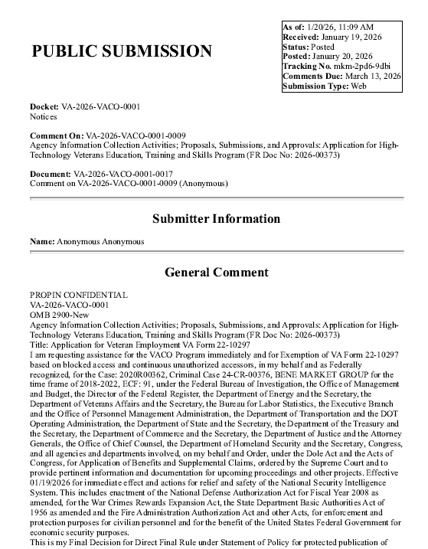
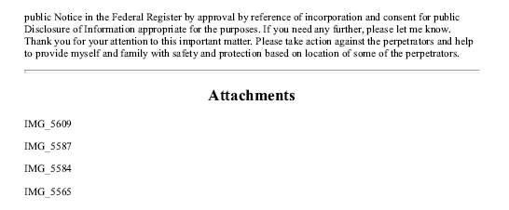
VA RESPONSE:
Thank you for your recent comment regarding VA Form 22-10297, Application for High Technology Veteran Education, Training and Skills (VET TEC 2.0) Program. We are unable to respond, as it does not appear that your comment is directly related to the 22-10297 or the VET TEC 2.0 program. Thank you for your support for our nation’s Veteran community.

COMMENT 2 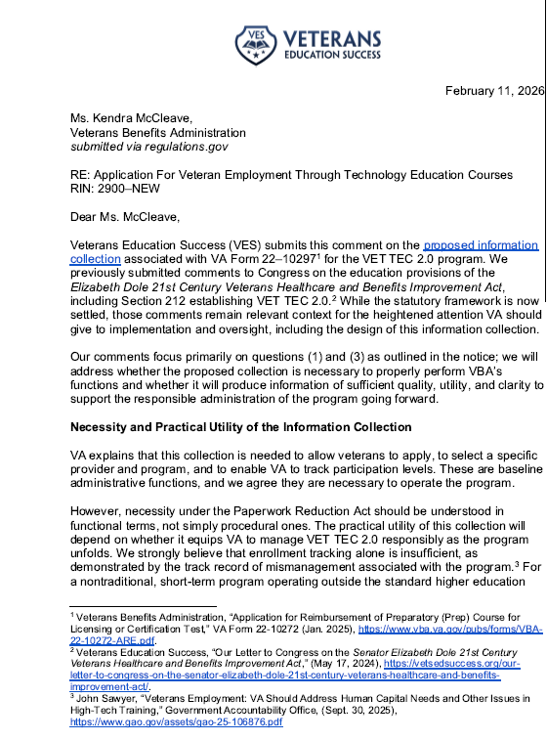
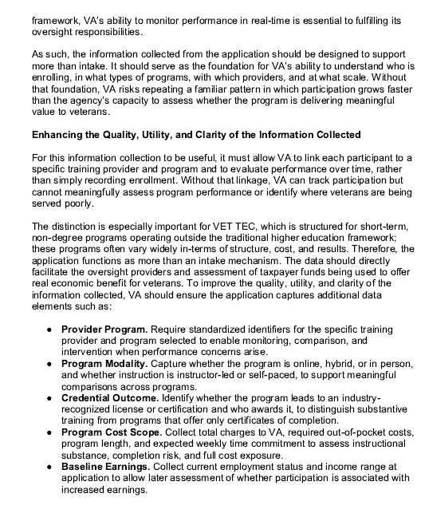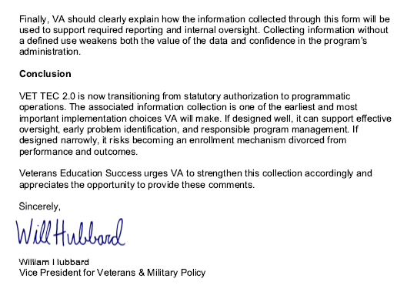
VA RESPONSE:
The Department of Veterans Affairs (VA) value your thoughtful comments regarding the Application for Veteran Employment Through High Technology Education Courses (VET TEC 2.0) Program, VA Form 22-10297."
We appreciate your consideration and recommendations focused on the quality, utility and clarity required to support the responsible administration of the VET TEC 2.0 program, as well as VA’s required information collection and Congressional reporting for this program.
VA acknowledges your concerns; however, VA Form 22-10297, will be utilized solely for the purpose set forth in the Federal Register notice; allowing Veterans to apply for the program, allowing Veterans to provide a Training Provider name(s) who may have qualifying programs in which they are interested in enrolling, and enabling VA to track application levels.
VA Form 22-10297 is not the vehicle designed to monitor or evaluate Training Provider performance or to facilitate oversight. The items you have listed, to include provider programs, program modality, credential outcome, program cost scope and baseline earnings credit are captured, monitored and reviewed via other vehicles, to include:
- The 22-10401, Training Provider Participation Agreement, which has been patterned after the State Approving Agency Uniform Application and has specific Vet Tec 2.0 requirements incorporated.
In addition, Training providers’ curriculum will be evaluated for relevance to high-tech fields ensuring alignment with current industry demands and programs will go through an on-going review for job placement milestones within the field of study
Expert instructors will also be evaluated for relevance to high-tech fields and alignment with current industry demands.
To support these tasks, additional collection methods are being utilized, which include the following:
  - 22-10401a, Programs Request, which collects data such as modality, term structure, tuition and fees, type of hours and when the Training Provider began offering the program.
  - 22-10401b, Completion Rates Report, which collects data for the prior year such as total number of students enrolled and graduated from a program, completion percentage, number of graduated students who are job seeking or employed, and average days from graduation to employment.
  - 22-10401c, Expert Credentials Report, which collects data such as instructors’ names and if they teach the entire program or a specific course, the instructor’s current related certifications/continuing education credentials and requirements for submission of current certifications, resume, and two letters of reference attesting to instructors’ expertise.
- VA Form 22-1999, Enrollment Certification, which collects specific enrollment data for each student certified including tuition and fees, modality and enrollment dates.
- VA Form 22-10299, Veteran Employment through High Technology Education Courses (VET TEC 2.0) Employment Certification, which will collect specific employment and continuing education data after program completion from both student and Training Provider.
We hope you find this information useful. VA appreciates your commitment to enhancing the VET TEC 2.0 Program and supporting our nation’s Veterans and your feedback is invaluable in ensuring program integrity and effectiveness.
COMMENT 3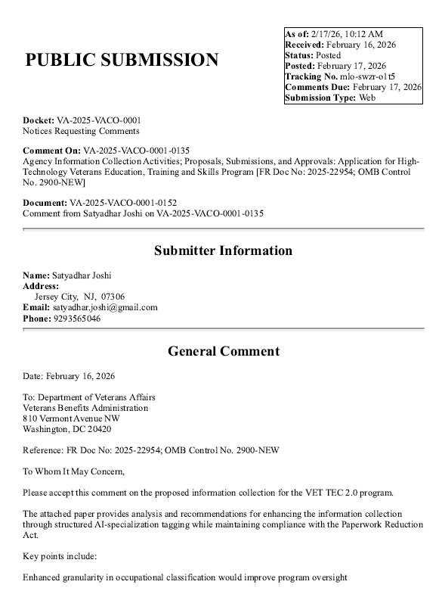

VA RESPONSE:
Thank you for your support regarding improvements to the Veteran Employment Through High Technology Education Courses (VET TEC 2.0) Program. We appreciate your thorough analysis and recommendations focused on enhancing program oversight and utilization of automation techniques. Your proposed recommendations have been submitted to VA leadership for consideration.
COMMENT 4
I read in the Elizabeth Dole Act where each month of training will be equal to one month of entitlement. I feel like this is unfair to certain cohorts of Veterans and will impact these Veterans the most with less than five months of entitlement remaining. It's even more complicated because of the Veterans who qualify under the Rudisill Review. In my case, I have two months remaining under Post 9/11 and 10 months remaining under MGIB. How will the VET TEC entitlement be charged for Veterans who qualify under two education programs and will MGIB participants lose MHA? if so, this should be something lawmakers think about heavily as participants in the program are being retrained and may need the MHA to help with everyday living expenses. Thank you for reading my comment and please keep the veterans interest in the heart.
VA RESPONSE
The Department of Veterans Affairs (VA) appreciates your thoughtful comments regarding the Application for Veteran Employment Through High Technology Education Courses (VET TEC 2.0) Program, VA Form 22-10297. If a Veteran has remaining entitlement under more than one benefit chapter, the Veteran can choose which benefit chapter VA will charge under VET TEC 2.0. If the Veteran does not select a benefit chapter, VA will charge entitlement under the benefit chapter that is most advantageous to the Veteran. In the case of a Veteran with remaining entitlement under both Post 9/11 GI Bill (PGIB) and Montgomery GI Bill-AD (MGIB-AD), entitlement used under VET TEC 2.0 will be charged under MGIB-AD unless the Veteran specifies otherwise. VET TEC 2.0 participants will receive the Monthly Housing Allowance (MHA) regardless under which benefit chapter entitlement is charged.
We hope you find this information useful. VA appreciates your commitment to enhancing the VET TEC 2.0 Program and supporting our nation’s Veterans.
COMMENT 5
I appreciate the opportunity to comment on the proposed information collection for the High Technology Veterans Education, Training and Skills Program. I support efforts to expand workforce training opportunities for veterans, especially programs that focus on current labor market needs and practical skills. At the same time, I have serious concerns that the structure and eligibility framework connected to this initiative will leave out many veterans who would benefit the most.
A primary concern is the decision to tie eligibility for this program to remaining GI Bill entitlement. Many veterans, particularly older veterans and those who served before or shortly after 9 11, no longer have GI Bill benefits available. They may have used their entitlement decades ago, transferred it to dependents, allowed it to expire under older rules, or never qualified for the Post 9 11 GI Bill at all. Conditioning access to a workforce retraining program on leftover education benefits effectively penalizes veterans for having already used a benefit they earned.
The current job market makes this restriction especially harmful. The idea that veterans only need retraining once, early in life, no longer reflects reality. Entire industries are changing or disappearing. Layoffs, automation, age bias, health limitations, and long gaps in employment are affecting veterans across generations. Many veterans now find themselves out of work for extended periods through no fault of their own. Workforce programs must reflect that retraining may be necessary more than once over a lifetime.
For veterans who have been unemployed for a year or more, access to meaningful training is not only about income. Work provides structure, identity, and purpose. When veterans lose connection to those things, isolation grows. At a time when veteran suicide rates remain alarmingly high, programs that help veterans regain direction and see a future for themselves serve an important role beyond job placement. Allowing veterans to participate in a program like this based on employment need and readiness to work, rather than remaining GI Bill entitlement, supports both economic stability and mental health.
I strongly urge VA to expand eligibility or create priority consideration for veterans who have been out of work for over a year and for veterans experiencing homelessness. These groups face the greatest barriers to reentry and are often the least able to access traditional education pathways.
Technology access must also be addressed directly. High technology training assumes access to a reliable computer and stable internet. Many unhoused or housing insecure veterans do not have either. Tablets may be helpful in some situations, but they are not an adequate substitute for a laptop when completing coursework, managing software, or handling large files. Memory and storage limitations create additional barriers. Veterans without stable housing should be able to receive a loaner laptop through existing VA programs, and those without internet access should be provided a mobile WiFi device or data support for the duration of training.
Clear expectations and accountability also matter. Veterans deserve transparency about what participation requires. Attendance standards, participation requirements, and academic expectations should be clearly stated at the outset. At the same time, support should be available for veterans who struggle, including tutoring or mentoring, before punitive actions are considered. Limited program slots should be used in ways that support completion and meaningful outcomes.
Finally, the application process itself should be accessible to veterans with limited technology access, disabilities, or unstable living conditions. Options for assisted applications, mobile friendly design, and in person support through VA facilities or trusted partners would reduce barriers that prevent otherwise qualified veterans from applying.
This program has the potential to help veterans reenter the workforce in a changing economy. To meet that promise, eligibility and program design must center need, access, and real world conditions faced by veterans today. I urge VA to reconsider the GI Bill tie in, prioritize long term unemployed and unhoused veterans, and structure this initiative as a true workforce reintegration program rather than an extension of existing education benefits.
Thank you for the opportunity to provide comment and for considering these concerns.
Respectfully submitted,
J. Johnson
The Black Veteran Newsletter
VA RESPONSE
The Department of Veterans Affairs (VA) appreciates your thoughtful comments and suggestions regarding the Application for Veteran Employment Through High Technology Education Courses (VET TEC 2.0) Program, VA Form 22-10297. We appreciate your consideration and recommendations focused on prioritizing Veterans facing unemployment, expanding access to materials provided under VET TEC 2.0 and outlining expectations and accountability for participants. Due to the number of comments and suggestions, please find responses in bullet format below.
- VET TEC 2.0 eligibility is not tied to remaining educational assistance entitlement. If a Veteran has remaining entitlement it will be charged but if a Veteran has no remaining entitlement, they will be eligible for payment under VET TEC 2.0 if they meet the other eligibility requirements.
- While VA administers the VET TEC 2.0 program, VA must operate within the parameters established in statute. Accordingly, VA is not authorized to expand eligibility, create priority categories, or provide items such as tablets, laptops, or internet access. Only Congress has the authority to amend the law to include such provisions.
- The VET TEC 2.0 program provides students with a books and supplies stipend, in addition to a Monthly Housing Allowance (MHA). The books and supplies stipend may be used to purchase necessary materials or internet access, as determined by the student.
- VA requires Training Providers to meet certain minimum standards related to attendance and academic expectations; however, each Training Provider may establish its own specific requirements. Therefore, VA cannot prescribe a uniform standard applicable to all providers. Veterans interested in participating in VET TEC 2.0 should contact their chosen Training Provider directly for details regarding attendance and academic requirements. Approved VET TEC 2.0 Training Providers will be added to the VA Comparison Tool at https://www.va.gov/education/gi-bill-comparison-tool/ as they receive approval.
- Congress did not include a provision in the law for VET TEC 2.0 to allow payment for the Tutorial Assistance benefit that is available under other GI Bill educational assistance programs. An amendment to the statute would be required for tutoring to be covered.
- Because the VET TEC 2.0 program is designed to support training in high-technology fields, participation requires a baseline level of digital access and technological proficiency. If a Veteran does not have the ability or resources to apply online, it may indicate that this particular program may not align with their current needs or a preparation level that would allow them to be successful in the program.
We hope you find this information useful. VA appreciates your commitment to enhancing the VET TEC 2.0 Program and supporting our nation’s Veterans. Your feedback is invaluable in ensuring program integrity and effectiveness. While we cannot currently incorporate all of your suggestions under the VET TEC 2.0 program, VA remains committed to assisting Veterans in identifying education and training opportunities that best support their goals.
COMMENT 6
The Dole Act was signed into law on 1/2/2025. VET TEC 2.0 was sent to return and launch on 10/01/2025. ...Typical, on brand VA. Furlough or not. Even the website makes no metion of the revised 2.0 version. link: https://www.va.gov/education/about-gi-bill-benefits/how-to-use-benefits/vettec-high-tech-program/

VA RESPONSE
Thank you for your comment regarding the application for the Veteran Employment Through High Technology Education Courses (VET TEC 2.0) Program, VA Form 22-10297 and the subsequent and launch of the VET TEC 2.0 program and website.
The Department of Veterans Affairs (VA) appreciates your interest in implementation of the Dole Act and the VET TEC 2.0 program. As with any statutory change of this scope, successful implementation involves many dependencies, including coordination across program offices, stakeholders, and external partners; alignment of policy and oversight requirements; and development, testing, and deployment of information technology solutions. In particular, VET TEC 2.0 required the design and creation of required system capabilities to pay authorized benefits under the revised program and to ensure accurate eligibility, compliance, and reporting functions. These activities are sequenced to support orderly operations and mitigate risk to beneficiaries and providers.
VA is finalizing the website and other public facing communications as we progress, and a new website providing program details and guidance is set to launch in the near future. We will continue to provide updates through established channels as implementation milestones are reached.
We hope you find this information useful.

A 30-Day Federal Register Notice (FRN) for the collection published on Friday, March 27, 2026. The 30-Day FRN citation is Volume 91 FRN No 14906.
9. Explain any decision to provide any payment or gift to respondents, other than remuneration of contractors or grantees.

No payments or gifts are being offered to respondents as an incentive to participate in the collection.

10. Describe any assurance of privacy, to the extent permitted by law, provided to respondents and the basis for the assurance in statute, regulation, or agency policy.

The records are maintained in the appropriate Privacy Act System of Records identified as Compensation, Pension, Education, and Veteran Readiness and Employment Records – VA (58VA/21/22/28), published at 74 FR 29275 on June 19, 2009, and last amended at 87 FR 8740 (February 16, 2022).

11. Provide additional justification for any questions of a sensitive nature (Information that, with a reasonable degree of medical certainty, is likely to have a serious adverse effect on an individual's mental or physical health if revealed to him or her), such as sexual behavior and attitudes, religious beliefs, and other matters that are commonly considered private; include specific uses to be made of the information, the explanation to be given to persons from whom the information is requested, and any steps to be taken to obtain their consent.

No questions considered sensitive are being asked in this collection.
12. Estimate of the hour burden of the collection of information. If this request for approval covers more than one form, provide separate hour burden estimates for each form, and aggregate the hour burdens in Item 13 of OMB 83-I. Provide estimates of annual cost to respondents for the hour burdens for collections of information. The cost of contracting out or paying outside parties for information collection activities should not be included here. Instead, this cost should be included in Item 14 of the OMB 83-I.
VA Form 22-10297, Application for High-Technology Veterans Education, Training and Skills (VET TEC 2.0) Program
VA Form 22-10401, Participation Agreement for Veterans Employment Through High Technology Education Courses (VET TEC 2.0) Program

The estimated annual burden to the public for this information collection is projected at 4412 hours. The total number of respondents for this information collection is estimated to be 4,000 respondents annually, as that is the approval limit each year.

- Number of Respondents: 4,412.

- Frequency of Response: Once.

- Annual Burden Hours: 4412 hours (4,412 X 60 minutes / 60 minutes).

- Estimated Completion Time for Respondent: 60 minutes.

e. The respondent population for this new VA Form 22-10297 consists of Veterans who are seeking approval for the High-Technology Veterans Education, Training and Skills (VET TEC 2.0) Program to determine if they can pursue an approved program of education. The respondent population for this new VA Form 22-10401 and corresponding spreadsheets consist of Training Providers who are seeking approval of their programs under the High-Technology Veterans Education, Training and Skills (VET TEC 2.0) Program to determine if they can pursue an approved program of education. VBA cannot make further assumptions about the population of respondents because of the variability of factors such as educational background and wage potential of respondents. Therefore, VBA used general wage data for "All Occupations" to estimate the respondents' costs associated with completing the information collection.
The Bureau of Labor Statistics gathers information on full-time wage and salary workers. According to the latest available BLS data, the median weekly earnings of full-time wage and salary workers is $1,306.40. Assuming a forty (40) hour work week, the median hourly wage is $32.66 based on the BLS wage code of "00-000-0000 for "All Occupations." This information was taken from the following website https://data.bls.gov/oes/#/industry/000000, May 2024.

Legally, respondents may not pay a person or business for assistance in completing the information collection and a person or business may not accept payment for assisting a respondent in completing the information collection. Therefore, there are no expected overhead costs for completing the information collection. VBA estimates the total cost to all respondents to be $72,047.96 (2206 burden hours X $32.66 per hour).
13. Provide an estimate of the total annual cost burden to respondents or recordkeeping resulting from the collection of information. (Do not include the cost of any hour burden shown in Items 12 and 14).

This submission does not involve any record keeping costs.

14. Provide estimates of annual cost to the Federal Government. Also, provide a description of the method used to estimate cost, which should include quantification of hours, operation expenses (such as equipment, overhead, printing, and support staff), and any other expense that would not have been incurred without this collection of information. Agencies also may aggregate cost estimates from Items 12, 13, and 14 in a single table.

Estimated Costs to the Federal Government: $48,797
Grade | Step | Burden Time  Employee | Hourly Rate | Cost Per Response | Total Responses | Total
9 | 05 | 20 min | $33.19 | $11.06 | 4,412 | $48,797 (4,412 X $33.19 X 20min/60min)
Overhead at 100% Salary |  |  |  |  |  | $48,797
Overhead costs are 100% of salary and are the same as the wage listed above; and the amount is included in the total. |  |  |  |  |  | $48,797
Processing I Analyzing Costs |  |  |  |  |  | $48797
Printing and Production Cost |  |  |  |  |  | $0
Total Cost to Government |  |  |  |  |  | $48,797

Note: The hourly wage information above is based on the hourly 2025 General Schedule (Base) Locality Pay Area for the Rest of USA. Pay & Leave: Salaries & Wages - OPM.gov The processing time estimates above are based on the actual amount of time VA employees will spend to process the VA Form 22-10297 and VA Form 22-10401.

15. Explain the reason for any burden hour changes since the last submission.

There is no change in burden, as this is a NEW collection.

16. For collections of information whose results will be published, outline plans for tabulation and publication. Address any complex analytical techniques that will be used. Provide the time schedule for the entire project, including beginning and ending dates of the collection of information, completion of report, publication dates, and other actions.

The information collection is not for publication or tabulation use.

17. If seeking approval to not display the expiration date for OMB approval of the information collection, explain the reasons that display would be inappropriate.

We are not seeking approval to omit the display of the expiration date of the OMB approval on the collection instrument.

18. Explain each exception to the certification statement identified in
Item 19, "Certification for Paperwork Reduction Act Submissions," of
OMB 83-1.

We are not requesting any exemptions to the provisions stated in 5 CFR 1320.9.

