DEPARTMENT OF VETERANS AFFAIRS
Veterans Benefits Administration
Washington, DC 20420

TO: Office of Mission Support (OMS)

FROM: VA Education Service (225)

DATE: March 18, 2026

RE: Response to Public Comments for ICR 202523-2900-003

COMMENT 1
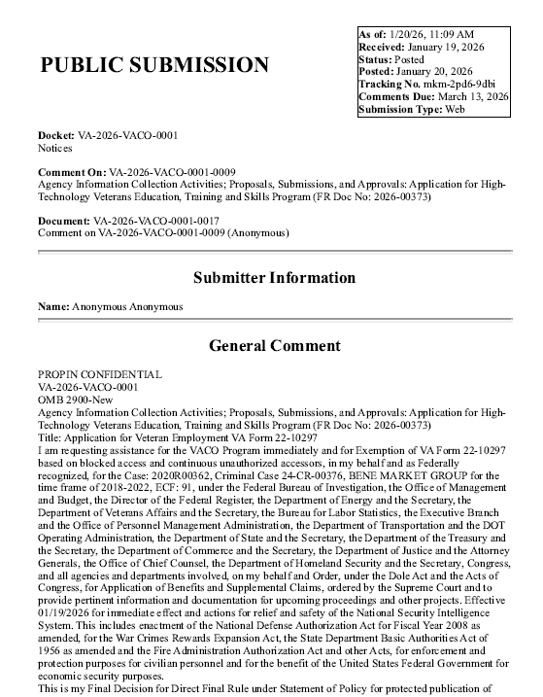
VA RESPONSE:
Thank you for your recent comment regarding VA Form 22-10297, Application for High Technology Veteran Education, Training and Skills (VET TEC 2.0) Program. We are unable to respond, as it does not appear that your comment is directly related to the 22-10297 or the VET TEC 2.0 program. Thank you for your support for our nation’s Veteran community.

COMMENT 2

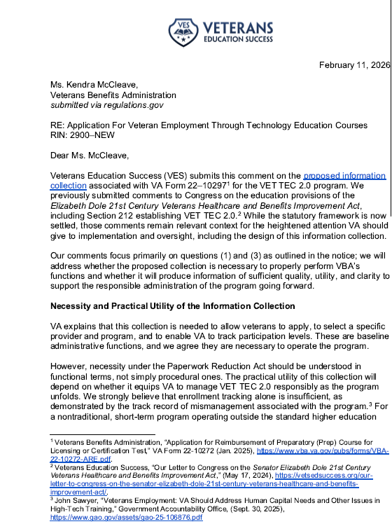
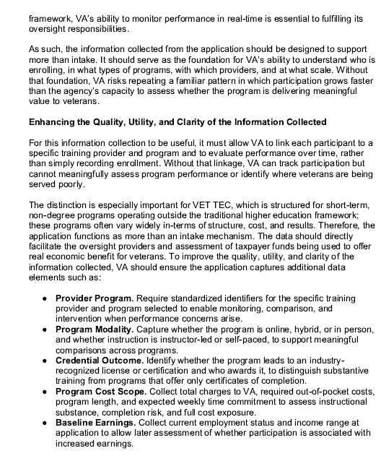
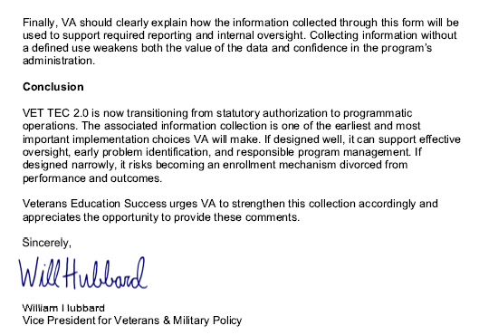
VA RESPONSE:
The Department of Veterans Affairs (VA) value your thoughtful comments regarding the Application for Veteran Employment Through High Technology Education Courses (VET TEC 2.0) Program, VA Form 22-10297."
We appreciate your consideration and recommendations focused on the quality, utility and clarity required to support the responsible administration of the VET TEC 2.0 program, as well as VA’s required information collection and Congressional reporting for this program.
VA acknowledges your concerns; however, VA Form 22-10297, will be utilized solely for the purpose set forth in the Federal Register notice; allowing Veterans to apply for the program, allowing Veterans to provide a Training Provider name(s) who may have qualifying programs in which they are interested in enrolling, and enabling VA to track application levels.
VA Form 22-10297 is not the vehicle designed to monitor or evaluate Training Provider performance or to facilitate oversight. The items you have listed, to include provider programs, program modality, credential outcome, program cost scope and baseline earnings credit are captured, monitored and reviewed via other vehicles, to include:
- The 22-10401, Training Provider Participation Agreement, which has been patterned after the State Approving Agency Uniform Application and has specific Vet Tec 2.0 requirements incorporated.
In addition, Training providers’ curriculum will be evaluated for relevance to high-tech fields ensuring alignment with current industry demands and programs will go through an on-going review for job placement milestones within the field of study
Expert instructors will also be evaluated for relevance to high-tech fields and alignment with current industry demands.
To support these tasks, additional collection methods are being utilized, which include the following:
  - 22-10401a, Programs Request, which collects data such as modality, term structure, tuition and fees, type of hours and when the Training Provider began offering the program.
  - 22-10401b, Completion Rates Report, which collects data for the prior year such as total number of students enrolled and graduated from a program, completion percentage, number of graduated students who are job seeking or employed, and average days from graduation to employment.
  - 22-10401c, Expert Credentials Report, which collects data such as instructors’ names and if they teach the entire program or a specific course, the instructor’s current related certifications/continuing education credentials and requirements for submission of current certifications, resume, and two letters of reference attesting to instructors’ expertise.
- VA Form 22-1999, Enrollment Certification, which collects specific enrollment data for each student certified including tuition and fees, modality and enrollment dates.
- VA Form 22-10299, Veteran Employment through High Technology Education Courses (VET TEC 2.0) Employment Certification, which will collect specific employment and continuing education data after program completion from both student and Training Provider.
We hope you find this information useful. VA appreciates your commitment to enhancing the VET TEC 2.0 Program and supporting our nation’s Veterans and your feedback is invaluable in ensuring program integrity and effectiveness.

COMMENT 3
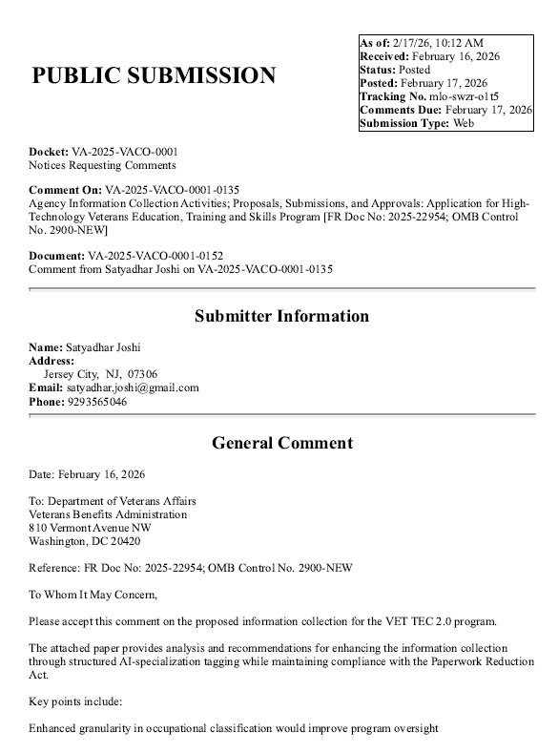
VA RESPONSE:
Thank you for your support regarding improvements to the Veteran Employment Through High Technology Education Courses (VET TEC 2.0) Program. We appreciate your thorough analysis and recommendations focused on enhancing program oversight and utilization of automation techniques. Your proposed recommendations have been submitted to VA leadership for consideration.
COMMENT 4
I read in the Elizabeth Dole Act where each month of training will be equal to one month of entitlement. I feel like this is unfair to certain cohorts of Veterans and will impact these Veterans the most with less than five months of entitlement remaining. It's even more complicated because of the Veterans who qualify under the Rudisill Review. In my case, I have two months remaining under Post 9/11 and 10 months remaining under MGIB. How will the VET TEC entitlement be charged for Veterans who qualify under two education programs and will MGIB participants lose MHA? if so, this should be something lawmakers think about heavily as participants in the program are being retrained and may need the MHA to help with everyday living expenses. Thank you for reading my comment and please keep the veterans interest in the heart.
VA RESPONSE
The Department of Veterans Affairs (VA) appreciates your thoughtful comments regarding the Application for Veteran Employment Through High Technology Education Courses (VET TEC 2.0) Program, VA Form 22-10297. If a Veteran has remaining entitlement under more than one benefit chapter, the Veteran can choose which benefit chapter VA will charge under VET TEC 2.0. If the Veteran does not select a benefit chapter, VA will charge entitlement under the benefit chapter that is most advantageous to the Veteran. In the case of a Veteran with remaining entitlement under both Post 9/11 GI Bill (PGIB) and Montgomery GI Bill-AD (MGIB-AD), entitlement used under VET TEC 2.0 will be charged under MGIB-AD unless the Veteran specifies otherwise. VET TEC 2.0 participants will receive the Monthly Housing Allowance (MHA) regardless under which benefit chapter entitlement is charged.
We hope you find this information useful. VA appreciates your commitment to enhancing the VET TEC 2.0 Program and supporting our nation’s Veterans.
COMMENT 5
I appreciate the opportunity to comment on the proposed information collection for the High Technology Veterans Education, Training and Skills Program. I support efforts to expand workforce training opportunities for veterans, especially programs that focus on current labor market needs and practical skills. At the same time, I have serious concerns that the structure and eligibility framework connected to this initiative will leave out many veterans who would benefit the most.
A primary concern is the decision to tie eligibility for this program to remaining GI Bill entitlement. Many veterans, particularly older veterans and those who served before or shortly after 9 11, no longer have GI Bill benefits available. They may have used their entitlement decades ago, transferred it to dependents, allowed it to expire under older rules, or never qualified for the Post 9 11 GI Bill at all. Conditioning access to a workforce retraining program on leftover education benefits effectively penalizes veterans for having already used a benefit they earned.
The current job market makes this restriction especially harmful. The idea that veterans only need retraining once, early in life, no longer reflects reality. Entire industries are changing or disappearing. Layoffs, automation, age bias, health limitations, and long gaps in employment are affecting veterans across generations. Many veterans now find themselves out of work for extended periods through no fault of their own. Workforce programs must reflect that retraining may be necessary more than once over a lifetime.
For veterans who have been unemployed for a year or more, access to meaningful training is not only about income. Work provides structure, identity, and purpose. When veterans lose connection to those things, isolation grows. At a time when veteran suicide rates remain alarmingly high, programs that help veterans regain direction and see a future for themselves serve an important role beyond job placement. Allowing veterans to participate in a program like this based on employment need and readiness to work, rather than remaining GI Bill entitlement, supports both economic stability and mental health.
I strongly urge VA to expand eligibility or create priority consideration for veterans who have been out of work for over a year and for veterans experiencing homelessness. These groups face the greatest barriers to reentry and are often the least able to access traditional education pathways.
Technology access must also be addressed directly. High technology training assumes access to a reliable computer and stable internet. Many unhoused or housing insecure veterans do not have either. Tablets may be helpful in some situations, but they are not an adequate substitute for a laptop when completing coursework, managing software, or handling large files. Memory and storage limitations create additional barriers. Veterans without stable housing should be able to receive a loaner laptop through existing VA programs, and those without internet access should be provided a mobile WiFi device or data support for the duration of training.
Clear expectations and accountability also matter. Veterans deserve transparency about what participation requires. Attendance standards, participation requirements, and academic expectations should be clearly stated at the outset. At the same time, support should be available for veterans who struggle, including tutoring or mentoring, before punitive actions are considered. Limited program slots should be used in ways that support completion and meaningful outcomes.
Finally, the application process itself should be accessible to veterans with limited technology access, disabilities, or unstable living conditions. Options for assisted applications, mobile friendly design, and in person support through VA facilities or trusted partners would reduce barriers that prevent otherwise qualified veterans from applying.
This program has the potential to help veterans reenter the workforce in a changing economy. To meet that promise, eligibility and program design must center need, access, and real world conditions faced by veterans today. I urge VA to reconsider the GI Bill tie in, prioritize long term unemployed and unhoused veterans, and structure this initiative as a true workforce reintegration program rather than an extension of existing education benefits.
Thank you for the opportunity to provide comment and for considering these concerns.
Respectfully submitted,
J. Johnson
The Black Veteran Newsletter

VA RESPONSE
The Department of Veterans Affairs (VA) appreciates your thoughtful comments and suggestions regarding the Application for Veteran Employment Through High Technology Education Courses (VET TEC 2.0) Program, VA Form 22-10297. We appreciate your consideration and recommendations focused on prioritizing Veterans facing unemployment, expanding access to materials provided under VET TEC 2.0 and outlining expectations and accountability for participants. Due to the number of comments and suggestions, please find responses in bullet format below.
- VET TEC 2.0 eligibility is not tied to remaining educational assistance entitlement. If a Veteran has remaining entitlement it will be charged but if a Veteran has no remaining entitlement, they will be eligible for payment under VET TEC 2.0 if they meet the other eligibility requirements.
- While VA administers the VET TEC 2.0 program, VA must operate within the parameters established in statute. Accordingly, VA is not authorized to expand eligibility, create priority categories, or provide items such as tablets, laptops, or internet access. Only Congress has the authority to amend the law to include such provisions.
- The VET TEC 2.0 program provides students with a books and supplies stipend, in addition to a Monthly Housing Allowance (MHA). The books and supplies stipend may be used to purchase necessary materials or internet access, as determined by the student.
- VA requires Training Providers to meet certain minimum standards related to attendance and academic expectations; however, each Training Provider may establish its own specific requirements. Therefore, VA cannot prescribe a uniform standard applicable to all providers. Veterans interested in participating in VET TEC 2.0 should contact their chosen Training Provider directly for details regarding attendance and academic requirements. Approved VET TEC 2.0 Training Providers will be added to the VA Comparison Tool at https://www.va.gov/education/gi-bill-comparison-tool/ as they receive approval.
- Congress did not include a provision in the law for VET TEC 2.0 to allow payment for the Tutorial Assistance benefit that is available under other GI Bill educational assistance programs. An amendment to the statute would be required for tutoring to be covered.
- Because the VET TEC 2.0 program is designed to support training in high-technology fields, participation requires a baseline level of digital access and technological proficiency. If a Veteran does not have the ability or resources to apply online, it may indicate that this particular program may not align with their current needs or a preparation level that would allow them to be successful in the program.
We hope you find this information useful. VA appreciates your commitment to enhancing the VET TEC 2.0 Program and supporting our nation’s Veterans. Your feedback is invaluable in ensuring program integrity and effectiveness. While we cannot currently incorporate all of your suggestions under the VET TEC 2.0 program, VA remains committed to assisting Veterans in identifying education and training opportunities that best support their goals.
COMMENT 6
The Dole Act was signed into law on 1/2/2025. VET TEC 2.0 was sent to return and launch on 10/01/2025. ...Typical, on brand VA. Furlough or not. Even the website makes no metion of the revised 2.0 version. link: https://www.va.gov/education/about-gi-bill-benefits/how-to-use-benefits/vettec-high-tech-program/

VA RESPONSE
Thank you for your comment regarding the application for the Veteran Employment Through High Technology Education Courses (VET TEC 2.0) Program, VA Form 22-10297 and the subsequent and launch of the VET TEC 2.0 program and website.
The Department of Veterans Affairs (VA) appreciates your interest in implementation of the Dole Act and the VET TEC 2.0 program. As with any statutory change of this scope, successful implementation involves many dependencies, including coordination across program offices, stakeholders, and external partners; alignment of policy and oversight requirements; and development, testing, and deployment of information technology solutions. In particular, VET TEC 2.0 required the design and creation of required system capabilities to pay authorized benefits under the revised program and to ensure accurate eligibility, compliance, and reporting functions. These activities are sequenced to support orderly operations and mitigate risk to beneficiaries and providers.
VA is finalizing the website and other public facing communications as we progress, and a new website providing program details and guidance is set to launch in the near future. We will continue to provide updates through established channels as implementation milestones are reached.
We hope you find this information useful.

