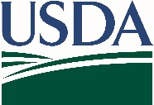
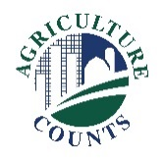
United States Department of Agriculture
National Agricultural Statistics Service

August 28, 2024
What should I do next?

Complete your survey in one of the following ways:

Online at agcounts.usda.gov. Online reporting is fast and secure. You just need your unique survey code on the enclosed form to begin.

By mail or fax. Complete the questionnaire and mail it back in the prepaid return envelope provided or fax it to 855-415-3687.

Why am I getting this letter?

Enclosed is your 2024 September Grain Stocks Report survey. Your participation is important. This survey collects information on stocks of whole grains and oilseeds stored off-farm as of September 1. Please complete the questionnaire at your earliest convenience.

You may receive an email reminder. If we do not receive your completed questionnaire by September 9, we may contact you for an interview.

How will the data be used?

The data help the industry evaluate export potential and calculate the supply of crops available for the marketing year.

We recommend that you respond online at agcounts.usda.gov. On the Respondent Portal, you can complete your survey, track upcoming surveys, access data visualizations and reports of interest, link to other USDA agencies, and more.

The information you provide will be used for statistical purposes only. In accordance with federal law, your responses will be kept confidential and will not be disclosed in identifiable form. We will publish the data
September 30 in the quarterly Grain Stocks report at nass.usda.gov/Publications.

Thank you for your participation and support of U.S. agriculture. For more information about this survey, visit nass.usda.gov/go/GrainStocks. If you need assistance, please contact us at 888-424-7828.

Sincerely,
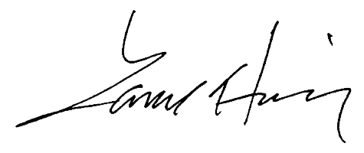

Lance Honig
Chair, Agricultural Statistics Board
USDA National Agricultural Statistics Service

Enclosure

