Supporting Statement – Part A

COMMERCIAL FLORICULTURE SURVEY

OMB No. 0535-0093

In an effort to increase the transparency of NASS's survey processes and provide information on the quality of its estimates, NASS publishes Methodology and Quality Measures Reports for some commodities. The Methodology and Quality Measures Reports are published at the same time or shortly after estimates are released.

This supporting statement incorporates data and methodology from the NASS 2024 Floriculture Crops Methodology and Quality Measures Publication. https://www.nass.usda.gov/Publications/Methodology_and_Data_Quality/Floriculture/08-2024/florqm24.pdf

A. JUSTIFICATION

The National Agricultural Statistics Service (NASS) is asking for an extension of 3 years to an ongoing annual data collection and publication of floriculture data. This is a voluntary ongoing data collection.

1. Explain the circumstances that make the collection of information necessary. Identify any legal or administrative requirements that necessitate the collection. Attach a copy of the appropriate section of each statute and regulation mandating or authorizing the collection of information.

The primary function of the National Agricultural Statistics Service (NASS) is to prepare current official State and national estimates of crop and livestock production, prices, and disposition. According to the 2024 Commercial Floriculture Survey (CFS), 10,216 operations produced floriculture crops that accounted for approximately $6.69 billion in sales at the U.S. level.

Scope and Purpose: The Commercial Floriculture Survey (CFS) is conducted annually and represents all growers that produced and sold $10,000 or more of floriculture crops during the previous year. Currently, the survey is conducted in all 50 States.

All floriculture growers are surveyed to report area used for production, hired labor, and value of sales. Detailed crop information is collected from operations with $100,000 or more in sales. The main types of crops included are cut flowers, annual bedding plants, herbaceous perennials, cut cultivated greens, potted flowering plants, and foliage plants for indoor and patio use. Information is also collected for propagative floriculture materials, including cuttings, liners, plug seedlings, pre-finished plants, and tissue cultures. Crops excluded from this survey are Christmas trees and nursery products such as, but not limited to, deciduous shade trees, fruit and nut trees, evergreen trees, ornamental shrubs and bushes (including roses and azaleas for outdoor landscaping and ornamental purposes), grapevines, and palms for outdoor landscaping. Aquatic and pond plants also are excluded.

Beginning in 2021, data collected from operations with $10,000 or more in sales are published individually for 28 States for the following items: value of all production, number of producers, area used for production, and peak hired workers. Starting in the same year, 22 minor States were published in an ‘Other States’ category. For the list of States included in the ‘Other States’ totals, reference the tables starting on page 4 of this report. For operations with $100,000 or more in sales, items published include number of producers, quantity sold, price and wholesale value for annual bedding/garden plants, potted herbaceous plants, potted flowering plants, foliage plants potted, cut flowers, cut cultivated greens, and propagative floriculture materials. Retail quantity, price, and value began to be published for the 2021 crop year. The publication contains data for the current survey year and the previous survey year. Commercial floriculture data are used by the government to measure the economic impact of the industry and by all segments of the industry to plan future production and marketing strategies.

General authority for these data collection activities is granted under U.S. Code Title 7, Section 2204 which specifies that "The Secretary of Agriculture shall procure and preserve all information concerning agriculture which he can obtain ... by the collection of statistics ... and shall distribute them among agriculturists."

2. Indicate how, by whom, and for what purpose the information is to be used. Except for a new collection, indicate the actual use the agency has made of the information received from the current collection.

Estimates from the CFS are used by all segments of the industry to assess current production levels, potential growth, and resource needs. Some of the industry organizations that rely on the data collected by this survey are the Society of American Florists, the Association of Specialty Cut Flower Growers, the American Orchid Society, the Perennial Plant Association, the California Cut Flower Commission, the Florida Nursery, Growers and Landscape Association, the Colorado Nursery & Greenhouse Association, AmericanHort, the Connecticut Florists Association, and the Certified American Grown.

The Bureau of Economic Analysis (BEA) and the USDA’s Economic Research Service (ERS) rely heavily on this data as a key factor in calculating total farm income and agricultural output. State Departments of Agriculture use the data to monitor growth and development of this industry and promote the exporting of products to other states and other countries.

Financial institutions use these data extensively to evaluate the granting of business loans. The U.S. Department of Agriculture uses the information to allocate grants to land grant universities. Land grant universities, in conjunction with USDA's Extension Service, use data from the floriculture survey to assess alternative agriculture opportunities. The U.S. Department of Labor uses the results of the floriculture survey to estimate the number of workers in the industry. The Environmental Protection Agency uses production figures to determine the extent of pesticide usage.

The International Trade Commission uses these data to address questions on imports and to calculate any injury caused by foreign competitors' unfair trade practices; floriculture data have been used to investigate the dumping of cut flowers by foreign producers. The office of the U.S. Trade Representative, Executive Office of the President, uses the data collected by NASS in their Generalized System of Preference (GSP), which determines preferred imports from other countries. The GSP is used for countries not included in the General Agreement on Trade and Tariff (GATT). Government representatives have used the data for GATT and the North American Free Trade Agreement (NAFTA) negotiations to make decisions regarding the importing of these products.

3. Describe whether, and to what extent, the collection of information involves the use of automated, electronic, mechanical, or other technological collection techniques or other forms of information technology, e.g., permitting electronic submission of responses, and the basis for the decision for adopting this means of collection. Also describe any consideration of using information technology to reduce burden.

The CFS will be available on the internet for anyone who is selected to be in the sample. Operators who do not have access to the internet or who choose not to use it, will still be able to complete the survey on paper, by phone, or in person with one of our field enumerators. In 2024, the response rate using Internet was 15 percent.

4. Describe efforts to identify duplication. Show specifically why any similar information already available cannot be used or modified for use for the purposes described in Item 2 above.

The National Agricultural Statistics Service cooperates with State departments of agriculture and land grant universities to conduct agricultural surveys; they are also coordinated with collections for the Census of Agriculture and the CHS done every 5 years. This survey meets both State and Federal needs, thus eliminating duplication and minimizing reporting burden on the agricultural industry. Data collected on this survey are not available from any other source.

5. If the collection of information impacts small businesses or other small entities (Item 5 of OMB Form 83-I), describe any methods used to minimize burden.

Approximately 95 percent of the operations in the sample are small businesses (as defined in the Small Business Administration’s Table of Small Business Size Standards:

SBA Table of Size Standards

6. Describe the consequence to Federal program or policy activities if the collection is not conducted or is conducted less frequently, as well as any technical or legal obstacles to reducing burden.

The CFS is conducted annually to collect total production and sales figures for the floriculture industry. Since many items included in this survey are seasonal, such as cut roses for Valentine’s Day, bedding plants for summertime, chrysanthemums for fall, and poinsettias for Christmas, the survey must be conducted annually to get a complete data set for this industry.

Collecting data less frequently than annually would not keep data users abreast of changes in the industry or provide data for government needs. There is a significant need for this data to measure production data changes from year to year.

7. Explain any special circumstances that would cause an information collection to be conducted in a manner inconsistent with the general information guidelines in 5 CFR 1320.5.

There are no special circumstances associated with this information collection.

8. Provide a copy and identify the date and page number of publication in the Federal Register of the agency's notice, required by 5 CFR 1320.8 (d), soliciting comments on the information collection prior to submission to OMB. Summarize public comments received in response to that notice and describe actions taken by the agency in response to these comments.

The Notice soliciting comments on this information collection was published in the Federal Register on July 18, 2024, on pages 58329 - 58330. No public comment was received.

Describe efforts to consult with persons outside the agency to obtain their views on the availability of data, frequency of collection, the clarity of instructions and record-keeping, disclosure, or reporting format (if any), and on the data elements to be recorded, disclosed, or reported.

The Society of American Florists has always been one of the primary industry contacts in planning and implementing the floriculture survey. Other producer groups that have been contacted in the past for input include the American Society for Horticultural Science, American Orchid Society, Association of Specialty Cut Flower Growers, Colorado Nursery and Greenhouse Association, AmericanHort, Florida Nursery Growers & Landscape Association, Connecticut Florists Association, Alaska Peony Cooperative, Alaska Peony Growers Association, California Cut Flower Commission, Certified American Grown, and several other State and local growers associations and numerous growers. Local industry specialists, university floriculture staff, and agricultural economists are also consulted on technical issues.

Whenever proposed changes to the questionnaire(s) arise, occasionally NASS will need to consult with the industry representative(s) to verify commodity specific issues. However, the biggest benefit NASS gets from these organizations, occurs when they talk with their members and let them know how this data is useful to them as growers and marketers of floriculture products, and they encourage their members to complete their surveys in a timely manner.

9. Explain any decision to provide any payment or gift to respondents.

There are no payments or gifts to respondents.

10. Describe any assurance of confidentiality provided to respondents and the basis for the assurance in statute, regulation, or agency policy.

Questionnaires include a statement that individual reports are confidential. U.S. Code Title 18, Section 1905; U.S. Code Title 7, Section 2276; and Title III of Pub. L. No. 115-435 (CIPSEA) provide for confidentiality of reported information. All employees of NASS and all enumerators hired and supervised under a cooperative agreement with the National Association of State Departments of Agriculture (NASDA) must read the regulations and sign a statement of compliance.

Additionally, NASS employees and NASS contractors comply with the OMB implementation guidance document, “Implementation Guidance for Confidential Information Protection and Statistical Efficiency Act of 2018, Title III of Pub. L. No. 115-435, codified in 44 U.S.C. Ch. 35” CIPSEA supports NASS’s pledge of confidentiality to all respondents and facilitates the agency’s efforts to reduce burden by supporting statistical activities of collaborative agencies through designation of NASS agents, subject to the limitations and penalties described in CIPSEA.

The following confidentiality pledge statement will appear on all NASS questionnaires.

The information you provide will be used for statistical purposes only. Your responses will be kept confidential and any person who willfully discloses ANY identifiable information about you or your operation is subject to a jail term, a fine, or both. This survey is conducted in accordance with the Confidential Information Protection and Statistical Efficiency Act of 2018, Title III of Pub. L. No. 115-435, codified in 44 U.S.C. Ch. 35 and other applicable Federal laws. For more information on how we protect your information please visit: https://www.nass.usda.gov/confidentiality. Response to this survey is voluntary.

11. Provide additional justification for any questions of a sensitive nature.

There are no questions of a sensitive nature.

12. Provide estimates of the hour burden of the collection of information. The statement should indicate the number of respondents, frequency of response, annual hour burden, and an explanation of how the burden was estimated. If this request for approval covers more than one form, provide separate hour burden estimates for each form and aggregate the hour burdens in Item 13 of OMB Form 83-I. Provide estimates of annualized cost to respondents for the hour burdens for collections of information, identifying and using appropriate wage rate categories.

Burden hour calculations are shown below. The minutes-per-response figures come from cognitive interviews. Cost to the public of completing the questionnaire is assumed to be comparable to the hourly rate of those requesting the data. Reporting time of 11,673 hours is multiplied by $42.75 per hour for a total cost to the public of $ 499,020.75.

NASS uses the Bureau of Labor Statistics’ Occupational Employment Statistics (most recently published on April 3, 2024 for the previous May) to estimate an hourly wage for the burden cost. The May 2023 mean wage for bookkeepers was $23.84. The mean wage for farm managers was $43.35. The mean wage for farm supervisors was $29.23. The mean wage of the three is $32.14. To calculate the fully loaded wage rate (includes allowances for Social Security, insurance, etc.) NASS will add 33% for a total of $42.75 per hour.

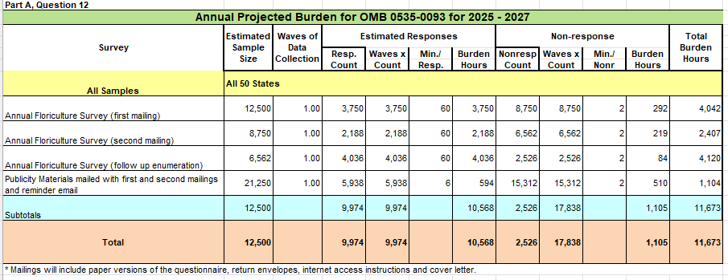
13. Provide estimates of the total annual cost burden to respondents or record keepers resulting from the collection of information, (do not include the cost of any hour burden shown in items 12 and 14). The cost estimates should be split into two components: (a) a total capital and start-up cost component annualized over its expected useful life; and (b) a total operation and maintenance and purchase of services component.

There are no capital/start-up or ongoing operation/maintenance costs associated with this information collection.

14. Provide estimates of annualized cost to the Federal government; provide a description of the method used to estimate cost which should include quantification of hours, operational expenses, and any other expense that would not have been incurred without this collection of information.

The total cost to the Federal government for the CFS is approximately $1,600,000. Most of the total cost goes to federal personnel wages and benefits; the remainder is for data collection, supplies, postage, computer processing, and similar items.

15. Explain the reasons for any program changes or adjustments reported in Items 13 or 14 of the OMB Form 83-I (reasons for changes in burden).

The expected burden is 11,673 hours, up 3,450 hours from the previous approval. The number of responses is 27,812, down 12,280 from the previous approval. The increase in burden hours is due to the elimination of short questionnaire that was used for small operations. The decrease in the number of responses is due to a decrease in number of producers.

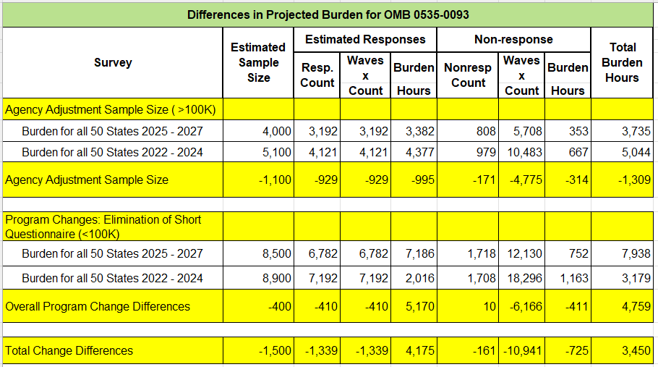

16. For collections of information whose results will be published, outline plans for tabulation and publication. Address any complex analytical techniques that will be used. Provide the time schedule for the entire project, including beginning and ending dates of the collection of information, completion of report, publication dates, and other actions.

Survey Timeline: Data are collected for the previous year’s production beginning in January with a survey mailing. A telephone follow-up is conducted for nonresponse records approximately one month after the mailing. Data collection takes place over a period of approximately eight weeks. Regional field office and Headquarters staff complete analysis, summarization, and review of estimates over a period of approximately four weeks. Estimates are released to the public on the date specified by the Agricultural Statistics Board.

Estimators: The CFS is a complete enumeration of all known floriculture operations with $10,000 or more in sales, and new operations are added to the sample when discovered. A coverage adjustment is made to account for list incompleteness. Response to the CFS is voluntary. Producers may refuse to participate in the survey, may not be located during the data collection period, or may submit incomplete reports. All nonresponse (item and unit) is manually imputed by RFO statisticians. The weights for current items are not adjusted for nonresponse. The measurement of error due to sampling in the current survey period is irrelevant for a fully enumerated census. Moreover, standard errors and coefficients of variation (CVs) are zero for all current data items collected.

Estimation: When all samples are accounted for, all responses are fully edited, and the analysis material is reviewed, Headquarters executes a preliminary summary and a final summary to evaluate and analyze the data. The summary results provide estimates and information used to evaluate the quality of the survey estimates such as response rates and number of usable positive reports.

Regional field offices and Headquarters are responsible for performing a detailed review of the survey results. Any irregularities revealed by the preliminary summary must be investigated and, if necessary, resolved.

Estimates are open to revision the following year if new information becomes available. If an operation responds that was inaccessible for the previous year, the previous year data is reviewed for accuracy and revised if necessary. The previous year estimates are recreated with the updated information and released at the same time as the current year estimates.

The annual results can be found at the following link:

USDA - National Agricultural Statistics Service - Surveys - Floriculture Name

The Census of Horticultural Specialties results can be found at this site.

USDA - National Agricultural Statistics Service - Census of Horticulture

17. If seeking approval to not display the expiration date for OMB approval of the information collection, explain the reasons that display would be inappropriate.

There is no request for approval of non-display of the expiration date.

18. Explain each exception to the certification statement identified in Item 19, “Certification for Paperwork Reduction Act Submissions” of OMB Form 83-I.

There are no exceptions to the certification statement.

September 2024

