2021 AQUACULTURE CENSUS - January 2022
OMB No. 0535-0150
Approval Expires: ??/??/20??
Project Code: XXX
Survey ID:
 |  |  |  |  |  |  |  | United States  Department of  Agriculture
 |  |  |  |  |  |  |  | NATIONAL  AGRICULTURAL  STATISTICS  SERVICE
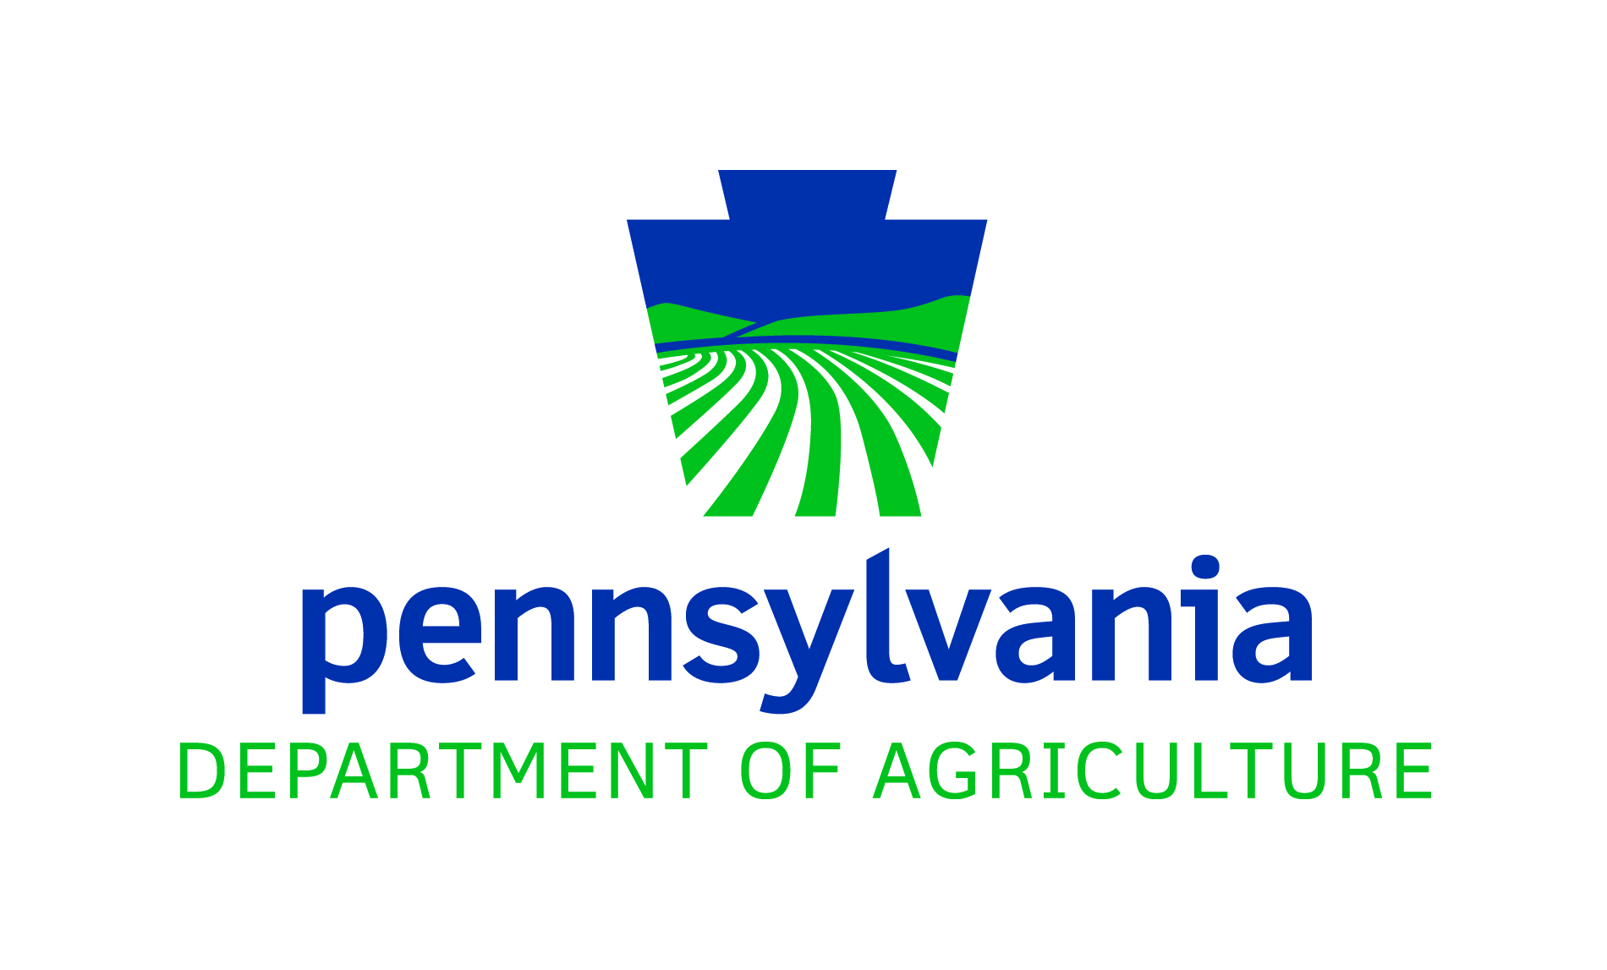

USDA/NASS – Pennsylvania
Northeastern Region
4050 Crums Mill Road, #203
Harrisburg, PA 17112-2875
Phone: 1-800-498-1518
Fax: 1-855-270-2719
E-mail: NASSRFONER@usda.gov
Please make corrections to name, address and ZIP Code, if necessary
This census is being conducted to obtain basic data on aquaculture production per Section 4217 of the Agriculture Act of 1998, which states that Persons licensed shall submit annually a summary report of sales specifying the amount or weight of each species sold and gross receipts. These data will be used as a basis for statistics of the amount of fish, baitfish, crustaceans, and mollusks sold and their value of sales.

Response to this census is required by Pennsylvania law for persons licensed for artificial propagation of aquaculture species. Information you provide will be used only in aggregation with other reports. Your cooperation is extremely important to accurately publish production and sales statistics to provide unbiased data for proper evaluation of the aquaculture industry.

The information you provide will be used for statistical purposes only. Your responses will be kept confidential and any person who willfully discloses ANY identifiable information about you or your operation is subject to a jail term, a fine, or both. This survey is conducted in accordance with the Confidential Information Protection and Statistical Efficiency Act of 2018, Title III of Pub. L. No. 115-435, codified in 44 U.S.C. Ch. 35 and other applicable Federal laws. For more information on how we protect your information please visit: https://www.nass.usda.gov/confidentiality. Response to this survey is voluntary.
According to the Paperwork Reduction Act of 1995, an agency may not conduct or sponsor, and a person is not required to respond to, a collection of information unless it displays a valid OMB control number. The valid OMB number is 0535-0150 The time required to complete this information collection is estimated to average 20 minutes per response, including the time for reviewing instructions, searching existing data sources, gathering and maintaining the data needed, and completing and reviewing the collection of information.

SECTION 1: IDENTIFICATION

1. On land operated by the farm, ranch or individual(s) listed on the label:
CHECK
YES or NO
a. Were any fish, mollusks, crustaceans or other aquaculture  products grown or produced from January 1, 2021 through  December 31, 2021? | □ YES-Continue | □ NO- Continue
b. Did this operation have at least $1,000 in sales of aquaculture  products from January 1, 2021 through December 31, 2021? | □ YES-Continue | □ NO- Continue
c. Were any aquaculture products sold from this  operation from January 1, 2021 through December 31, 2021? | □ YES-Go to Section 3 | □ NO- Continue
- Will any fish, mollusks, crustaceans, or other aquaculture  products be produced in the future? | □ YES-Go to Section 4 | □ NO-Go to Section 4

SECTION 2: DEFINITIONS

The following definitions and explanations provide a more detailed description of the terms used in this questionnaire.

Baitfish - Fish used for bait such as fathead minnows, golden shiners, and feeder goldfish. Examples of fish in the "other" baitfish category include suckers, killifish, chubs, and other types of minnows.

Crustaceans - Invertebrate animals with many jointed legs and a hard external shell, such as crawfish, shrimp, and soft-shell crabs. The "other" category includes other crustaceans such as prawns.

Food fish - Farm raised for food or for either food or sport such as carp, catfish, hybrid striped bass, perch, salmon, sturgeon, tilapia, and walleye. Examples of fish in the "other" food fish category include croakers, moi, redfish, and rockfish.

Hybrid Striped Bass - A cross between a male white bass and a female striped bass.

Mollusks - Invertebrate animals with soft body coverings and shells of 1-18 parts or sections. This category includes the production of clams, mussels, and oysters. Examples of mollusks in the "other" mollusk category include abalone, snails, and quahogs.

Ornamental/aquarium fish - Various fish raised for water gardens such as koi, ornamental goldfish, and ornamental catfish. Examples of fish in the Aquarium fish category include angelfish, guppies, and tropical fish. Ornamental fish are divided into two categories: Aquarium species may not be propagated in open air facilities; Ornamental species can be propagated outdoors.

Other animal aquaculture - The production of alligators, frogs, turtles, and egg and seed stock not listed separately.

Sport/game fish - Farm-raised fish for sport or game fishing, such as largemouth bass, bluegill, crappie, and sunfish. Examples of fish in the "other" sport/game fish category include muskie, northern pike, and small mouth bass.

Value of sales - Gross value received by the producer before marketing and production costs were deducted.

SECTION 3: SPECIES OTHER THAN TROUT
Please complete the table below by recording the aquaculture sales from your operation in 2021. Record the species, species code, amount sold, unit of measure code, and total sales for each species.
Species and Code  (from Table 1 below) |  |  | Amount Sold and Unit of Measure  (from Table 2 below) |  | Total Sales for Each Species  ($)
Line # | Species | Code | Amount Sold | Unit | Total Sales for Each Species  ($)
EX. | Hybrid Striped Bass | 10 | 10,000 | 2 | $26,800
EX. | Frogs | 71 | 20,000 | 1 | $10,000
01 |  | ¹⁰¹ | ²⁰¹ | ³⁰¹ | ⁴⁰¹
02 |  | ¹⁰¹ | ²⁰¹ | ³⁰¹ | ⁴⁰¹
03 |  | ¹⁰¹ | ²⁰¹ | ³⁰¹ | ⁴⁰¹
04 |  | ¹⁰¹ | ²⁰¹ | ³⁰¹ | ⁴⁰¹
05 |  | ¹⁰¹ | ²⁰¹ | ³⁰¹ | ⁴⁰¹
06 |  | ¹⁰¹ | ²⁰¹ | ³⁰¹ | ⁴⁰¹
07 |  | ¹⁰¹ | ²⁰¹ | ³⁰¹ | ⁴⁰¹
08 |  | ¹⁰¹ | ²⁰¹ | ³⁰¹ | ⁴⁰¹
09 |  | ¹⁰¹ | ²⁰¹ | ³⁰¹ | ⁴⁰¹
10 |  | ¹⁰¹ | ²⁰¹ | ³⁰¹ | ⁴⁰¹
11 |  | ¹⁰¹ | ²⁰¹ | ³⁰¹ | ⁴⁰¹
12 |  | ¹⁰¹ | ²⁰¹ | ³⁰¹ | ⁴⁰¹
13 |  | ¹⁰¹ | ²⁰¹ | ³⁰¹ | ⁴⁰¹
14 |  | ¹⁰¹ | ²⁰¹ | ³⁰¹ | ⁴⁰¹
15 |  | ¹⁰¹ | ²⁰¹ | ³⁰¹ | ⁴⁰¹
16 |  | ¹⁰¹ | ²⁰¹ | ³⁰¹ | ⁴⁰¹
17 |  | ¹⁰¹ | ²⁰¹ | ³⁰¹ | ⁴⁰¹
18 |  | ¹⁰¹ | ²⁰¹ | ³⁰¹ | ⁴⁰¹
19 |  | ¹⁰¹ | ²⁰¹ | ³⁰¹ | ⁴⁰¹
20 |  | ¹⁰¹ | ²⁰¹ | ³⁰¹ | ⁴⁰¹

Table 1 – Species Codes

Code | Food fish | Code | Ornamental/Aquarium fish | Code | Crustaceans
10 | Hybrid Striped Bass | 30 | Koi (outdoors) | 60 | Crawfish
11 | Salmon | 31 | Ornamental Goldfish (outdoors) | 61 | Shrimp
12 | Tilapia | 39 | Other outdoor ornamental fish | 62 | Softshell Crabs
13 | Carp | 32 | All aquarium fish | 69 | Other crustaceans
14 | Perch
15 | Catfish | Code | Sport/Game fish | Code | Other Aquaculture
16 | Walleye | 40 | Largemouth Bass | 70 | American Eels
19 | Other foodfish | 41 | Bluegill | 71 | Frogs
 |  | 42 | Crappie | 72 | Tadpoles
Code | Baitfish | 43 | Sunfish | 73 | Newts
20 | Fathead Minnows | 44 | Smallmouth Bass | 77 | Algae and sea vegetables
28 | All other minnows | 45 | Rock Bass | 79 | Other animal aquaculture
21 | Golden Shiners | 46 | Pickerel
22 | Common Shiners | 47 | Bullheads | Table 2
27 | All other shiners | 49 | Other sport/game fish
23 | Suckers | 80 | Other fish than listed above | Code | Units of Measure for Sales
24 | Rosey Reds | Code | Mollusks | Code | Units of Measure for Sales
25 | Feeder Goldfish | 50 | Clams | 1 | Number or count (preferred unit)
26 | All species of Dace | 51 | Mussels | 2 | Pounds live weight
29 | Other baitfish | 52 | Oysters | 3 | Dozen
 |  | 53 | Snails | 4 | Eggs
 |  | 59 | Other mollusks | 5 | Other (specify)

SECTION 4: CHANGE IN OPERATOR

Has this operation (name on label) been sold, or turned over to someone else?

□ YES - Please identify the new operator(s). □ NO - Go to Section 6.

Operation Name:
Operator Name:
Address:
City: |  | State: |  | Zip:
Phone:

SECTION 5: CONCLUSION

1. Do you make any day-to-day decisions for another aquaculture operation?

□ YES - List other operation(s) _____________
□ NO

2. Would you like to receive a free copy of the results of this survey in the mail?

□YES = 1
□YES = 1 | 099
□NO = 3 | 099

REPORTED BY:

DATE:

TELEPHONE: (Area code) (Number)

THANK YOU FOR YOUR COOPERATION.

OFFICE USE

Response |  | Respondent |  | Mode |  | Enum. | Eval. | Office Use for POID
1-Comp  2-R  3-Inac  4-Office Hold  5-R – Est  6-Inac – Est  7-Off Hold – Est  8-Known Zero | 9901 | 1-Op/Mgr  2-Sp  3-Acct/Bkpr  4-Partner  9-Oth | 9902 | 1-Mail  2-Tel  3-Face-to-Face  4-CATI  5-Web  6-e-mail  7-Fax  8-CAPI  19-Other | 9903 | 098 | 100 | 789  __ __ __ - __ __ __ - __ __ __
 |  |  |  |  |  |  |  | Optional Use
 |  |  |  |  |  |  |  | 895 |  | 896
S/E Name

