March 20, 2025

Dear producer,

According to our records, we have still not received your completed 2024 Census of Horticultural Specialties form. If you have recently completed it, thank you. If not, your response is overdue. If you are no longer involved in any horticultural operations, please call us toll free at 888-424-7828 so we can update our records.

Your response will help gather information on U.S. nursery, floriculture, and specialty crop industries. The data are important because it provides the only source of comparable and consistent data to help associations, businesses, and policymakers advocate for your operation and industry.

This survey is a special study to the Census of Agriculture, which means everyone who receives it is required by law (Title 7 USC 2204(g) Public Law 105-113) to respond. Please respond in one of the following ways by April 18, 2025:

- Online – Some questions in your online report form may be pre-filled with information from previous NASS surveys of your operation, helping to make online reporting faster and easier. Go to agcounts.usda.gov and enter your survey code found on the front of the enclosed form to begin.

- By mail – Complete the paper form and return it in the prepaid envelope provided.

You may receive a mail, email, or phone call reminder to complete the survey.

The information you provide will be used for statistical purposes only. In accordance with federal law, your responses will be kept confidential and will not be published in identifiable form. We will publish the data December 16, 2025 at quckstats.nass.usda.gov.

Thank you for your participation and support of U.S. agriculture. For more information about the Census of Horticultural Specialties and how it relates to the Census of Agriculture, visit nass.usda.gov/AgCensus.

Sincerely,
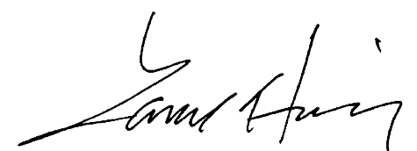
Lance Honig
Chair, Agricultural Statistics Board
National Agricultural Statistics Service
United States Department of Agriculture

Enclosures

