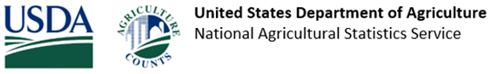
Your response is due by February 15, 2025
The United States Department of Agriculture (USDA) recently mailed you a form for the 2024 Census of Horticultural Specialties. Everyone who receives a Census form is required by law to respond (Title 7 USC 2204(g) Public Law 105-113). If you are not farming or ranching, please call us toll free at 1-888-424-7828 and enter 0 to speak with a representative so we can update our records.
If you have already responded, thank you! If not, please respond by February 15, 2025, in one of the following ways:
- Online at www.agcounts.usda.gov and enter your unique survey code found on the front of the Census of Agriculture form mailed to you.
- Mail your completed Census form back using the prepaid envelope.
All information you provide is confidential and protected by federal law. For more information, visit www.nass.usda.gov/AgCensus.
Thank you for responding and for your support of U.S. agriculture.

