Supporting Statement – Part A

WATER USE SURVEYS

OMB No. 0535-0262

This supporting statement addresses the renewal of the North Carolina Water Use Survey for a period of three years. This project will concentrate on agricultural operations that likely use between 10,000 to 999,999 gallons of water in any one day for agricultural purposes in North Carolina. The reference period will be water used for each calendar year. The survey is required to be conducted for the 2024 calendar year.

Data collected under this docket are for a cooperative agreement between the National Agricultural Statistics Service (NASS) and North Carolina Department of
Agriculture and Consumer Services (NCDACS). The purpose of this survey is to collect annual water use data for agricultural operations that likely use between 10,000 to 999,999 gallons of water a day for agricultural purposes. The results will satisfy the requirements from North Carolina legislation enacted in 2008 (SL2008-0143). The 2024 survey will be the ninth (2008-2024) of the statewide data collection effort by NCDAS and NASS.

A. JUSTIFICATION

This survey is being conducted through a cooperative agreement with the North Carolina Department of Agriculture and Consumer Services. NASS is being fully reimbursed for all expenses.

This survey is being conducted through a cooperative agreement with the North Carolina Department of Agriculture and Consumer Services under a full-cost recovery basis. NASS has cooperative agreements with State Departments of Agriculture and Land Grant Universities to fulfill its mission of providing timely, accurate, and useful statistics in service to United States agriculture. These cooperators often seek the assistance of NASS to provide statistics beneficial to agriculture, but are not covered by NASS’s annual Congressional appropriation. General authority for conducting cooperative projects is granted under U.S. Code Title 7, Section 450a which states that USDA officials may, “enter into agreements with and receive funds…for the purpose of conducting cooperative research projects…”

NASS benefits from these cooperative agreements by: (1) obtaining additional data to update its list of farm operators; (2) encouraging both parties to coordinate Federal survey activities and activities funded under a cooperative agreement to reduce the need for overlapping data collection and/or spread out respondent burden; and (3) facilitating additional promotion of NASS surveys and statistical reports funded by annual Congressional appropriations.

Respondents benefit from these cooperative agreements by: (1) having their reported data protected by Federal Law (Confidential Information Protection and Statistical Efficiency Act of 2018, Title III of Pub. L. No. 115-435, codified in 44 U.S.C. Ch. 35); (2) having data collection activities for Federal and Cooperative surveys coordinated to minimize respondent burden; and (3) having high-quality agricultural data that are important to a state or region be collected and published.

1. Explain the circumstances that make the collection of information necessary. Identify any legal or administrative requirements that necessitate the collection. Attach a copy of the appropriate section of each statute and regulation mandating or authorizing the collection of information.

The primary function of the National Agricultural Statistics Service (NASS) is to prepare and issue current official State and national estimates of crop and livestock production, value, disposition, and resource use.

General authority for these data collection activities is granted under U.S. Code Title 7, Section 2204. This statute specifies that "The Secretary of Agriculture shall procure and preserve all information concerning agriculture which he can obtain ... by the collection of statistics ... and shall distribute them among agriculturists."

2. Indicate how, by whom, and for what purpose the information is to be used. Except for a new collection, indicate the actual use the agency has made of the information received from the current collection.

NASS will conduct a census of agricultural operations that likely use between 10,000 to 999,999 gallons of water in any one day for agricultural purposes in North Carolina. The universe size is around 4,000 operations. The operations will be asked to provide monthly or daily water use and the source (ground or surface water) by county.

For operations that are unable to provide water use data, an estimation guide is included in the questionnaire that the respondents can use to estimate their water usage based on their agricultural production data.

The summarized and published information will be analyzed by the NCDACS and data users to investigate water use in North Carolina to include

- Average number of days per month there was demand for 10,000 to 999,999 gallons of water per day.
- Average daily usage of water for operations that use 10,000 to 999,999 gallons of water in any one day.
- Aggregated statistics for operations that use 10,000 to 999,999 gallons of water in any one day by county and hydrologic unit code.

3. Describe whether, and to what extent, the collection of information involves the use of automated, electronic, mechanical, or other technological collection techniques or other forms of information technology, e.g., permitting electronic submission of responses, and the basis for the decision for adopting this means of collection. Also describe any consideration of using information technology to reduce burden.

During this data collection, NASS will mail out a paper questionnaire along with a cover letter and return envelope. There will be instructions to respond via Computer Aided Web Interviewing (CAWI). Operators who do not respond to this mailing or by CAWI will be contacted by a Computer Assisted Telephone Interview (CATI). Data will be collected by a trained National Association of State Departments of Agriculture (NASDA) enumerator.

4. Describe efforts to identify duplication. Show specifically why any similar information already available cannot be used or modified for use for the purposes described in Item 2 above.
NASS cooperates with State departments of agriculture, land grant universities, and other State and Federal agencies to conduct surveys. Wherever possible, surveys meet both State and Federal needs, thus eliminating duplication and minimizing reporting burden on the agricultural industry.

Data on water use for agricultural purposes can only be obtained from farm operators; they are not available from any other source. Agricultural operations who use over 1,000,000 gallons in any one day are required to report their water usage directly to North Carolina Department of Environmental Quality (NC DEQ) and are not included in this survey.

5. If the collection of information impacts small businesses or other small entities (Item 5 of OMB Form 83-I), describe any methods used to minimize burden.

This information collection will not have a significant economic impact on small entities. Out of the estimated universe size of 4,000, approximately 68% are estimated to be classified as small operations.

6. Describe the consequence to Federal program or policy activities if the collection is not conducted or is conducted less frequently, as well as any technical or legal obstacles to reducing burden.

Collecting data less frequently would prevent the agriculture industry from being kept abreast of water use changes for North Carolina.

7. Explain any special circumstances that would cause an information collection to be conducted in a manner inconsistent with the general information guidelines in 5 CFR 1320.5.

There are no special circumstances associated with this information collection.

8. Provide a copy and identify the date and page number of publication in the Federal Register of the agency's notice, required by 5 CFR 1320.8 (d), soliciting comments on the information collection prior to submission to OMB. Summarize public comments received in response to that notice and describe actions taken by the agency in response to these comments.

The Federal Register Notice soliciting comments was published on November 20, 2023 on pages 80688-80689.

Describe efforts to consult with persons outside the agency to obtain their views on the availability of data, frequency of collection, the clarity of instructions and record-keeping, disclosure, or reporting format (if any), and on the data elements to be recorded, disclosed, or reported.

NASS consulted with the following individuals on the Water Use Survey:

David Smith, Chief Deputy Commissioner
N C Department of Agriculture & Consumer Services

Dr. Joe French
Assistant Commissioner of Agricultural Services
NC Department of Agriculture and Consumer Services

Tim Watkins
Chief Deputy Secretary
North Carolina Department of Environmental Quality (DEQ)

Mitch Peele
Senior Director, Public Policy
North Carolina Farm Bureau

9. Explain any decision to provide any payment or gift to respondents.

No payment or gifts will be provided to respondents.

10. Describe any assurance of confidentiality provided to respondents and the basis for the assurance in statute, regulation, or agency policy.

Questionnaires include a statement that individual reports are confidential. U.S. Code Title 18, Section 1905; U.S. Code Title 7, Section 2276; and Title III of Pub. L. No. 115-435 (CIPSEA) provide for confidentiality of reported information. All employees of NASS and all enumerators hired and supervised under a cooperative agreement with the National Association of State Departments of Agriculture (NASDA) must read the regulations and sign a statement of compliance.

The following confidentiality pledge statement will appear on all NASS questionnaires.

The information you provide will be used for statistical purposes only. Your responses will be kept confidential and any person who willfully discloses ANY identifiable information about you or your operation is subject to a jail term, a fine, or both. This survey is conducted in accordance with the Confidential Information Protection and Statistical Efficiency Act of 2018, Title III of Pub. L. No. 115-435, codified in 44 U.S.C. Ch. 35 and other applicable Federal laws. For more information on how we protect your information please visit: https://www.nass.usda.gov/confidentiality. Response to this survey is voluntary.

11. Provide additional justification for any questions of a sensitive nature.

There are no questions of a sensitive nature.

12. Provide estimates of the hour burden of the collection of information. The statement should indicate the number of respondents, frequency of response, annual hour burden, and an explanation of how the burden was estimated. If this request for approval covers more than one form, provide separate hour burden estimates for each form and aggregate the hour burdens in Item 13 of OMB Form 83-I. Provide estimates of annualized cost to respondents for the hour burdens for collections of information, identifying and using appropriate wage rate categories.

Burden hours based on the average completion time per questionnaire are summarized below.

Burden hour calculations are shown below. The minutes-per-response figures are estimated based on previous surveys. Annual burden for this survey is estimated at 1,918 hours.

Cost to the public of completing the questionnaire is assumed to be comparable to the hourly rate of those requesting the data. Reporting time of 1,918 hours is multiplied by $40.51 per hour for a total cost to the public of $ 77,698.18.

NASS uses the Bureau of Labor Statistics’ Occupational Employment Statistics (most recently published on April 25, 2023 for the previous May) to estimate an hourly wage for the burden cost. The May 2022 mean wage for bookkeepers was $22.81. The mean wage for farm managers was $40.29. The mean wage for farm supervisors was $28.28. The mean wage of the three is $30.46. To calculate the fully loaded wage rate (includes allowances for Social Security, insurance, etc.) NASS will add 33% for a total of $40.51 per hour.

Estimated Sample Size and Respondent Burden for the 2024-2026 surveys:

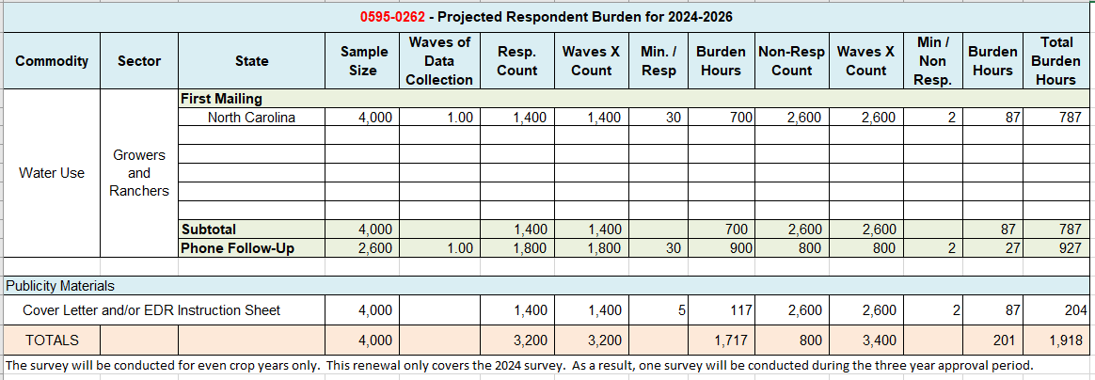

13. Provide an estimate of the total annual cost burden to respondents or record-keepers resulting from the collection of information.

There are no capital/start-up or ongoing operation/maintenance costs associated with this information collection.

14. Provide estimates of annualized cost to the Federal government; provide a description of the method used to estimate cost which should include quantification of hours, operational expenses, and any other expense that would not have been incurred without this collection of information.

The projected annual cost to conduct the Water Use Survey is approximately $184,300 for each fiscal year, most of which is staff costs. The costs will be reimbursed by the North Carolina Department of Agriculture and Consumer Services. There will be no cost to the Federal government.

15. Explain the reasons for any program changes or adjustments reported in Items 13 or 14 of the OMB Form 83-I (reasons for changes in burden).

There is an increase in the burden hours from the previous submission. The increase resulted from changes to the target population. The previous submission was 1,773 hours annually and this submission is 1,918 hours.

There is an increase in the sample size from the previous submission. The previous submission was 3700 and this submission is 4000.

.

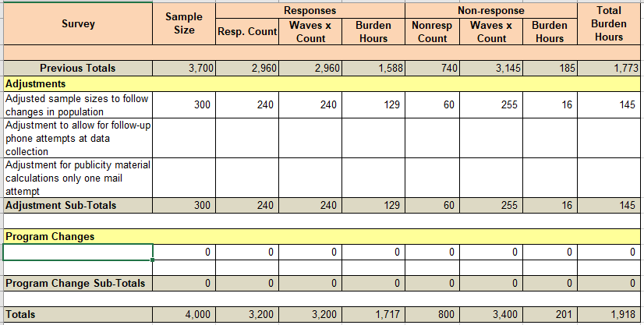

16. For collections of information whose results will be published, outline plans for tabulation and publication. Address any complex analytical techniques that will be used. Provide the time schedule for the entire project, including beginning and ending dates of the collection of information, completion of report, publication dates, and other actions.

The Regional Field Office (RFO) is responsible for manually editing and processing the questionnaires. The RFO creates and provides editing guidelines and estimation documentation to help ensure that all questionnaires are edited and analyzed in a consistent manner. After the data has been key entered and run through computer edits, detailed computer analyses and summaries of the data are provided by the RFO for evaluation and estimation.

In July, estimates of water usage will be published in a Water Use report. The 2020 report can be found at this link: https://www.ncagr.gov/agricultural-statistics/2020-water-use-survey-report/open

2024 Survey:
Survey design August-September, 2024
Sample selection November 2024
Mail Survey December, 2024
Phone Follow-up January – April, 2025
End of Data Collection April, 2025
Publication July, 2025

17. If seeking approval to not display the expiration date for OMB approval of the information collection, explain the reasons that display would be inappropriate.
No approval is requested for non-display of the expiration date.

18. Explain each exception to the certification statement identified in Item 19, “Certification for Paperwork Reduction Act Submissions” of OMB Form 83-I.

There are no exceptions to the certification statement.

January, 2024

