Summary of changes for 2025 ARMS Phase 3

COSTS AND RETURNS REPORT (CRR) version
(compared to 2023 ARMS Phase 3 CRR)

Section A (Land in Farm/Ranch)

Items 13 and 14 removed. Item 15 is updated and renumbered to item 13 (sub-items a, a(i), b, c, c(i), g, h, i, j, k are new).

13. For each of the conservation management practices listed below, report the total acres on this operation using this practice in 2025.
Acres where practice was used in 2025
Tillage and Cover Crop Practices
a. Cropland acres where no-till practices were used
(i)Of the acres in part a), on how many acres were no-till practices used continuously over the last 5 years?

b. Cropland acres where conservation or reduced tillage, excluding no-till, practices were used
c. Cropland acres where intensive or conventional tillage practices were used
(i)Of the acres in part c), on how many acres were intensive or conventional tillage practices used continuously over the last 5 years?
d. Acres of cover crops harvested for forage (whether grazed or not grazed)
e. Acres of cover crops grazed but not harvested for forage
f. Acres of cover crops not grazed or harvested for forage
Nutrient Management and Other Practices
g. Cropland acres that received manure (but not fertilizer)
h. Cropland acres that received inorganic (synthetic, commercial) fertilizer (but not manure)
i. Cropland acres that received both inorganic (synthetic, commercial) fertilizer and manure
j. Cropland acres where a nitrogen inhibitor or other product was used to slow the breakdown of nitrogen
k. Cropland acres drained by tile
(i)Of these tile drained acres, how many acres include a mechanism for controlled drainage (e.g. control structure, stop logs, risers, or float mechanisms)
l. Rotational or management-intensive grazing

New items 14, 15, 16

14. Did this operation practice alley cropping, silvopasture, or forest farming, or have riparian forest buffers or windbreaks?
Answer options: Yes, No
15. Did this operation use any feed additives such as 3-NOP, seaweed, or nitrates to reduce methane or green house gas (GHG) emissions in your flock/herd?
Answer options: Yes, No
16. Does this operation use what you consider to be regenerative agricultural practices? Answer options: Yes, No

Section B (Acreage, Production, and Cash Sales)
Items 3–5 – Removed

Section E (Marketing and Production Contracts)
Items 3–4 – Removed

Section F (Accounts Receivable & Deferred payments)
add item 2 – updated question wording (this was Section G, item 1 in 2023)

2. During 2025, did this operation produce and sell any crops, livestock, poultry, or agricultural products directly to Consumers, Retails Markets, Institutions, or Intermediate Markets?

Section G-Direct Sales from 2023 ARMS 3 is Removed
Subsequent sections re-lettered

Section G (Government Payments & Other Farm Related Income)
Item 2c(iv) – Removed “pandemic assistance” from EXCLUDE statement

Add new question 2c(iv)a – “Of Item (iv), how much was received from supplemental disaster assistance, including Emergency Commodity Assistance Program (ECAP), Emergency Livestock Relief Program (ELRP), and Supplemental Disaster Relief Program (SDRP)?”

Section I (Farm Assets)
Item 4a – Removed

Section J (Farm Debt)
Items 5–8 – Removed

Section K (Personal Characteristics and Farm Management)
Item 2e – aligns with OMB-SPD-15

Item 6 – aligns with OMB-SPD-15

Items 13–19a – New “Training and Skills” questions (see Appendix A)

Items 20–23b – New “Risk Management” questions (see Appendix B)

Section L (Type of Organization)
Item 1a - Removed

Section M (Farm Producer Household-Income, Assets, & Debt)
Item 3a – add the word “cryptocurrency” to the INCLUDE statement

Items 9–15 – new “Childcare” questions (see Appendix C)

COTTON version
(compared to 2019 ARMS Phase 3 Cotton version)

Section G (Government Payments & Other Farm Related Income)
Item 2c(i) – Removed [Market Facilitation Program payments (tariff off-set payments)]

Add new question 2c(iv)a – “Of Item (iv), how much was received from supplemental disaster assistance, including Emergency Commodity Assistance Program (ECAP), Emergency Livestock Relief Program (ELRP), and Supplemental Disaster Relief Program (SDRP)?”

Section H (Operating & Capital Expenditures)
Add question after #39 for "ATVs, Side by Sides, UTVs, etc." (see 2023 ARMS Phase 3 CRR version); renumber subsequent questions

Item 45 – Remove “ATVs, and…” from the INCLUDE statement

Section K (Personal Characteristics and Farm Management)
Item 2e – aligns with OMB-SPD-15

Item 6 – aligns with OMB-SPD-15

Items 13–19a – New “Training and Skills” questions (see Appendix A)

HOGS version
(compared to 2020 ARMS Phase 3 Hogs version)

Section G (Government Payments & Other Farm Related Income)
Item 2c – Removed

Item 2d – Removed
Renumber subsequent items

Item 2e(i) (now 2c(i))– Removed [Market Facilitation Program payments (tariff off-set payments)]

Add new question 2c(iv)a – “Of Item (iv), how much was received from supplemental disaster assistance, including Emergency Commodity Assistance Program (ECAP), Emergency Livestock Relief Program (ELRP), and Supplemental Disaster Relief Program (SDRP)?”

Item 2f – Removed

Section H (Operating & Capital Expenditures)
Item 8a(i) – Removed

Add question after #39 for "ATVs, Side by Sides, UTVs, etc." (see 2023 ARMS Phase 3 CRR version); renumber subsequent questions

Item 45 – Remove “ATVs, and…” from the INCLUDE statement

Section K (Personal Characteristics and Farm Management)
Item 2e – aligns with OMB-SPD-15

Item 6 – aligns with OMB-SPD-15

Item 12 (now Item 11) – Removed “(work and management time)” wording from the question

Add new Livestock Risk Protection questions (items 14 and 14a):
14. In 2025, did you purchase Livestock Risk Protection (LRP) insurance for hogs (swine)?
___Yes – continue ___No – Go to [next]

a. What was the total number of head covered under LRP? (Do not double count head if the same head were covered by multiple LRP policies) ___[number]____

Item 15 – Removed
Item 16 – Removed
Item 17 – Removed
Item 18 – Removed

Section M (Farm Producer Household-Income, Assets, & Debt)
Item 1j – Removed

Section O (Access to Veterinary Services)
Entire section removed
Re-letter subsequent sections

Section P (Hog and Pig Purchases, Contract Placements and Farrowings)
Item 5 – Removed
Item 6 – Removed

Section Q (Hog Sales and Contract Removals)
Item 2 – Removed

Section R (Hog Feed)
Add new question (new item 3) after item 2 – “What was the typical interval time between deliveries for the highest-volume feed type listed in the table above?” [number of days]
Renumber subsequent question

Section S (Hog Production Feeding and Biosecurity)
Item 1 – Removed
Item 2 – Removed
Renumber subsequent questions

BROILER version
(compared to 2011 ARMS Phase 3 Broiler version)

OVERALL – reformat and align sections A – M with current ARMS Phase 3 survey design.

Section A – changes made to align with current ARMS Phase 3 questionnaires
Add item 2b –

Item 5b, 5c, 5d – Removed
Item 6 – removed
Item 7, 7a, 7b – removed

Add items 8a, 8b, 9 –
Item 8a – moved from Section B
Item 8b – moved from Section C
Item 9 – moved from 2011 Section G
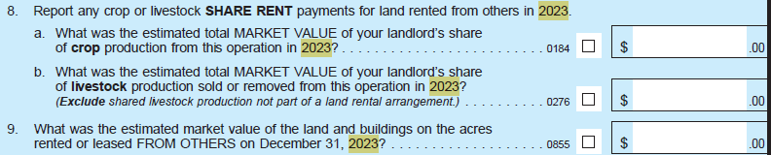

Add item 12 – moved from 2011 Section G

Section B – changes made to align with current ARMS Phase 3 questionnaires
Add item 1 –

Add column 5 to current item 2 table –
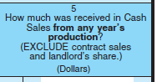

Item 3 – moved to Section A, as item 8a

Section C – changes made to align with current ARMS Phase 3 questionnaires
Add item 1 –
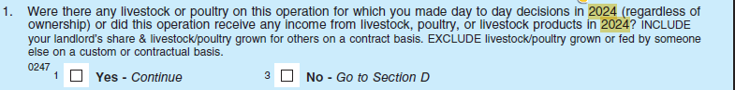

Current Item 2 table – rearrange columns; add column 5
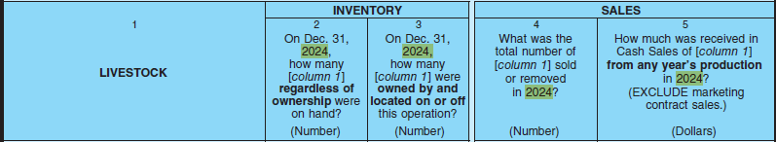

Add items d(i), d(ii) for column 5 only –
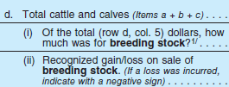

Add item e(i) for columns 4 and 5 only –
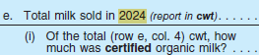

Add items f(i), f(ii) for column 5 only –
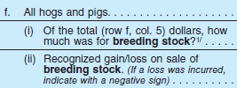

Add items j, k, k(i), k(ii);
k(i) and k(ii) added to column 5 only –
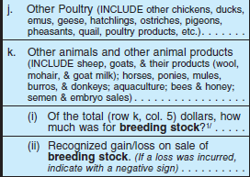

Item 2 – moved to Section A, as item 8b

Item 3 – moved to Section D (Other operations growing, feeding, or raising livestock for this operation)

Items 3a, 3b, 3c – removed

Current Section D (Other Operations growing, feeding, or raising livestock for this operation) – added to 2025 ARMS Phase 3 Broilers to align with current questionnaires
Item 1 – moved to this section from Section C
Table: added
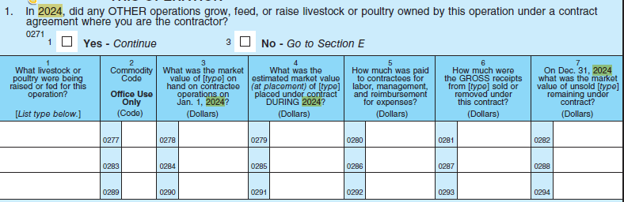

Current Section E (Marketing and Production Contracts) – added to 2025 ARMS Phase 3 Broilers to align with current questionnaires
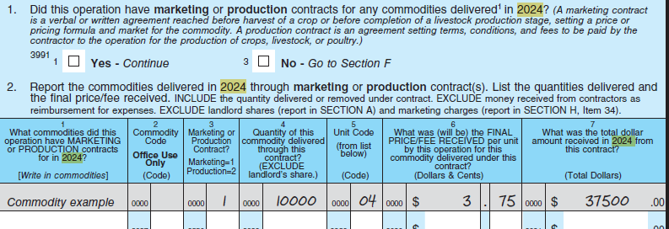

2011 Section D (Commodity Marketing and Income) – removed
Items 1, 2, 3, 4, 5a-5n, 6 – removed
Cash sales are now collected in Sections B and C.

Item 7 – ‘Operator and Partner’ expense now collected in Section H
Item 7 – ‘Landlord’ and ‘Contractor’ columns removed

Item 7a – removed

Items 8a, 8a(i), 8b – moved; Accounts Receivable and Deferred Payments questions are now in their own section, Section F

Current Section F (Accounts Receivable and Deferred Payments) – added to 2025 ARMS Phase 3 Broilers to align with current questionnaires
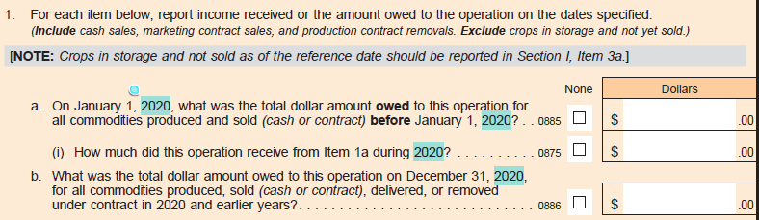

2011 Section E (Other Farm Related Income)
Re-titled to Section G (Government Payments and Other Farm Related Income); changes made to align with current ARMS Phase 3 questionnaires

Items 2, 2a, 2a(i)-2a(iv) – removed
Item 2b – renumbered to 2a
Item 2c – renumbered to 2d
Add items 2b-2c
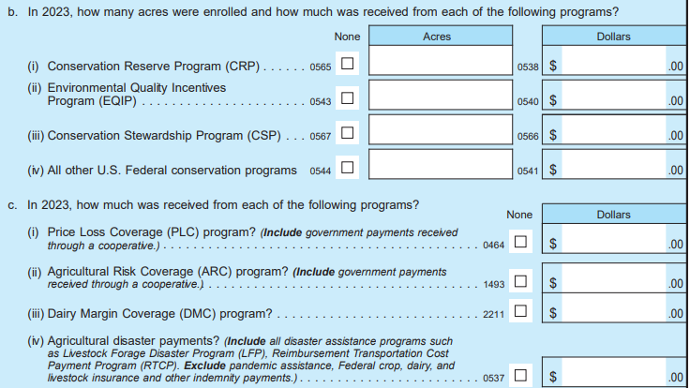

Add new question 2c(iv)a – “Of Item (iv), how much was received from supplemental disaster assistance, including Emergency Commodity Assistance Program (ECAP), Emergency Livestock Relief Program (ELRP), and Supplemental Disaster Relief Program (SDRP)?”

Item 3 – removed; renumber subsequent items

Item 4 – renumbered to item 3
Item 4a – renumbered to item 3a
Item 4b – removed

Add items 3b, 3c – renumber subsequent items
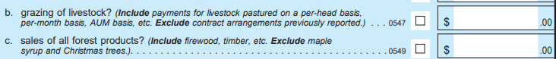

Item 4c – renumbered to item 3d

Add items 3e, 3f, 3g, 3g(i), 3g(ii), 3h, 3i
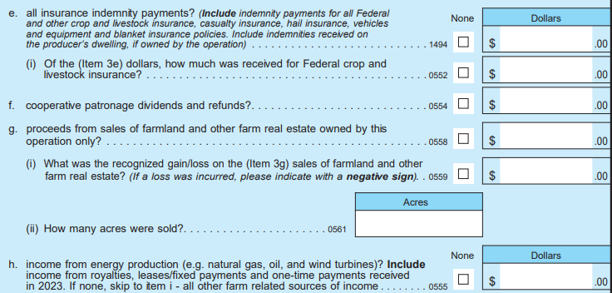
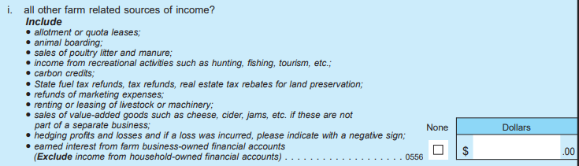

Add item 4
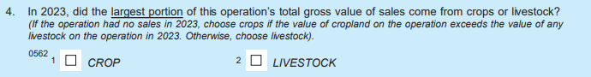

Item 5 – removed

2011 Section F (Operating and Capital Expenditures)
Re-lettered to Section H; changes made to align with current ARMS Phase 3 questionnaires

NOTE: some question images below show “HOG enterprise”; this language will be replaced with “BROILER enterprise”

All Operating expense questions for Landlords and Contractors are removed (columns 2 and 3 removed) EXCEPT for the following four questions. Re-formatted to align with current survey design.
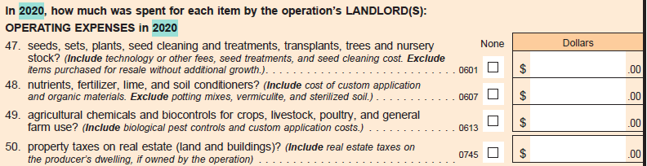

Item 3a – removed
Item 6a – removed
Item 7a – removed
Item 8a – removed
Item 9b – removed
Item 10c(i) – removed
Item 12a – removed
Item 13a – removed
Item 14a – removed
Item 15a(i) – removed
Add Item 15b

Add item 17; renumber subsequent items

Item 23a – removed
Item 25a – removed
Item 26a – removed
Item 27a – removed
Item 28c – removed

Add items 34, 34a; moved from Section D; renumber subsequent items
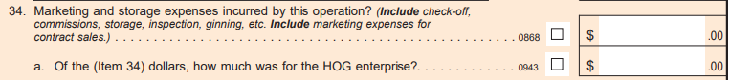

Add item 40; renumber subsequent items

Item 43 – Add question part about “Acres”; “Dollars” is an existing question

Add three questions on Landlord Operating Expenses to align with current survey design:
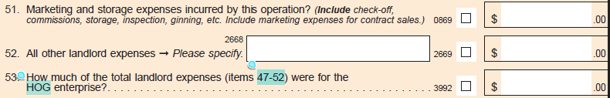

2011 Section G (Farm Assets)
Re-lettered to Section I; changes made to align with current ARMS Phase 3 questionnaires

Add NEW item 1e; re-letter subsequent item

Item 2 – moved to Section A
Item 3 – moved to Section A

2011 Section H (Farm Debt)
Re-lettered to Section J; changes made to align with current ARMS Phase 3 survey design

Add NEW item 1; renumber subsequent items

Items 2, 3, 4 – removed

Add NEW items 3, 4
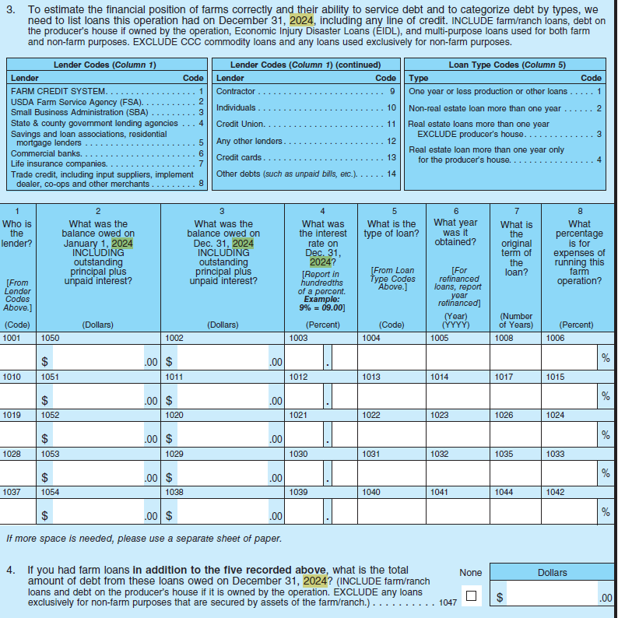

2011 Section I (Farm Management and Use of Time) – changes made to align with current ARMS Phase 3 survey design
Questions in this section have either been removed or moved to different sections

Items 1, 2, 2a, 3, 4, 5, 6, 7, 7a, 8, 8a, 8b – moved to current Section L (Type of Organization)

Item 9 – removed

Items 10, 11, 12, 13, 14, 15 – moved to current Section K (Personal Characteristics and Farm management); re-formatted in Section K

Item 16 – removed

Items 17, 17a, 17b, 17c, 18, 18a, 19a, 19b, 19b(i), 10a, 20b, 21, 22

2011 Section J (Farm Household) – changes made to align with current ARMS Phase 3 survey design
Questions in this section have moved to different sections

Items 1, 2, 3, 4, 5, 6, 7, 7a, 7b, 8, 8a, 8b – moved to current Section K (Personal Characteristics and Farm management); re-formatted in Section K

Items 9a-9j, 13, 14, 15 – moved to Section M (Farm Producer Household-Income, Assets, & Debt)

Items 10, 11, 12 – removed

Current Section K (Personal Characteristics and Farm Management)

Items 1 – 12 – moved from 2011 Section J; showing the current ARMS Phase 3 formatting for these questions
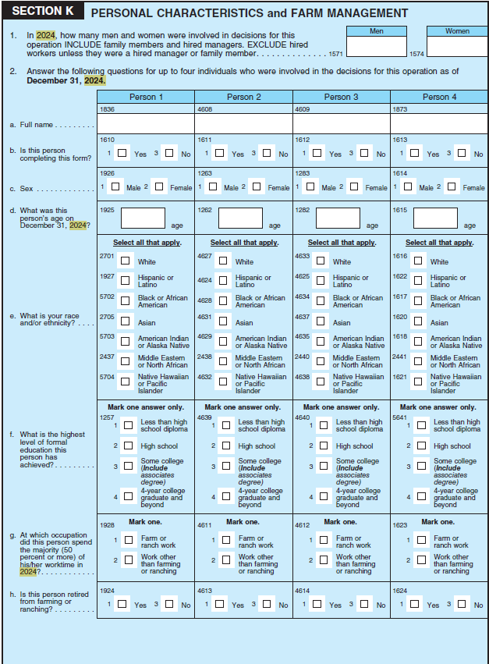
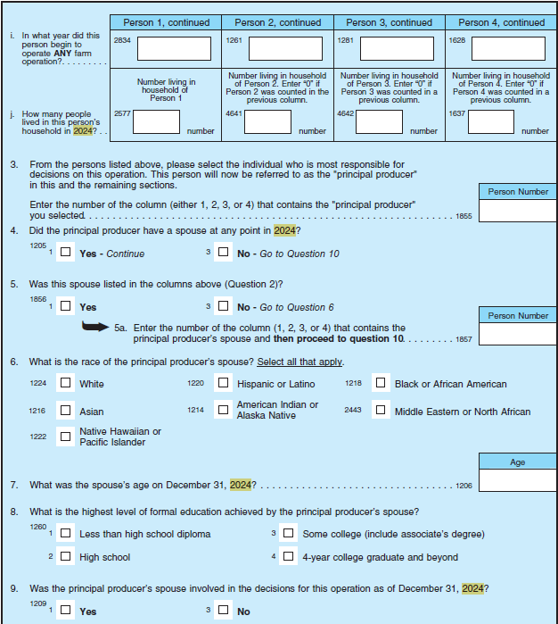
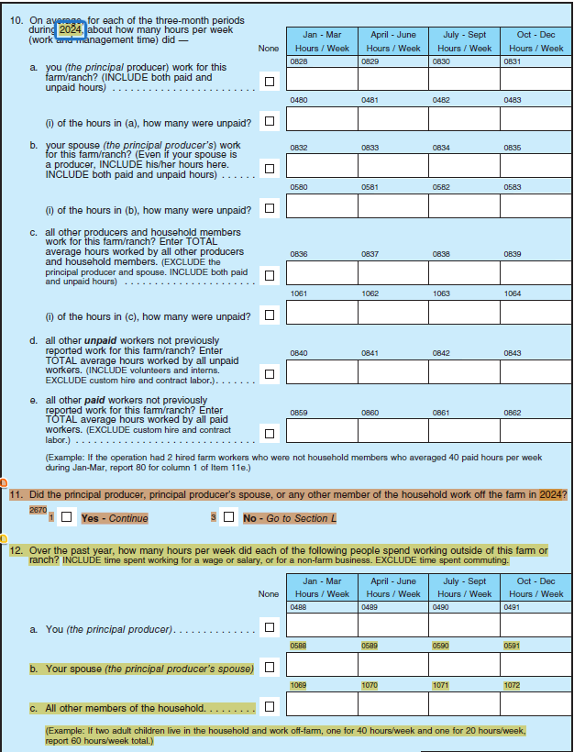

Item 13 – moved from 2011 Section I; showing the current ARMS Phase 3 formatting; “Hog” will be replaced with “Broiler”
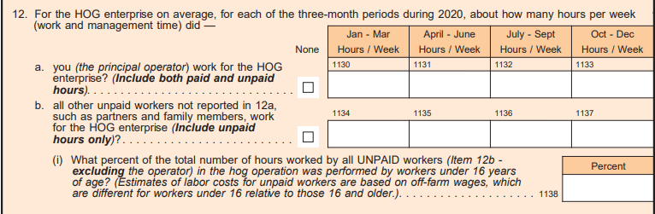

Items 14-16 – moved from 2011 Section I; showing the current ARMS Phase 3 formatting; “Dairy” will be replaced with “Broiler”

Add Current Section L (Type of Organization) to align with current ARMS Phase 3 survey design

Add Current Section M (Farm Producer Household-Income, Assets, & Debt) to align with current ARMS Phase 3 survey design

Section N (Broiler Screening, Inventory, and Certification)

Item 1 – update question wording to “Were 1,000 or more broilers produced for meat on this operation at any time during 2025, regardless of ownership?”

Delete enumerator note below Item 2

Add Item 4a – “Select reason for shut down”
Answer options: rebuilding, quarantine, other
Add item 4b – “How many weeks was this operation shut down?”
Add item 4c – “How many houses were shut down?”

Item 6 – removed
Items 7a, 7b, 7c, 7d – removed

Add NEW items 6a, 6a(i), 6b, 6c:
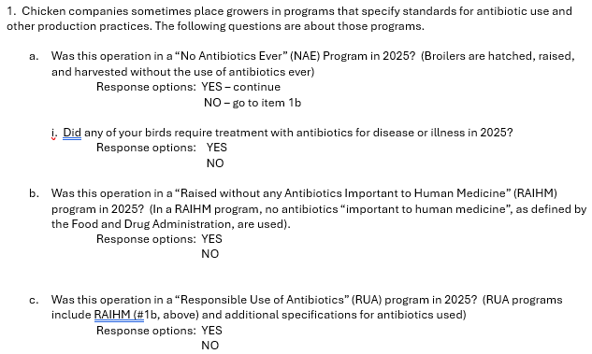

Add NEW item 7, 7a, 7a(i), 7a(ii):
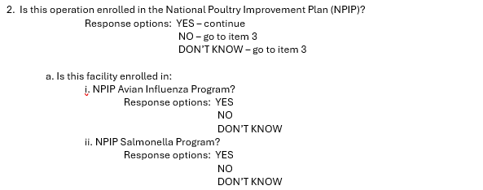

Add item 8, previously Section T, item 6:
Answer options: yes, no, don’t know

Add item 9, previously Section T, item 14:
Answer options: yes, no, don’t know

Section O (Chick Purchases, Placements, and Death Loss)

Item 1 – update question wording to “Were any broiler chicks placed on or purchased for this operation in 2025?”
Updated skip instruction for “NO” – Go to Conclusion
Item 1a – update question wording to “How many live chicks were placed on or purchased for this operation in 2025?”

Items 2, 2a, 2b – removed

Section P (Broiler Sales and Contract Removals)

Items 6a, 6a(i), 6a(ii), 6c, 6c(i) – removed

Item 7a – delete and replace with “a higher based payment for newer houses?”
Add NEW item 7b – “a higher base payment for the use of specified equipment?”
Add NEW item 7c – “a bonus for persistent high performance over multiple flocks?”
Re-number existing 7b, 7c
Item 7d – remove
Item 7f – update to “minimum guaranteed number of birds per flock?”
Item 7g – update to “minimum guaranteed number of flocks per year?”

Item 8 – update to “What is the one-way driving distance, in miles, to your processing plant?”

Section Q (Broiler Feed)

Item 1 – removed

Item 2 – update to “What was the total amount of feed provided to broilers in 2025?”

Item 5 – removed
Add NEW item 5 – “How long is your water withdrawal time before birds are collected?”
Item 7 – update to “Does your feed contain animal byproducts, including poultry or fish?”

Section R (Broiler Housing)

Item 1d – remove
Add NEW item 1d – “Does this house have radian heaters for brooding?”

Item 1e – remove
Add NEW item 1e – “Is this house equipped with gradient or runway lights attached to feedlines?”

Item 1f – removed
Add NEW item 1f – “Is this house equipped with sprinklers for cooling?”

Item 1k – update to “Does this house have automatic static pressure-controlled vent boxes?”

Add NEW item 3 – “Have you had an energy audit or ventilation assessment of this operation?”
Answer options: Yes, No

Section S (Broiler Litter)

STORAGE TYPE CODES:
Code 1 – removed
Code 2 – removed
Add NEW codes: “Covered stockpile with ground liner”; “In-field covered stockpile”; “In-field open stockpile”
Code 3 – update to “Open stockpile with ground liner”

Item 1 – update to “Did this operation have storage facilities for used litter, other than broiler houses, which were used for litter storage in 2025?”
Item 1 table, column 3 – change to “What percentage of litter is stored in this structure type?”
Item 1 table, column 4 – change to “On average, how many days is litter stored in this structure type?”

Add NEW item 2b – “Did you fully clean out but NOT sanitize your poultry houses at any time in 2025?”
Answer options: Yes, No
Re-letter existing items 2b, 2c

Add NEW item 3a – “If yes, how often?”

Add NEW item 5a – “composted on farm?”
Re-letter existing item 5a to 5b and update to “applied directly to fields on this operation?”
Re-letter existing items 5b, 5c

Add NEW items 6b(i) – (iv):
(i) What percentage was surface applied?
(ii) What percentage was incorporated within 3 days?
(iii) What percentage was incorporated within a week?
(iv) What percentage was incorporated after more than a week?

Add NEW item 11 – “Did this operation or a third party calibrate the manure spreader used for application in 2025?”
Answer options: Yes, No
Re-number subsequent items in the section

Section T (Technology)
Change title to “Biosecurity”

Items 5, 8, 10 – removed
Items 6, 14 – moved to Section N

Add NEW item 5 – “In the previous 2 years, were any biosecurity audits or assessments (company or third party) conducted on this farm?”
Answer options: Yes, No, don’t know

Item 7 – renumber to item 6
Item 9 – renumber to item 7

Add NEW items 8, 8a, 8a(i):
In 2025, did this operation use any equipment, other than vehicles, that was also used on other poultry operations (such as lawn mowers, live haul loaders, transport crates, litter/manure handling, tillers/decaking equipment, processing equipment) including equipment that you lent, borrowed, or co-owned with another poultry operation?
Yes - continue No – go to Item 9

- How often was equipment cleaned when it came onto the operation? Mark one.
____Never ____Sometimes ____Always

- Which of the following best describes this operation's cleaning procedures? Mark only one
__Wash equipment with water or steam only
__Chemically disinfect only
__Wash and chemically disinfect equipment
__Other

Add NEW items 9a-9f:
Were the following practices typically followed by workers , including the flock owner, entering and exiting broiler houses?
a. Dedicated protected clothing including disposable or
washable coveralls Yes No
b. Use of masks or respirators Yes No
c. Change of shoes or use of shoe covers Yes No
d. Use of Dutch Bench for changing footwear Yes No
e. Use of footbaths Yes No
f. Wash hands or use hand sanitizer before entering the barn Yes No

Add NEW item 10:
Were the following insect-control methods ever used on this broiler operation?
Mark all that apply
__Diatomaceous earth (environmentally, topically, and/or orally)
__Other environmental fly control (such as sprays, foggers, strips, zappers)
__Insecticides
__Oral products (such as feed-through larvicides)
__Biological control (such as predator wasps)
__Drying out moisture, keeping things clean, removing fresh manure, screen doors/ windows/curtain openings on houses
__Other

Add NEW item 11:
Prior to use, is fresh litter accessible to:
a. Wild birds Yes No
b. Wild animals (e.g., raccoons, opossums, coyotes, foxes)? Yes No
c. Domestic animals (e.g., dogs, cats)? Yes No

Add NEW item 12:
Prior to use, is feed kept in a bin that prevents access from wild or domestic birds or animals? Mark one.
__Always or most of the time
__Sometimes
__Never

Add NEW item 13:
When are feed spills cleaned up on your operation? Mark one.
__Immediately
__Same day as spill
__Same week as spill
__Feed spills not cleaned up within a week

Existing item 11 – renumber to item 14
Existing item 12 – renumber to item 15

Add NEW item 16:
In 2025, how often did you see the following animals or evidence of the following animals:

Animal Type | Seen in the bird production area?  (Include indoor and outdoor bird areas) |  |  |  |  |  | Seen in feed storage area?
Animal Type | Check one box per row |  |  |  |  |  | Check one box per row
Wild waterfowl (e.g. ducks, and geese) | xxxx |  |  |  |  |  | xxxx
Wild waterfowl (e.g. ducks, and geese) |  | Never |  | Sometimes |  | Often |  | Never |  | Sometimes | Often | Often
 |  | Never |  | Sometimes |  | Often |  | Never | 2 | Sometimes |  | Often
Wild birds other than waterfowl | xxxx |  |  |  |  |  | xxxx
Wild birds other than waterfowl |  | Never |  | Sometimes |  | Often |  | Never | 2 | Sometimes | Often | Often
Rodents | xxxx |  |  |  |  |  | xxxx
Rodents |  | Never |  | Sometimes |  | Often |  | Never | 2 | Sometimes | Often | Often
Wild animals other than rodents (e.g. raccoons, skunks, opossums, coyotes, foxes) | xxxx |  |  |  |  |  | xxxx |  |  | Sometimes | Often
 |  | Never | 2 | Sometimes | 1 | Often | 3 | Never | 2 |  | 1 | Often
Poultry from a neighbor | xxxx | Never |  | Sometimes |  | Often | xxxx | Never |  | Sometimes | Often | Often
Poultry from a neighbor | 3 | Never | 2 | Sometimes | 1 | Often | 3 | Never | 2 | Sometimes |  | Often

APPENDIX A – TRAINING and SKILLS questions

Thinking about current production practices…
(Include NONE boxes for each skill in both the principal producer column and the paid workers column. Grayed-out boxes are not allowed to be selected.)
1. What skills are missing, or need to be improved, to meet current production practices? Mark all that apply for both principal producers and paid workers. | Principal producers and other decision makers listed on page xx | Paid workers who are not decision makers listed on page xx
Using Farm Management Information Systems (FMIS)
Mechanical, such as maintaining or repairing equipment
Operating equipment
Using precision agriculture technology
Communication or language to be able to communicate
Specific task/crop skills, such as pruning fruit trees
Animal husbandry
Leadership or supervisory skills
Math or numeration
Other

2. How many of your paid workers need additional skills to meet current production practices?
____None
____Less than 50%
____More than 50%

Thinking about potential changes to production practices…

3. Do you anticipate making changes to production practices within the next 5 years?
____Yes – Continue ____No (Go to Item 6)

4. What changes to production practices do you anticipate making? [SELECT ALL THAT APPLY]
Adopting precision agriculture technology (e.g., automated guidance, variable rate technologies)
Adopting worker replacing technology (e.g., fully robotic planting, harvesting, or pruning)
Adopting technology that increases worker productivity (e.g., remote grain bin monitors,
conveyors to transport harvested product, hydraulic lifts to replace ladders)
Changing the mix of crop and/or livestock commodity production
Changes to fertilization or irrigation practices
(vi) Other Specify: ____________________________

5. Will the potential changes to production practices require any of the producers or paid workers to acquire new skills or improve existing skills?
___Yes – Continue ___No – Go to Item 6

PRINCIPAL PRODUCERS and OTHER DECISION MAKERS  List up to three skills any of the producers will need to learn or improve upon for anticipated changes to production practices:  None | OTHER PAID WORKERS  List up to three skills paid workers will need to learn or improve upon for anticipated changes to production practices: None
1. | 1.
2. | 2.
3. | 3.

6. How will the principal producer or other decision makers obtain the training needed to meet current or potential changes to production practices? [SELECT ALL THAT APPLY]
____No training needed – Go to Item 7
Self-directed training Private company, such as an input dealer or insurance company
Local cooperatives Land grant university Extension workshops or other training
Attend a community or local college USDA, such as technical assistance
Other Specify: ____________________________

7. How will you obtain the training needed for your paid workers to meet current or potential changes to production practices? [SELECT ALL THAT APPLY]
____No training needed – Go to [next section]

Provide training at the operation/farm Send paid workers off site
Hire a private training provider Use a Federal, State, or local government training provider
Other Specify: ____________________________

a. How many of your paid workers would you select for training?
____None – Go to [next section]
____Less than 50%
____More than 50%

APPENDIX B – RISK MANAGEMENT questions

1. In 2025, did you or anyone acting on your behalf use futures or options markets?
___Yes – complete the table ___No – Go to item 2

Commodity | Futures Markets  What were the total bought (long) and sold (short) positions taken in the futures market in 2025? |  | Options Markets  What were the total bought (long) and sold (short) positions taken in the puts and calls options market in 2025?
 |  |  | Puts |  | Calls
 | Bought | Sold | Bought | Sold | Bought | Sold
Corn (bu.)
Soybeans (bu.)
Wheat (bu.)
Hogs (lbs.)
Live Cattle (lbs.)
Feeder Cattle (lbs.)

2. In 2025, did you use accumulator contracts to market any part of the following commodities?
____Corn ____Soybeans ____Wheat

3. In 2025, did you use an average seasonal price contract to market any part of the following commodities?
____Corn ____Soybeans ____Wheat

4. In 2025, did you purchase Livestock Risk Protection (LRP) insurance for hogs, fed cattle, or feeder cattle?
___Yes – continue ___No – Go to [next]

a. What commodity did you purchase LRP for?
___Swine (Hogs) ___Fed Cattle ___Feeder Cattle

b. What was the total number of head covered under LRP? ___[number]____

APPENDIX C – CHILDCARE questions

1. As of December 31, 2025, were there any children in your household age 6 or younger who were not yet in kindergarten?
____Yes (Continue) ____No (Go to next section)

2. How many children were age 6 or younger and not yet in kindergarten?.......................

These next questions only concern the care arrangements for children age 6 or younger on December 31, 2025, who were not yet in kindergarten. Please do not include information about older children.

3. Did you have a care arrangement on a regular basis (at least once a week) for any of these children at any time during calendar year 2025? Do not include care by parents or guardians.
____Yes (Continue) ____No (Go to next section)

4. Please provide the following information for the youngest two children age 6 or younger.
 | Age in years on 12/31/2025 | For how many months in 2025 did you have care arrangements for this child on a regular basis (at least once per week)? | What type(s) of regular care arrangements did this child have during calendar year 2025? Mark all that apply. | What was the average monthly cost of care for your household? Do not include any money received from others to help pay for care.
Child 1 |  |  | ☐ Relative  ☐ Non-relative, home-based setting  ☐ Center-based daycare or school setting | $_______ thousand  ☐ None
Child 2 |  |  | ☐ Relative  ☐ Non-relative, home-based setting  ☐ Center-based daycare or school setting | $_______ thousand  ☐ None

5. How much difficulty did you have finding the childcare you wanted for your child(ren)?
☐ No difficulty (Go to question 7)
☐ A little difficulty
☐ Some difficulty
☐ A lot of difficulty
☐ Did not find the type of childcare I wanted

6. What was the main reason for the difficulty finding care for your child(ren)? Mark only one.
☐ Cost
☐ Location
☐ Quality
☐ Lack of open spots for new children
☐ Child has a special need and could not find appropriate care
☐ Looking for specific hours or schedule
☐ Other

7. Thinking about all of your children age 6 or younger, how much time did all members of your household miss combined in 2025 from work or school either because of failures in childcare arrangements or because you could not find a childcare provider? Mark only one.
☐ None ☐ 1 – 3 weeks ☐ 7 – 9 weeks
☐ Less than 1 week ☐ 4 – 6 weeks ☐ 10 or more weeks

