mPINC 2026 Screenshots - English

Table of Contents
mPINC Survey Introduction Screenshots 2
SECTION A: HOSPITAL DATA 6
SECTION B: SPECIAL CARE NURSERY (SCN) AND / OR NEONATAL INTENSIVE CARE UNIT (NICU) 11
SECTION C: CARE PRACTICES 14
SECTION D: FEEDING PRACTICES 16
SECTION E: EDUCATION AND SUPPORT OF MOTHERS 17
SECTION F: STAFFING 20
SECTION G: POLICIES AND PROCEDURES 23
SECTION H: CONTACT INFORMATION 27

mPINC Survey Introduction
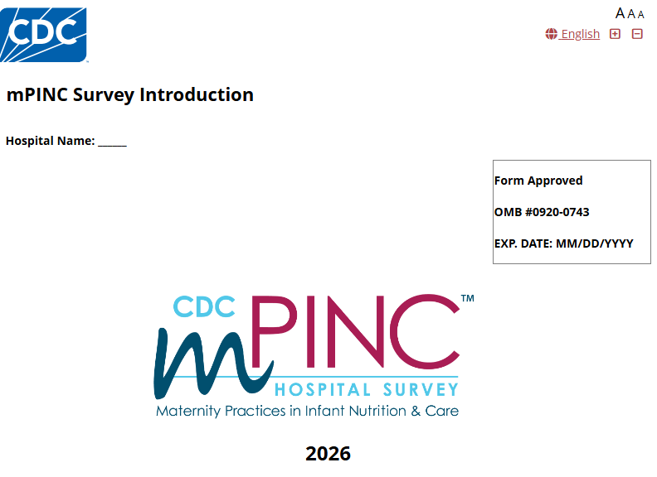
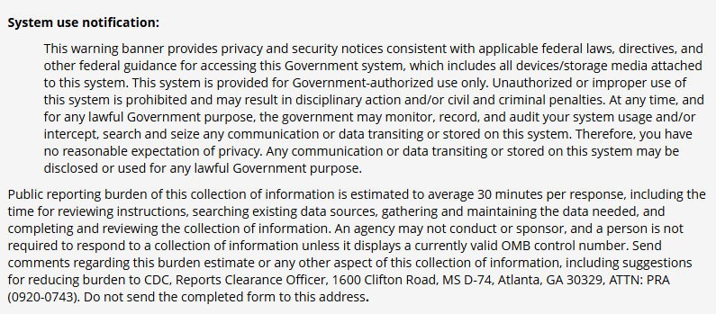
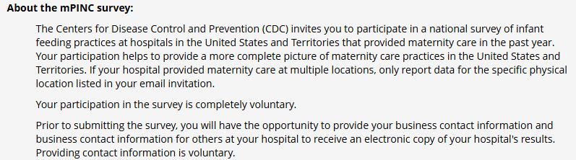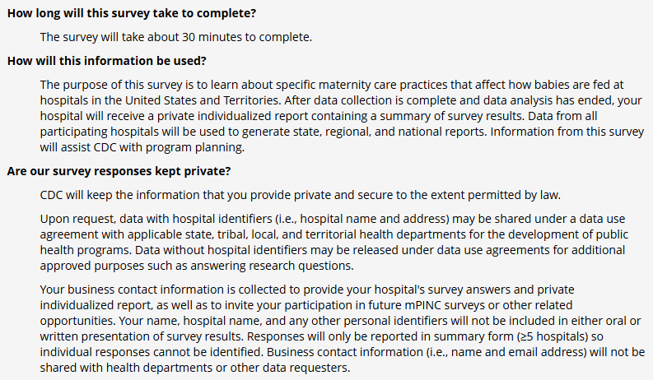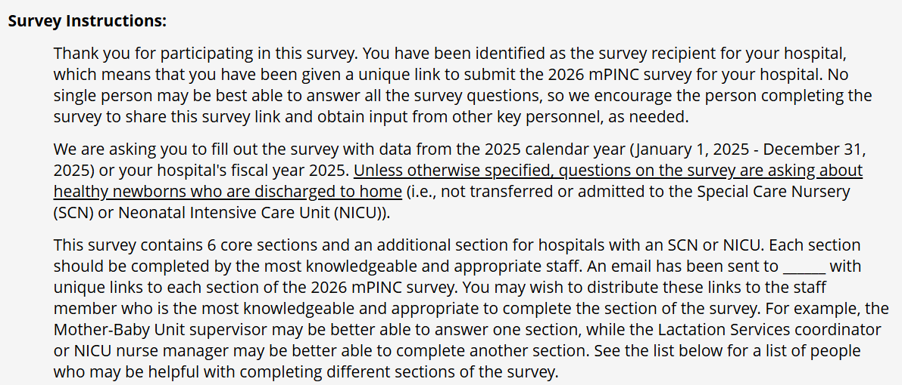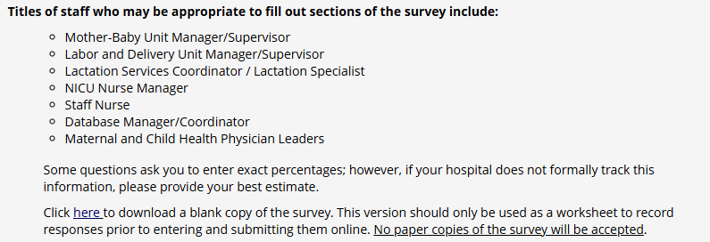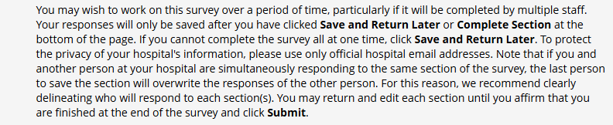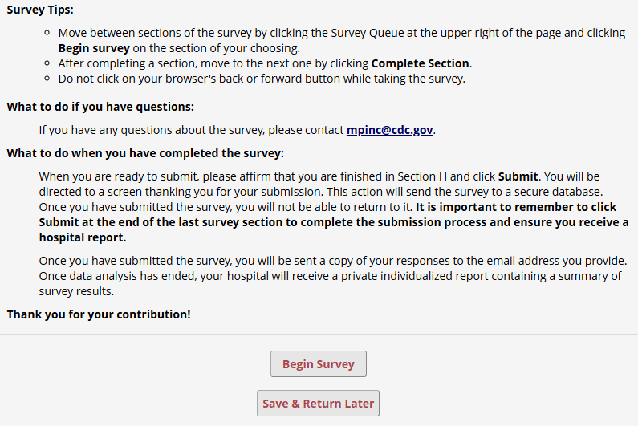

SECTION A: HOSPITAL DATA
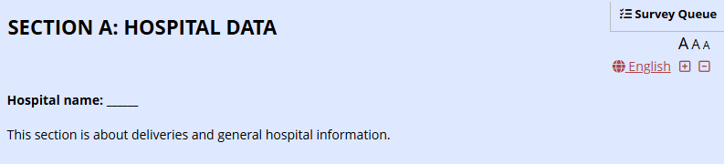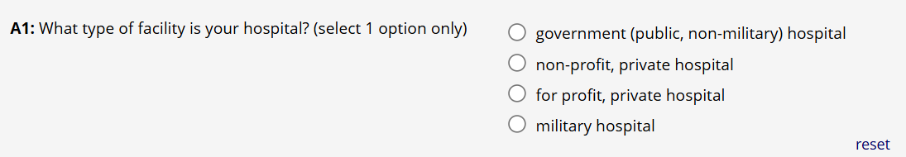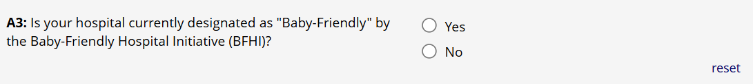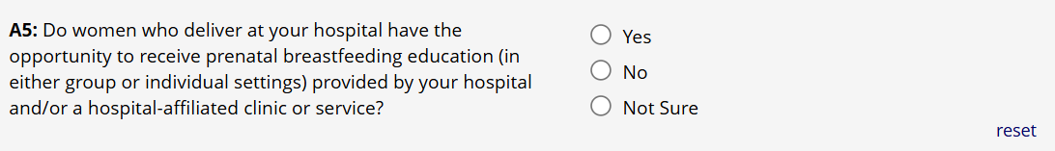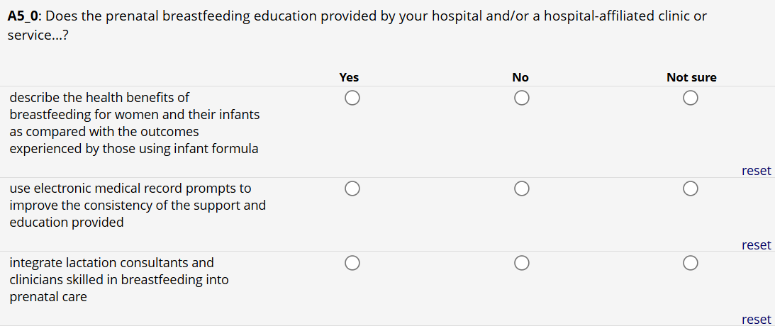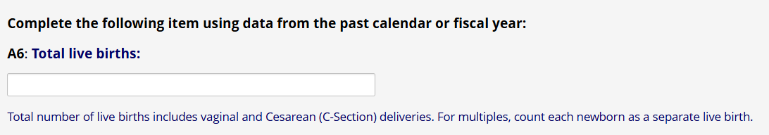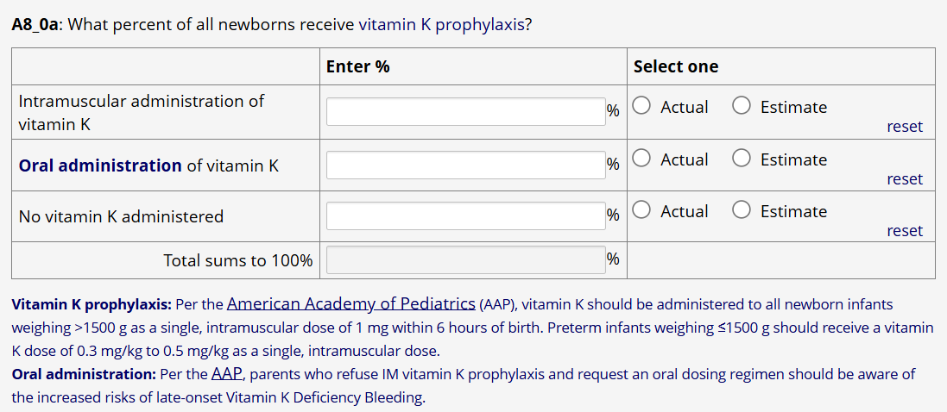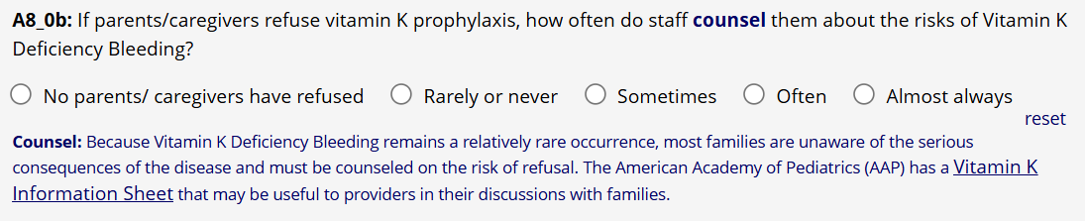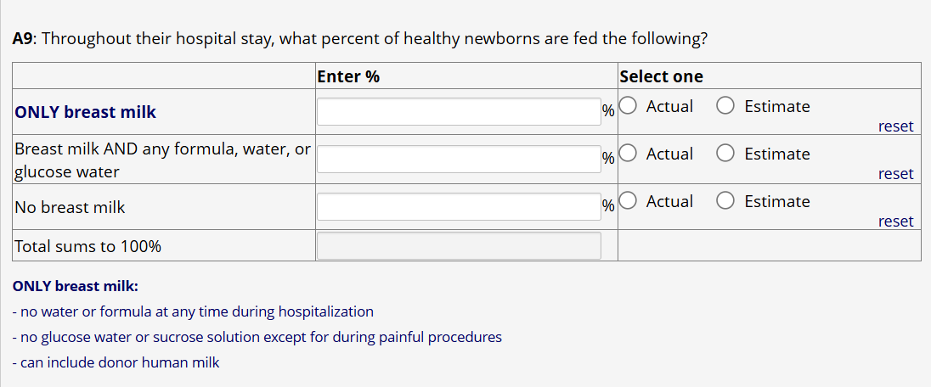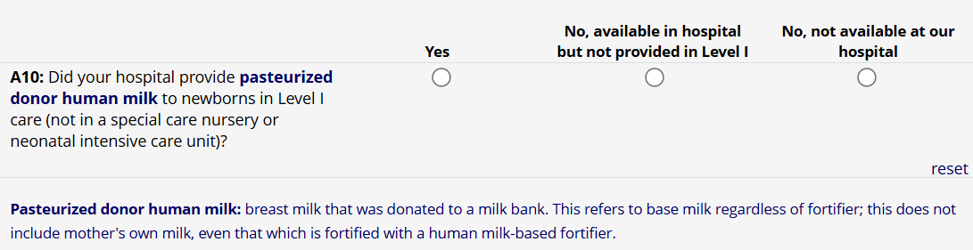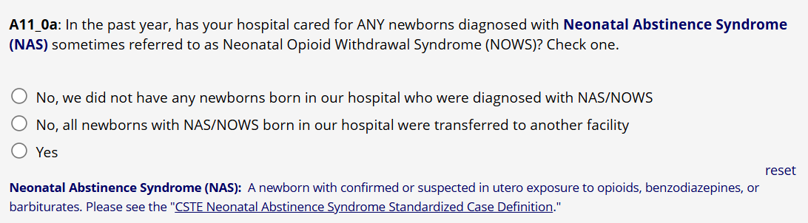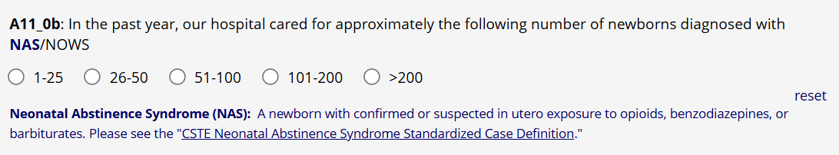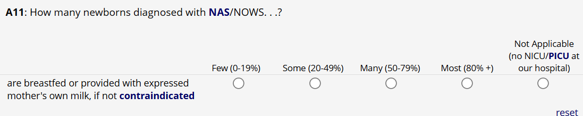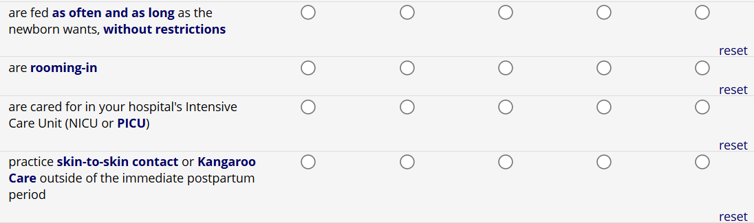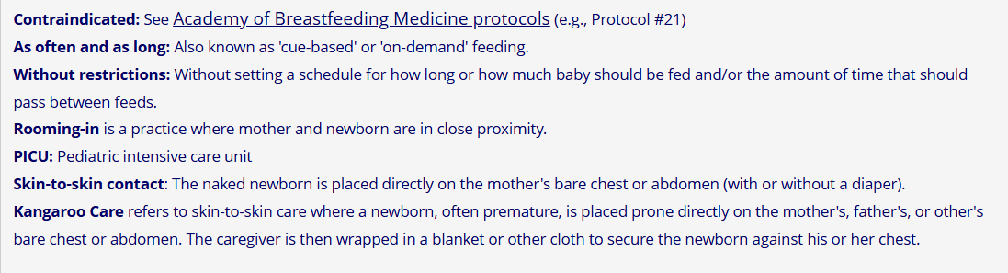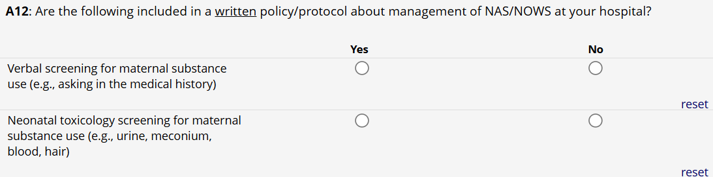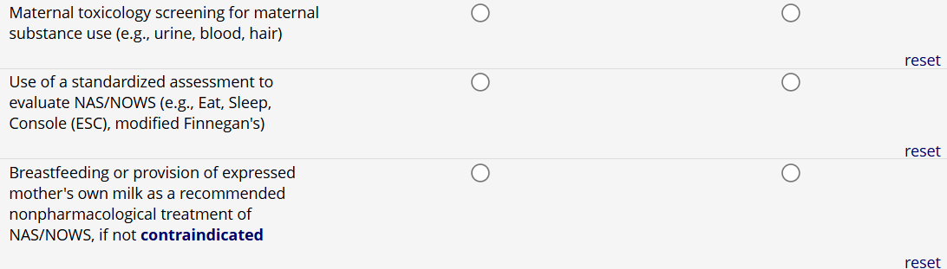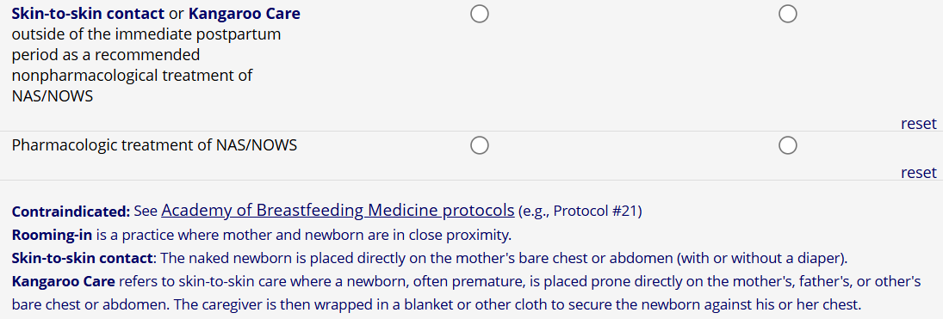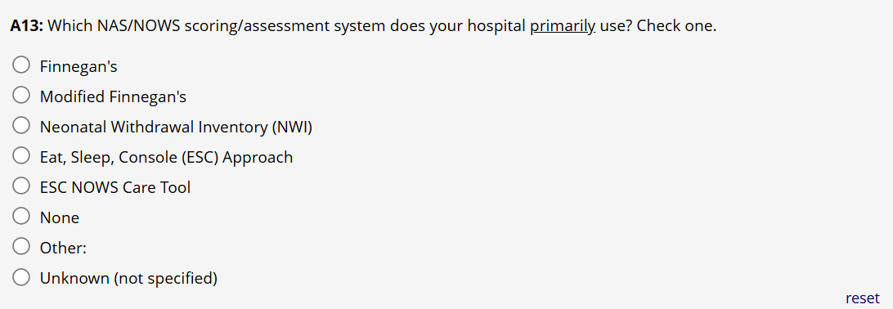

SECTION B: SPECIAL CARE NURSERY (SCN) AND / OR NEONATAL INTENSIVE CARE UNIT (NICU)
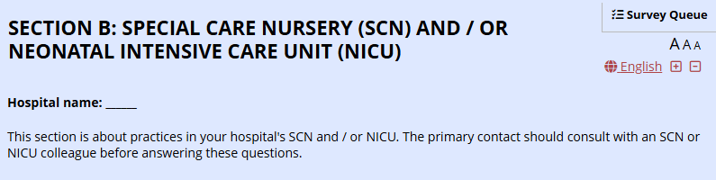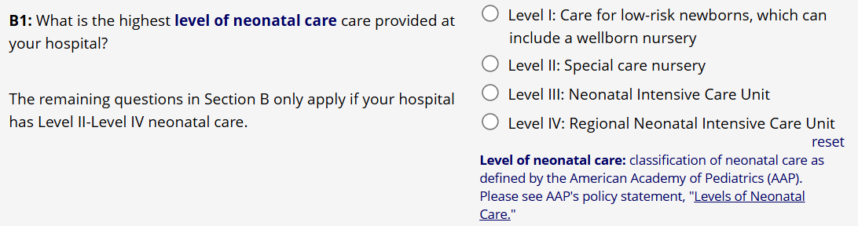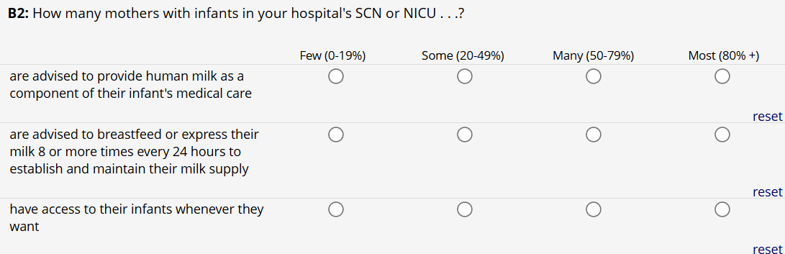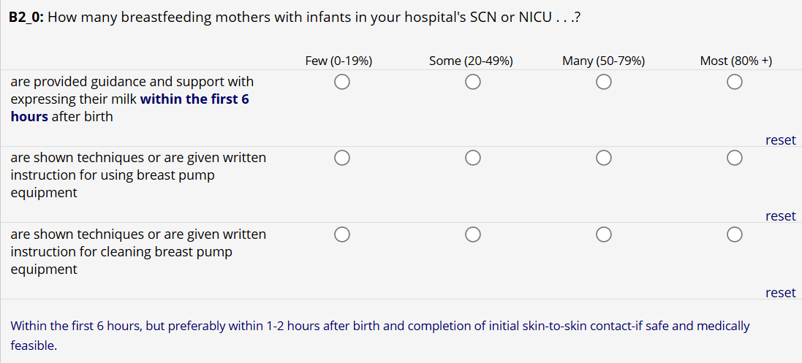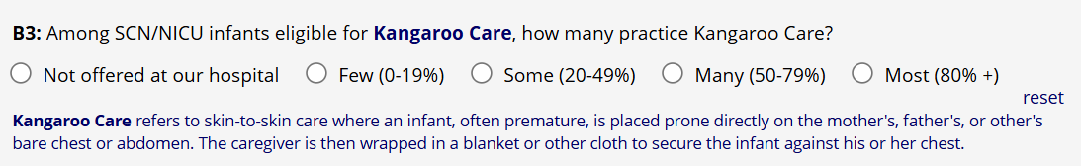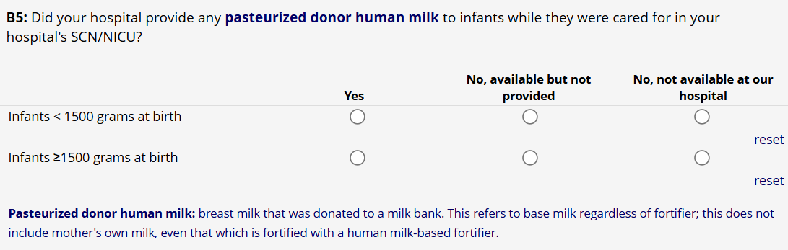
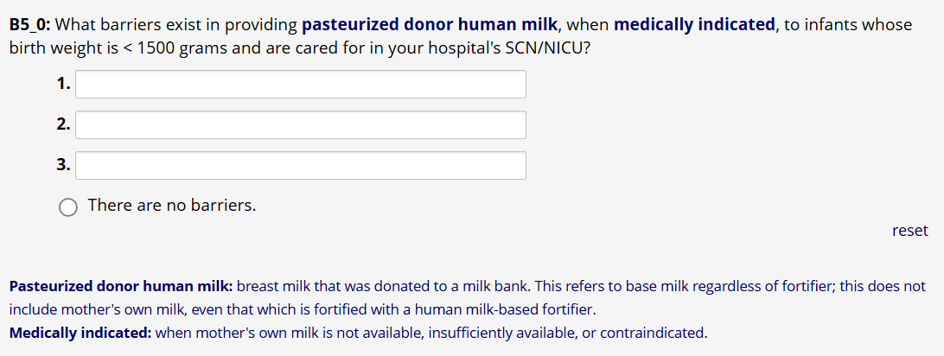

SECTION C: CARE PRACTICES
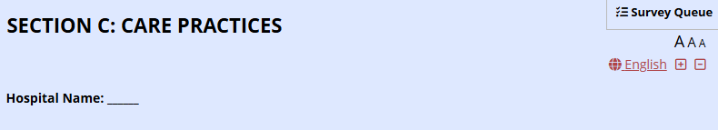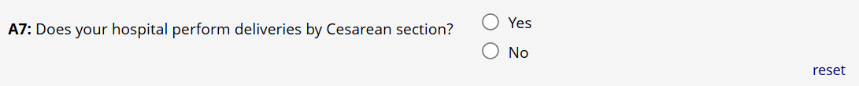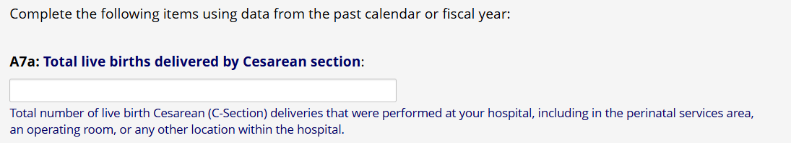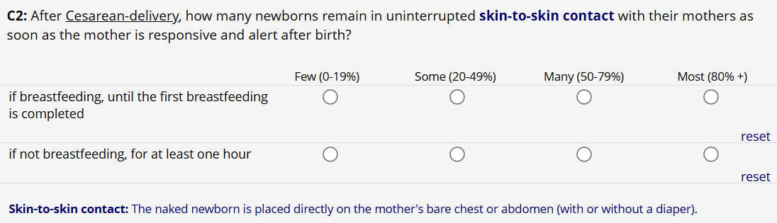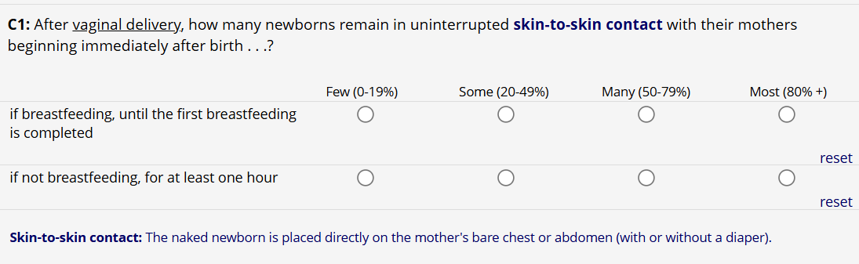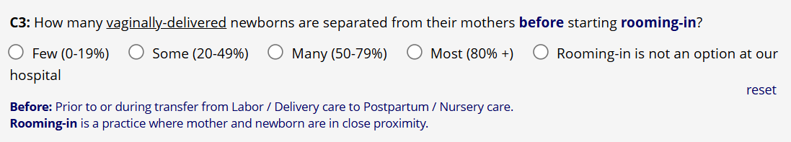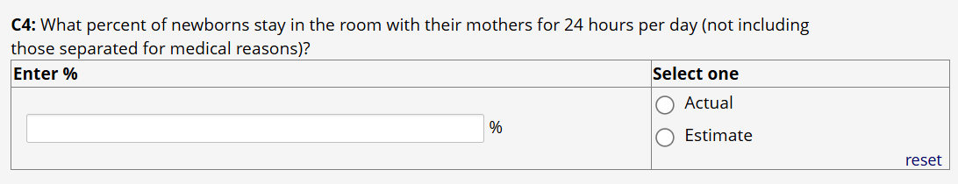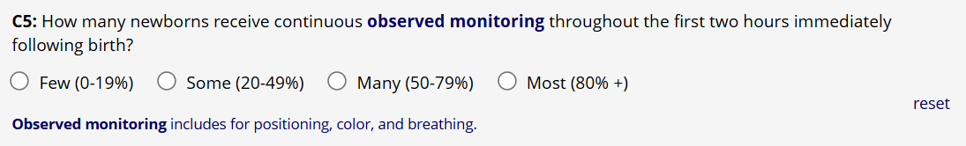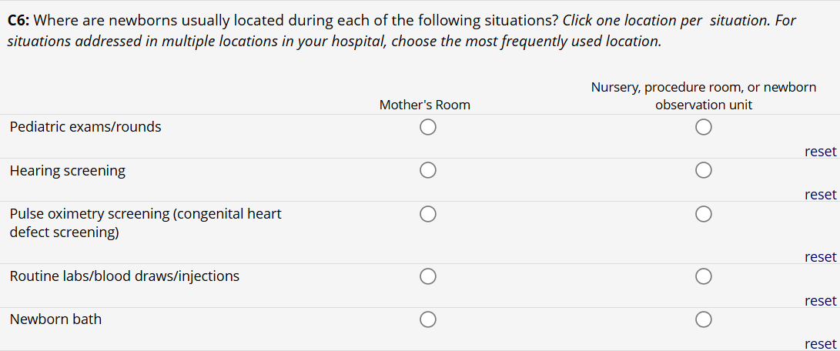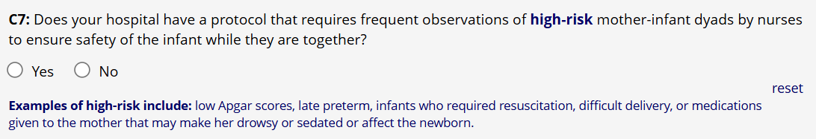

SECTION D: FEEDING PRACTICES
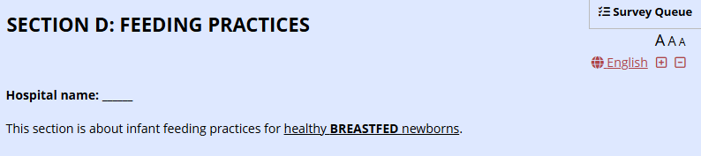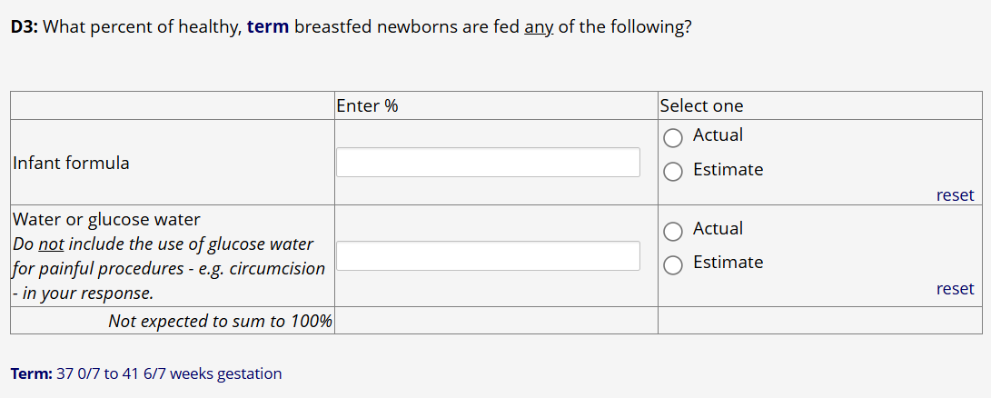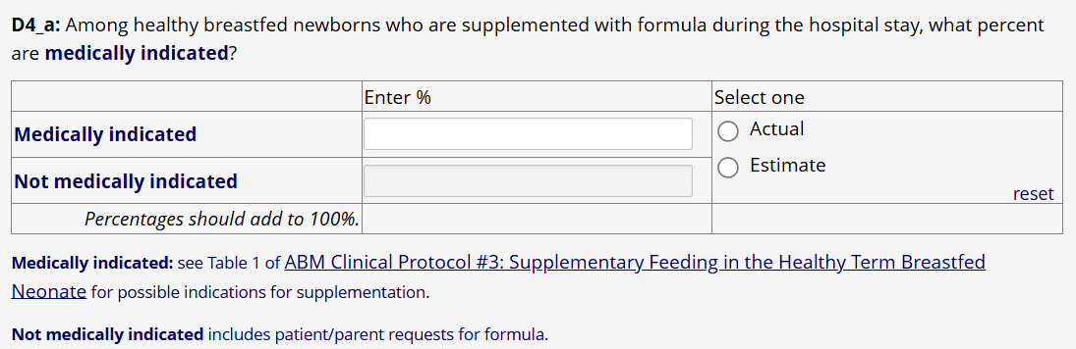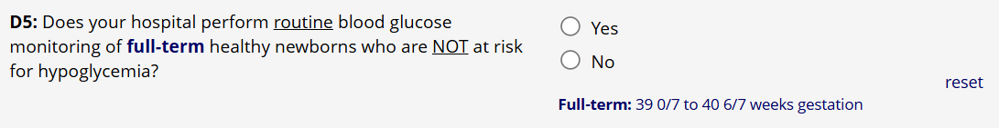

SECTION E: EDUCATION AND SUPPORT OF MOTHERS
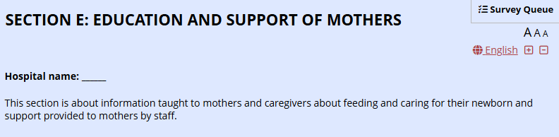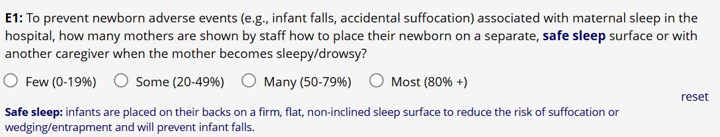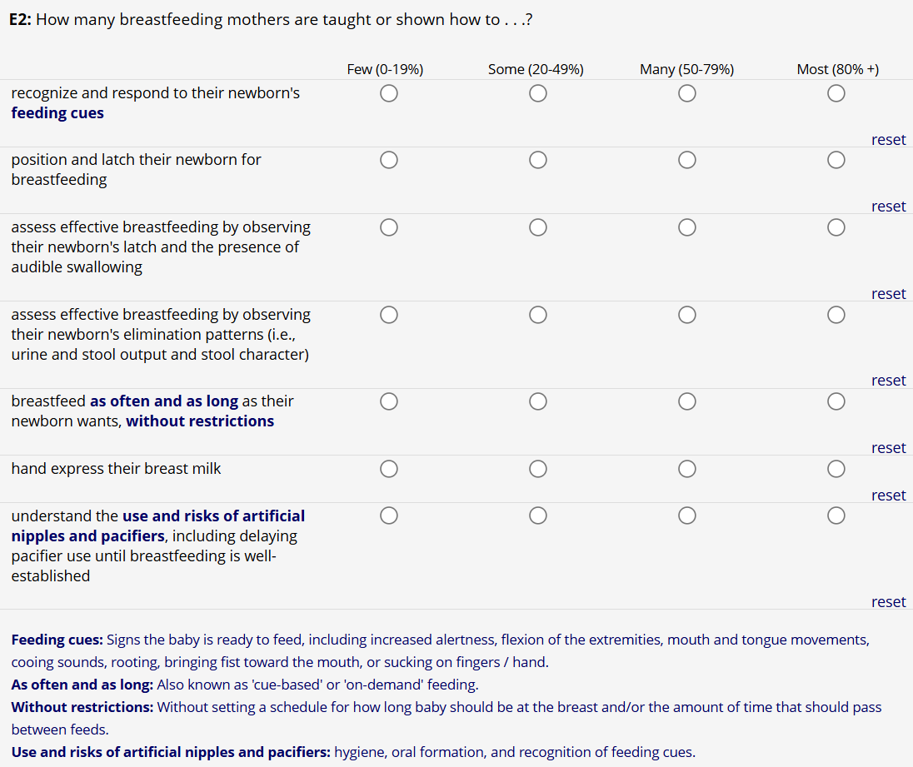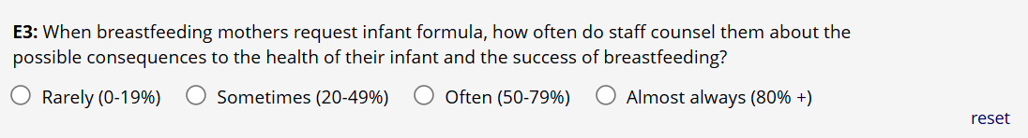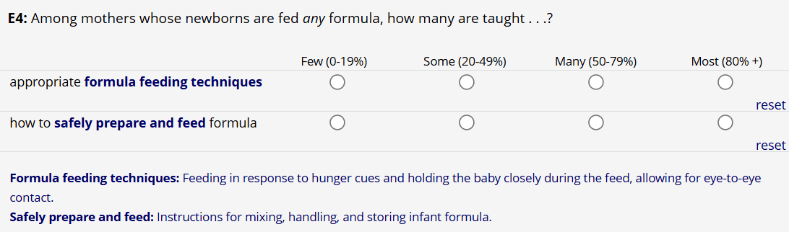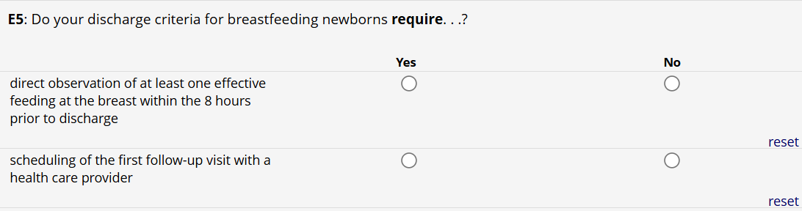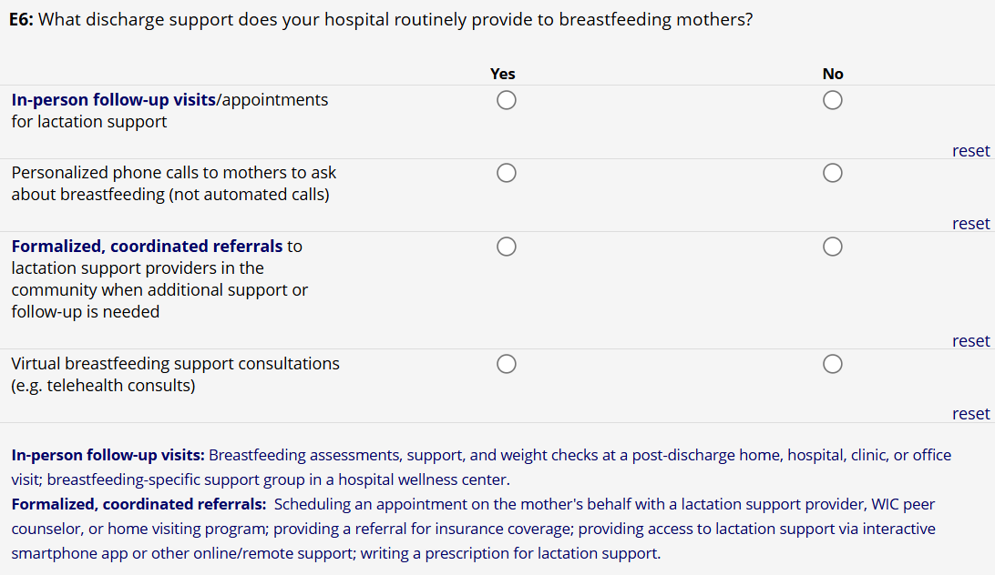

SECTION F: STAFFING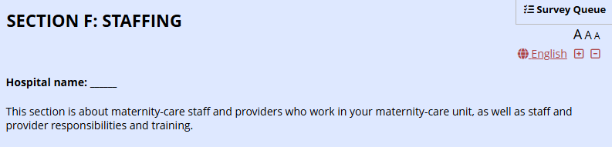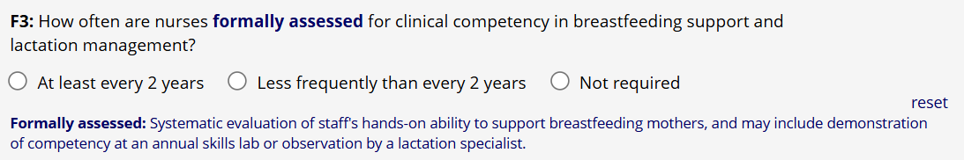

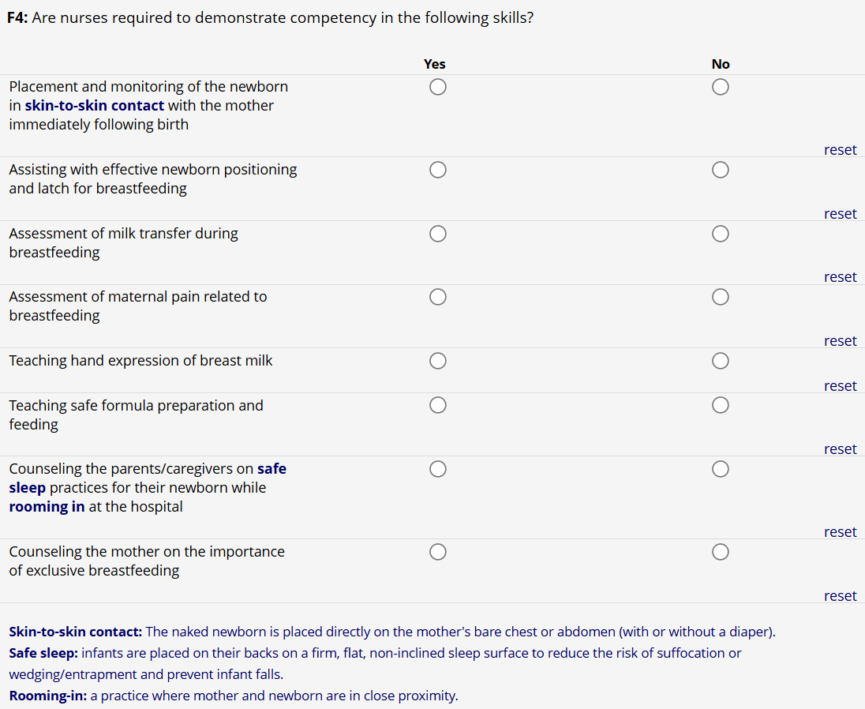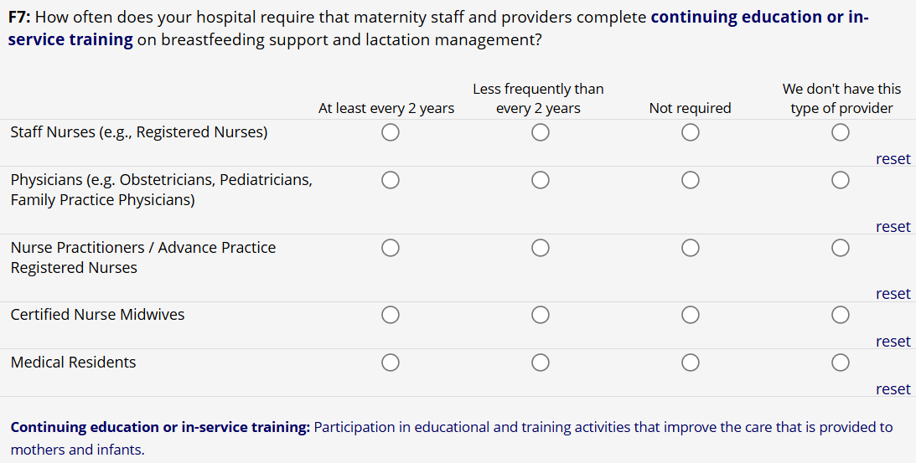

SECTION G: POLICIES AND PROCEDURES
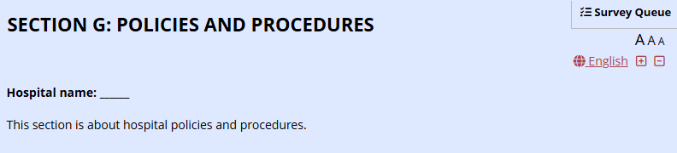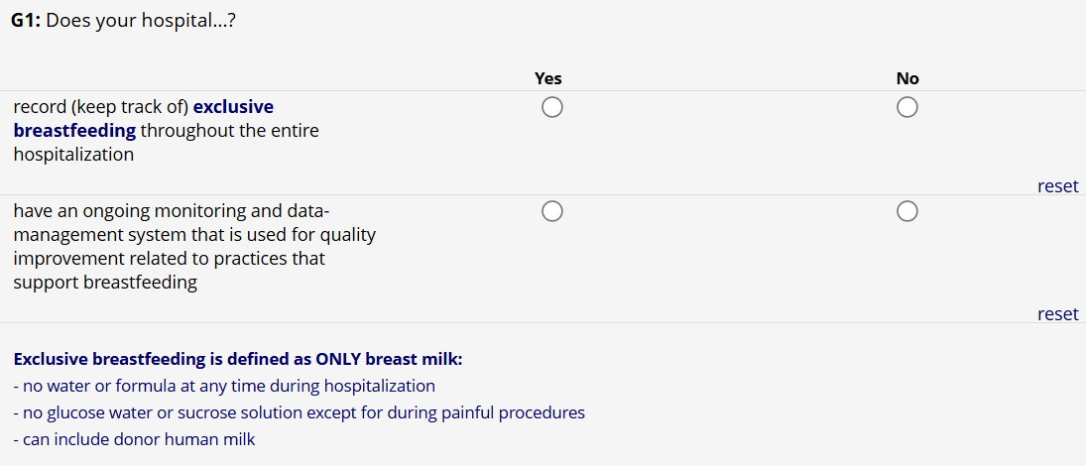
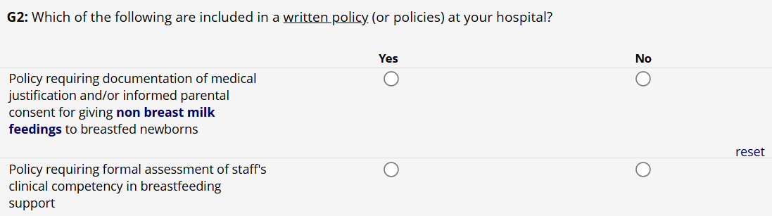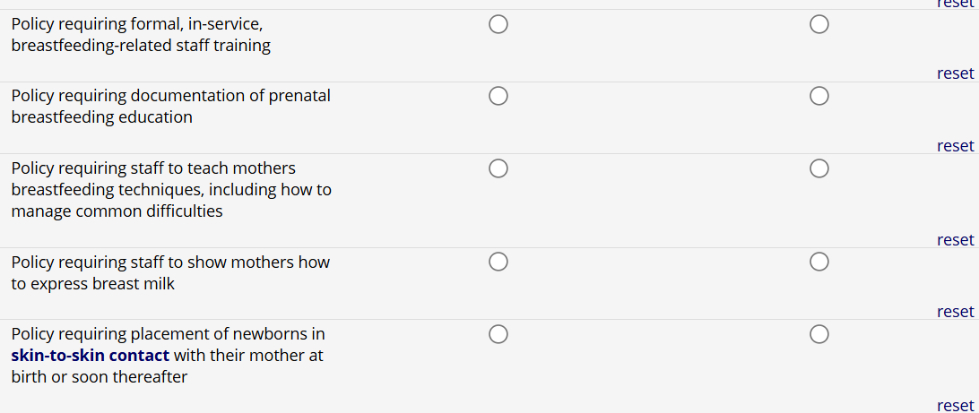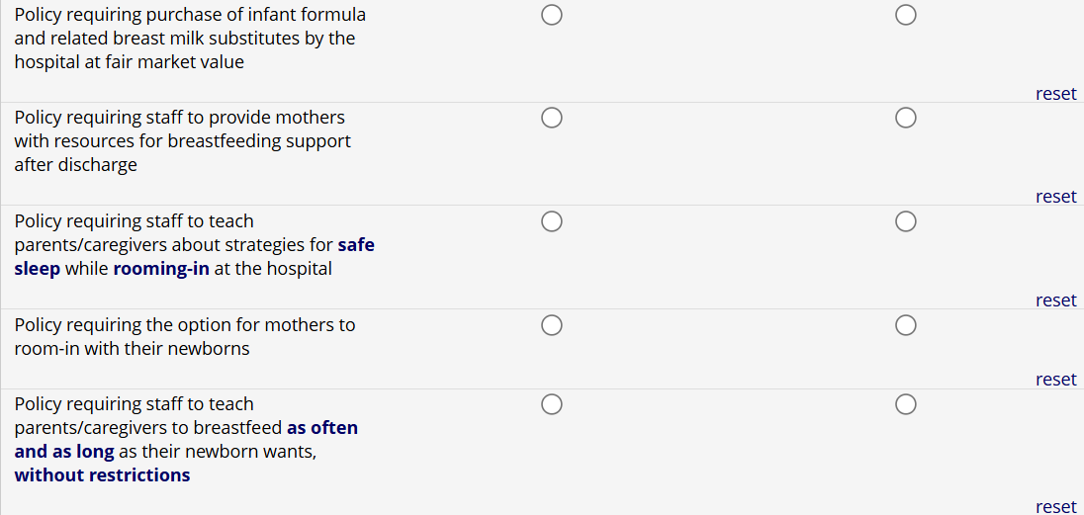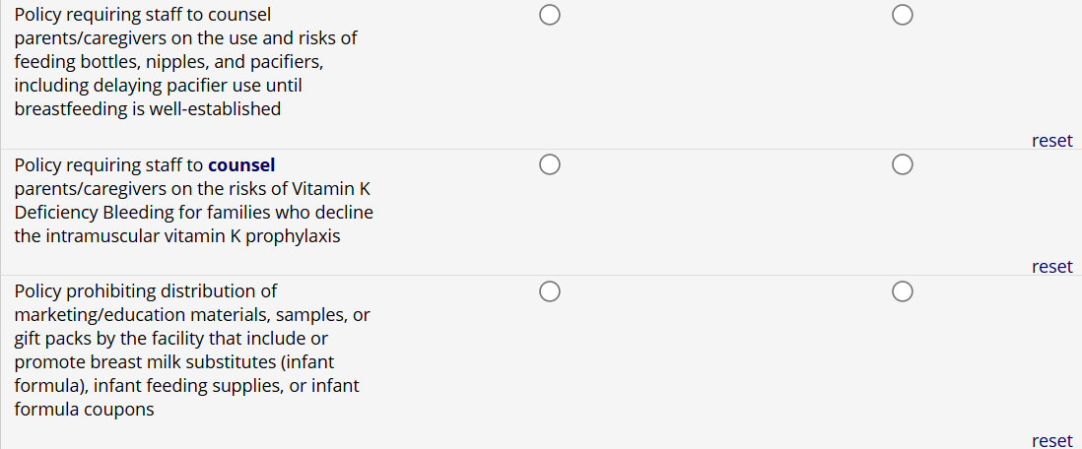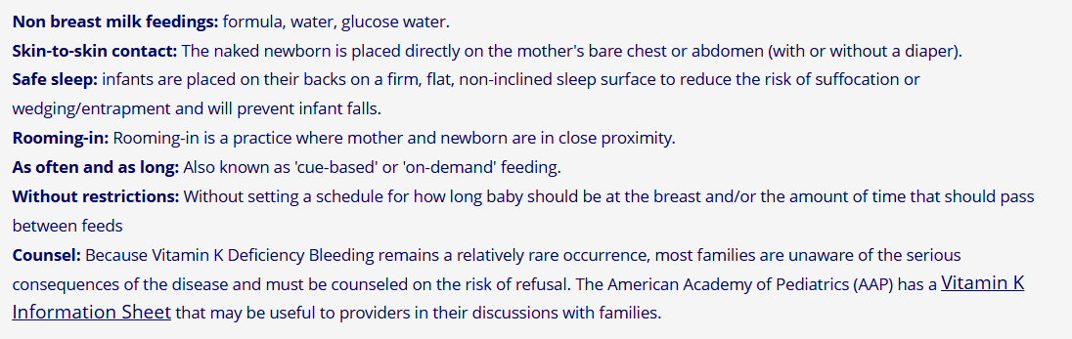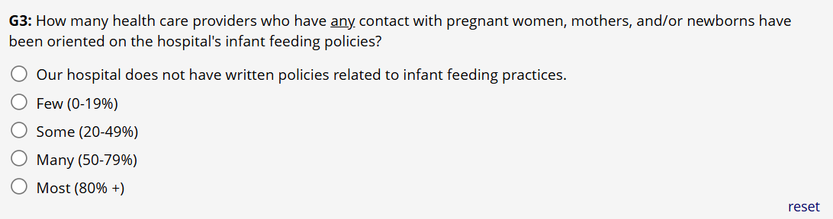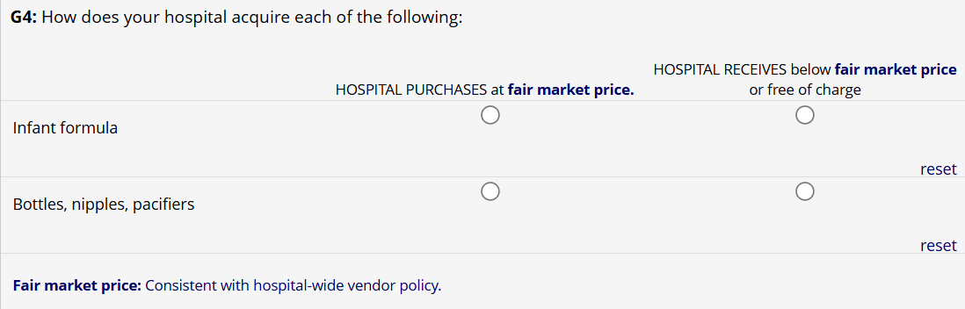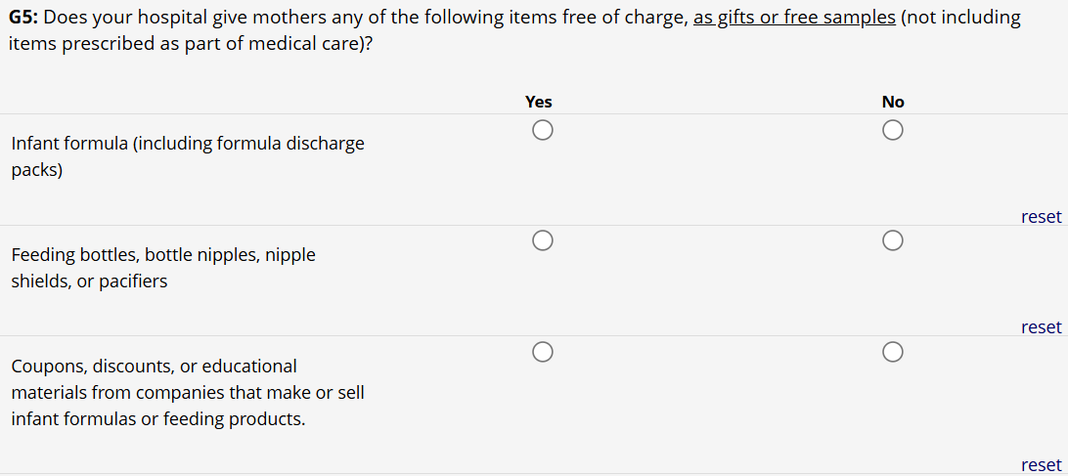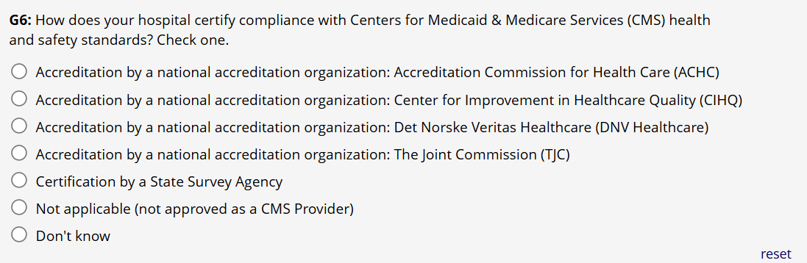

SECTION H: CONTACT INFORMATION
