OMB No. 0920-1423

Expiration Date: 12/31/2026

Expanding PrEP in Communities of Color (EPICC+)

Attachment 3b

Aim 2a Cohort Recruitment Plan (English)

Cohort Recruitment Plan

We will use text and photos in combination for the aim 2a of the EPICC research study recruitment campaign. Please see sample ad text and sample recruitment advertisements below. Ad text will be combined with photos (see samples below) to create engaging advertisements. The language, photos and graphics might be used alone or with text statements on a variety of online platforms including but not limited to, websites, social media, online news outlets, mobile phone apps, social networking sites, micro-blogging outlets, photo sharing portals, etc. Ad text and images may also be used for printed materials, including but not limited to stickers, palm cards, flyers, and print advertisements. All ads will identify EPICC as a research study. The format of the materials below may differ based on advertisement placement. For example, fonts and colors may be changed, the image maybe resized or cropped to allow for use in differing formats, sizes, and types of media. Likewise, the graphic might be used in whole or in part to account for these different formats, sizes, and types of media. URLs in the attached graphics might be changed to a different recruitment website such as Craigslist, Facebook, Instagram, Twitter, Grindr, Jack’d, Reddit, Tik Tok etc. Additionally, screener URLs will be unique for each recruitment site to ensure study staff at different recruitment sites only see screeners for their recruitment site.

Sample Taglines:
Taking PrEP? Join a [FSU or site name] research study to share your experience. Get after it!
Taking PrEP? Join a [FSU or site name] research study to share your experience. Participate from home and get up to [incentive].
Taking PrEP? Join a [FSU or site name] research study that can help you take PrEP. Get up to [incentive] for participating.
Starting PrEP? Join a [FSU or site name] research study to share your experience. Get after it!
Starting PrEP? Join a [FSU or site name] research study to share your experience. Participate from home and get up to [incentive].
Starting PrEP? Join a [FSU or site name] research study that can help you take PrEP. Get up to [incentive] for participating.
On PrEP and interested in research? Why not see if joining [FSU’s or site name’s] EPICC+ study can help make it easier? Get up to [incentive] for participating.
Starting PrEP and interested in research? Why not see if joining [FSU’s or site name’s] EPICC+ study can help make it easier? Get up to [incentive] for participating.
On PrEP and interested in research? Join a [FSU or site name] research study to help us test a strategy that can help you remember to take PrEP. Get up to [incentive] for participating.
Starting PrEP and interested in research? Join a [FSU or site name] research study to help us test a strategy that can help you remember to take PrEP. Get up to [incentive] for participating.

On PrEP and forgetting your pill?

Starting PrEP and worried about forgetting your pill?
On PrEP and forgetting your pill? Join a [FSU or site name] research study that can help you take PrEP.
Starting PrEP and worried about forgetting your pill? Join a [FSU or site name] research study that can help you take PrEP.
On PrEP? Join a [FSU or site name] research study to share your experience. Participate from home and get up to [incentive].
Starting PrEP? Join a [FSU or site name] research study to share your experience. Participate from home and get up to [incentive].
Ayyyy! On PrEP and forgetting your pill? Join a [FSU or site name] research study that can help you take PrEP. Get up to [incentive] for participating.
Ayyyy! Starting PrEP and worried about forgetting your pill? Join a [FSU or site name] research study that can help you take PrEP. Get up to [incentive] for participating.
On PrEP and forgetting your pill? Join a [FSU or site name] research study to help us test a strategy that can help you remember to take PrEP Get up to [incentive] for participating.
On PrEP? Interested in research? Join a FSU research study and share your experience with taking PrEP. Get up to [incentive] for participating.
Starting PrEP? Interested in research? Join a FSU research study and share your experience with starting PrEP. Get up to [incentive] for participating.
Taking PrEP every day is hard. Why not see if joining [FSU’s or site name’s] EPICC+ study can help make it easier? Get up to [incentive] for participating.
Taking PrEP? Help [recruitment site] test a health app! Starting PrEP? Help [recruitment site] test a health app!
Give back to the community today by helping [recruitment site] test a health app! Get up to [incentive] for participating.
Help [recruitment site] test an app for taking PrEP and get up to [incentive]! Test an app on taking PrEP and get up to [incentive]! Participate from home. Help test technology to support sexual health and get up to [incentive]!
Seeking: Men for a new tech research study
Looking for: Men for a new health tech research study Seeking: Men of color to help test a new health app Help fight HIV and get up to [incentive]!
Help us test our new app for that. Get up to [incentive] for participating.
[site location] Men of color: Get up to [incentive] for participating in a research study from [site name]

[site location]: Interested in joining an online research study?
Black, indigenous, Asian, Pacific Islander, Latino, multi-racial gay, bi men: Join our research study. Get up to [incentive] for participating.
Research study at [site name]: Participate from home, get HIV prevention info on your phone. Get up to [incentive] for participating.
Research study at [site name]: Participate from home, get PrEP info on your phone. Get up to [incentive] for participating.
Join our research study and give your feedback on PrEP services. Get up to [incentive] for participating.

Part 2: Sample body text
Below are illustrative examples of ad text that may be used.

Text:
We’re looking for young men between 18-39 years old to participate in a research study using technology or mobile apps to support sexual health. Get up to [incentive] for participating.

OR
We’re looking for young men to participate in a research study using technology or mobile apps to support sexual health. Get up to [incentive] for participating.

OR

We’re looking for young people of color who are starting or already taking PrEP to participate in a research study using mobile apps to support sexual health. Get up to [incentive] for participating.

OR
We are looking for young men who have sex with men (MSM) and who are on PrEP or starting PrEP to participate in a research study using technology or mobile apps to support sexual health. Get up to [incentive] for participating.

OR
We’re looking for young people to help us test out [new technology OR mobile app] to support sexual health. You may be eligible if you are a male between the ages of 18-39 and a person of color.
Visit [OR check out] [website URL or screener link] to learn how you can volunteer for this HIV prevention research study. Get up to [incentive] for participating.

OR
The EPICC+ research study from [site name] would like your opinion on our PrEP information. Enroll online and get up to [incentive] over 18 months for your participation.

OR

The EPICC+ research study allows you to give feedback on PrEP choices. Get up to [incentive] and participate from home.

OR
Give your feedback on PrEP and HIV prevention information. Participate from home. Get up to [incentive] for participating.

OR
Receive PrEP information on your phone. Join the EPICC+ research study, participate from home, and get up to [incentive].

OR
We want to hear from you! Give your opinion on PrEP information on your phone. Participate from home and get up to [incentive].

OR
Safer sex information – learn about testing and PrEP on your phone, and give your feedback. We’re looking for young people of color who are taking PrEP or about to start PrEP to participate in a research study using mobile apps to support sexual health.

OR
Give feedback on our PrEP information. We’re looking for young people of color who are taking PrEP or about to start PrEP to participate in a research study using mobile apps to support sexual health. Participate from home and get up to [incentive].

Images, photos and sample graphics
Graphics and images appealing to our target population (such as but not limited to the ones below) will be used with text (such as the examples from above) to create graphics and online advertising. Graphics are typically found using Unsplash and Canva. Site-specific logos may be added to the images.

Some photos used in ads come from Pexels.com. Their licensing agreements are listed below:
Pexels:
- “All photos and videos on Pexels are free to use. Attribution is not required. Giving credit to the photographer or Pexels is not necessary but always appreciated. You can modify the photos and videos from Pexels. Be creative and edit them as you like."

Other similar photos may be used from Unsplash.com and Adobe Stock, and this is how their licensing agreement reads:
- “Unsplash grants you an irrevocable, nonexclusive copyright license to download, copy, modify, distribute, perform, and use photos from Unsplash for free, including for

commercial purposes, without permission from or attributing the photographer or Unsplash, but this license does not include the right to compile photos from Unsplash to replicate a similar or competing service.
- This means that Photos on the Service come with a very, very broad copyright license under the Unsplash License. This is why we say that they are ‘Free to Use.’”

Adobe Stock:
- “An Adobe Stock perpetual, worldwide license allows you to use your licensed asset in all media, including print, presentations, broadcasts, websites, and on social media sites.“
“Most Adobe Stock photos, vectors, and illustrations come with a Standard license. With a Standard license, you may: Reproduce up to 500,000 copies of the asset in all media, including product packaging, printed marketing materials, digital documents, or software. Include the asset in email marketing, mobile advertising, or a broadcast or digital program if the expected number of viewers is fewer than 500,000. Post the asset to a website or social media site with no limitation on views. Include the asset in some types of products, such as inside a textbook, as long as the primary value of the product is not the asset itself, and the product is not reproduced more than 500,000 times. Share the unmodified asset with your employees and contractors who have contractually agreed to abide by the license terms. Transfer the license to your client or employer.”

Sample Ads

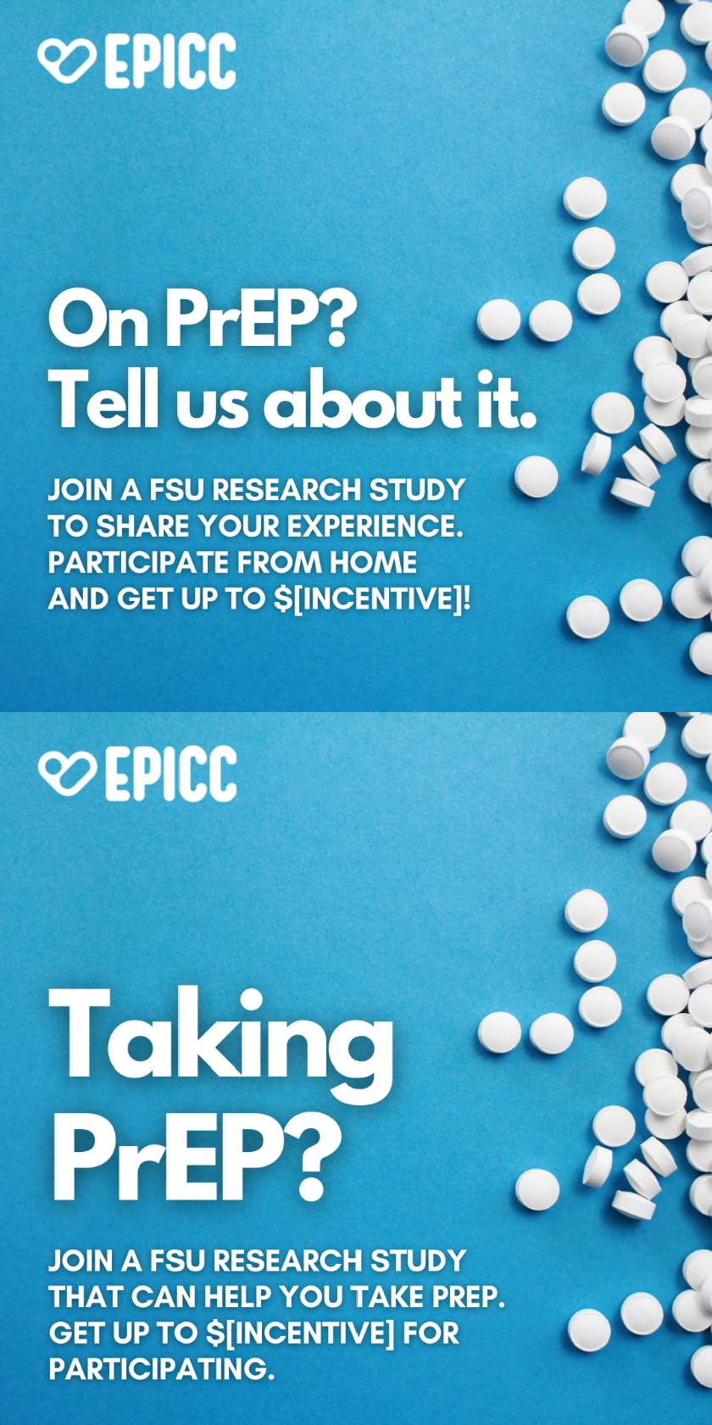

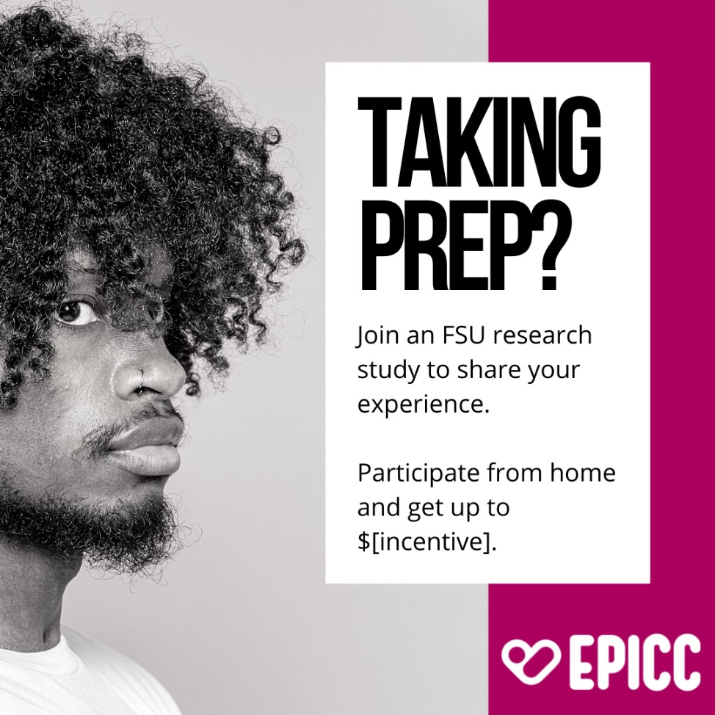

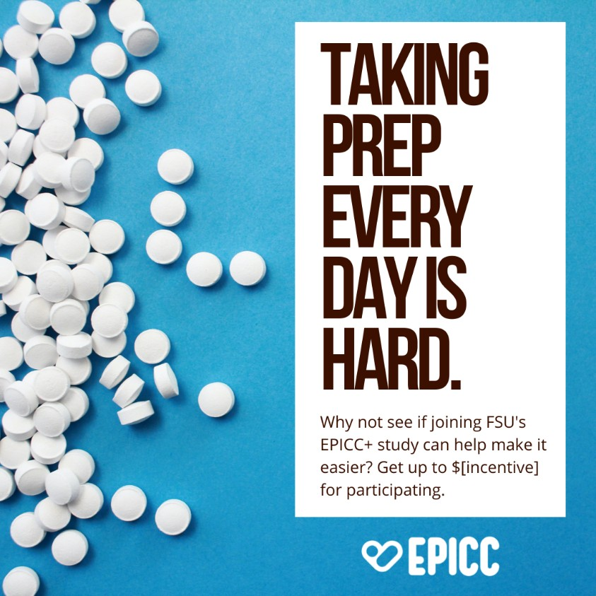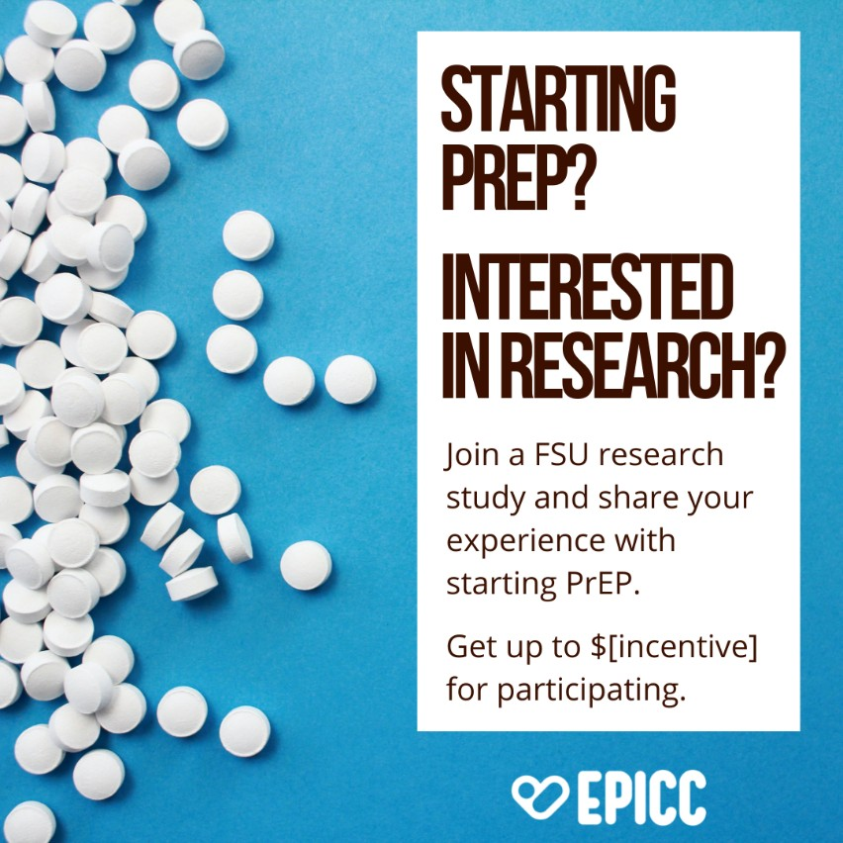

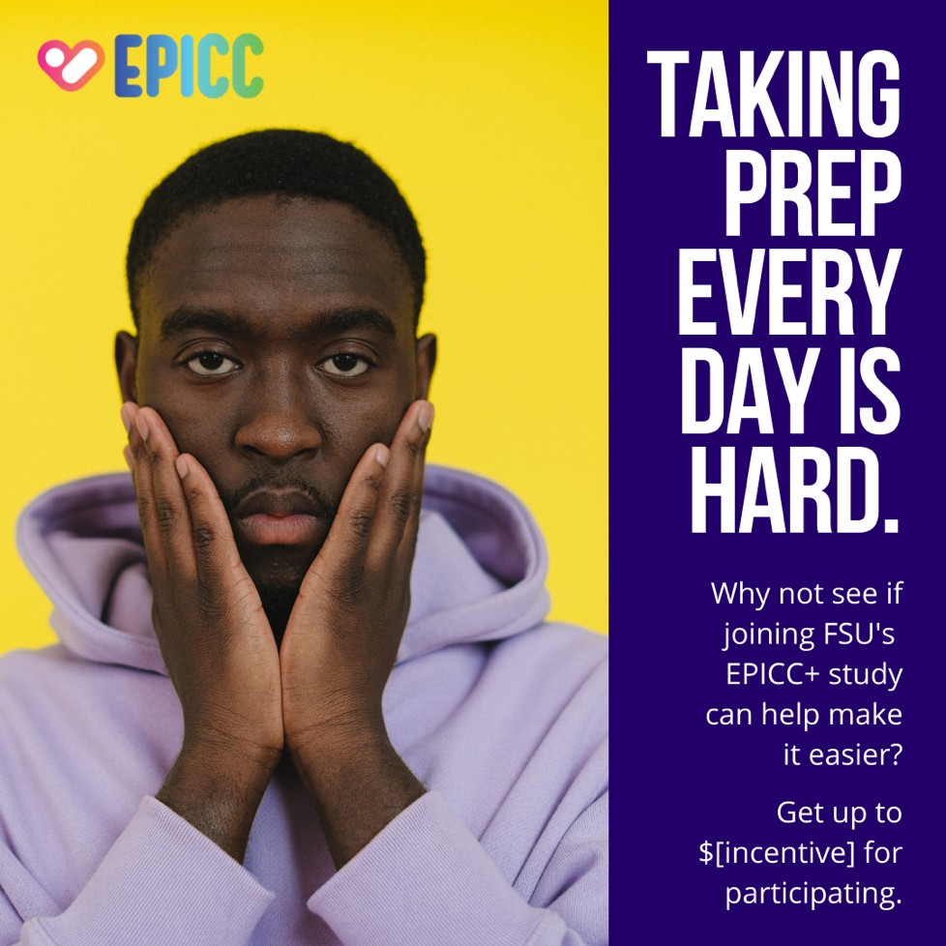

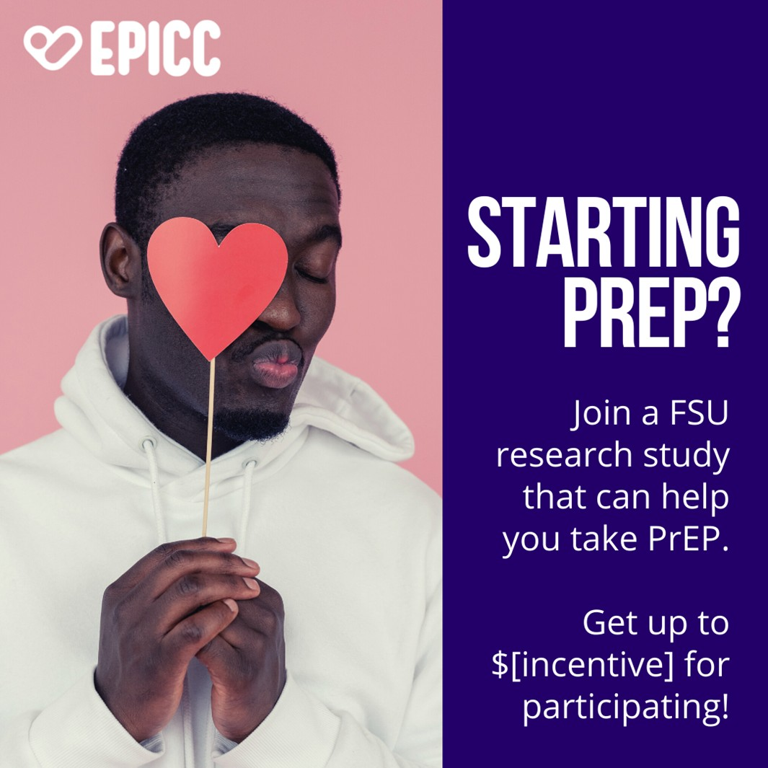



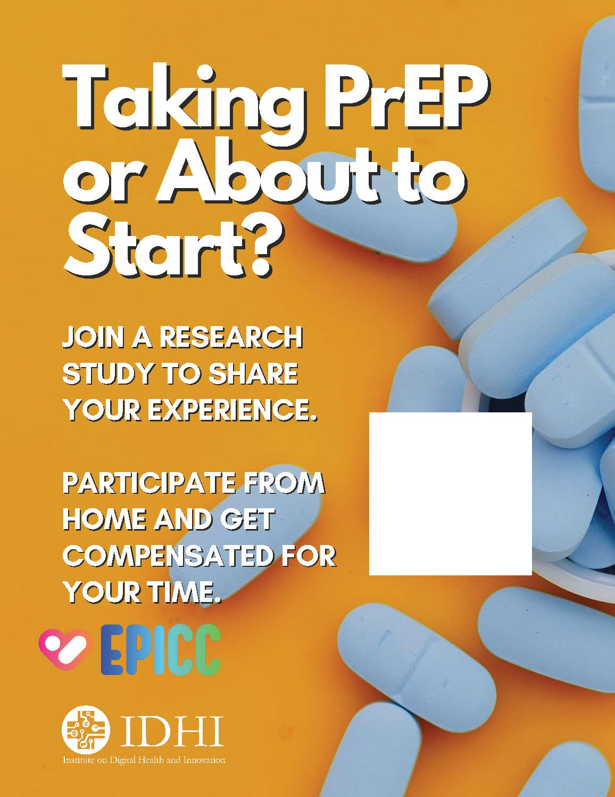
Logos



