Form Approved
OMB No. 0920-1423
Expiration Date: 12/31/2026

Expanding PrEP in Communities of Color (EPICC+)

Attachment 4j
Aim 2a Cohort App Setup English and Spanish

Public reporting burden of this collection of information is estimated to average 30 minutes per response, including the time for reviewing instructions, searching existing data sources, gathering and maintaining the data needed, and completing and reviewing the collection of information. An agency may not conduct or sponsor, and a person is not required to respond to a collection of information unless it displays a currently valid OMB control number. Send comments regarding this burden estimate or any other aspect of this collection of information, including suggestions for reducing this burden to CDC/ATSDR Reports Clearance Officer; 1600 Clifton Road NE, MS D-74, Atlanta, Georgia 30333; Attn: OMB-PRA (0920-New)
EPICC+ App
The EPICC+ app is designed to be a safe space for users to explore fun and educational material related to sexual health, nutrition, relationships, careers, advocacy, finance and more. Users can opt to read articles on these topics, complete quizzes and other interactive games or even ask anonymous questions to health care providers to gain knowledge on topics important to them. Users of EPICC+ can also leverage tools to help them achieve their health and wellness goals, such as receiving medication reminders to help keep up their adherence to PrEP, as well as connect anonymously with a community of people who can offer a support and insight on issues or experiences, they may also have encountered.
The app is used at will by participants; no interaction beyond downloading, user account sign-up, app orientation, health tracker set up and completing DBS kits are mandatory within study protocol. The app download, sign-up and orientation process takes approximately 10-15 minutes, the health tracker set up takes approximately 5-10 minutes and completing a DBS kit takes approximately 20-30 minutes. The DBS kit will only be done at baseline and every 6 months within the study.
The app is categorized into two components, informational and health and wellness-related tracking. Informational app components supply participants with educational resources related to health, wellness, and lifestyle topics. Their engagement with these sections requires no personal input from them. They are merely clicking through their interests or answering an educational quiz or activity at their own discretion. Paradata from these features can be analyzed to help study team determine things such as popular content topics or activity types from users overall, but individual responses are not generally looked at. Health and wellness-related tracking features, while still voluntary to participate in, are those in which a participant provides information related to their health and wellness journey. For example, if a participant chooses to engage with the health tracker, they will be prompted with a reminder to track their PrEP adherence. They will enter the feature whether they have taken their medication that day, and if not, provide the reason. Staff can analyze medication tracker data to assess barriers to PrEP adherence and as a result, post related support content within the app to aid all users experiencing the same challenge, as well as gauge effectiveness of the app to impact PrEP adherence.

EPICC+ App
Required EPICC Actions | Informational Features (Not Required)
Medication (PrEP) Tracker Setup: This section helps participants remember to take their medication. Participants can link reminders to daily actions, such as brushing their teeth, customize text in the reminders to ensure discreetness, track their medication, and view patterns and analytics. Use of the medication tracker is optional but recommended after the initial app setup.  Health (Sex) Tracker Setup: This section helps participants recognize how their sexual habits may impact what type of PrEP form suits them best given their activity (e.g., start dating and having sex more regularly, then they can move from on demand PrEP to daily PrEP). Participants can also choose to track other behaviors that may influence PrEP adherence, such as smoking, alcohol and mood. Participants can track their sexual activity and other health behaviors, view patterns and analytics. Use of the health tracker is optional but recommended after the initial app setup.  DBS Test Kit: Within the study, participants are sent dried blood spot collection kits to predict and measure adherence rates to PrEP. Participants can use this page to find their kit’s USPS tracking information for up-to-date notifications around delivery. They can also view an instructional video on how to complete the DBS kit. | Resources: A knowledge center for participants to read articles and watch videos on a variety of health and wellness topics.  Activities: Reinforce knowledge through interactive activities. Complete quizzes, fill-in-the blank, categorizing and choose-your-own-adventure activities, as well as set goals and complete health assessments  Goal Setting: Participants select goals that they would like to achieve from a list of goals provided in the following categories: All About HIV, Health and Wellness, Life Skills, Great Sex/Safer Sex, Creating Change, and Uncategorized. Milestones, tasks, connections, tips, a journey area and suggested next goals are provided for each goal to help participants achieve it. This section also allows participants to run through a curriculum that keeps them on target with their chosen health and wellness goals.  Forum: A space for participants to voluntarily engage in group conversation. Includes ability to post, comment, like and save content, as well as participate in polls created by staff. This section is like a social media newsfeed.  Ask the Expert: Allow participants to send anonymous health and wellness questions to a medical expert. Questions are submitted anonymously; answers are displayed for all to see.  Care Locator: Find resources based off location or services needed from a pre-developed directory or website (e.g., hiv.gov for finding testing locations)  Help & FAQ: Participants can find commonly asked questions and answers related to the app and study.  Community Guidelines: Participants can read about guidelines the study enforces around inclusive and respectful behavior on the app.  Consent: Participants can review the informed consent document they signed upon enrolling in the study. This document explains key components of the study and any potential benefits and risks they may experience from being in the study.

Initial Use
*Required
For the required EPICC+ app actions, we include expanded descriptions of actions and representative screenshots of how these actions will be displayed to participants. These screenshots are representative of the graphics and displays that participants will view in the app; however, graphics and displays are updated regularly by the app management team.
Done with required items

At baseline and every 6 months while in study
*Required

EPICC+ App Set-Up
Time required to complete: 5-7 minutes

Upon receiving the enrollment email, a user will download the app from the Apple or Play Store and select “Sign Up”. Using the unique access code provided in the email, a user can then create a username and password for their time in the study. They are encouraged to protect their privacy and choose a username that will ensure anonymity. Next, the user will be prompted to choose a PIN, confirm said PIN, enter in their mailing address for future DBS kits, and provide an email and phone number. The last step in the sign-up process is enabling notifications. This will allow the app to send push notifications for key events, such as survey availability or new content being released.

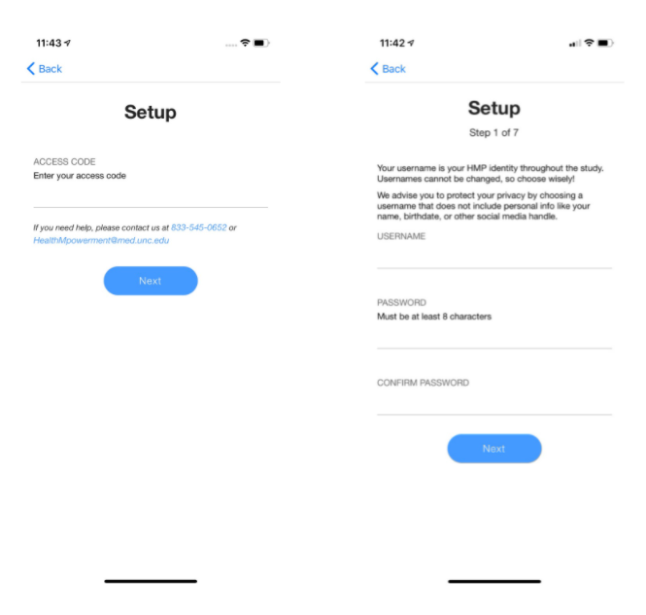
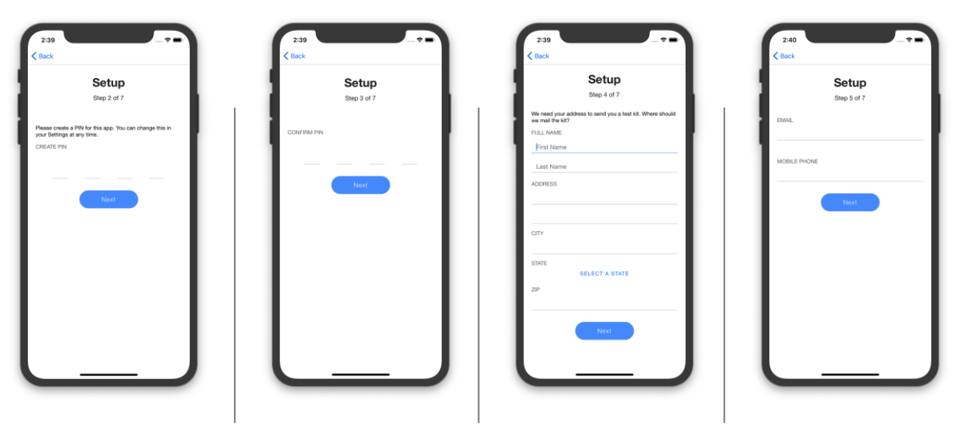
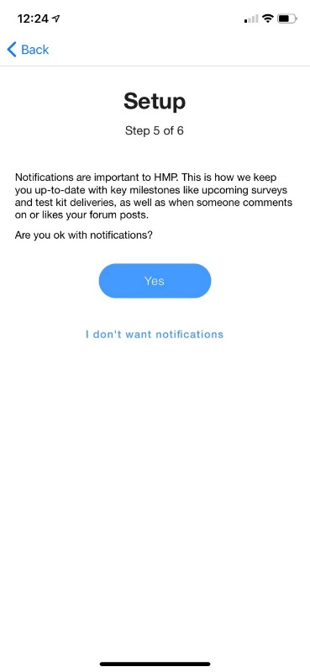
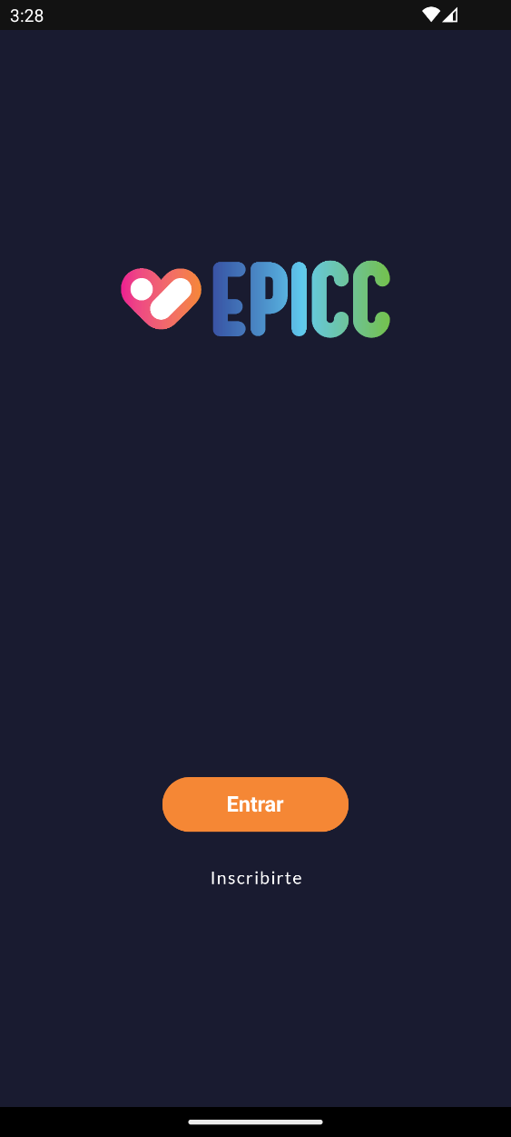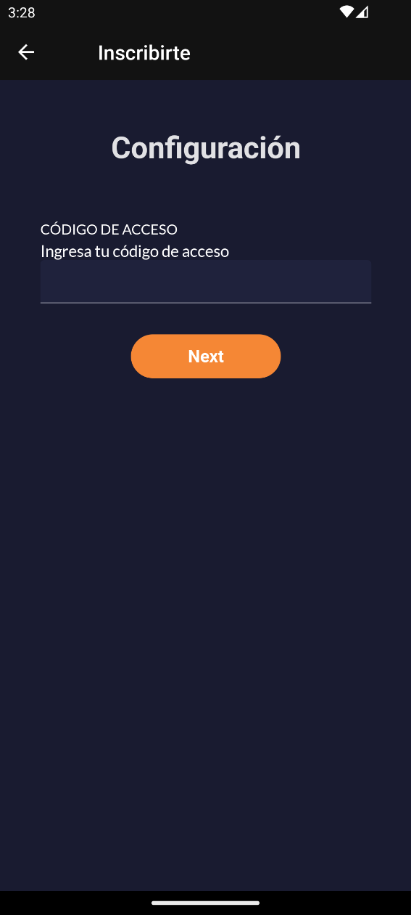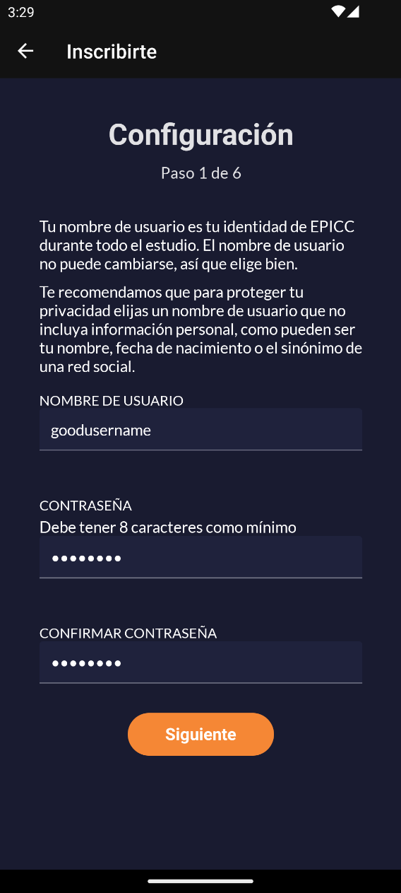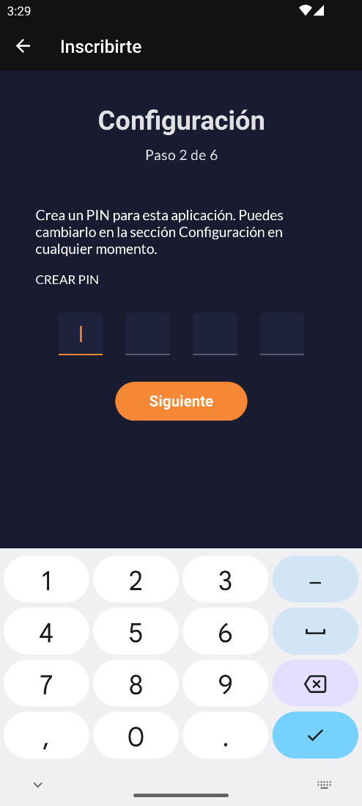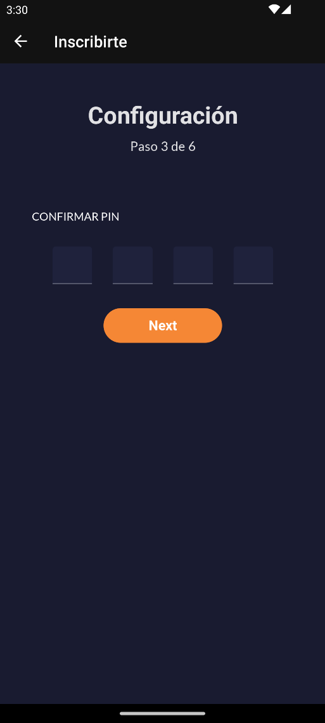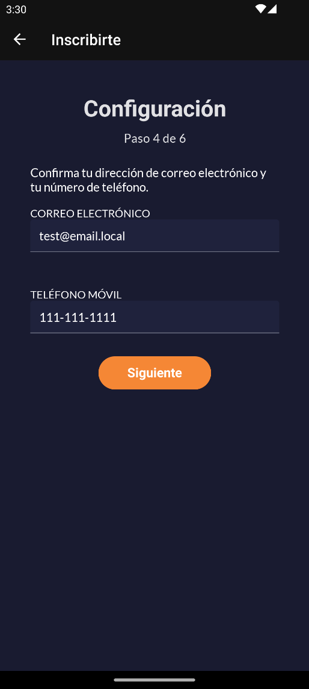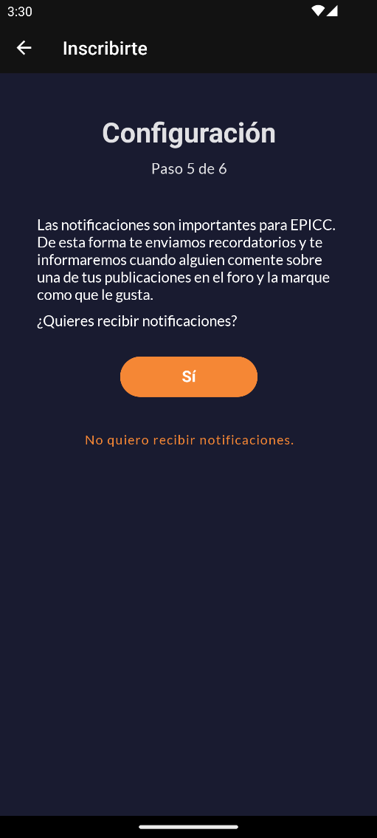

EPICC+ app orientation
Time required to complete: 3-5 minutes
The user will then be prompted to tap through the app orientation screens, introducing them to key features including their care navigator, the medication and sexual activity tracker, forum, resources, activities, goals and how to customize their avatar.
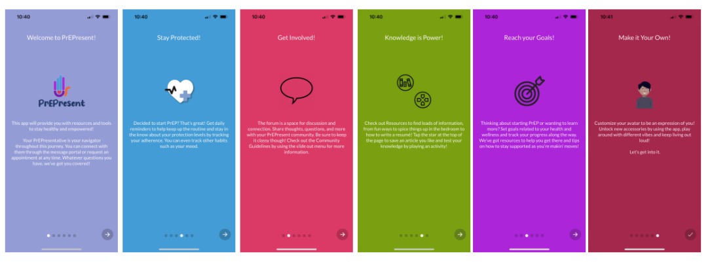
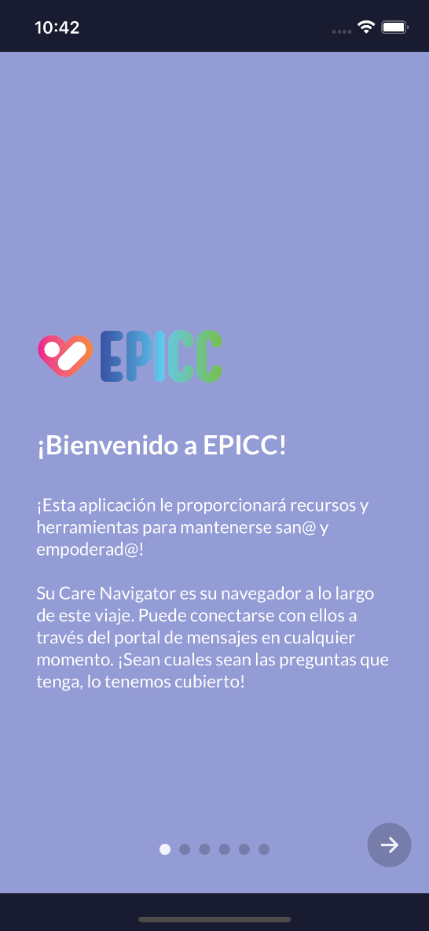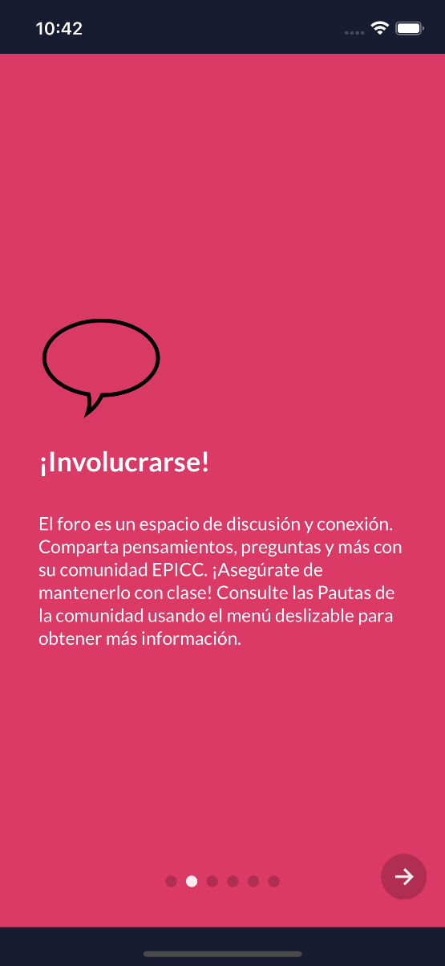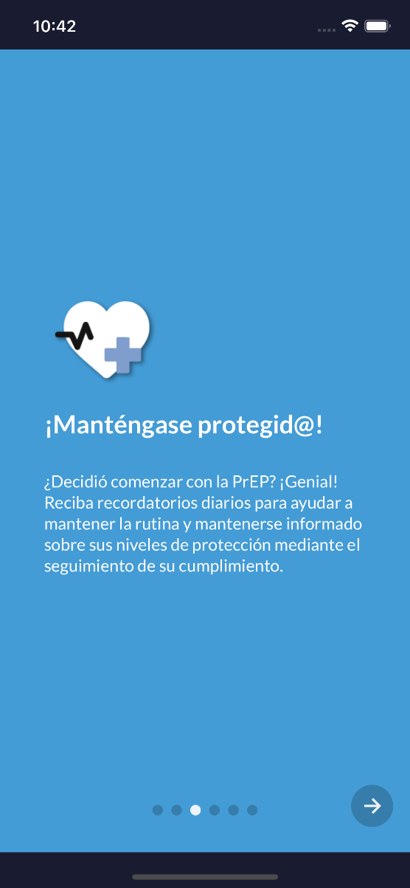
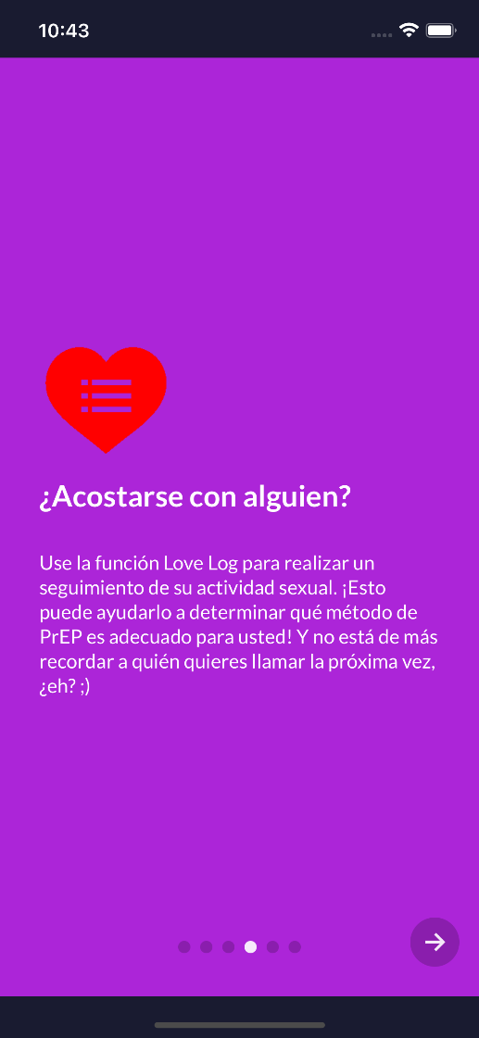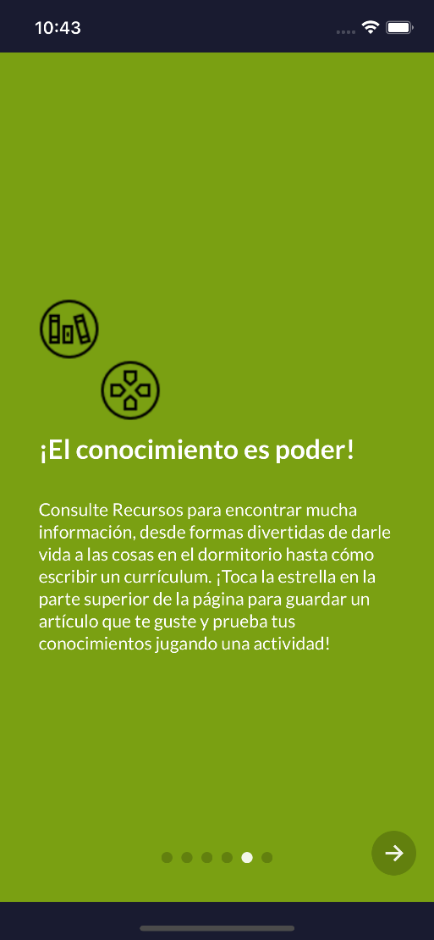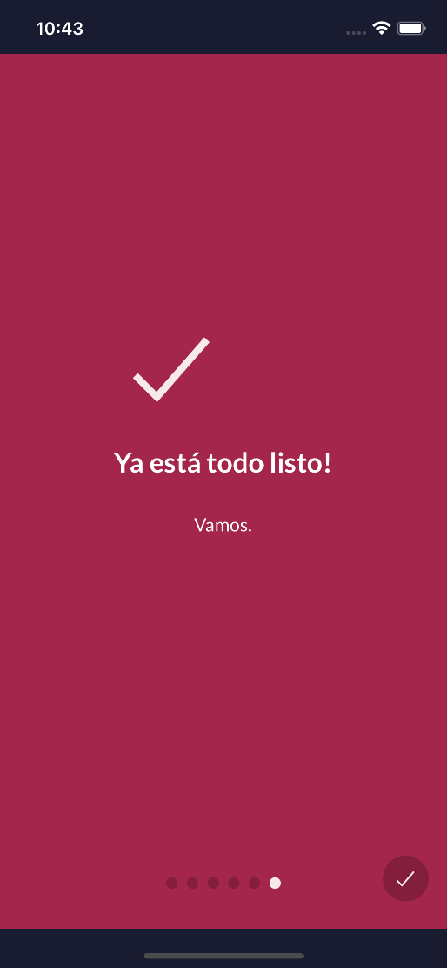

Homepage
After tapping through the orientation screens, the user will land on the home screen. Here users are prompted to add medication, sexual activity, and other habits. The screen also provides easy navigation to setting goals, customizing their avatar, scheduling an appointment with the care navigator, completing activities, reading articles, and connecting with others in the forum.
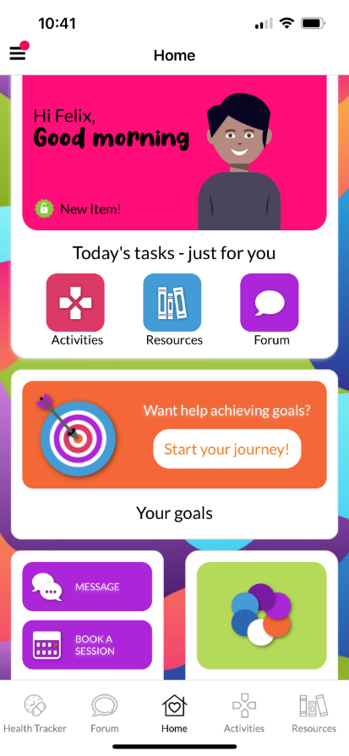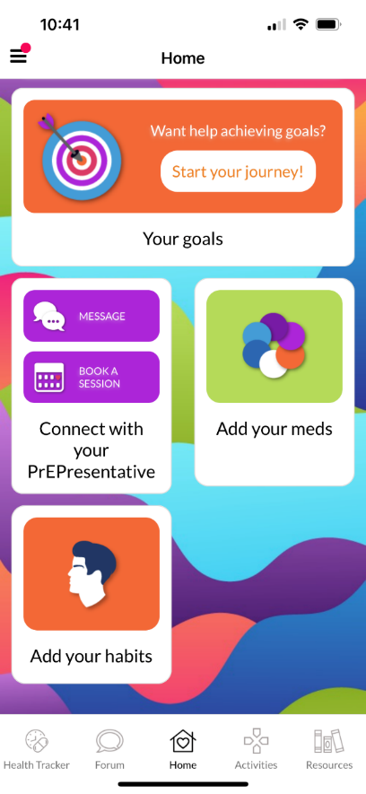

Medication (PrEP) Tracker Set-up
Time required to set up: <5 minutes
From the home screen, users can set up their health tracker, starting by inputting their medication type, choosing a strategy to link it to and customizing their medication reminder notification text.
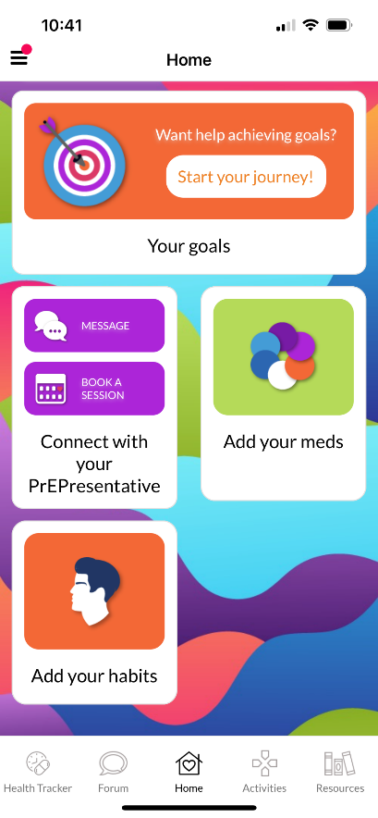
- Main health tracker page
  - Add and/or edit medication (also includes updating reminders)
  - Track your medicine
  - View your stats – choose specific medicine view analytics
- Calendar (icon in top right on main health tracker page and track health page)
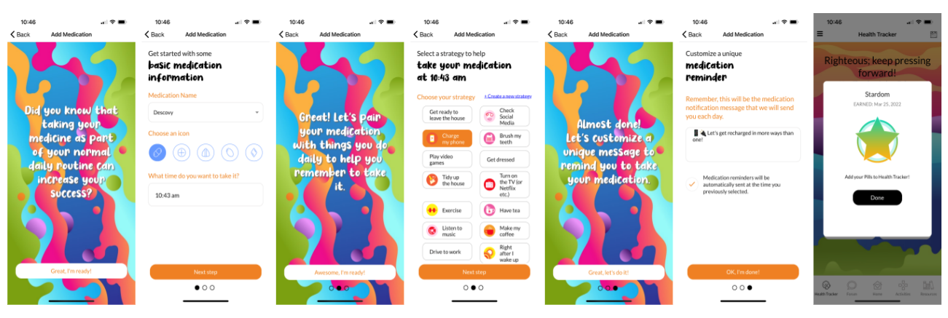
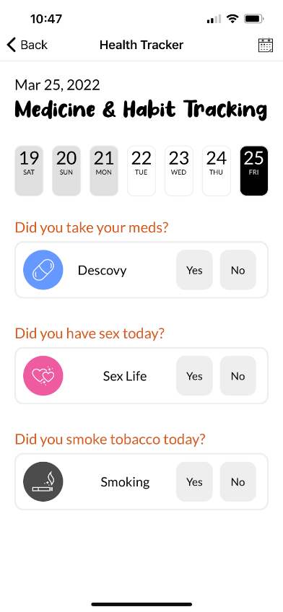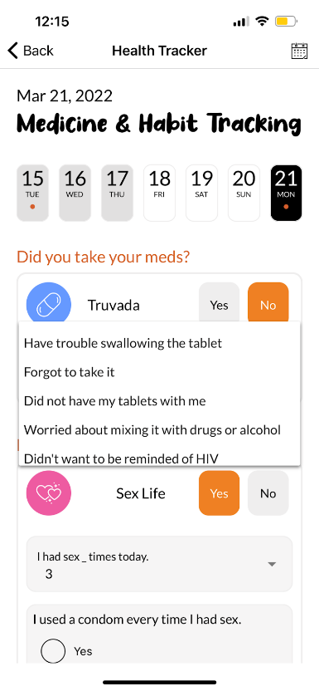

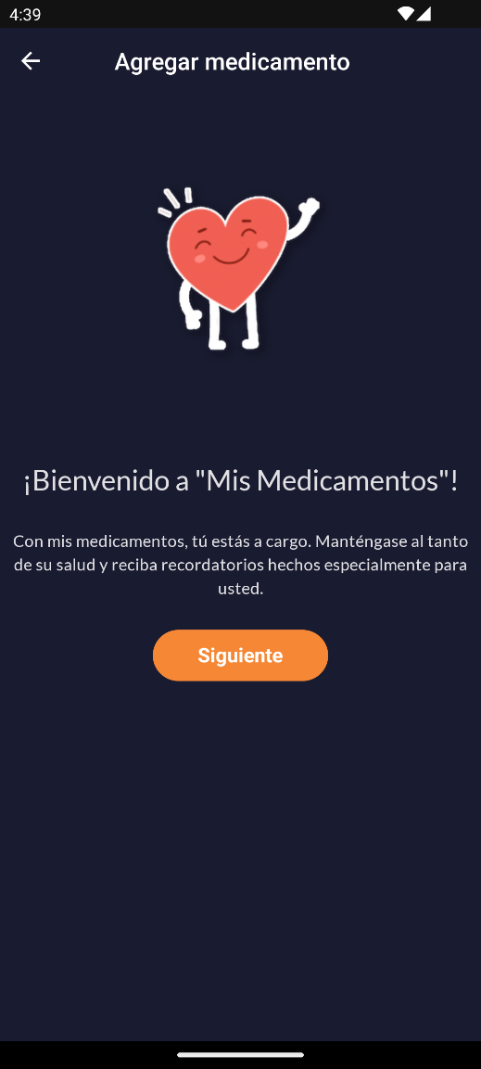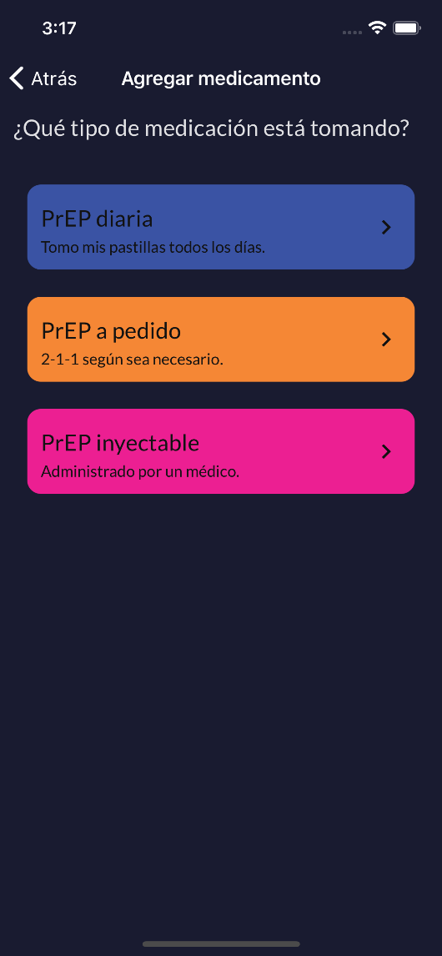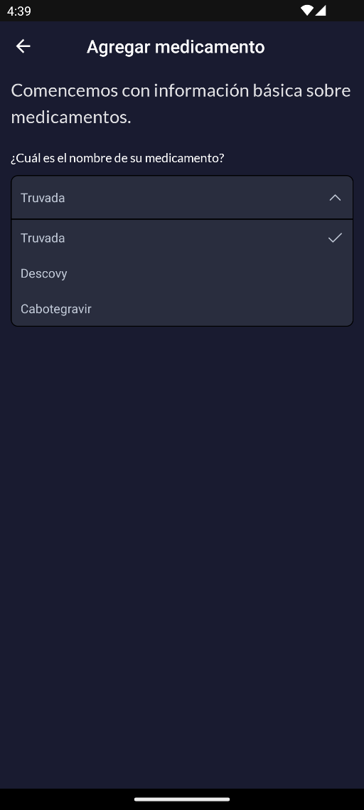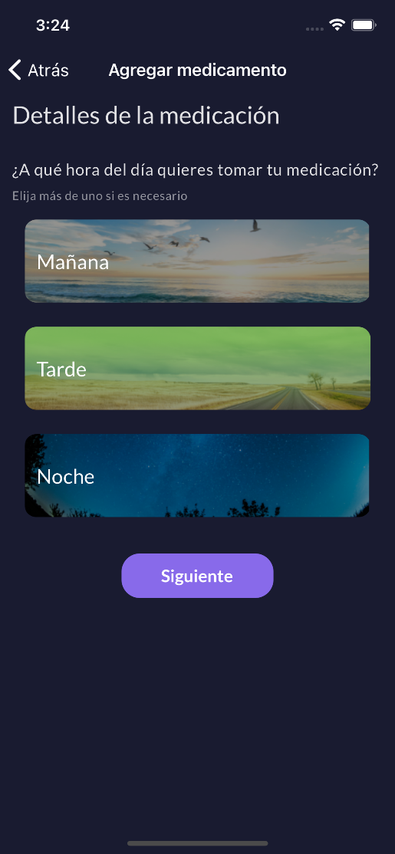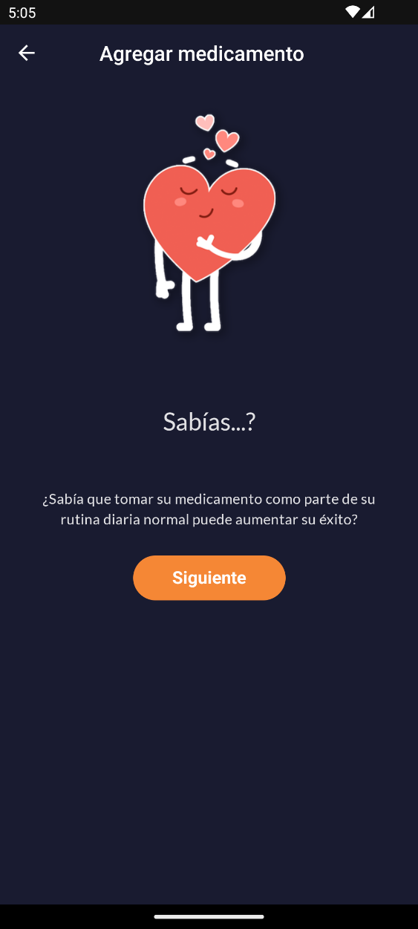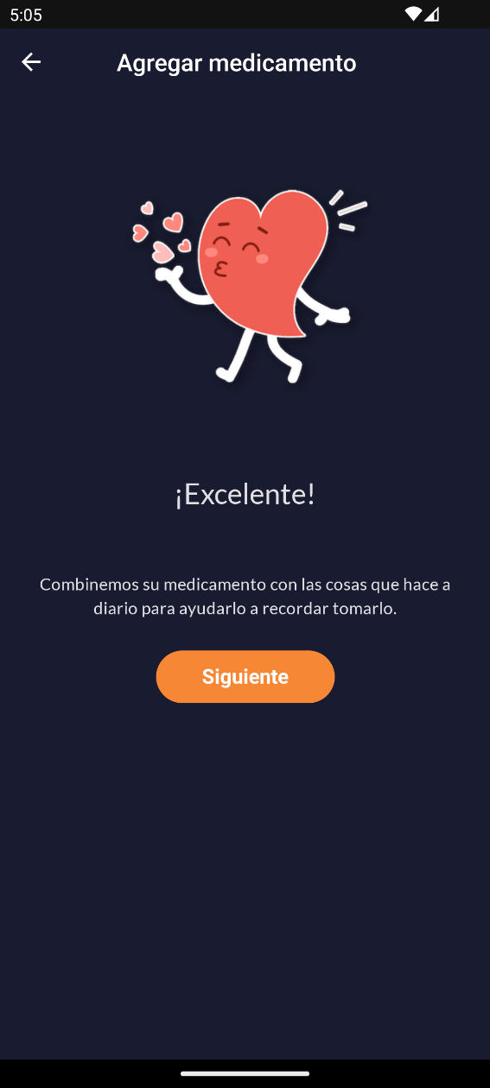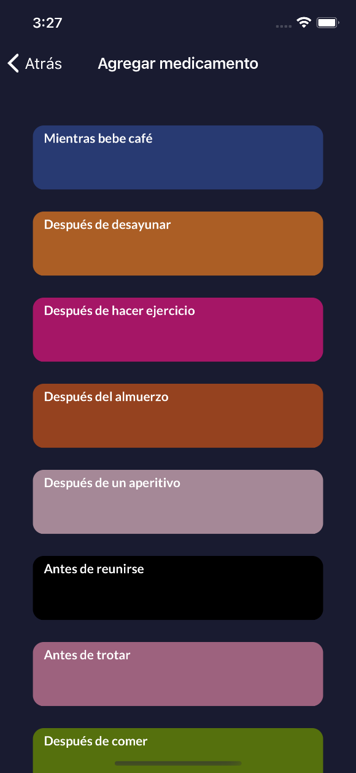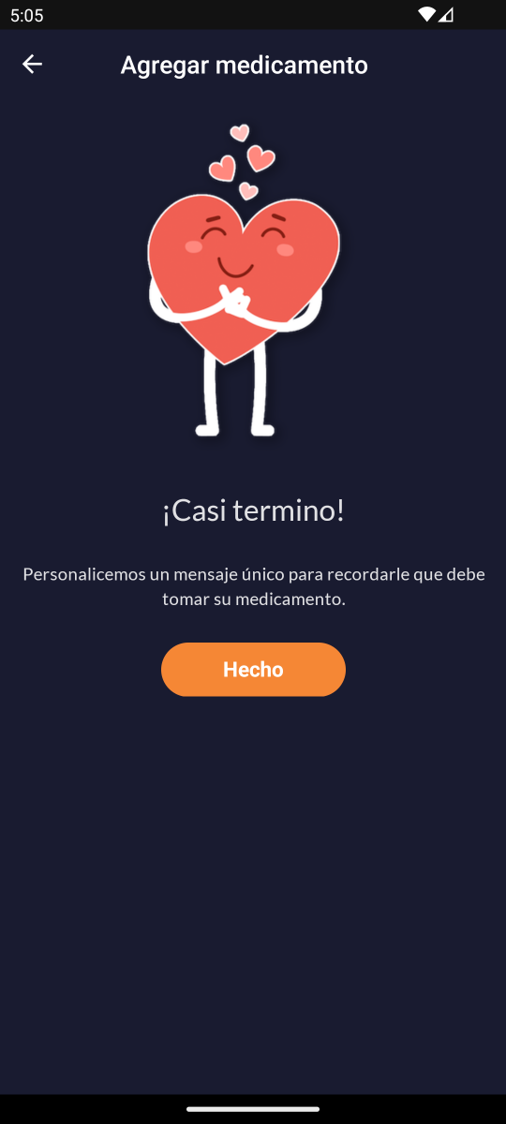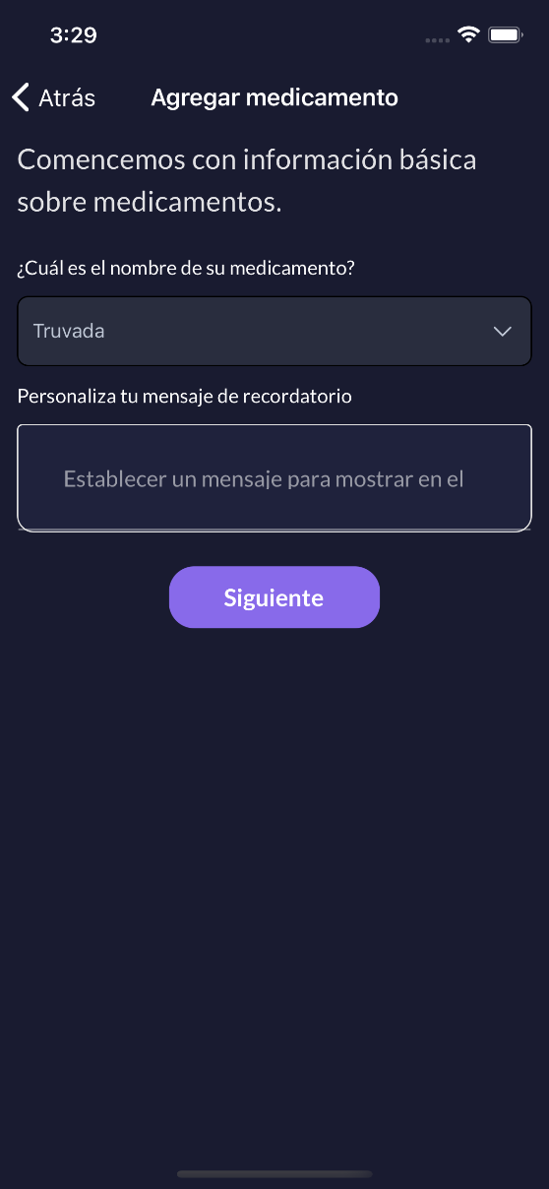
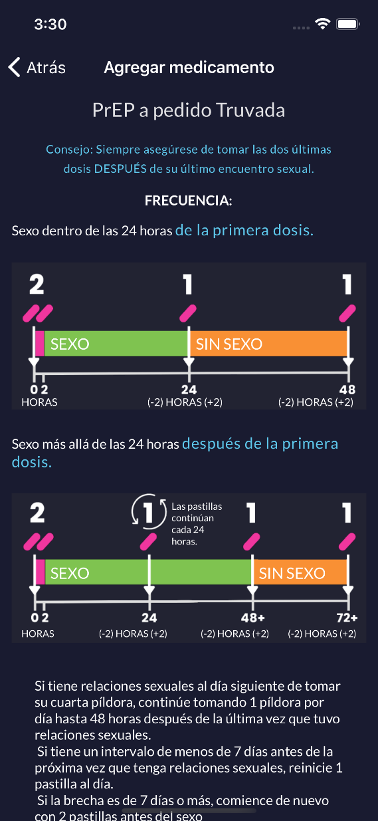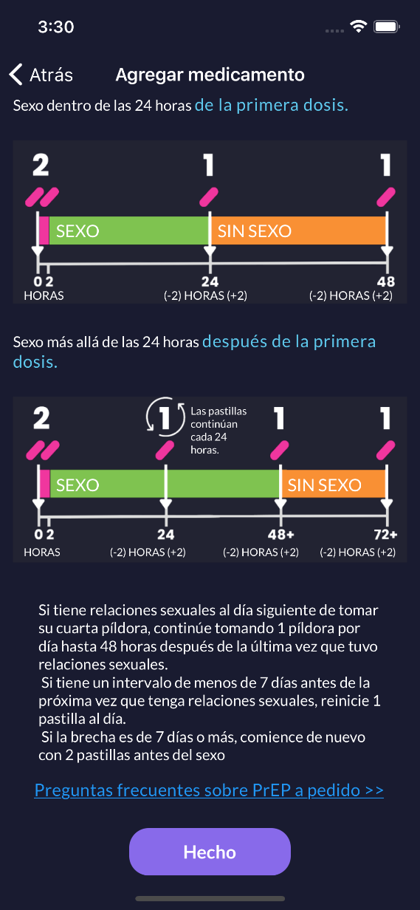
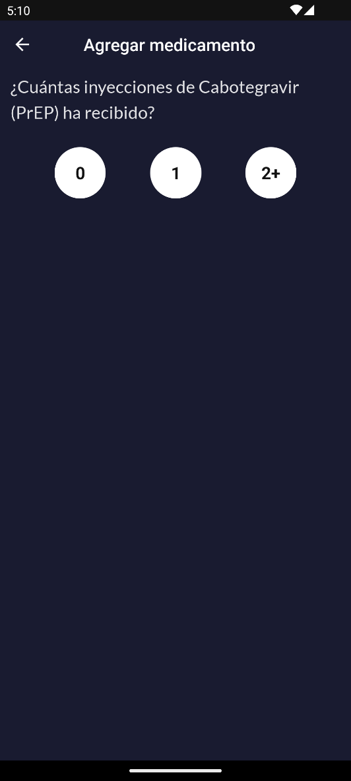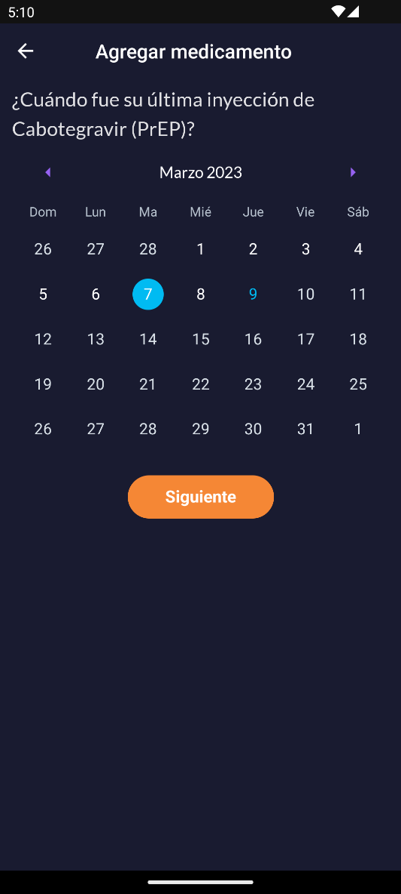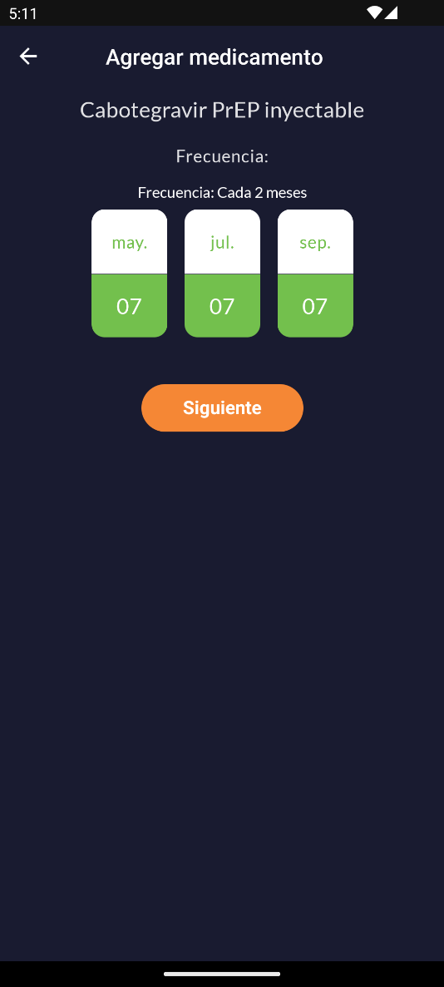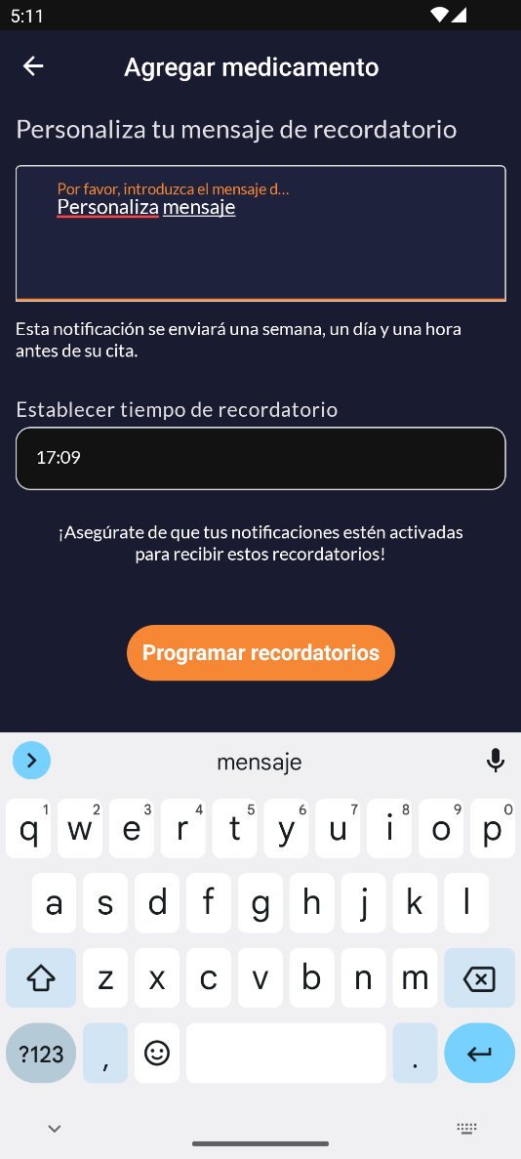

Health (Sex) Tracker Set-up
Time required to set up: 1-2 minutes
From the home screen or main health tracker screen, users can set up and track their sexual activity. Tracking their sexual activity, and other habits if they so choose, can help users recognize patterns within their medication adherence and identify factors that may influence how adherent they are over time. It can also help them recognize if a different method of PrEP might be better suited for them given their activity. E.g., if a user is not having very much sex, they might opt for on demand PrEP instead of daily PrEP.
- Main health tracker page
  - Add and/or edit sexual behavior (also includes updating reminders)
  - Track your sexual activity
  - View your stats
- Calendar (icon in top right on main health tracker page and track health page)
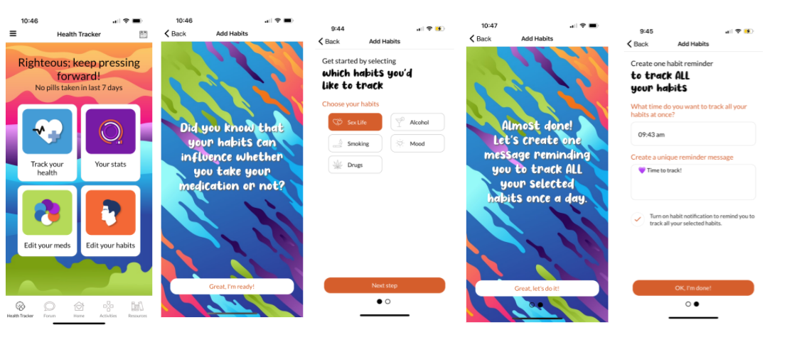
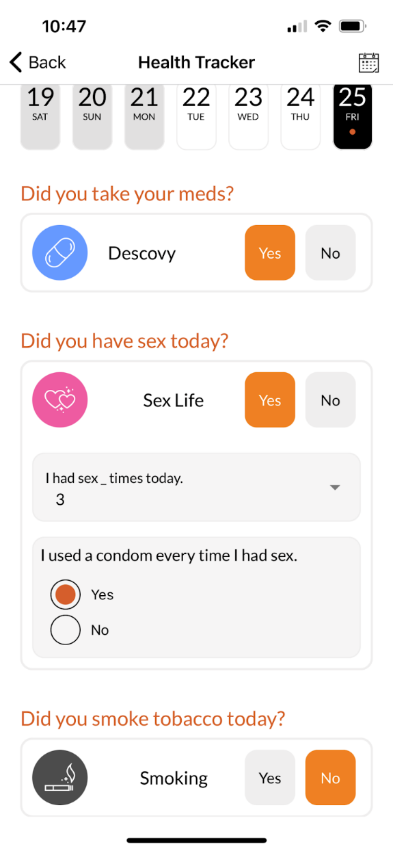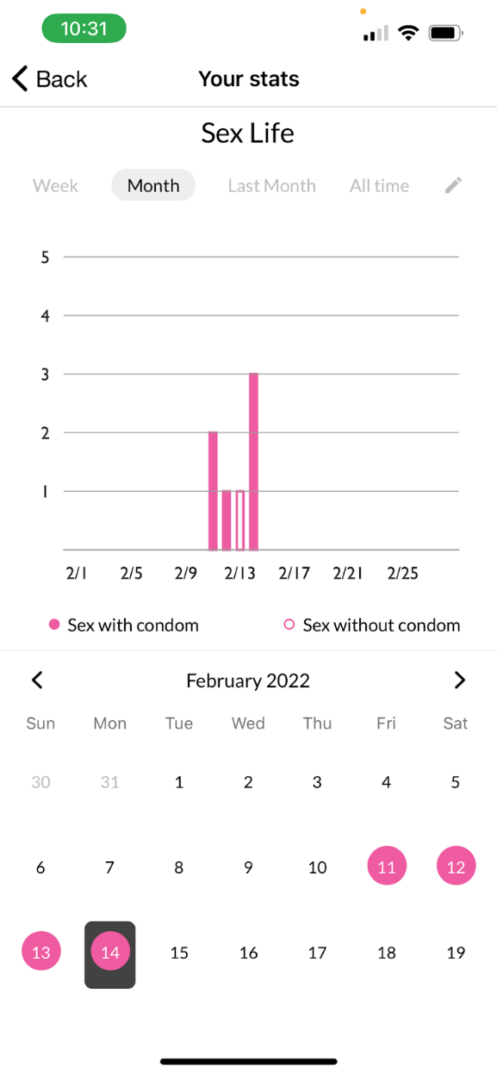
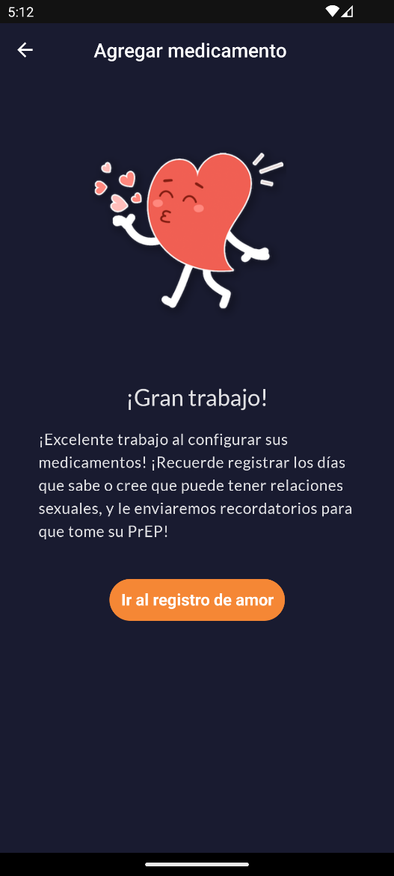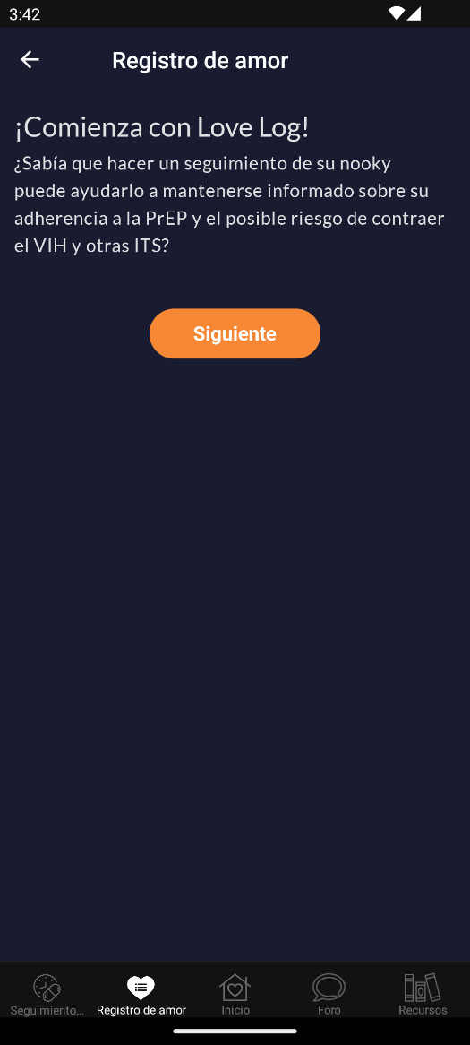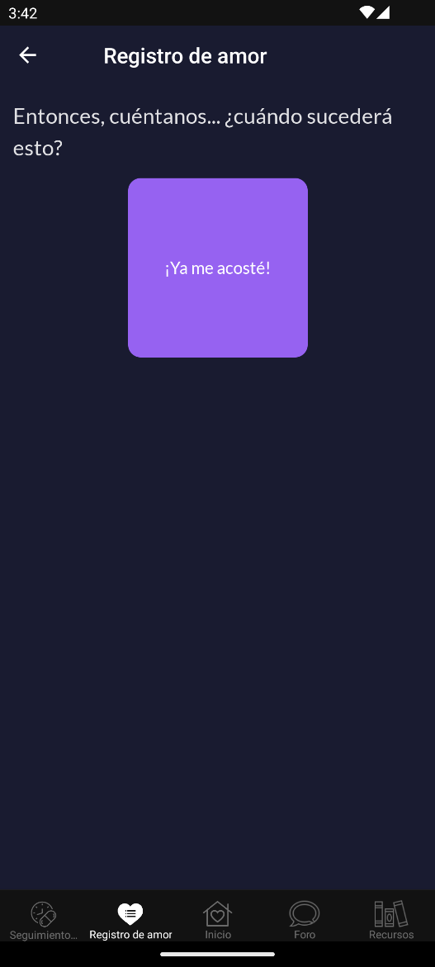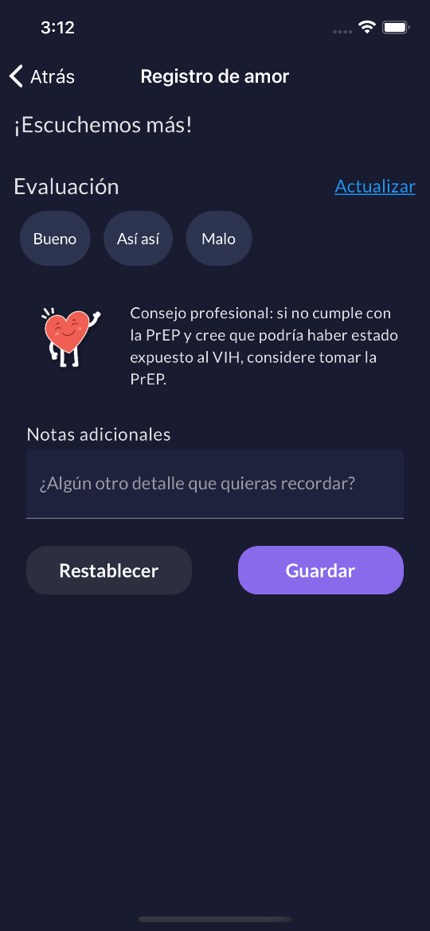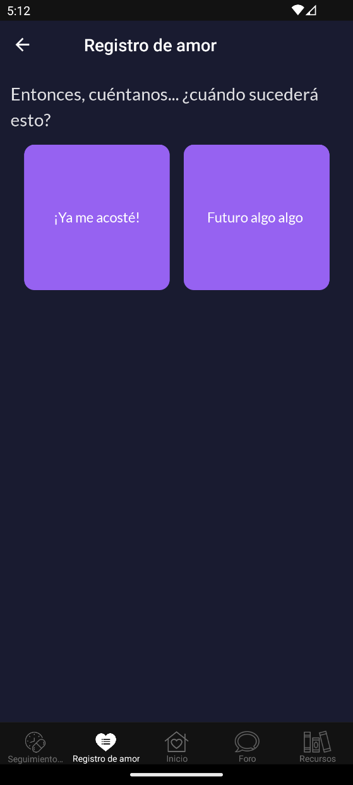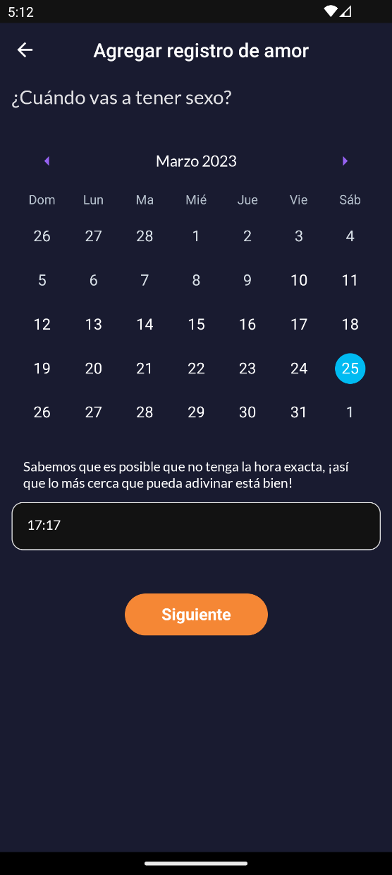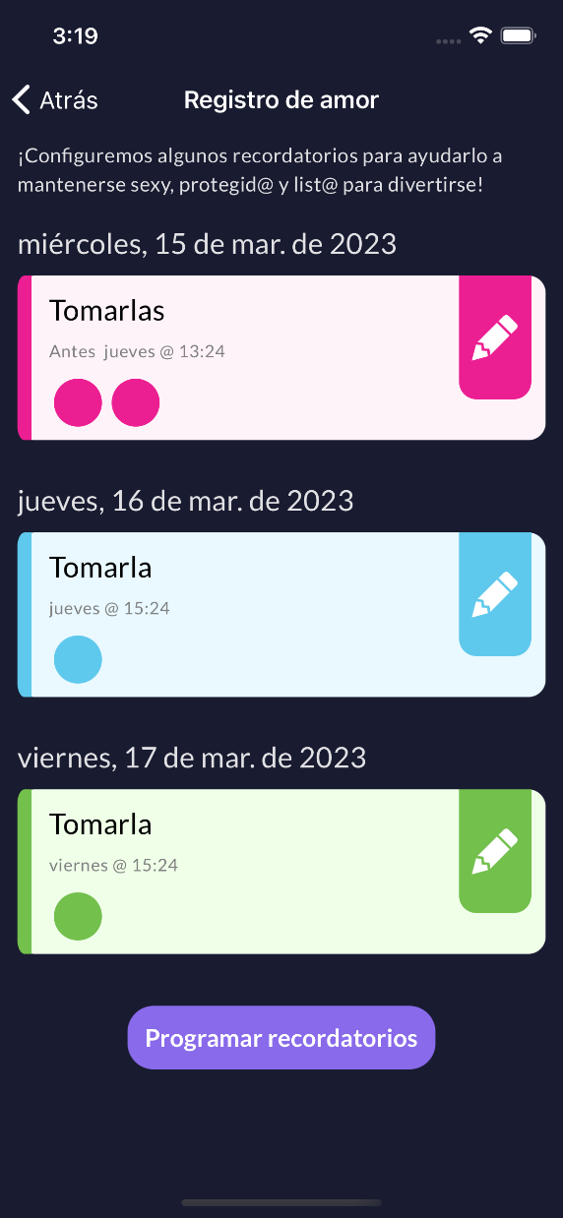

Test Kits
Time required to complete: 20-30 minutes at baseline and every 6 months while in study
At baseline and every 6 months while in study, users will be asked to complete an at-home DBS kit. Users will be asked to confirm their mailing address and be provided USPS tracking information. Once the test is received, the user can watch an instructional video and read instructional text to help them complete the kit. There will also be an option to reach out to staff for support. Users will be provided a pre-labeled envelope and instructions on how to mail the completed kit back to the lab. After it is mailed, they will receive their incentive.
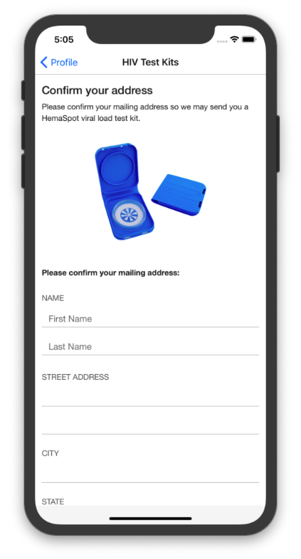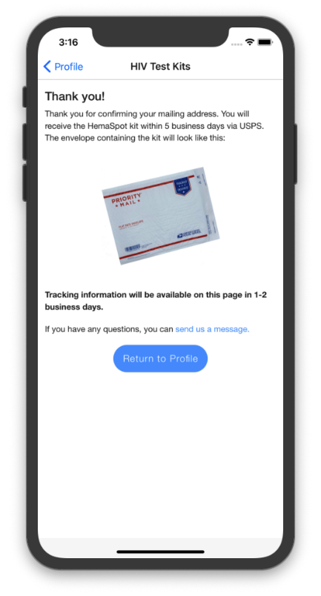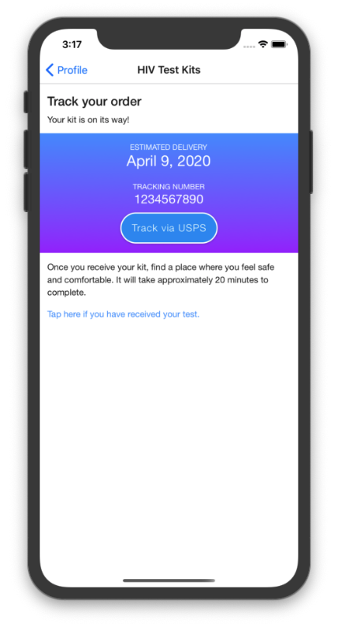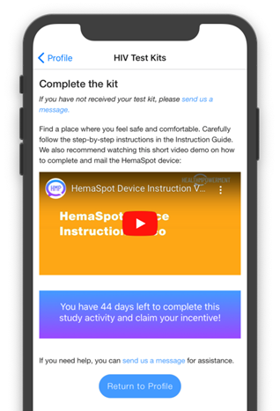
- Address confirmation page
- USPS tracking information page
- Instructional video and mailing to the lab information page

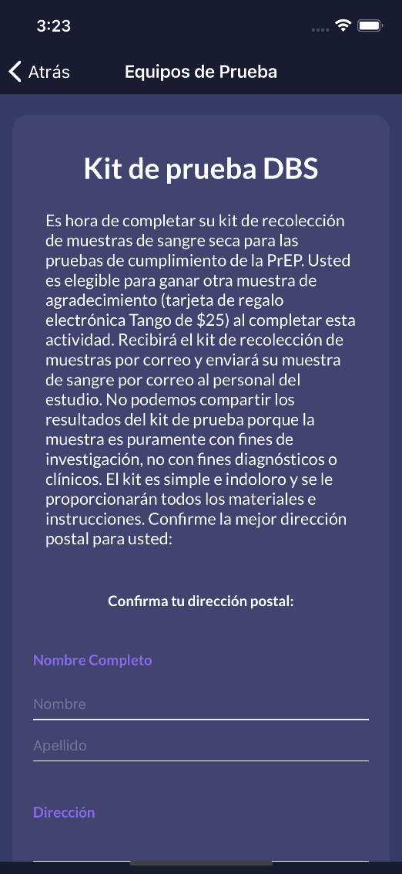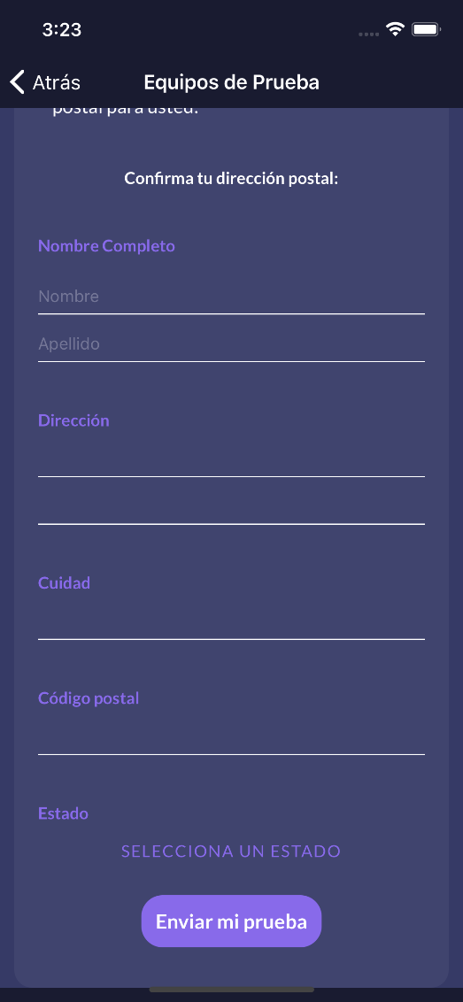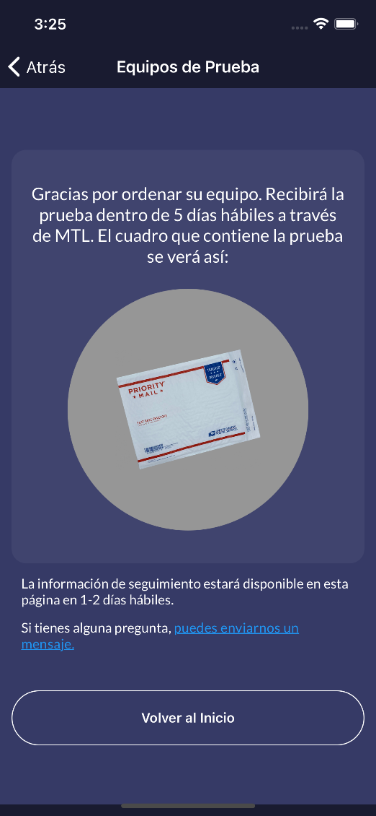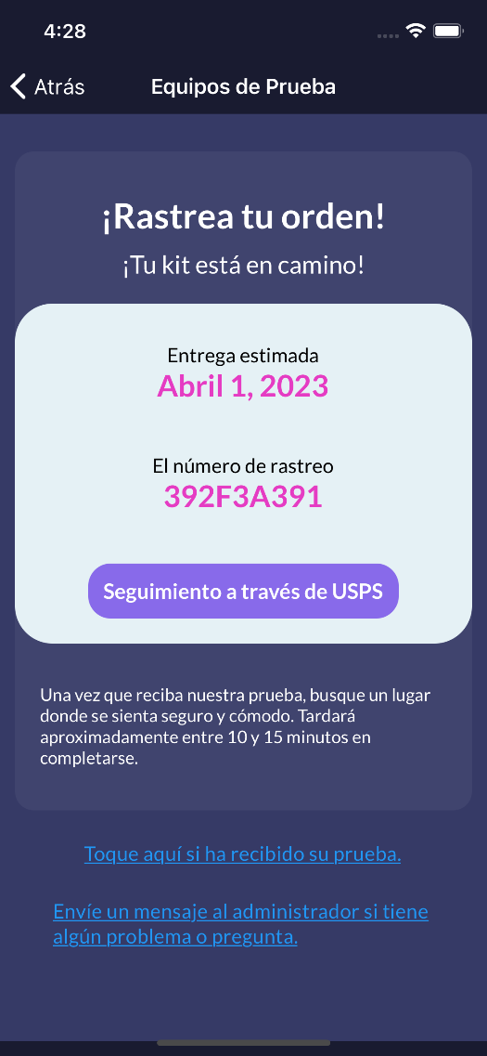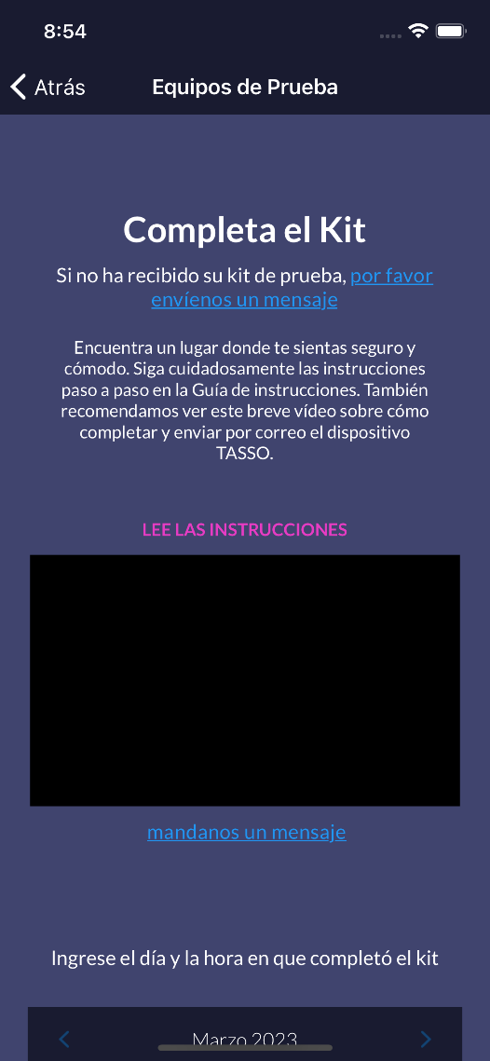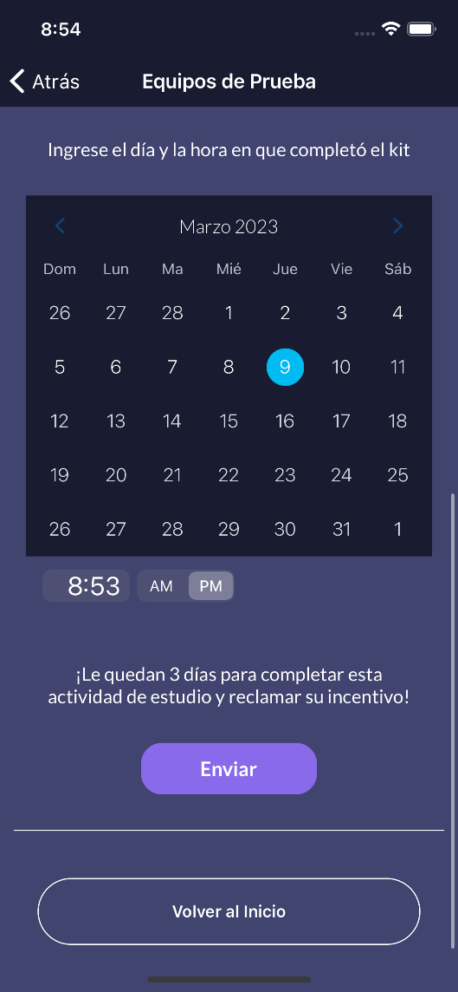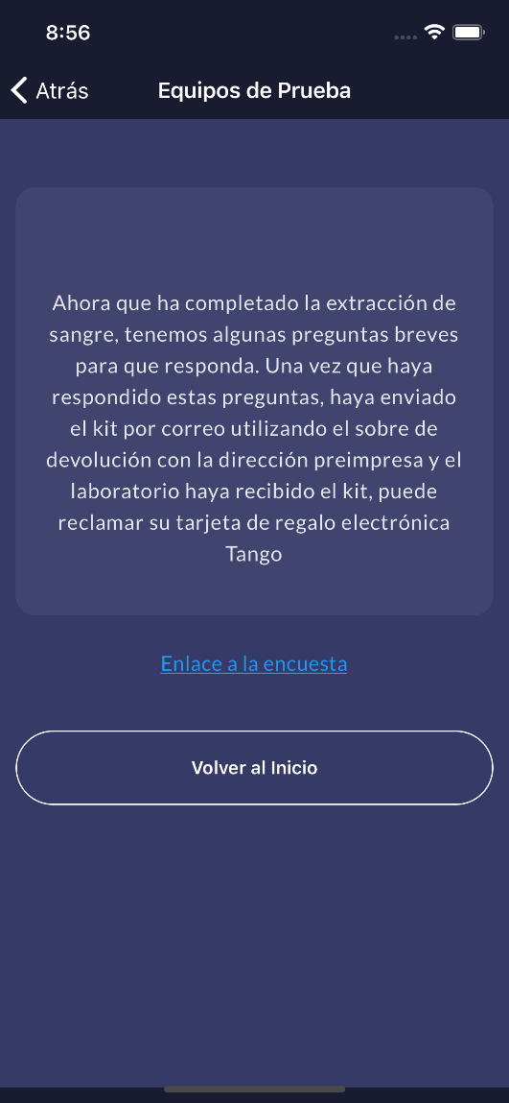

THIS ENDS THE REQUIRED FEATURES OF THE EPICC APP. THE FOLLOWING PROVIDES SOME ADDITIONAL DETAILS AND SCREEN SHOTS OF OPTIONAL FEATURES OF THE APP THAT ARE AVAILABLE TO PARTICIPANTS BUT NOT REQUIRED

Daily Use
*Optional, but recommended

Medication (PrEP) Tracker
Optional, but recommended: time to complete daily: 1-3 minutes
- Main health tracker page
  - Add and/or edit medication (also includes updating reminders)
  - Track your medicine
  - View your stats – choose specific medicine view analytics
- Calendar (icon in top right on main health tracker page and track health page)
Health (Sex) Tracker
Optional, but recommended: time to complete daily: 1-3 minutes
From the home screen or main health tracker screen, users can track their sexual activity. Tracking their sexual activity, and other habits if they so choose, can help users recognize patterns within their medication adherence and identify factors that may influence how adherent they are over time. It can also help them recognize if a different method of PrEP might be better suited for them given their activity. E.g., if a user is not having very much sex, they might opt for on demand PrEP instead of daily PrEP.
- Main health tracker page
  - Add and/or edit sexual behavior (also includes updating reminders)
  - Track your sexual activity
  - View your stats
- Calendar (icon in top right on main health tracker page and track health page)

Resources
If the user taps on the “Resources” button in the “Just for You” section, the app will take them to a randomly selected article. The user can save the article by selecting the star at the top right, as well as mark “yes” or “no” to the question “Was this information helpful to you?” Users can also access resources through the bottom navigation bar.
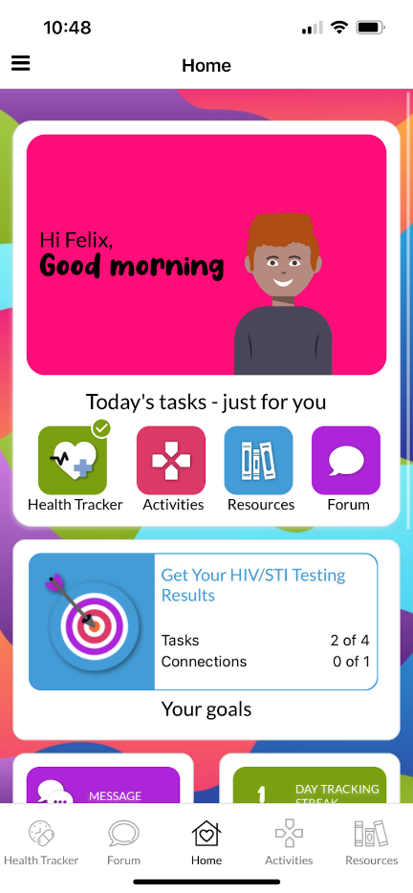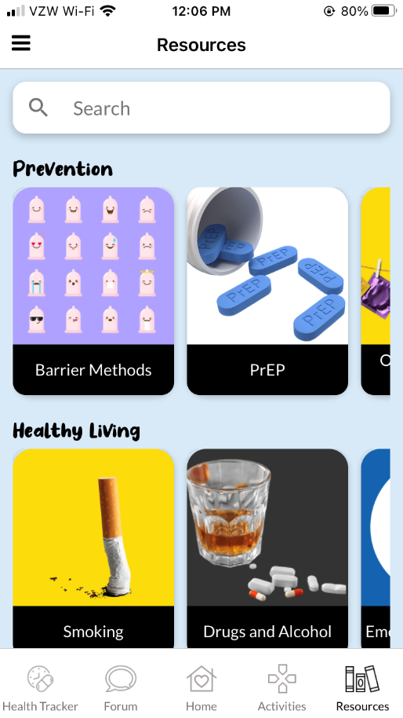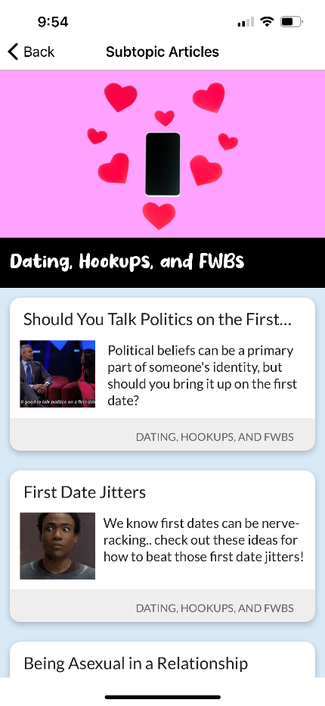
- Main list screen with parent topics and subtopics
- Subtopic list with article thumbnail and description
- Article view

Activities
Users can access activities through the “Just for You” section on the home screen or at the bottom navigation bar. The “Just for You” section will pull a random activity from the published pool. There are seven types of activities: quizzes, assessments, choose-your-own-adventure, free text fill in the blank, sorting and categorizing drag and drop. Topic areas include HIV/STI prevention, creating change, love and relationships, health living, great sex, culture and current events and life skills.
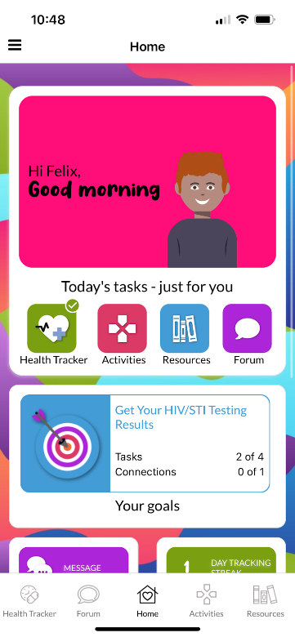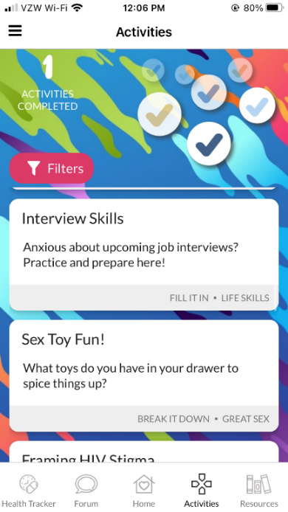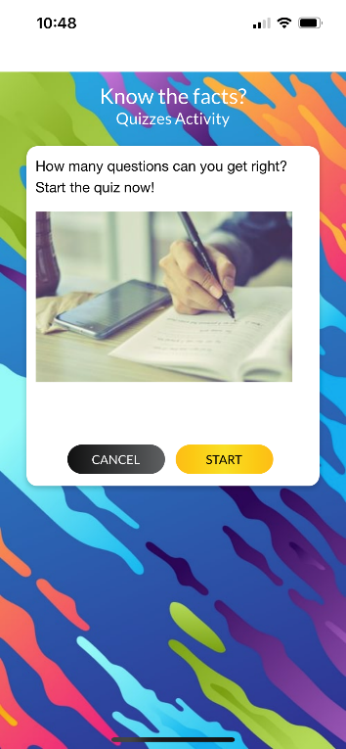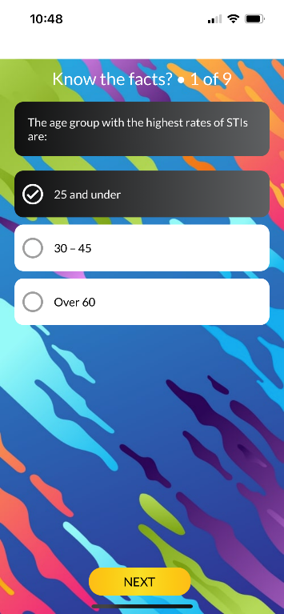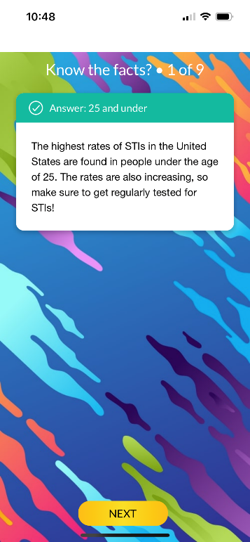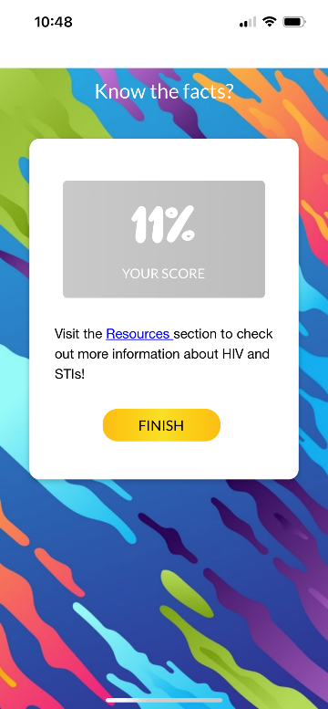
- Main list screen with title and short description
  - Filter by topic or type
  - Types include quizzes, assessments, choose-your-own-adventure, free text fill in the blank, sorting and categorizing drag and drop
- Introduction screen with image and expanded description
- Question/answer pages (screens may appear different depending on the type of activity)
- Summary page with links to more resources within or outside of the app

Goals
From the home screen or slide out menu, users can select various health and wellness goals to achieve.
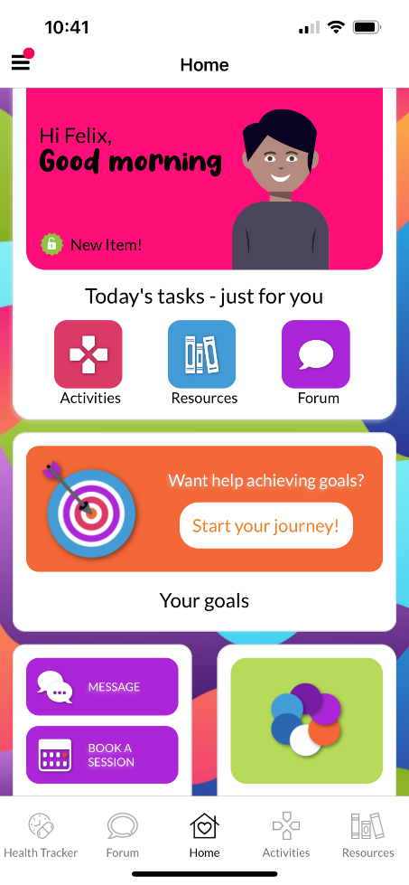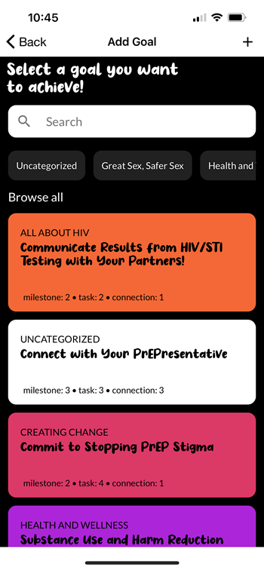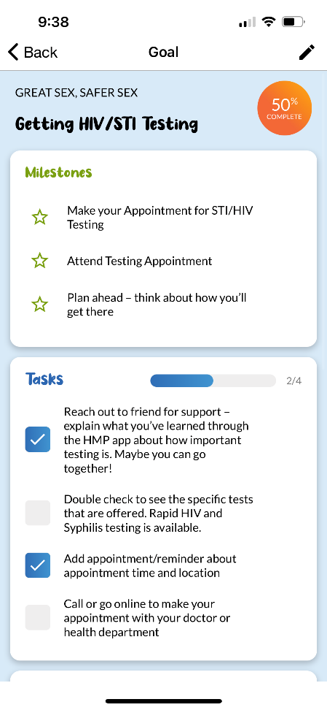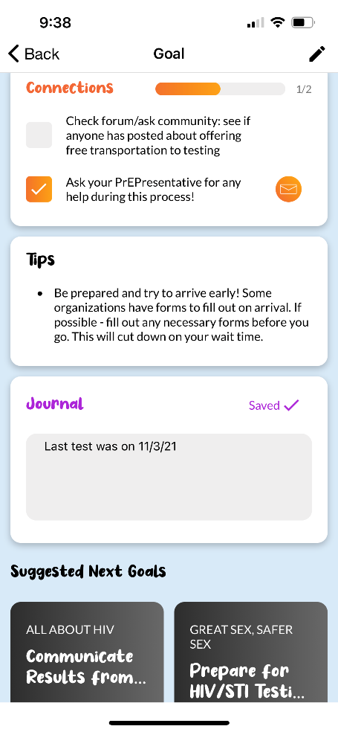
- Main list screen with ability to filter based on topic area or search using free text
- Details of individual goals
  - Milestones
  - Tasks
  - Connections
  - Tips
  - Journal
  - Suggested Next Goals

Forum
Users can access the forum via the bottom navigation bar or the “Just for You” section on the home screen. Here they can read what others have posted and contribute their own thoughts. Upon their first time in the forum, they will be presented a pop-up message asking them to agree to the study’s Community Guidelines that encourage a safe and tolerant space for people to express themselves.
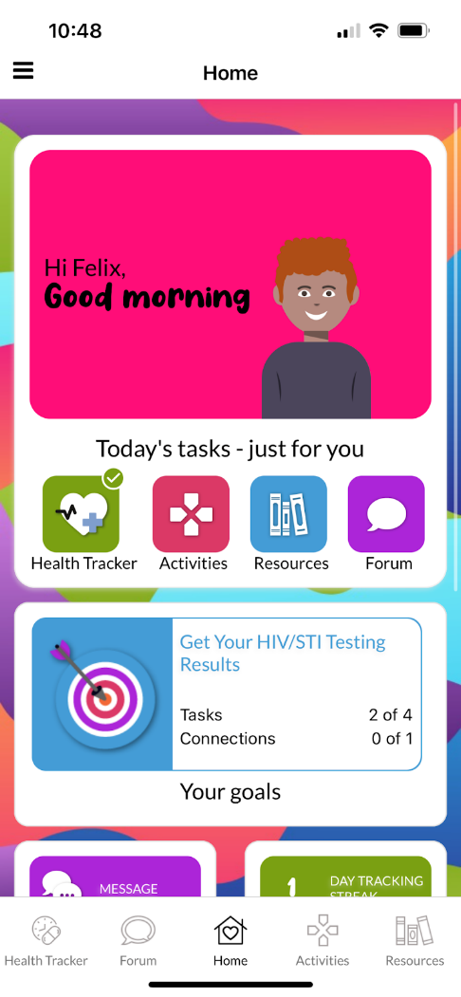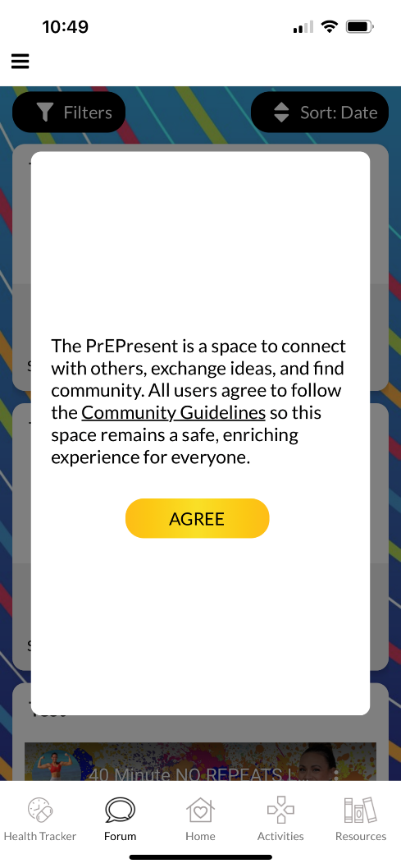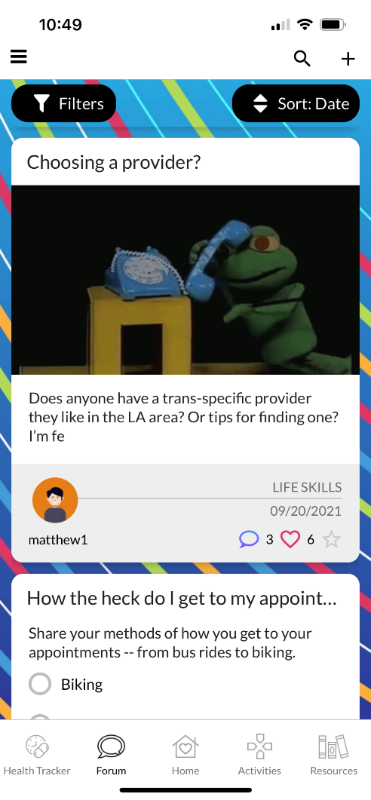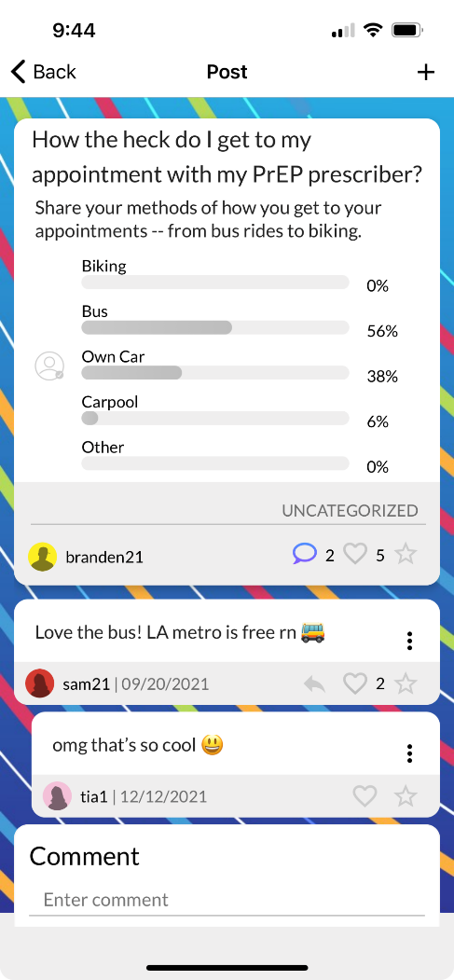
- Upon first entry into the forum, acknowledgment on community guidelines pop-up message
- Main forum screen
  - Polls can be answered directly from the main page
  - Likes, favorites and flags can be given directly from the main page
  - Sort by date, most popular, most favorited, most liked
  - Filter by topic or users followed
- Detailed post view with comment/reply function
Ask the Expert
Using the slide out menu, users can access the “Ask the Expert” feature. Here they can read what others have asked and the expert’s responses, ask their own question or meet the experts and read more about their backgrounds.
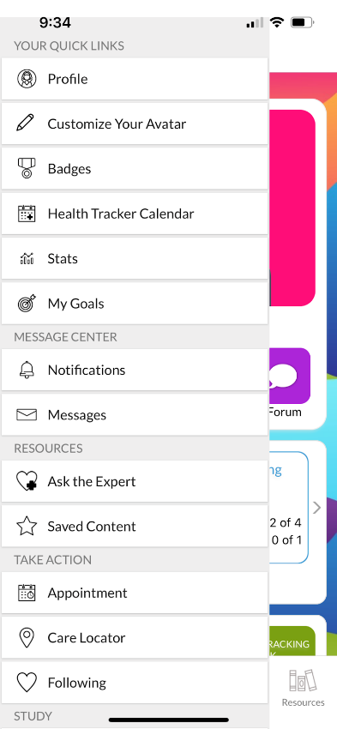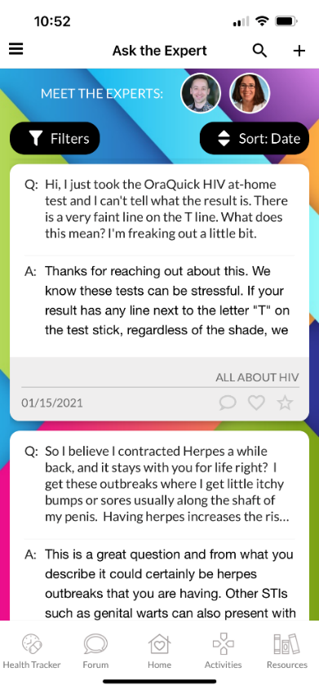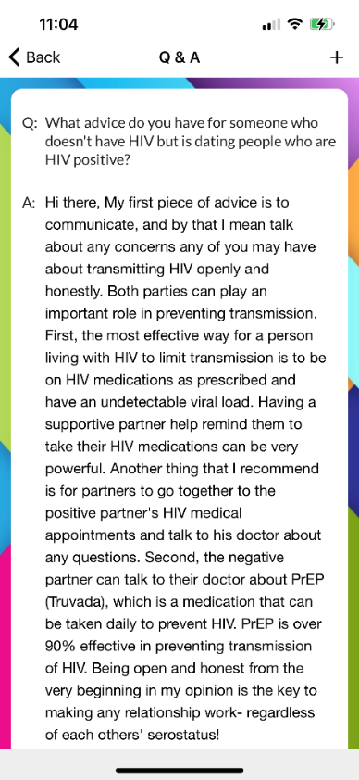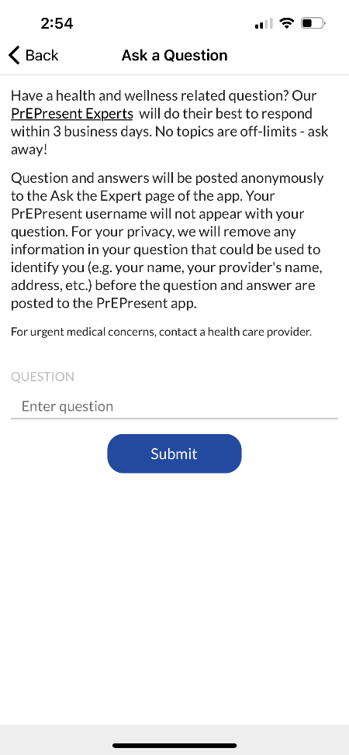
- Main Ask the Expert screen
  - Past participant submitted questions with expert answers
    - Sort by date, most commented, most favorited, most liked
    - Filter by topic
- Detailed view of specific question
- Submit a question screen
- Meet the experts screen

Care Locator
The slide out menu will take users to the care locator, to help users search for locally-based resources.
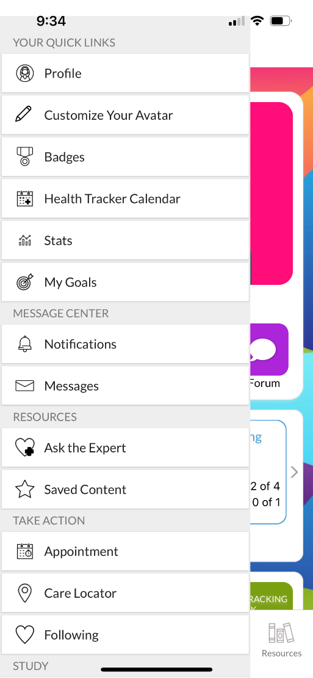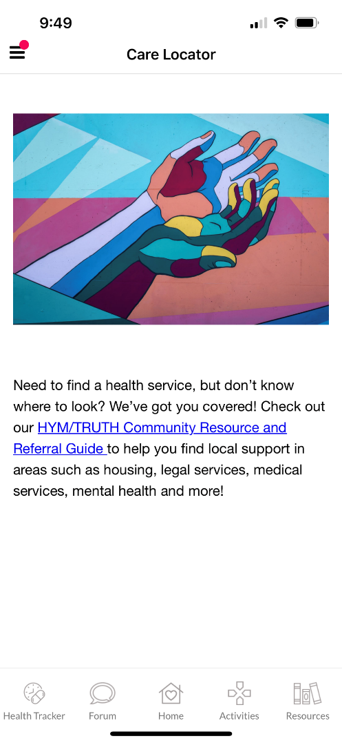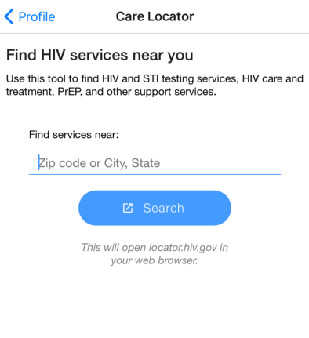
- Care locator main screen
  - Either project created resource document link OR embedded service finder website such as locator.hiv.gov or pleaseprepme.org
    - Clicking or entering in location information will take you out of the app to the external site

Help & FAQ
Users can access commonly asked questions about the study and app from the slide out menu.
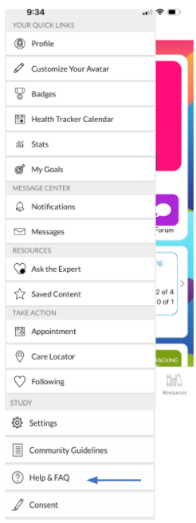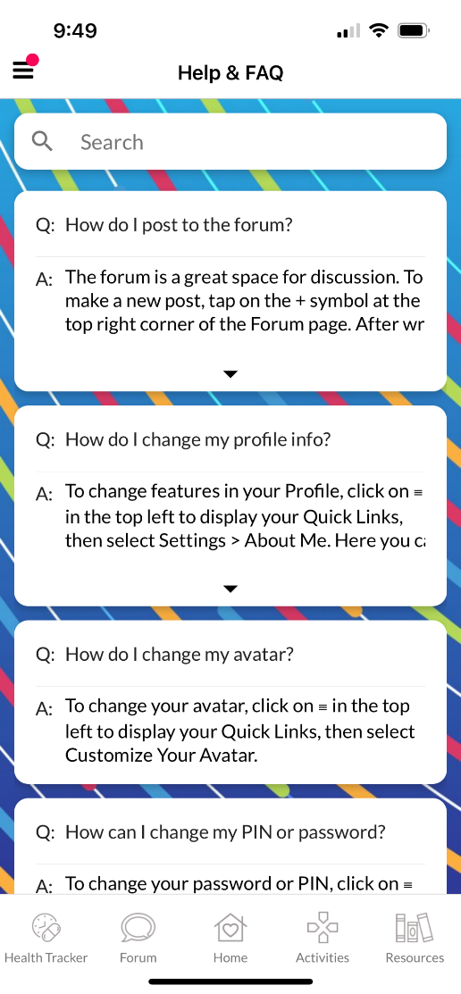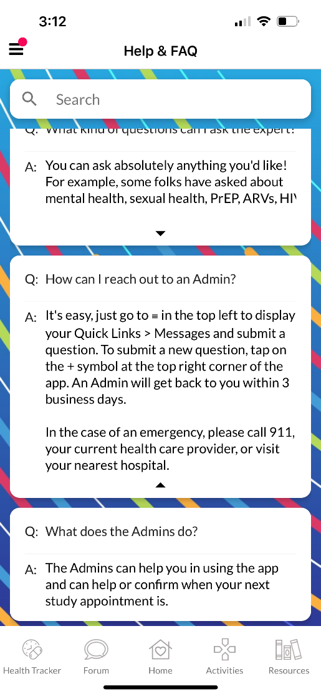
- Main list of FAQs
- Detailed view of specific FAQ

Community Guidelines
Users can view the community guidelines via the slide out menu.
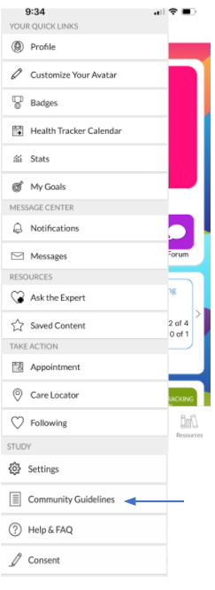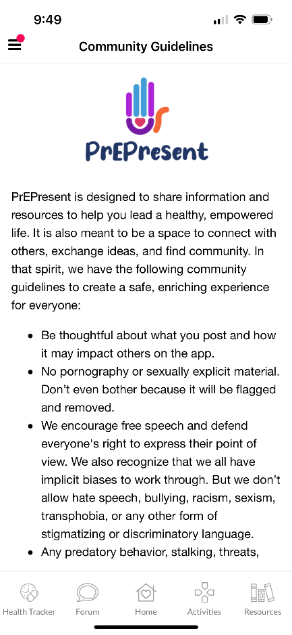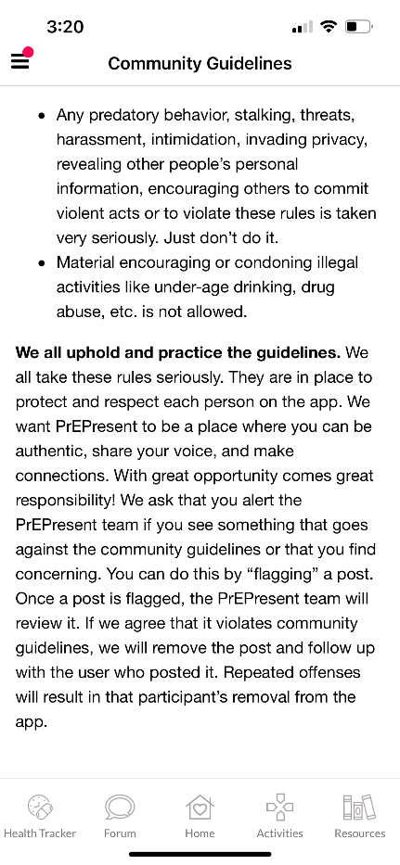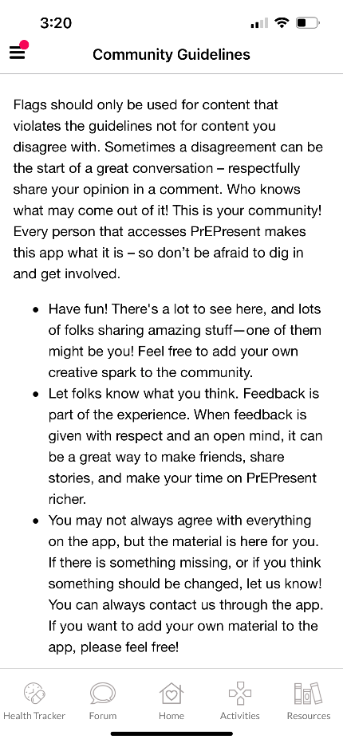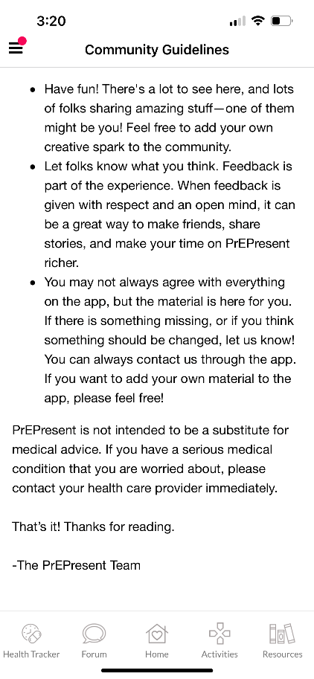
- Main community guidelines screen
  - Explains guidelines on types of content acceptable to post in the forum
  - Explains what flagging is if a user does deem any content inappropriate
  - Encourages participation
  - Provides disclaimer that the app is not meant to be a replacement for medical advice or care

Copy of Informed Consent
Participants will complete the informed consent process outside of the app; however, they will be able to view a copy of the consent form within the app. Accessing and viewing a copy of the consent form is not a mandatory action for participants within the app, but it is always available to participants. Any modifications or updates submitted to the IRB are updated within the app as well. This update does not require users to update their mobile devices but happens automatically ensuring they always have access to the most current version. Users can access this page via the slide out menu.

- Copy of project informed consent form
  - Updated within the app if any modifications to the IRB are submitted

