Medical Travel Refund Request – Expenses
U.S. Department of Labor

Office of Workers' Compensation Programs

NOTE: This report is authorized by the Federal Employees' Compensation Act (5 USC 8103(a)), the Black Lung Benefits Act (30 USC 901; 20 CFR 725.406 and 725.701) and the Energy Employees Occupational Illness Compensation Program Act of 2000, (42 USC 7384 and 20 CFR 30.701). While you are not required to respond, this information is required to obtain reimbursement for travel expenses.
The method of collecting information complies with the Freedom of Information Act, the Privacy Act of 1974, and OMB Circ. 130. This form should be used for medically related travel covered by the Federal Employees' Compensation Act, the Black Lung Benefits Act, and the Energy Employees Occupational Illness Compensation Program Act of 2000.

OMB No. 1240-0037
Expires: 11/30/2026

- Claimant Name (Last, First, M.I.): 2. Case/Claim Number:

3. Payee Name if different from claimant's name (Last, First, M.I.): 4. Claimant/Payee Phone No.:

5. Claimant/Payee Address (House #, Street or RR, City, State, Zip Code): 6. Claimant/Payee Email:

7. Payee relationship to Claimant: 8. Reason Payee other than Claimant is requesting reimbursement:

Special Instructions: 1. See reverse side of form for complete instructions.
- Physician's signature or facsimile is REQUIRED by BLACK LUNG for verification of each service date and type.
9. CLAIMANT’S TRAVEL EXPENSE REIMBURSEMENT REQUEST |  |  | For Black Lung Use Only
Date: |  |  | DOL USE ONLY | CARE RENDERED
From: |  | One-way | TOS/Procedure Code  ------------ $ ------------  ------------ -------------  ------------ -------------  ------------ ------------  ------------ -------------  ------------ -------------  -----------------------------  Total $  --------------------- | To be completed by Physician: (Mark one box only)  Treatment for Black Lung Not Black Lung Related  Determination Testing for Black Lung  Diagnosis  Signature of Physician Date Care Rendered
 |  | Round trip
 |  | Hospital
 |  | Medical Appt.
To: |  | Therapy/Rehab
 |  | Pharmacy
 |  | Med. Supply
 |  | Other
Total miles traveled (Private auto only):
 | Train
 | Bus
Other travel expenses: | Pkg/Tolls
(Attach receipts for each listed | Taxi
expense) | Lodging
 | Meals
 | Other
Specify “Other” expenses:
Date: |  |  | DOL USE ONLY | CARE RENDERED
From: |  | One-way | TOS/Procedure Code  ------------ $ ------------  ------------ -------------  ------------ -------------  ------------ ------------  ------------ -------------  ------------ -------------  -----------------------------  Total $  --------------------- | To be completed by Physician: (Mark one box only)  Treatment for Black Lung Not Black Lung Related  Determination Testing for Black Lung  Diagnosis  Signature of Physician Date Care Rendered
 |  | Round trip
 |  | Hospital
 |  | Medical Appt.
To: |  | Therapy/Rehab
 |  | Pharmacy
 |  | Med. Supply
 |  | Other
Total miles traveled (Private auto only):
 | Train
 | Bus
Other travel expenses: | Pkg/Tolls
(Attach receipts for each listed | Taxi
expense) | Lodging
 | Meals
 | Other
Specify “Other” expenses:
Payee's Certification: I certify that the information provided is true and accurate to the best of my knowledge and belief. I am aware that any person who knowingly makes any false statement, misrepresentation, concealment of fact, or any other act of fraud, to obtain reimbursement as provided by the OWCP, or who knowingly accepts reimbursement to which that person is not entitled is subject to civil or administrative remedies as well as criminal prosecution and may, under appropriate criminal provisions, be punished by a fine or imprisonment, or both. In addition, a state or federal criminal conviction for OWCP fraud will result in termination of all current and future OWCP benefits.

Instructions - Form OWCP-957 Part B - Medical Travel Refund Request – Expenses (All fields must be completed)

  - Enter Claimant's full name: last name, first name, middle initial (M.I.).
  - Enter Claimant's claim/case file number.
  - Enter payee's full name (if person other than the claimant is to be reimbursed): last name, first name, middle initial. A payee other than the claimant must have special authorization. Not applicable to FECA Program.
  - Enter the Claimant’s or Payee’s phone number (No.) to reach with questions about this form.
  - Enter the street address of the person to be reimbursed including the: Street or Rural Route (RR), City, State, Zip Code
Note: For the Federal Employees’ Compensation Act (FECA) program to process your request, a FECA claimant must provide the home address where the claimant resides. A Post Office (PO) Box or attorney/representative address is not an acceptable address.
  - Enter the Claimant’s or Payee’s email address to reach with questions about this form.
  - If a person other than the claimant is to be reimbursed state your relationship to the claimant and provide evidence of authorization. A payee other than the claimant must have special authorization.
  - If a Payee other than the Claimant is requesting reimbursement, please state the reason the Payee is requesting reimbursement.
  - Complete a separate block for each medical facility, pharmacy, therapist, etc. visited.
Date: Enter the date of travel.
From: Enter the full street address of the address where your trip started, i.e., home, work, or Physician’s office.
To: Enter the full street address of the address where your trip ended. In the checkboxes to the right of the address field, check the box indicating whether the trip was one-way or round trip.
Total miles traveled: If you drove or were driven in a private car, enter the number of miles here for mileage reimbursement.
Other travel expenses: Check the box and enter the dollar amount spent in each category. Attach receipts for each item. If you use the “Other” checkbox, name the item in the line below the checkbox.

Example:
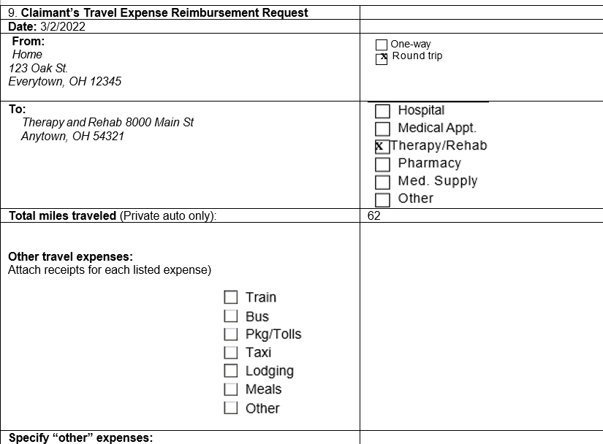

  - The person claiming reimbursement must sign and date here.

Claimant’s/Payee’s Signature: Date:

FOR BLACK LUNG ONLY
Note: Travel for diagnostic or determination examination
    - Special approval from the district office is required for lodging. Pre-approval should be requested and obtained before the travel occurs.

Travel for treatment of Black Lung disease
    - Special approval from the district office is needed for overnight travel, related meals and lodging, and mileage exceeding 100 miles one way or 200 miles roundtrip. Pre-approval should be requested and obtained before the travel occurs.
    - To obtain your district office telephone number, call toll free 1-800-638-7072.
FOR ENERGY EMPLOYEES OCCUPATIONAL ILLNESS COMPENSATION ONLY
Note: Special approval from the Medical Benefits Adjudication Unit is needed for travel exceeding 100 miles one way or 200 miles roundtrip. To contact the Medical Benefit Adjudication Unit, call toll free 1-866-272-2682.

Return this completed claim form to the appropriate program address below.

Division of Federal Employees' Compensation (DFEC) | Division of Coal Mine Workers’ Compensation (DCMWC) | Division of Energy Employees Occupational Illness Compensation (DEEOIC)
DFEC  PO Box 8300  London, KY 40742-8300 | DCMWC  PO Box 8302  London, KY 40742-8302 | DEEOIC  PO Box 8304  London, KY 40742-8304  Or submit electronically via Energy Document Portal (EDP)

To receive payment, you must have electronic banking information (Electronic Funds Transfer or EFT) on file with the appropriate program to prevent a delay in the processing of your bills. Go To https://www.fiscal.treasury.gov/files/forms/form-1199a.pdf to download and complete the EFT form. Mail your completed claim form to the appropriate program below:

DFEC  PO Box 8311  London, KY 40742-8311 | DCMWC  PO Box 8307  London, KY 40742-8307 | DEEOIC  PO Box 8306  London, Kentucky 40742-8306  Or submit electronically via Energy Document Portal (EDP)
If you have any questions regarding the completion of the form, please call  Toll Free: 1-844-493-1966 | If you have any questions regarding the completion of the form, please call  Toll Free: 1-800-638-7072 | If you have any questions regarding the completion of the form, please call  Toll Free: 1-866-272-2682

BURDEN DISCLOSURE NOTICE
The public reporting burden for this data collection is estimated to average seven minutes per response. The burden estimate includes the time for reviewing instructions, searching existing data sources, gathering and maintaining the data needed, and completing and submitting the form. This collection of information is mandatory, as it is needed by OWCP and authorized by 5 USC 8101 et seq., 30 USC 901 et seq., and 42 USC 7384d to collect this information to administer the FECA, BLBA and EEOICPA. The information collected is used to identify the eligibility of the claimant for benefits, and to determine coverage of services provided. Please send comments regarding the burden estimate or any other aspect of this collection of information including suggestions for reducing this burden, and reference OMB control number 1240-0037 to the Office of Workers' Compensation Programs, Department of Labor, Room S3522, 200 Constitution Avenue NW, Washington, DC 20210; and to the Office of Management and Budget, Paperwork Reduction Project (1240-0037), Washington, DC 20503. NOTE: Please do not send your completed form to this address.

PRIVACY ACT STATEMENT

We are authorized by OWCP to ask you for information needed in the administration of the FECA, Black Lung and EEOICPA programs. Authority to collect information is in 5 USC 8101 et seq.; 30 USC 901 et seq.; 38 USC 613; E.O. 9397; and 42 USC 7384d, 20 CFR 30.11 and E.O. 13179. The information we obtain to complete claims under these programs is used to identify you and to determine your eligibility. It is also used to decide if the services and supplies you received are covered by these programs and to ensure that proper payment is made. Your response regarding the medical service(s) received or the amount charged is required to receive payment for the claim. See 20 CFR §§ 10.801, 30.701, 725.406, 725.701, and 725.704. Failure to furnish information regarding the medical service(s) received or the amount charged will prevent payment on the claim. The information may also be given to other providers of services, carriers, intermediaries, medical review boards, health plans, and other organizations or Federal agencies, for the effective administration of Federal provisions that require other third-party payers to pay primary to Federal programs, and as otherwise necessary to administer these programs. For example, it may be necessary to disclose information about the benefits you have used to a hospital or doctor. Additional disclosures are made through routine uses for information contained in systems of records. See Department of Labor systems DOUGOVT-1, DOUESA-5, DOL/ESA-6, DOU ESA-29, DOL/ESA-30, DOL/ESA-43, DOL/ESA-44, DOUESA-49 and DOL/ESA-50 published in the Federal Register, Vol. 67, page 16816, Mon. April 8, 2002, or as updated and republished. You should be aware that P.L. 100-503, the "Computer Matching and Privacy Protection Act of 1988," permits the government to verify information by way of computer matches.

NOTICE
If you have a substantially limiting physical or mental impairment, Federal disability nondiscrimination law gives you the right to receive help from OWCP in the form of communication assistance, accommodation and modification to aid you in the claims process. For example, we will provide you with copies of documents in alternate formats, communication services such as sign language interpretation, or other kinds of adjustments or changes to account for the limitations of your disability. Please contact our office or your claims examiner to ask about this assistance.

