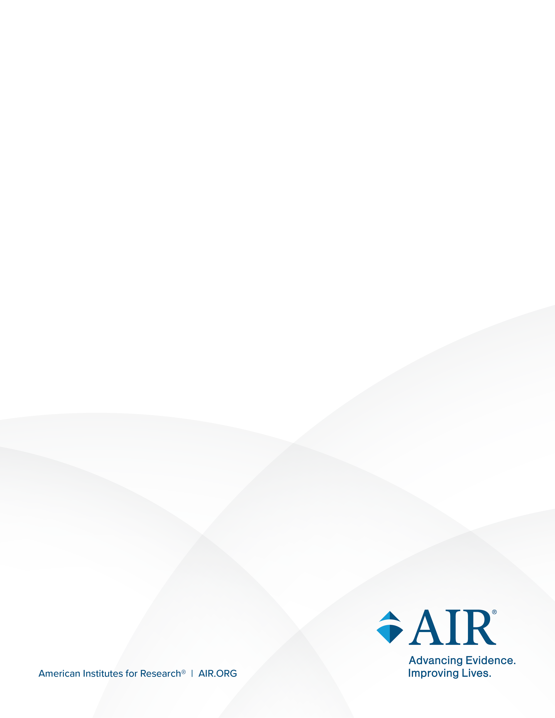
National Study of Special Education Spending

Attachment A: Initial Contact Letters
April 2026
LETTERHEAD
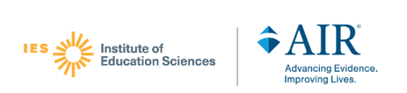
STATE EDUCATION AGENCY LETTER
<Date>
<Addressee’s Name>
<Organization>
<Address>
<City, State Zip>
Dear [AGENCY CONTACT]:
The Institute of Education Sciences (IES) at the U.S. Department of Education is starting a critical new effort, the National Study of Special Education Spending (NSSES). The study will provide policymakers and special education administrators the first national estimates in more than 2 decades of how and how much states and districts spend to educate students with disabilities.
The study is being conducted as part of the National Assessment of the Individuals with Disabilities Education Act (IDEA), mandated by Congress to collect information that can inform future updates to the law. As recipients of IDEA funding, state agencies and school districts are expected to participate (Education Department General Administrative Regulations Section, 34 C.F.R. § 76.591).
How you can help:
It is critical that the unique experiences of your state, districts, and schools are reflected in this national effort. IES and its partners—the American Institutes for Research® (AIR®); NORC at the University of Chicago (NORC); and Allovue, a PowerSchool company—will collect information from some districts and schools in your state during school year 2026–27.
Please see the enclosed list of districts in your state that have been selected to represent the U.S. experience of special education spending. We ask that you notify the selected districts in your state, by phone or e-mail, to encourage their participation in this exciting study.
We also will ask you or someone you designate to complete a short survey about special education in your state. The enclosed Study FAQ details the study timeline and the information requests. The Study FAQ, along with a study outreach letter, will be mailed to the selected districts in the next week.
I invite you to contact me with any questions about the study (Sarah.brasiel@ed.gov). You may also contact the study Principal Investigator, Tammy Kolbe, at NSSES@AIR.org.
Sincerely,
(Note: Signature to be added to official letter)

Sarah Brasiel
Project Officer
National Study of Special Education Spending
Institute of Education Sciences
Sarah.brasiel@ed.gov
Districts selected from [STATE] for the NSSES:
[INSERT DISTRICT LIST]

LOCAL EDUCATION AGENCY LETTER
<Date>
<Addressee’s Name>
<Organization>
<Address>
<City, State Zip>
Dear [DISTRICT CONTACT]:
The Institute of Education Sciences (IES) at the U.S. Department of Education is starting a critical new effort, the National Study of Special Education Spending (NSSES). We are writing to inform you that [District] has been selected to participate in this study during the 2026–27 school year.
Key details:
The NSSES will provide policymakers and special education administrators the first national estimates in more than 2 decades of how and how much states and districts spend to educate students with disabilities. Although no districts or schools in the study will be individually identified, it is critical that your district’s unique experiences are reflected.
IES and its partners—the American Institutes for Research® (AIR®); NORC at the University of Chicago (NORC); and Allovue, a PowerSchool company—will collect data from some schools in your district about a small set of students. Teachers, service providers, and district staff will be asked to complete web surveys and provide financial data. Please see the enclosed Study FAQ for more information.
Why is it important to participate?
Your district’s participation is vital to understanding what is spent to educate students with disabilities. The study is being conducted as part of the National Assessment of the Individuals with Disabilities Education Act (IDEA), mandated by Congress to collect information that can inform future updates to the law. As recipients of IDEA funding, districts and schools are expected to participate (Education Department General Administrative Regulations Section, 34 C.F.R. § 76.591).
Next steps:
Study staff will be contacting you soon about your participation and the participation of selected schools in your district. Please see the enclosed list of schools selected for the study. The expected time commitment for study activities in school year 2026–27 is 10–13 hours for districts and 1–2 hours per survey for selected schools.
Specifically, district and school participation will include the following:
District | School
- Notify schools about the study and encourage participation  - Provide district student enrollment data  - Complete two online surveys  - Provide administrative and financial data | - Identify a school coordinator to help the study team and serve as main contact person  - In some cases, provide school student enrollment data  - Identify the teacher(s) and service provider(s) who can complete an online Student Resources Survey about the educational program of some students  - Encourage staff to complete the online Student Resources Surveys
The U.S. Department of Education values the time that educators devote to important studies such as these, and districts, schools, school coordinators, and respondents will be reimbursed for the time it takes to coordinate and complete surveys and provide administrative data.
For their crucial role in ensuring the success of this study, and if your district permits, district staff, schools, school coordinators, and respondents will be provided a monetary token of appreciation for the time it takes to coordinate and complete study surveys and provide data from district systems.
Payments will be made in the form of electronic gift cards for individual survey respondents and staff who prepare and deliver the local education agency financial data file. Districts will receive either electronic gift cards or checks to offset the overall cost of producing the roster information needed for sampling and coordinating data collection activities.
- Districts will receive $500.
- District staff who prepare and deliver the local education agency financial data file will receive $60.
- District staff who complete the Program Officer survey and the Financial Officer survey will receive $60 for each completed survey.
- School coordinators will receive $150 if 70 percent of the Student Resources Surveys are completed for the school, plus a bonus of $50 if all surveys are completed.
- Staff who complete the Student Resources Survey will receive $60 for each completed survey.
Your district’s participation is vital to understanding what is spent to educate students with disabilities. Your support will be invaluable in shaping future policies and programs.
A NORC team member will reach out to discuss the study and what we will be requesting from your district and school(s). If you have any questions, please contact the research team at NORC-NSSES@norc.org or call our study toll-free number at 888-872-0626.
We look forward to working with you on this exciting study and are ready to address any questions or concerns you have about this effort.
Sincerely,

Tammy Kolbe
Principal Investigator
American Institutes for Research
Cynthia Simko
Data Collection Project Director
NORC at the University of Chicago

School(s) selected from [DISTRICT] for the NSSES:
[SCHOOL LIST]
SCHOOL LETTER
<Date>
<Addressee’s Name>
<Organization>
<Address>
<City, State Zip>
Dear [SCHOOL CONTACT]:
The Institute of Education Sciences (IES) at the U.S. Department of Education is starting a critical new effort, the National Study of Special Education Spending (NSSES). We are writing to inform you that [School] has been selected to participate in the study during the 2026–27 school year. Your district has approved this study.
Key details:
The NSSES will provide policymakers and special education administrators the first national estimates in more than 2 decades of how and how much states and districts spend to educate students with disabilities. Although no districts or schools in the study will be individually identified, it is critical that your school’s unique experiences are reflected.
IES and its partners—the American Institutes for Research® (AIR®); NORC at the University of Chicago (NORC); and Allovue, a PowerSchool company—will collect data from your school about a small set of students. Teachers and service providers will be asked to complete web surveys about services students receive. Please see the enclosed Study FAQ for more information.
For their crucial role in ensuring the success of this study, and if your district permits, your school coordinator will receive $150 if 70 percent of the Student Resources Surveys are completed for your school, plus a bonus of $50 if all surveys are completed (approximately 5 surveys total, on average). School staff who complete surveys that provide information about students will receive $60 for each completed survey. Payments will be made via electronic gift cards.
Why is it important to participate?
Your school’s participation is vital to understanding what is spent to educate students with disabilities. The study is being conducted as part of the National Assessment of the Individuals with Disabilities Education Act (IDEA), mandated by Congress to collect information that can inform future updates to the law. As recipients of IDEA funding, districts and schools are expected to participate (Education Department General Administrative Regulations Section, 34 C.F.R. § 76.591). The U.S. Department of Education values educators’ time, and, if allowed by your district, respondents will receive a monetary token of appreciation for participating.
Next steps:
A NORC team member will reach out to you to discuss the study and what we are requesting from your school. Participation includes:
- identifying a school coordinator to help the study team and serve as the main contact person; and
- identifying the teacher(s) and service provider(s) who can complete an online Student Resources Survey about the educational program of students selected for the study.
If you have any questions, please contact the research team at NORC-NSSES@norc.org or call our study toll-free number at 888-872-0626. We look forward to working with you on this important study about special education.
Sincerely,

Tammy Kolbe
Principal Investigator
American Institutes for Research
Cynthia Simko
Data Collection Project Director
NORC at the University of Chicago

