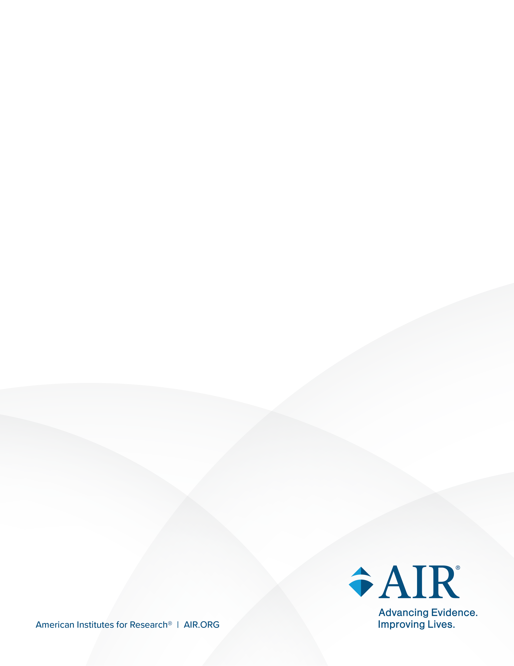
National Study of Special Education Spending

Attachment B: E-mail Follow-Up
April 2026
E-MAIL FOLLOW-UP TO LOCAL EDUCATION AGENCY SUPERINTENDENTS
Dear [Insert Name]:
I am reaching out to you from NORC at the University of Chicago to follow up on a recent FedEx mailing regarding the National Study of Special Education Spending (NSSES). This study will provide urgently needed updated estimates of spending on special education and will take place during the 2026–27 school year.
We are conducting this study in partnership with the American Institutes for Research® and Allovue, a PowerSchool company. The study is funded by the U.S. Department of Education’s Institute of Education Sciences (IES).
The NSSES will provide policymakers and special education administrators the first national estimates in more than 2 decades of how and how much states and districts spend to educate students with disabilities. Although no districts or schools in the study will be individually identified, it is critical that your district’s unique experiences are reflected. As a district that receives Individuals with Disabilities Education Act (IDEA) funding, your participation is expected and appreciated.
I would like to discuss and confirm your participation. Please let me know a good time to reach you.
When you respond to confirm your participation, please also provide the contact name and information for your district’s Special Education Director and Chief Financial Officer or individuals with comparable roles. We will need to contact them about the study as well.
(For your reference, attached is a copy of the letter from the U.S. Department of Education that was sent to your State Superintendent.)
Thank you for your assistance, and I look forward to our discussion. You may contact me directly or via NORC-NSSES@norc.org and toll-free at 888-872-0626.
Best,
E-MAIL FOLLOW-UP to SCHOOL PRINCIPALS
Dear Principal [INSERT NAME]:
I am reaching out to you from NORC at the University of Chicago to follow up on a recent FedEx mailing regarding the National Study of Special Education Spending (NSSES). This study will provide urgently needed updated estimates of spending on special education and will take place during the 2026–27 school year.
Your district has approved participation and is working closely with [NAME] as we move forward.
We are conducting this study in partnership with the American Institutes for Research® and Allovue, a PowerSchool company. The study is funded by the U.S. Department of Education.
As a school in a district that is a recipient of Individuals with Disabilities Education Act (IDEA) funding, your participation is expected and appreciated.
I am reaching out today to confirm your participation and next steps.
Now:
- Respond to this e-mail to confirm your participation.
- Identify a school coordinator to work with us during the study, and provide their contact information.
School Coordinator Name:
Title:
E-mail:
Phone Number:
Later:
- Fall 2026/Winter 2027: Provide name of the staff person who is most knowledgeable (teacher, service provider, etc.) about services a student receives and who will complete the survey for each student sampled for your school.
- Winter 2027: Encourage staff to complete the survey for each sampled student.
  - On average, 5 students will be selected per school.
Please respond to this e-mail to confirm your participation.
Thank you for your assistance, and I look forward to our collaboration. You may contact me directly or via NORC-NSSES@norc.org and toll-free at 888-872-0626.
Best,

