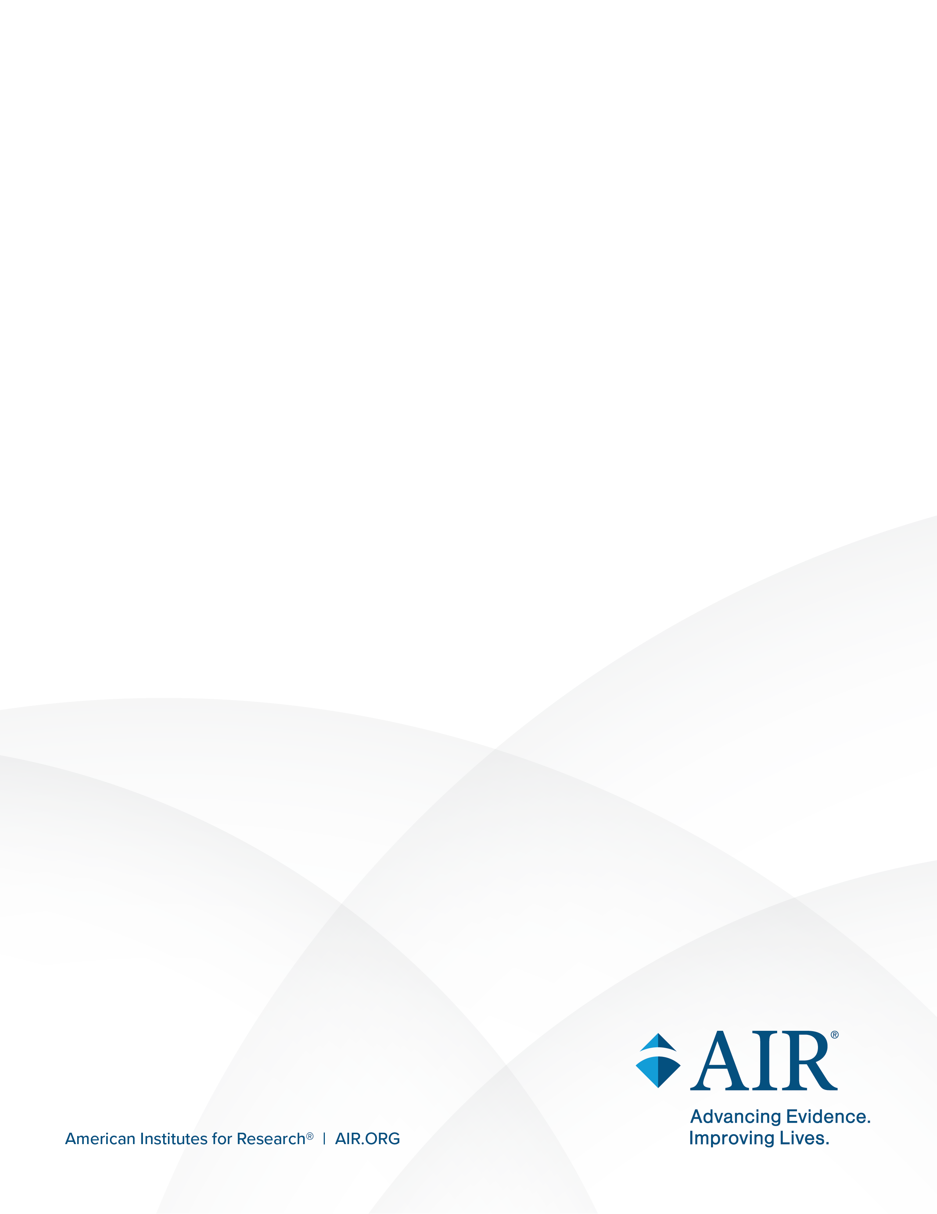
National Study of Special Education Spending

Attachment C: Study Information and FAQ
April 2026

National Study of Special Education Spending (NSSES) Study FAQ
Purpose. The U.S. Department of Education’s (ED) National Study of Special Education Spending (NSSES) will provide national estimates of special education spending.
The federal Individuals with Disabilities Education Act (IDEA) has long committed to covering a portion of the added costs of special education services that must be provided to students with disabilities, but there is little national data on what states, districts, and schools actually spend. The most recent spending estimates are nearly 25 years old, and in the past 2 decades there have been significant shifts in the number and composition of students with disabilities and in the policies and conditions under which they are identified and served.
Your participation is vital.
Information about current spending on special education and related services is needed to inform funding policies and budgeting.
As recipients of IDEA funding, districts are expected to participate in studies such as this one. (See Education Department General Administrative Regulations Section 34 C.F.R. § 76.591.)
Federal, state, and local policymakers and education leaders urgently need up-to-date national estimates for what is spent on special education services to inform their funding policies and budgeting for special education. The study will estimate spending on students with disabilities, reveal the key factors that influence that spending, and determine whether federal funding is close to IDEA’s target of covering 40 percent of the added costs of special education.

Frequently Asked Questions
Who is conducting the study? The Institute of Education Sciences (IES) within ED has partnered with the American Institutes for Research® (AIR®), NORC at the University of Chicago (NORC), and Allovue, a PowerSchool company, to conduct the study.
How will data be kept secure? Information collected for this study comes under the confidentiality and data protection requirements of IES (The Education Sciences Reform Act of 2002, Title Ⅰ, Part E, Section 183). Responses to this data collection will be used by ED, its contractors, and collaborating researchers for statistical purposes only. Individual respondents will never be identified, and responses to survey questions may not be disclosed, or used, in identifiable form for any other purpose except as required by law (20 U.S.C. § 9573 and 6 U.S.C. § 151).
What data will participants provide?
- Special Education and General Education Student Rosters: Districts will be asked to submit student directory information, including a student’s name, gender, race, date of birth, individualized education program (IEP) status, disability classification, English learner status, Least Restrictive Environment (LRE) placement, and Free or Reduced-Price Lunch (FRPL)/Economically Disadvantaged (ED) designation. This information will be used to select samples of students.
- School Student Resources Survey: School staff will be asked to complete a survey about the instruction and services each sampled student receives as well as the student’s educational needs. The survey will be divided into sections corresponding to different general and special education services, related services, and other academic interventions and supports. Each section will be completed by the staff member(s) most knowledgeable about the sampled student, such as classroom teachers, special education coordinators, or related service providers.
- District Program Survey: District officials will be asked to complete an online survey about their special education program and resources used to comply with federal and state special education laws.
- District Financial Data and Financial Officer Survey: District officials will be asked to submit data from their financial and personnel information systems and complete a survey about aggregated special and general education spending.
What is the study schedule?
Summer  2026 | Fall  2026 | Fall/winter  2026 | Winter/spring  2027 | Summer  2027
Information collected for this study comes under the confidentiality and data protection requirements of the Institute of Education Sciences (The Education Sciences Reform Act of 2002, Title I, Part E, Section 183). Responses to this data collection will be used by the U.S. Department of Education, its contractors, and collaborating researchers only for statistical purposes. Individual respondents will never be identified, and responses to survey questions may not be disclosed, or used, in identifiable form for any other purpose except as required by law (20U.S.C. §9573 and 6 U.S.C. §151). | Information collected for this study comes under the confidentiality and data protection requirements of the Institute of Education Sciences (The Education Sciences Reform Act of 2002, Title I, Part E, Section 183). Responses to this data collection will be used by the U.S. Department of Education, its contractors, and collaborating researchers only for statistical purposes. Individual respondents will never be identified, and responses to survey questions may not be disclosed, or used, in identifiable form for any other purpose except as required by law (20U.S.C. §9573 and 6 U.S.C. §151). | Information collected for this study comes under the confidentiality and data protection requirements of the Institute of Education Sciences (The Education Sciences Reform Act of 2002, Title I, Part E, Section 183). Responses to this data collection will be used by the U.S. Department of Education, its contractors, and collaborating researchers only for statistical purposes. Individual respondents will never be identified, and responses to survey questions may not be disclosed, or used, in identifiable form for any other purpose except as required by law (20U.S.C. §9573 and 6 U.S.C. §151). | Information collected for this study comes under the confidentiality and data protection requirements of the Institute of Education Sciences (The Education Sciences Reform Act of 2002, Title I, Part E, Section 183). Responses to this data collection will be used by the U.S. Department of Education, its contractors, and collaborating researchers only for statistical purposes. Individual respondents will never be identified, and responses to survey questions may not be disclosed, or used, in identifiable form for any other purpose except as required by law (20U.S.C. §9573 and 6 U.S.C. §151). | Information collected for this study comes under the confidentiality and data protection requirements of the Institute of Education Sciences (The Education Sciences Reform Act of 2002, Title I, Part E, Section 183). Responses to this data collection will be used by the U.S. Department of Education, its contractors, and collaborating researchers only for statistical purposes. Individual respondents will never be identified, and responses to survey questions may not be disclosed, or used, in identifiable form for any other purpose except as required by law (20U.S.C. §9573 and 6 U.S.C. §151).
District  onboarding | School onboarding | Roster  collection | Survey administration | Finance data collection
What are the roles and responsibilities of those involved in the study? States, districts, schools, and staff who work with students all play a critical role in the study’s success.
Participant | Roles and responsibilities | Expected time commitment
State | - Communicate with districts in their state to prepare them for outreach from AIR and NORC starting in summer 2026  - Complete a brief survey about federal and state funding for special education | 2–4 hours
District | - Coordinate with the NORC outreach team who will confirm approval to participate in the study  - Notify schools about the district’s decision to participate in the study  - Provide student rosters (template will be provided)  - Provide financial and personnel data files  - Complete two surveys about special education programs, spending, and revenues | 10–13 hours
School | - Coordinate with the NORC outreach team  - Identify a school coordinator who will work with NORC to prompt teachers to complete surveys, assist with identifying the appropriate staff to complete a survey (teachers, aides, guidance counselors, case managers, etc.), and in some cases provide student rosters | 4–6 hours for school coordinator
School staff | - Complete survey about the special and general education services a sampled student receives | 45–90 minutes per student survey
Is there payment for participation? Yes. You will receive a token of appreciation for the time it takes to coordinate and complete surveys and provide administrative data. Districts will receive $500. School coordinators will receive $150 if 70 percent of the Student Resources Surveys are completed for the school, plus a bonus of $50 if all surveys are completed. District and school staff who complete surveys will receive $60 for each completed survey. District staff who prepare and deliver the local education agency (LEA) financial data file will also receive $60. Payments will be made in the form of electronic gift cards for individual survey respondents and respondents providing the LEA financial data files. Districts will receive either electronic gift cards or checks.
OMB approval. The study’s recruitment activities, including collection of student rosters, have been approved by the Office of Management and Budget (OMB). The OMB control number is 1850-0952, and the approval expiration date is XXXXX.
Who should I contact if I have questions about this study? More information about the study can be found at https://air.org/project/NSSES. Study staff at NORC can be reached by phone at 888-872-0626, Monday through Friday, between 8:00 a.m. and 5:00 p.m. (Central Time). Study staff also are available to answer your questions via e-mail at NORC-NSSES@norc.org. You may contact the study Principal Investigator, Tammy Kolbe, at NSSES@air.org.

American Institutes for Research, www.air.org
NORC at the University of Chicago, www.norc.org
Allovue, www.allovue.com

