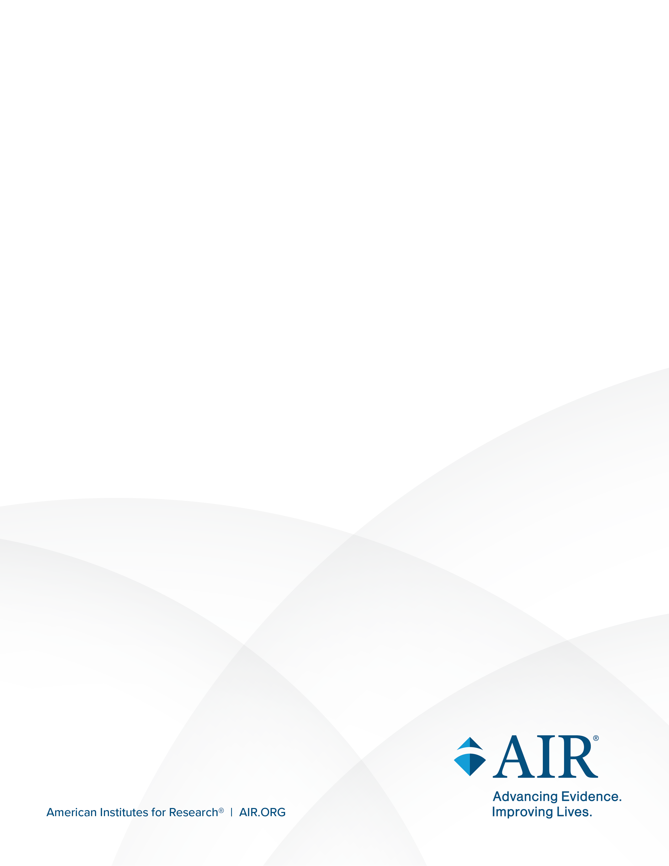
National Study of Special Education Spending

Attachment E: FERPA Agreement
April 2026
FERPA Agreement
for [NAME OF DISTRICT]
Consistent with the federal Family Educational Rights and Privacy Act (FERPA), [NAME OF DISTRICT] (also referred to here as District) designates the American Institutes for Research® (AIR®) and NORC at the University of Chicago (NORC), under contract with the U.S. Department of Education, as institutions with legitimate educational interests for the purpose of disclosing personally identifiable information (PII) from students’ education records in connection with the National Study of Special Education Spending (NSSES) and pursuant to 34 C.F.R. § 99.31(a)(6)(i). This federal evaluation study is being conducted as part of the National Assessment of the Individuals with Disabilities Education Act (IDEA), which is mandated by Congress to collect information that can inform future updates to the law.
AIR and NORC are conducting this study on behalf of the National Center for Education Evaluation and Regional Assistance within the Institute of Education Sciences at the U.S. Department of Education (the Department). AIR, the primary contractor conducting this study, is an independent, not-for-profit, nonpartisan research institution. NORC, a subcontractor primarily responsible for the study’s data collection, is an organization that conducts objective, nonpartisan research.
The District agrees to provide AIR and NORC education records, including PII, under the terms of the “for, or on behalf of” provision of FERPA § 99.31(a)(6). This study falls under an exception within FERPA that permits disclosures of PII from an education record to authorized representatives of the Secretary of Education for the purpose of evaluating federally supported education programs (34 C.F.R. §§ 99.31(a)(3)(iii) and 99.35). The District retains control over the PII from education records that is disclosed and is never required to endorse or agree with the study’s results or conclusions. AIR and NORC will collect and use all study data for the agreed-to purpose, and all data collected and used by these institutions will be stored and maintained on a U.S. Department of Education–authorized secure server.
Purpose, Scope, and Duration of the Study
The primary goal of this study is to generate national estimates of average special education spending per student with a disability and, for comparison, national estimates of average general education spending for students without disabilities. The data will be aggregated to report estimates for average spending per student, overall and according to other district and school characteristics. The study is expected to continue through December 2028.
Terms and Conditions
To allow the transfer of data and information that are subject to state and federal confidentiality laws and to ensure that the required confidentiality of PII is always maintained, AIR and NORC agree to:
- use PII shared under the Agreement for no purpose other than the evaluation project described in this Agreement, and as authorized under 34 C.F.R. § 99.31(a)(6)(i) (disclosure of information without consent to organizations conducting studies for, or on behalf of, educational agencies or institutions); the Agreement does not convey ownership of data to the Department, AIR, or NORC;
- not disclose data contained under the Agreement in any manner that could identify an individual district, school, parent, or student, except as authorized by FERPA, to an entity other than the District, entities approved by the District, or authorized employees, contractors, and agents of the Department working on this project and consistent with this Agreement;
- not identify the District in the study’s public reports unless an authorized representative from the District agrees in writing to have the District identified; and
- destroy the PII when no longer needed for the purposes for which the study was conducted; no later than 3 years after the end of the study, AIR and NORC will destroy all copies of data that the district provided for the purposes of this study from the Department’s system in compliance with 34 C.F.R. §§ 99.31(a)(6)(iii)(B) and 99.35(b)(2) (including copies, extracts, or other reproductions retained in standard archival or computer backup systems).
Data Security
The District agrees to upload requested data files to the Department’s IES secure data center (IESDC). The IESDC is a Department-authorized system at the Federal Information Security Modernization Act (FISMA) Moderate level and housed in Amazon Web Services’ government-only environment GovCloud. Only authorized members of the study team at AIR, NORC, and the Department with an active 5C/moderate risk–level security clearance (or higher) will have access to the District-submitted data in this controlled environment. Each authorized member is required to have a unique account with complex password requirements and mandatory multifactor authentication. All access to and use of the uploaded District data will be through the IESDC. The data will not be placed on the hard drive of any personal desktop or laptop computer.
Data will be uploaded to the IESDC through a data collection website hosted by the Department, which is equipped with several protections against a potential data breach. The data collection website does not have read access to the collected data; it can only write data, greatly reducing the risk of exposing the submitted data if the website were to be compromised. Data will be encrypted and only accessible with the encryption key, which is not stored on the web servers. The data are stored on drive volumes that are fully encrypted with AES-256, including drive backups. All traffic to and from the website is encrypted via HTTPS, TLS 1.2 and 1.3 encryption protocols.
Uses of Personally Identifiable Information
The PII provided by the District will not be used for any purposes other than survey operations and research purposes, for which students’ names and dates of birth will be used to identify students to the teachers and staff who need to report about them, and personal health and disability information will be used only for research purposes.
Questions and Concerns
If the District has any questions or concerns regarding this data agreement, please contact the study’s Principal Investigator at AIR, Dr. Tammy Kolbe (tkolbe@air.org).

