SUPPORTING STATEMENT - PART A
Request for Retroactive Induction for a Period Previously Completed under Chapter 33 (Chapter 31, Title 38, U.S.C.) – 2900-0933

Summary of Changes from Previously Approved Collection
- On page one the note under #7 was amended to include plain language and information regarding process and evaluation of retroactive induction.
- On page two the note under #17 was amended to include plain language and information regarding retroactive induction.
- On page three the Information and Instructions section was amended to include plain language, adjust the font to be consistent and update the VA Form 28-1905m for title reference.
- 4 public comments received during the 60-Day comment period.

1. Need for the Information Collection

The Department of Veterans Affairs (VA) through its Veterans Benefits Administration (VBA) administers an integrated program of benefits and services, established by law, for Veterans, service personnel, and their dependents and/or beneficiaries. Title 38 U.S.C. §501(a) provides VA the authority to collect this information. VA Form (VAF) 28-10286, Request for Retroactive Induction for a Period Previously Completed under Chapter 33 (Chapter 31, Title 38, U.S.C.) is necessary in the determination to verify if a Veteran in the Veteran Readiness and Employment (VR&E) program meets the criteria for retroactive induction for a period previously completed under Chapter 33 (38 U.S.C. §3102, §3103, §3108, §5113).

2. Use of the Information

VA Form 28-10286 is used by Veterans with service-connected disabilities to request a retroactive induction for a period previously completed under Chapter 33 benefits. The VR&E program subsequently uses the information on this form to determine if a Service member or Veteran qualifies for a retroactive induction under 38 U.S.C. §3102, §3103, §3108, §5113 under the Chapter 31 program.

Without this information, a retroactive induction for a period previously completed under Chapter 33 benefits could not be determined. Veterans are able to access and complete the VA Form 28-10286 by using the VA Forms external website “Find a Form” and submit the completed and signed application one of the following ways: by mail, via VR&E’s electronic virtual assistant (e-VA), or in-person to a VA Regional Office, out-based location, VA hospital, medical center, community-based outpatient clinic, or Vet Center. A VR&E Vocational Rehabilitation Counselor (VRC) reviews the request for retroactive induction to ensure all necessary steps and supported documentation are received and completed prior to the VR&E Officer approving the retroactive induction. Upon review and a final decision is rendered, the Veteran receives a notification letter.

3. Use of Information Technology

VA Form 28-10286 is available on https://www.va.gov/find-forms/ website in a fillable electronic format.

4. Non-duplication

The information obtained through this collection is unique and is not already available for use or adaptation from another cleared source.

5. Burden on Small Businesses

This information collection does not impose a significant economic impact on a substantial number of small businesses or entities.

6. Less Frequent Collection

VA Form 28-10286 is used to gather the necessary information for Veterans to request a retroactive induction for a period previously completed under Chapter 33 benefits. Without this information, a retroactive induction for a period previously completed under Chapter 33 benefits could not be determined.

7. Paperwork Reduction Act Guidelines

This collection of information does not require collection to be conducted in a manner inconsistent with the guidelines delineated in 5 C.F.R. §1320.5(d)(2).

8. Consultation and Public Comments

Part A: PUBLIC NOTICE
A 60-Day Federal Register Notice (FRN) for the collection published on Wednesday, July 15, 2026. The 60-Day FRN citation is 91 FRN 43453.
4 public comments were received during the 60-Day comment period.
A 30-Day Federal Register Notice for the collection published on Wednesday, September 30, 2026. The 30-Day FRN citation is 91 FRN 61936-61937.
Part B: CONSULTATION
No additional consultation apart from soliciting public comments through the Federal Register was conducted for this submission.

9. Gifts or Payment

No payments or gifts are being offered to respondents as an incentive to participate in the collection.

10. Confidentiality

The records are maintained in the appropriate Privacy Act System of Records identified as “Compensation, Pension, Education, and Veteran Readiness and Employment Records-VA (58VA21/22/28),” published at 74 FR 29275 on June 19, 2009, and last amended at 87 FR 8740 (February 16, 2022).

11. Sensitive Questions

No questions considered sensitive are being asked in this collection.

12. Respondent Burden and its Labor Costs

- Number of Respondents: 144,601 per year
- Number of Responses Per Respondent: one time
- Annual burden hours are: 48,333.33 hours
- The estimated completion time for this form is: 20 minutes
- VA cannot make further assumptions about the population of respondents because of the variability of factors such as the educational background and wage potential of respondents. Therefore, VBA uses general wage data to estimate the respondents’ costs associated with completing the information collection.

The Bureau of Labor Statistics (BLS) gathers information on full-time wage and salary workers. According to the latest available BLS data, the mean hourly wage is $32.66 based on the BLS wage code – “00-0000 All Occupations.” This information was taken from the following website: https://www.bls.gov/oes/current/oes_nat.htm.

Legally, respondents may not pay a person or business for assistance in completing the information collection. Therefore, there are no expected overhead costs for completing the information collection. VBA estimates the total cost to all respondents to be $1,578,566.5578 (48,333.33 burden hours x $32.66 per hour)

13. Respondent Costs Other Than Burden Hour Costs

There are no annualized costs to respondents other than the labor burden costs addressed in Section 12 of this document to complete this collection.

14. Cost to the Federal Government

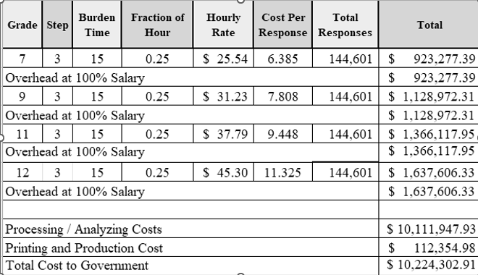

Overhead costs are 100% of salary and are the same as the wage listed above and the amounts are included in the total.

Printing and production costs approximates the cost of printing this information collection per year. (Processing/Analyzing Cost total divided by $90).

Note: The hourly wage information above is based on the hourly 2025 General Schedule (Base) Pay (SALARY TABLE 2025-GS-RUS). This rate does not include any locality adjustment as applicable.

The processing time estimates above are based on the actual amount of time employees of each grade level spend to process to completion a claim received on this form. The within-grade step (3) of each employee represents the average experience of employees within each grade.

15. Reasons for Change in Burden

The burden has increased due to the number of respondents since the last approved collection.

16. Publication of Results

The results of this information collection will not be published.

17. Non-Display of OMB Expiration Date

We are not seeking approval to omit the display of the expiration date of the OMB approval on the collection instrument.

18. Exceptions to “Certification for Paperwork Reduction Submissions”

We are not requesting any exemptions to the provisions stated in 5 C.F.R. §1320.9.

