OMB 3060-0600
Application to Participate in an FCC Auction (FCC Form 175)

(Displayed to Wireless and Broadcast Auction Applicants)

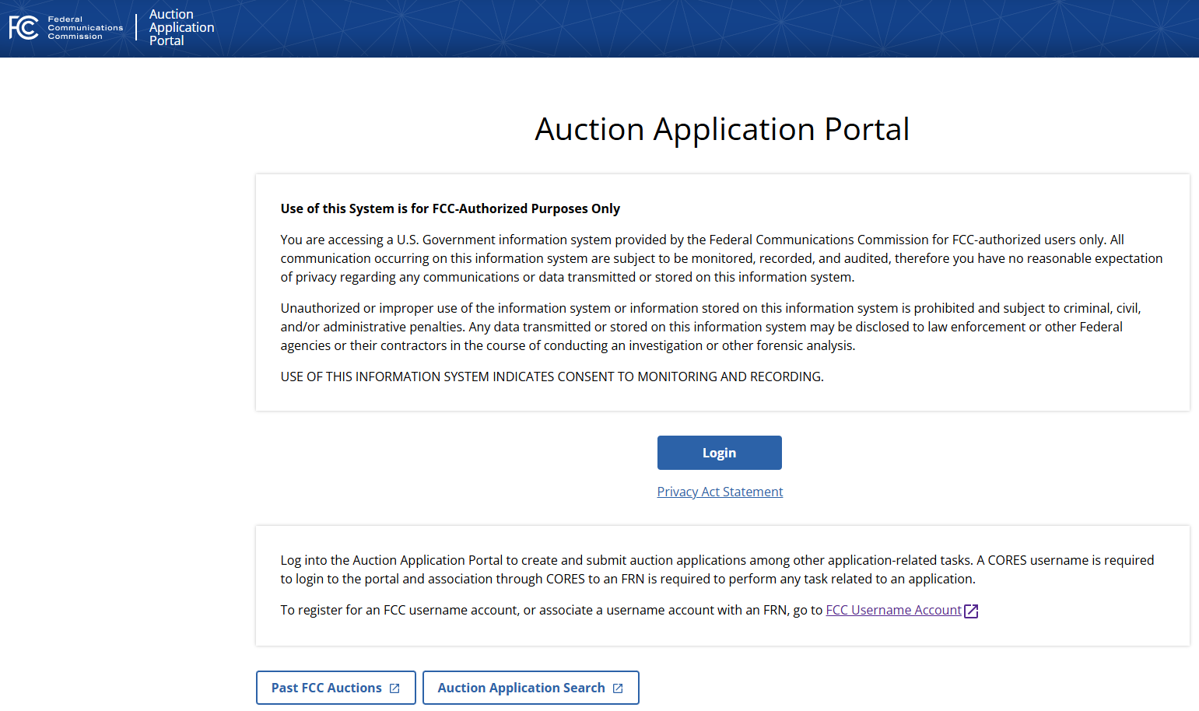

(Displayed to Wireless and Broadcast Auction Applicants)

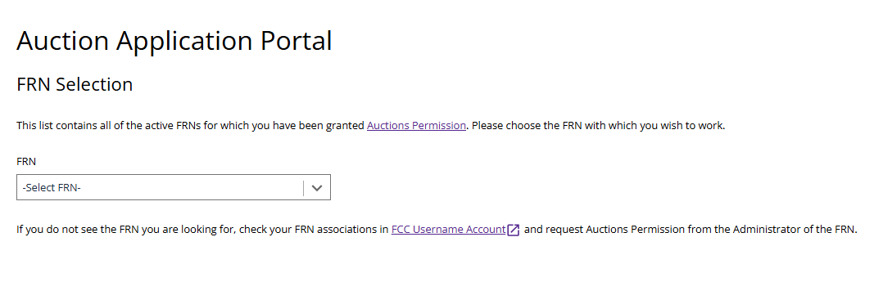

(Displayed to Wireless and Broadcast Auction Applicants)

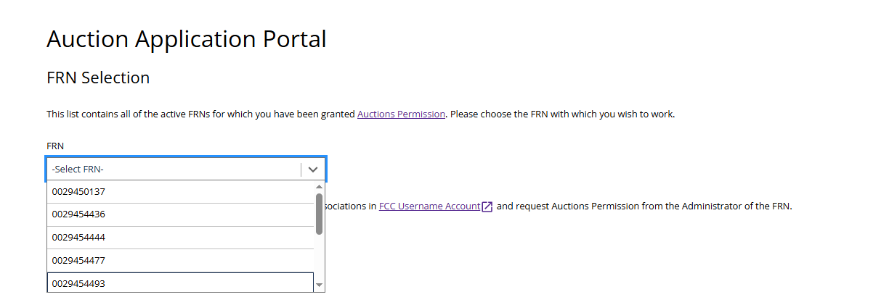

(Displayed to Wireless and Broadcast Auction Applicants)

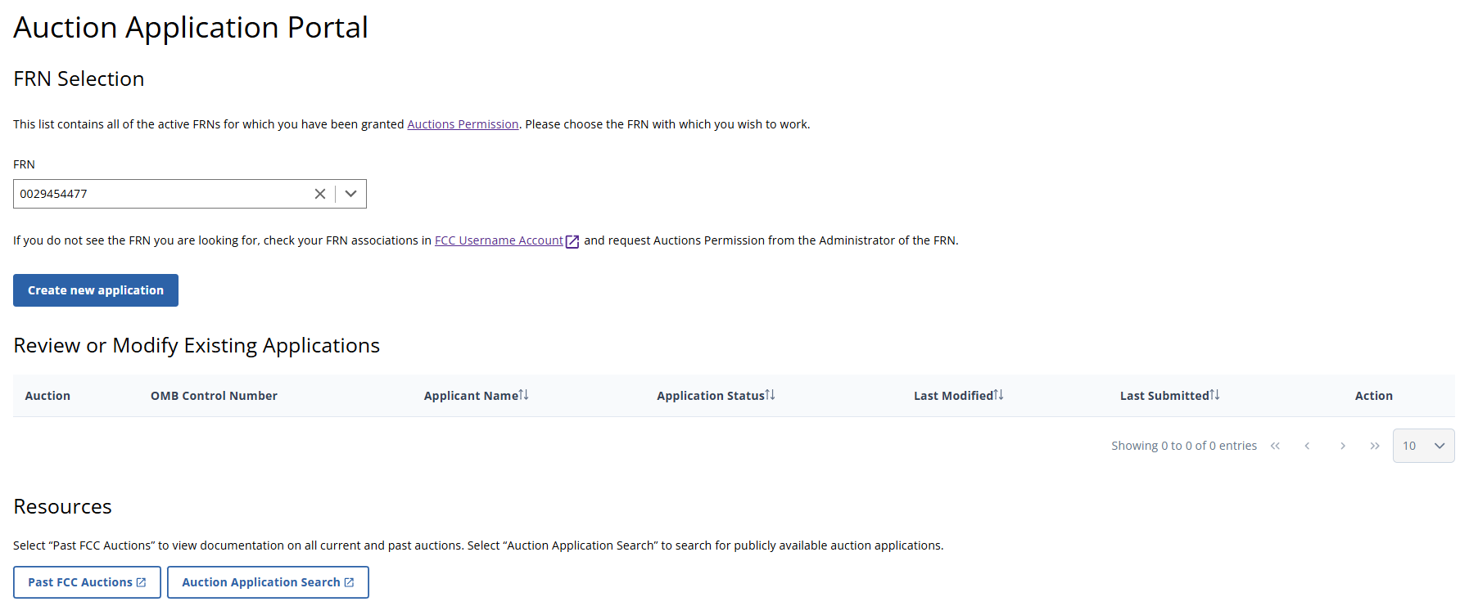

(Displayed to Wireless and Broadcast Auction Applicants)

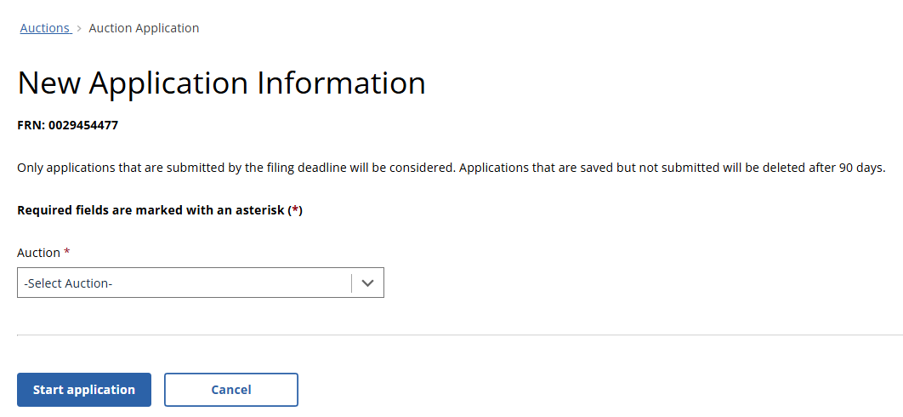

(Displayed to Wireless and Broadcast Auction Applicants)

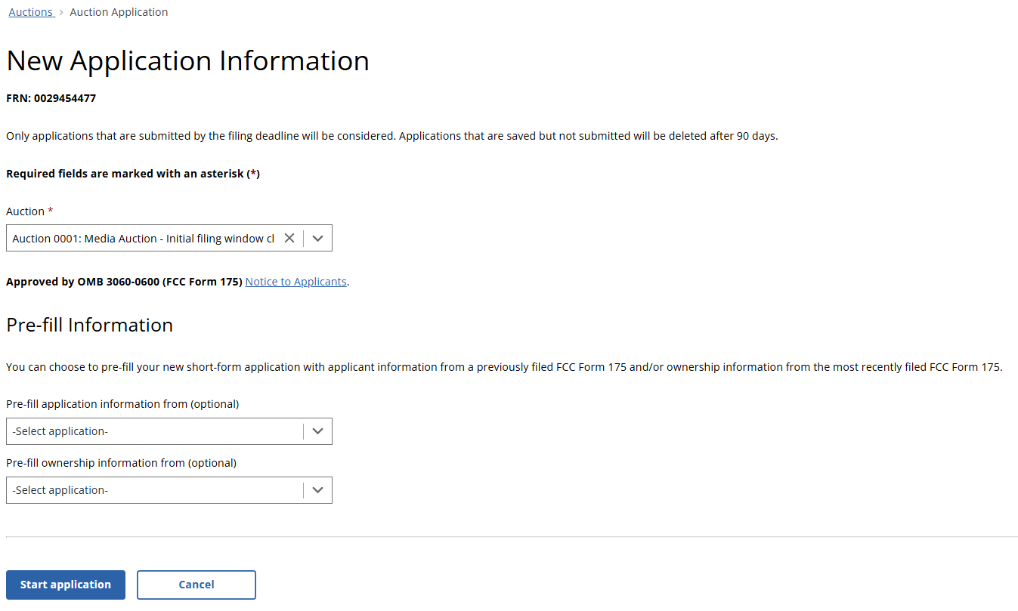

(Displayed to Wireless and Broadcast Auction Applicants)

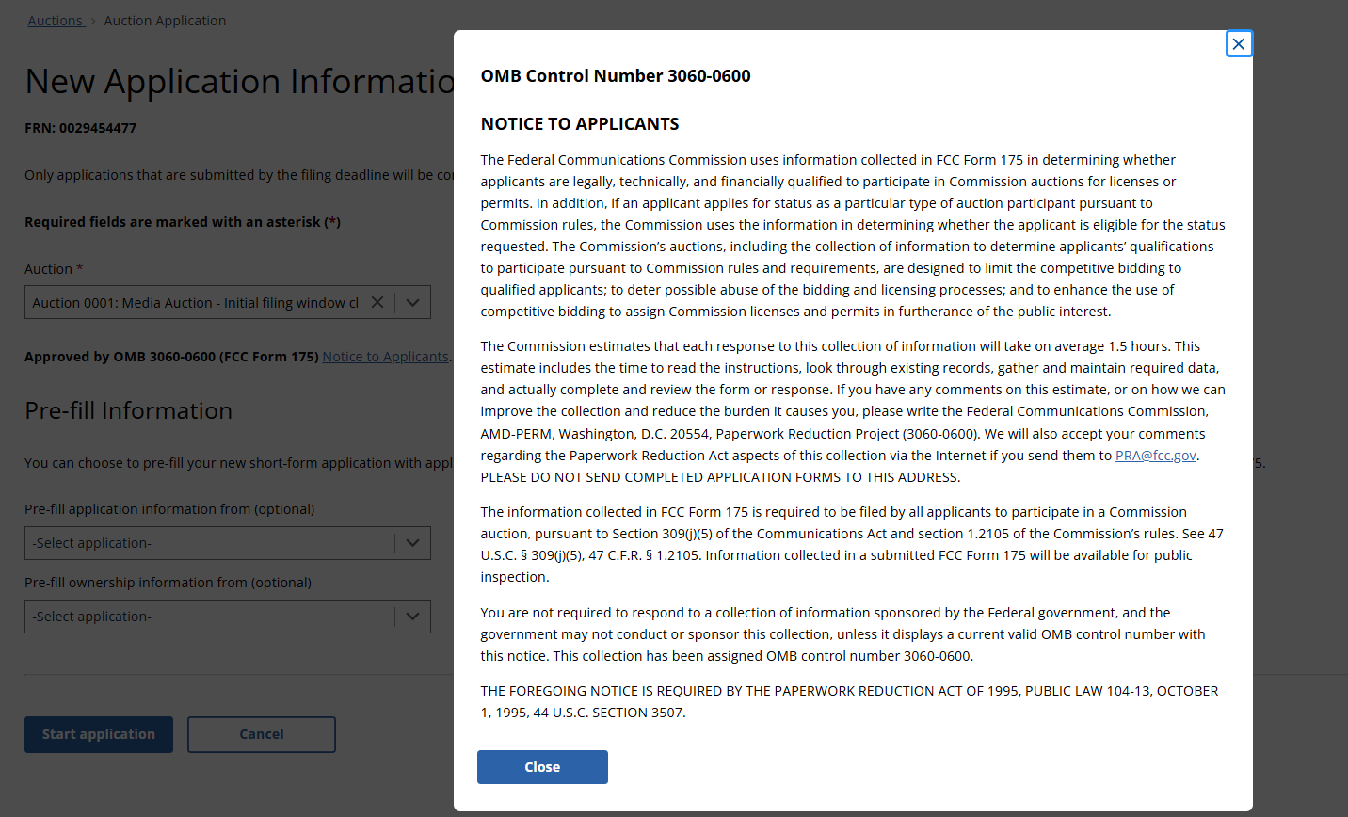

(Displayed Only to Wireless Auction Applicants)

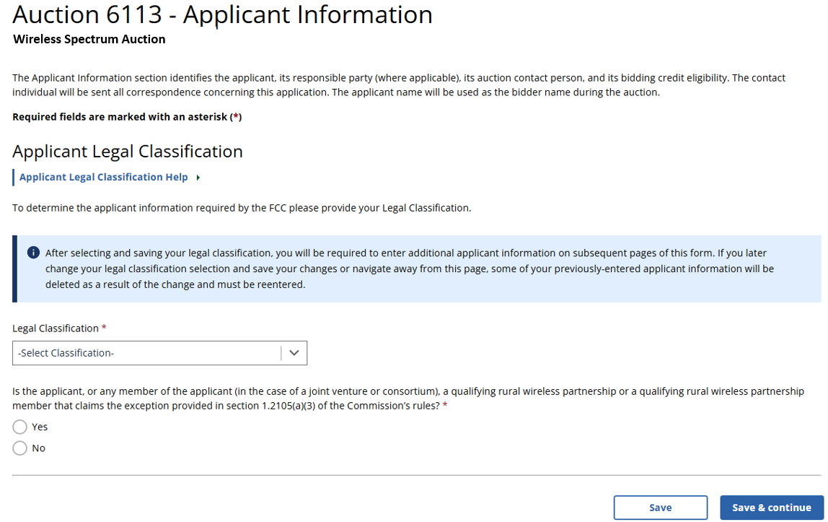

(Displayed Only to Wireless Auction Applicants That Answer “Yes” to the Qualifying Rural Wireless Partnership Question)

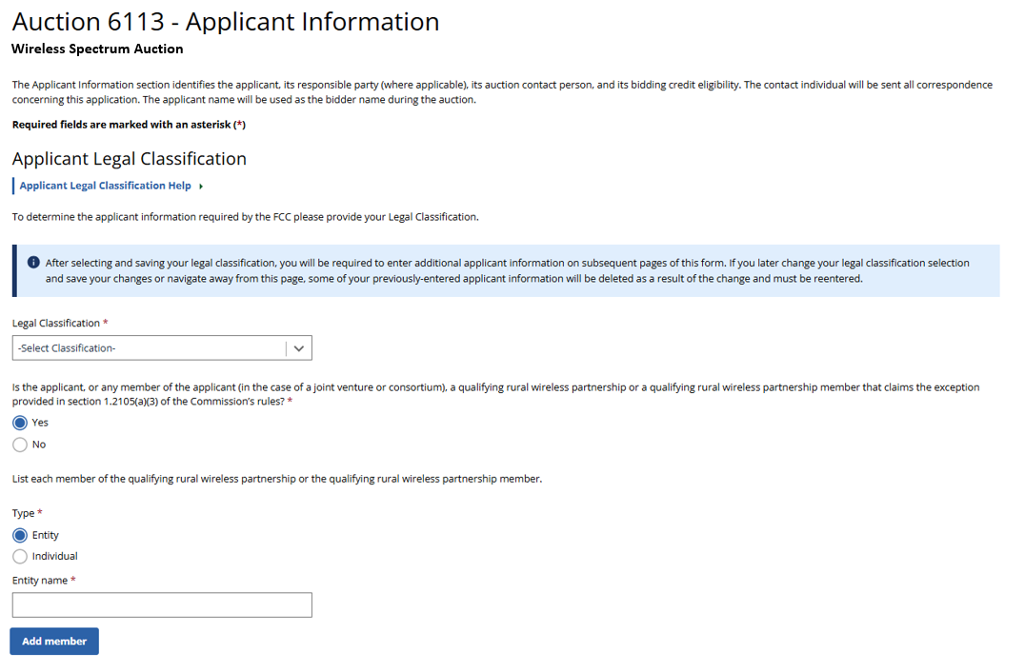

(Displayed Only to Wireless Auction Applicants That Answer “Yes” to the Qualifying Rural Wireless Partnership Question)
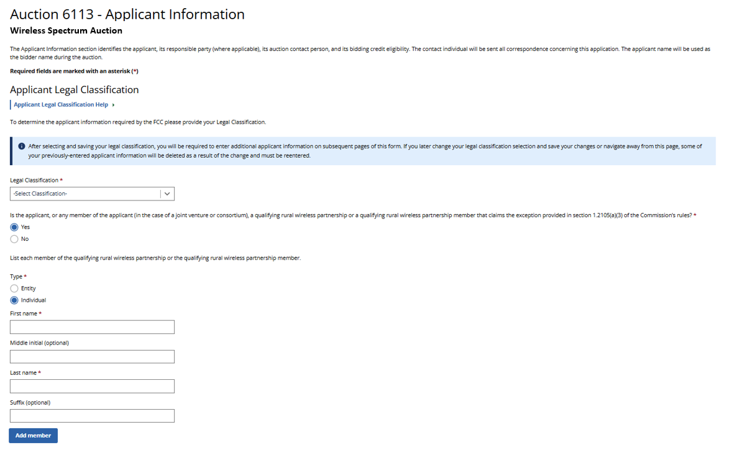
(Displayed Only to Broadcast Auction Applicants)

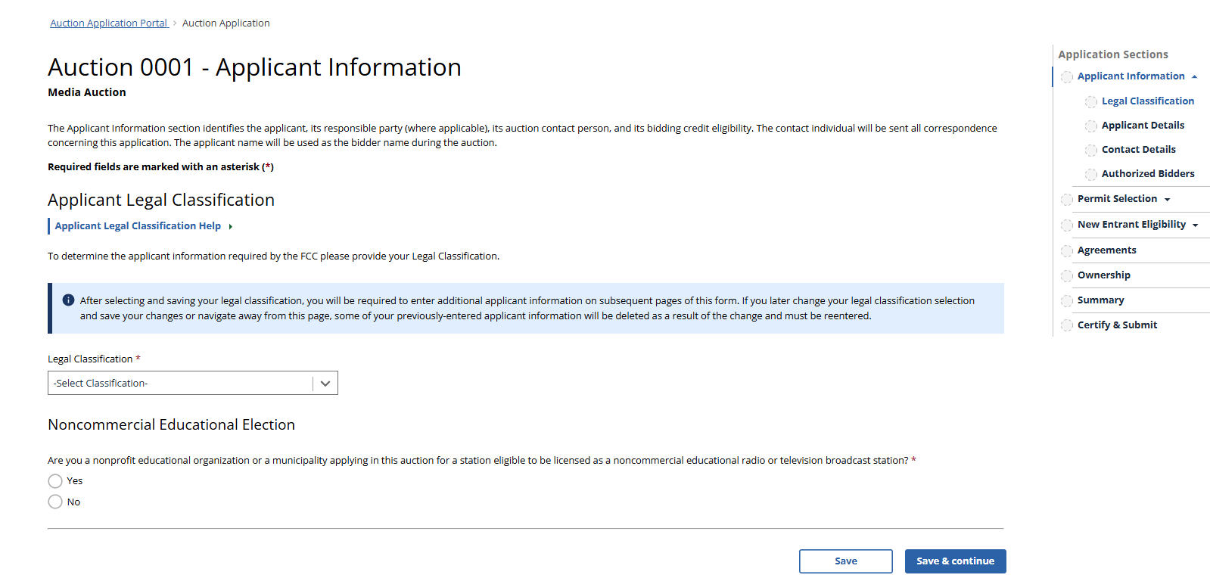

(Displayed Only to Broadcast Auction Applicants That Answer “Yes” to the Noncommercial Educational Election Question)

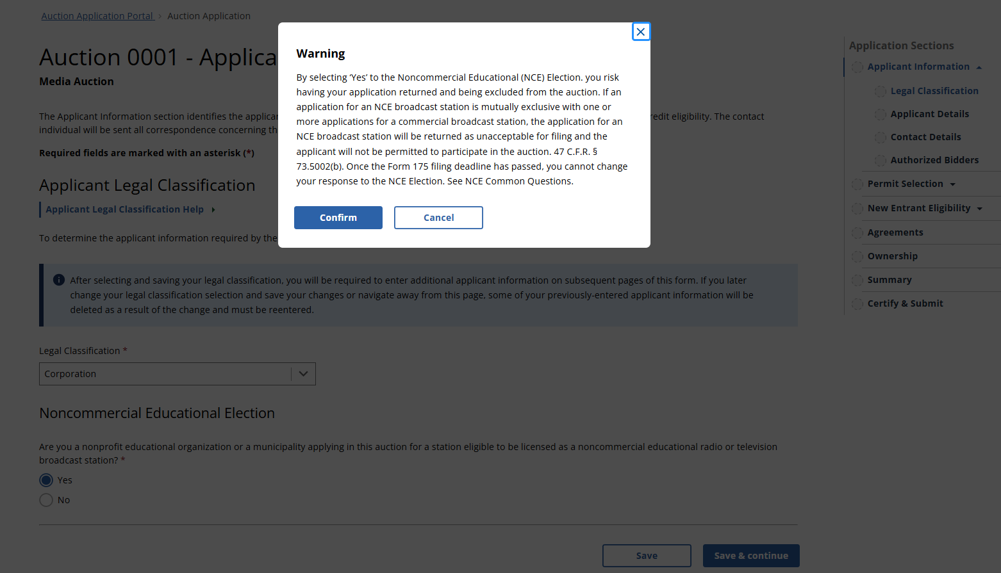

(Displayed to Wireless and Broadcast Auction Applicants)
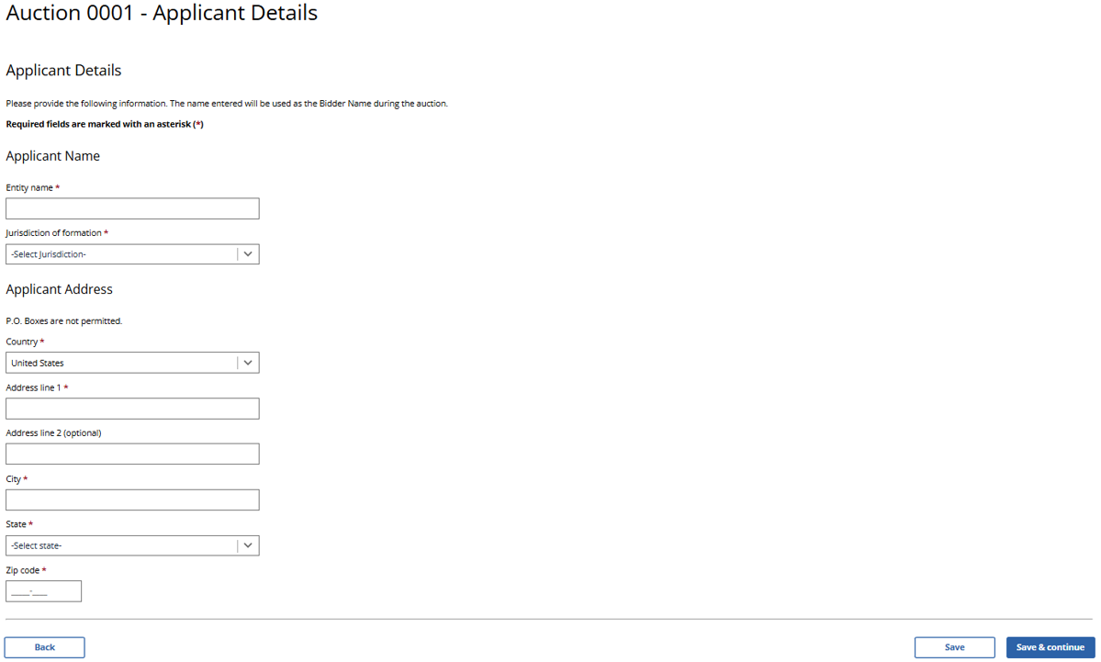

(Displayed to Wireless and Broadcast Auction Applicants)
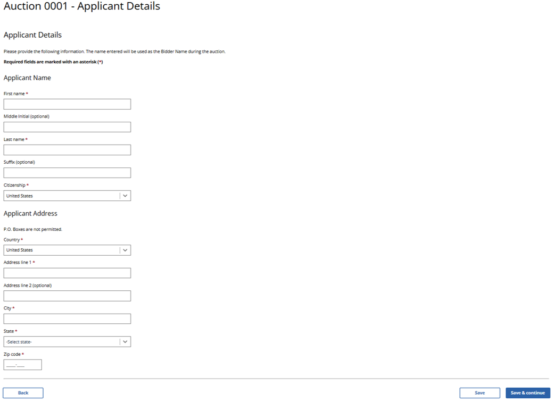
(Displayed to Wireless and Broadcast Auction Applicants)

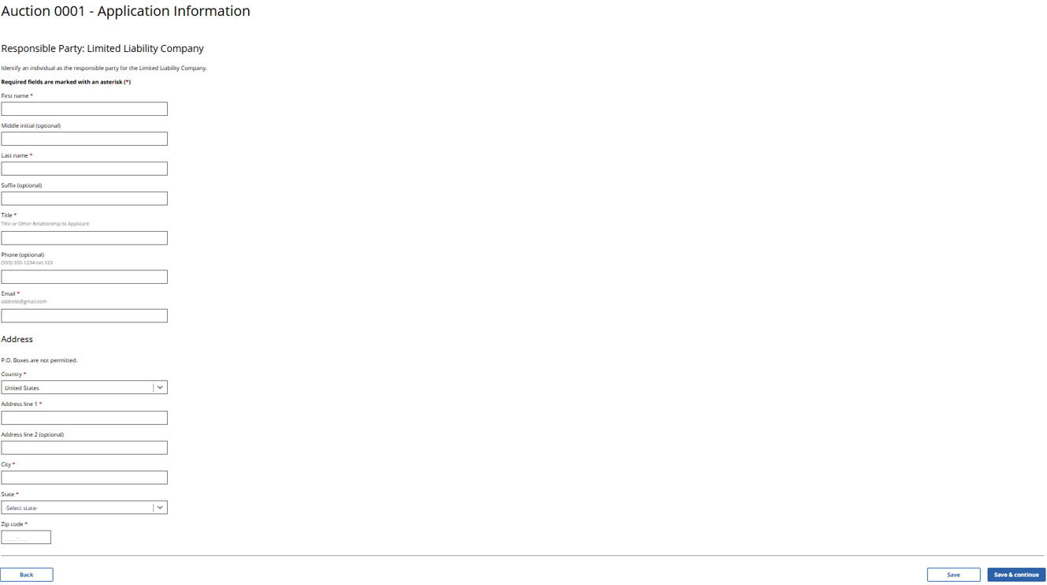

(Displayed to Wireless and Broadcast Auction Applicants)

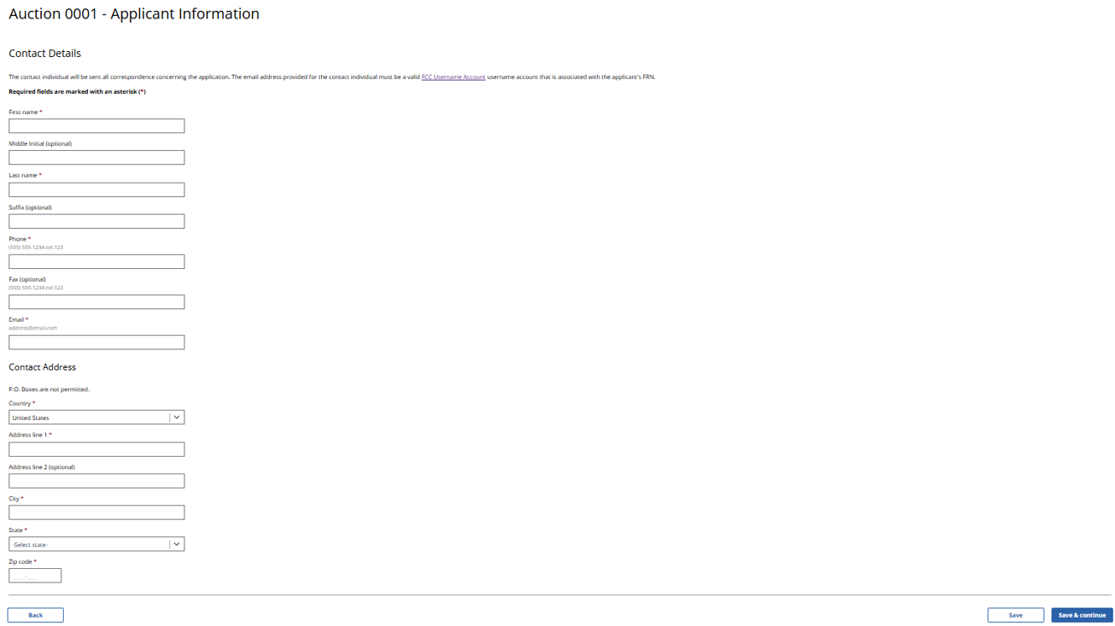

(Displayed to Wireless and Broadcast Auction Applicants)

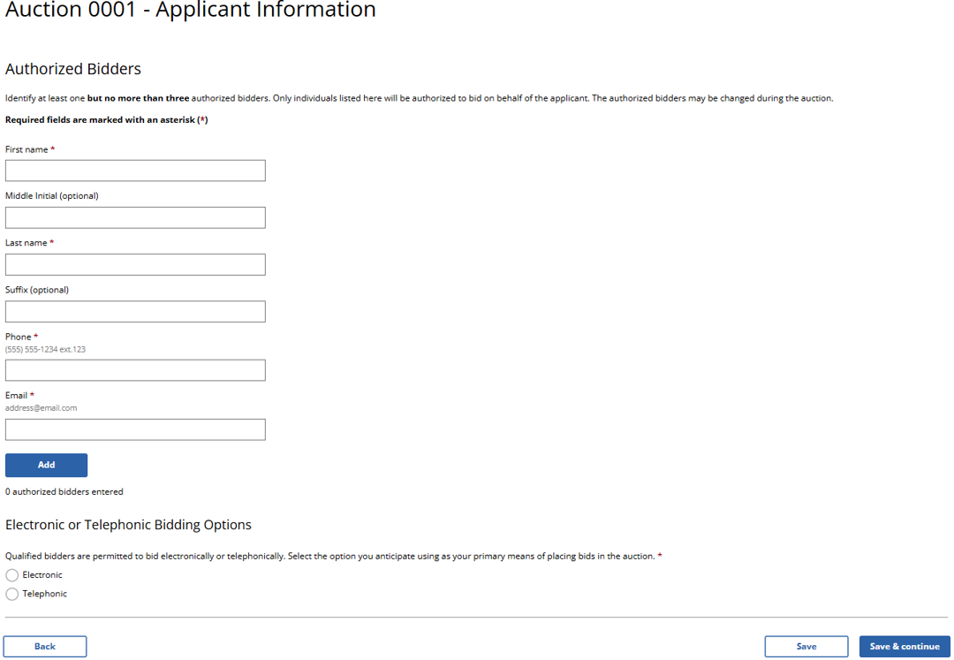
(Displayed Only to Wireless Auction Applicants)

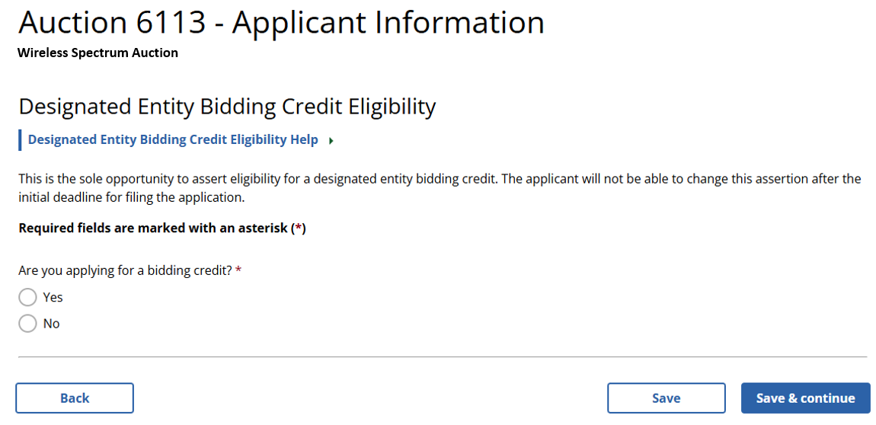

(Small Business Bidding Credit Assertion – Displayed Only to Wireless Auction Applicants Seeking a Small Business Bidding Credit)
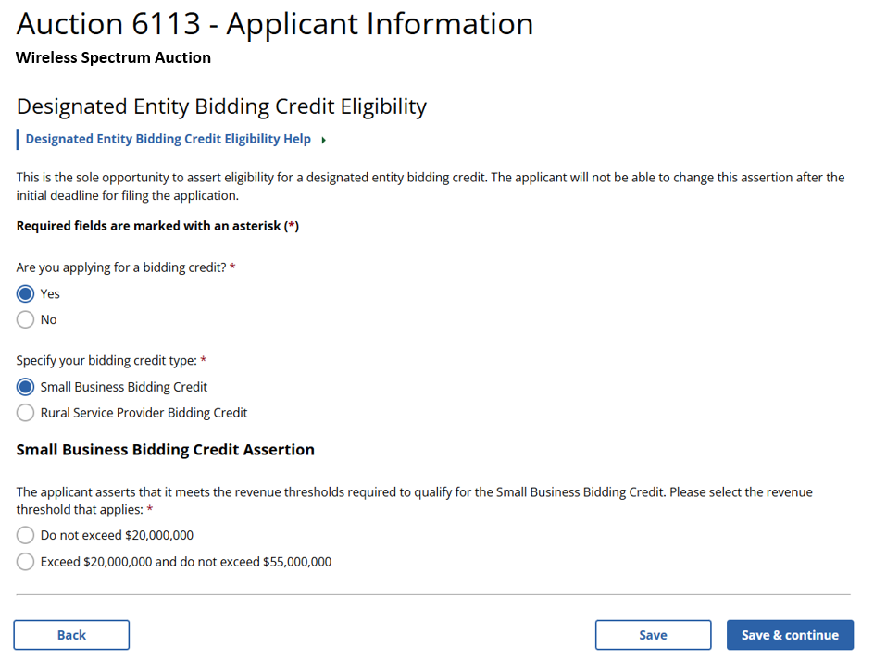
(Rural Service Provider Bidding Credit Assertion – Displayed Only to Wireless Auction Applicants Seeking a Rural Service Provider Bidding Credit)
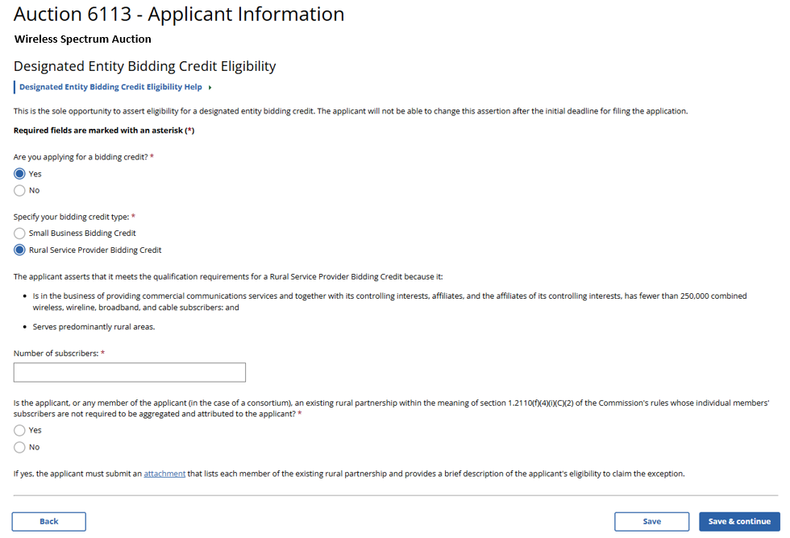
(Displayed Only to Wireless Auction Applicants)

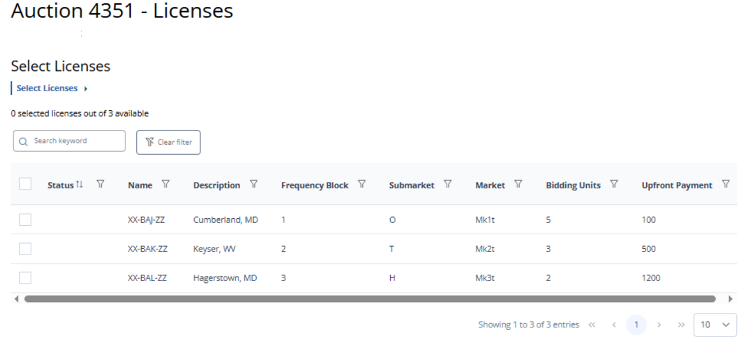

(Displayed Only to Wireless Auction Applicants)

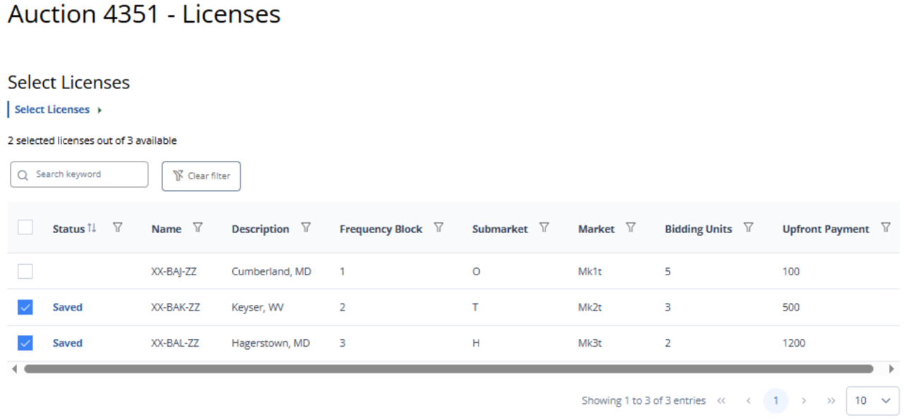

(Displayed Only to Wireless Auction Applicants)

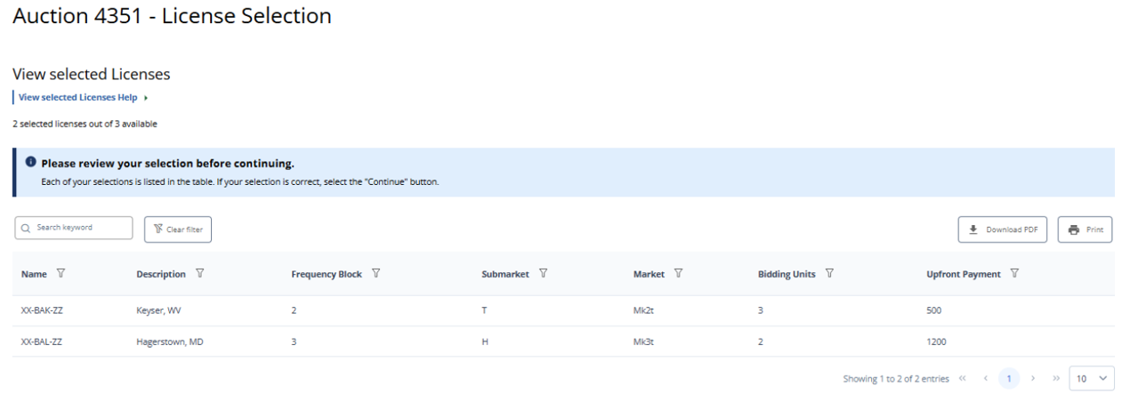

(Displayed Only to Wireless Auction Applicants)

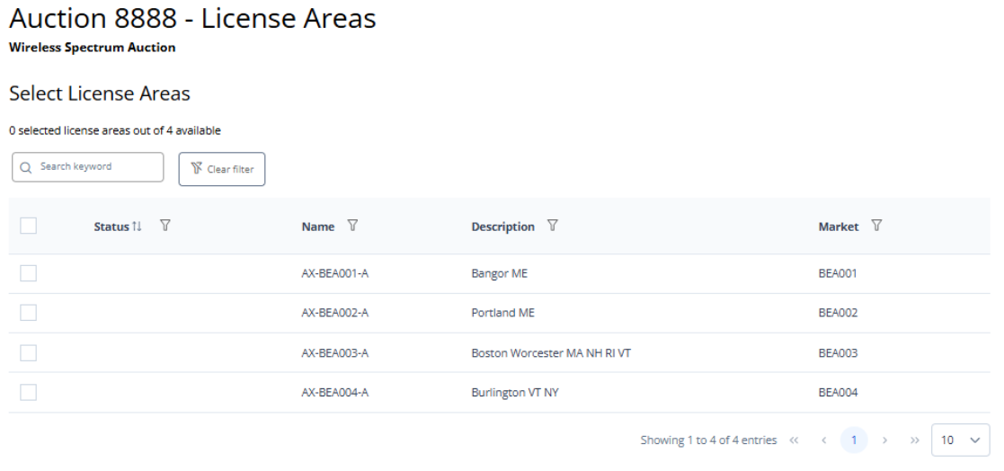

(Displayed Only to Wireless Auction Applicants)

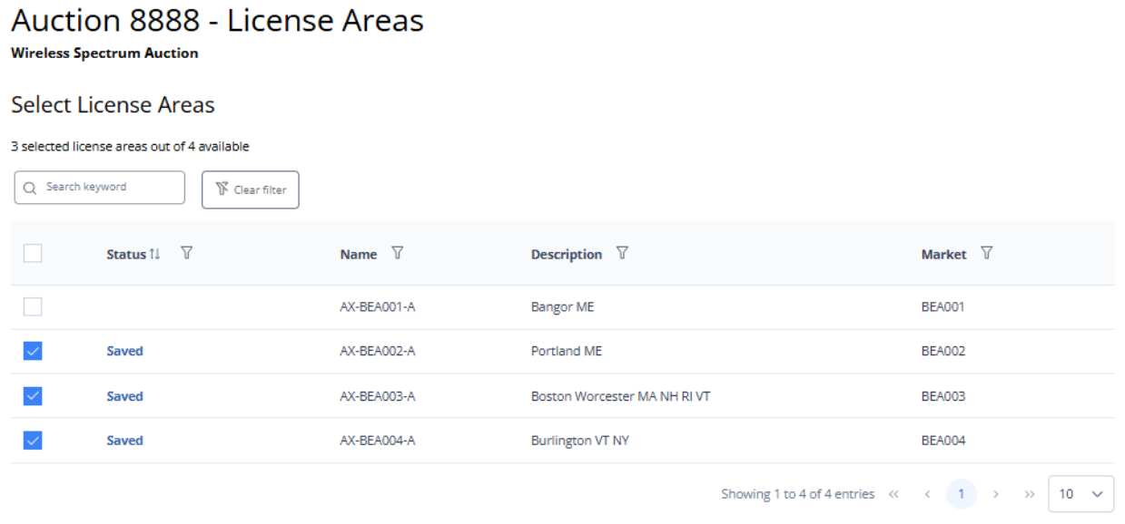

(Displayed Only to Wireless Auction Applicants)

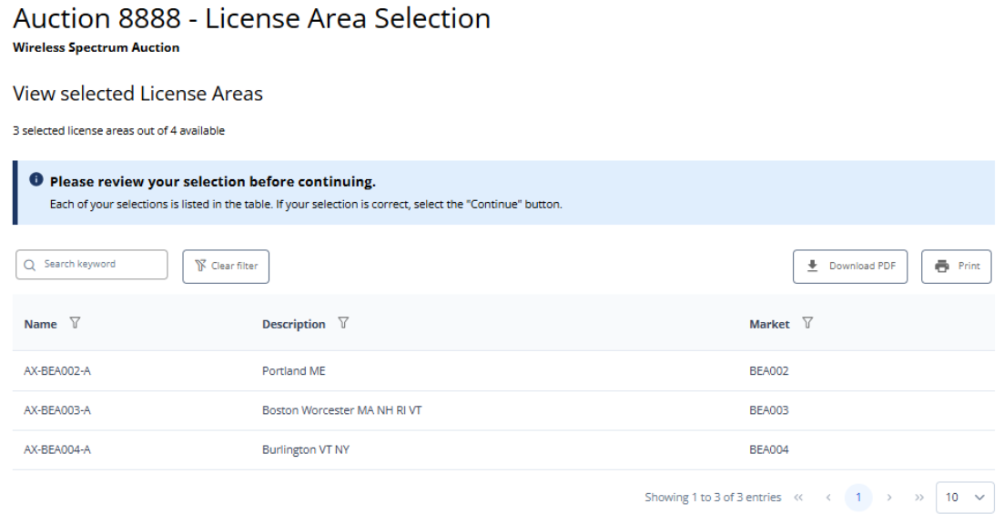

(Displayed Only to Wireless Auction Applicants in Auctions in Which Reserved Spectrum is Available)

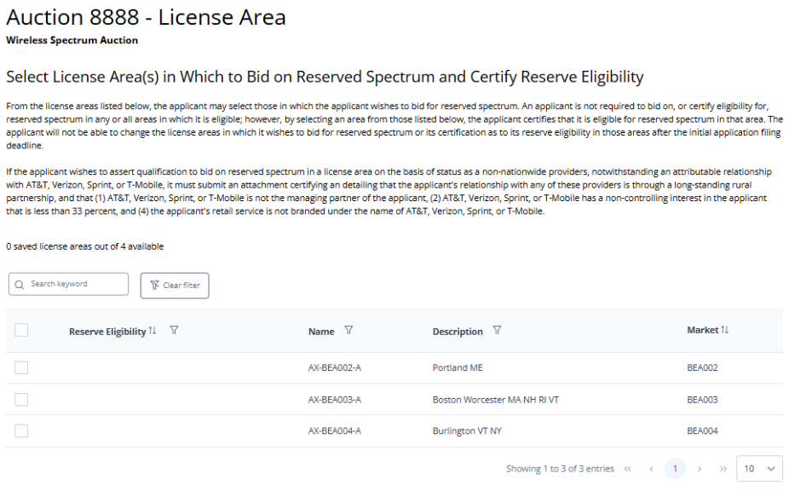

(Displayed Only to Wireless Auction Applicants in Auctions in Which Reserved Spectrum is Available)

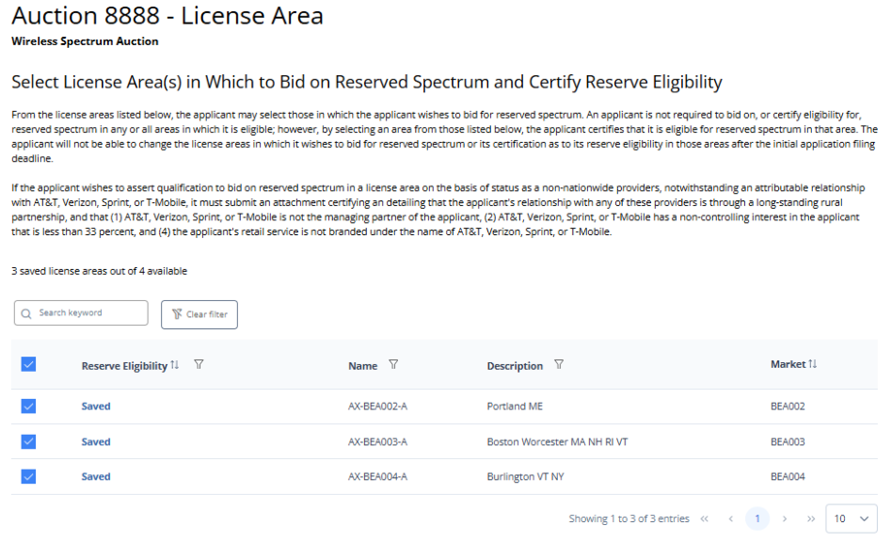

(Displayed Only to Wireless Auction Applicants in Auctions in Which Reserved Spectrum is Available)

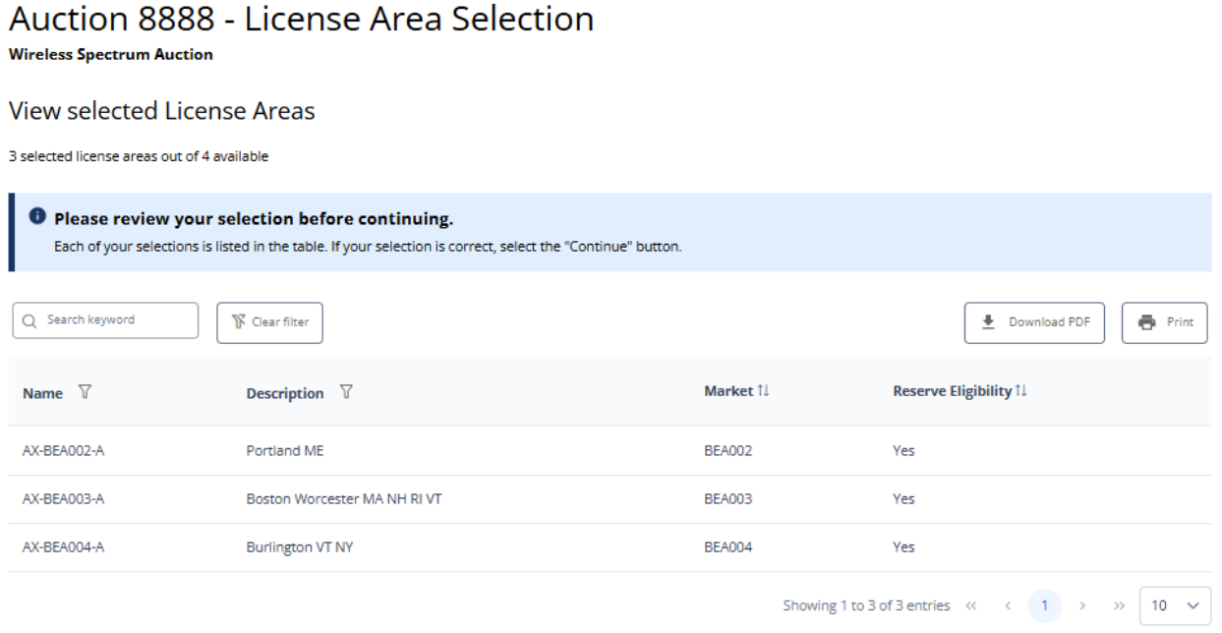

(Displayed Only to Wireless Auction Applicants in Auctions in Which Reserved Spectrum is Available)

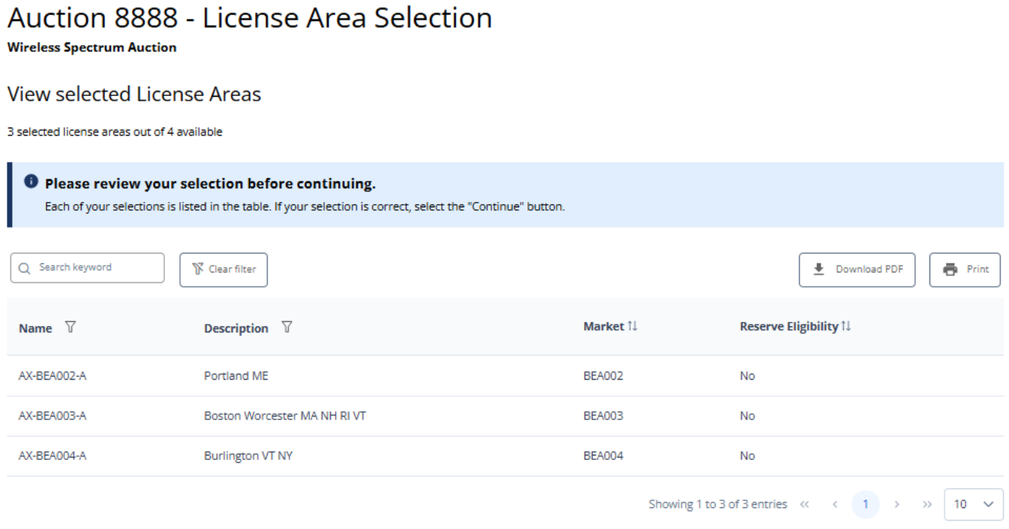

(Displayed Only to Broadcast Table Service Auction Applicants)
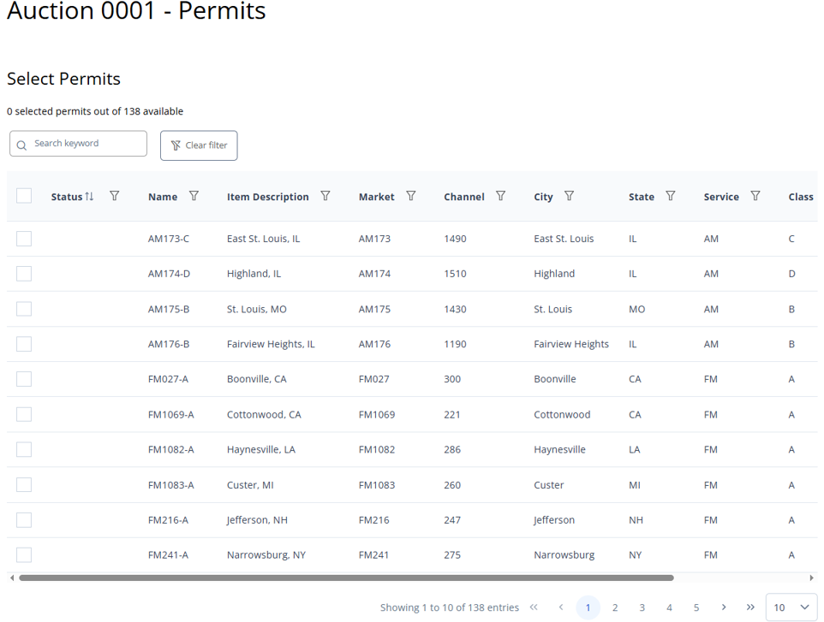
(Displayed Only to Broadcast Table Service Auction Applicants)

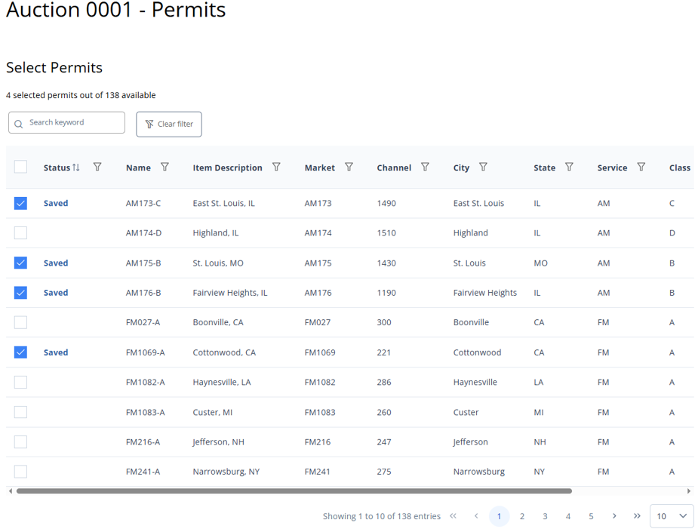
(Displayed Only to Broadcast Table Service Auction Applicants)
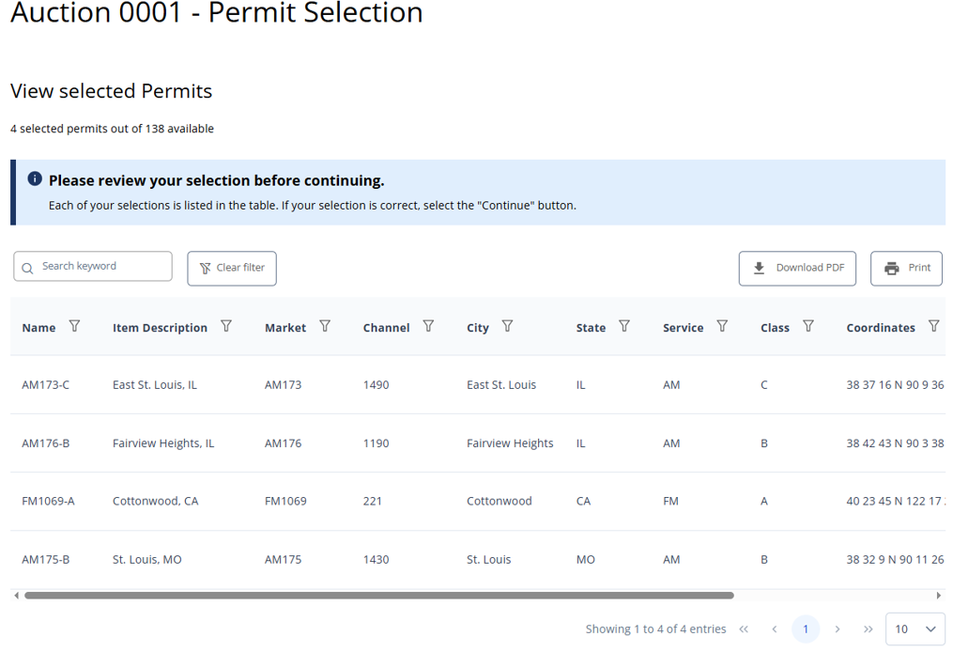
(Displayed Only to Broadcast Non-Table Service Auction Applicants)
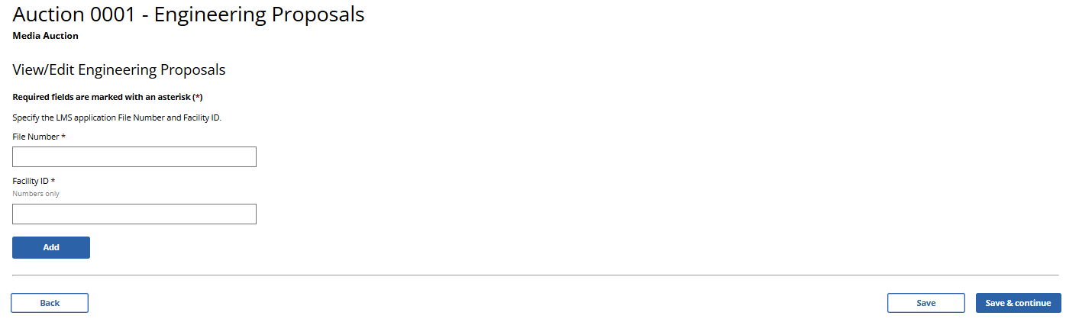

(Displayed Only to Broadcast Non-Table Service Auction Applicants)
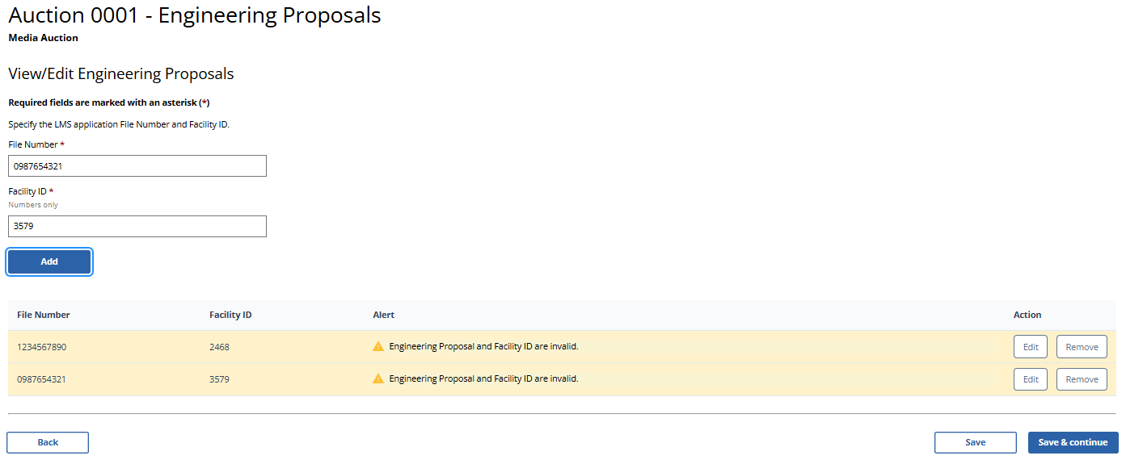

(Displayed Only to Broadcast Auction Applicants)
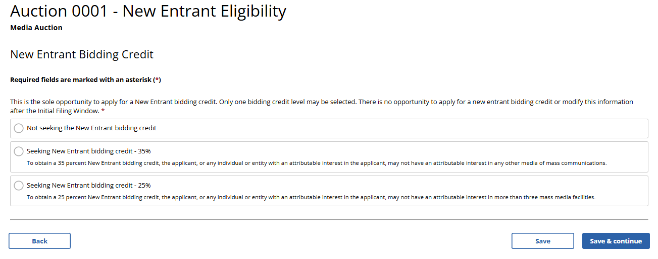

(Displayed Only to Broadcast Auction Applicants Seeking a 35% New Entrant Biding Credit)
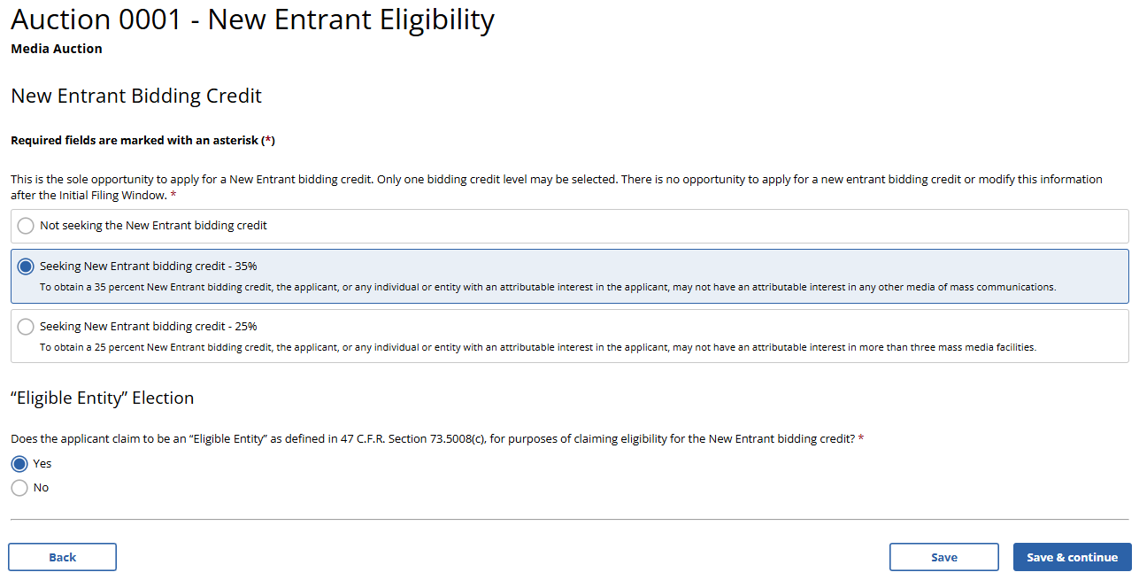

(Displayed Only to Broadcast Auction Applicants Seeking a 25% New Entrant Biding Credit)
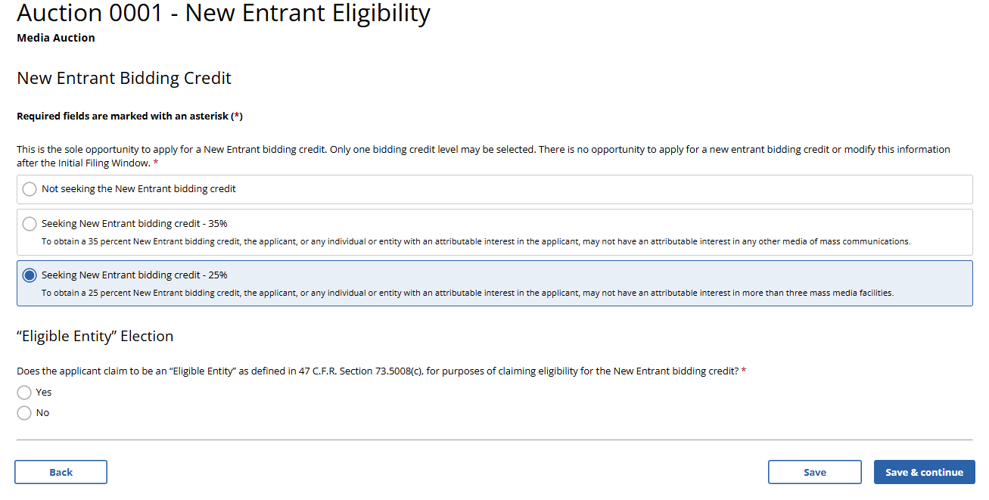

(Displayed Only to Broadcast Auction Applicants Seeking a 25% New Entrant Bidding Credit)
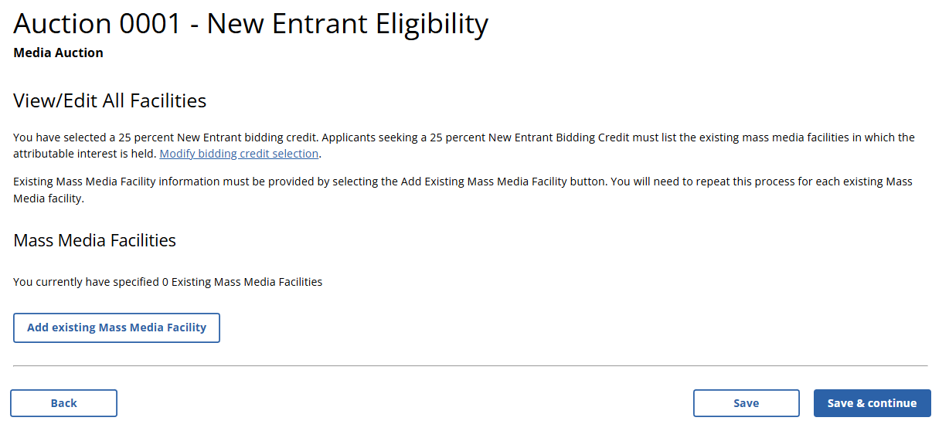

(Displayed Only to Broadcast Auction Applicants Seeking a 25% New Entrant Bidding Credit)
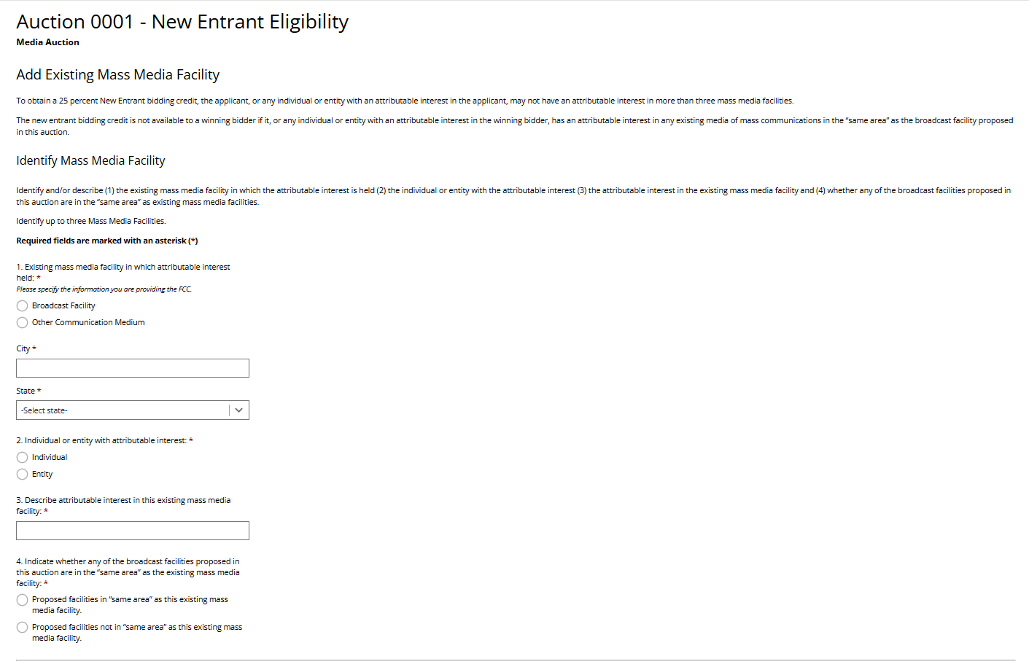

(Displayed Only to Broadcast Auction Applicants Seeking a 25% New Entrant Bidding Credit)
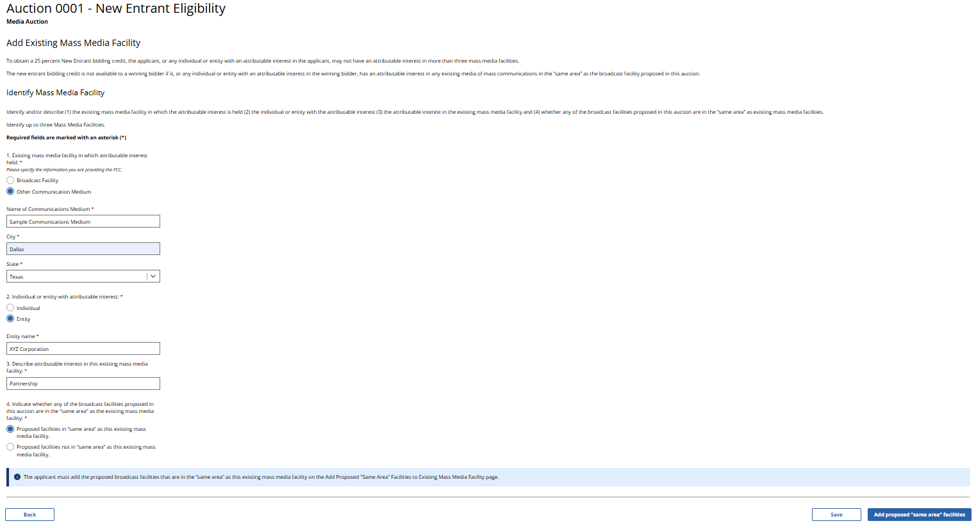

(Displayed Only to Broadcast Auction Applicants Seeking a 25% New Entrant Bidding Credit)
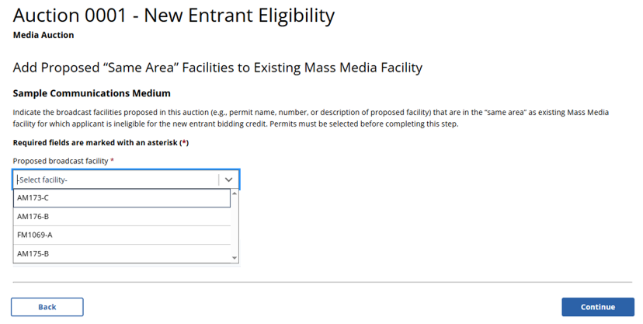

(Displayed Only to Broadcast Auction Applicants Seeking a 25% New Entrant Bidding Credit)
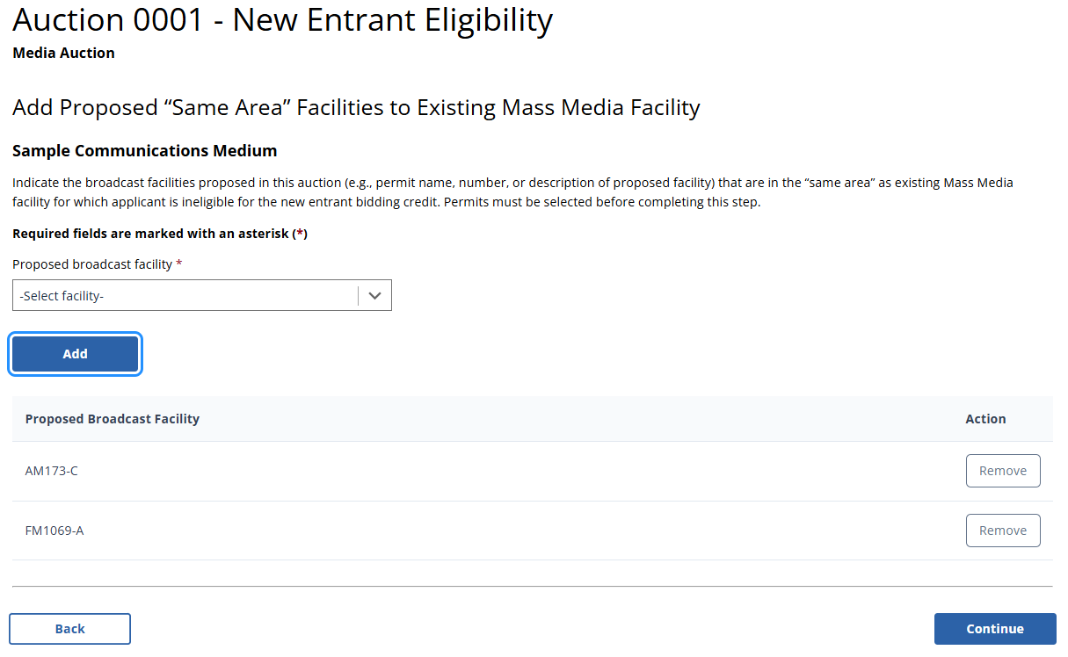

(Displayed Only to Broadcast Auction Applicants Seeking a 25% New Entrant Bidding Credit)
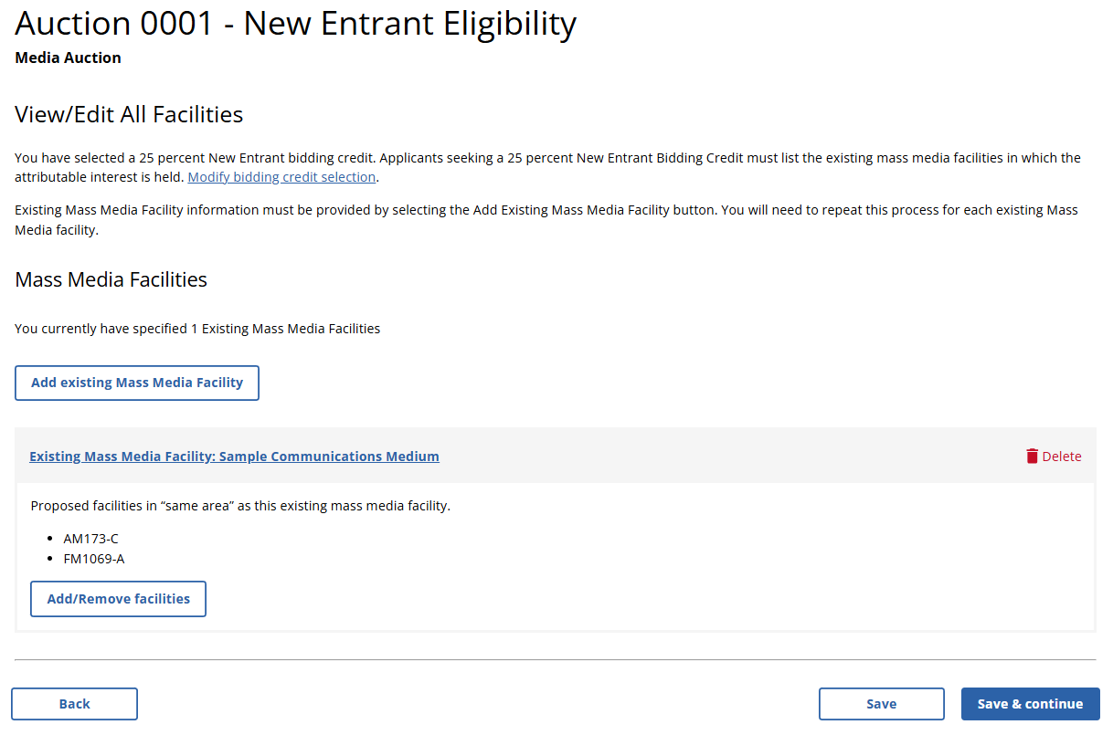

(Displayed Only to Wireless Auction Applicants)

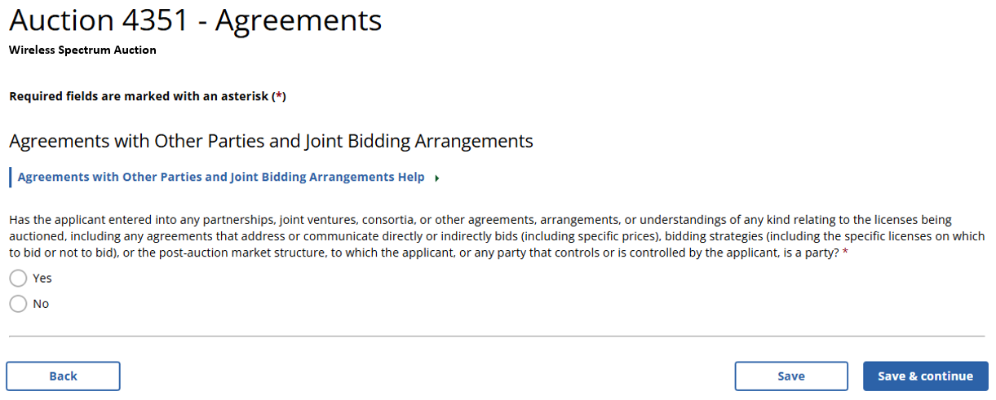

(Displayed Only to Broadcast Auction Applicants)

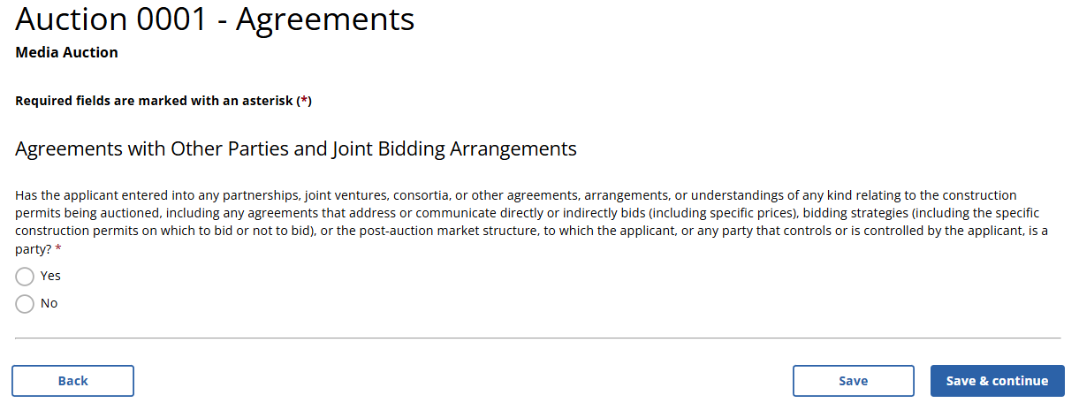

(Displayed to Wireless and Broadcast Auction Applicants)

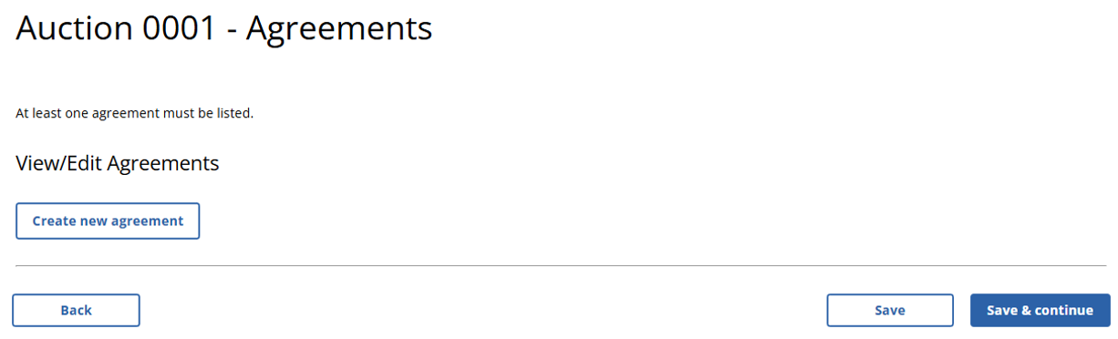

(Displayed Only to Wireless Auction Applicants)
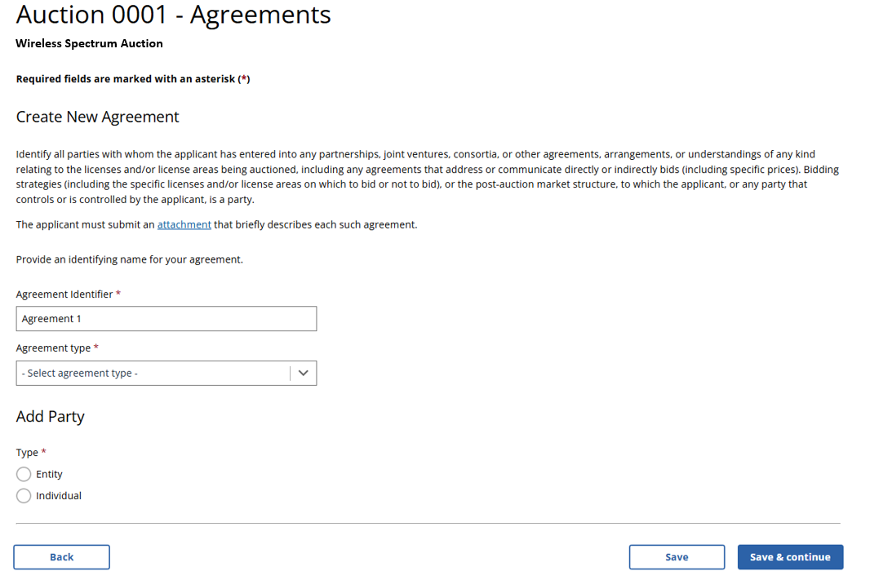
(Displayed Only to Broadcast Auction Applicants)
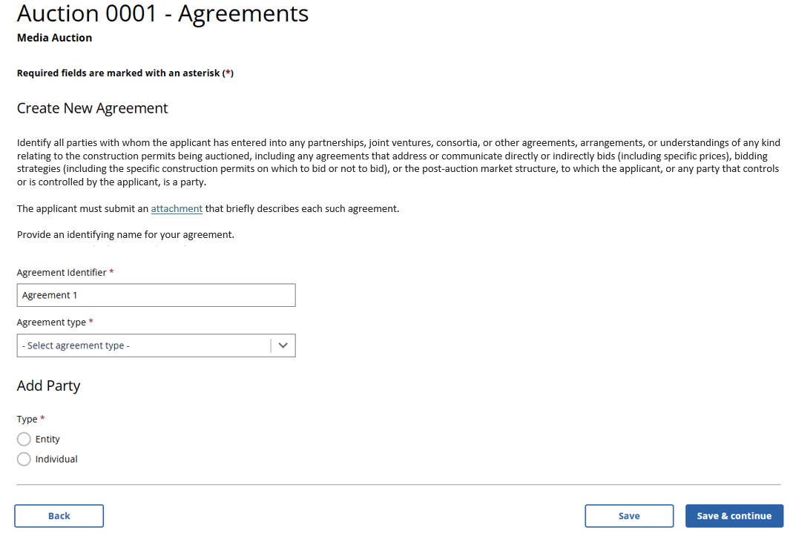

(Displayed to Wireless and Broadcast Auction Applicants)

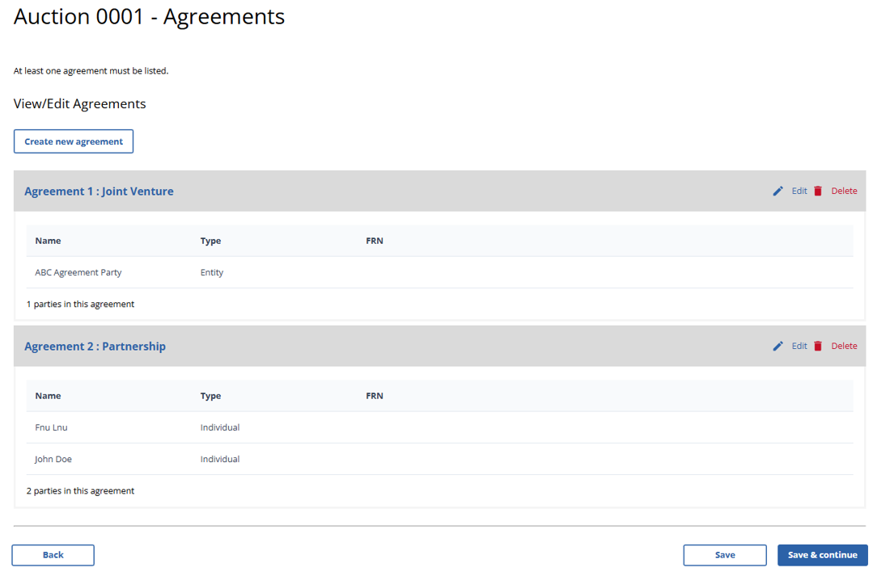
(Displayed Only to Broadcast Auction Applicants and to Wireless Auction Applicants Not Seeking a Bidding Credit)

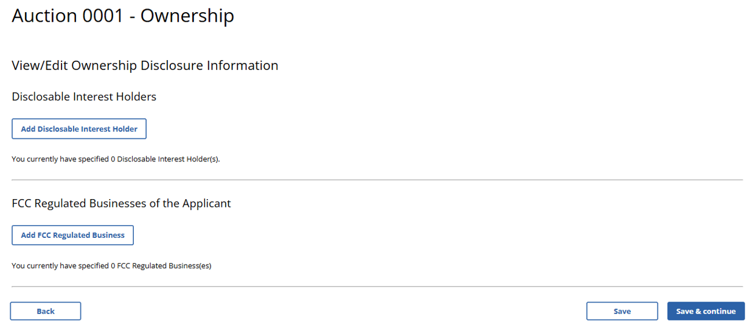

(Displayed Only to Wireless Auction Applicants Seeking a Small Business Bidding Credit Where Preceding 3 Years of Gross Revenues Must Be Disclosed)
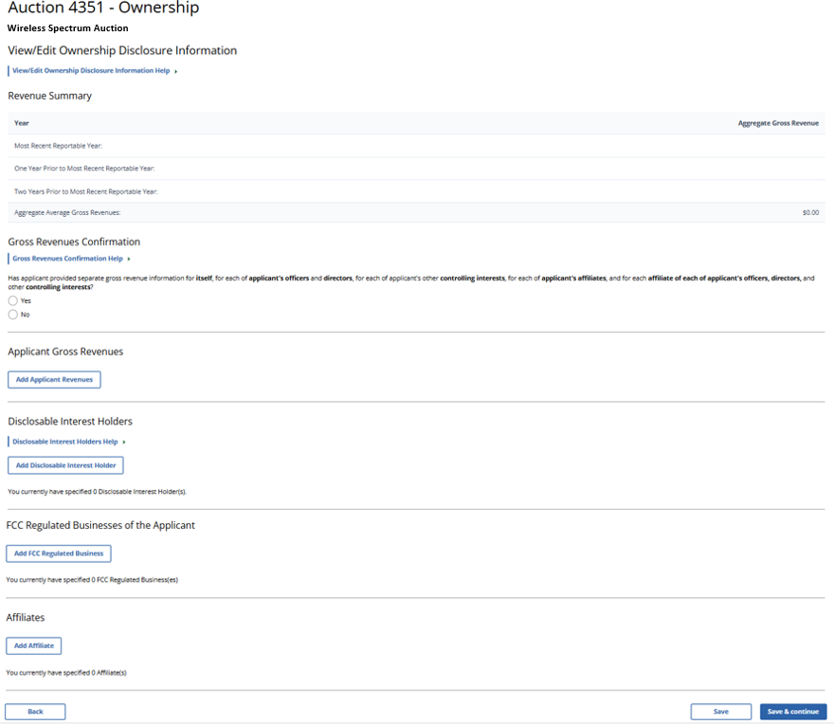
(Displayed Only to Wireless Auction Applicants Seeking a Small Business Bidding Credit Where Preceding 5 Years of Gross Revenues Must Be Disclosed)
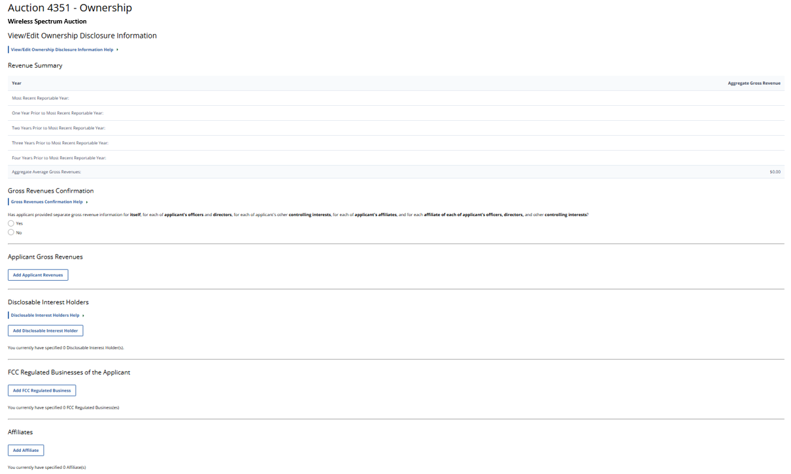

(Displayed Only to Wireless Auction Applicants Seeking a Rural Service Provider Bidding Credit)
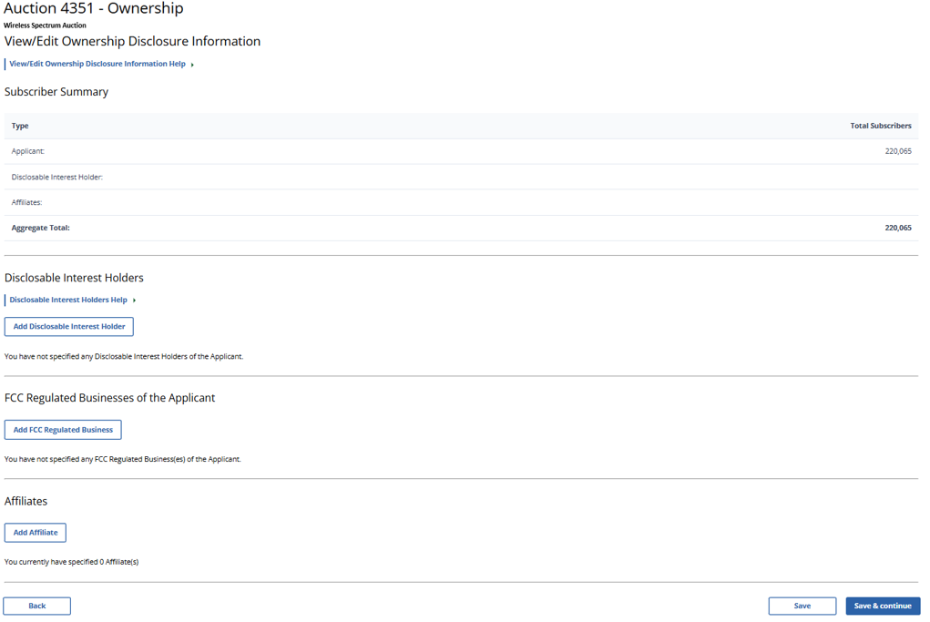

(Displayed Only to Wireless Auction Applicants Seeking a Small Business Bidding Credit Where Preceding 3 Years of Gross Revenues Must Be Disclosed)
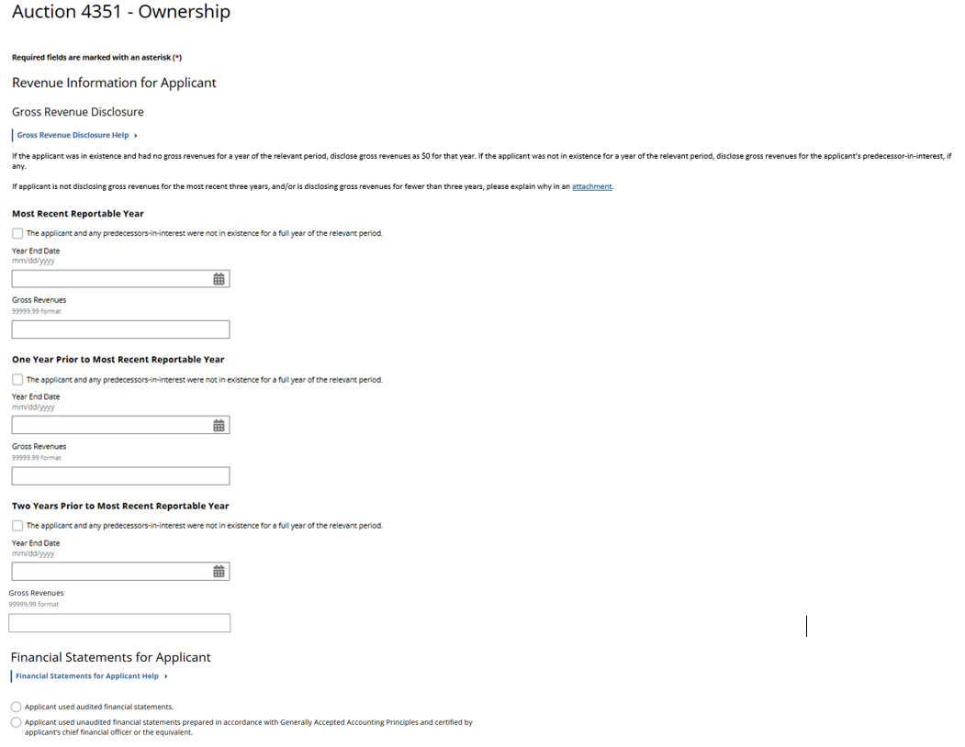
(Displayed Only to Wireless Auction Applicants Seeking a Small Business Bidding Credit Where Preceding 5 Years of Gross Revenues Must Be Disclosed)
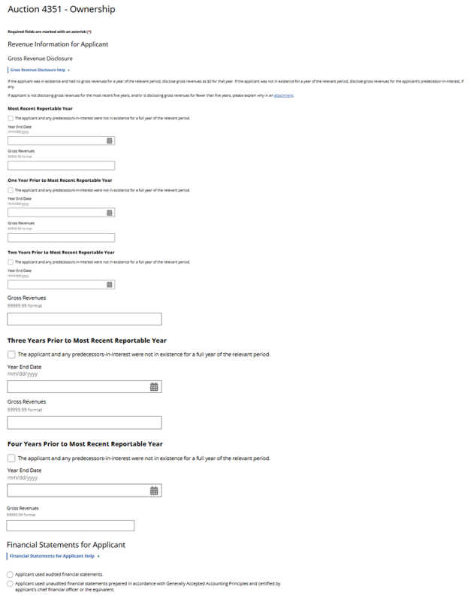
(Displayed Only to Wireless Auction Applicants)
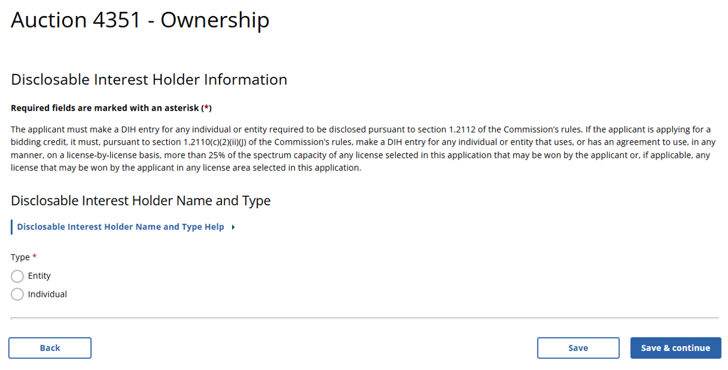

(Displayed Only to Wireless Auction Applicants)
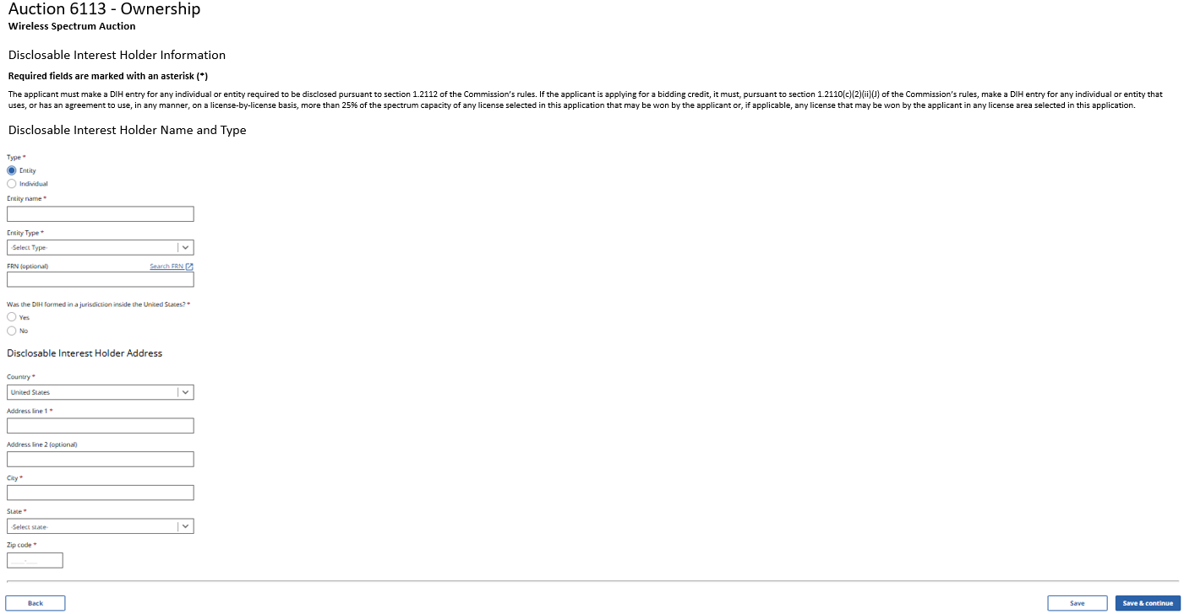
(Displayed Only to Wireless Auction Applicants)
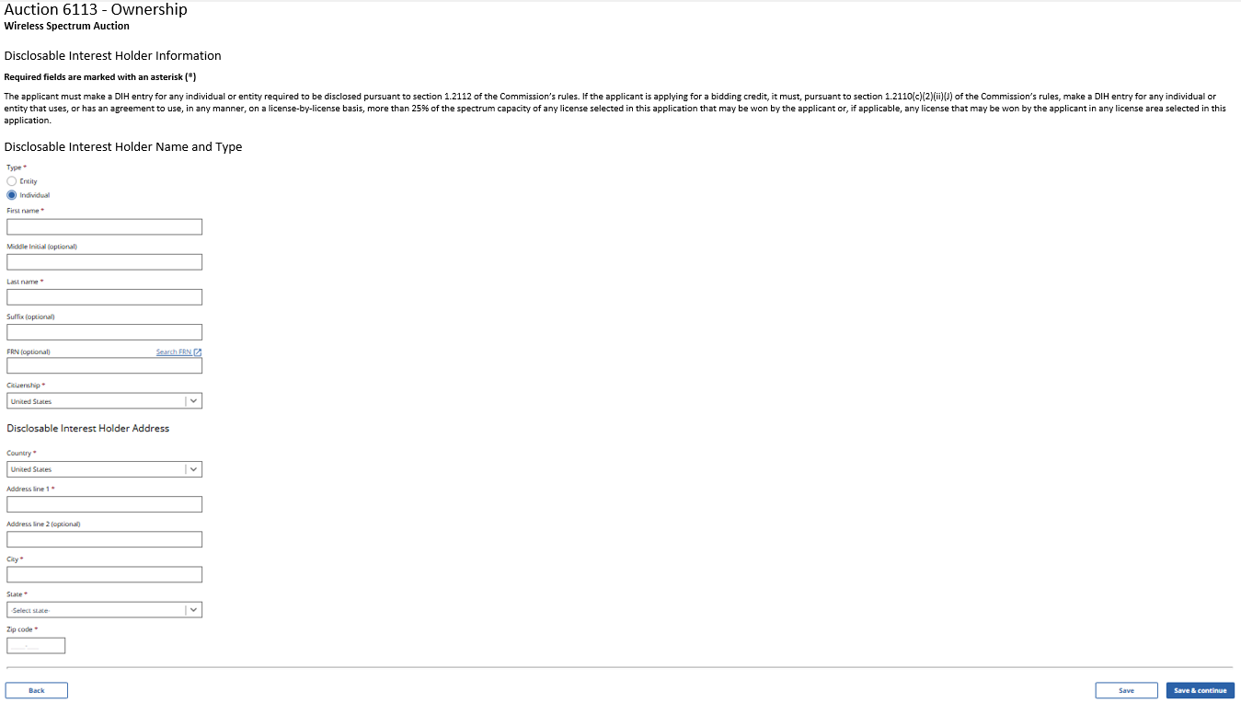

(Displayed Only to Broadcast Auction Applicants)
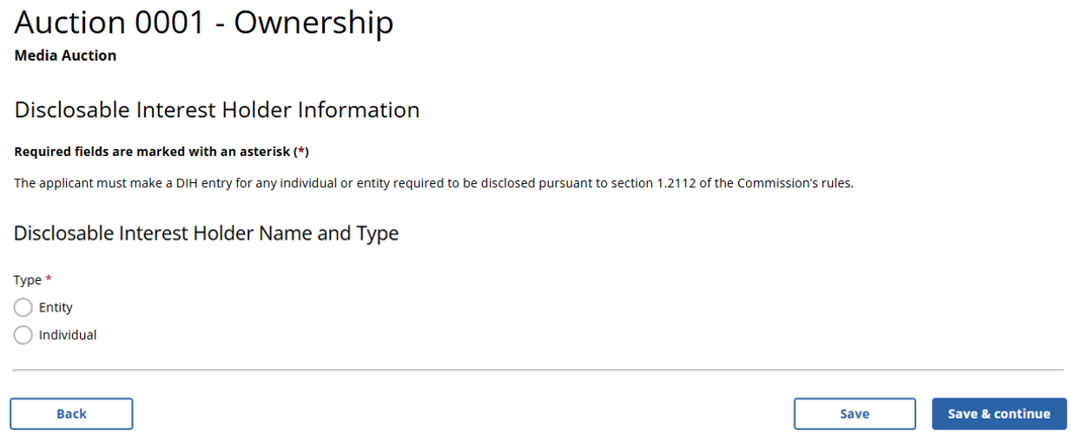

(Displayed Only to Broadcast Auction Applicants)
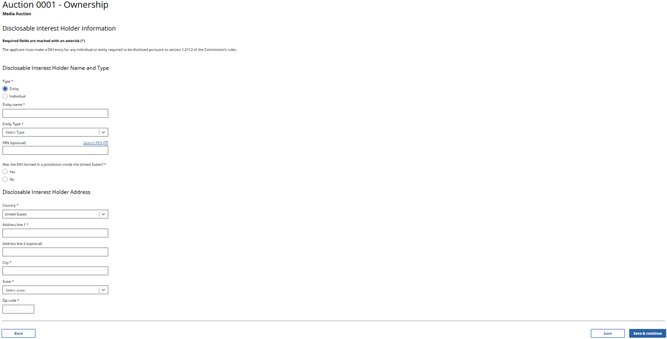

(Displayed Only to Broadcast Auction Applicants)
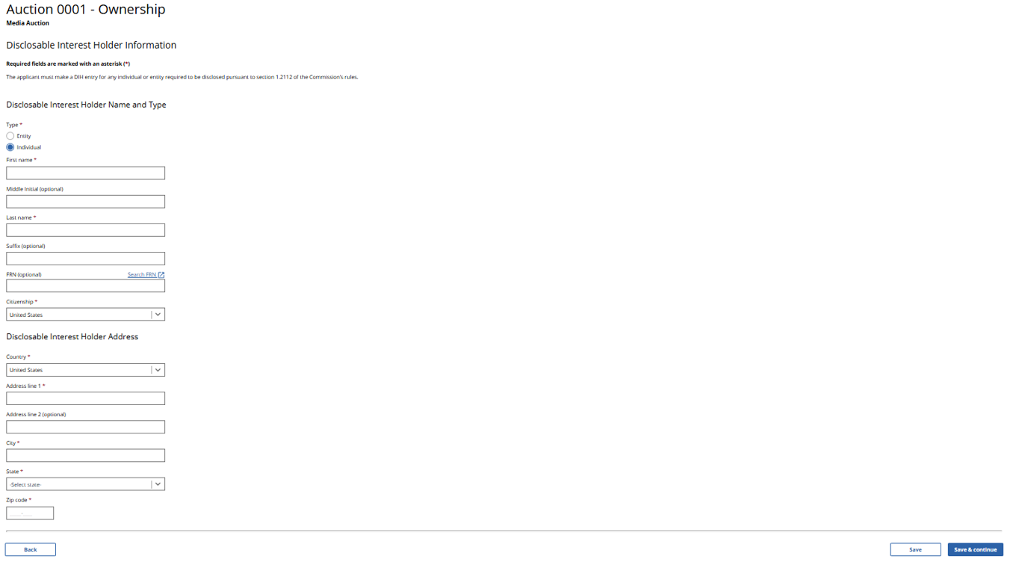

(Displayed to Wireless and Broadcast Auction Applicants)
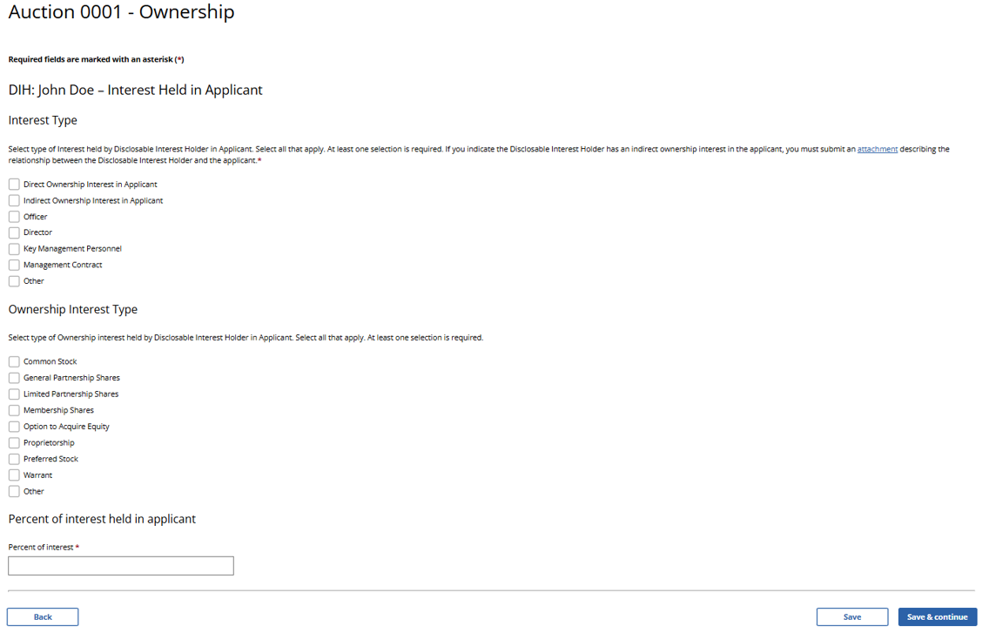

(Displayed to Wireless and Broadcast Auction Applicants)
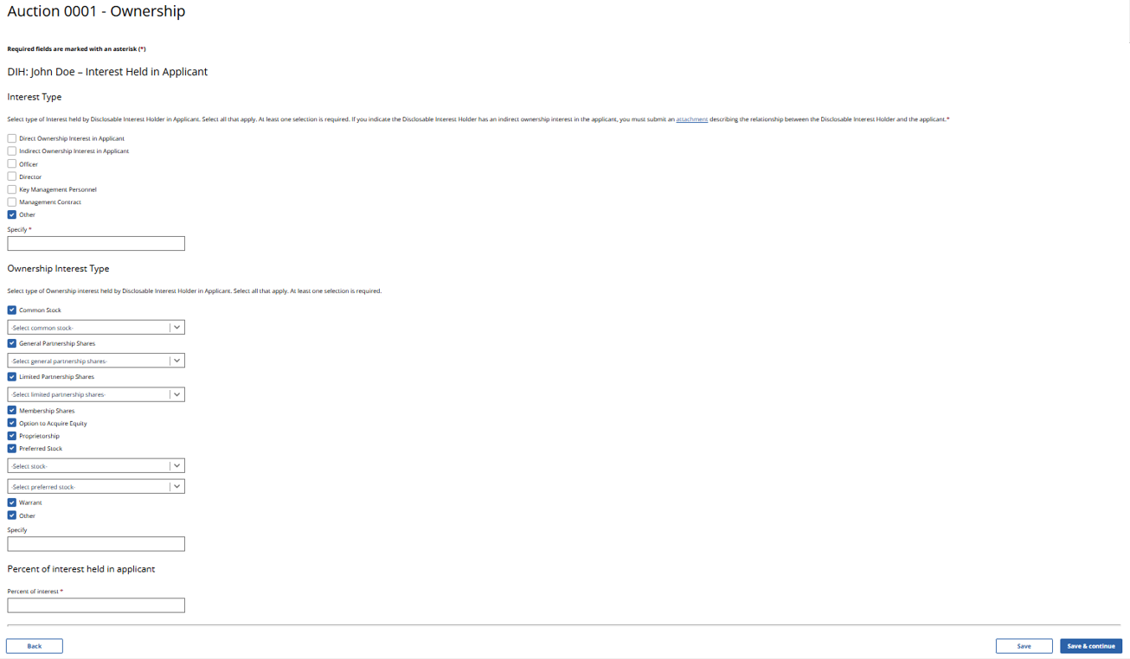

(Displayed Only to Wireless Auction Applicants Seeking a Small Business Bidding Credit)

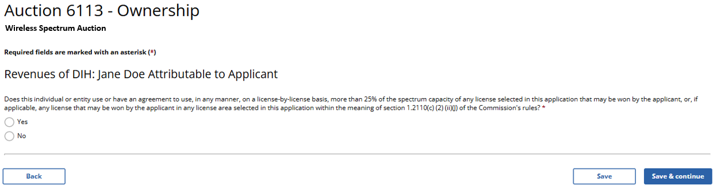

(Displayed Only to Wireless Auction Applicants Seeking a Small Business Bidding Credit That Answer “Yes”)
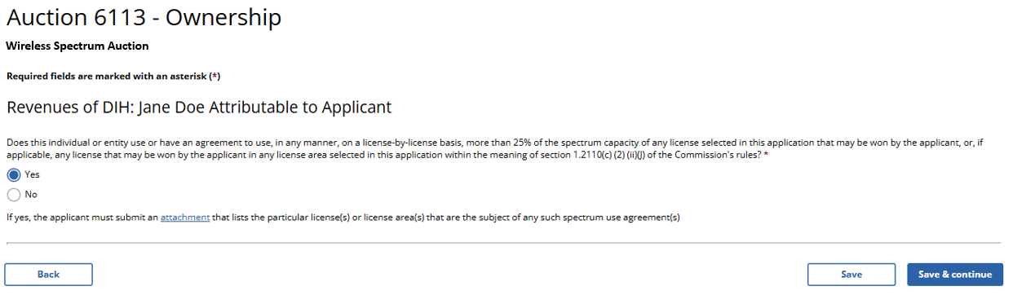

(Displayed Only to Wireless Auction Applicants Seeking a Small Business Bidding Credit Where Preceding 3 Years of Gross Revenues Must Be Disclosed)
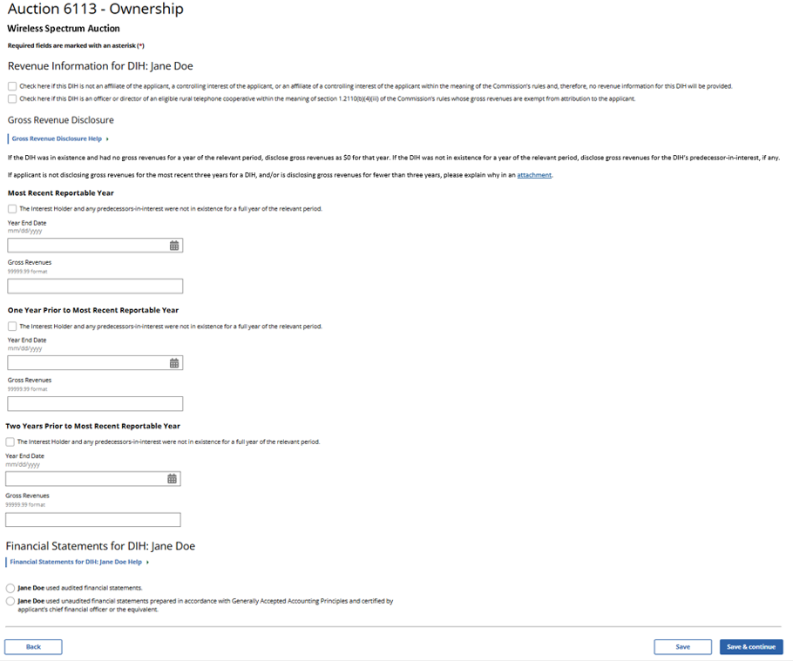
(Displayed Only to Wireless Auction Applicants Seeking a Small Business Bidding Credit Where Preceding 3 Years of Gross Revenues Must Be Disclosed)
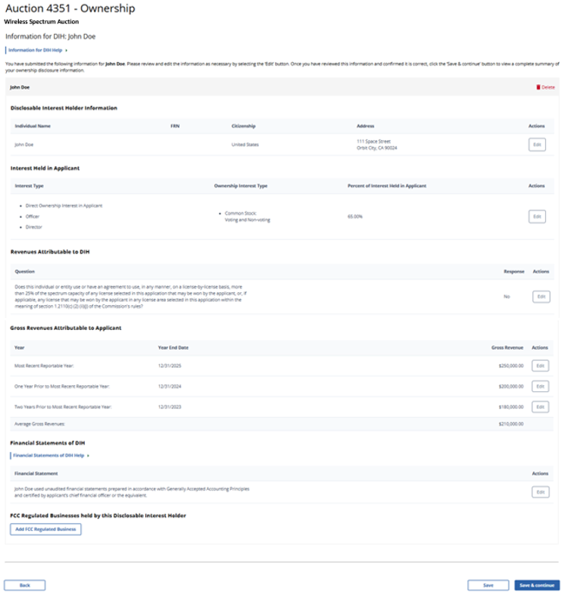
(Displayed Only to Wireless Auction Applicants Seeking a Small Business Bidding Credit Where Preceding 5 Years of Gross Revenues Must Be Disclosed)
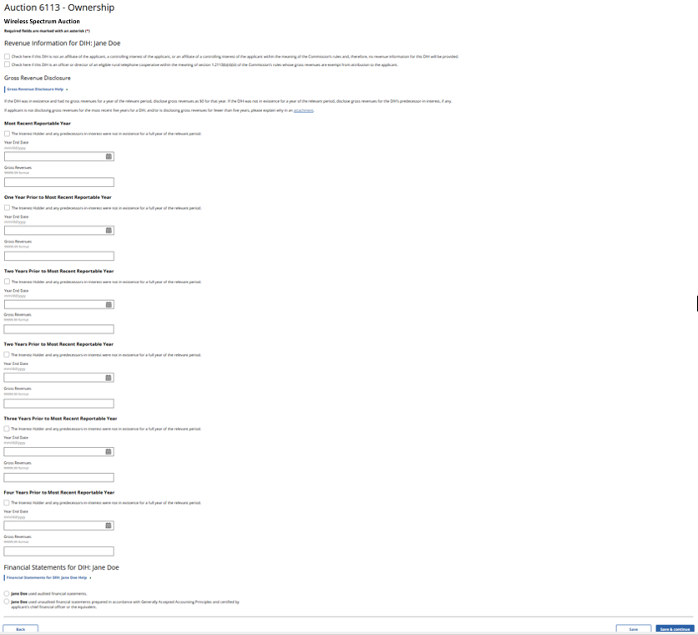
(Displayed Only to Wireless Auction Applicants Seeking a Small Business Bidding Credit Where Preceding 5 Years of Gross Revenues Must Be Disclosed)
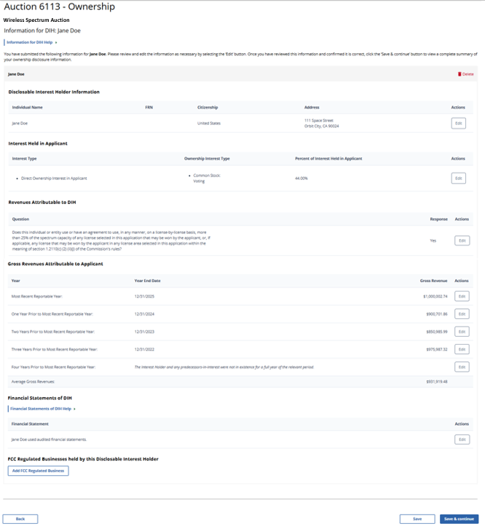
(Displayed Only to Wireless Auction Applicants Seeking a Rural Service Provider Bidding Credit)
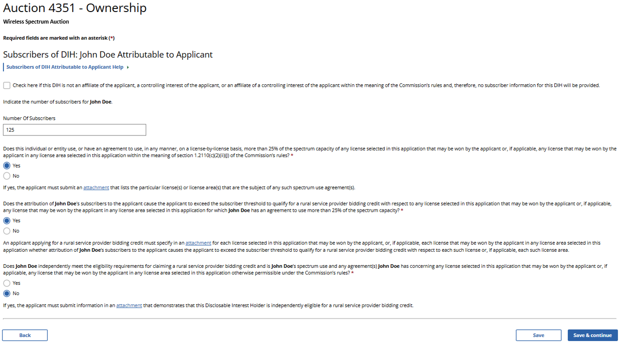

(Displayed Only to Wireless Auction Applicants Seeking a Rural Service Provider Bidding Credit)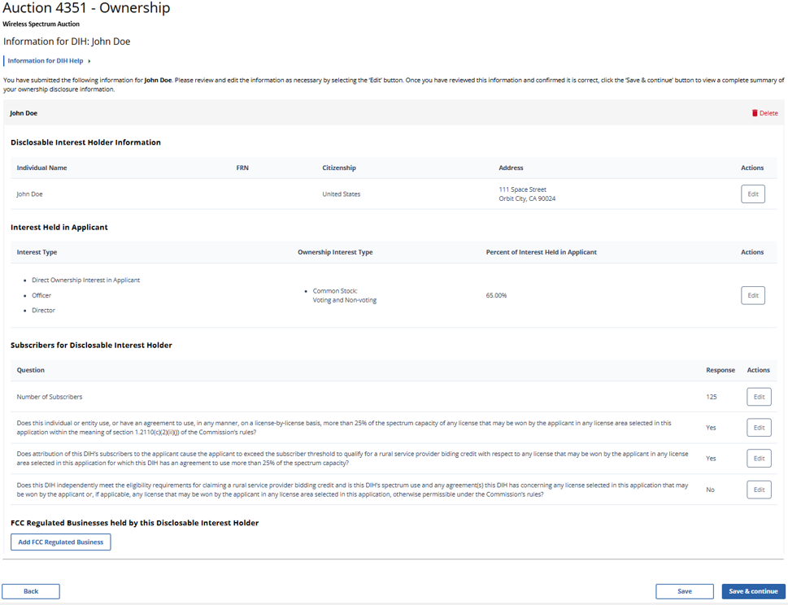
(Displayed to Wireless and Broadcast Auction Applicants)
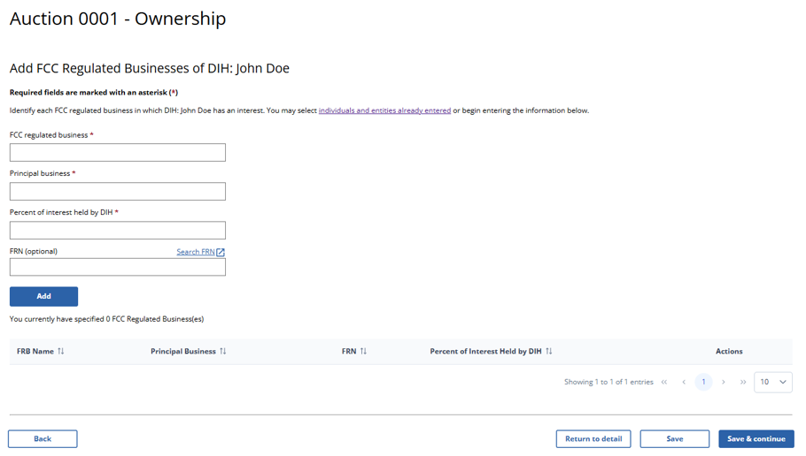

(Displayed to Wireless and Broadcast Auction Applicants)
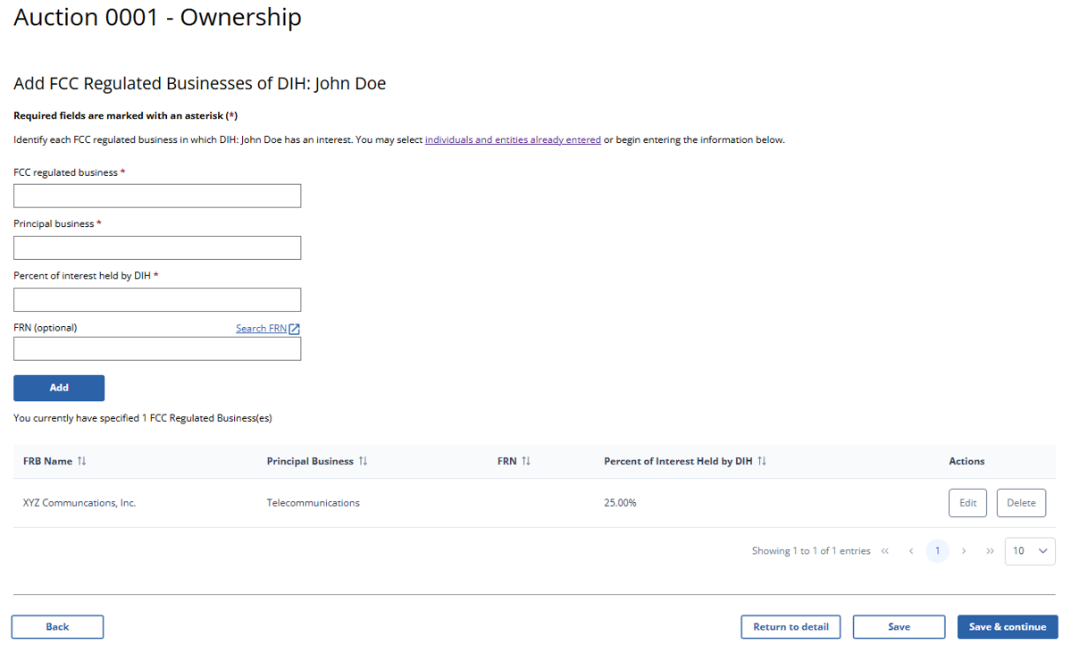

(Displayed to Wireless and Broadcast Auction Applicants)
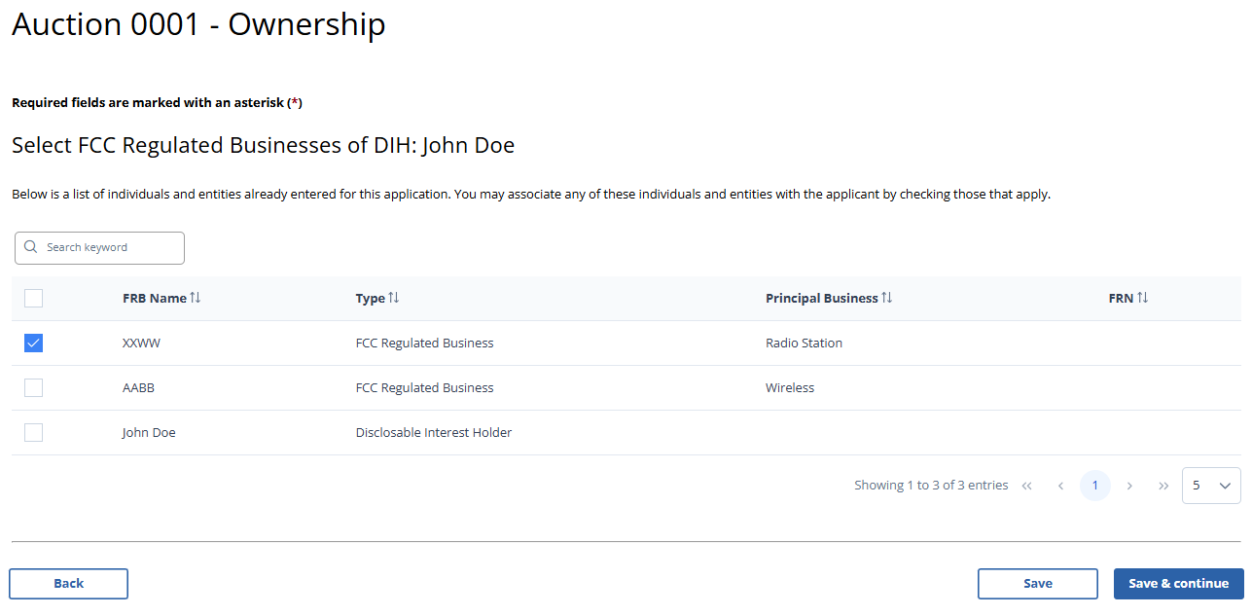

(Displayed to Wireless and Broadcast Auction Applicants)
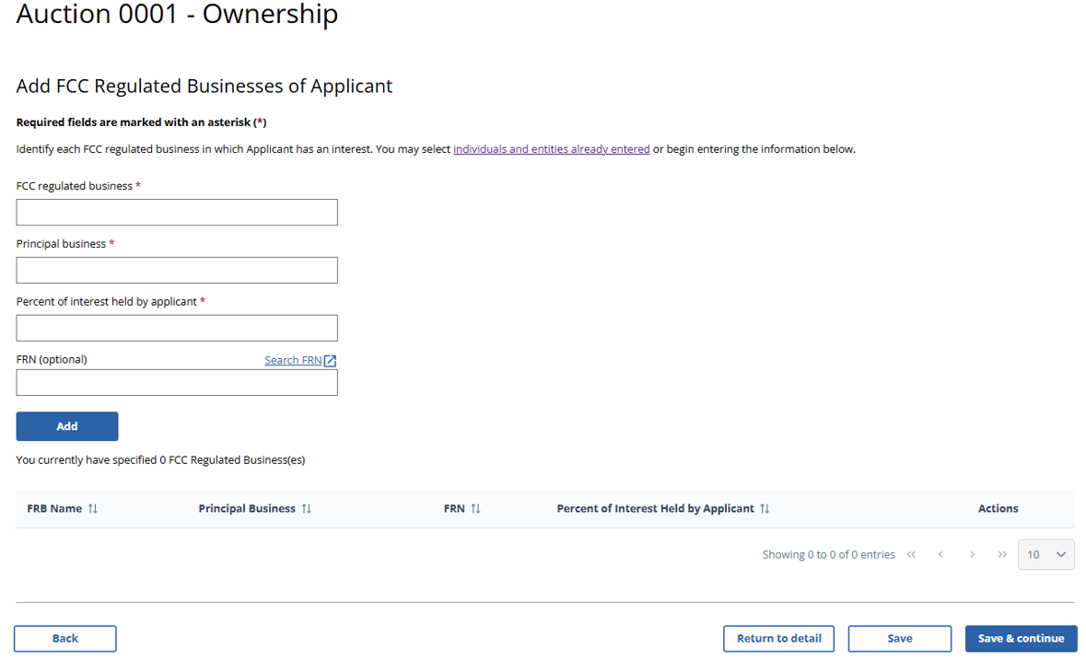

(Displayed to Wireless and Broadcast Auction Applicants)
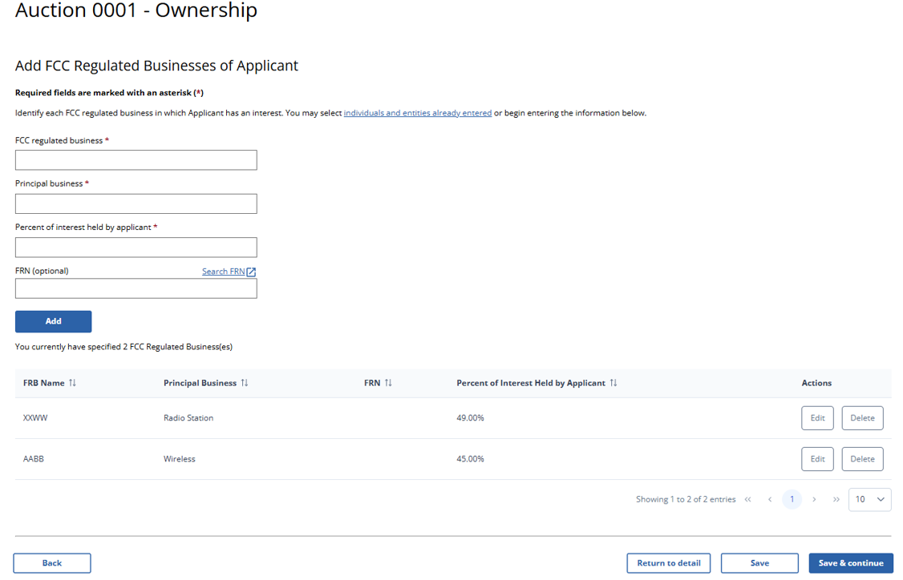

(Displayed to Wireless and Broadcast Auction Applicants)
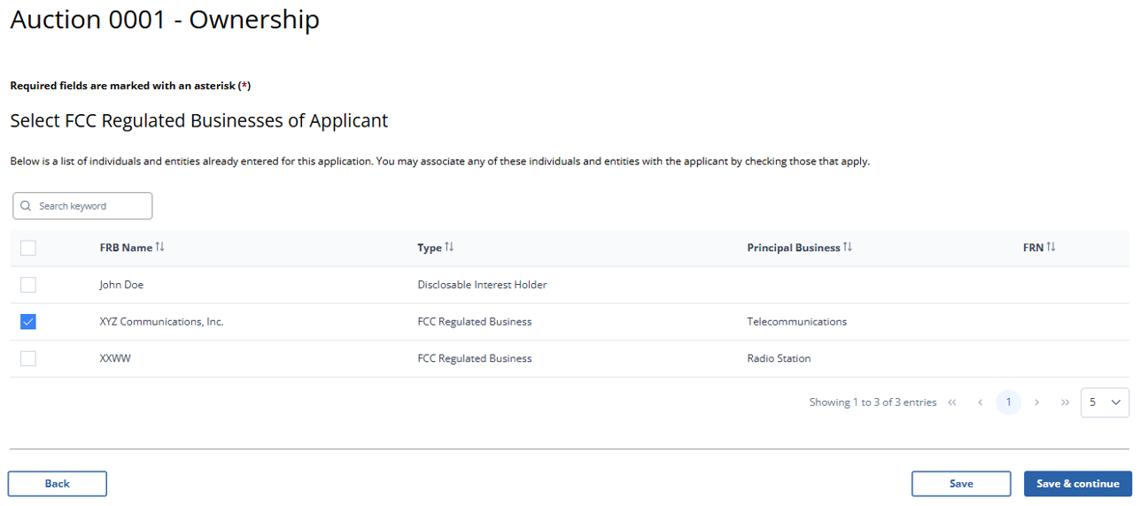

(Displayed Only to Wireless Auction Applicants Seeking a Small Business Bidding Credit or a Rural Service Provider Bidding Credit)
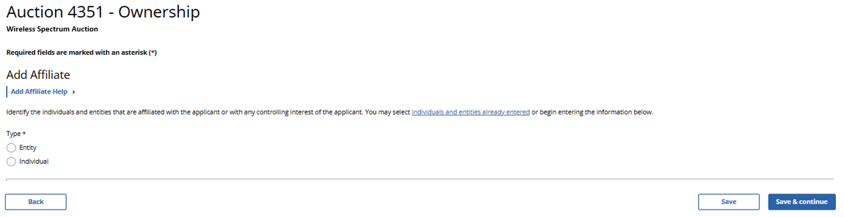

(Displayed Only to Wireless Auction Applicants Seeking a Small Business Bidding Credit)
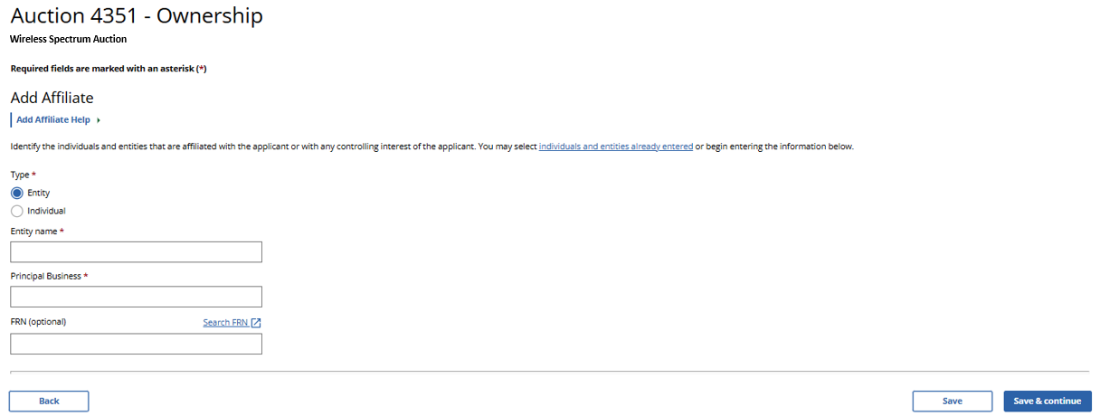

(Displayed Only to Wireless Auction Applicants Seeking a Small Business Bidding Credit)
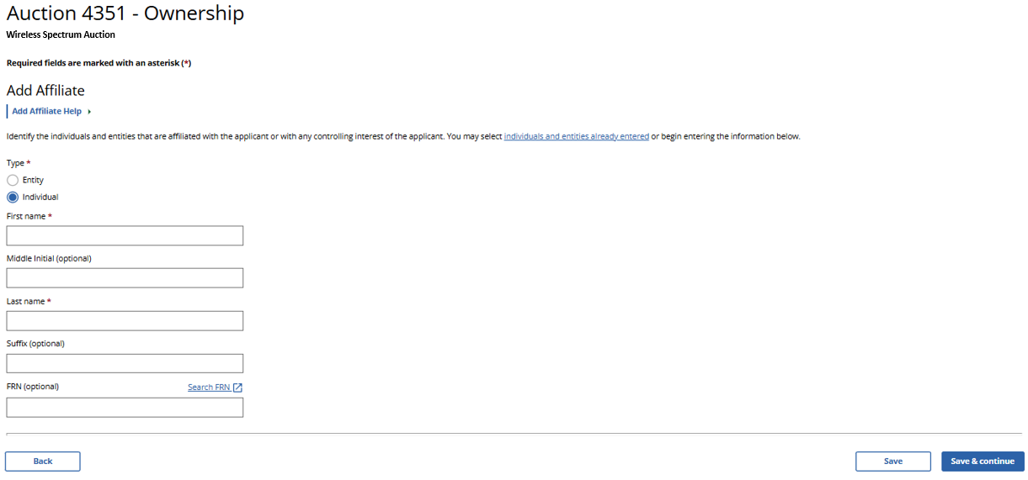

(Displayed Only to Wireless Auction Applicants Seeking a Small Business Bidding Credit Where Preceding 3 Years of Gross Revenues Must Be Disclosed)
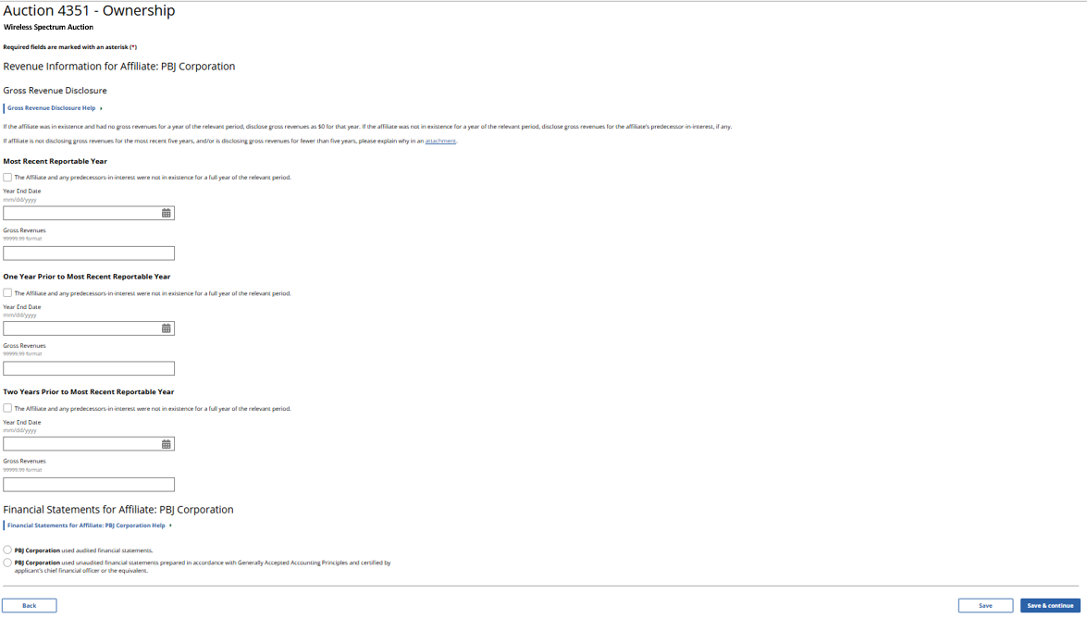

(Displayed Only to Wireless Auction Applicants Seeking a Small Business Bidding Credit Where Preceding 3 Years of Gross Revenues Must Be Disclosed)
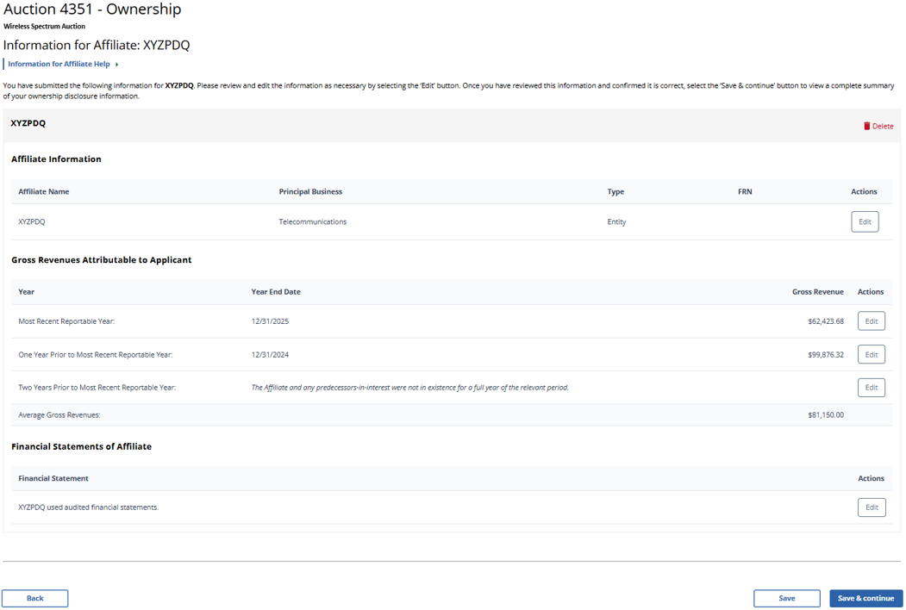
(Displayed Only to Wireless Auction Applicants Seeking a Small Business Bidding Credit Where Preceding 5 Years of Gross Revenues Must Be Disclosed)
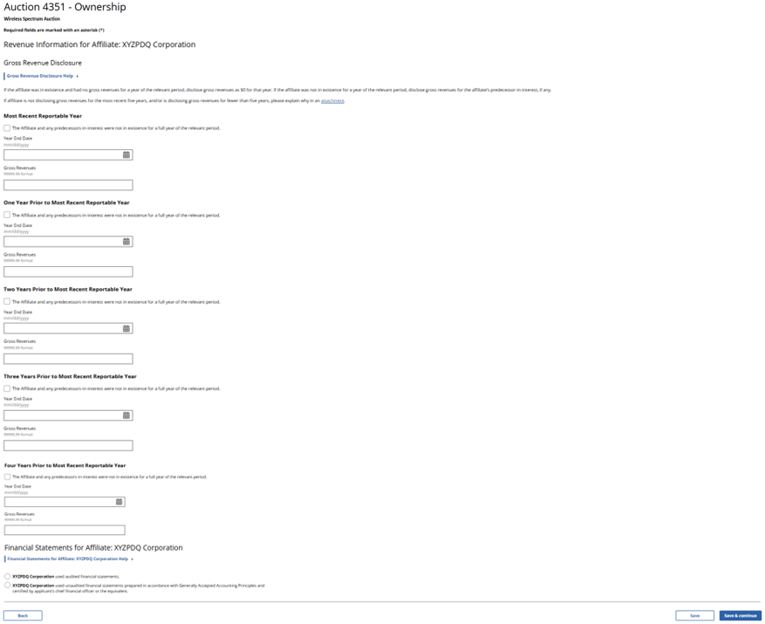
(Displayed Only to Wireless Auction Applicants Seeking a Small Business Bidding Credit Where Preceding 5 Years of Gross Revenues Must Be Disclosed)
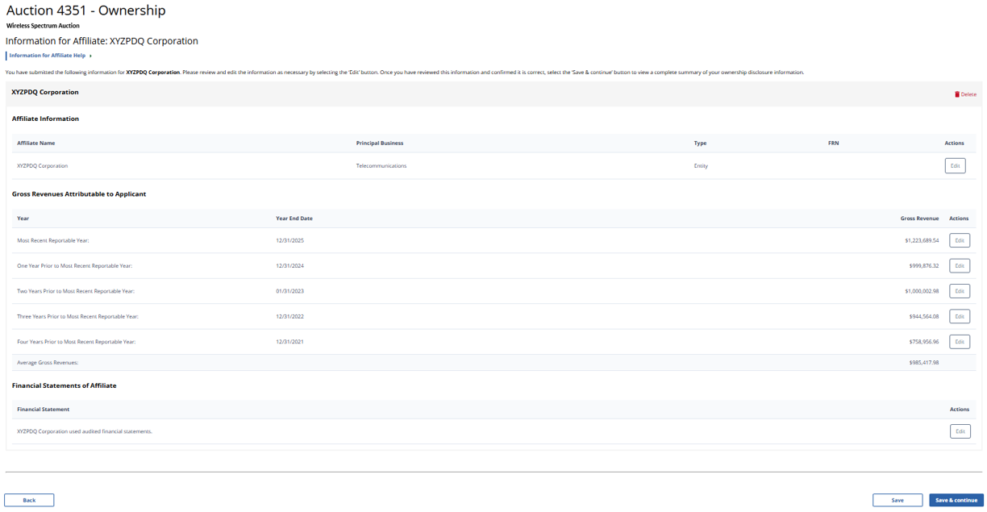

(Displayed Only to Wireless Auction Applicants Seeking a Rural Service Provider Bidding Credit)
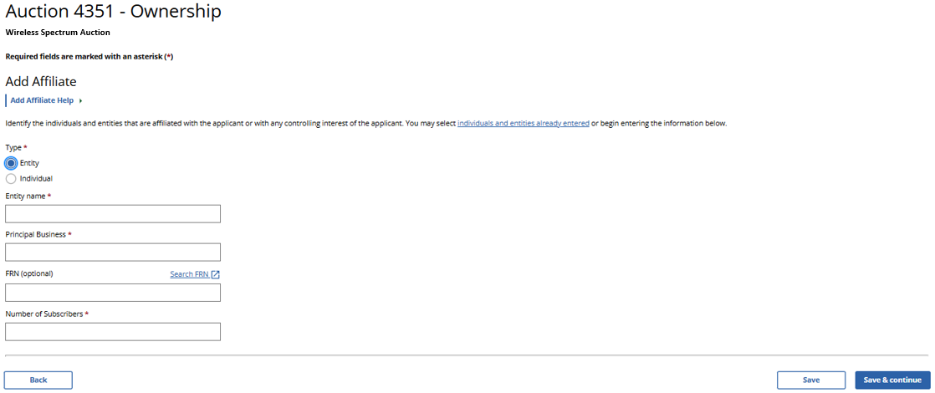

(Displayed Only to Wireless Auction Applicants Seeking a Rural Service Provider Bidding Credit)
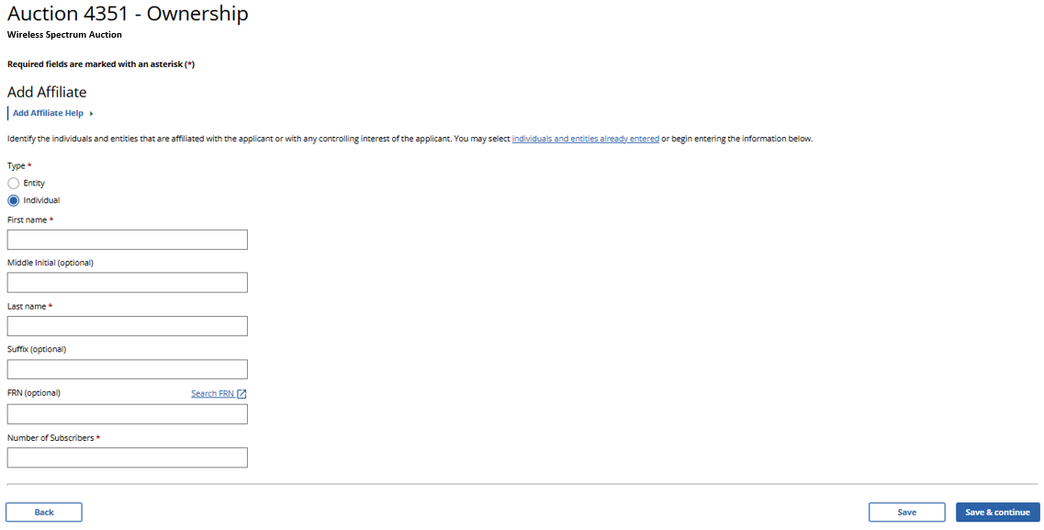

(Displayed Only to Wireless Auction Applicants Seeking a Small Business Bidding Credit or a Rural Service Provider Bidding Credit)
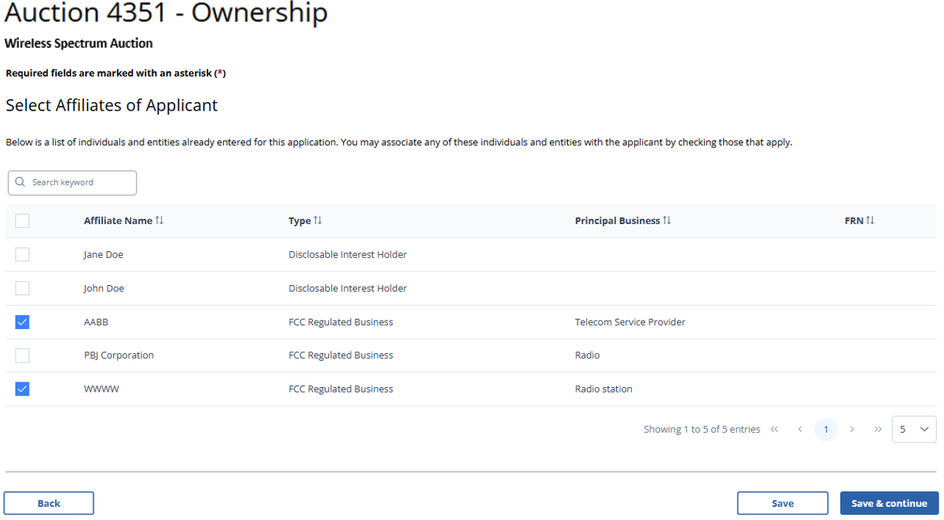

(Displayed Only to Broadcast Auction Applicants and to Wireless Auction Applicants Not Seeking a Bidding Credit)
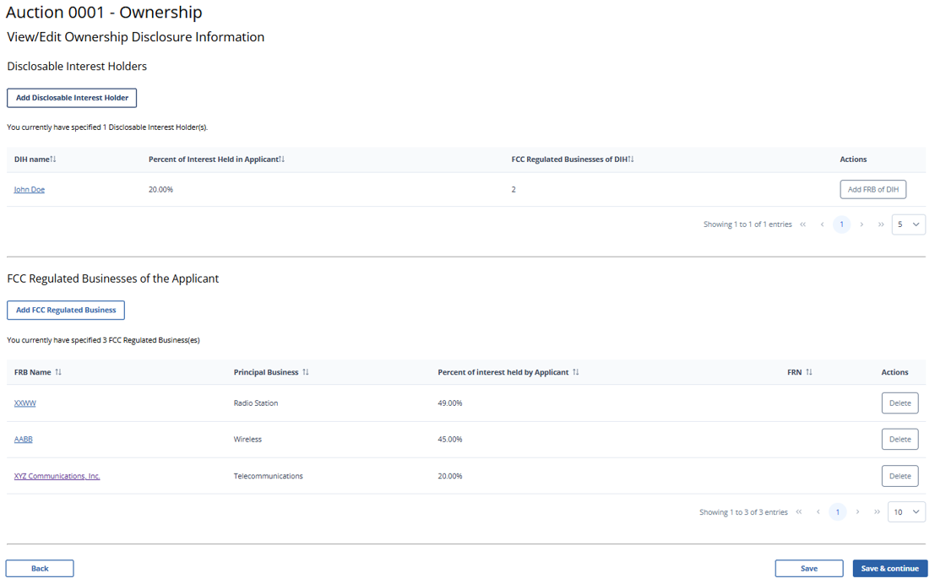

(Displayed Only to Wireless Auction Applicants Seeking a Small Business Bidding Credit Where Preceding 3 Years of Gross Revenues Must Be Disclosed)
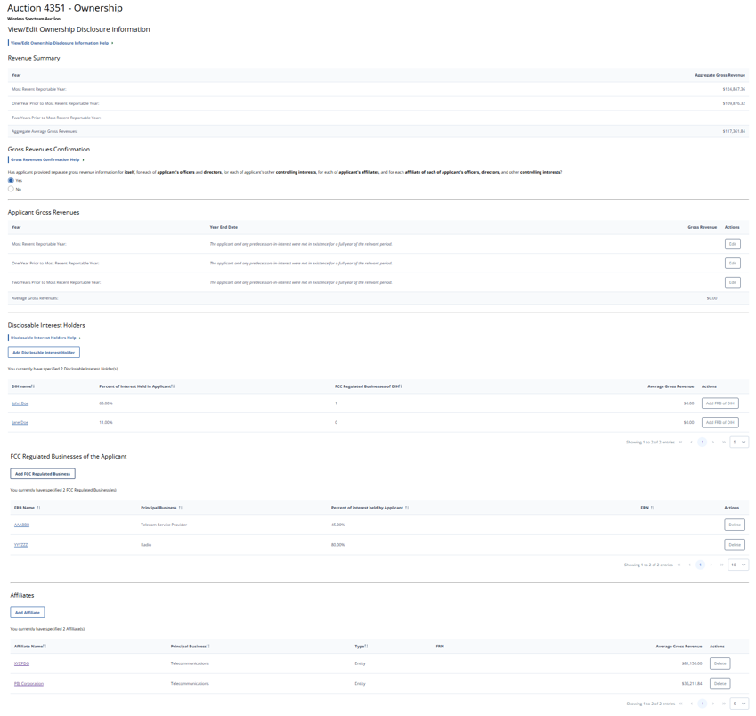
(Displayed Only to Wireless Auction Applicants Seeking a Small Business Bidding Credit Where Preceding 5 Years of Gross Revenues Must Be Disclosed)
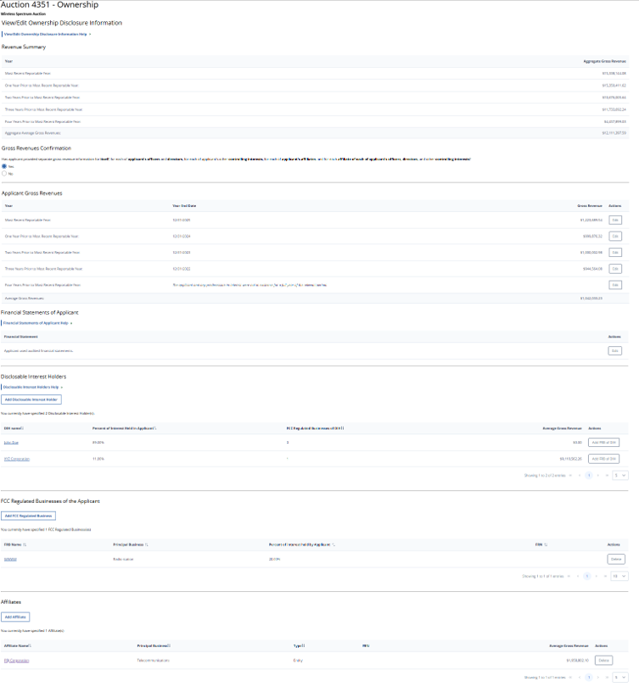
(Displayed Only to Wireless Auction Applicants Seeking a Rural Service Provider Bidding Credit)
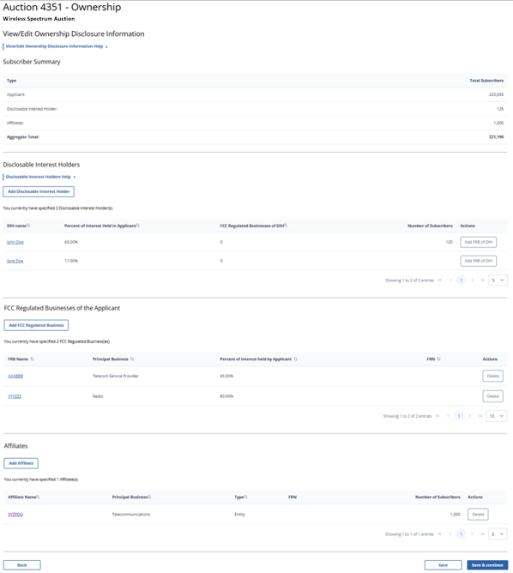
(Displayed to Wireless and Broadcast Auction Applicants)
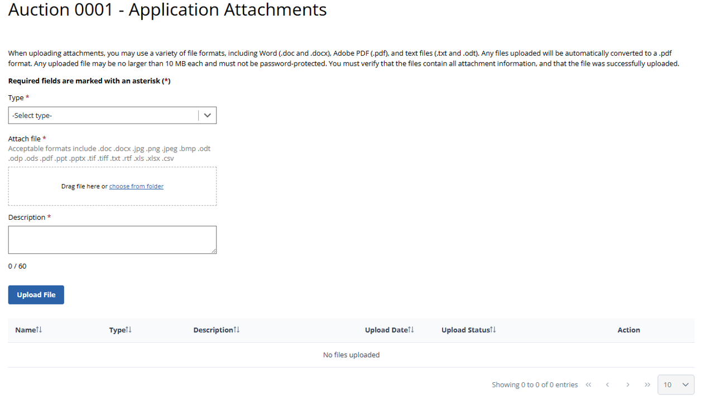

(Displayed to Wireless and Broadcast Auction Applicants)
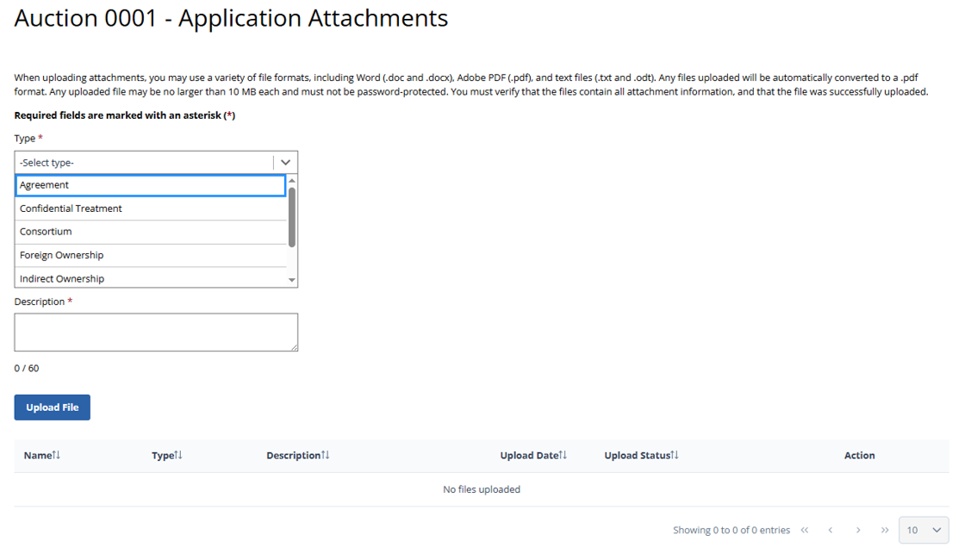

(Displayed to Wireless and Broadcast Auction Applicants)
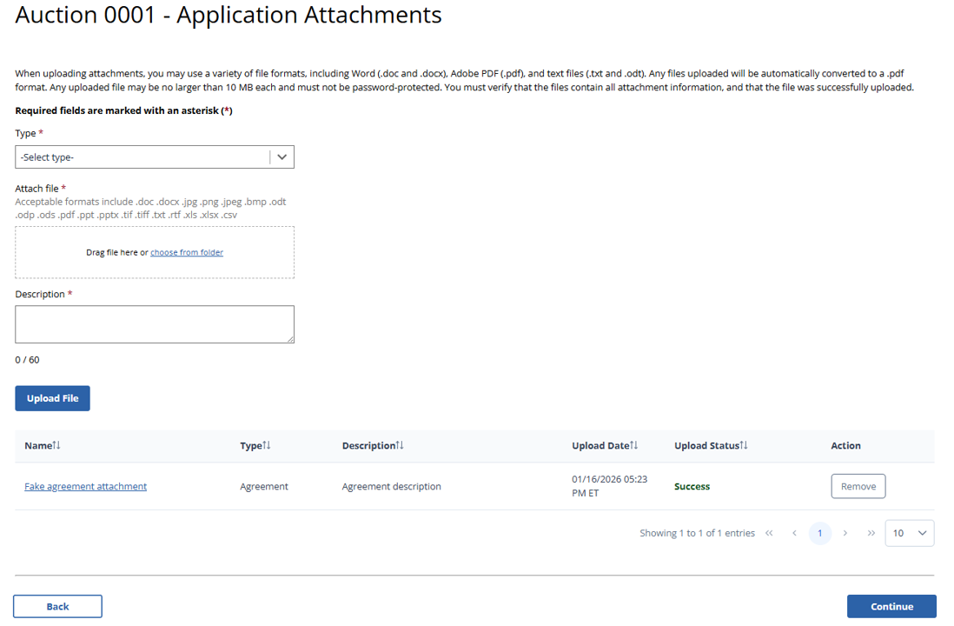

(Error Summary With Errors Detected as Displayed to Wireless Auction Applicants)
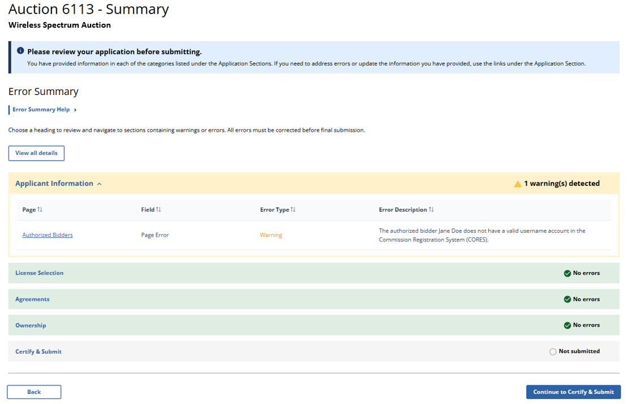

(Error Summary With No Errors Detected as Displayed to Wireless Auction Applicants)
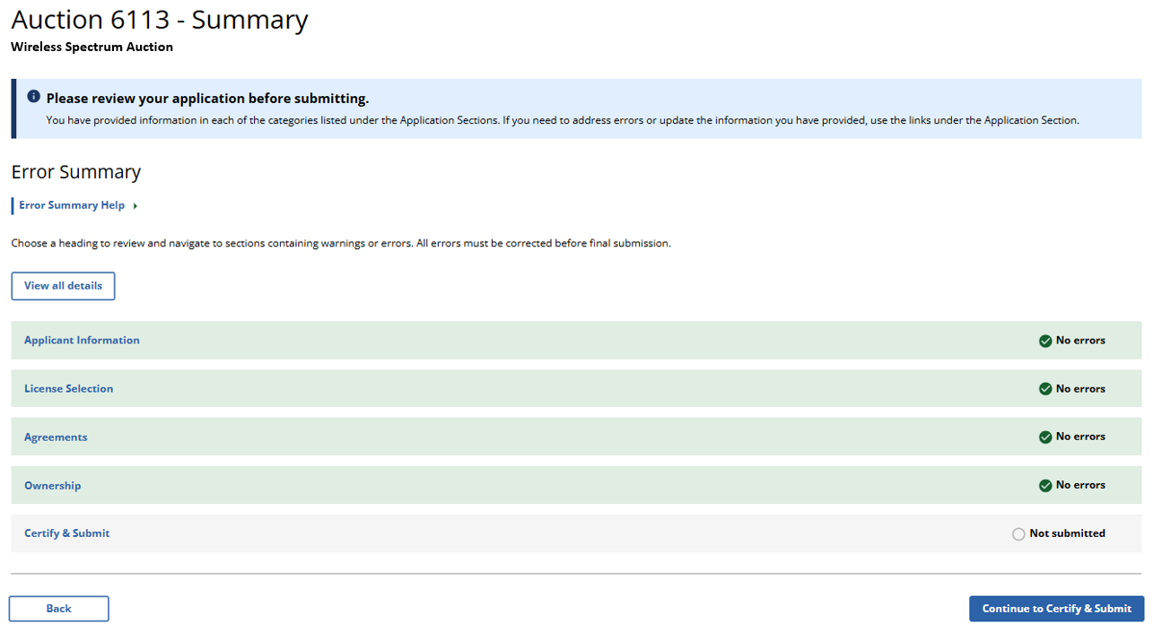

(Error Summary With Errors Detected as Displayed to Broadcast Table Service Auction Applicants)
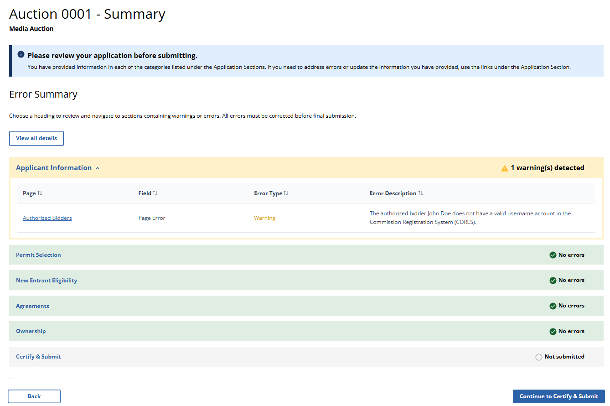

(Error Summary With No Errors Detected as Displayed to Broadcast Table Service Auction Applicants)
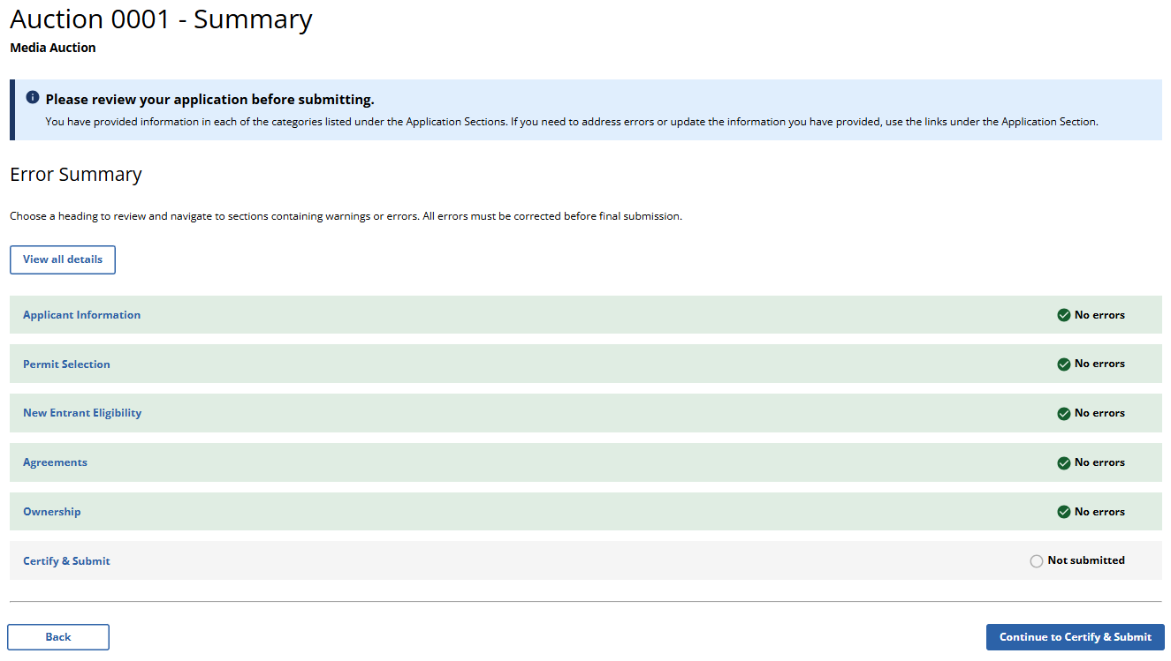

(Error Summary With Errors Detected as Displayed to Broadcast Non-Table Service Auction Applicants)
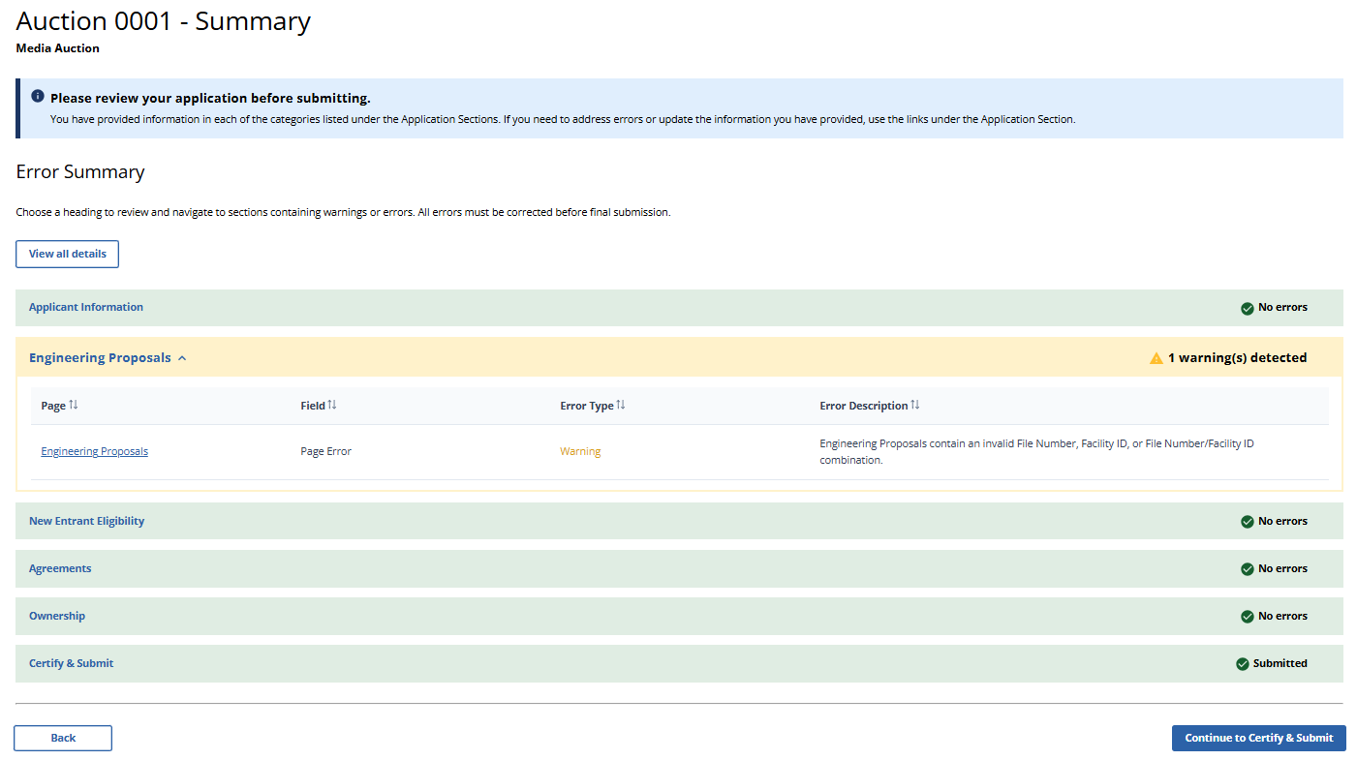

(Error Summary With No Errors Detected as Displayed to Broadcast Non-Table Service Auction Applicants)
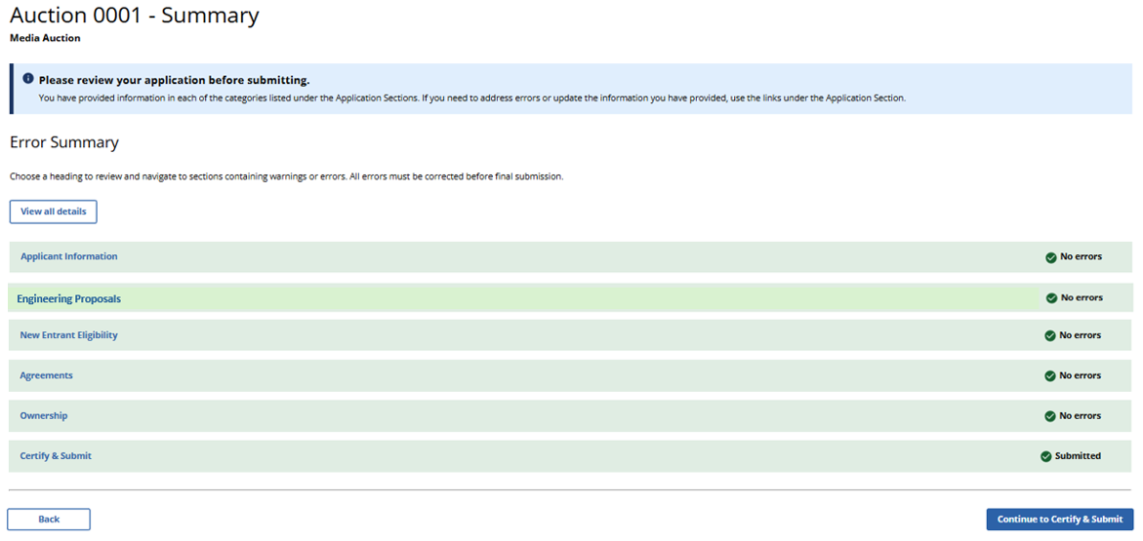

(Displayed to Wireless and Broadcast Auction Applicants)
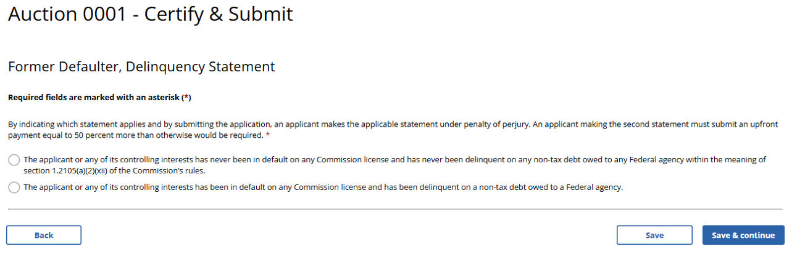

(Displayed to Wireless Auction Applicants in Non-Spectrum Act Auctions)
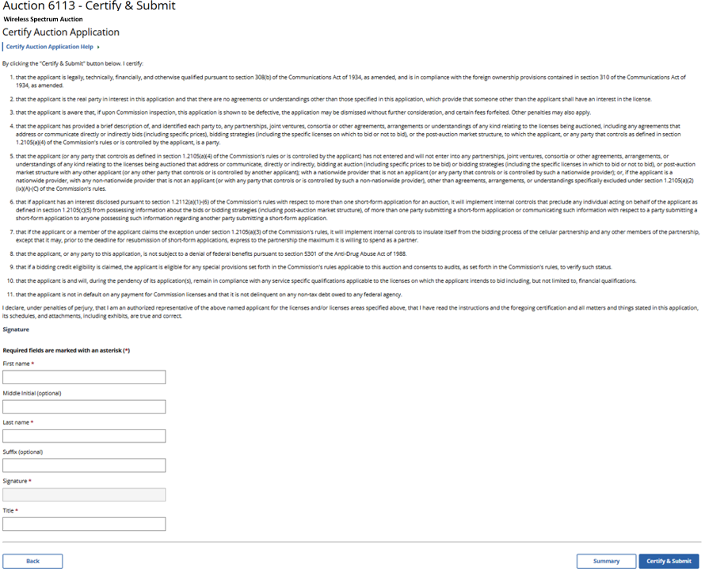
(Displayed to Broadcast Auction Applicants in Non-Spectrum Act Auctions)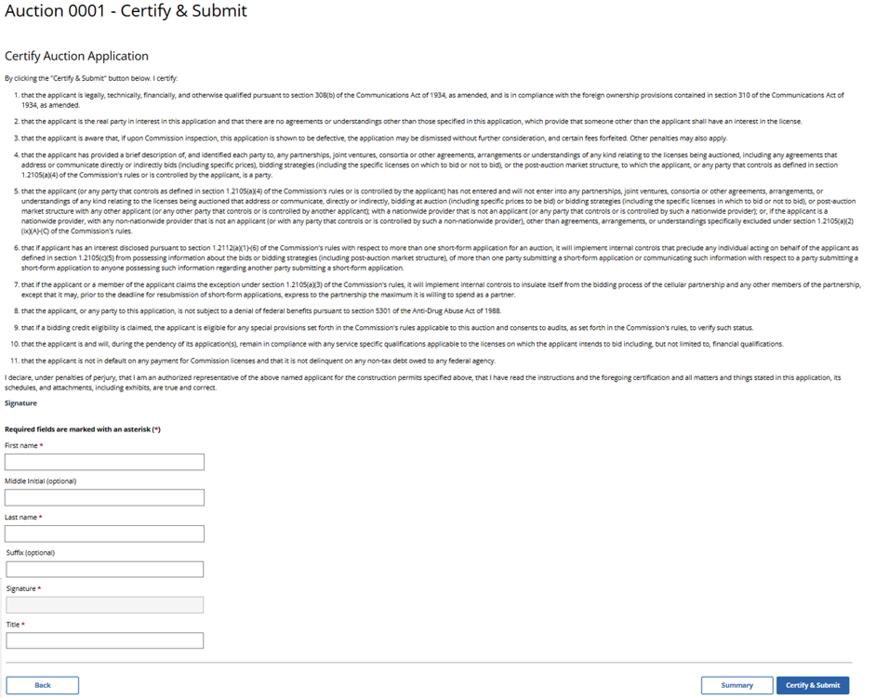
(Displayed to Wireless Auction Applicants in Auctions Required or Authorized by the 2012 Spectrum Act)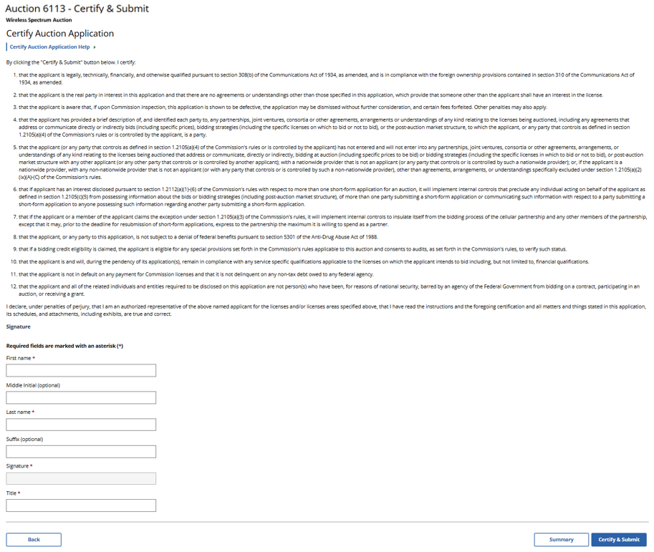
(Displayed to Broadcast Auction Applicants in Auctions Required or Authorized by the 2012 Spectrum Act)

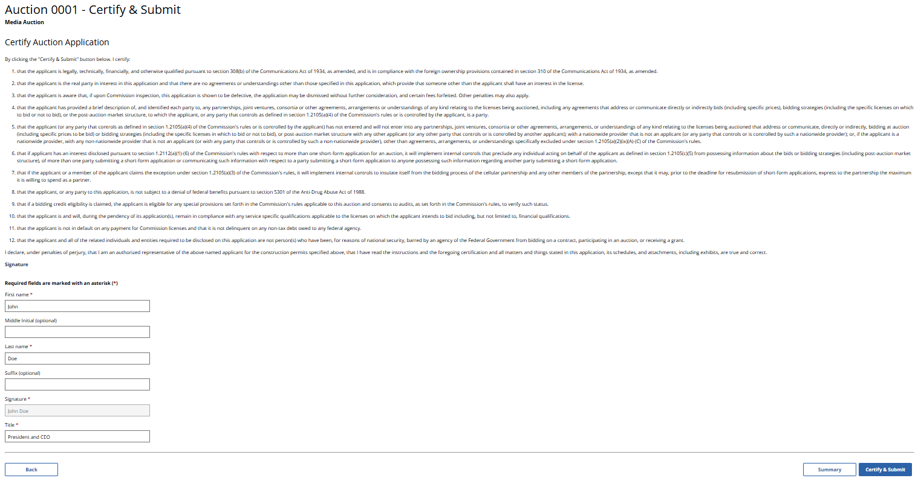

(Displayed to Auction 110 Applicants)
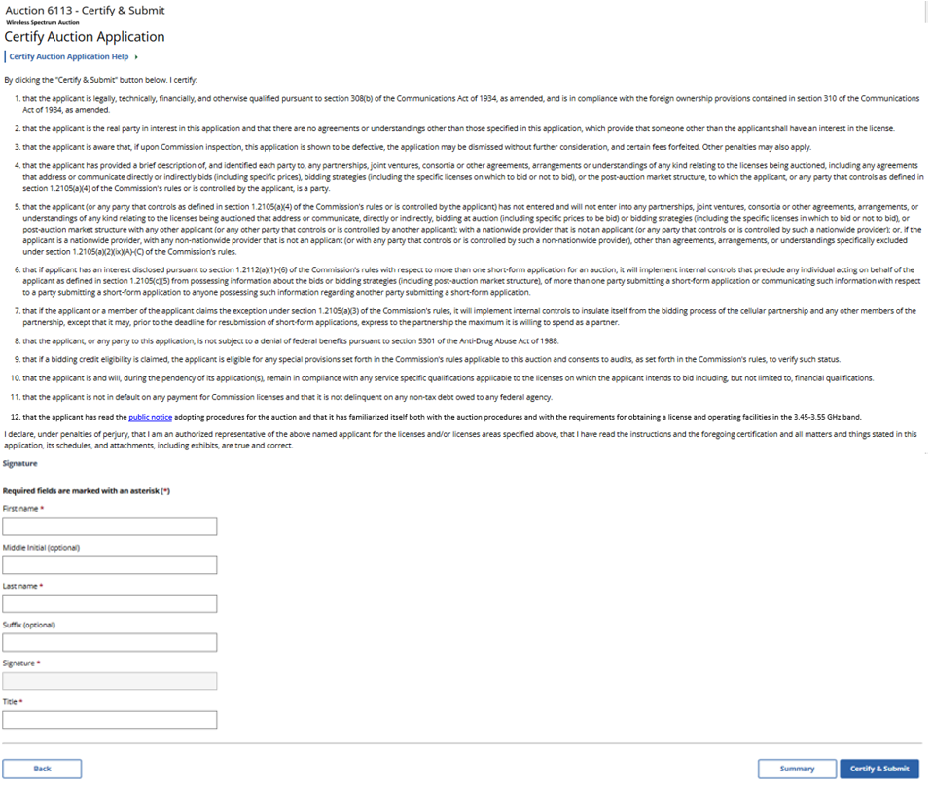
(Displayed to Auction 112 Applicants)
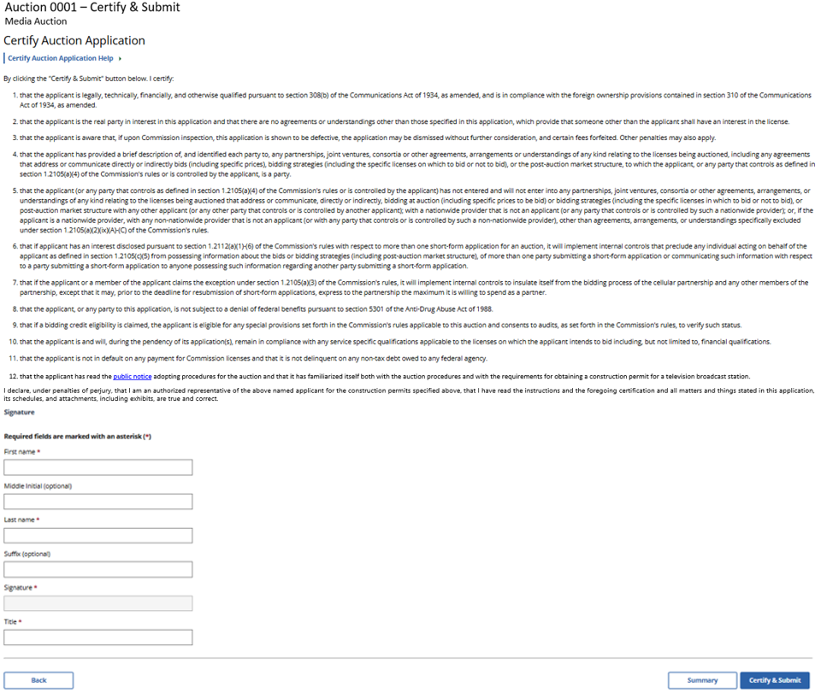
(Displayed to Auction 108 Applicants)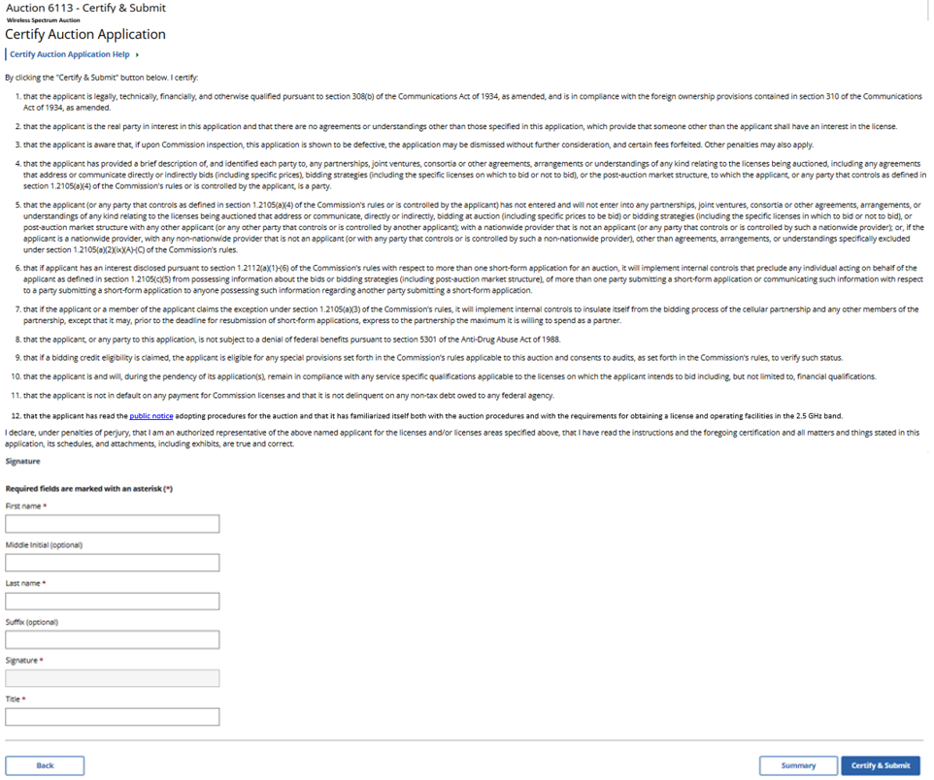
(Displayed to Auction 113 Applicants)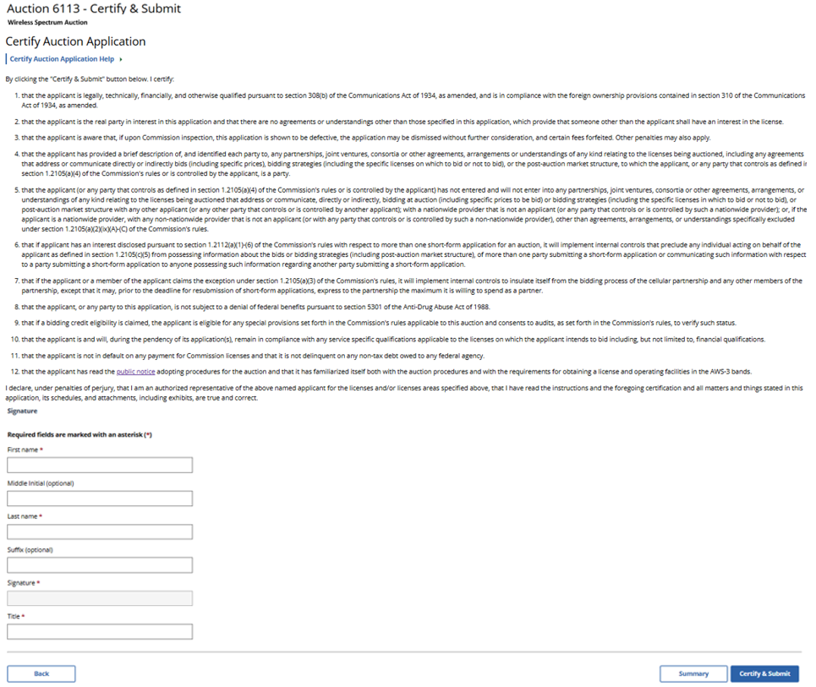
(Displayed to Wireless and Broadcast Auction Applicants)
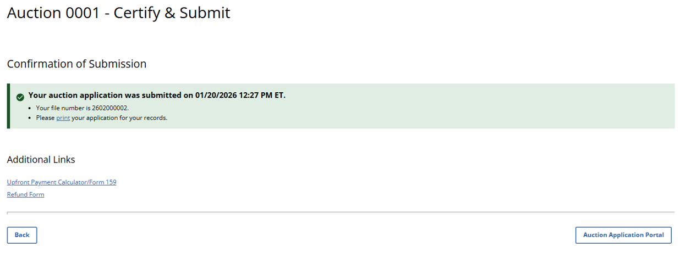
(Displayed Only to Wireless Auction Applicants)
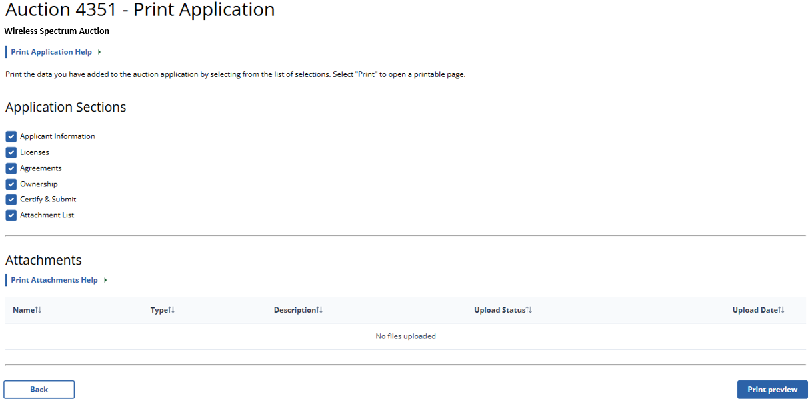

(Displayed Only to Broadcast Table Service Auction Applicants)
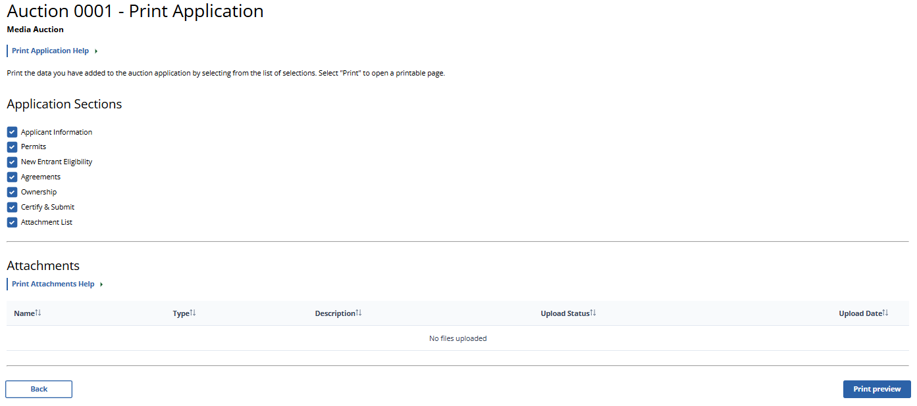

(Displayed Only to Broadcast Non-Table Service Auction Applicants)
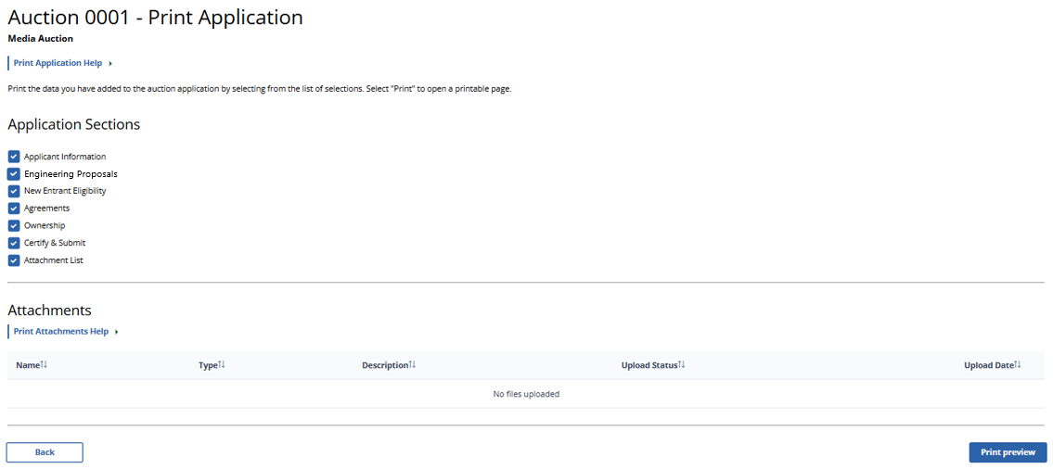

(Withdraw Auction Application – Displayed to Wireless and Broadcast Auction Applicants)
