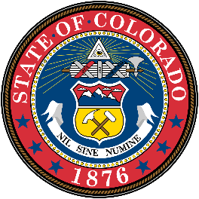
Office of the State Auditor
Kerri L. Hunter, CPA, CFE
State Auditor

Date: February 17, 2026
To: NASACT
Re: GSA Federal Audit Clearinghouse, Proposed revisions to Data Collection Form
VIA EMAIL: adrane@nasact.org
The Colorado Office of the State Auditor has reviewed the General Services Administration’s revisions to the existing Data Collection form. We believe that overall, the proposed revisions will strengthen the audit reporting process and meet the objectives of the Single Audit Act and Uniform Guidance. Based on our review, the estimated burden appears reasonable, provided that the proposed revisions remain “optional” and do not introduce additional mandatory reporting requirements. We appreciate the opportunity to comment on the proposed revisions to Data Collection Form.

