Enhancing Data-driven Disease Detection in Newborns (ED3N)

Type of ICR – EXTENSION
OMB Control No. 0920-1391, Exp. Date 04/30/2026
  - Supporting Statement Part A –
  - Justification

  - Program Official/Project Officer:
  - Title: Carla Cuthbert, PhD, FACMG
  - Phone: 770-488-7571
  - Email: ccuthbert@cdc.gov
  - Fax: 770-488-4520

  - Date: December 10, 2025
Table of Contents
A.1. Circumstances Making the Collection of Information Necessary 3
A.2. Purpose and Use of the Information Collection 7
A.3. Use of Improved Information Technology and Burden Reduction 8
A.4. Efforts to Identify Duplication and Use of Similar Information 8
A.5. Impact on Small Businesses or Other Small Entities 9
A.6. Consequences of Collecting the Information Less Frequently 9
A.7. Special Circumstances Relating to the Guidelines of 5 CFR 1320.5 10
A.8. Comments in Response to the Federal Register Notice and Efforts to Consult Outside the Agency 10
A.9. Explanation of Any Payment or Gift to Respondents 11
A.10. Protection of the Privacy and Confidentiality of Information Provided by Respondents 11
A.11. Institutional Review Board (IRB) and Justification for Sensitive Questions 12
A.12. Estimates of Annualized Burden Hours and Costs 13
A.13. Estimates of Other Total Annual Cost Burden to Respondents and Record Keepers 14
A.14. Annualized Cost to the Federal Government 14
A.15. Explanation for Program Changes or Adjustments 15
A.16. Plans for Tabulation and Publication and Project Time Schedule 15
A.17. Reason(s) Display of OMB Expiration Date is Inappropriate 15
A.18. Exceptions to Certification for Paperwork Reduction Act Submissions 15

List of Attachments
- Authorizing Legislation
- Federal Register Notice
  - PDF of the published 60-day FRN
  - Public Comments (CSV format, PDF format)
  - Public comments responses
- Elements of Burden
  - ED3N Initial Set-up
  - ED3N Ongoing Data Transfer Elements
- Privacy and Data Sharing
  - Privacy Impact Assessment
  - Data Sharing Agreement Approved Template
- CDC Research/Non-research Determination
Part A. Justification
Goal of the study: Address analytic and post-analytic challenges in newborn screening and improve program ability to assess disease risk.
Intended use of the resulting data: Data will be used to create analytic solutions to help newborn screening programs identify at-risk newborns and curate and interpret molecular variants found through newborn screening.
Methods to be used to collect: Data will be collected using electronic data transfer of retrospective and prospective cohorts of newborns
Subpopulation to be studied: Newborns in the United States who have had newborn screening
How data will be analyzed: A number of analytical approaches will be applied, including but not limited to: machine learning, regression, other normalization techniques (e.g., MoM, Z-Score), as well as variant curation and interpretation models.

A.1. Circumstances Making the Collection of Information Necessary

The Centers for Disease Control and Prevention (CDC) requests a three-year OMB approval for an extension of an existing information collection (ICR) for the national newborn screening data platform titled “Enhancing Data-driven Disease Detection in Newborns (ED3N), under OMB Control Number 0920-1391”.
Newborn Screening (NBS) is a state-administered public health program that aims to detect newborns at-risk for congenital, but treatable diseases before the onset of symptoms. Current NBS panels include metabolic, endocrine, immunological, respiratory, lysosomal, blood, and other genetic diseases that affect children. The Newborn Screening and Molecular Biology Branch (NSMBB) has the only laboratory in the world devoted to ensuring the accuracy of newborn screening (NBS) tests in every state and more than 78 countries. NSMBB supports NBS programs by conducting research, developing methods, and performing analyses by using complex, state-of-the-art molecular and biochemical techniques for identifying risk factors for diseases of public health importance. Both NSMBB and state NBS programs are experiencing increased data analytic challenges associated with continued expansion of the number of newborn screening diseases, increased complexity of disease detection, and difficulties in correlating disease markers with disease risk. Further, the addition of late-onset diseases to NBS panels necessitates a better way to routinely capture clinical information and outcomes so that NBS programs can fully appreciate the spectrum of disease they are detecting.
In consultation with US NBS programs and relevant Federal Partners, the NSMBB has done a significant amount of development work on ED3N to address these analytic and post-analytic challenges and promote sharing of molecular, biochemical, and clinical information amongst NBS partners. The goal of this platform is to provide a robust risk assessment and data analytic solution for the use by NBS programs across the country while aligning with the CDC’s Data Modernization Initiative. The information shared will help NSMBB and newborn screening partners be better equipped to assess disease risk and will help harmonize approaches for disease detection in newborns in the United States. Given the rarity of newborn screening diseases, it is imperative that data be collected and analyzed at a national level in order to glean useful insights and trend analyses. The NSMBB is best-suited to oversee this work given its role in providing technical assistance to NBS programs nationally and internationally.
Numerous studies along with presentations by NBS programs suggest that gaps in programmatic resources and expertise are hampering the ability to perform more complex data analytics resulting in low positive predictive values for a number of conditions (which subsequently results in higher false positive and negative rates and downstream burden to families and the medical system),. Smaller-scale work on the use of post-analytical tools such as machine learning algorithms have shown that incorporation of these elements into newborn screening can improve detection rates, while reducing false positives. These studies, however, have been limited to single sites and have not been integrated into the daily workflow of high-throughput NBS programs.
Without this project, NBS programs will continue to be unable to keep up with the increasing complexity and future demands of screening, perpetuating inequities in screening across the nation.
The NSMBB has worked heavily with NBS programs throughout the country to develop requirements and needs around the ED3N platform. Needs and potential solutions within ED3N coming out of these consultations can be seen in the Figures below. Additionally, the NSMBB has met with several federal partners who also participate in NBS activities to achieve buy-in and support for the ED3N project. Additional information can be found on the ED3N website.
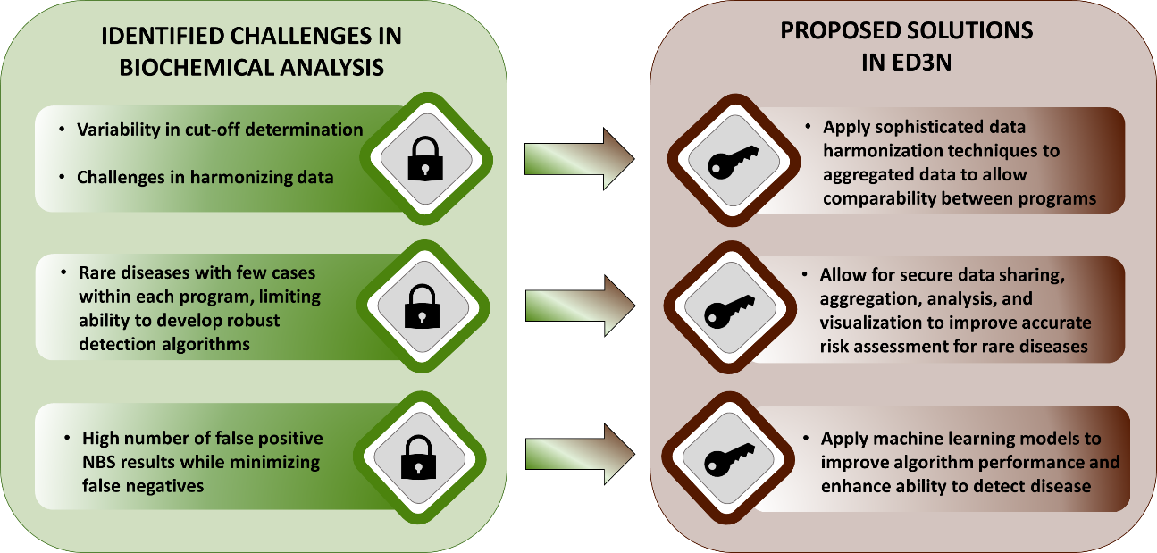

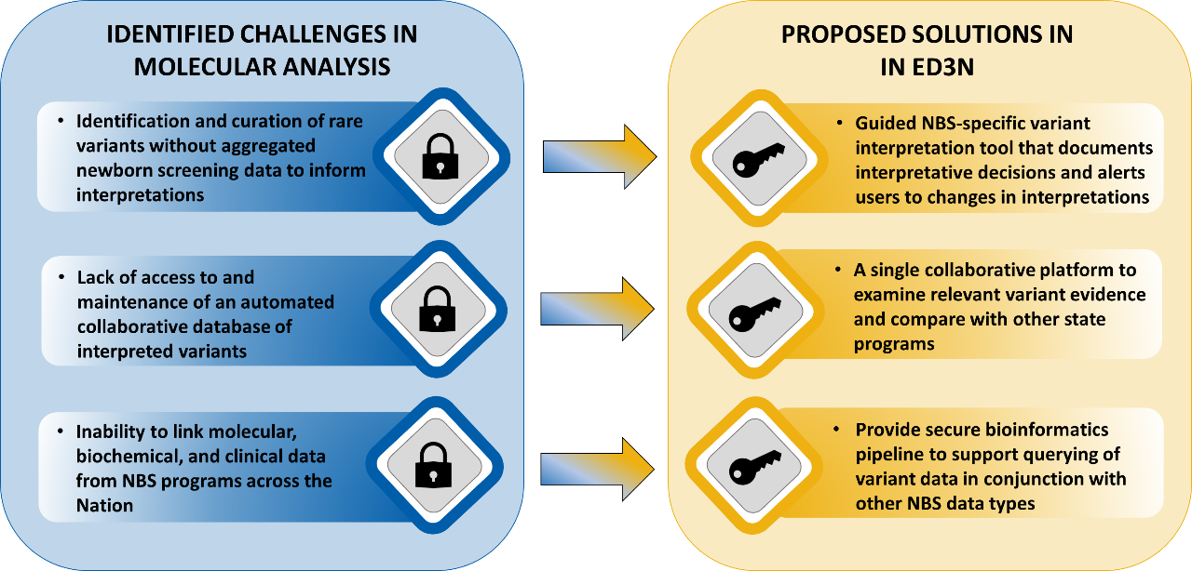

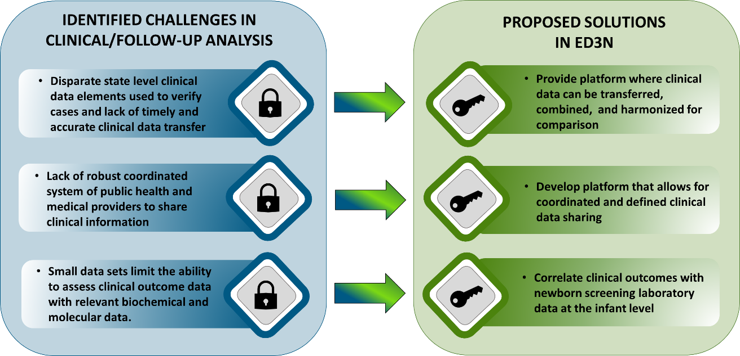

Through the Newborn Screening Saves Lives Reauthorization Act (NBSSLA; Attachment 1), Congress directed the CDC to provide the coordination of surveillance and quality assurance activities for newborn screening programs. This Act indicates that these activities should be achieved through standardized electronic data collection and reporting and promoting data sharing.
Specifically, the NBSSLA states:

The Secretary, acting through the Director of the Centers for Disease Control and Prevention, and taking into consideration the expertise of the Advisory Committee on Heritable Disorders in Newborns and Children established under section 1111, shall provide for the coordination of national surveillance activities, including—

“(1) standardizing data collection and reporting through the use of electronic and other forms of health records to achieve real-time data for tracking and monitoring the newborn screening system, from the initial positive screen through diagnosis and long-term care management; and

“(2) by promoting data sharing linkages between State newborn screening programs and State-based birth defects and developmental disabilities surveillance programs to help families connect with services to assist in evaluating long-term outcomes.”.

A supplemental budget increase for the Newborn Screening and Molecular Biology Branch (Attachment 1) brought with it associated expectations, including providing more robust support to NBS programs in interpretating screening results, minimizing false positive results, and monitoring screening performance overall. Specifications for the data collection include infant demographics, parental demographics, specimen information, molecular results, biochemical results, disease clinical information (Attachment 3b).

A.2. Purpose and Use of the Information Collection

The NSMBB provides a wide range of technical assistance to NBS programs, including developing analytical methods, producing quality control and reference materials, and provides education and site visits. This technical assistance helps ensure that NBS programs are producing the highest quality results using the latest technology. ED3N will extend current technical assistance offerings by providing more robust risk assessment and clinical decision support directly to NBS program with authorized access to the platform. Interpretation of results is a key and vital component to successful screening and ED3N will be a new value-add to NBS programs in the post-testing space.

The purpose of this information collection is program evaluation and improvement.

- Positive needs and impact of this information collection include better equipping newborn screening partners to accurately identify and appropriately act on newborns at-risk for life-threatening diseases.
- The negative consequence of not having this information is reduced ability for newborn screening partners to identify and appropriately act on diseases in newborns. This can lead to poor screening performance, delayed diagnoses of affected infants, and lawsuits.

The ED3N project is funded through CDC NSMBB program funds at around $1 million annually. This project is intended to be long-term with ongoing and sustainable use by NBS programs and ultimately incorporated into their daily screening workflows. Information collected will be used by NBS programs and relevant specialty healthcare providers as well as by the CDC’s NSMBB. Prior to use, NBS programs will complete Data Sharing Agreements and CDC Secure Access Management Systems (SAMS) Authorization for access. Data will be used at various periodicity but may be as often as daily so NBS programs can utilize the algorithmic solutions for their daily testing and interpretation needs. Programs may choose to use this platform and data on a near real-time basis and incorporate it into its daily patient reporting. Alternatively, programs may choose to use this platform on a less frequent basis as part of a quality control check. The platform is customizable to the needs of the NBS program and is flexible to changing needs within a single program and across the community. The CDC will utilize this data to meet its requirements for providing technical assistance and interpretative solutions to NBS programs. These uses will include refinement of machine learning models, new biomarker discovery, and programmatic trend analysis.

A.3. Use of Improved Information Technology and Burden Reduction

The ED3N Project relies heavily on information technology for collection and transfer of requested data in order to minimize burden to NBS programs. All data elements requested for ED3N are housed in each NBS program’s Laboratory Information Management System (LIMS) and/or Case Management System (CMS) and will be sent via electronic data transfer using either a flat file upload or direct transfer mechanisms such as Health Level Seven International (HL7) 2.5 or Fast Healthcare Interoperability Resources (FHIR). A common data model has been generated that builds upon the data elements listed in Attachment 3b. The common data model describes the appropriate standard terminology codes (e.g., LOINC, SNOMED, etc.) associated with each data element as well as the associated HL7 segments that should be used for the purpose of data transfer.
Implementation of this electronic data transfer process will take some time up front as the data messages are developed, tested, and validated.
Once the transfer functionality is implemented, 100% of participating NBS programs should easily be able to either run a canned report or query to pull the data from their LIMS/CMS and upload it into ED3N or the data should be pulled and sent automatically from the LIMS/CMS when using direct transfer mechanisms. Because of the nature of the data request involving numerous data elements (including complex analyte values) combined with the near real-time data collection need to meet the needs of the NBS program and CDC, electronic exchange of data will be the only data collection mechanism suggested. Additionally, because the data will be utilized to create and train machine learning algorithms for clinical decision support, the enhanced data integrity afforded by electronic data collection is preferred over manual methods.

A.4. Efforts to Identify Duplication and Use of Similar Information

Examination of and discussion with other CDC and HHS (i.e., HRSA and NIH) programs indicate that this type of NBS data collection is not occurring anywhere else. Relevant areas within CDC (e.g., NCBDDD) and within HRSA and NIH have been notified of the ED3N project and support the data elements proposed as this data collection may be beneficial for furthering cross-government collaborations.
An Alternatives Analysis (inclusive of exhaustive searches, presentations at national meetings, consultations with other agencies and organizations, and discussions with fewer than 9 NBS programs) was conducted and there are currently no fully overlapping data/information collections being conducted that meet the range of data elements or purpose of ED3N.
There are two identified partially overlapping data collections. However, discussions with NBS programs have indicated that the breadth of ED3N’s offering make it a preferred data collection option. The existing data collections do not provide a complete NBS patient picture, and thus, do not meet the identified needs of NBS programs. The data from these data collections also do not include all data elements.

A.5. Impact on Small Businesses or Other Small Entities

It is not expected that this data collection will impact small businesses or other small entities. Data collection is targeted to NBS programs and large tertiary care centers (typically large children’s hospitals or academic medical centers).

A.6. Consequences of Collecting the Information Less Frequently

The data collectors will transmit data at various periodicities depending on their desired use of the ED3N platform. This may be done daily, weekly, monthly, or quarterly.

For NBS programs who wish to utilize the ED3N platform as part of their daily testing and interpretation workflow, data will be transmitted to ED3N in near real-time on a daily basis. This frequency is needed so that they can utilize the algorithmic outputs of ED3N in order to make risk assessments in a timely manner. Due to the nature of the diseases being screened for by NBS programs, results must be available as quickly as possible – usually within 5 to 7 days of birth, and thus, data collection would need to occur each day that the NBS program is operational (typically 6 to 7 days a week). As such, if the data is collected/transmitted less frequently, the NBS programs would not be able to utilize ED3N to improve risk detection of newborns and help prevent morbidity and mortality.

For NBS programs who wish to utilize the ED3N platform as a quality check or supplemental tool to their current testing and interpretation processes, data can be transmitted less frequently. Discussions with NBS programs about using ED3N in this capacity suggest that data would likely be transmitted monthly or quarterly in these cases.

There are no technical or legal obstacles to reducing burden. As stated in Section A3, information technology will be heavily utilized to offset any burden of submitting information at the above frequencies.

A.7. Special Circumstances Relating to the Guidelines of 5 CFR 1320.5

The following special circumstance(s) apply to this information collection. We are requesting the following:
- Respondents will report information to the agency more often than quarterly.
  - For NBS programs who wish to utilize the ED3N platform as part of their daily testing and interpretation workflow, data will be transmitted to ED3N in near real-time on a daily basis. This frequency is needed so that they can utilize the algorithmic outputs of ED3N in order to make risk assessments in a timely manner. Due to the nature of the diseases being screened for by NBS programs, results must be available as quickly as possible – usually within 5 to 7 days of birth, and thus, data collection would need to occur each day that the NBS program is operational (typically 6 to 7 days a week). As such, if the data is collected/transmitted less frequently, the NBS programs would not be able to utilize ED3N to improve risk detection of newborns and help prevent morbidity and mortality.

  - For NBS programs who wish to utilize the ED3N platform as a quality check or supplemental tool to their current testing and interpretation processes, data can be transmitted less frequently. Discussions with NBS programs about using ED3N in this capacity suggest that data would likely be transmitted monthly or quarterly in these cases.

A.8. Comments in Response to the Federal Register Notice and Efforts to Consult Outside the Agency

- A 60-day Federal Register Notice was published in the Federal Register on July 18, 2025, Vol. 90, No. 136, pp. 33961-62 (Attachment 2a).
- CDC received 1,135 comment(s). CDC reviewed each comment and provided responses. Comments were largely in regards to activities out-of-scope to the proposed data collection and project. CDC made no changes to the ICR (Attachments 2b and 2c).
- Several people outside the agency have reviewed and consulted on the availability of data, frequency of collection, the clarity of instructions and record keeping, disclosure, or reporting format (if any), and on the data elements to be recorded, disclosed, or reported. These consultations remain ongoing with select NBS programs who are also participating in pilot and beta testing.

Table 1. 2023-2025 CDC External Consultations

Name | Title | Affiliation
NBS Programs
Anne Comeau, PhD | Deputy Director | New England NBS Program
Pranesh Chakraborty, MD | Medical Director | Ontario NBS Program
Joseph Orsini, PhD | Director | Wadsworth Center
Michele Caggana, ScD | Deputy Director | Wadsworth Center
Susan Tanksley, PhD | Deputy Director | Texas Public Health Laboratory
Jelili Ojodu, MPH | Director | APHL
Adrienne Manning | Division Director | Connecticut NBS program

Example Table 2. 2023-2025 Consultations with CDC/HRSA/NIH

Name | Title | Affiliation
Melissa Parisi, MD, PhD | Chief | NICHD
Debi Sarkar, MPH | Branch Chief | HRSA
Karen Remley | Director | NCBDDD

A.9. Explanation of Any Payment or Gift to Respondents

There is no plan to offer incentives or any payment to respondents.

A.10. Protection of the Privacy and Confidentiality of Information Provided by Respondents

Activities in ED3N do not involve the collection of directly individually identifiable information (IIF). The CDC Chief Privacy Officer reviewed this submission and determined that the Privacy Act does not apply on May 24, 2024. Approval for a Privacy Impact Assessment (PIA) was co-signed by the HHS Senior Agency Official for Privacy on January 03, 2025 (Attachment 4a).

Data collected through the ED3N project will not include directly identifiable data (i.e., names, addresses, etc.) from NBS programs or clinical sites. However, some individuals could be identified indirectly through combinations of variables, so information shared could be potentially identifiable. In addition to potentially identifiable data, these data are considered sensitive. All data collected will be at the infant level, including any associated data such as parent demographics. Use of non-identifiable unique identifiers will be associated with newborn records in the system and will be used as the primary key for maintaining linkage of data for a given newborn in the system. Names will not be collected as part of ED3N.
Each NBS program staff members will have their own user logins where they can only access individual-level information related to their own program; they will not have access to individual-level data from other NBS programs. Access to all submitted data will be managed by CDC’s Secure Access Management System (SAMS), which performs credential and identity authentication and grants authorization to access the ED3N application. SAMS and the CDC ED3N Data Administrator shall collaborate to manage all data access, remove users that no longer require access, and track all attempts to access ED3N in collaboration with the CDC Cloud Task Force. The CDC Cloud Task Force, which resides in CDC’s Office of the Chief Information Officer (OCIO), in part provides assistance to programs with migrating information technology (IT) applications and systems to cloud environments to promote increased scalability, flexibility, collaboration, and access to the latest tools and technologies. ED3N defines user roles with specific data access rights and functionality and has the ability to limit user data access using these roles.
The following IIF Categories apply to this information collection (Attachments 3a & 3b):
☒ Date of Birth
☒ Medical Information and Notes
☒ Medical Records Numbers

The Data Use Agreement template is in Attachment 4b and describes the data/information collection procedures, roles, and data ownership and stewardship. In addition, the respondent will be informed that his or her response is voluntary.
The system’s Security Plan defines the process for handling security incidents. The system’s team and the Office of the Chief Information Security Officer (OCISO) share the responsibilities for event monitoring and incident response. The team will direct reports of suspicious security or adverse privacy-related events to the NCEH Information Systems Security officer (ISSO), CDC helpdesk, or to the CDC Incident Response team. The CDC OCISO reports to the HHS Secure One Communications Center, which reports incidents to US-CERT as appropriate.

A.11. Institutional Review Board (IRB) and Justification for Sensitive Questions

As this project falls under public health surveillance, IRB review has been deemed not required (Attachment 5). If research is proposed using the ED3N data, CDC commits that a separate project review and determination will be conducted.

A.12. Estimates of Annualized Burden Hours and Costs

The estimated annualized burden hours were determined as follows. There are 53 domestic NBS programs in the United States. A “respondent” refers to a single NBS program.
Given that data submission will ultimately be accomplished through automatic electronic data transfer, each respondent’s burden hours were split into two estimates: 1) the one-time need to set-up, test, and implement the electronic data transfer mechanism (Attachment 3a); and 2) the ongoing daily automatic electronic data transfer occurring after initial set-up (Attachment 3b). Initial set-up time burden was estimated based on analysis of similar data transfer projects embarked upon by NBS programs as well as brief discussions with NBS Program Laboratory Information Management System vendors. The one-time burden to set-up the data transfer interface was estimated to be 40 hours total, annualized to 14 hours per year per respondent. Ongoing daily data submission burden was estimated assuming automatic transfer thereafter, 365 days per year. The estimated burden per response is one minute. The total estimated annualized burden is 1,064 hours.

Estimated Annualized Burden (Hours)
Type of Respondent | Form Name | No. of Respondents | No. of Responses per Respondent | Average Burden per Response (in hours) | Total Burden Hours
Newborn Screening Programs | Set-up of ED3N Data Elements | 53 | 1 | 14 | 742
Newborn Screening Programs | Ongoing transfer of ED3N Data Elements | 53 | 365 | 1/60 | 322
Total |  |  |  |  | 1,064

Estimates for the average hourly wage for respondents are based on the May 2024 Department of Labor (DOL) National Occupational Employment and Wage Estimates United States website for laboratory technician occupations and computer and information technicians. Based on DOL data, average hourly wages of $31.41 (Clinical Laboratory Technologists and Technicians (bls.gov)) and $90.38 (Computer and Information System Managers (bls.gov)) were utilized and is estimated for the respondents. The total estimated annualized burden cost is $75,549.14. The following table shows estimated burden cost information.

Estimated Annualized Burden Costs
Type of Respondent | Form Name | Total Burden Hours | Hourly Wage Rate | Total Respondent Costs
Newborn Screening Programs | Set-up of ED3N Data Elements | 742 | $90.38 | $67,061.96
Newborn Screening Programs | Ongoing transfer of ED3N Data Elements | 322 | $31.41 | $10,114.02
Total |  | 1,064 |  | $77,176

A.13. Estimates of Other Total Annual Cost Burden to Respondents and Record Keepers

Data transfer mechanisms already in existence with public health laboratories will be utilized and CDC will utilize existing funding and Data Modernization Initiative expertise and work to offset any additional costs that may be incurred for initial set-up.

A.14. Annualized Cost to the Federal Government

The ED3N project is funded through CDC NSMBB program funds at around $1 million annually. Currently, all development costs are through the use of contracts as indicated in the cost below.
Expense Type | Expense Explanation | Cost (dollars)
ED3N Development and Oversight
Direct Cost to the Federal Government | Contracted Staff, including: Bioinformatician, Genetic Counselor, Developers, and Program Management | $1,000,000

Costs were estimated by determining the contract staff time to develop the capability for electronic data transfer, provide TA, and generate algorithms and reports based on the expected number of participating programs and include operational overhead such as program management.

A.15. Explanation for Program Changes or Adjustments

This is an extension of a data/information collection.

A.16. Plans for Tabulation and Publication and Project Time Schedule

Publication of this data would only occur at the aggregate level. The data is used to improve screening and interpretation performance of newborn screening programs. However, publications on processes and comparison of performance metrics may occur. This project will be ongoing with no planned end date as the purpose is for this to be available as a tool to newborn screening programs for the foreseeable future.

A.17. Reason(s) Display of OMB Expiration Date is Inappropriate

The display of the OMB expiration date is appropriate.

A.18. Exceptions to Certification for Paperwork Reduction Act Submissions

There are no exceptions to the certification. These activities comply with the requirements in 5 CFR 1320.9.

Bailey DB Jr, Porter KA, Andrews SM, Raspa M, Gwaltney AY, Peay HL. Expert Evaluation of Strategies to Modernize Newborn Screening in the United States. JAMA Netw Open. 2021;4(12):e2140998.
Watson MS, Lloyd-Puryear MA, Howell RR. The Progress and Future of US Newborn Screening. Int J Neonatal Screen. 2022 Jul 18;8(3):41.

