Attachment 2c. Public comment and CDC response
The following comment was submitted on February 4, 2026.
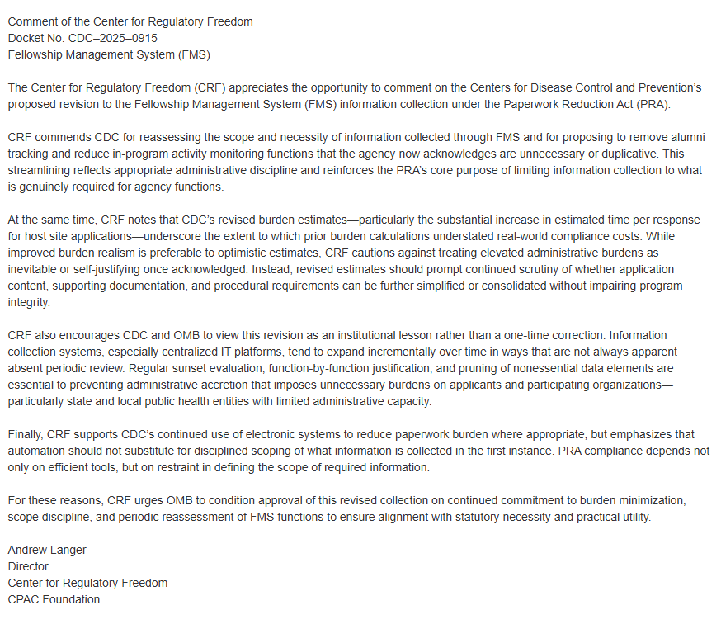
CDC provided the following response.
