mySSA: Initiate Earnings Correction
Office of Management & Budget (OMB) Screen Package



Table of Contents
1. Screen Package Document Version Information 3
2. Initiate Earnings Corrections: Happy Path 4
2.1 My Social Security Plan and Prepare Landing page 4
2.1.2. Initiate Earnings Corrections Privacy Act Statement 5
2.2 Earnings Record – Home 6
2.2.1. Earnings Record Home - Additional Information shown 7
2.2.3. Earnings Record Home – ‘Not Yet Recorded’ Help Link: Lag year - Light box 8
2.3. Earnings record with details 9
2.3.1. Detailed Earnings: Multiple employers on record 10
2.3.2. Detailed Earnings: Single employer on record 11
2.3.3. Detailed Earnings: No earnings on record 11
2.3.4. Detailed Earnings: Earnings on record but no details available 12
2.3.5. Detailed Earnings: Lag year - no details available 12
2.3.6. Detailed Earnings: Lag year – Details on record 12
2.3.7. Detailed Earnings: Self-Employment earnings 13
2.3.8. Detailed Earnings: Self-employment and regular wages on record 13
2.3.9. Detailed Earnings Modals for Quarterly Earnings Prior to 1978 14
2.3.9.2. Detailed Earnings: Quarterly details for single employer (1978 & prior) 15
2.3.9.3. Detailed Earnings: Details unavailable for 1978 (& prior years) 16
2.3.9.4. Detailed Earnings: Quarterly self-employment 1978 (& prior) 16
2.3.9.5. Detailed Earnings: Quarterly self-employment and wages 1978 (& prior) 17
2.3.9.6 Detailed Earnings: Details Unavailable for 1937-1950 18
2.3.10. Detailed Earnings: Shown information for years containing Self-employment Earnings 18
2.3.10. Detailed Earnings Screen: ‘How do I request a correction of Self-Employment Earnings?’ modal 19
2.4. Earnings Corrections Overview 20
2.4.1. Earnings Correction Overview: ‘Current and prior year’ - Info modal 21
2.4.2. Earnings Correction Overview: 'What kind of evidence can I provide?' modal 21
2.4.3. Earnings Corrections Overview: ‘Correcting Self-Employment Earnings…’ modal 22
2.5. Earnings corrections: Confirm your information Screen 23
2.5.1. Confirm Your Information Screen (Other Name & SSN) 24
2.6. Earnings Corrections request: Select a year 25
2.6.1. Select a year: 'Don't see the year you’re looking for?' modal 25
2.6.2. Select a year: Multiple employers variant 26
2.6.3. Select a year: One employer variant 27
2.6.4. Select a year: No earnings variant 28
2.6.4.1. Select a year: No earnings variant - 'Why would earnings be missing?' modal 29
2.6.6. Select year: Quarterly details variant (1978 & prior) 30
2.7. Correction Details Screens 31
2.7.1. Correction Details: Correct existing earnings 31
2.7.1.1. Correction Details: Correct existing earnings: Correction type drop down 31
2.7.1.2. Correction Details: Edit existing - incorrect wages 32
2.7.1.3. Correction Details: Edit existing: did not work for employer 33
2.7.1.4. Correction Details: Edit existing: Other correction type 34
2.7.6. Correction Details: Add missing earnings 35
2.7.6.1. Add missing earnings: employment type drop down 36
2.7.5. Correction Details: Help & hidden information 36
2.7.5.1. Correction Details: ‘What kind of evidence can I provide?' Modal 36
2.7.5.2. Correction Details: Edit existing - upload help: 'Having trouble?' modal 36
2.7.5.3. Correction Details: 'How do I find this?' help modal 37
2.7.5.4. Correction Details: Other Evidence option 37
2.8. Review & submit/ add another Screen 38
2.8.1. Review & submit/ add another Screen: no evidence warning variant 39
2.8.1.1. Review & submit/ add another Screen: (Warning Variant) ‘What kind of evidence can I provide?’ modal 40
2.9. Earnings Record Correction Request receipt 41
3. mySSA Earnings Corrections: Return screen Variants 42
3.1. Confirm your information Screen (Return/Edit Variant) 42
3.2. Select a Year Screen (Return Variant) 43
3.2.1. Select a Year Screen (Return Variant): Pending correction 44
3.2.3. Select a Year Screen (Return Variant): Pending Correction: No Existing Earnings on record 45
3.2.5. Select a Year Screen (Return Variant): Pending Correction: Multiple Corrections Pending 46
3.2.5.1. Select a Year Screen (Return Variant): Pending: delete confirmation 47
3.3. Correction Details (Return/ Edit Variants) 48
3.3.1. Correction Details (Update Existing Earnings): Return Variant 48
3.3.1.1. Correction Details (Update Existing): Edit Variant 49
3.3.2. Correction Details (Add missing): Return Variant 50
3.3.2.1. Correction Details (Add missing): Edit Variant 51
3.4. Review and Submit / add another (Return Variant – Multiple corrections) 52
3.4.1. Review and Submit (Return Variant: Maximum corrections) 53
4. Initiate Earnings Corrections: Error Variants 54
4.1. Confirm Your Information Screen (Error Variant) 54
4.3. Correction Details (Error Variants) 55
4.3.1. Correction Details: Add missing (Error Variant) 55
4.3.2. Correction Details: Error – File upload size 56
4.3.3. Correction Details: Error – Unsupported File Format 56
4.4. Review and Submit (Review and add another screen) - Error Variant 57
4.5. Earnings Correction Request: System Unavailable Error Message 58
5. Initiate Earnings Corrections: Other Screen Variants 59
5.1. Earnings Record Home: No access to Earnings Corrections Variant 59
5.2. Waiting Indicator modal 60

Screen Package Document Version Information
The first release of this document as a project deliverable is numbered 1.0.
Subsequent revisions are numbered 1.1, 1.2, 1.3, etc. Content revisions are listed below with corresponding page numbers.
Version  Number | Date | Content Revisions | Page  # | Revised by
1.0 | July 17, 2020 | Author of initial release and all revisions – Caroline Galbraith, William Hanke, Robert Summerville |  | N/A
1.1 | April 4, 2023 | Privacy Act Statement | 5 | Camille Dailey
1.2 | Apr 5, 2023 | Updated screen shots |  | Karen Haynes

2. Initiate Earnings Corrections: Happy Path

My Social Security Plan and Prepare Landing page
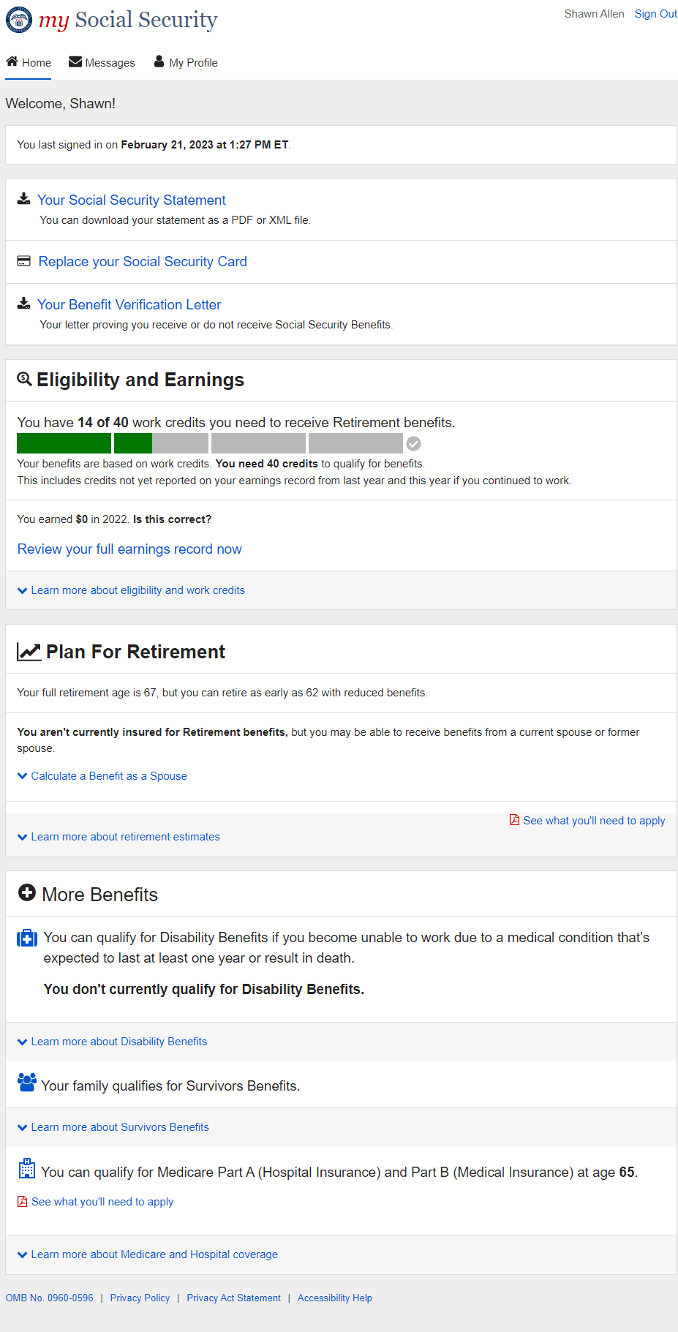

2.1.2. Initiate Earnings Corrections Privacy Act Statement
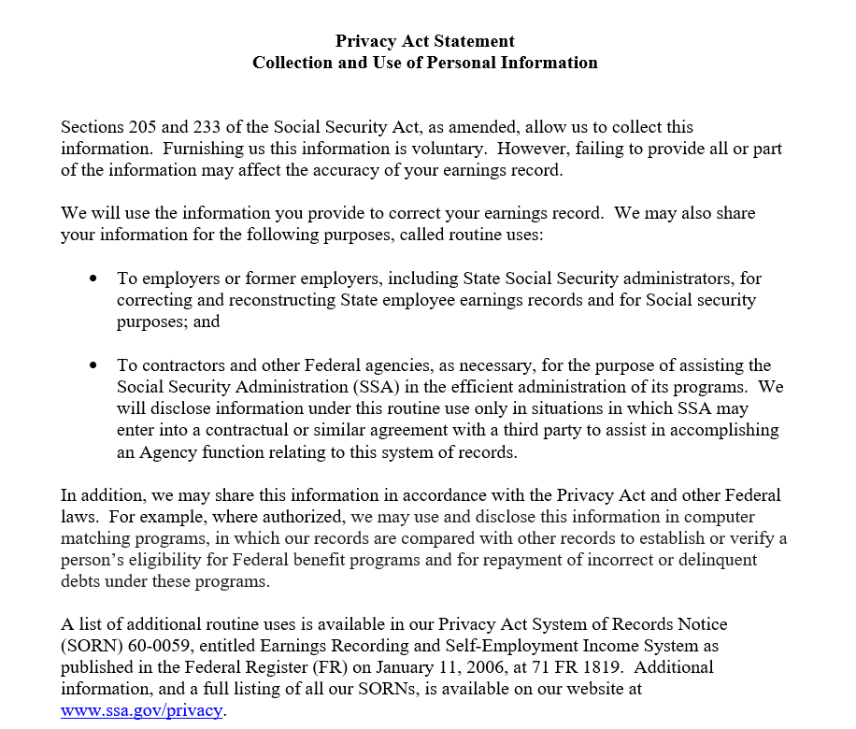

Paperwork Reduction Act Statement - This information collection meets the requirements of 44 U.S.C. § 3507, as amended by section 2 of the Paperwork Reduction Act of 1995. You do not need to answer these questions unless we display a valid Office of Management and Budget (OMB) control number. We estimate that it will take about 15 minutes to read the instructions, gather the facts, and answer the questions. Send only comments regarding this burden estimate or any other aspect of this collection, including suggestions for reducing this burden to: SSA, 6401 Security Blvd, Baltimore, MD 21235-6401

Earnings Record – Home
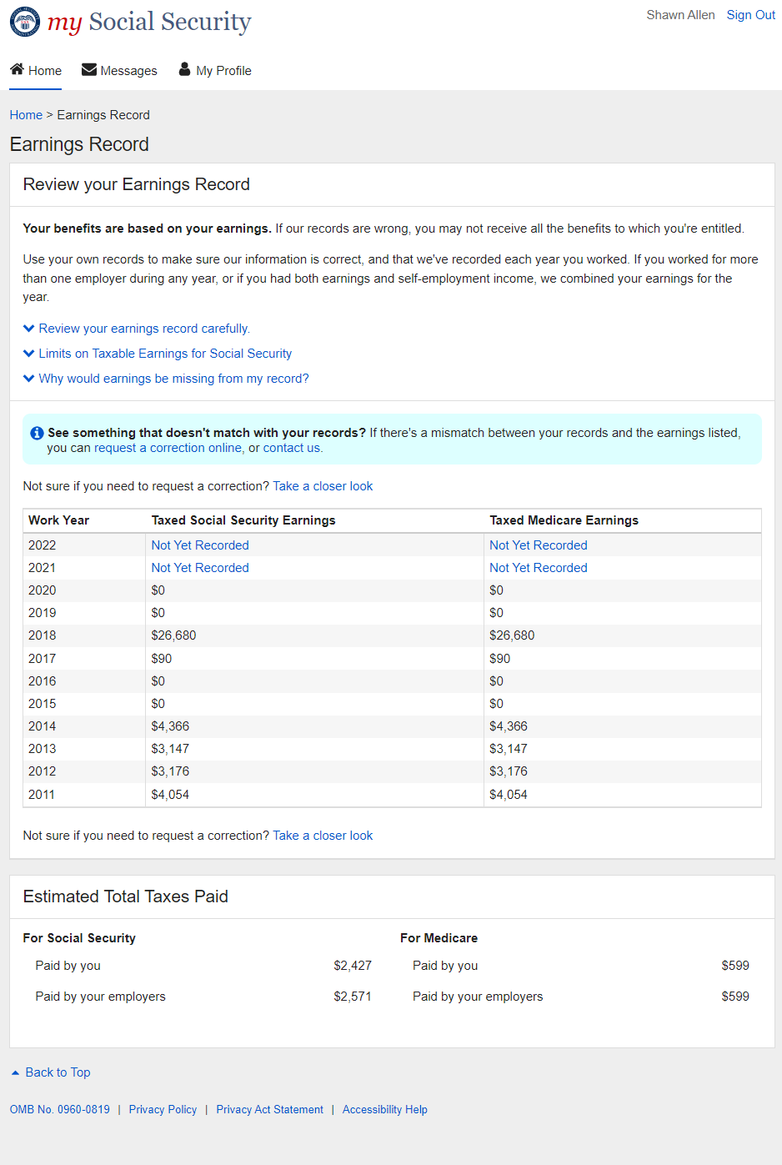

2.2.1. Earnings Record Home - Additional Information shown
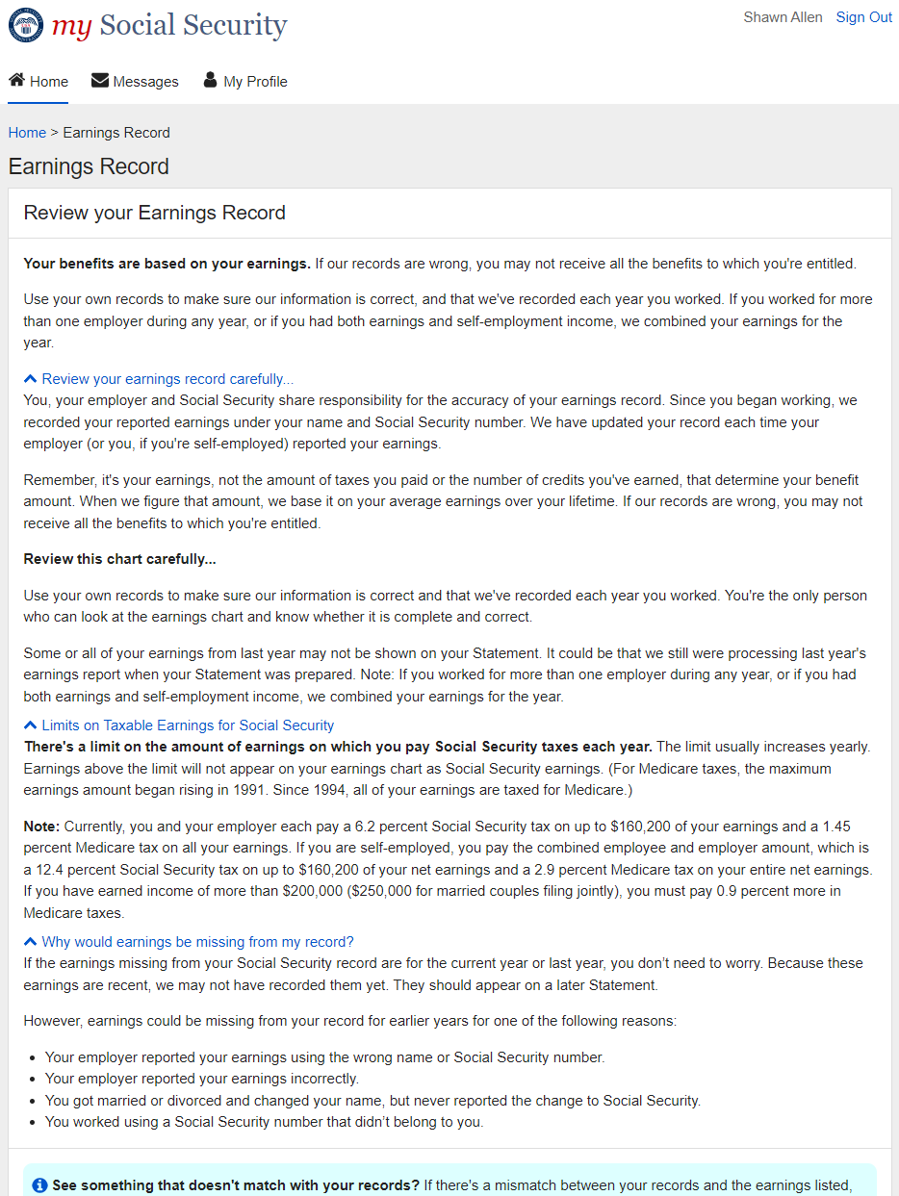

Earnings Record Home – ‘Not Yet Recorded’ Help Link: Lag year - Light box
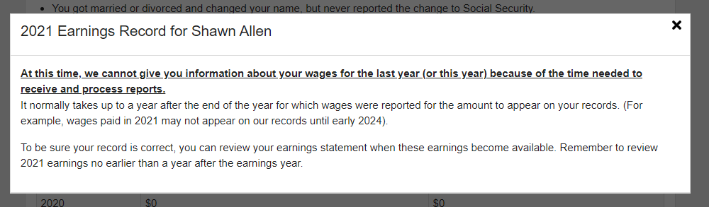

Earnings record with details
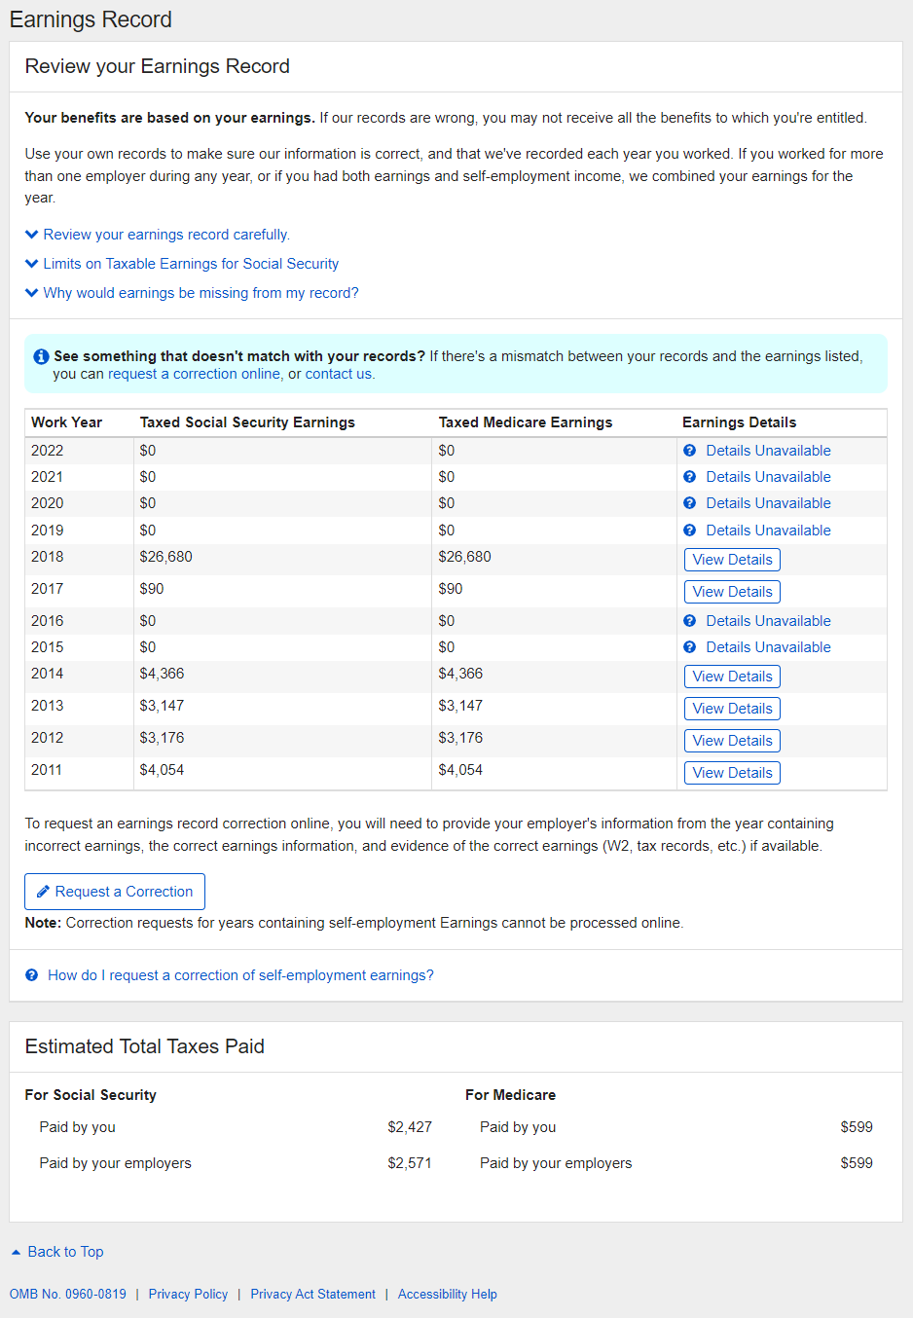

2.3.1. Detailed Earnings: Multiple employers on record
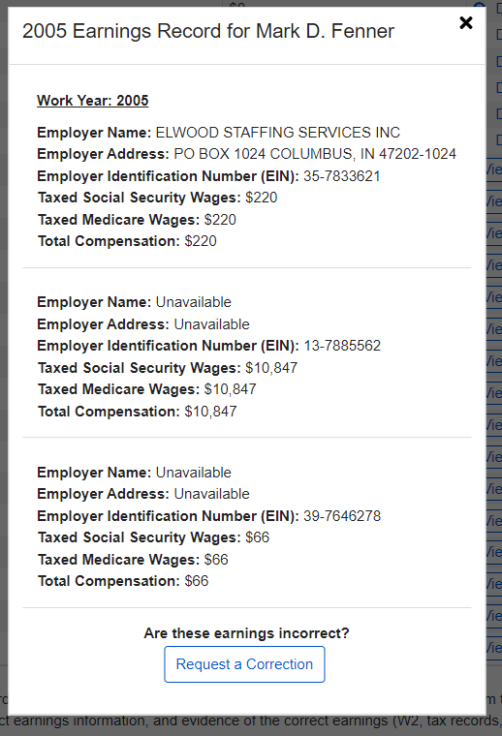

2.3.2. Detailed Earnings: Single employer on record
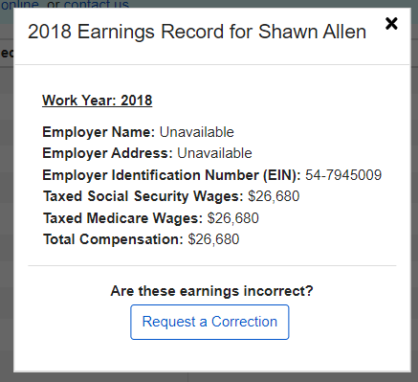

2.3.3. Detailed Earnings: No earnings on record
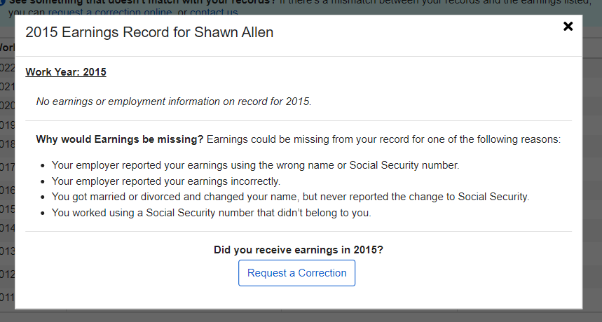

2.3.4. Detailed Earnings: Earnings on record but no details available
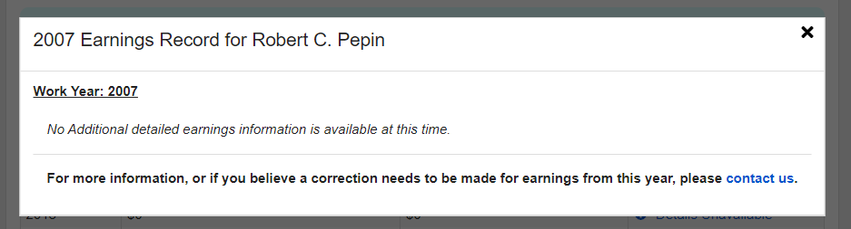

2.3.5. Detailed Earnings: Lag year - no details available
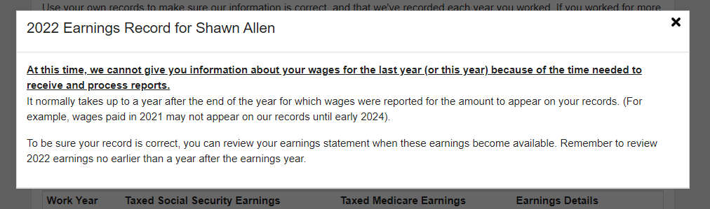

2.3.6. Detailed Earnings: Lag year – Details on record
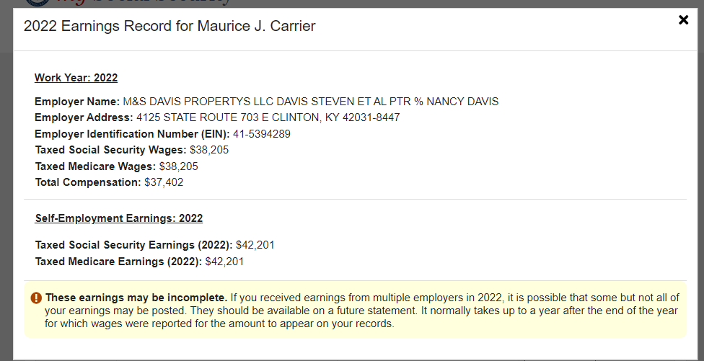

2.3.7. Detailed Earnings: Self-Employment earnings
(Expanded information for ‘What will I need to request a self-employment correction?’ in 2.3.10.)
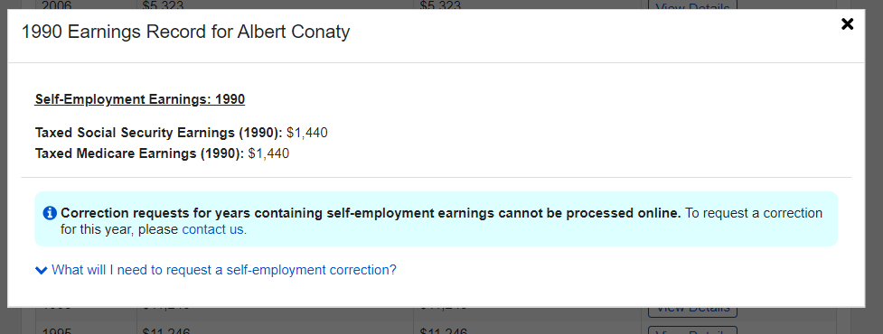

2.3.8. Detailed Earnings: Self-employment and regular wages on record
(Expanded information for ‘What will I need to request a self-employment correction?’ in 2.3.10.)
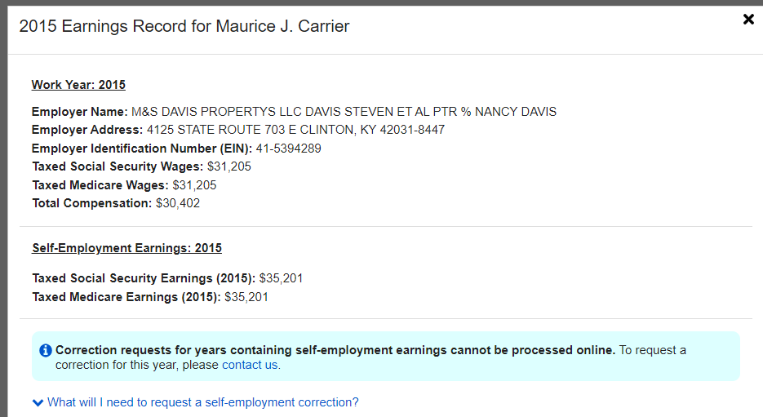

2.3.9. Detailed Earnings Modals for Quarterly Earnings Prior to 1978
2.3.9.1. Detailed Earnings: Quarterly details for 1978 (& prior years) 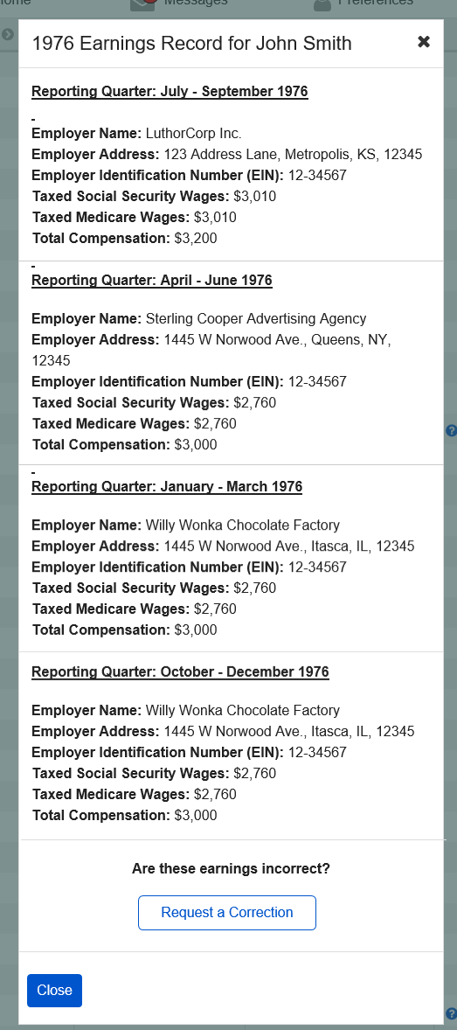

2.3.9.2. Detailed Earnings: Quarterly details for single employer (1978 & prior)
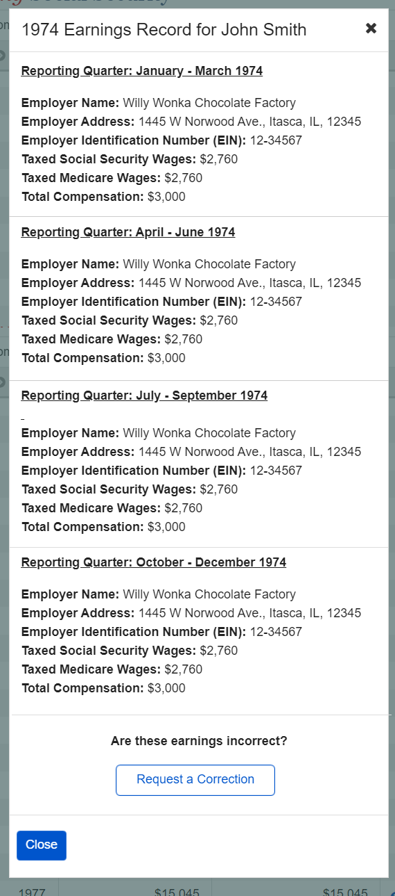

2.3.9.3. Detailed Earnings: Details unavailable for 1978 (& prior years)
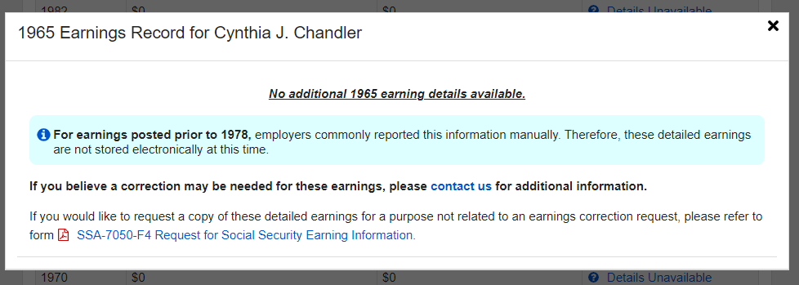

2.3.9.4. Detailed Earnings: Quarterly self-employment 1978 (& prior)
(Expanded information for ‘What will I need to request a self-employment correction?’ in 2.3.10.)
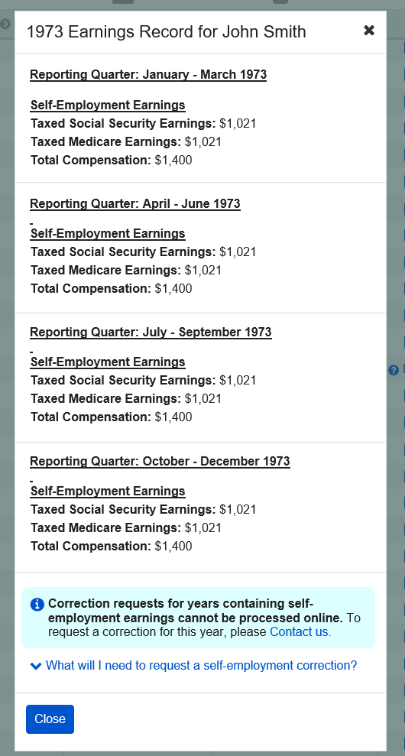

2.3.9.5. Detailed Earnings: Quarterly self-employment and wages 1978 (& prior)
(Expanded information for ‘What will I need to request a self-employment correction?’ in 2.3.10.)

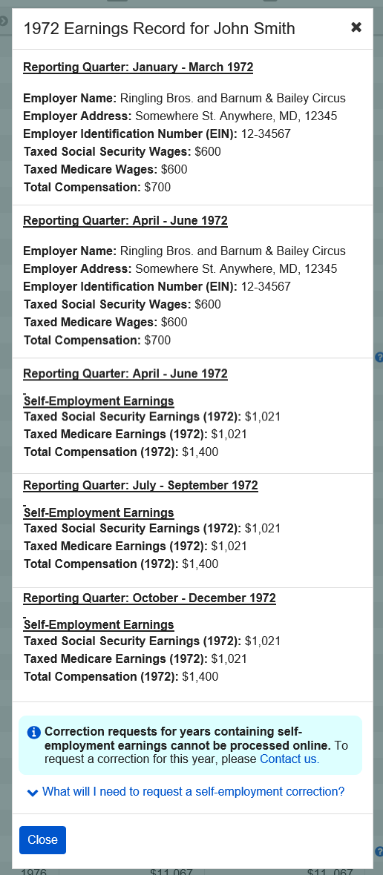

2.3.9.6 Detailed Earnings: Details Unavailable for 1937-1950
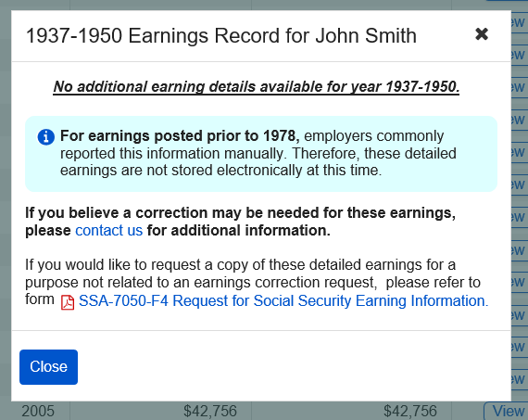

2.3.10. Detailed Earnings: Shown information for years containing Self-employment Earnings
(Appears on 2.3.8.; 2.3.7; 2.3.9.4.; 2.3.9.5)
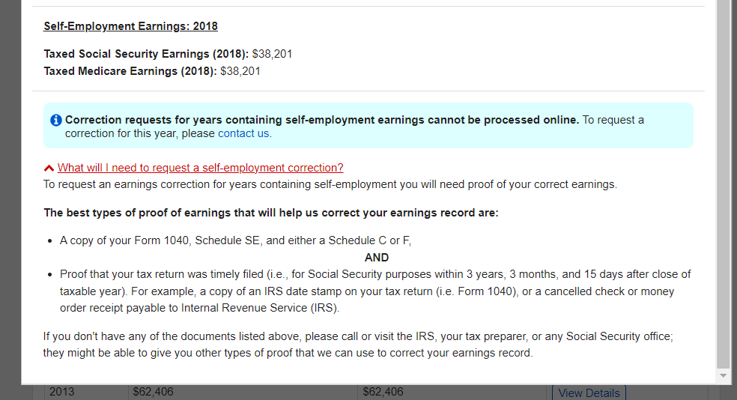

2.3.10. Detailed Earnings Screen: ‘How do I request a correction of Self-Employment Earnings?’ modal
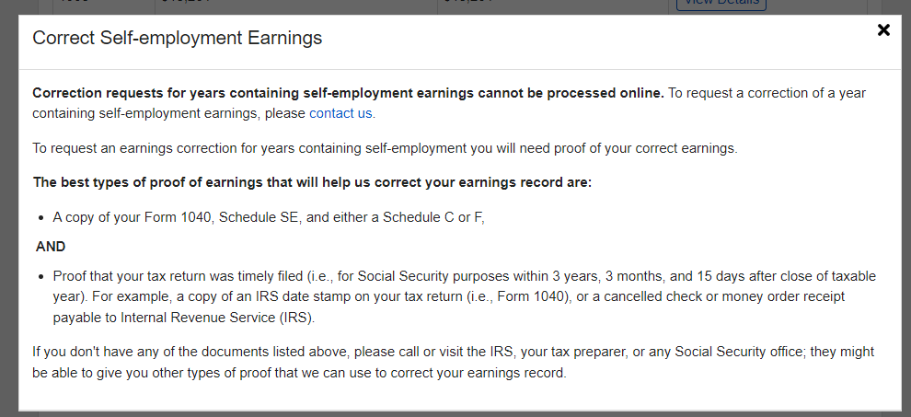

Earnings Corrections Overview
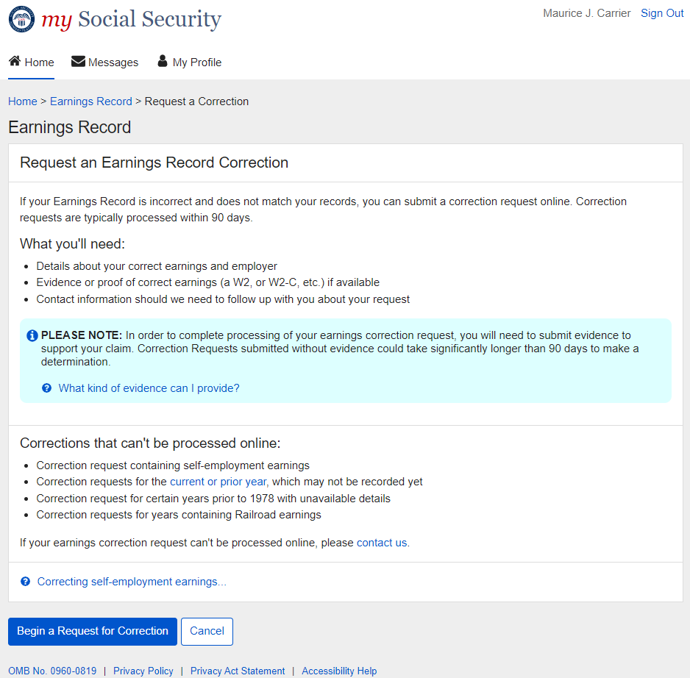

Earnings Correction Overview: ‘Current and prior year’ - Info modal
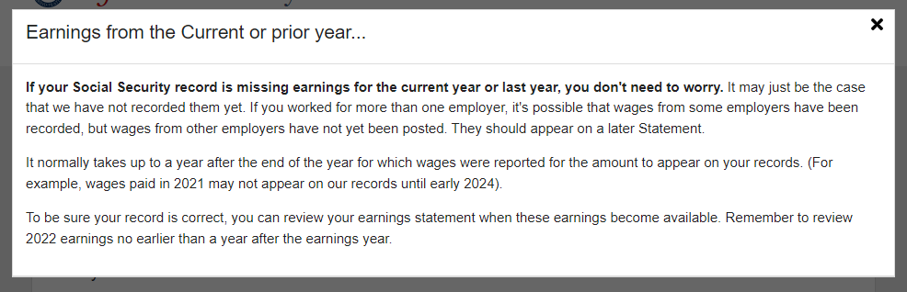

Earnings Correction Overview: 'What kind of evidence can I provide?' modal

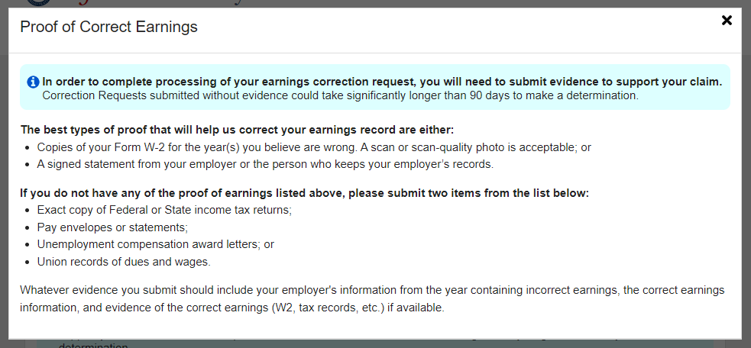

Earnings Corrections Overview: ‘Correcting Self-Employment Earnings…’ modal
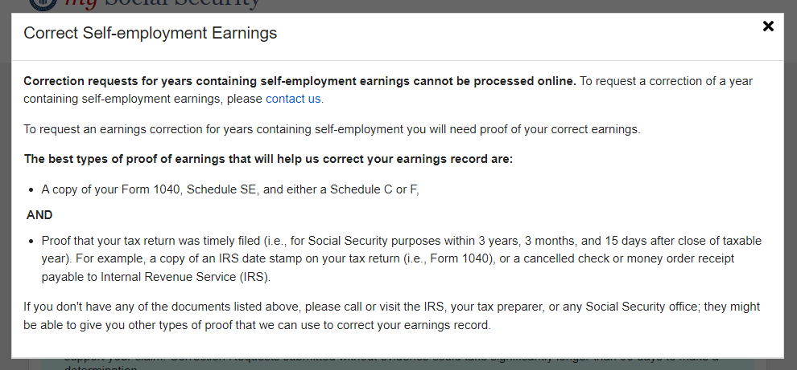

Earnings corrections: Confirm your information Screen
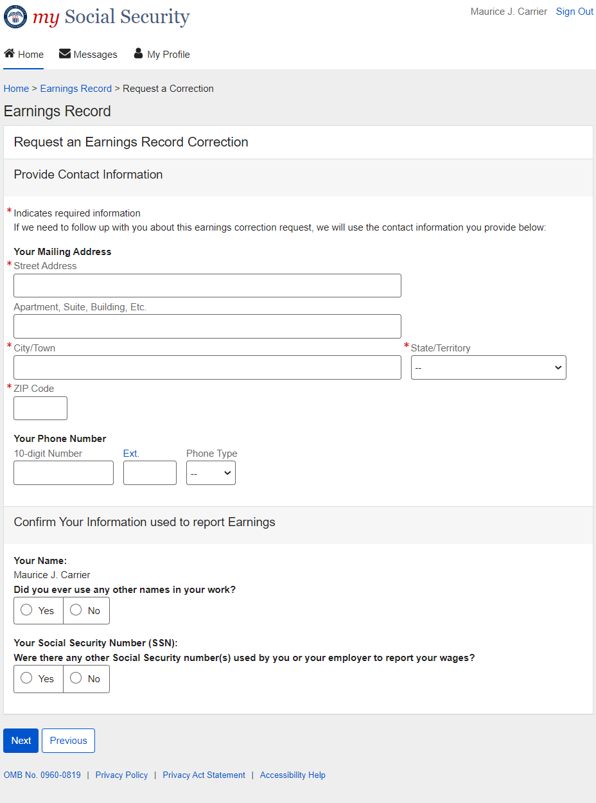

Confirm Your Information Screen (Other Name & SSN)
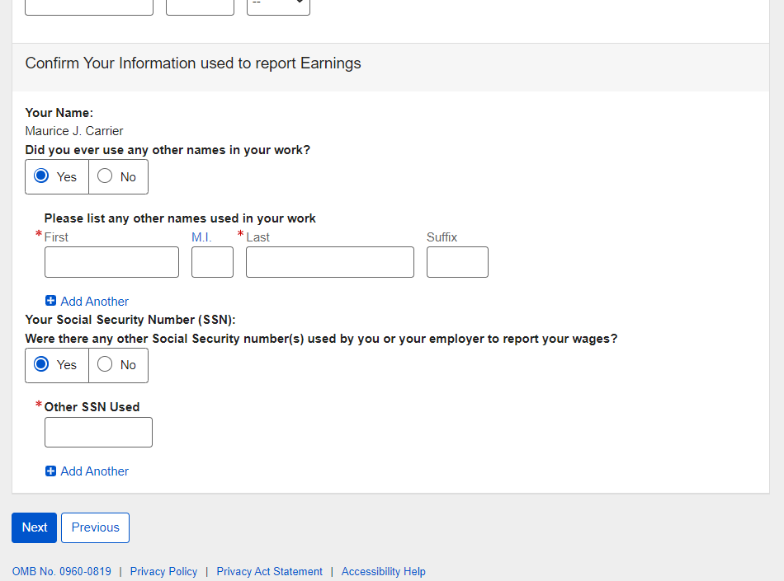

Earnings Corrections request: Select a year
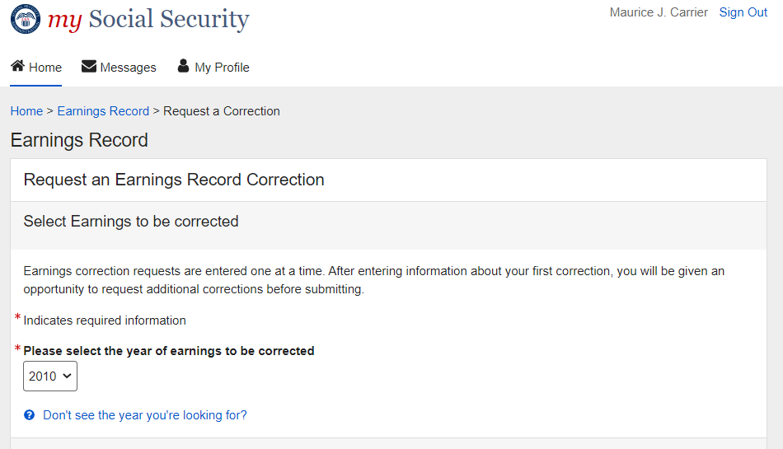

2.6.1. Select a year: 'Don't see the year you’re looking for?' modal
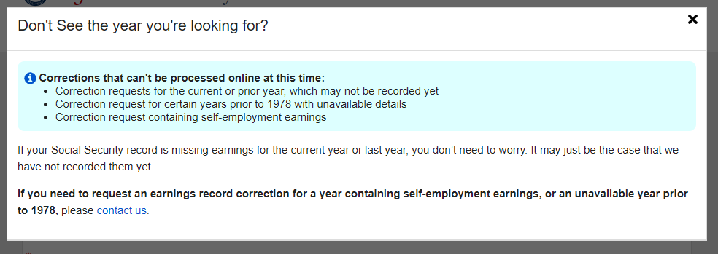

2.6.2. Select a year: Multiple employers variant
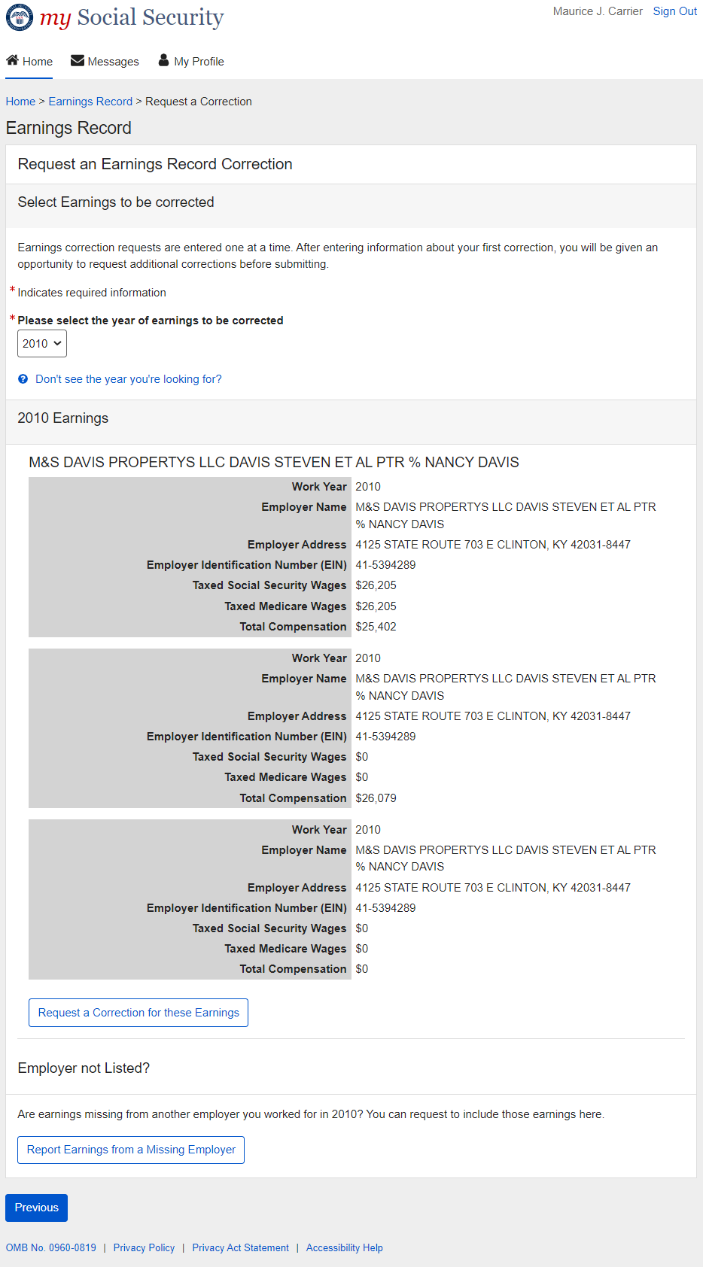

2.6.3. Select a year: One employer variant
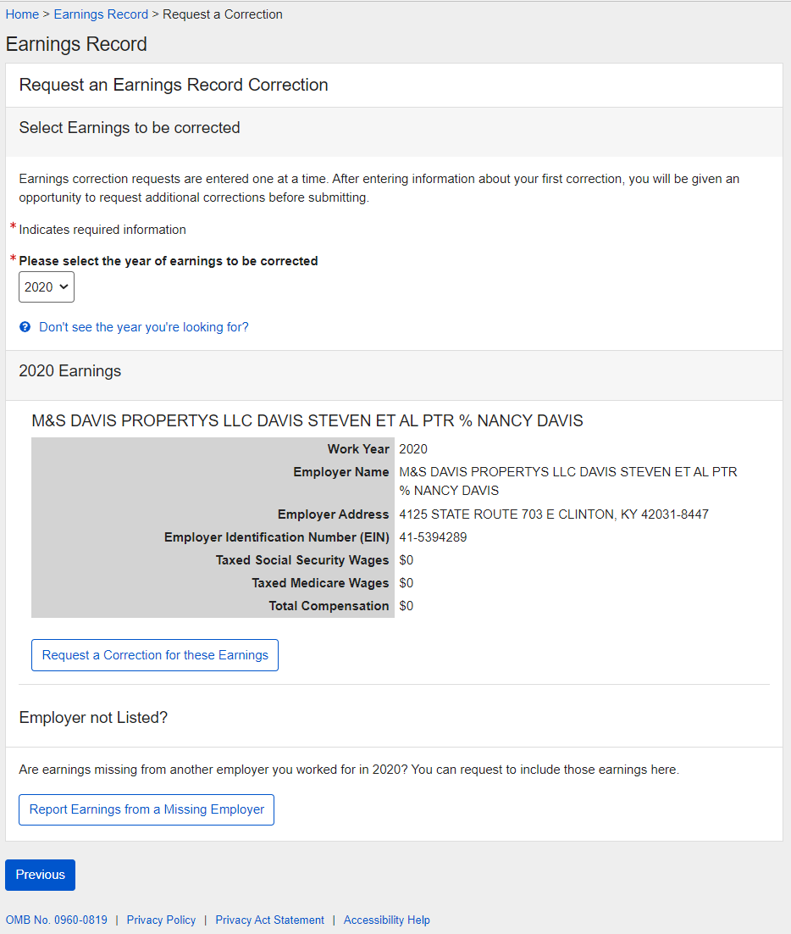

2.6.4. Select a year: No earnings variant
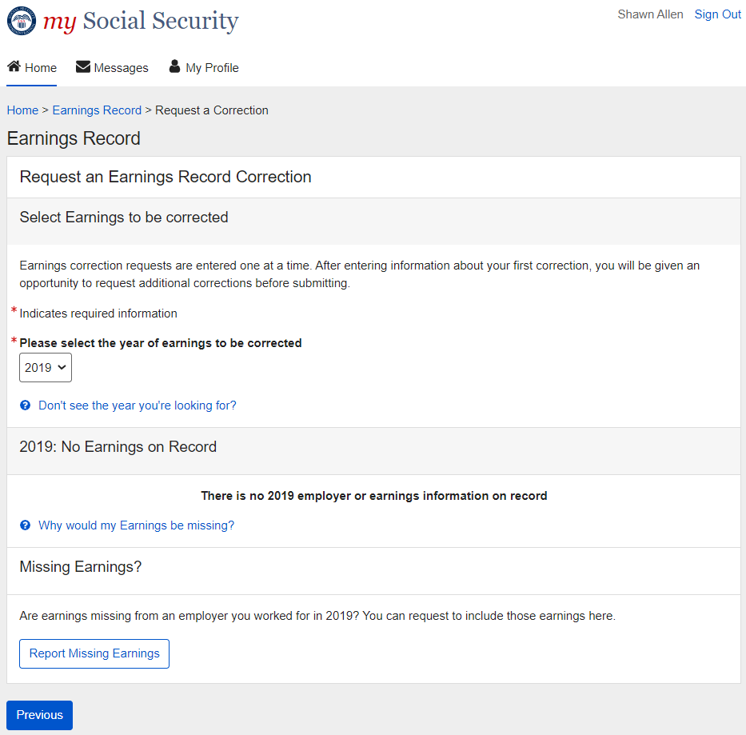

2.6.4.1. Select a year: No earnings variant - 'Why would earnings be missing?' modal
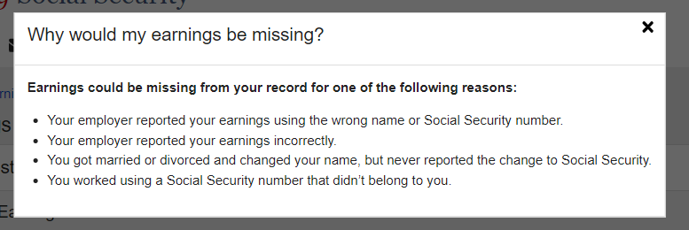

2.6.6. Select year: Quarterly details variant (1978 & prior)
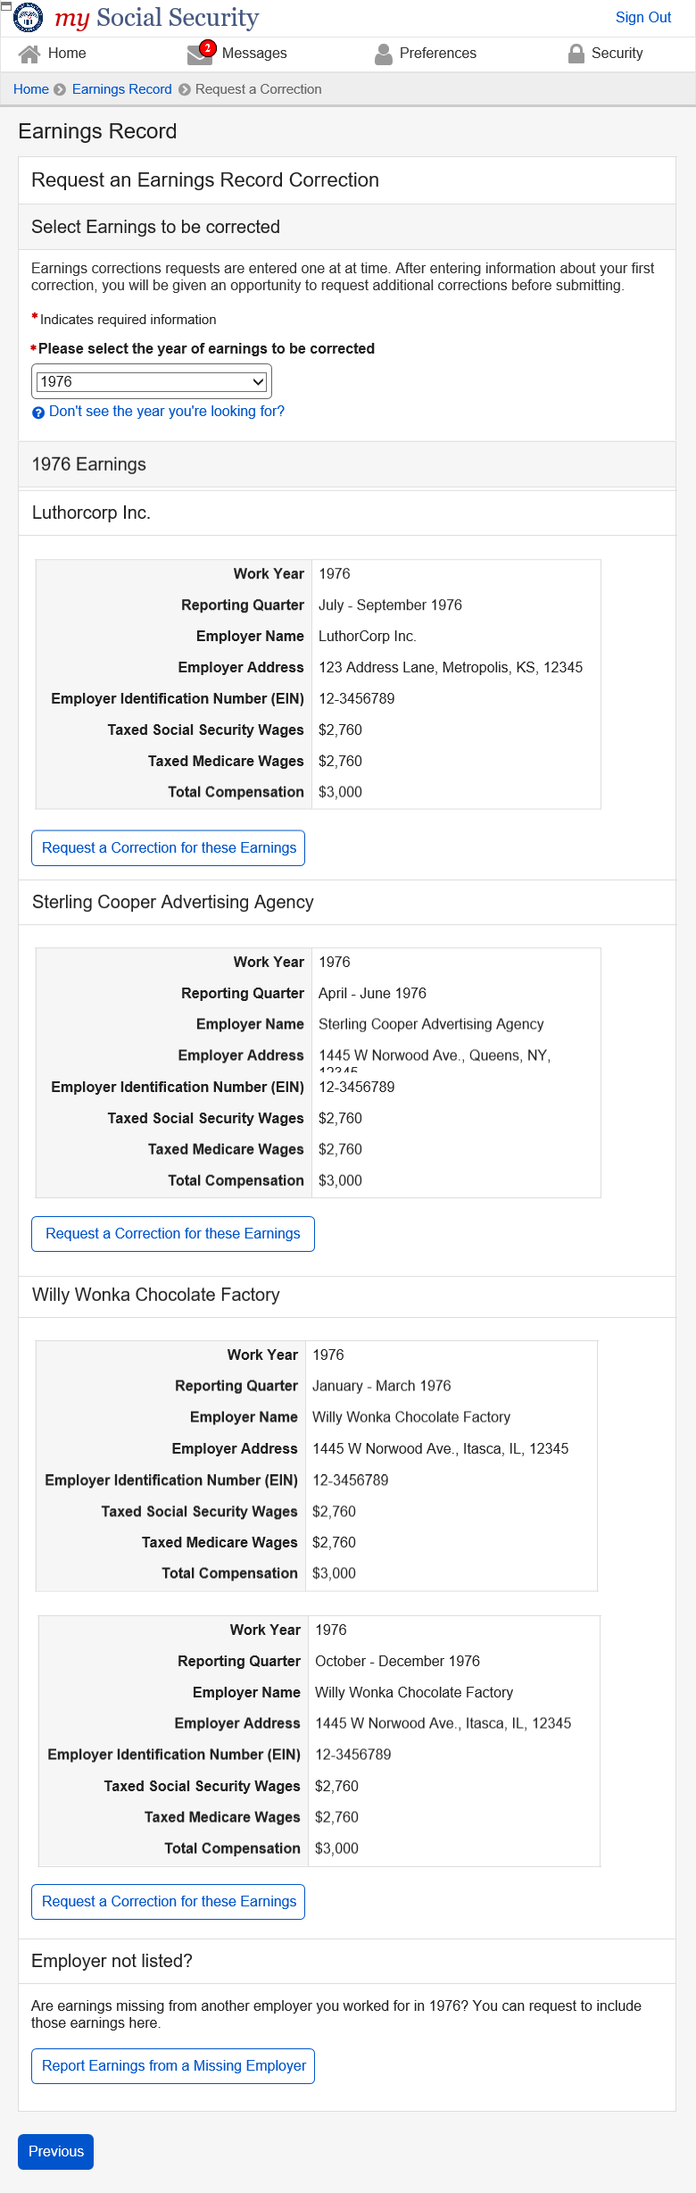

2.7. Correction Details Screens

2.7.1. Correction Details: Correct existing earnings
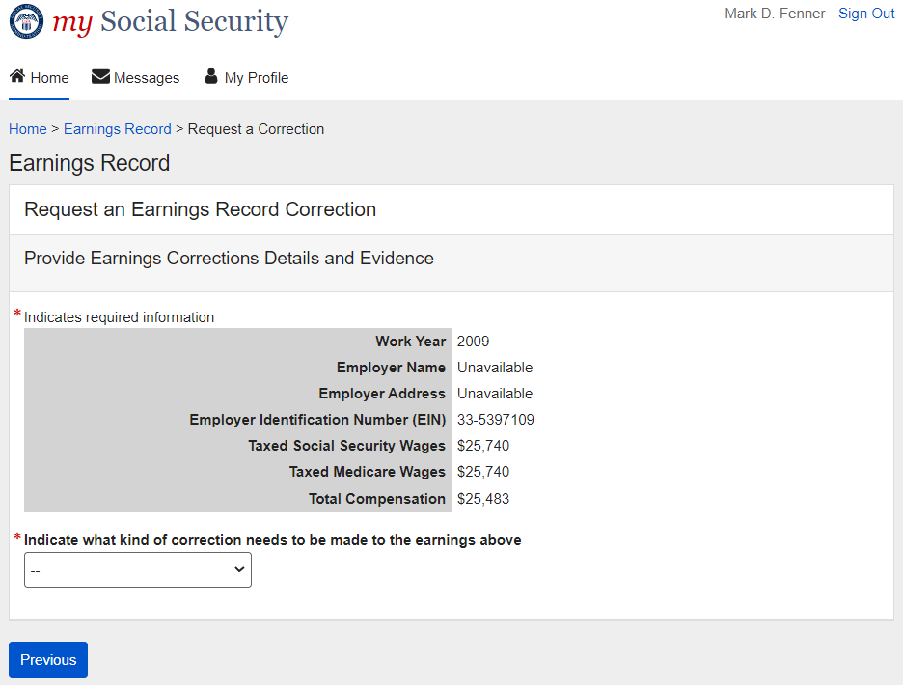

2.7.1.1. Correction Details: Correct existing earnings: Correction type drop down
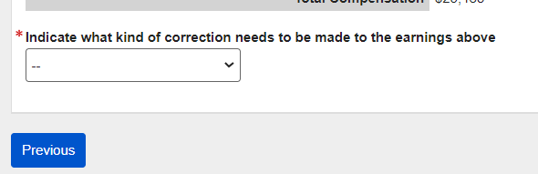

2.7.1.2. Correction Details: Edit existing - incorrect wages
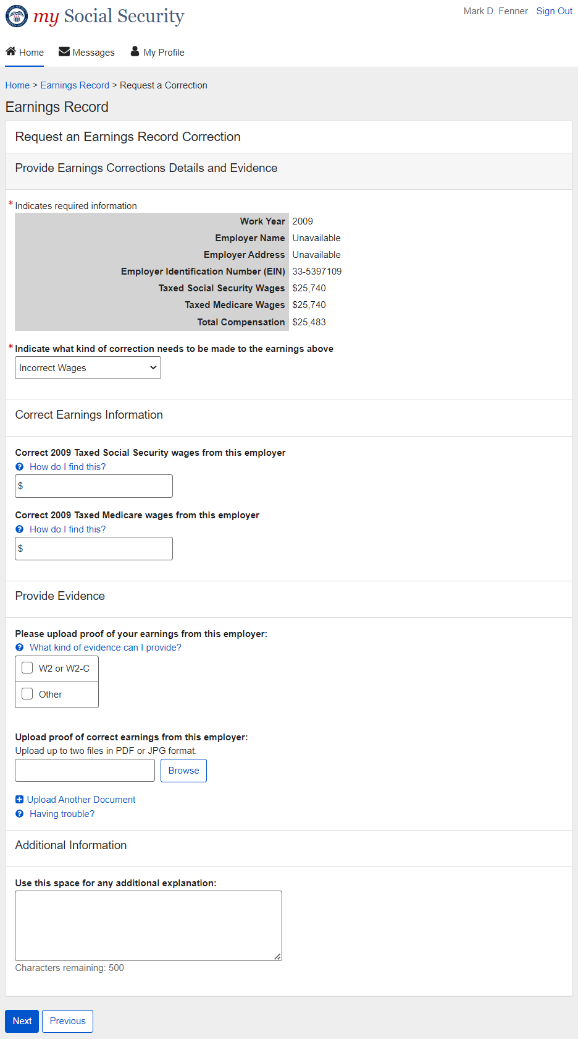

2.7.1.3. Correction Details: Edit existing: did not work for employer
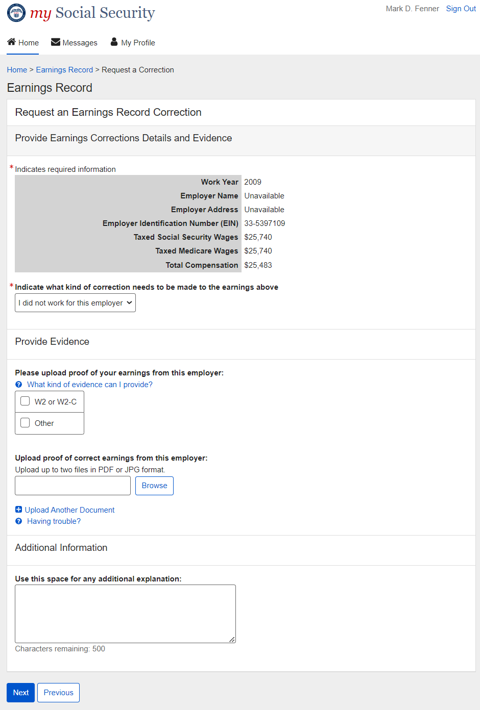

2.7.1.4. Correction Details: Edit existing: Other correction type
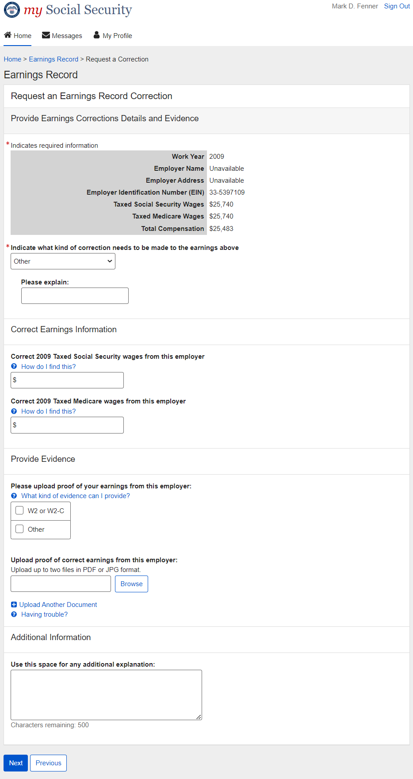

2.7.6. Correction Details: Add missing earnings
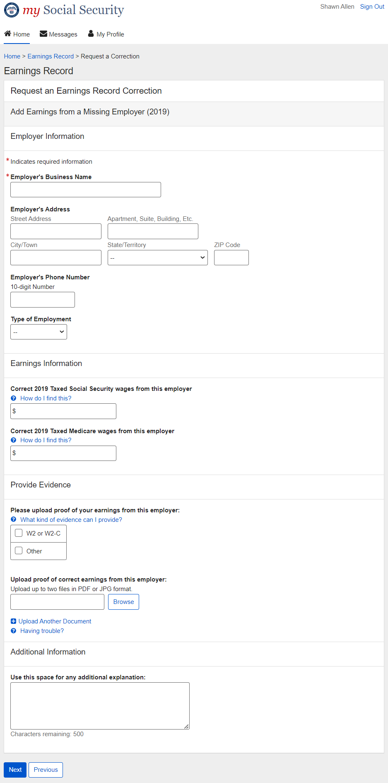

2.7.6.1. Add missing earnings: employment type drop down
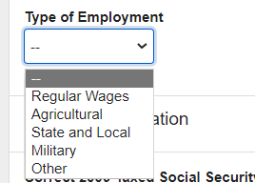

2.7.5. Correction Details: Help & hidden information

2.7.5.1. Correction Details: ‘What kind of evidence can I provide?' Modal
(Appears on 2.7.1.2. ; 2.7.1.3. ; 2.7.1.4. ; 2.7.6)

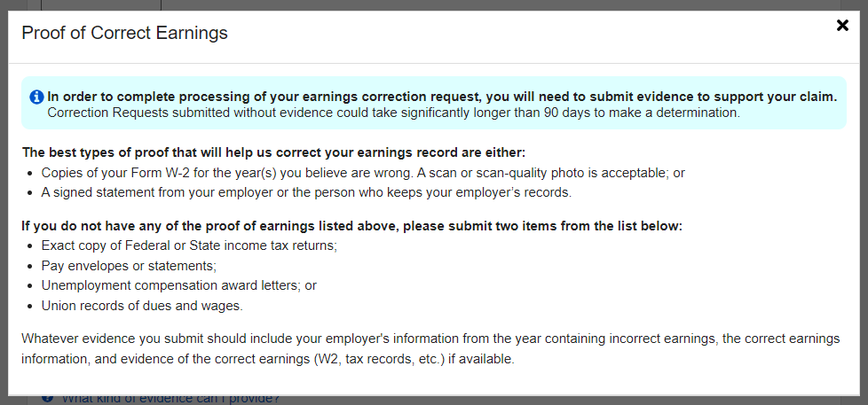

2.7.5.2. Correction Details: Edit existing - upload help: 'Having trouble?' modal
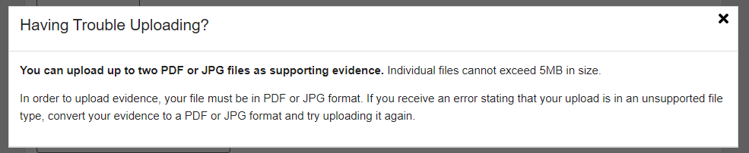

2.7.5.3. Correction Details: 'How do I find this?' help modal
(Appears on 2.7.1.2. ; 2.7.1.3. ; 2.7.1.4. ; 2.7.6 .)
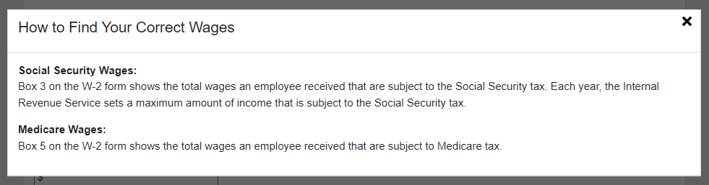

2.7.5.4. Correction Details: Other Evidence option
(Appears on 2.7.1.2. ; 2.7.1.3. ; 2.7.1.4. ; 2.7.6)
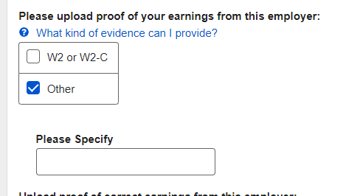

2.8. Review & submit/ add another Screen
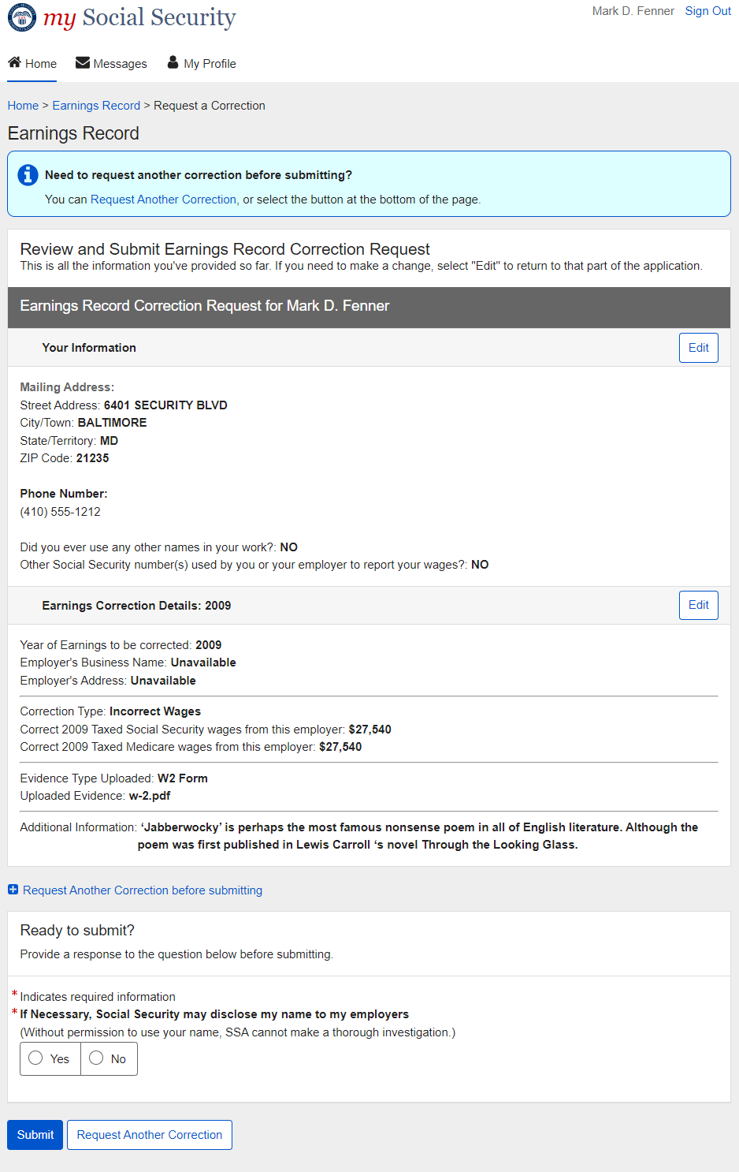

2.8.1. Review & submit/ add another Screen: no evidence warning variant
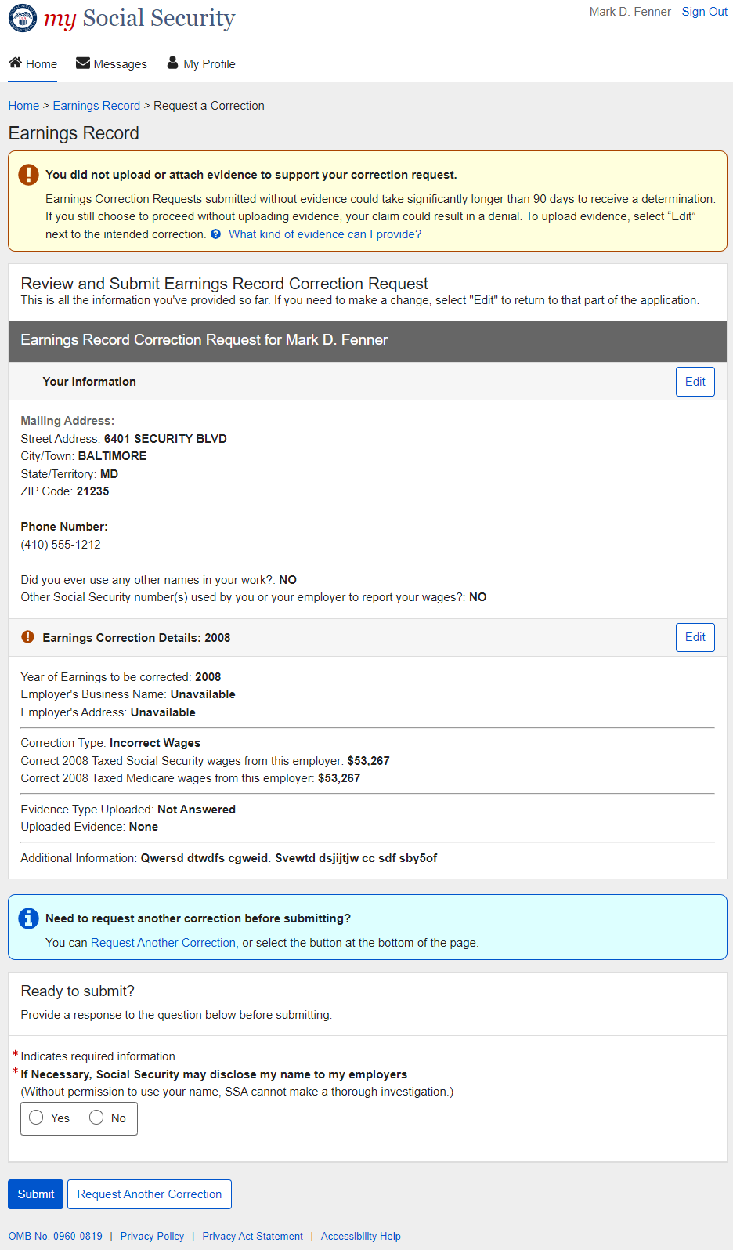

2.8.1.1. Review & submit/ add another Screen: (Warning Variant) ‘What kind of evidence can I provide?’ modal
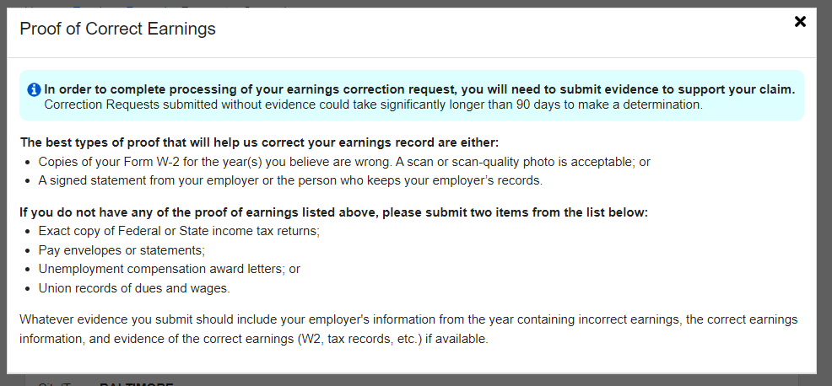

2.9. Earnings Record Correction Request receipt
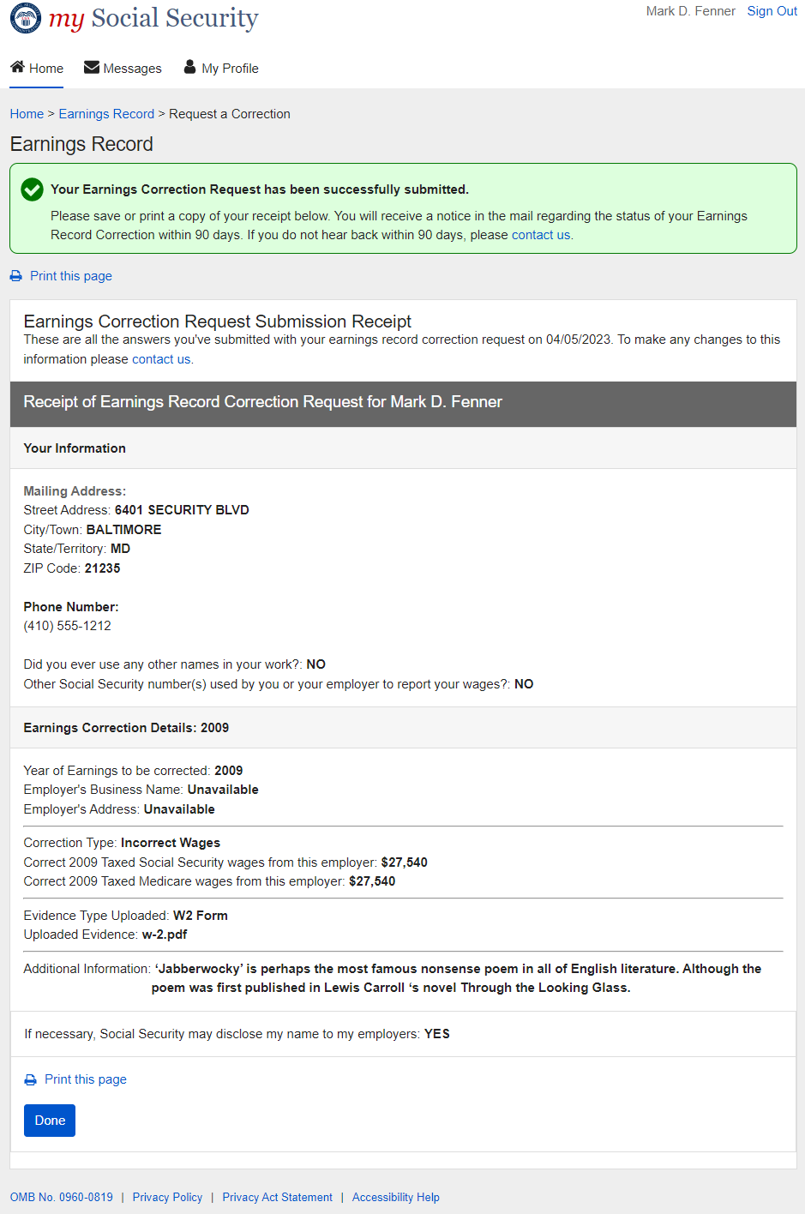

3. mySSA Earnings Corrections: Return screen Variants

3.1. Confirm your information Screen (Return/Edit Variant)
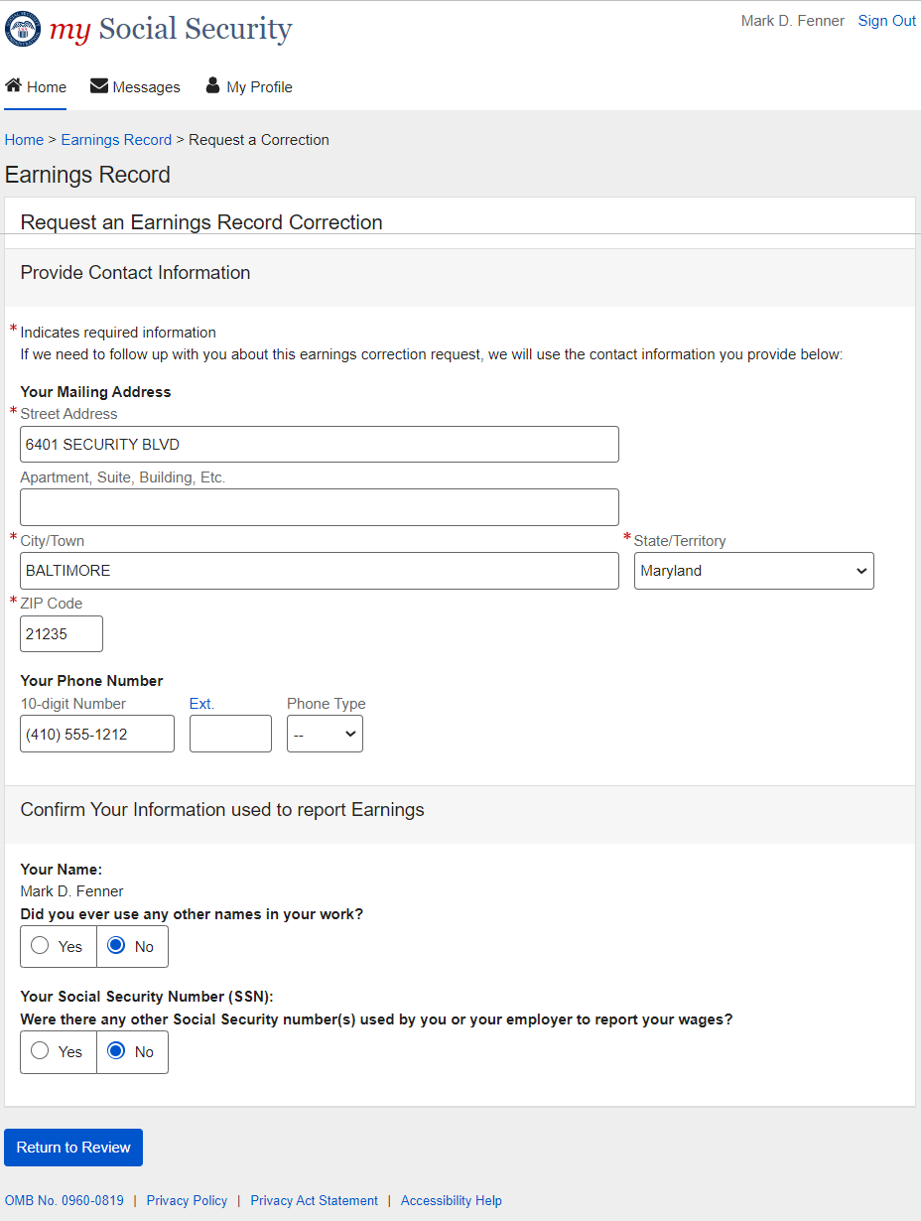

3.2. Select a Year Screen (Return Variant)
(link ‘don’t see the year you’re looking for?’ opens the light box in 2.6.1.)
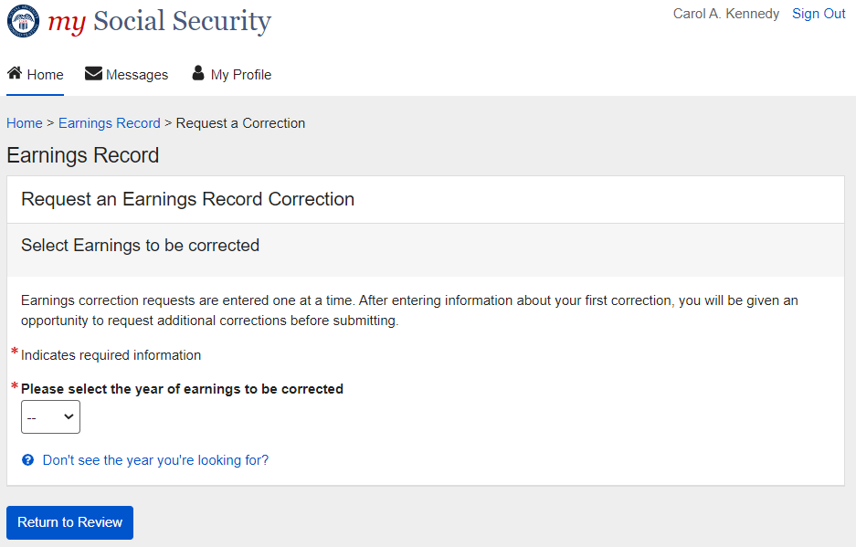

3.2.1. Select a Year Screen (Return Variant): Pending correction
Pending table will display the same way for all pending correction types (edit existing earnings/adding new earnings)
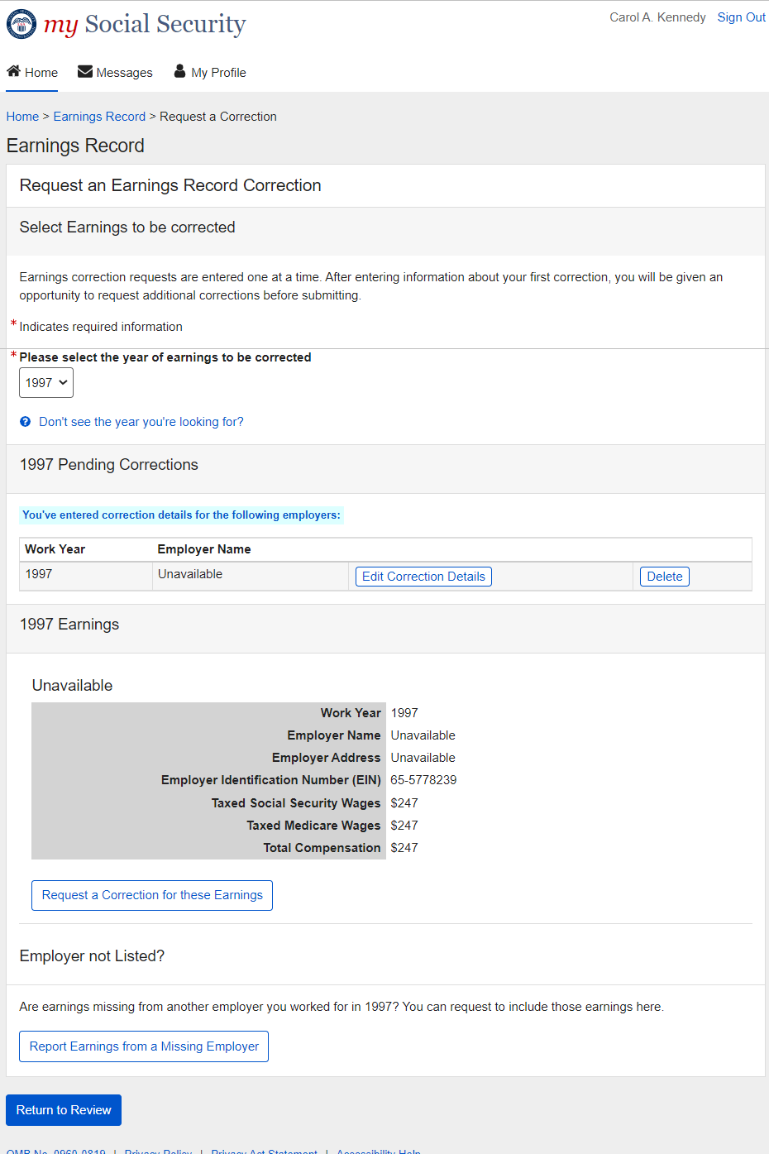

3.2.3. Select a Year Screen (Return Variant): Pending Correction: No Existing Earnings on record
(‘Why would my earnings be missing?’ link opens modal in 2.6.4.1.)
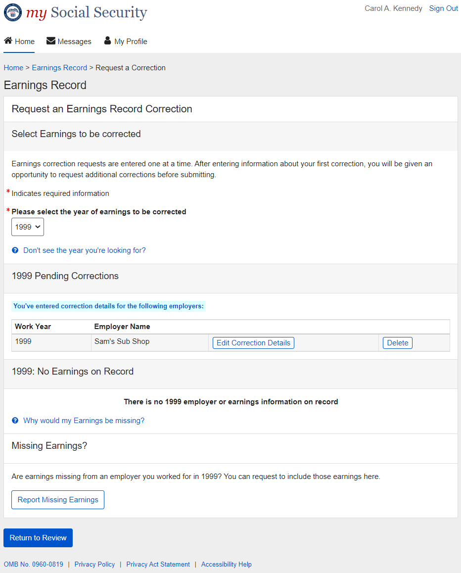

3.2.5. Select a Year Screen (Return Variant): Pending Correction: Multiple Corrections Pending
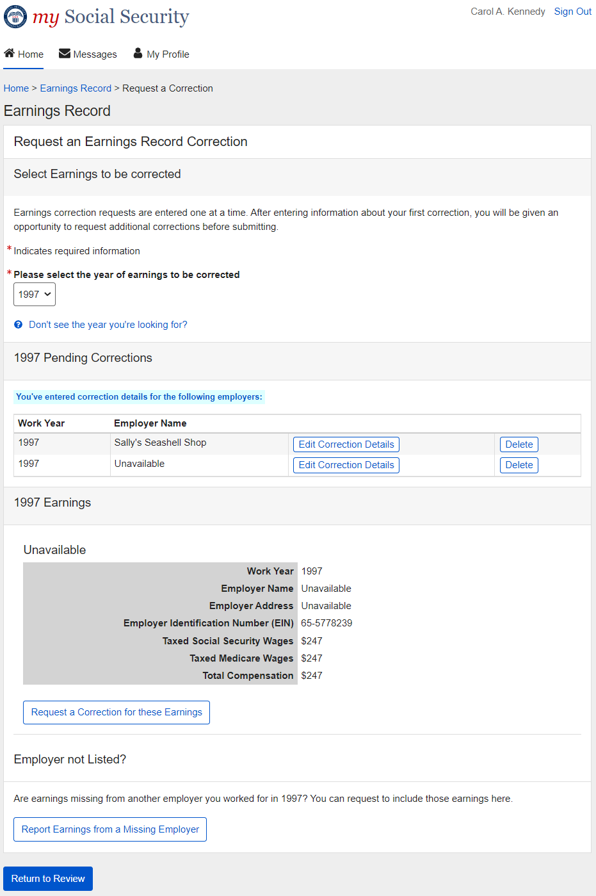

3.2.5.1. Select a Year Screen (Return Variant): Pending: delete confirmation
Displays when ‘delete’ is selected on pending table (3.2.1. ; 3.2.2. ; 3.2.3.)
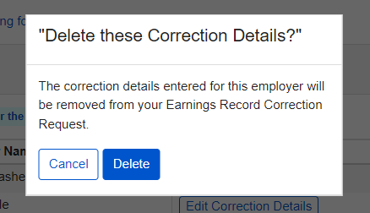

3.3. Correction Details (Return/ Edit Variants)

3.3.1. Correction Details (Update Existing Earnings): Return Variant
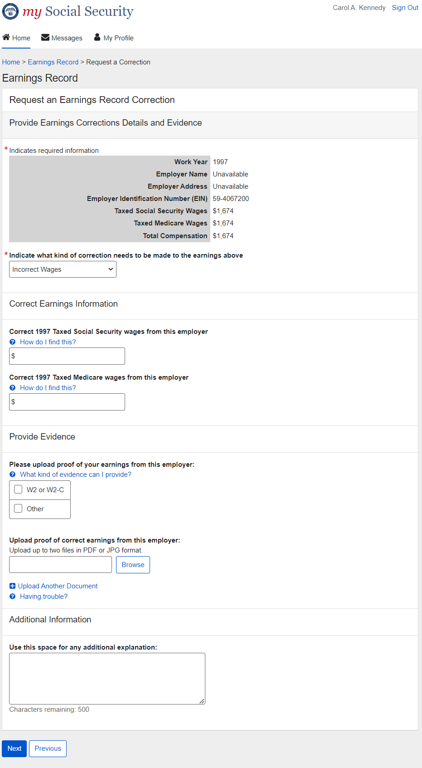

3.3.1.1. Correction Details (Update Existing): Edit Variant
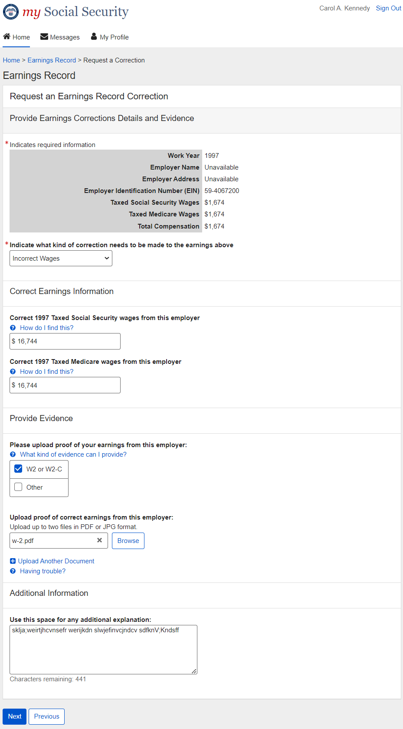

3.3.2. Correction Details (Add missing): Return Variant
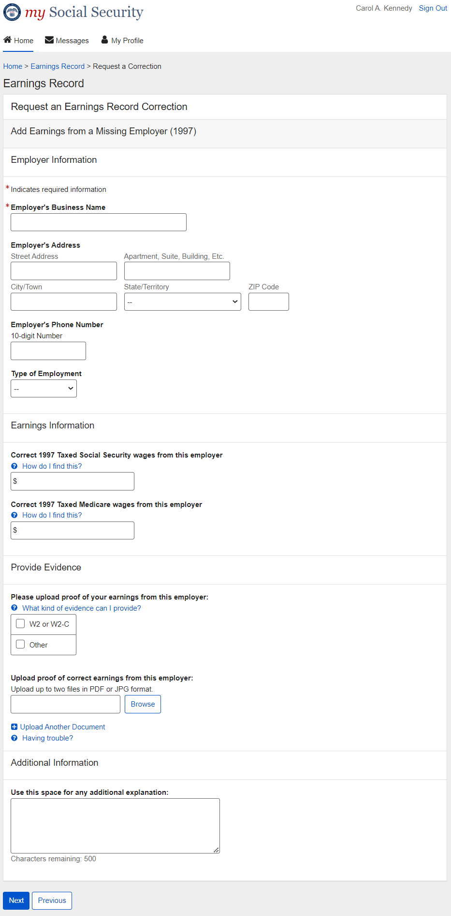

3.3.2.1. Correction Details (Add missing): Edit Variant
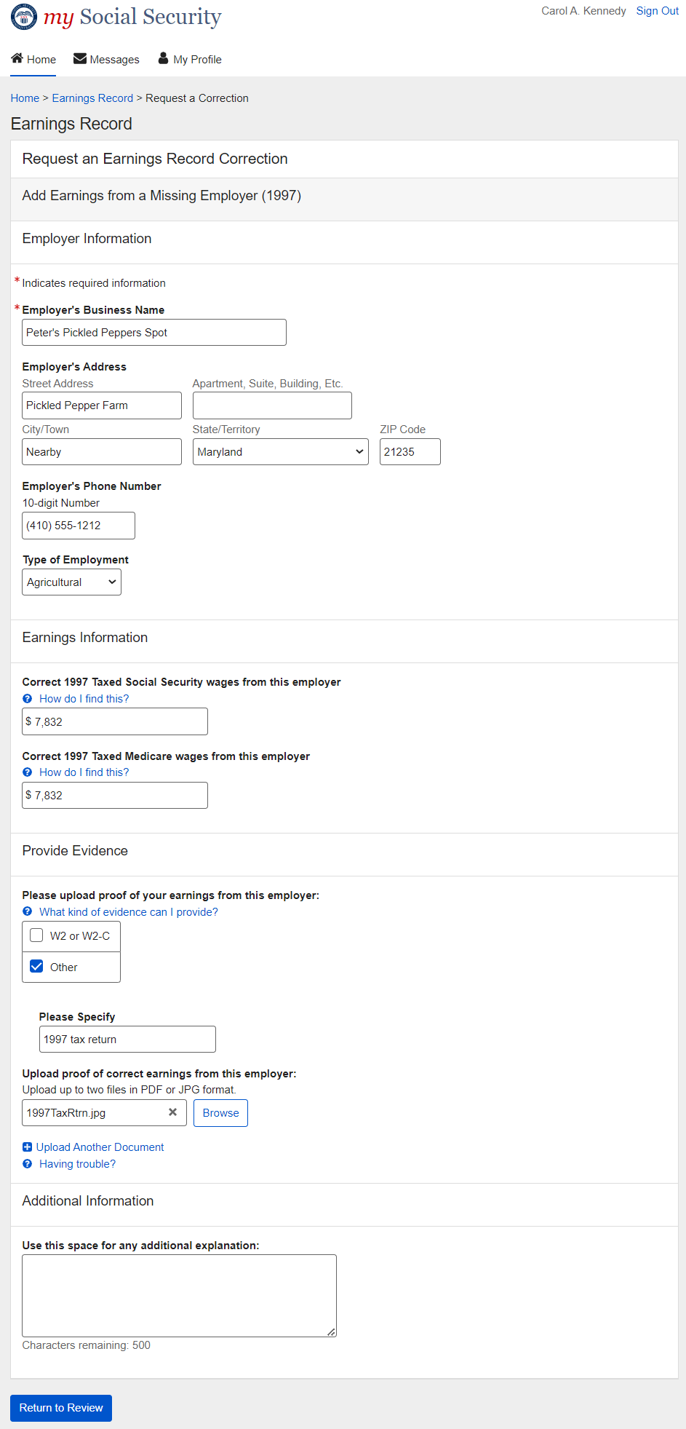

3.4. Review and Submit / add another (Return Variant – Multiple corrections)
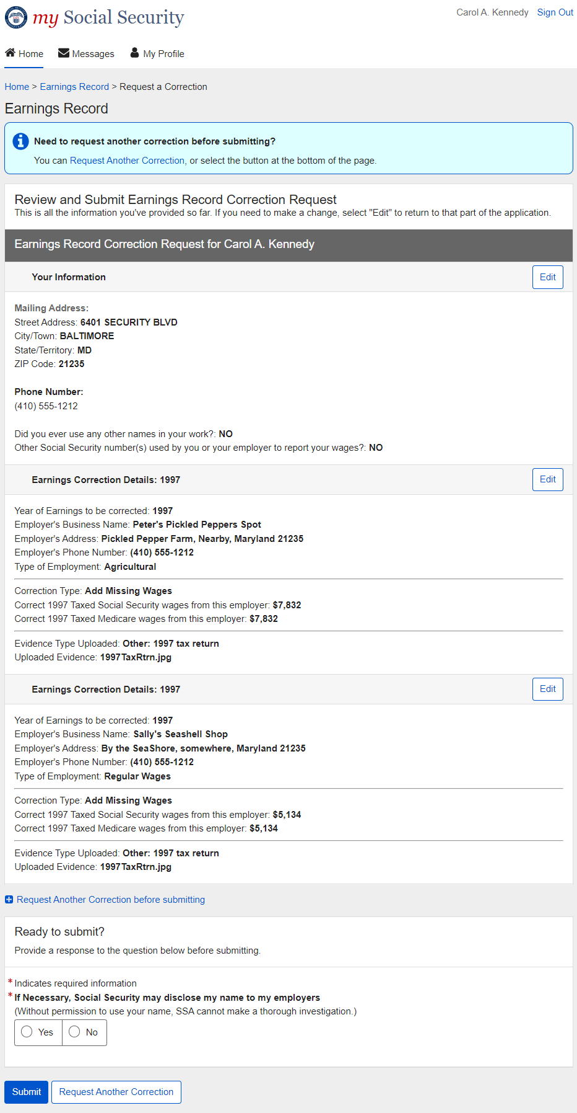

3.4.1. Review and Submit (Return Variant: Maximum corrections)
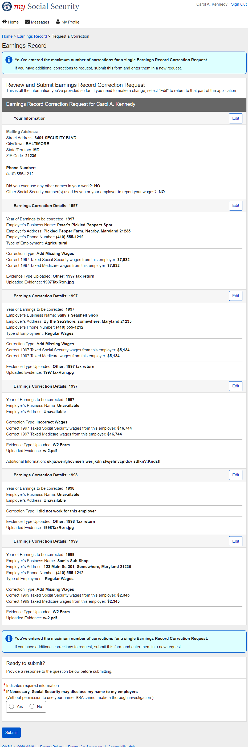

4. Initiate Earnings Corrections: Error Variants

4.1. Confirm Your Information Screen (Error Variant)
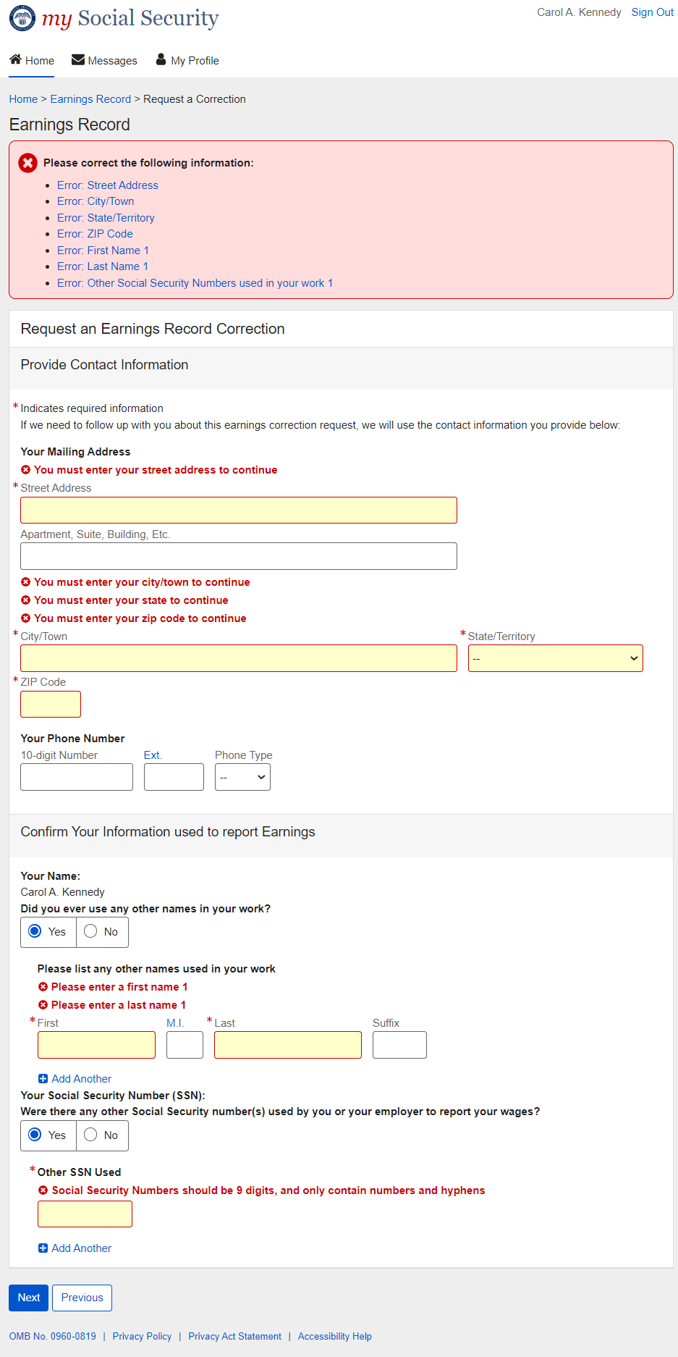

4.3. Correction Details (Error Variants)

4.3.1. Correction Details: Add missing (Error Variant)
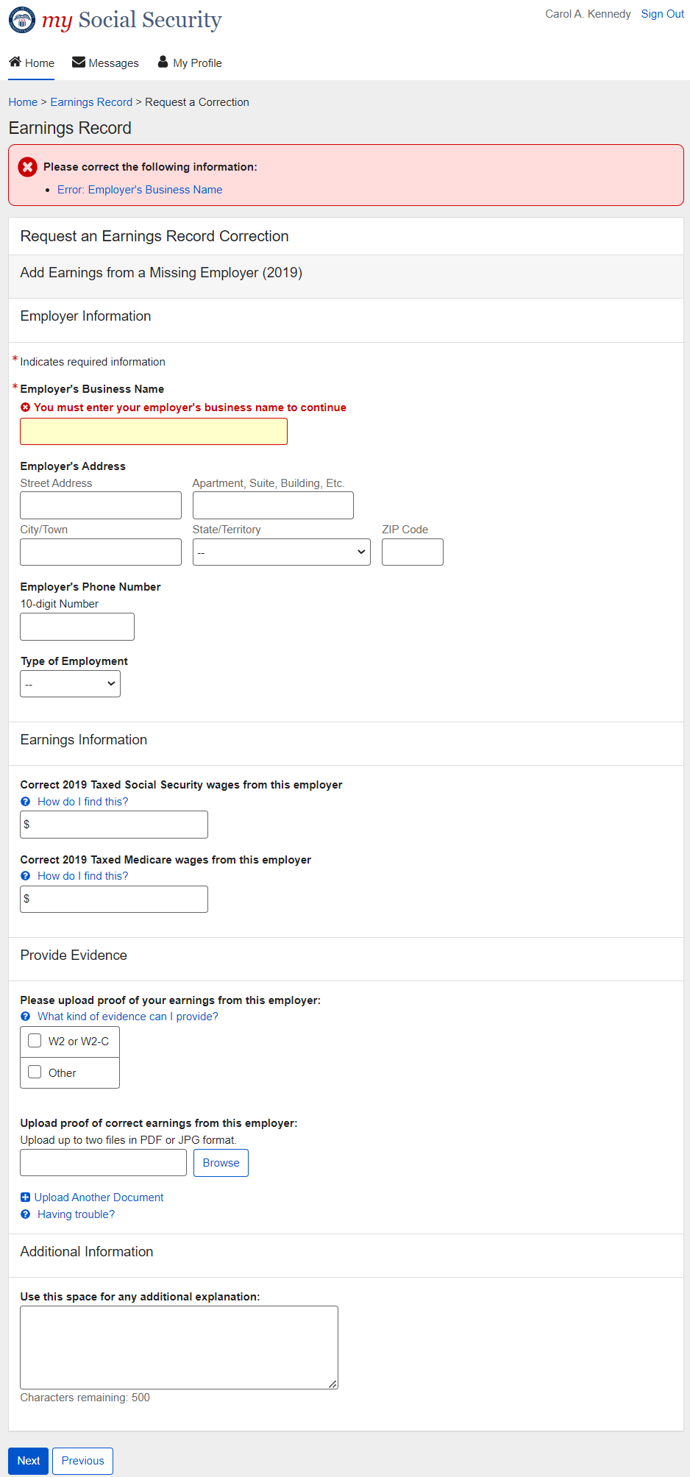

4.3.2. Correction Details: Error – File upload size
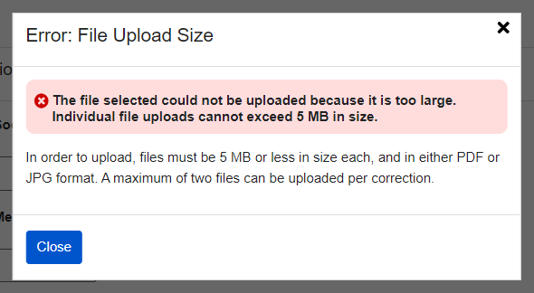

4.3.3. Correction Details: Error – Unsupported File Format
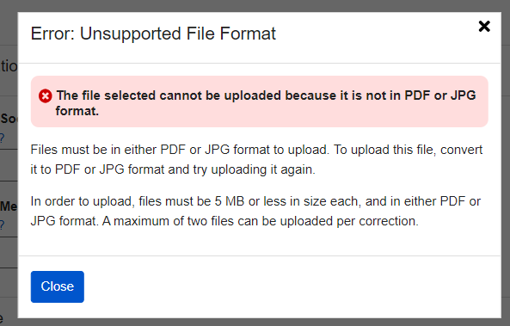

4.4. Review and Submit (Review and add another screen) - Error Variant
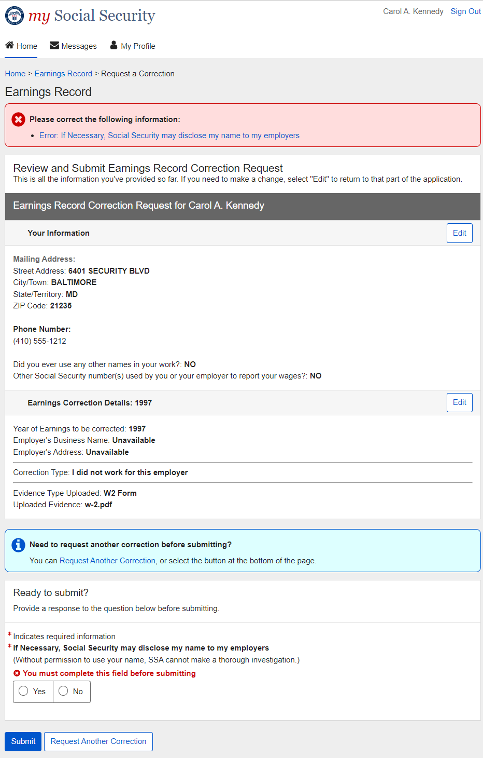

4.5. Earnings Correction Request: System Unavailable Error Message
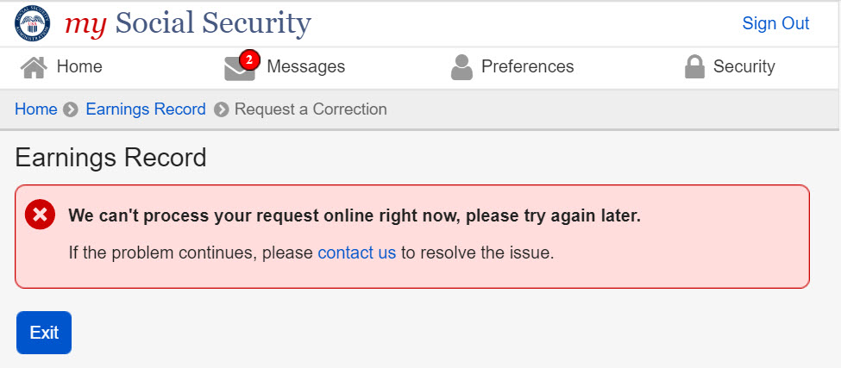

5. Initiate Earnings Corrections: Other Screen Variants

5.1. Earnings Record Home: No access to Earnings Corrections Variant
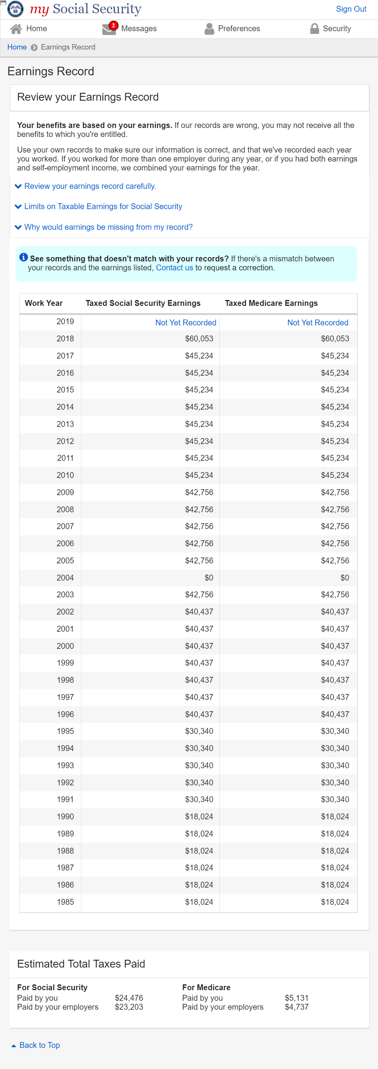

5.2. Waiting Indicator modal
