UAC Referral (Form P-7)

Data Entry Window
- New Pending
- Processed Pending
- Placement Match Under Review
- Placement Designated
- Placement Requested
- Placement Not Accepted
- Supervisor Approval Requested
- Supervisor Approved
- Supervisor Override
- Referral Cancelled
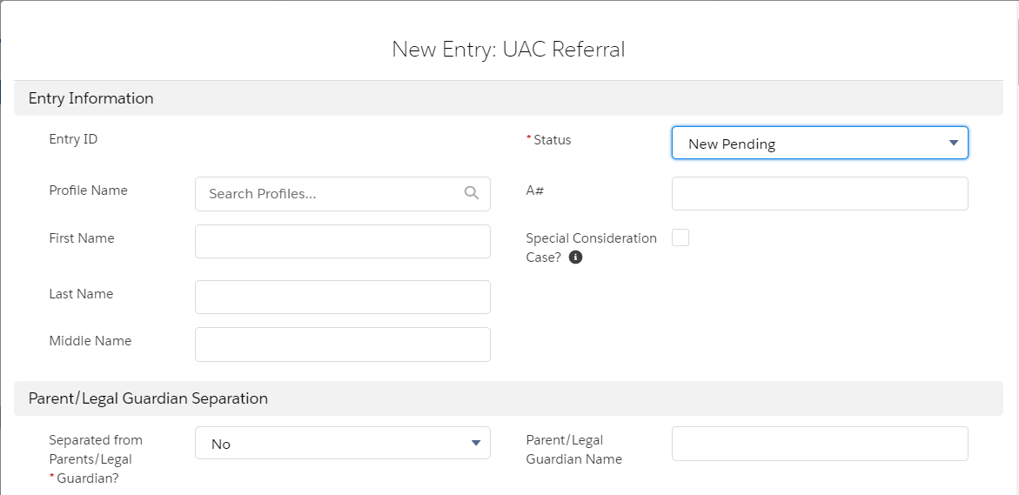
- Parent criminal history
- Parent criminal history and immigration history
- Parent criminal history, immigration history, and cartel/gang affiliation
- Parent cartel/gang affiliation and immigration history
- Parent cartel/gang affiliation
- Referred for prosecution
- Communicable disease
- Health issue/hospitalization
- Parent fitness (other than for hospitalization)/child danger concerns
- Unverified familial relationship/fraud
- Separated from other adult relative
- Other – warrant
- Other
- Parent cartel/gang affiliation and criminal history
- Yes
- No
- None
- Unknown
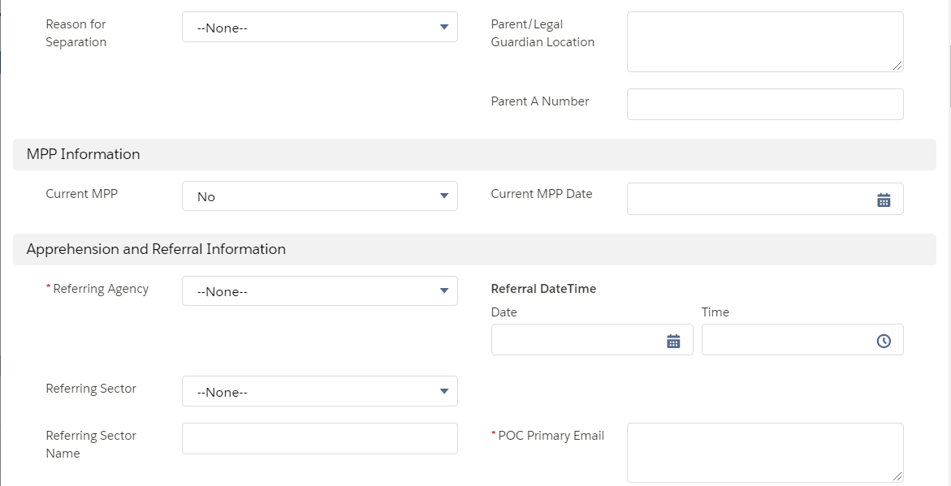
- Arriving/Inadmissible
- EWI/Entered
- Material Witness
- Overstay
- Parole/Arriving UAC
- Visitor/Student
- Without Inspection
- None
List of all referring sector locations.
- Office of Field Operations (CBP)
- Border Patrol (CBP)
- Immigration and Custom Enforcement ERO
- US Marshals Service
- Federal Bureau of Investigation
- Homeland Security (ICE)
- Department of Labor
- Bureau of Prisons
- None
- Yes
- No
- Pending
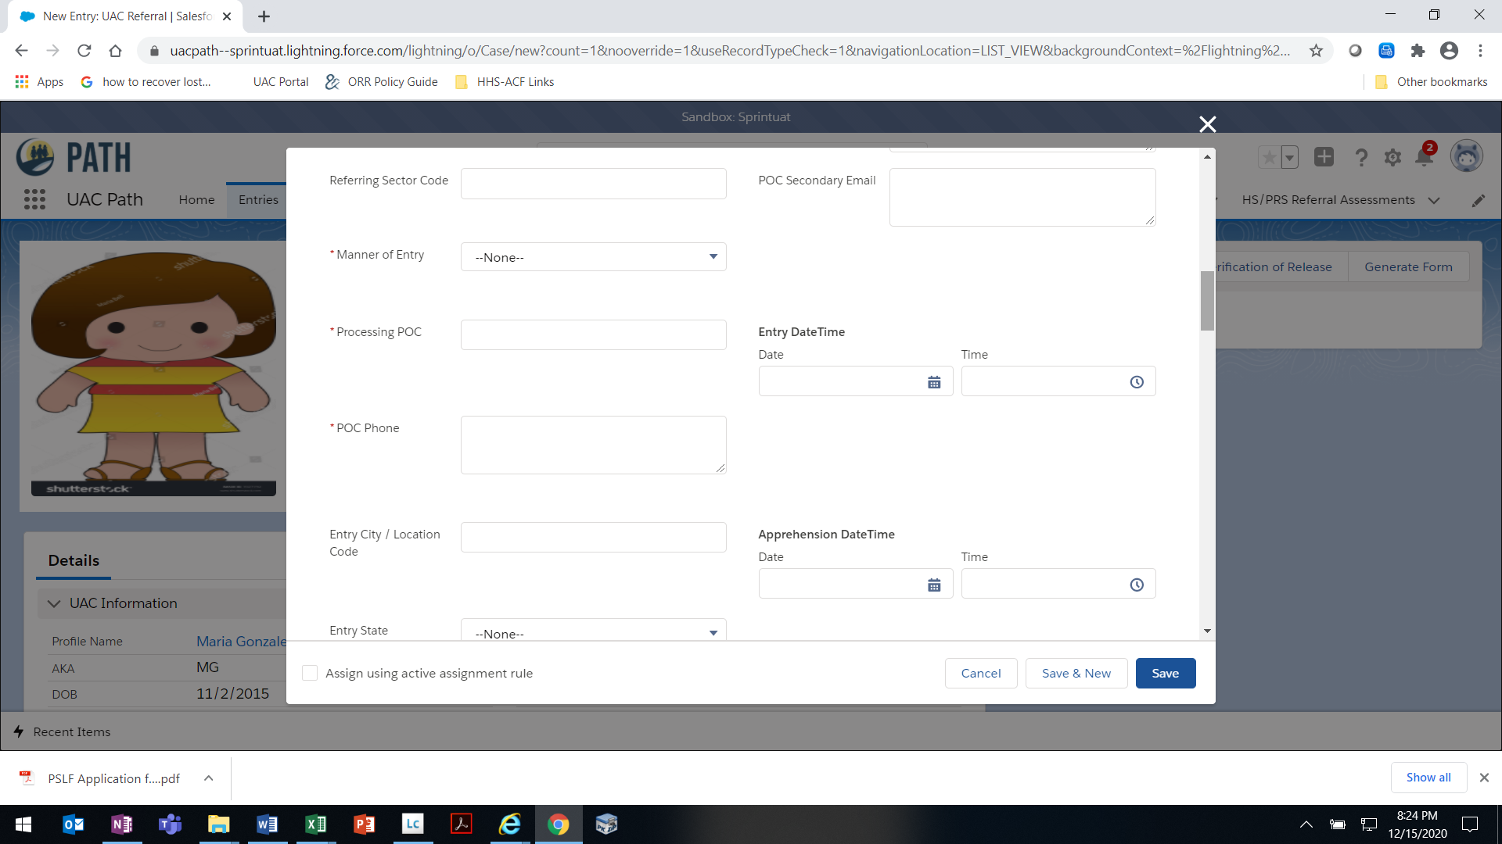

List of all 50 U.S. states and the District of Columbia
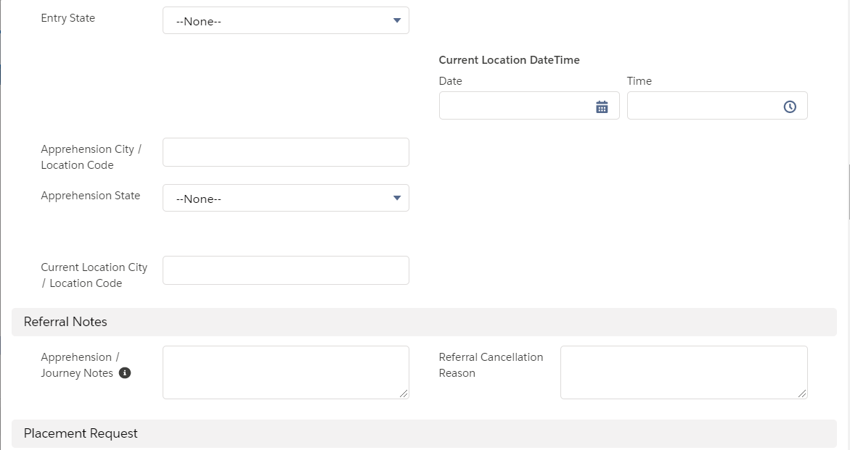
- Influx Care Facility
- Long Term Foster Care
- LTFC – Community Placements
- LTFC – Group Home
- Out-of-Network RTC
- Residential Treatment Center
- Secure
- Shelter
- Staff Secure
- Therapeutic Group Home
- Therapeutic Staff Secure
- Transitional Foster Care
- Emergency Intake Sites
- URN
- Other
List of all 50 U.S. states and the District of Columbia
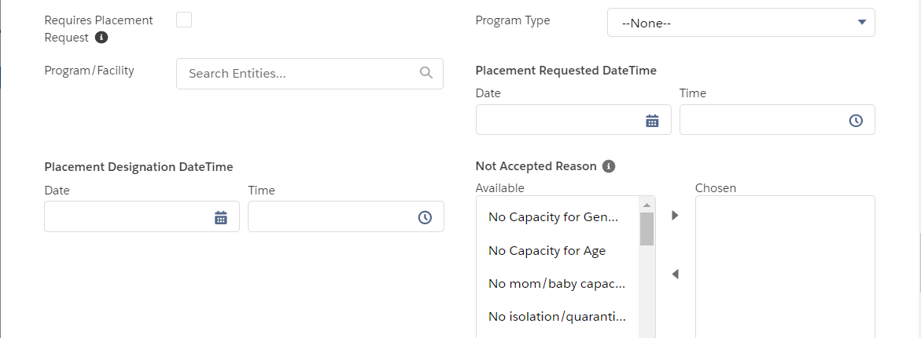
- No Capacity for Sex, No Capacity for Age, No mom/baby capacity
- No isolation/quarantine space
- Medical issues
- Mental illness
- Licensing issues
- Internal policy
- Aggressive to peers
- Aggressive to staff
- Danger to self
- Escape risk
- Disruptive behavior
- Risk of danger to UAC or other UAC in care
- Sexual predatory behavior
- Inappropriate sexual behavior
- Weather event/Building compromised
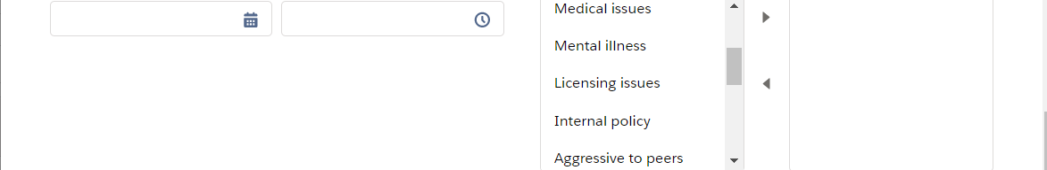
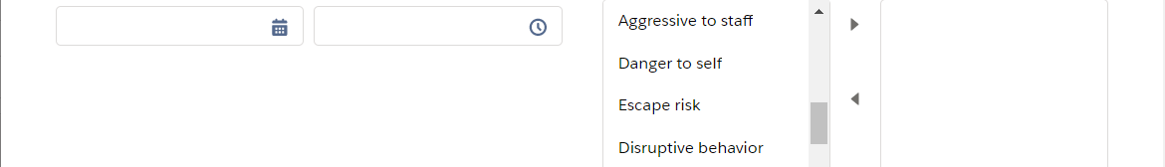
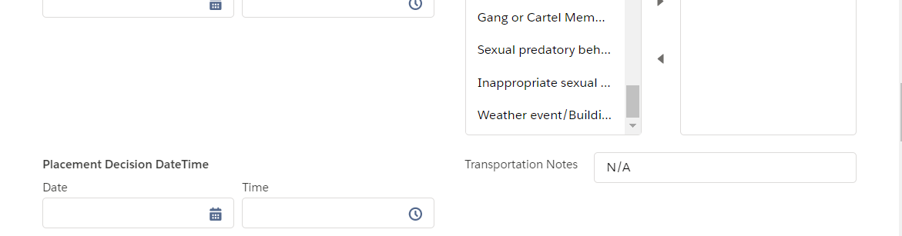

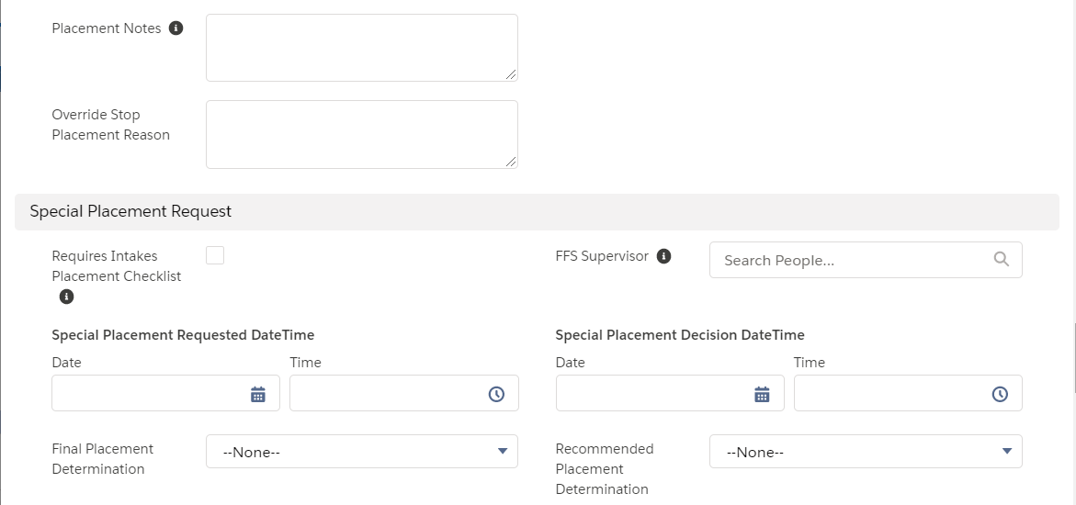
- Transitional Foster Care
- Residential Treatment Center
- Secure
- Shelter
- Staff Secure
- Therapeutic Staff Secure
- Therapeutic Group Home
- Transitional Foster Care
- Residential Treatment Center
- Secure
- Shelter
- Staff Secure
- Therapeutic Staff Secure
- Therapeutic Group Home
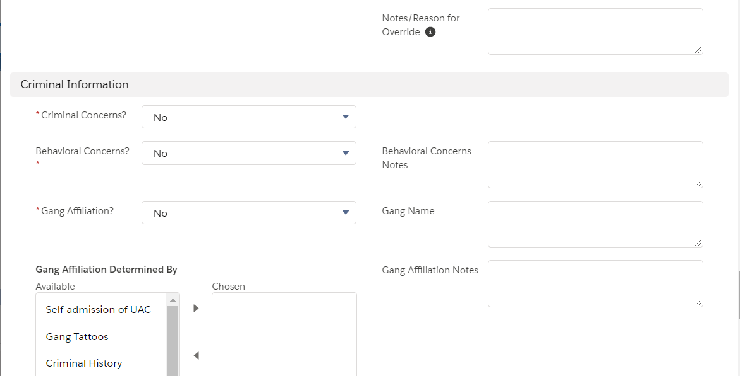
- Self-admission of UAC
- Gang tattoos
- Criminal history
- Family/peers known members
- Other
- Yes
- No
- Suspect
- Yes
- No
- Yes
- No
- Unknown
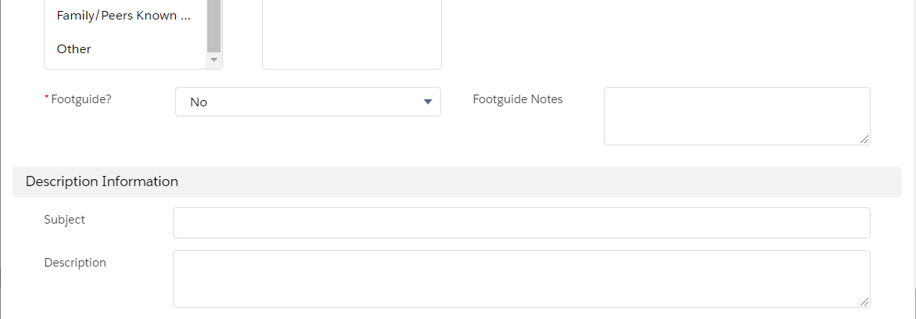
Standard system fields that will not be completed and will be removed in future development.
- Yes
- No
- Unknown
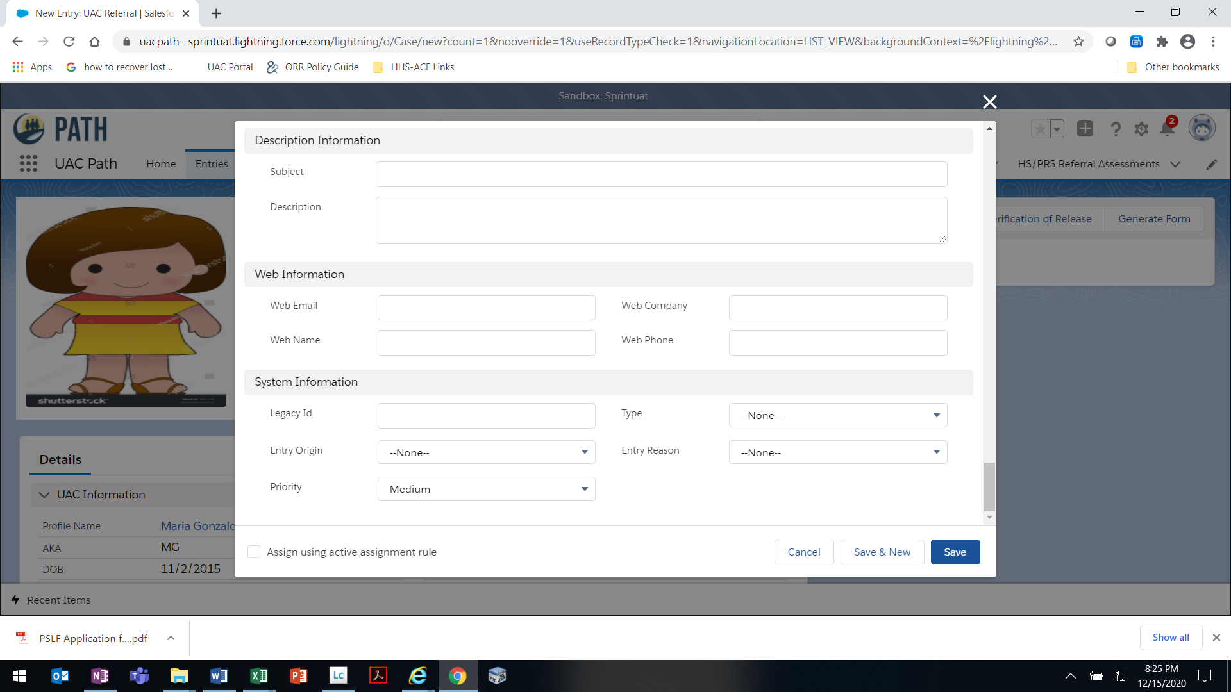

Standard system fields that will not be completed and will be removed in future development.
OMB 0970-0554 [valid through MM/DD/YYYY]

THE PAPERWORK REDUCTION ACT OF 1995 (Pub. L. 104-13) STATEMENT OF PUBLIC BURDEN: The purpose of this information collection is to allow ORR to receive a referral from a Federal agency and place the UAC in an ORR care provider facility. Public reporting burden for this collection of information is estimated to average 1.0 hour (plus an additional 0.5 hours for UAC who may require placement in a restrictive setting) per response, including the time for reviewing instructions, gathering and maintaining the data needed, and reviewing the collection of information. This is a mandatory collection of information (Homeland Security Act, 6 U.S.C. 279). An agency may not conduct or sponsor, and a person is not required to respond to, a collection of information subject to the requirements of the Paperwork Reduction Act of 1995, unless it displays a currently valid OMB control number. If you have any comments on this collection of information please contact UACPolicy@acf.hhs.gov.

P-7 [Rev. MM/DD/YYYY]

UAC Referral Page – Details Tab
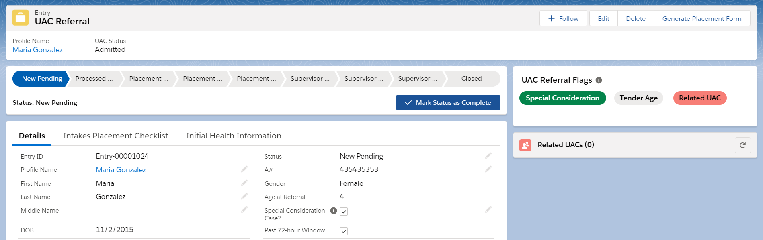
Sex
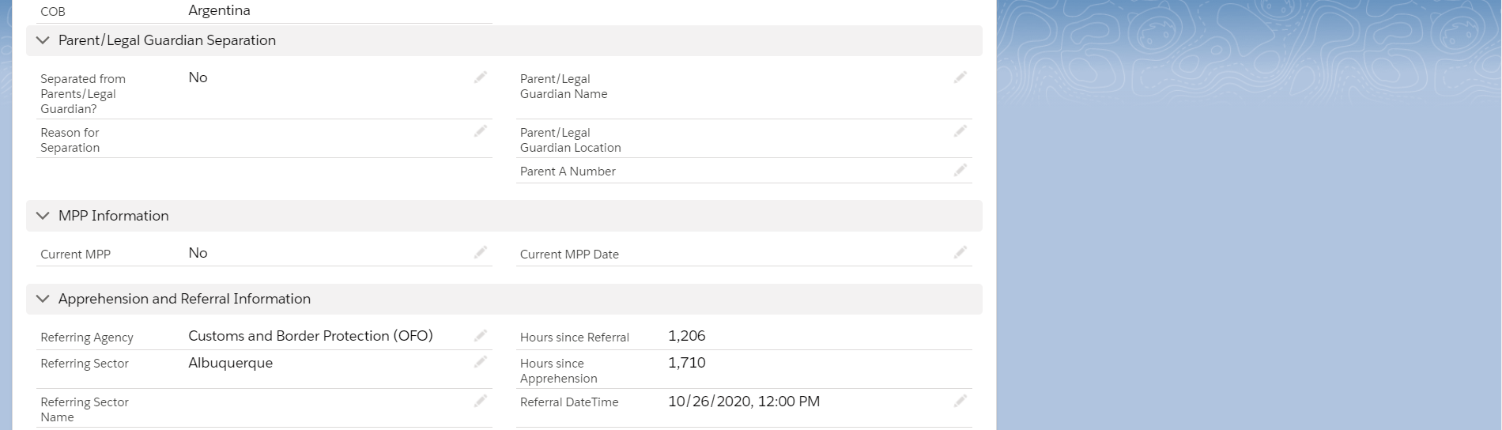
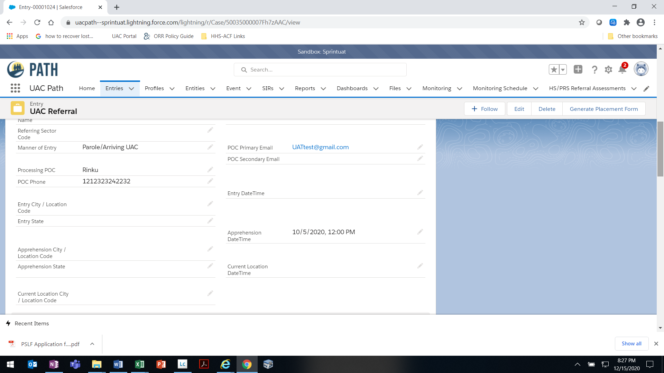
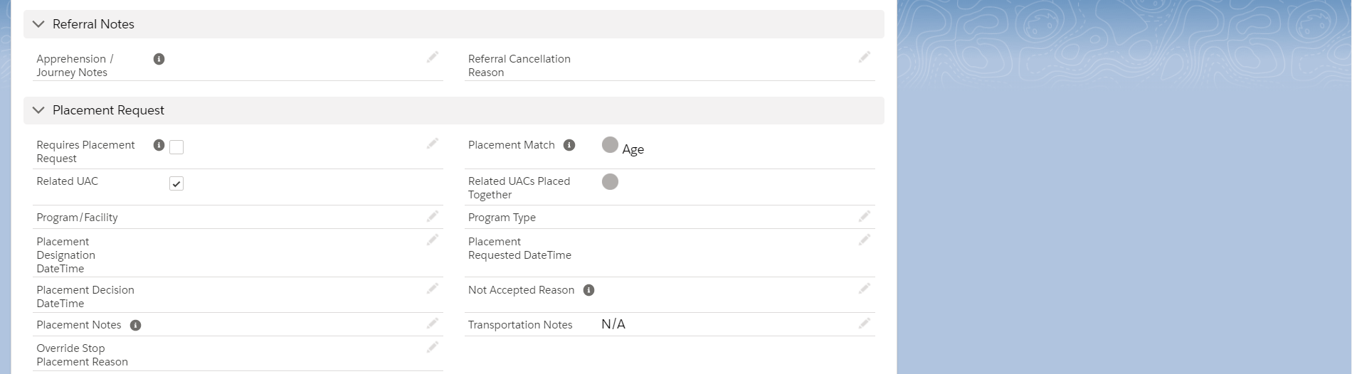
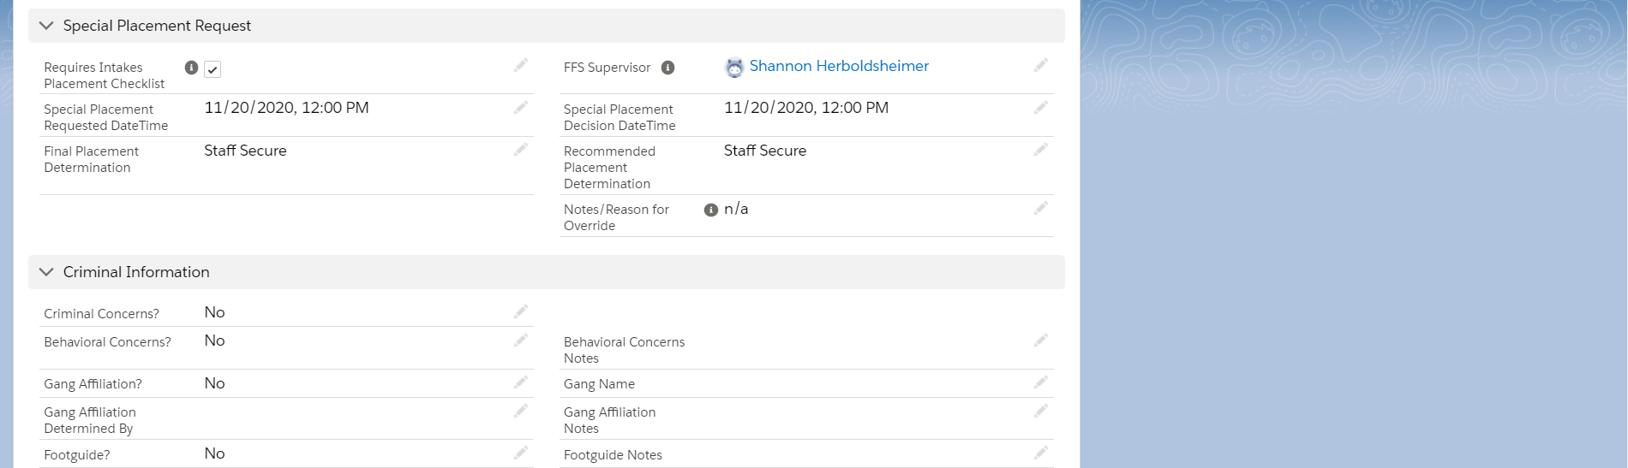
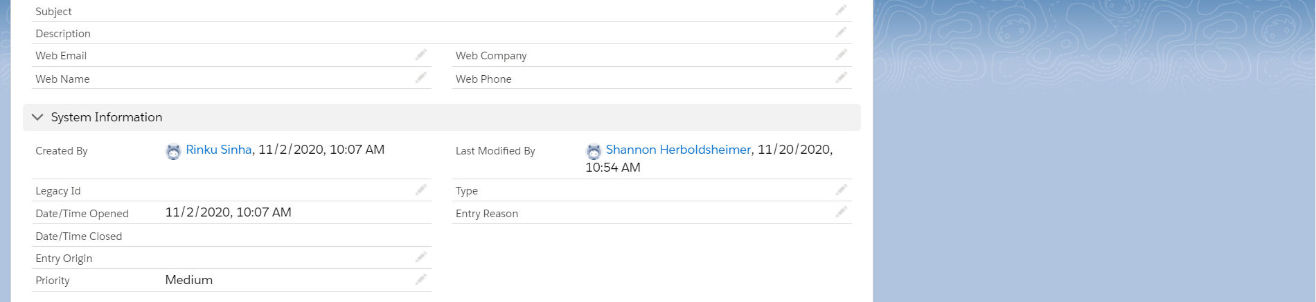
Standard system fields that will not be completed and will be removed in future development.
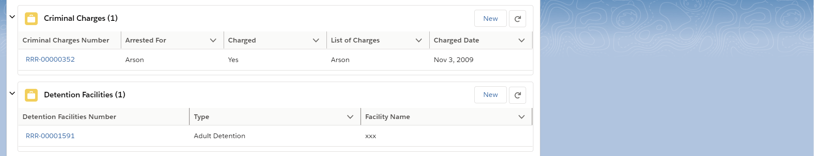
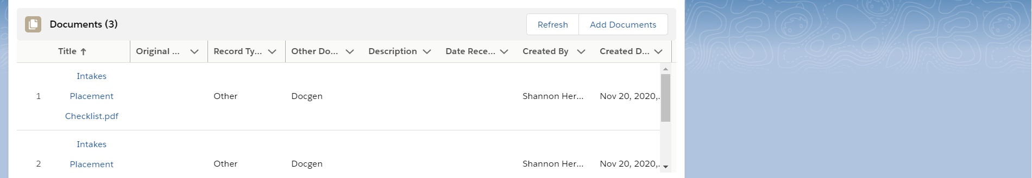
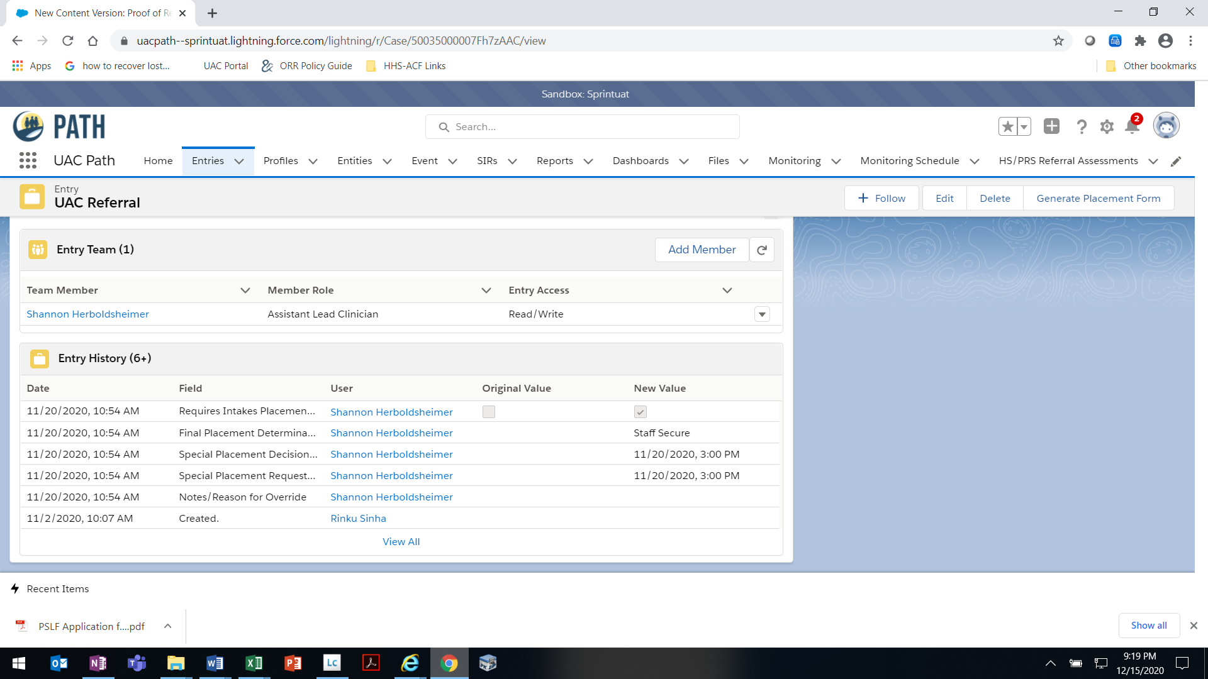
OMB 0970-0554 [valid through MM/DD/YYYY]
THE PAPERWORK REDUCTION ACT OF 1995 (Pub. L. 104-13) STATEMENT OF PUBLIC BURDEN: The purpose of this information collection is to allow ORR to receive a referral from a Federal agency and place the UAC in an ORR care provider facility. Public reporting burden for this collection of information is estimated to average 1.0 hour (plus an additional 0.5 hours for UAC who may require placement in a restrictive setting) per response, including the time for reviewing instructions, gathering and maintaining the data needed, and reviewing the collection of information. This is a mandatory collection of information (Homeland Security Act, 6 U.S.C. 279). An agency may not conduct or sponsor, and a person is not required to respond to, a collection of information subject to the requirements of the Paperwork Reduction Act of 1995, unless it displays a currently valid OMB control number. If you have any comments on this collection of information please contact UACPolicy@acf.hhs.gov.
P-7 [Rev. MM/DD/YYYY]

Criminal Charges Data Entry Window
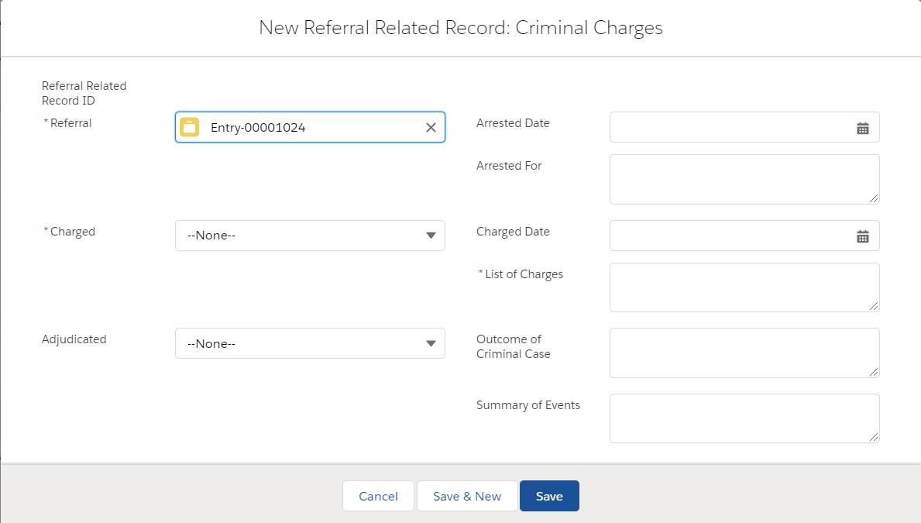
- Yes
- No
- NA
- Yes
- No
- Pending

Detention Facilities Data Entry Window
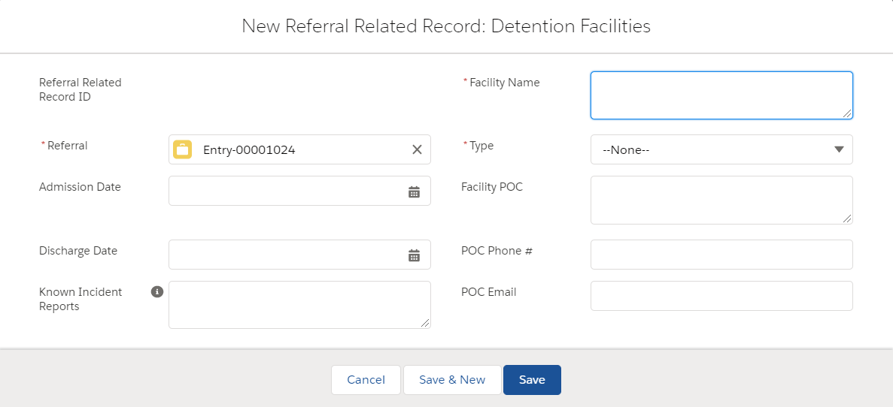
- Adult Detention
- Juvenile Detention
- Unknown

Documents Data Entry Window
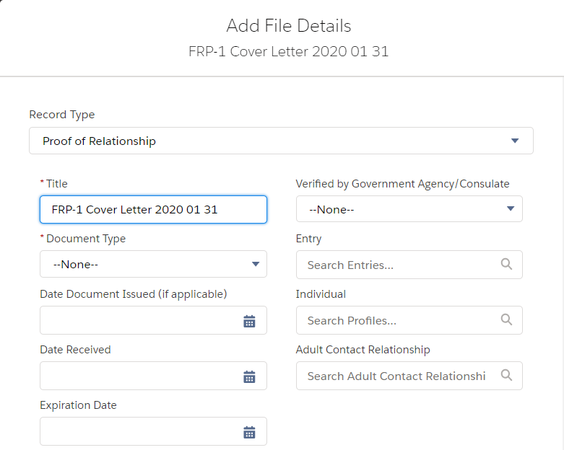
- Yes
- No
See table below.
See table below.
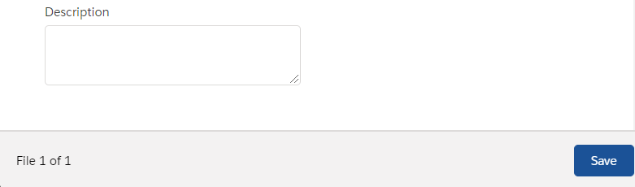

Dropdown options for “Record Type” and corresponding options for “Document Type”
Record Type | Document Type
Proof of Relationship | Birth Certificate – UAC; Baptismal Certificate; Birth Certificate – Sponsor; Birth Certificate – Other; Consulate Written Affirmation of Relationship; Verified by Government Agency/Consulate; Court Order – Adoption; Court Order – Guardianship; Court Order – Other; Government Issued Photo ID; Government Issued Ration Card; Hospital Record; Interview Notes; Land Deeds – Sponsor and UAC’s Family; Letter of Designation for Care of a Minor; Marriage Certificate; Passport (including stamps); Photographs; Remittance Receipts; School Record/Diploma; Social Media Posts; Genogram; Other
Background Check | FBI Criminal History and FBI Name Check
Case Coordination and Discharge | Verification of Release; Release Request; Discharge Notification; ORR Notice to ICE; and Notice of Transfer to ICE
Case Management | Verification of Release; Release Request; Discharge Notification; ORR Notice to ICE; New Placement Orientation; Safety Plan; Other; Medical Checklist; Transfer; Admission Assessment; Influx Transfer Facility Checklist; and LTFC Memo
Compliance Document | Other; ORR Closed Corrective Action; ORR Closed Monitoring Report; ORR Site Visit Report; Program Licensing Investigation; and PSA Audit
Compliance Forms | Privacy 101; ROB; and Cybersecurity
Education | Other, Initial Education Intake Assessment; ESL Assessment; Progress Report Card; and Educational Reassessment Report
FRP Forms | FRP 2 Authorization for Release of Information; FRP 3 Family Reunification Application; FRP 9 Letter of Designation for Care of a Minor; and FRP 10 Sponsor Declaration
Facility Document | Other; Facility Intake List; Program Brief; Program Lease; Signed Cooperative Agreement; State Licensure; Fire Inspection; Emergency/Evacuation Plan; and Facility Floor Plan
HS/PRS Document | Addendum; Other Supporting Documents; and Post Release Assessment Report
Health Documentation | Public Health Investigation Form; Hospital Discharge Instructions; Hospital Discharge Summary; Image Study Reading (TB); Image Study Reading (Non-TB); Immunization Record; Initial Medical Exam Form; Initial Dental Exam Form; Lab Results; Medications; Health Evaluation Form; Office Notes; Specialist Notes; Supplemental TB Screening Form; and Other Health Document
Legacy Document | All “Document Type” options available under other Record Types are available for this Record Type
Legal Document | Birth Certificate – UAC; Court Order (Flores Bond); Court Order (Other); Court Order (Removal); Court Order (VD); Decision (Administrative Review); Decision (Appeal of ORR Decision); Decision (Flores Bond Letter); Decision (Specific Consent); DHS Document (I-213); DHS Document (NTA); DHS Document (Other); Form (Attorney of Record); Form (Authorization for Release of Information); Form (Change of Venue); Form (Flores Bond Hearing Motion); Form (Legal Resource Guide Part II – Admission); Form (Legal Resource Guide Part III – Release); Form (Notice of Placement); Form (Specific Consent); Other Legal Document; OTIP Eligibility Letter; OTIP Interim Assistance Letter; Placement Identification Document; Records (Court); Records (Criminal/Delinquency Records); and Post Legal Status Plan
Medical Document | DHS Docs and Medical Checklist
Mental Health Documentation | Clinical Notes; Progress Notes; Discharge Summary; Psychiatric Evaluation Report; Psychological Evaluation Report; RTC Recommendation Letter; Developmental Assessment Report; and Other Mental Health Document
Monitoring Visit | Behavior Management Plan; Care Provider Policies and Procedures; Community Partnerships/Services; Cost of Care; Education Documents; Emergency and Evacuation Plan; Fire and Safety Code Permits/Reports; Food Services; Foster Home Safety Checklist; Foster Parent Agreement; Foster Parent Files; Foster Parent Orientation Manual; Foster Parent Trainings; Full Staff List; Geographic Areas Served; Health/Sanitation Inspection Reports; Independent Living Resources; List of Current Foster Parents; List of Home Study Cases; Map of Facility; Memorandum of Understanding; Monitoring Schedule; Monitoring Tools and Instruments; Monitoring Visit Reports; Mosquito Control Inspection; Organizational Chart; Quality Assurance Resources; Respite and Retention Procedures; Site Visit Guide; Staff Trainings; Staffing Plan; State Licensing/CPS; UAC Case Files; UAC Orientation Packet; UAC with G-28s; and Vehicle Inspections
Operational Document | Other; Grantee Daily Schedule; Internal SOPs; Staff Training Curriculum; Educational Curriculum; Vocational Curriculum; Food Menu; UAC Handbook/Orientation; Prevention of Sexual Abuse/Harassment SOPs; and Organizational Chart
Other | DocGen; Placement Authorization; Medical Authorization; Notice of Placement; UAC Assessments; New Placement Orientation; Other; and Manifest
Policy Guidance Documents | Policy Memo; Field Guidance; Interim Guidance; Form or Related Material; Frequently Asked Questions; Procedure Manual; Other Guidance; Resource Material; and Training
Profile Picture | Other
Proof of Address | Current Lease or Mortgage Statement; Notarized Letter from Landlord; Utility Bill, Bank Statement; Payroll Check Stub; Official Mail; Other Similar Document; and Letter/Code
Proof of Financial Stability | Proof of Financial Stability
Proof of Identity | US Passport; US Passport Card; Foreign Passport; Permanent Resident Card; Alien Registration Receipt Card; Employment Authorization Document; US Driver’s License or Identification Card; US Certificate of Naturalization; US Military Identification Card; Birth Certificate; Court Order for Name Change; Foreign National Identification Card; Consular Passport Renewal Receipt; Foreign Driver’s License; Foreign Voter Registration Card; Canadian Border Crossing Card; Mexican Border Crossing Card; Refugee Travel Documents; Other Similar Government Document; and Marriage Certificate
Proof of Immigration Status or U.S. Citizenship | US Passport; Valid Visa; Legal Permanent Resident Card; Notice to Appear; Other Federal Government Document Providing Immigration Status; US Birth Certificate; US Naturalization Papers; Court Order; and Other Government Issued Document Proving US Citizenship
Referral Documents | Birth Certificate – UAC; Baptismal Certificate; DocGen; FRP 2 Authorization for Release of Information; FRP 3 Family Reunification Application; FRP 9 Letter of Designation for Care of a Minor; and FRP 10 Sponsor Declaration; US Passport; US Passport Card; Foreign Passport; Permanent Resident Card; Alien Registration Card Receipt; Employment Authorization Document; US Driver’s License or Identification Card; US Certificate of Naturalization; US Military Identification Card; Birth Certificate; Court Order for Name Change; Foreign National Identification Card; Consular Passport Renewal Receipt; Foreign Driver’s License; Foreign Voter Registration Card; Canadian Border Crossing Card; Mexican Border Crossing Card; Refugee Travel Documents; Valid Visa; Legal Permanent Resident Card; Notice to Appear; Other Federal Government Document Providing Immigration Status; US Birth Certificate; US Naturalization Papers; Court Order; and Other Government Issued Document Proving US Citizenship; Birth Certificate – Sponsor; Birth Certificate – Other; Consulate Written Affirmation of Relationship; Verified by Government Agency/Consulate; Court Order – Adoption; Court Order – Guardianship; Court Order – Other; Death Certificate; Family Session Case Note; Government Issued Photo ID; Government Issued Ration Card; Hospital Record; Interview Notes; Land Deeds – Sponsor and UAC’s Family; Letter of Designation for Care of a Minor; Marriage Certificate; Passport (including stamps); Photographs; Remittance Receipts; School Record/Diploma; Social Media Posts; Genogram; Current Lease or Mortgage Statement; Notarized Letter from Landlord; Utility Bill, Bank Statement; Payroll Check Stub; Official Mail; Other Similar Document; Letter/Code; Proof of Financial Stability; Self-Disclosed Criminal History; Verification of Release; Release Request; Discharge Notification; ORR Notice to ICE; Referral Documents; and Other
Release Request | Best Interest Recommendation Letter; R-4 Release Request; ORR Denial Letter; Parent Denial Letter; Program Acceptance Letter; Recommendation to Deny Release; Referral Services COO; Safety Plan; Travel Document; Travel Itinerary; and Other
SIR/PLE Report Document | Police Report; State Licensing Documentation; Fraud Documentation; CPS Documentation; Significant Incident Report; PLE Report; Other; DOJ/FBI Documentations; and HHS OIG Documentation
Self-Disclosed Criminal History | Self-Disclosed Criminal History
Sponsor Assessment | Initial and Final

Entry Team Data Entry Window
- Assistant Lead Case Manager
- Assistant Lead Clinician
- Attorney
- Case Coordinator
- Case Manager
- Clinician
- Contractor Field Specialist
- Direct Care Worker
- Direct Operations Coordinator
- Federal Field Specialist
- Federal Field Specialist Supervisor
- HS/PRS Primary Provider
- HS/PRS Subcontractors
- Lead Case Manager
- Lead Clinician
- Medical Coordinator
- Program Support Staff
- Read Only
- Supervisor
- Supervisory Case Coordinator
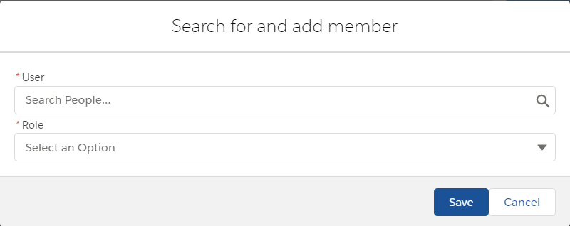

Intakes Placement Checklist Tab
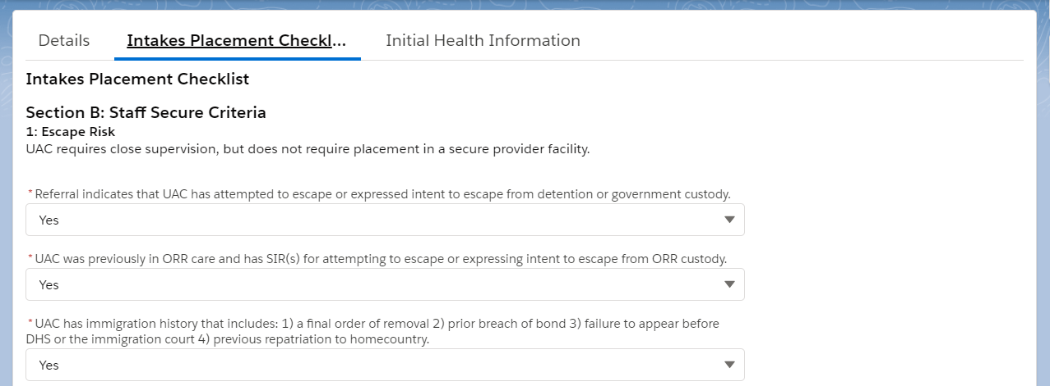
2. Conduct
UAC has been unacceptably disruptive in ORR custody or has displayed a pattern of severity of behavior prior to entering ORR custody that requires a staff secure setting. If applicable, previous SIRs or other internal ORR documents must be submitted in support of this finding.
- Yes
- No
- Yes
- No
- Yes
- No
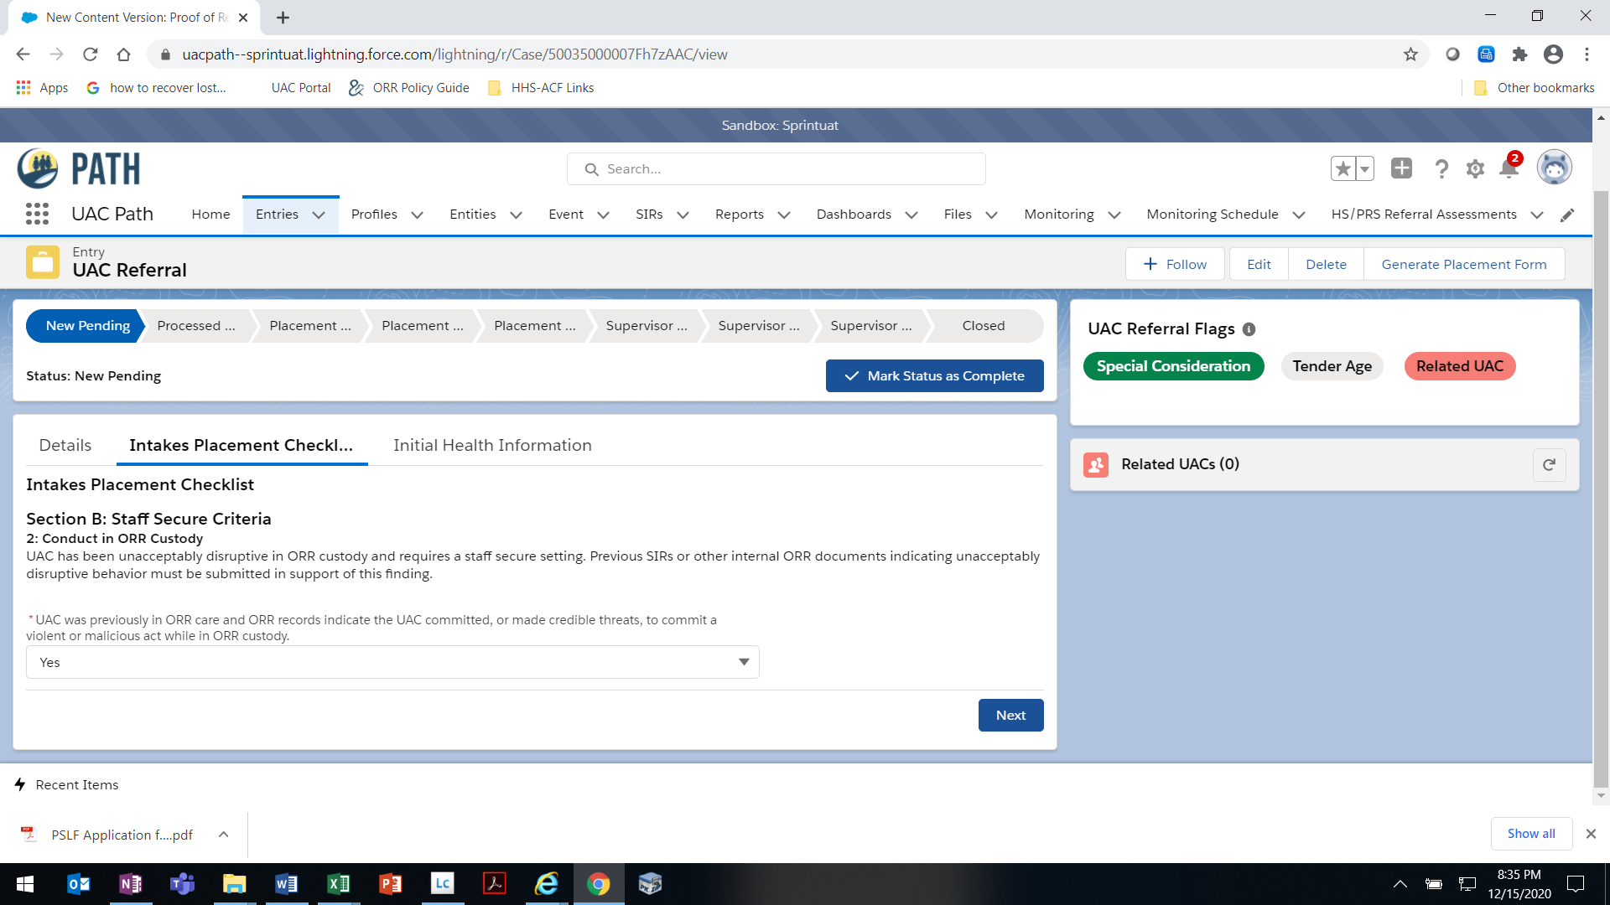
- Yes
- No
- Yes
- No
* UAC has displayed a pattern of severity of behavior, either prior to entering ORR custody or while in ORR care, that requires an increase in supervision by trained staff.
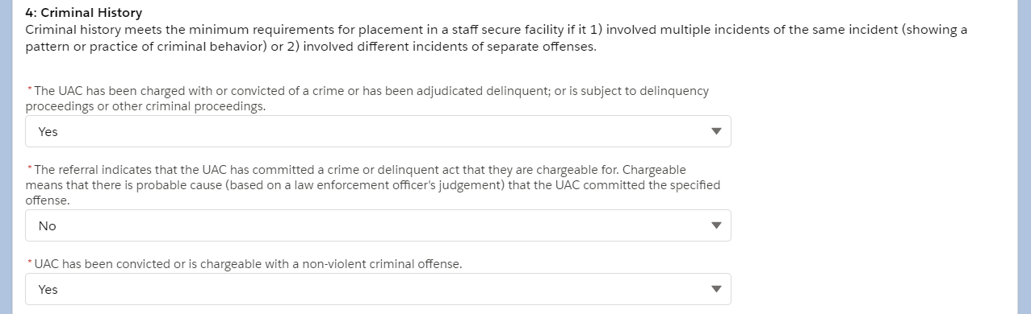
3. Criminal History
- Yes
- No
- Yes
- No
- Yes
- No
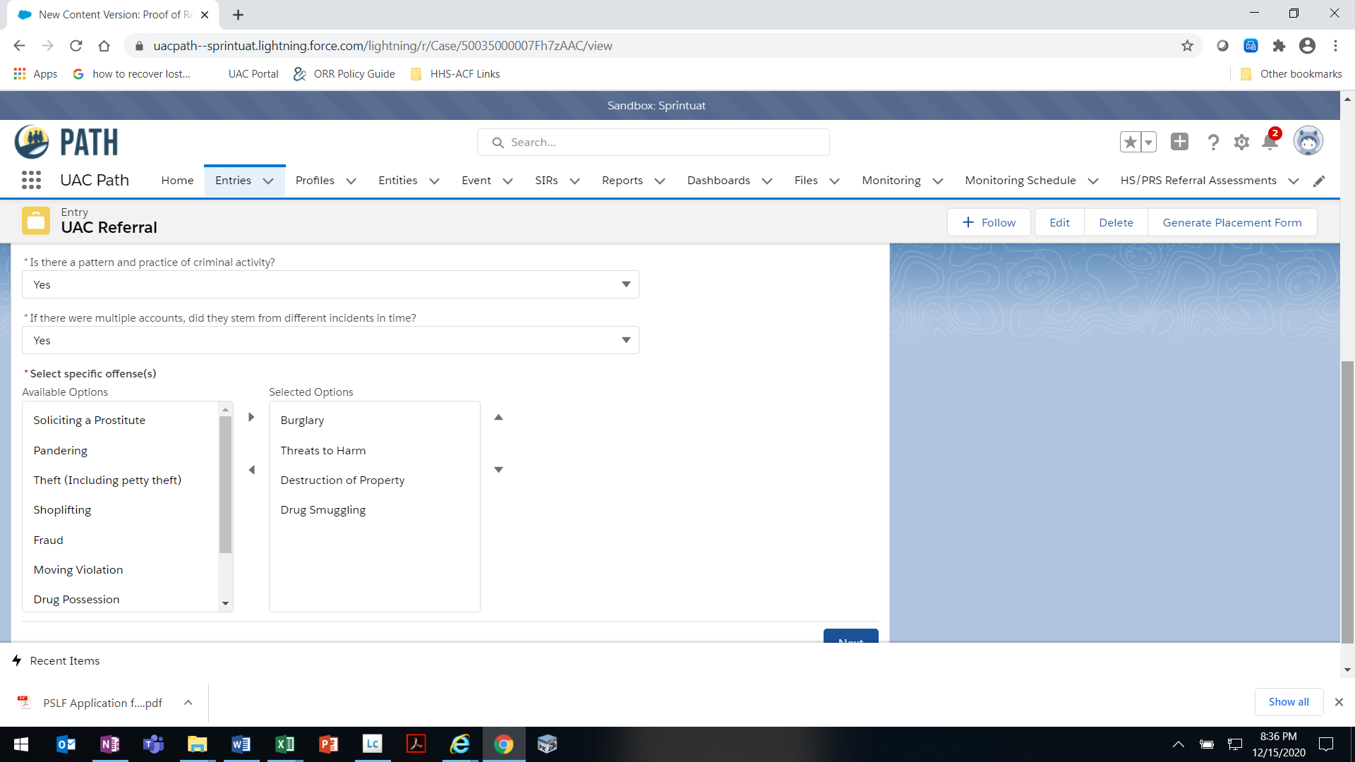
- Yes
- No
- Yes
- No
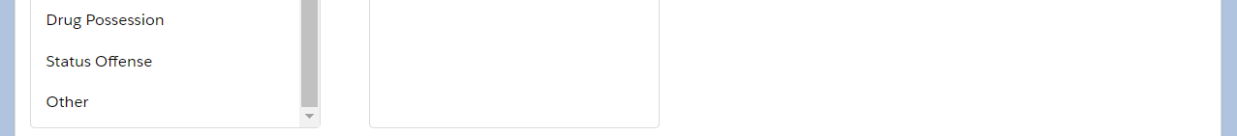
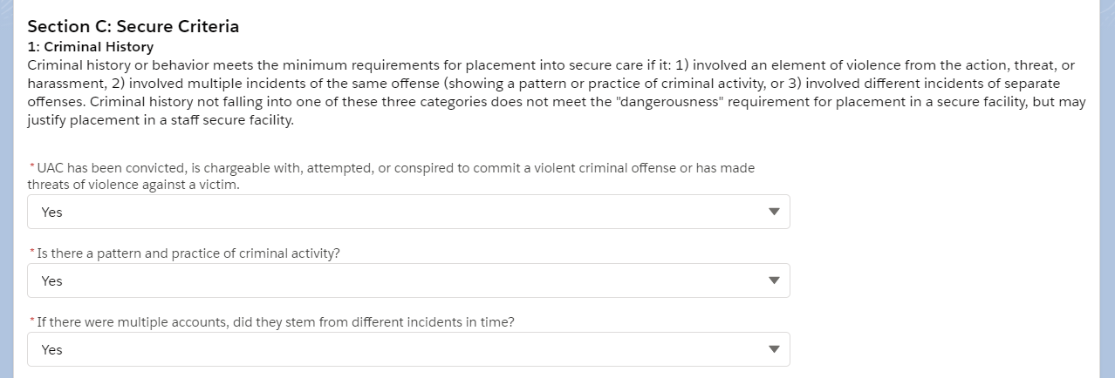
- Yes
- No
- Yes
- No
- Yes
- No
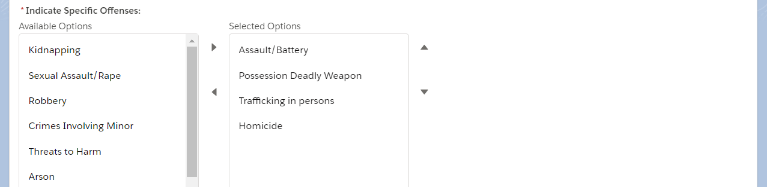
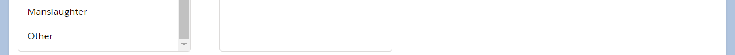
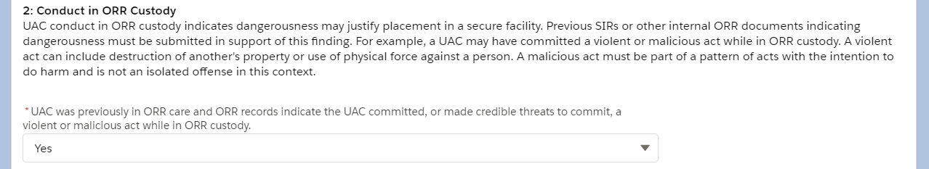
- Yes
- No
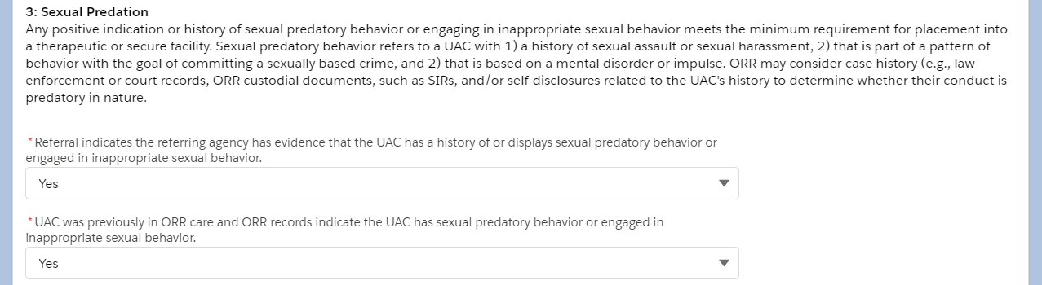
- Yes
- No
- Yes
- No
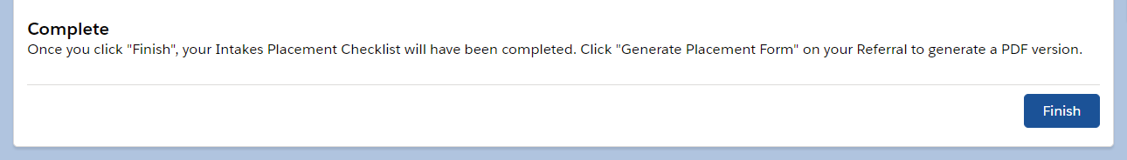
OMB 0970-0554 [valid through MM/DD/YYYY]

THE PAPERWORK REDUCTION ACT OF 1995 (Pub. L. 104-13) STATEMENT OF PUBLIC BURDEN: The purpose of this information collection is to allow ORR to receive a referral from a Federal agency and place the UAC in an ORR care provider facility. Public reporting burden for this collection of information is estimated to average 1.0 hour (plus an additional 0.5 hours for UAC who may require placement in a restrictive setting) per response, including the time for reviewing instructions, gathering and maintaining the data needed, and reviewing the collection of information. This is a mandatory collection of information (Homeland Security Act, 6 U.S.C. 279). An agency may not conduct or sponsor, and a person is not required to respond to, a collection of information subject to the requirements of the Paperwork Reduction Act of 1995, unless it displays a currently valid OMB control number. If you have any comments on this collection of information please contact UACPolicy@acf.hhs.gov.

P-7 [Rev. MM/DD/YYYY]

UAC Referral – Initial Health Information Tab
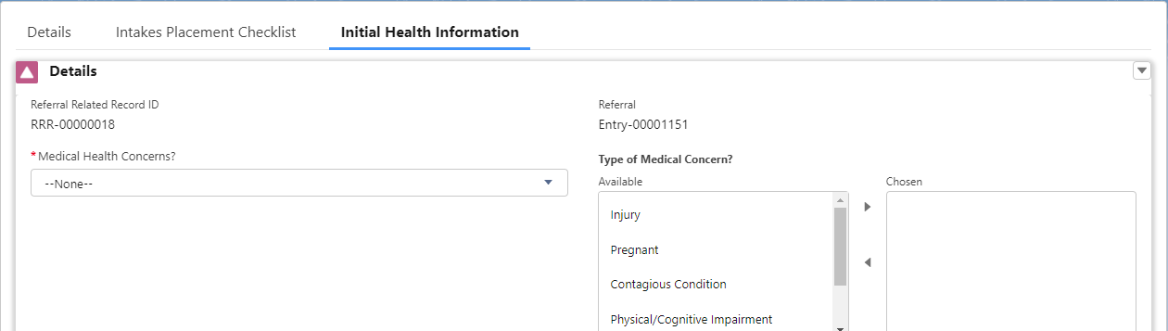
- Yes
- No
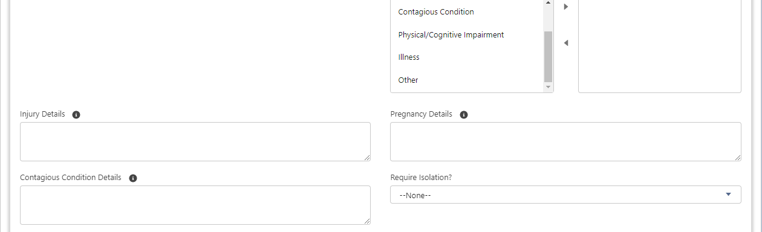
- Yes
- No
- Unknown
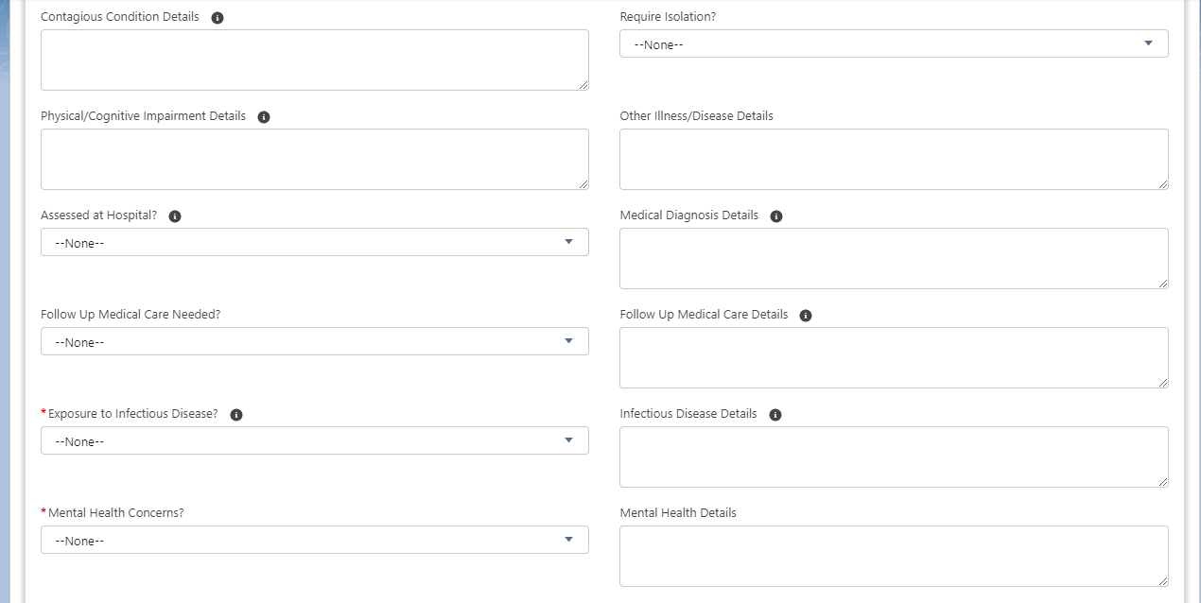
- Yes
- No
- Unknown
- Yes
- No
- Unknown
- Yes
- No
- Yes
- No
- Unknown
- Yes
- No
- NA
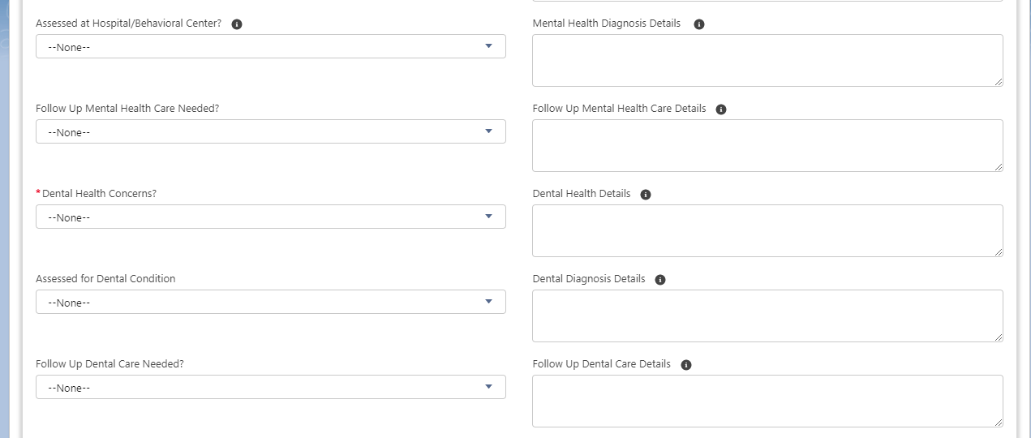
- Yes
- No
- Unknown
- Yes
- No
- Unknown
- Yes
- No
- Unknown
- Yes
- No
- Unknown
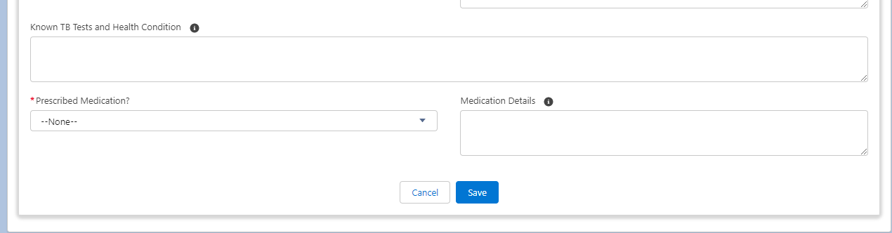
- Yes
- No
- Unknown
OMB 0970-0554 [valid through MM/DD/YYYY]

THE PAPERWORK REDUCTION ACT OF 1995 (Pub. L. 104-13) STATEMENT OF PUBLIC BURDEN: The purpose of this information collection is to allow ORR to receive a referral from a Federal agency and place the UAC in an ORR care provider facility. Public reporting burden for this collection of information is estimated to average 1.0 hour (plus an additional 0.5 hours for UAC who may require placement in a restrictive setting) per response, including the time for reviewing instructions, gathering and maintaining the data needed, and reviewing the collection of information. This is a mandatory collection of information (Homeland Security Act, 6 U.S.C. 279). An agency may not conduct or sponsor, and a person is not required to respond to, a collection of information subject to the requirements of the Paperwork Reduction Act of 1995, unless it displays a currently valid OMB control number. If you have any comments on this collection of information please contact UACPolicy@acf.hhs.gov.

P-7 [Rev. MM/DD/YYYY]

Intakes Placement Checklist – System-Generated PDF
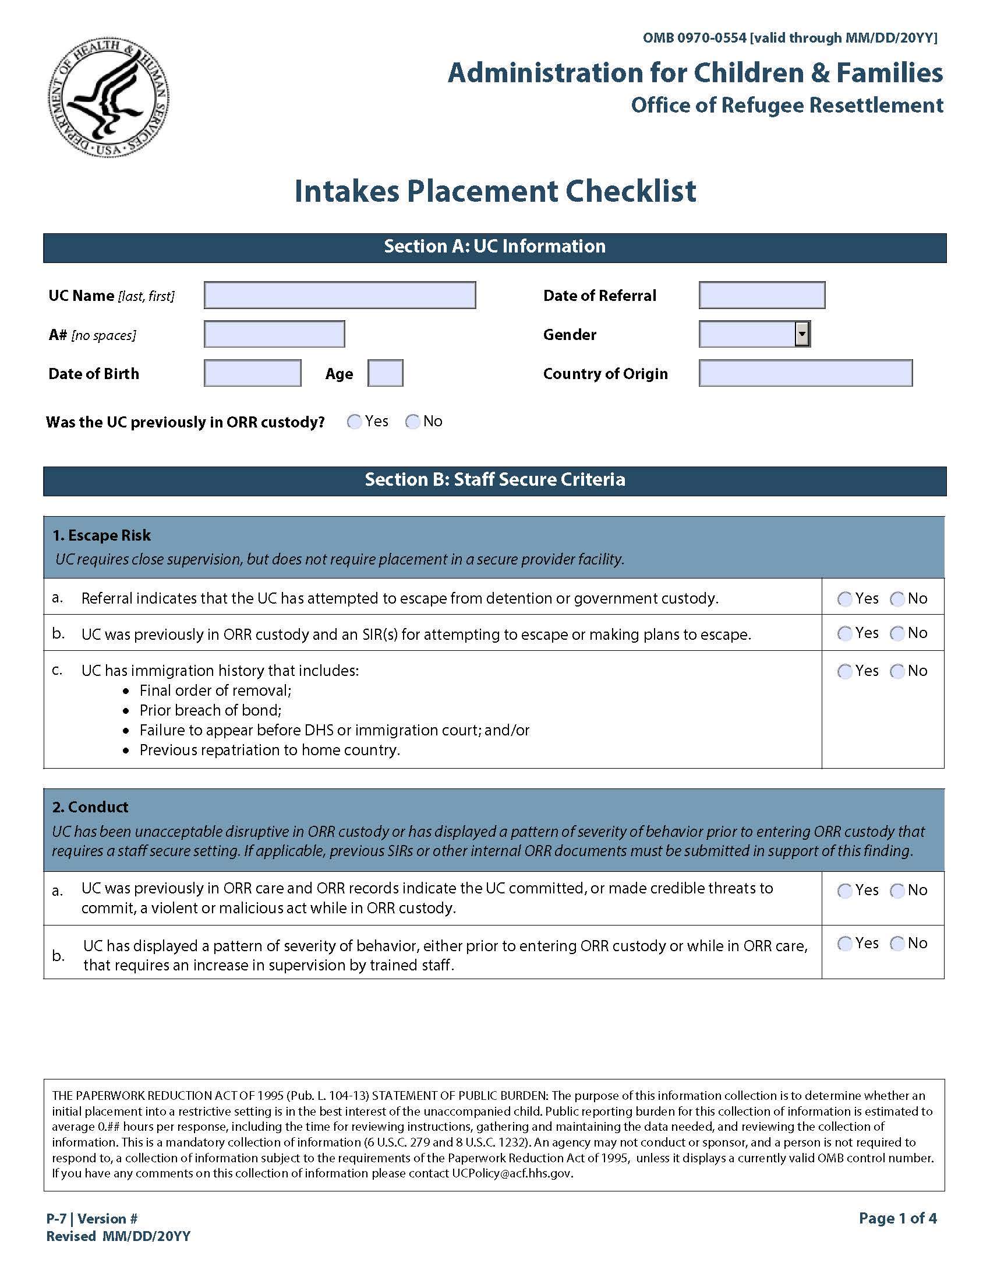
Sex
