UAC Profile (Form P-13)

Data Entry Window
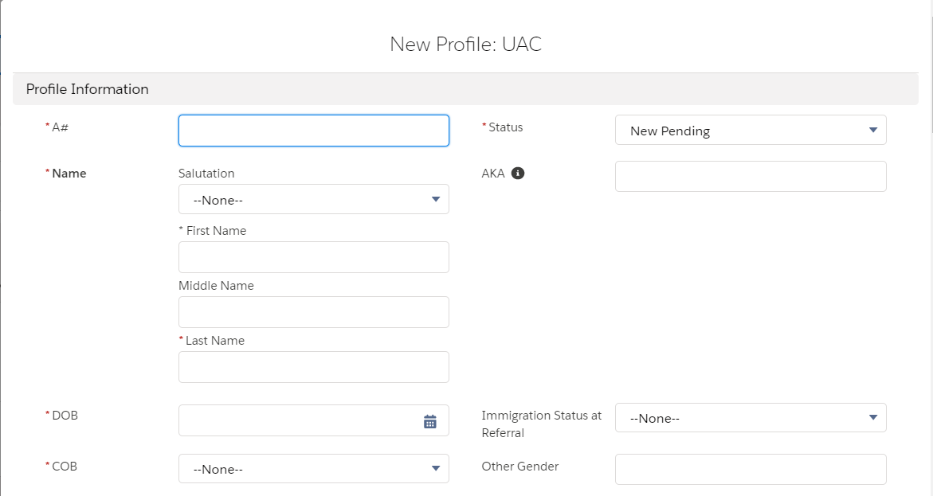

- Yes
- No
- NTA Issued
- Final Deportation Order
- US Citizen (Child of ORR Minor in Care)
- None
- New Pending
- Processed Pending
- Referral Cancelled
- Placement Designation
- Admitted
- In Transfer
- Discharged
- Pending Transfer
List of all countries
- None
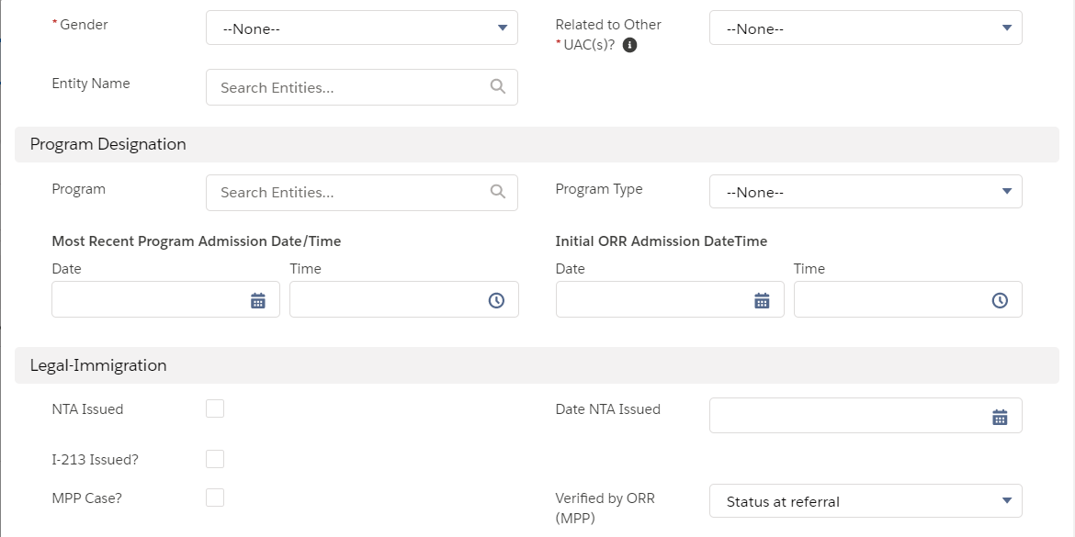
Sex
- Male
- Female
- Status at referral
- Confirmed
- Pending
- Needs Further Review
- Status at referral
- Confirmed
- Pending
- Needs Further Review
- Influx Care Facility
- Long Term Foster Care
- LTFC – Community Placements
- LTFC – Group Home
- Residential Treatment Center
- Secure
- Shelter
- Staff Secure
- Therapeutic Group Home
- Therapeutic Staff Secure
- Therapeutic Foster Care
- Emergency Intake Sites
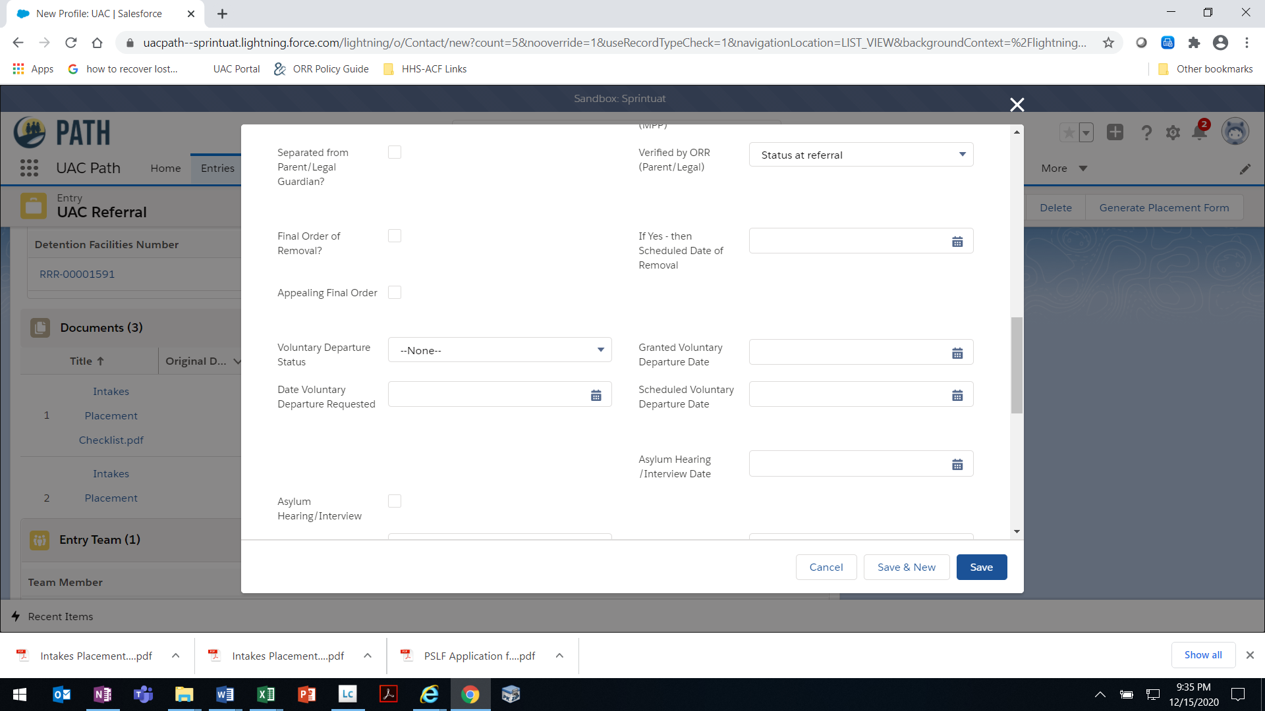
- Requested
- In Progress
- Granted
- Denied
- Withdrawal

- SIJ
- Asylum
- U-Visa
- T-Visa
- Other
- VAWA
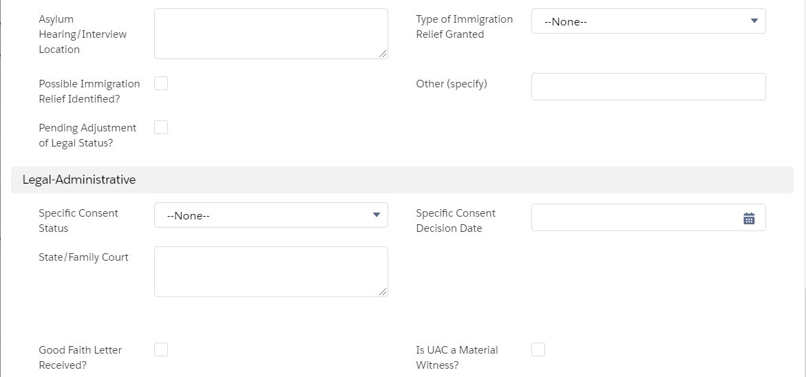
- Requested
- In Progress
- Granted
- Denied
- Appealed
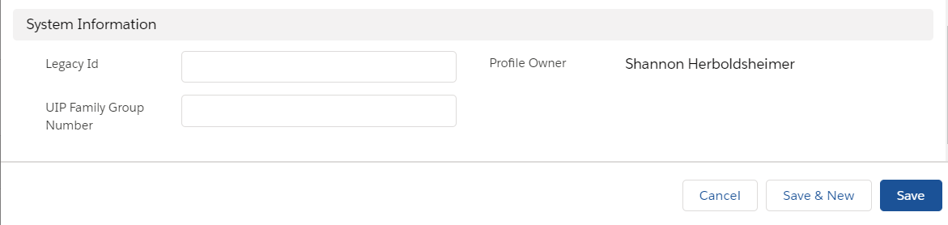
OMB 0970-0554 [valid through MM/DD/YYYY]
THE PAPERWORK REDUCTION ACT OF 1995 (Pub. L. 104-13) STATEMENT OF PUBLIC BURDEN: The purpose of this information collection is to create a profile for a UAC from which all information related to their case can be accessed. Public reporting burden for this collection of information is estimated to average 0.75 hours per response, including the time for reviewing instructions, gathering and maintaining the data needed, and reviewing the collection of information. This is a mandatory collection of information (Homeland Security Act, 6 U.S.C. 279). An agency may not conduct or sponsor, and a person is not required to respond to, a collection of information subject to the requirements of the Paperwork Reduction Act of 1995, unless it displays a currently valid OMB control number. If you have any comments on this collection of information please contact UACPolicy@acf.hhs.gov.
P-13 [Rev. MM/DD/YYYY]

UAC Profile Page
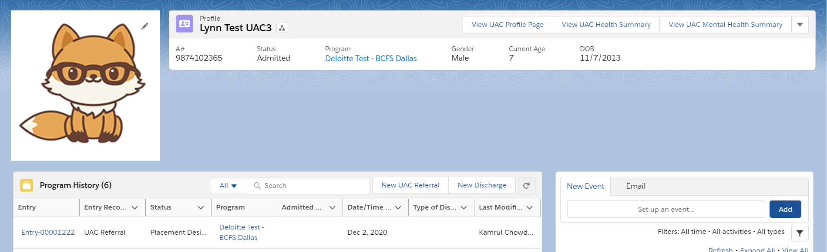
Sex
[PHOTO]
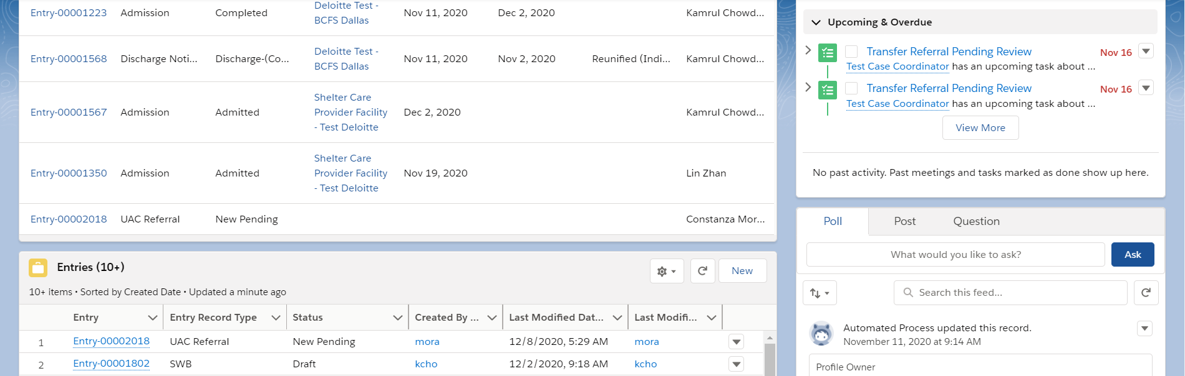
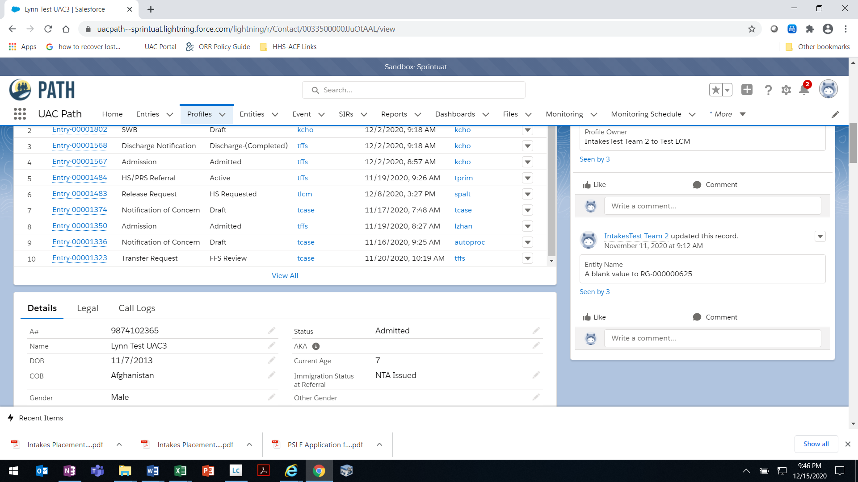

Sex
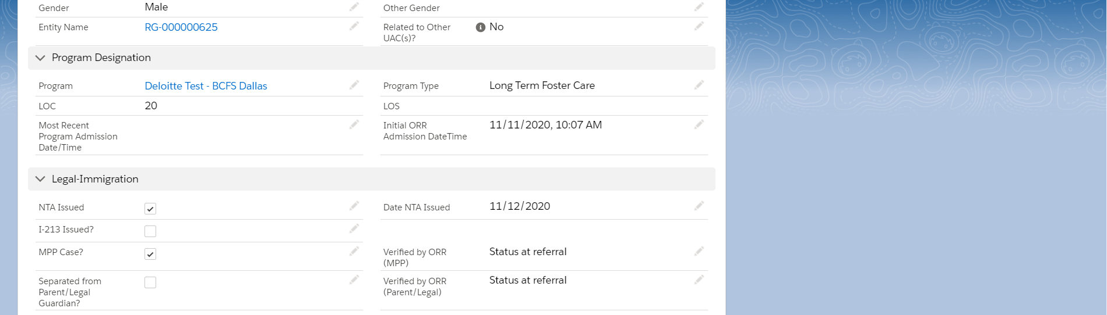
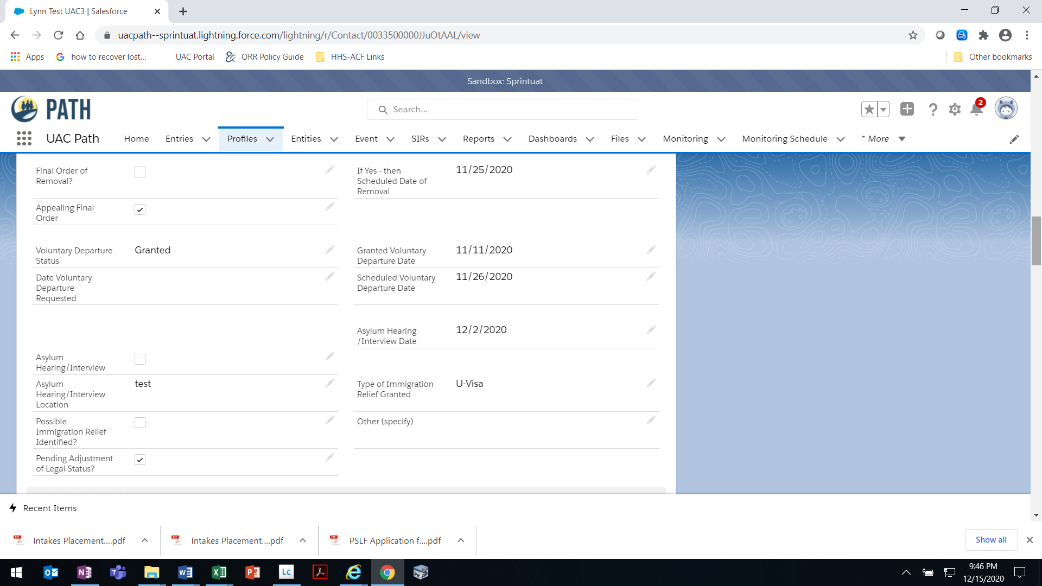

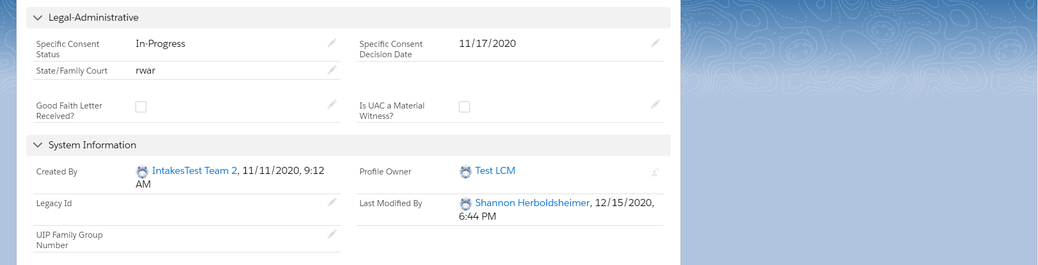
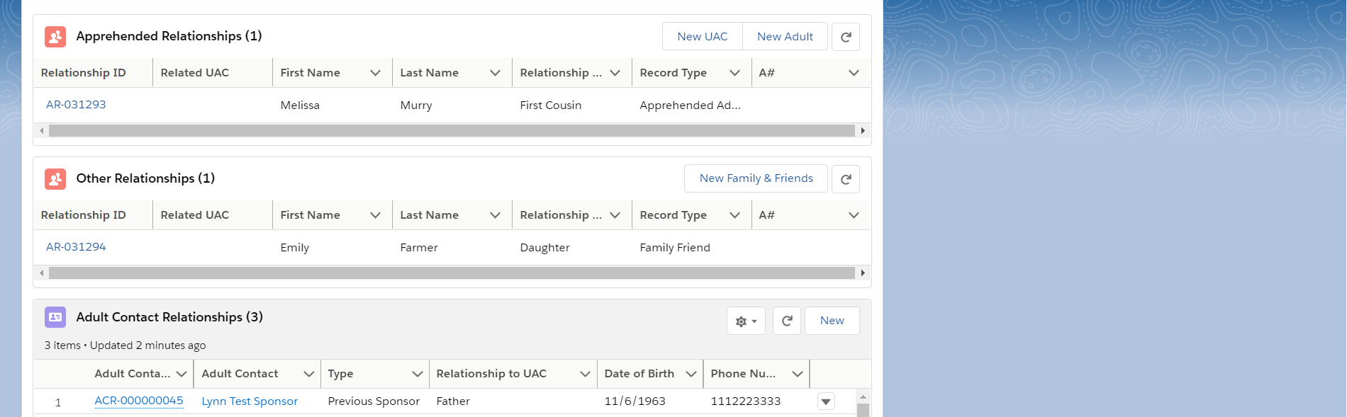

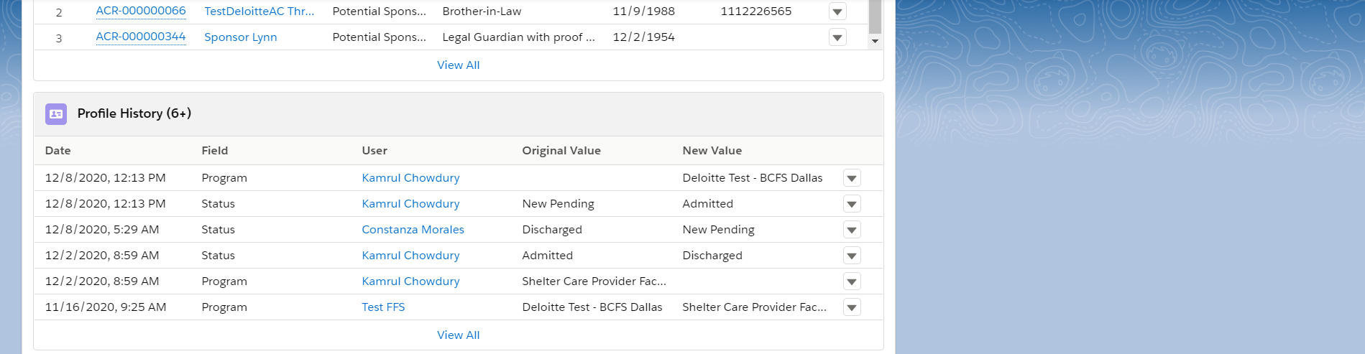
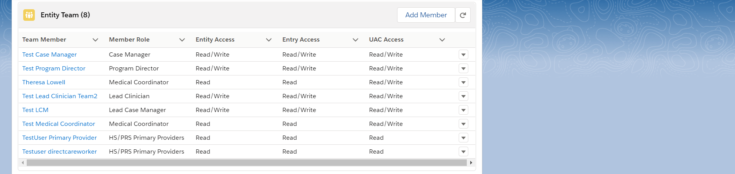
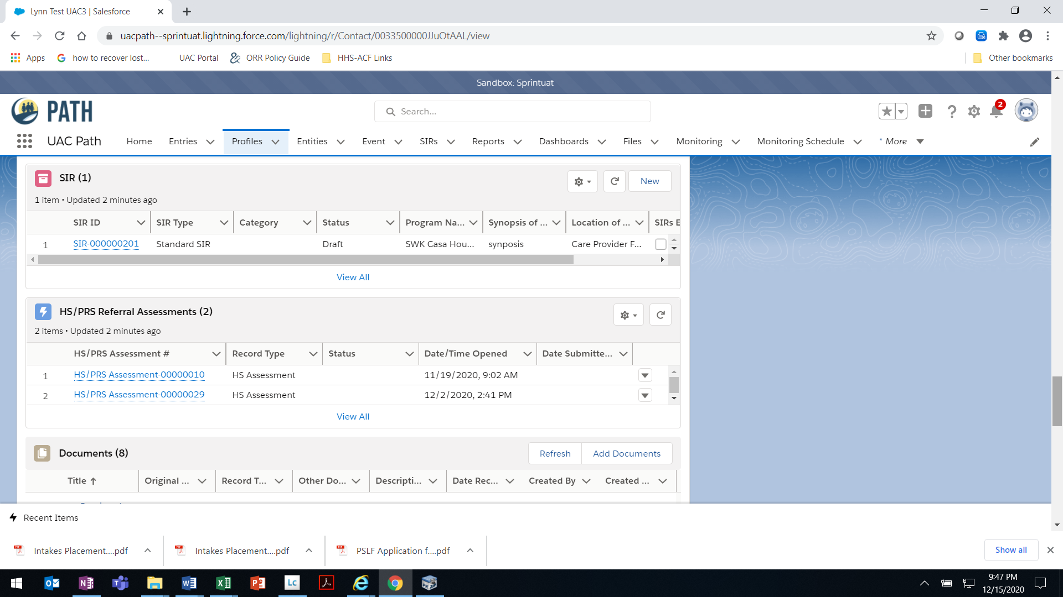
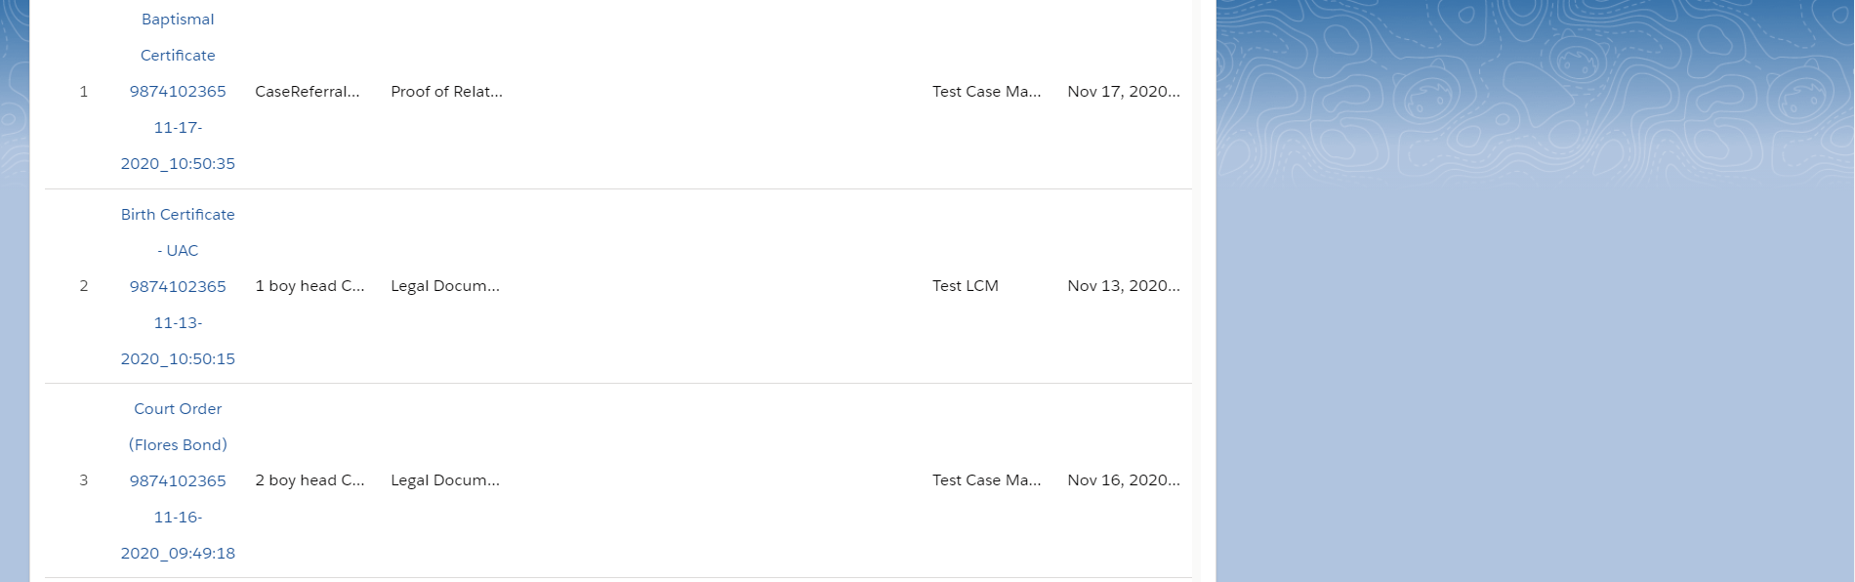
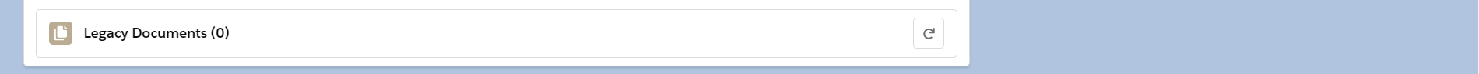
OMB 0970-0554 [valid through MM/DD/YYYY]

THE PAPERWORK REDUCTION ACT OF 1995 (Pub. L. 104-13) STATEMENT OF PUBLIC BURDEN: The purpose of this information collection is to create a profile for a UAC from which all information related to their case can be accessed. Public reporting burden for this collection of information is estimated to average 0.75 hours per response, including the time for reviewing instructions, gathering and maintaining the data needed, and reviewing the collection of information. This is a mandatory collection of information (Homeland Security Act, 6 U.S.C. 279). An agency may not conduct or sponsor, and a person is not required to respond to, a collection of information subject to the requirements of the Paperwork Reduction Act of 1995, unless it displays a currently valid OMB control number. If you have any comments on this collection of information please contact UACPolicy@acf.hhs.gov.

P-13 [Rev. MM/DD/YYYY]

Apprehended Relationships Data Entry Windows
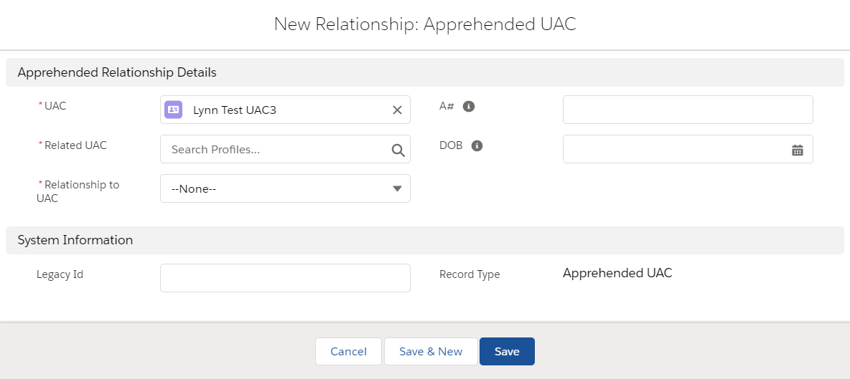
See below

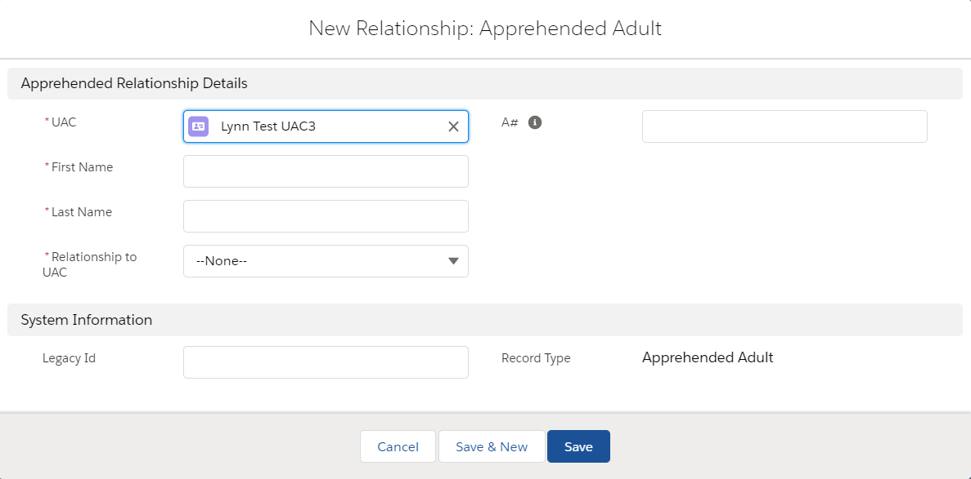
See below

Other Relationships Data Entry Window
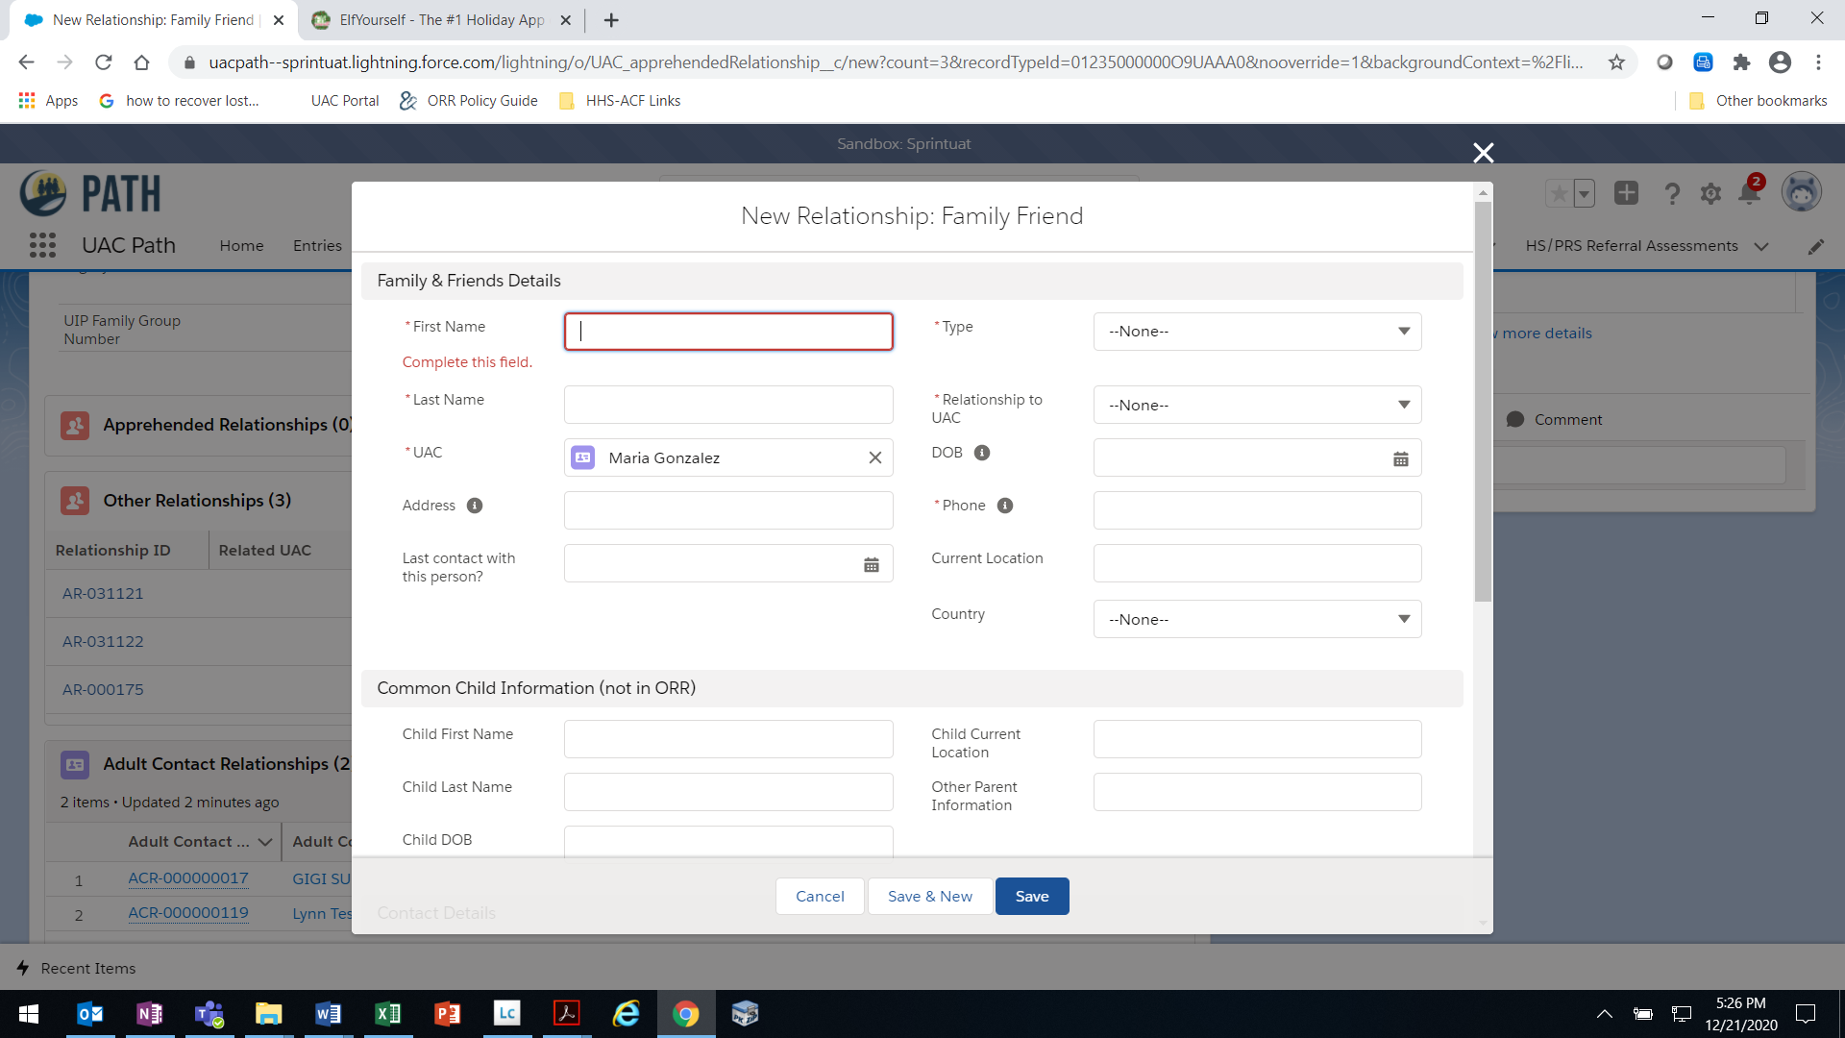

See below
List of all countries
- Family/Friend in U.S.
- Family/Friend in COB
- Caregiver in COB

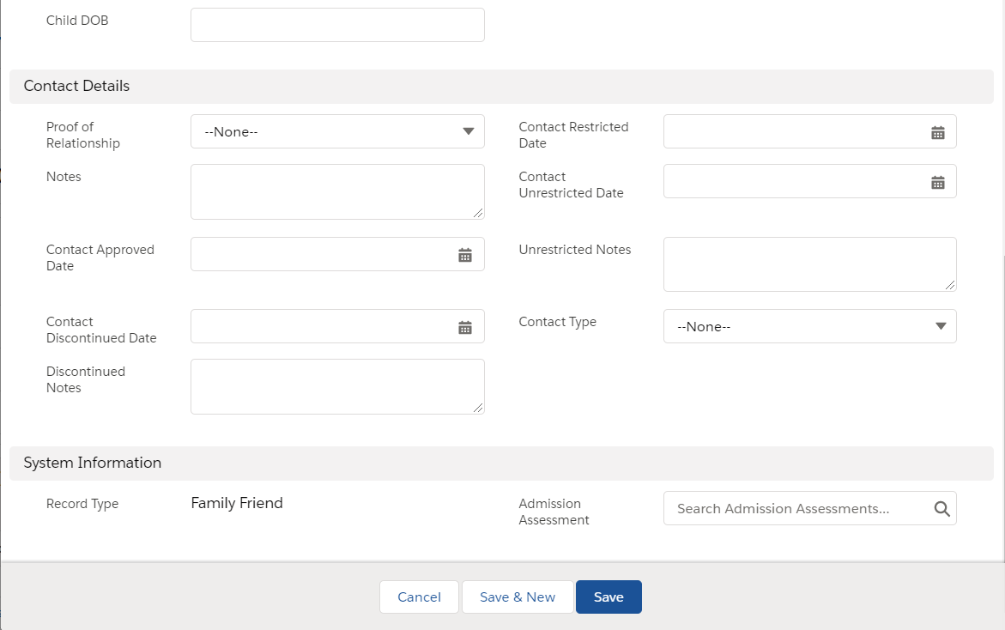
- Yes
- No
- N/A
- Authorized
- Restricted

Adult Contact Relationships Data Entry Window
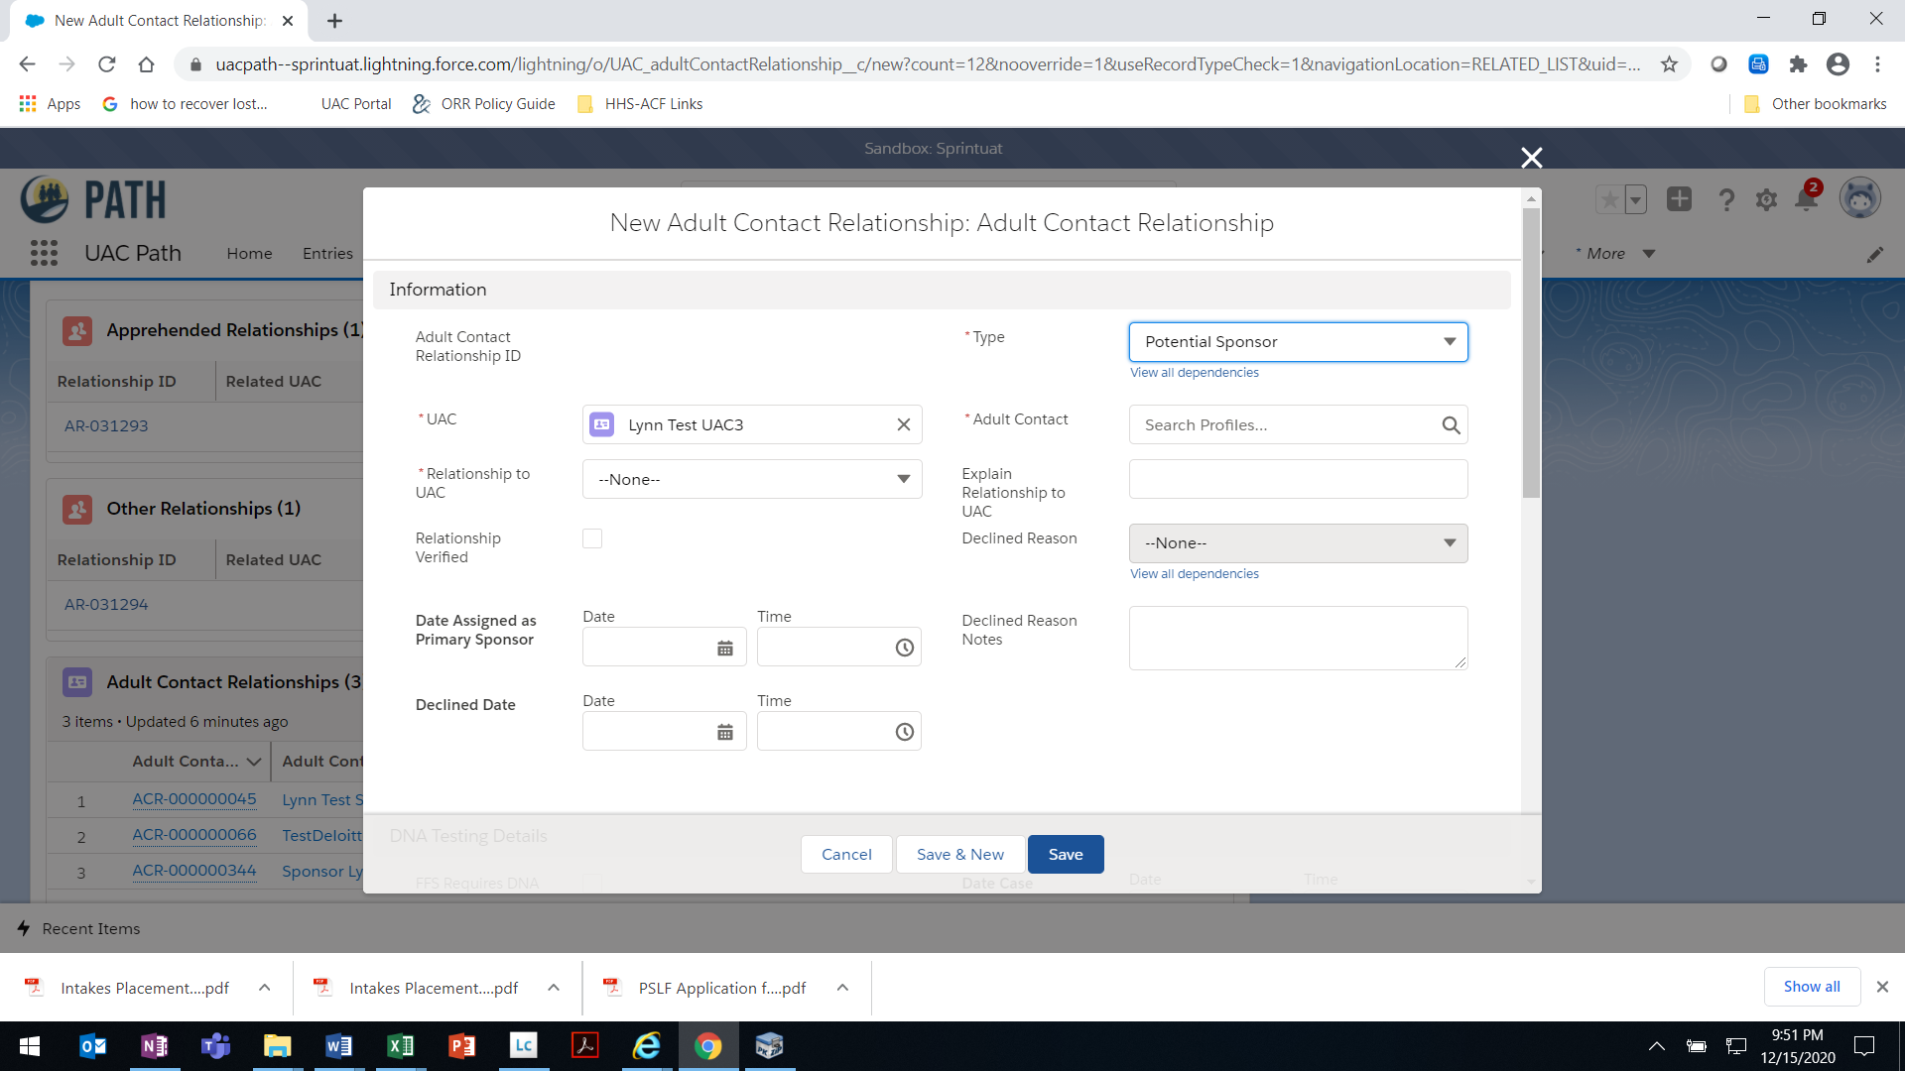
- No interest
- Lack of financial/residential stability
- Immigration fears
- No available at this time
See below
- Potential Sponsor
- Primary Sponsor
- Previous Sponsor
- Declined
- Legacy
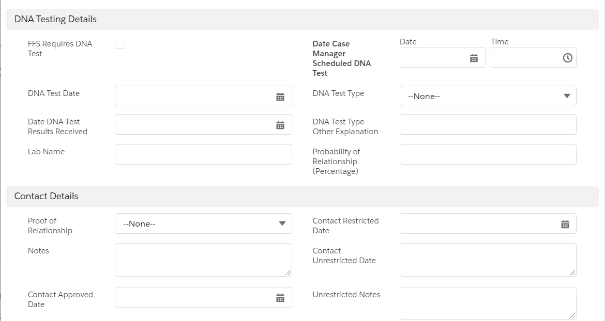
- Maternity
- Paternity
- Other
- Authorized
- Restricted
- Yes
- No
- N/A
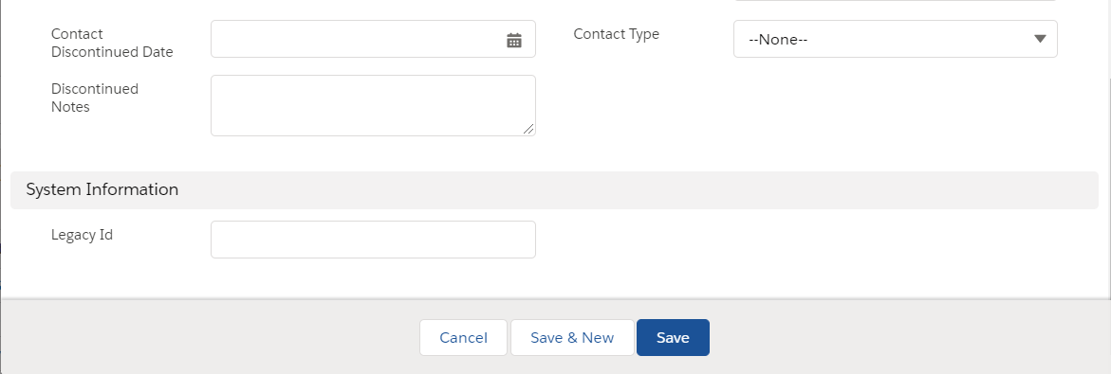

Relationship to UAC Dropdown Options
Adult First Cousin (Non-Primary Caregiver)  Adult First Cousin (Primary Caregiver)  Adult Nephew (Non-Primary Caregiver)  Adult Nephew (Primary Caregiver)  Adult Niece (Non-Primary Caregiver)  Adult Niece (Primary Caregiver)  Aunt (Non-Primary Caregiver)  Aunt  Brother-in-law (Non-Primary Caregiver)  Brother-in-law (Primary Caregiver)  Father  Godfather  Godmother  Half-Sibling (Non-Primary Caregiver)  Half-Sibling (Primary Caregiver)  Legal Guardian | Mother  Other Distant Relative  Sister-in-law (Non-Primary Caregiver)  Sister-in-law (Primary Caregiver)  Stepbrother  Stepfather Legally Adopted  Stepfather Non-Lgl Adopt. (Non-Primary Caregiver)  Stepfather Non-Lgl Adopted (Primary Caregiver)  Stepmother Legally Adopted  Stepmother Non-Lgl Adopt. (Non-Primary Caregiver)  Stepmother Non-Lgl Adopted (Primary Caregiver)  Stepsister  UAC’s Spouse  Uncle (Non-Primary Caregiver)  Uncle (Primary Caregiver)  Unrelated Sponsor

Entity Team Data Entry Window
This is a global picklist used across multiple forms that contains all roles. Appearance of a role on this list does not mean that role will be granted access to this form.
- Assistant Program Director
- Attorney
- Case Coordinator
- Case Manager
- Child Advocate Contact
- Clinician
- Contractor Field Specialist
- DHUC Medical Team Member
- DHUC Quality Assurance Specialist
- Direct Operations Coordinator
- DOJ/FBI
- Federal Field Specialist
- HHS OIG
- HS/PRS Primary Providers
- ICE FOJC
- Influx POC
- Intakes Backup Contact
- Intakes Contact
- Lead Case Manager
- Lead Clinician
- Legal Service Provider
- LNO
- Medical Coordinator
- Medical Service Director
- On-site Health Care Provider
- ORR Compliance Team
- Program Director
- Program Support Center
- Project Officer
- PSA Compliance Manager
- PSA Program Specialist
- PSA Team
- Regional Director
- Registered Nurse
- Senior Advisor for Child Well-Being & Safety
- Shift Supervisor
- Supervisory Case Coordinator
- Supervisory FFS
- Supervisory Project Officer
- Temporary
- VOLAG User
- Program Support Staff
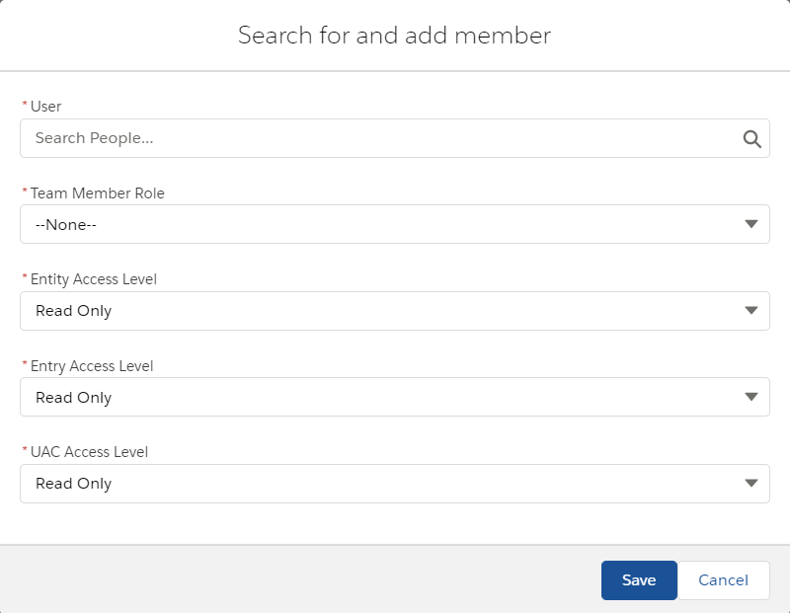
- Read Only
- Read/Write
- No Access
- Read Only
- Read/Write
- No Access
- Read Only
- Read/Write

Documents Data Entry Window

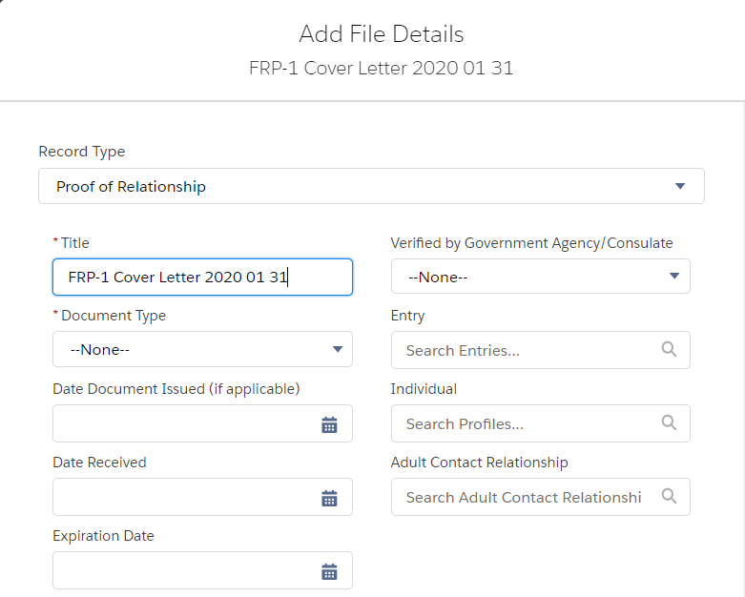
See table below.
- Yes
- No
See table below.
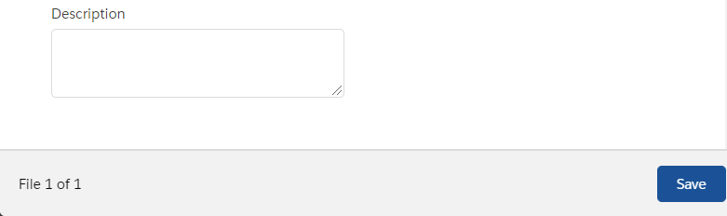

Dropdown options for “Record Type” and corresponding options for “Document Type”
Record Type | Document Type
Proof of Relationship | Birth Certificate – UAC; Baptismal Certificate; Birth Certificate – Sponsor; Birth Certificate – Other; Consulate Written Affirmation of Relationship; Verified by Government Agency/Consulate; Court Order – Adoption; Court Order – Guardianship; Court Order – Other; Government Issued Photo ID; Government Issued Ration Card; Hospital Record; Interview Notes; Land Deeds – Sponsor and UAC’s Family; Letter of Designation for Care of a Minor; Marriage Certificate; Passport (including stamps); Photographs; Remittance Receipts; School Record/Diploma; Social Media Posts; Genogram; Other
Background Check | FBI Criminal History and FBI Name Check
Case Coordination and Discharge | Verification of Release; Release Request; Discharge Notification; ORR Notice to ICE; and Notice of Transfer to ICE
Case Management | Verification of Release; Release Request; Discharge Notification; ORR Notice to ICE; New Placement Orientation; Safety Plan; Other; Medical Checklist; Transfer; Admission Assessment; Influx Transfer Facility Checklist; and LTFC Memo
Compliance Document | Other; ORR Closed Corrective Action; ORR Closed Monitoring Report; ORR Site Visit Report; Program Licensing Investigation; and PSA Audit
Compliance Forms | Privacy 101; ROB; and Cybersecurity
Education | Other, Initial Education Intake Assessment; ESL Assessment; Progress Report Card; and Educational Reassessment Report
FRP Forms | FRP 2 Authorization for Release of Information; FRP 3 Family Reunification Application; FRP 9 Letter of Designation for Care of a Minor; and FRP 10 Sponsor Declaration
Facility Document | Other; Facility Intake List; Program Brief; Program Lease; Signed Cooperative Agreement; State Licensure; Fire Inspection; Emergency/Evacuation Plan; and Facility Floor Plan
HS/PRS Document | Addendum; Other Supporting Documents; and Post Release Assessment Report
Health Documentation | Public Health Investigation Form; Hospital Discharge Instructions; Hospital Discharge Summary; Image Study Reading (TB); Image Study Reading (Non-TB); Immunization Record; Initial Medical Exam Form; Initial Dental Exam Form; Lab Results; Medications; Health Evaluation Form; Office Notes; Specialist Notes; Supplemental TB Screening Form; and Other Health Document
Legacy Document | All “Document Type” options available under other Record Types are available for this Record Type
Legal Document | Birth Certificate – UAC; Court Order (Flores Bond); Court Order (Other); Court Order (Removal); Court Order (VD); Decision (Administrative Review); Decision (Appeal of ORR Decision); Decision (Flores Bond Letter); Decision (Specific Consent); DHS Document (I-213); DHS Document (NTA); DHS Document (Other); Form (Attorney of Record); Form (Authorization for Release of Information); Form (Change of Venue); Form (Flores Bond Hearing Motion); Form (Legal Resource Guide Part II – Admission); Form (Legal Resource Guide Part III – Release); Form (Notice of Placement); Form (Specific Consent); Other Legal Document; OTIP Eligibility Letter; OTIP Interim Assistance Letter; Placement Identification Document; Records (Court); Records (Criminal/Delinquency Records); and Post Legal Status Plan
Medical Document | DHS Docs and Medical Checklist
Mental Health Documentation | Clinical Notes; Progress Notes; Discharge Summary; Psychiatric Evaluation Report; Psychological Evaluation Report; RTC Recommendation Letter; Developmental Assessment Report; and Other Mental Health Document
Monitoring Visit | Behavior Management Plan; Care Provider Policies and Procedures; Community Partnerships/Services; Cost of Care; Education Documents; Emergency and Evacuation Plan; Fire and Safety Code Permits/Reports; Food Services; Foster Home Safety Checklist; Foster Parent Agreement; Foster Parent Files; Foster Parent Orientation Manual; Foster Parent Trainings; Full Staff List; Geographic Areas Served; Health/Sanitation Inspection Reports; Independent Living Resources; List of Current Foster Parents; List of Home Study Cases; Map of Facility; Memorandum of Understanding; Monitoring Schedule; Monitoring Tools and Instruments; Monitoring Visit Reports; Mosquito Control Inspection; Organizational Chart; Quality Assurance Resources; Respite and Retention Procedures; Site Visit Guide; Staff Trainings; Staffing Plan; State Licensing/CPS; UAC Case Files; UAC Orientation Packet; UAC with G-28s; and Vehicle Inspections
Operational Document | Other; Grantee Daily Schedule; Internal SOPs; Staff Training Curriculum; Educational Curriculum; Vocational Curriculum; Food Menu; UAC Handbook/Orientation; Prevention of Sexual Abuse/Harassment SOPs; and Organizational Chart
Other | DocGen; Placement Authorization; Medical Authorization; Notice of Placement; UAC Assessments; New Placement Orientation; Other; and Manifest
Policy Guidance Documents | Policy Memo; Field Guidance; Interim Guidance; Form or Related Material; Frequently Asked Questions; Procedure Manual; Other Guidance; Resource Material; and Training
Profile Picture | Other
Proof of Address | Current Lease or Mortgage Statement; Notarized Letter from Landlord; Utility Bill, Bank Statement; Payroll Check Stub; Official Mail; Other Similar Document; and Letter/Code
Proof of Financial Stability | Proof of Financial Stability
Proof of Identity | US Passport; US Passport Card; Foreign Passport; Permanent Resident Card; Alien Registration Receipt Card; Employment Authorization Document; US Driver’s License or Identification Card; US Certificate of Naturalization; US Military Identification Card; Birth Certificate; Court Order for Name Change; Foreign National Identification Card; Consular Passport Renewal Receipt; Foreign Driver’s License; Foreign Voter Registration Card; Canadian Border Crossing Card; Mexican Border Crossing Card; Refugee Travel Documents; Other Similar Government Document; and Marriage Certificate
Proof of Immigration Status or U.S. Citizenship | US Passport; Valid Visa; Legal Permanent Resident Card; Notice to Appear; Other Federal Government Document Providing Immigration Status; US Birth Certificate; US Naturalization Papers; Court Order; and Other Government Issued Document Proving US Citizenship
Referral Documents | Birth Certificate – UAC; Baptismal Certificate; DocGen; FRP 2 Authorization for Release of Information; FRP 3 Family Reunification Application; FRP 9 Letter of Designation for Care of a Minor; and FRP 10 Sponsor Declaration; US Passport; US Passport Card; Foreign Passport; Permanent Resident Card; Alien Registration Card Receipt; Employment Authorization Document; US Driver’s License or Identification Card; US Certificate of Naturalization; US Military Identification Card; Birth Certificate; Court Order for Name Change; Foreign National Identification Card; Consular Passport Renewal Receipt; Foreign Driver’s License; Foreign Voter Registration Card; Canadian Border Crossing Card; Mexican Border Crossing Card; Refugee Travel Documents; Valid Visa; Legal Permanent Resident Card; Notice to Appear; Other Federal Government Document Providing Immigration Status; US Birth Certificate; US Naturalization Papers; Court Order; and Other Government Issued Document Proving US Citizenship; Birth Certificate – Sponsor; Birth Certificate – Other; Consulate Written Affirmation of Relationship; Verified by Government Agency/Consulate; Court Order – Adoption; Court Order – Guardianship; Court Order – Other; Death Certificate; Family Session Case Note; Government Issued Photo ID; Government Issued Ration Card; Hospital Record; Interview Notes; Land Deeds – Sponsor and UAC’s Family; Letter of Designation for Care of a Minor; Marriage Certificate; Passport (including stamps); Photographs; Remittance Receipts; School Record/Diploma; Social Media Posts; Genogram; Current Lease or Mortgage Statement; Notarized Letter from Landlord; Utility Bill, Bank Statement; Payroll Check Stub; Official Mail; Other Similar Document; Letter/Code; Proof of Financial Stability; Self-Disclosed Criminal History; Verification of Release; Release Request; Discharge Notification; ORR Notice to ICE; Referral Documents; and Other
Release Request | Best Interest Recommendation Letter; R-4 Release Request; ORR Denial Letter; Parent Denial Letter; Program Acceptance Letter; Recommendation to Deny Release; Referral Services COO; Safety Plan; Travel Document; Travel Itinerary; and Other
SIR/PLE Report Document | Police Report; State Licensing Documentation; Fraud Documentation; CPS Documentation; Significant Incident Report; PLE Report; Other; DOJ/FBI Documentations; and HHS OIG Documentation
Self-Disclosed Criminal History | Self-Disclosed Criminal History
Sponsor Assessment | Initial and Final

