Form ETA-9141C
CW 1 Application for Prevailing Wage Determination – New Application

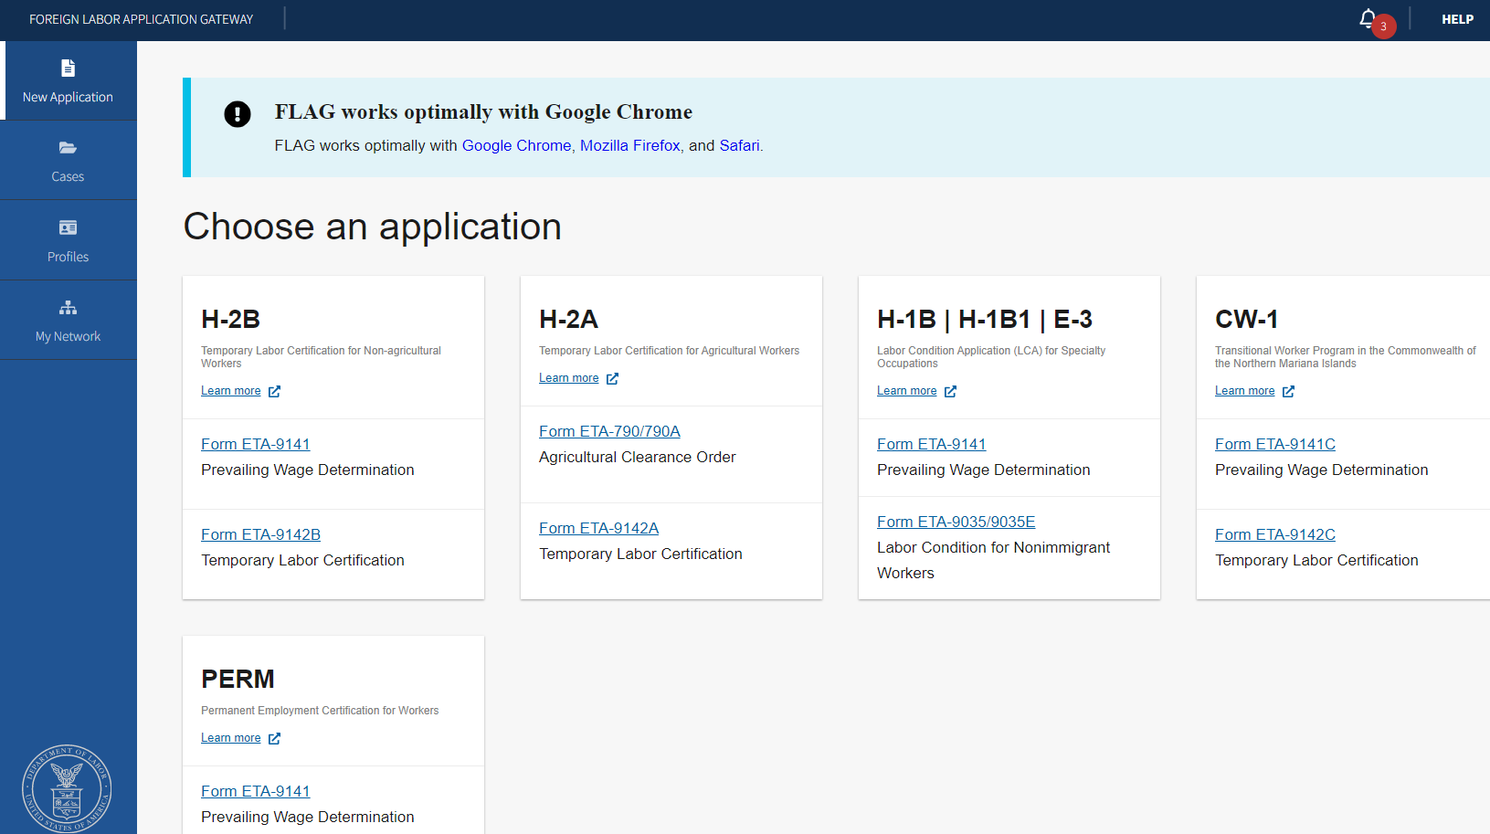

Figure 1: Home Screen to choose an application for CW-1 Form ETA-9141C

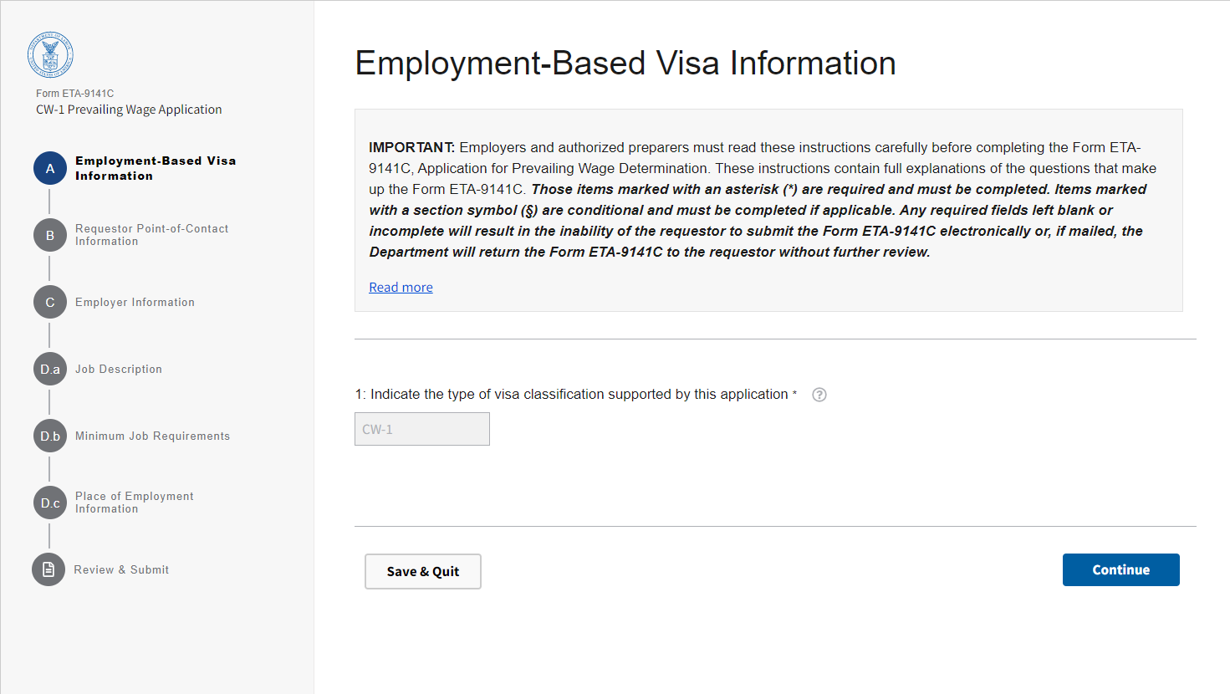

Figure 2: Section A: Employment-Based Visa Information

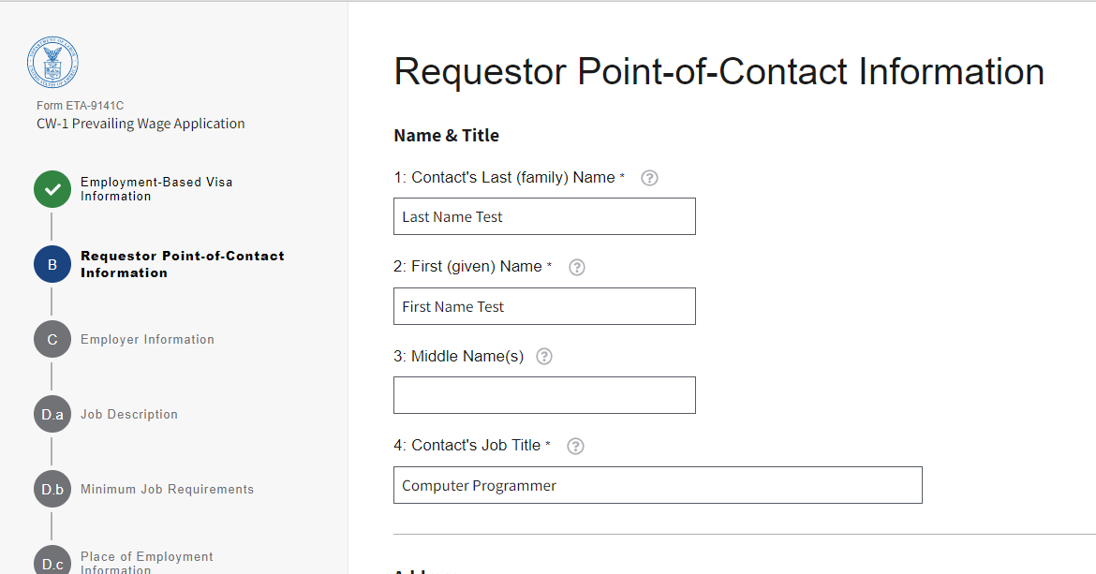

Figure 3: Section B: Requestor Point-of-Contact Information, Name and Title (B1 through B4)

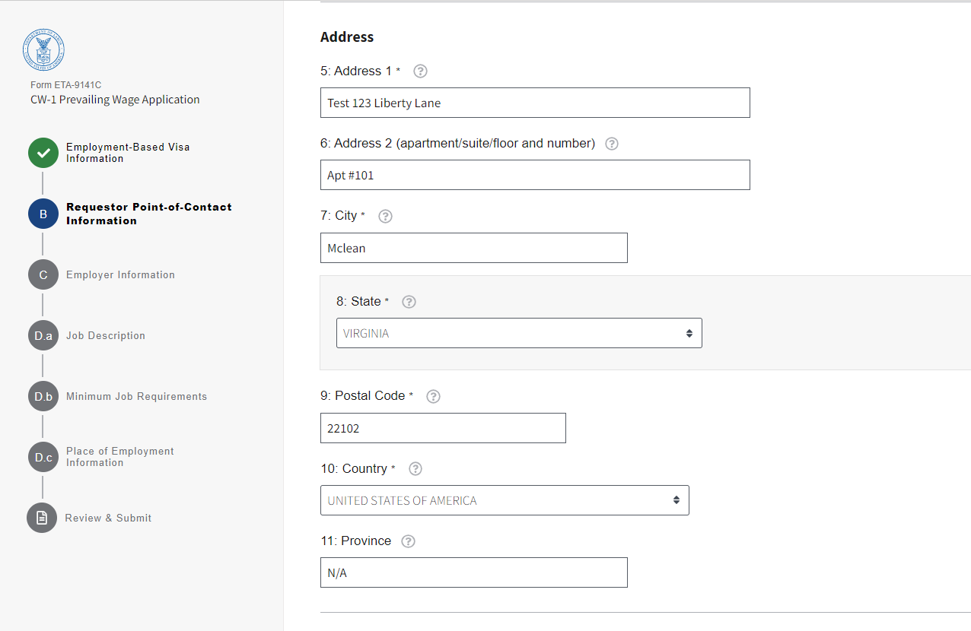

Figure 4: Section B: Requestor Point-of-Contact Information, Address (B5 through B11)

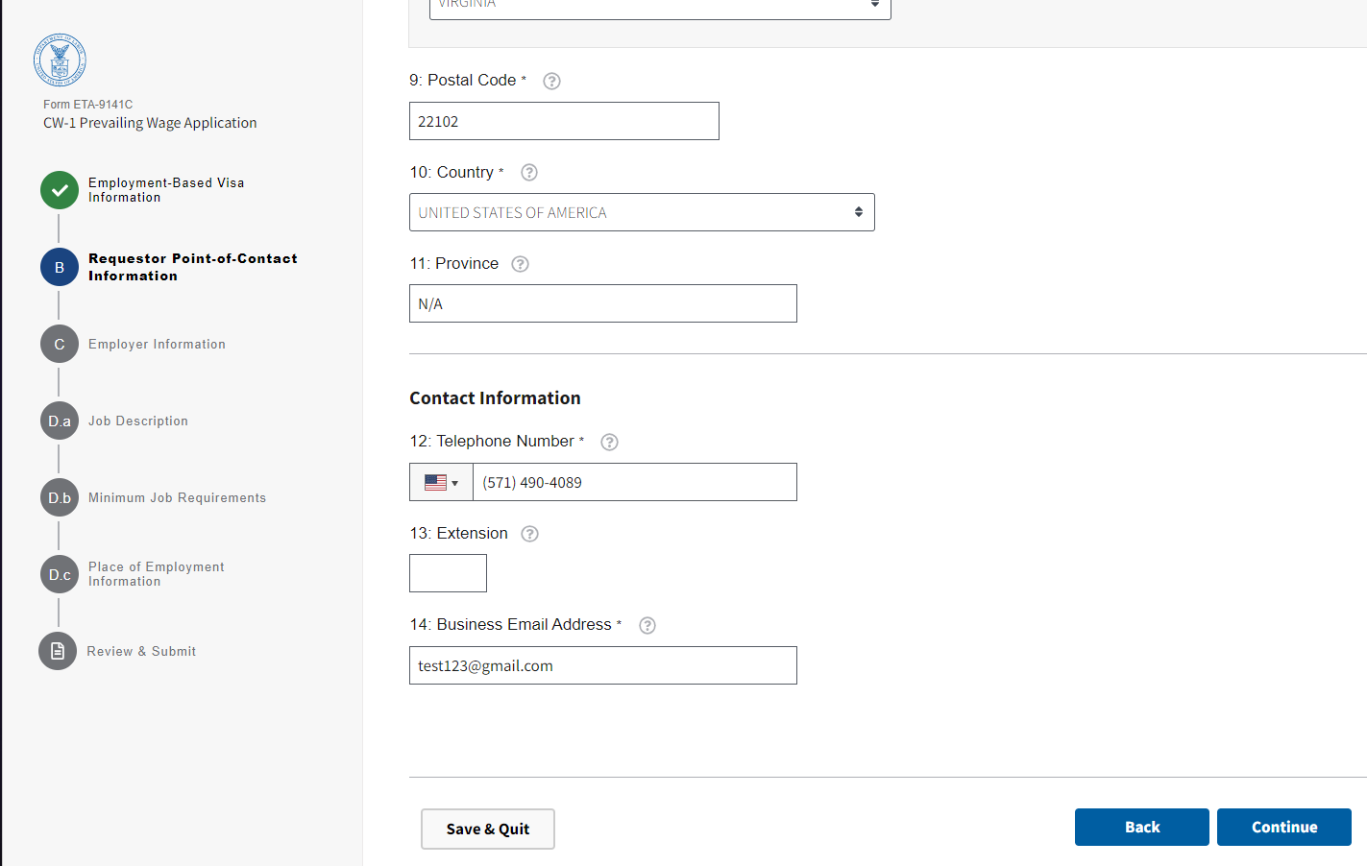

Figure 5: Section B: Requestor Point-of-Contact Information, Contact Information (B12 through B14)

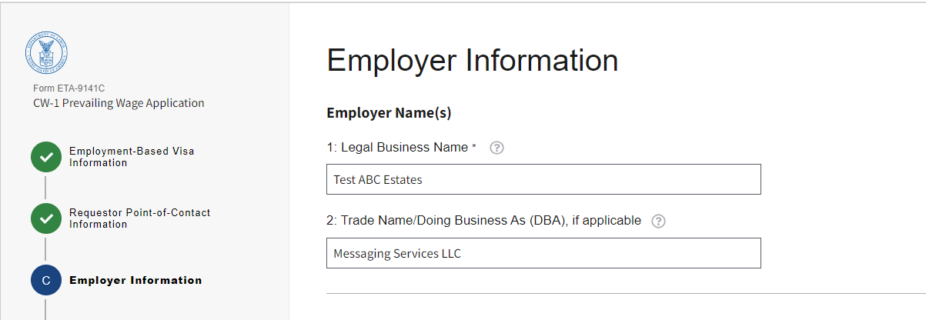

Figure 6: Section C: Employer Information, Employer Name (s) (C1 and C2)

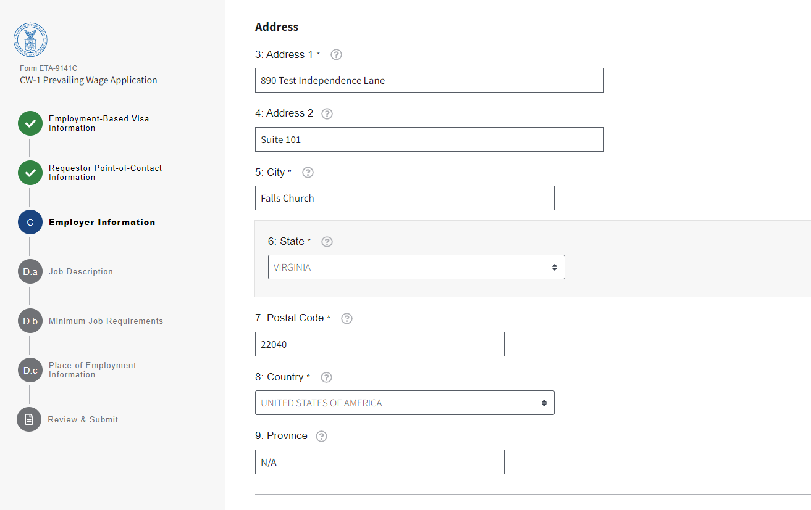

Figure 7: Section C: Address (C3 through C9)

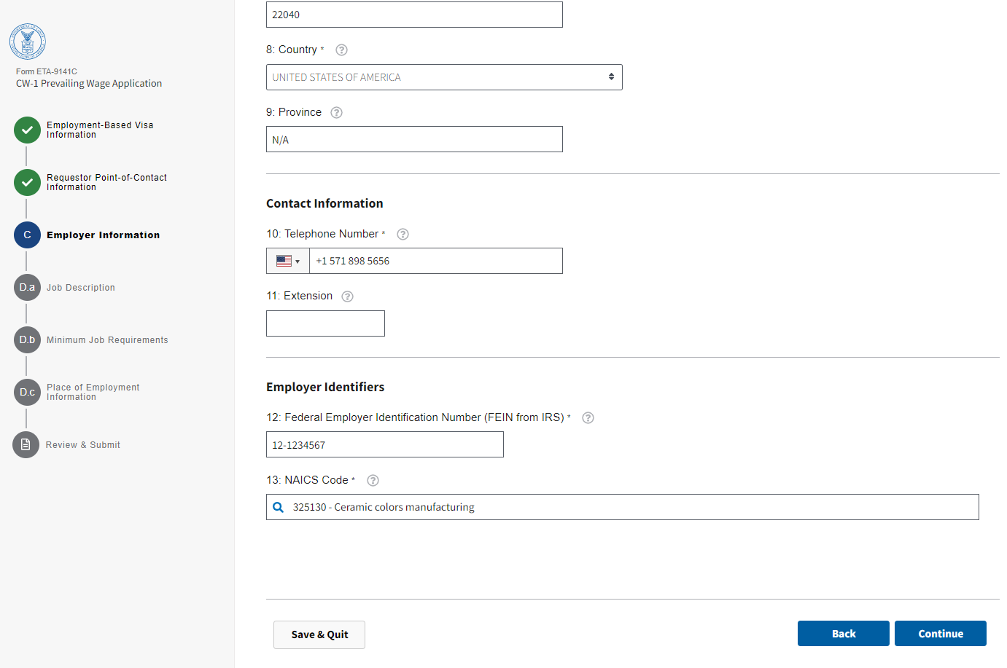

Figure 8: Section C: Contact Information (C10 and C11), Employer Identifiers (C12 and C13)

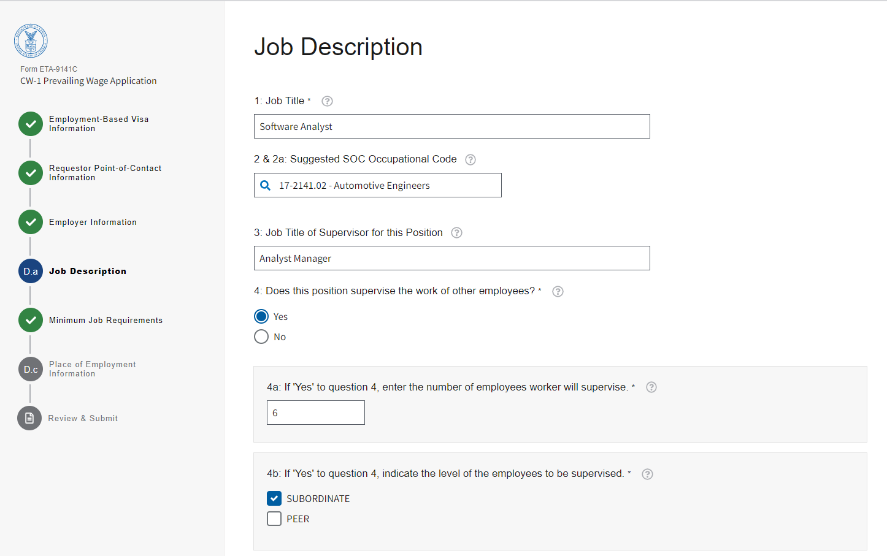

Figure 9: Section D.a: Job Description (D.a.1 through D.a.4b)

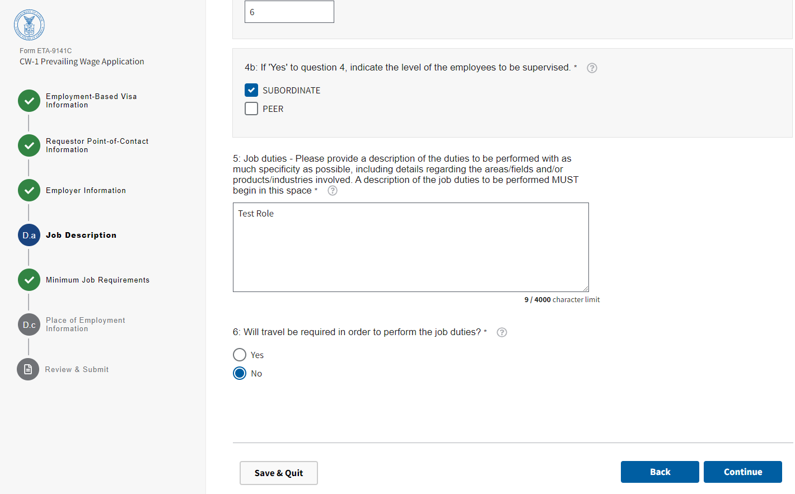

Figure 10: Section D.a: Job Description (D.a.5 and D.A.6)

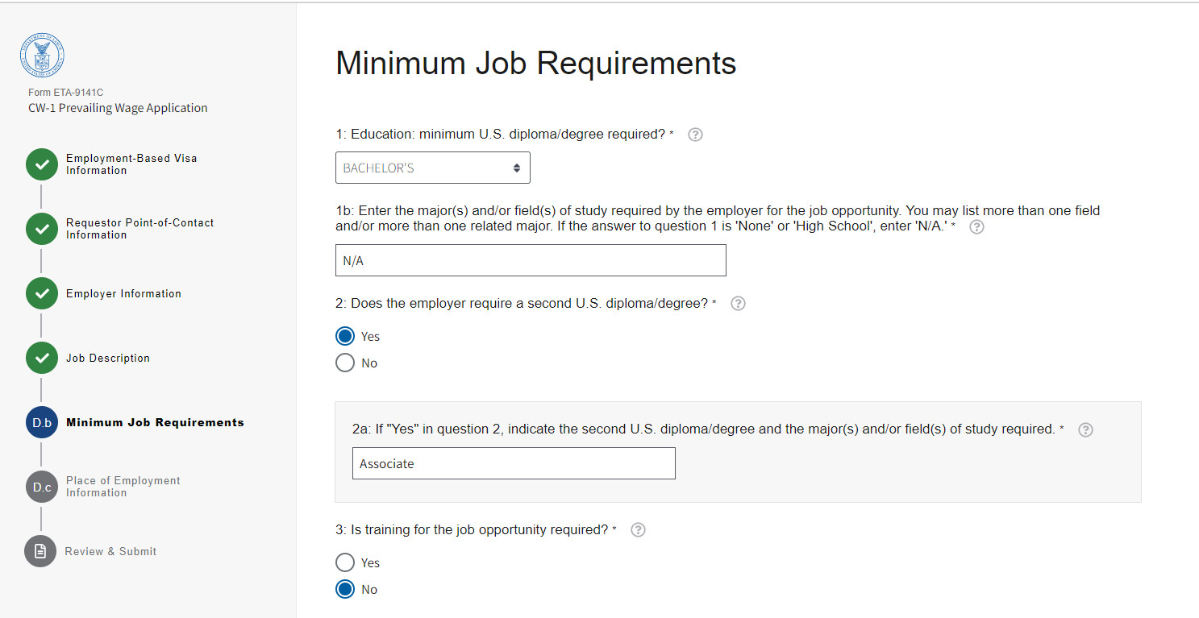

Figure 11: Section D.b: Minimum Job Requirements (D.b.1 through D.b.3)

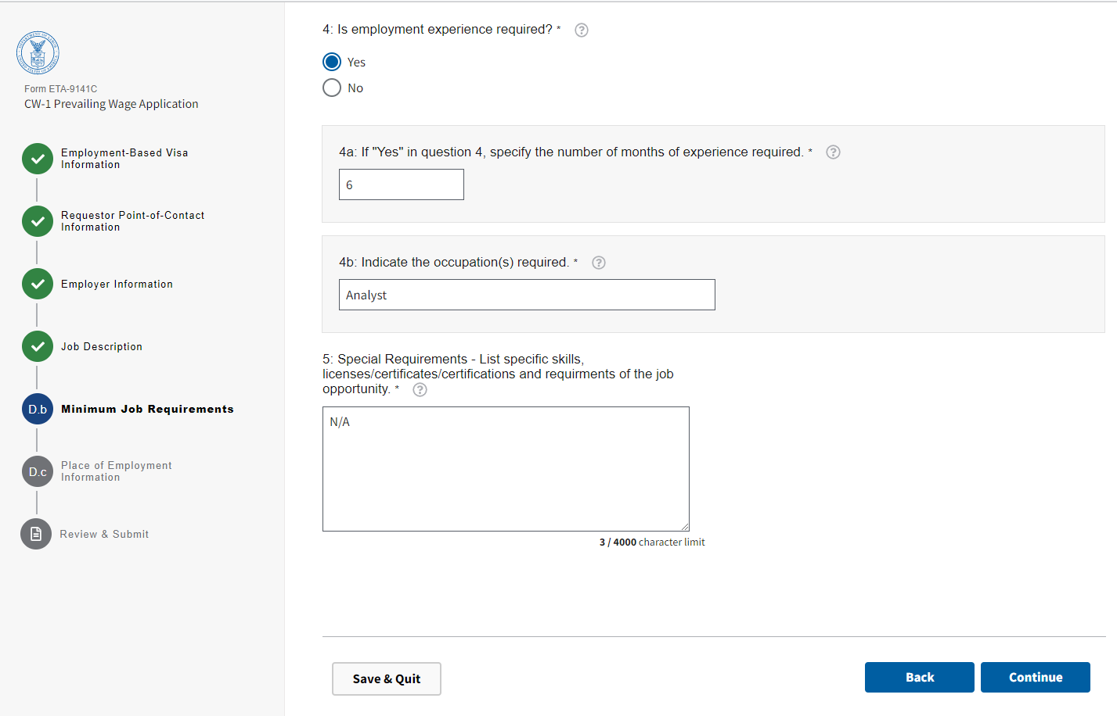

Figure 12: Section D.b: Minimum Job Requirements (D.b.4 and D.b.5)

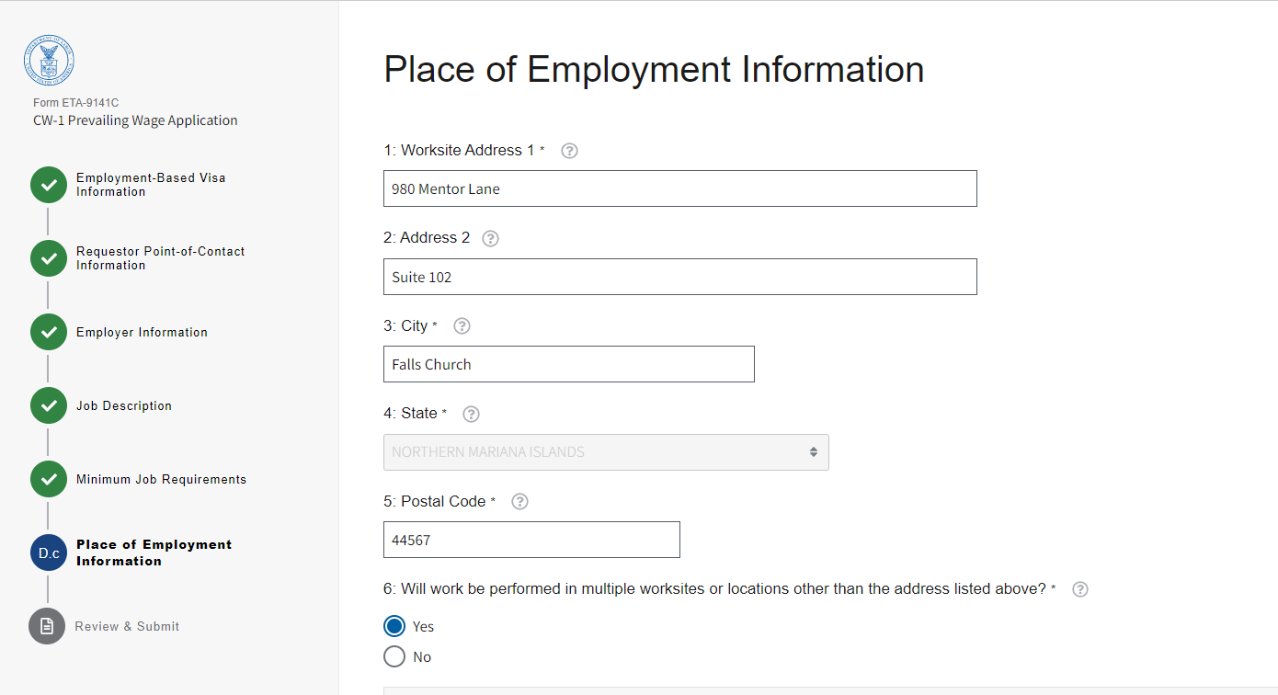

Figure 13: Section D.c: Place of Employment Information (D.c.1 through D.c.6)

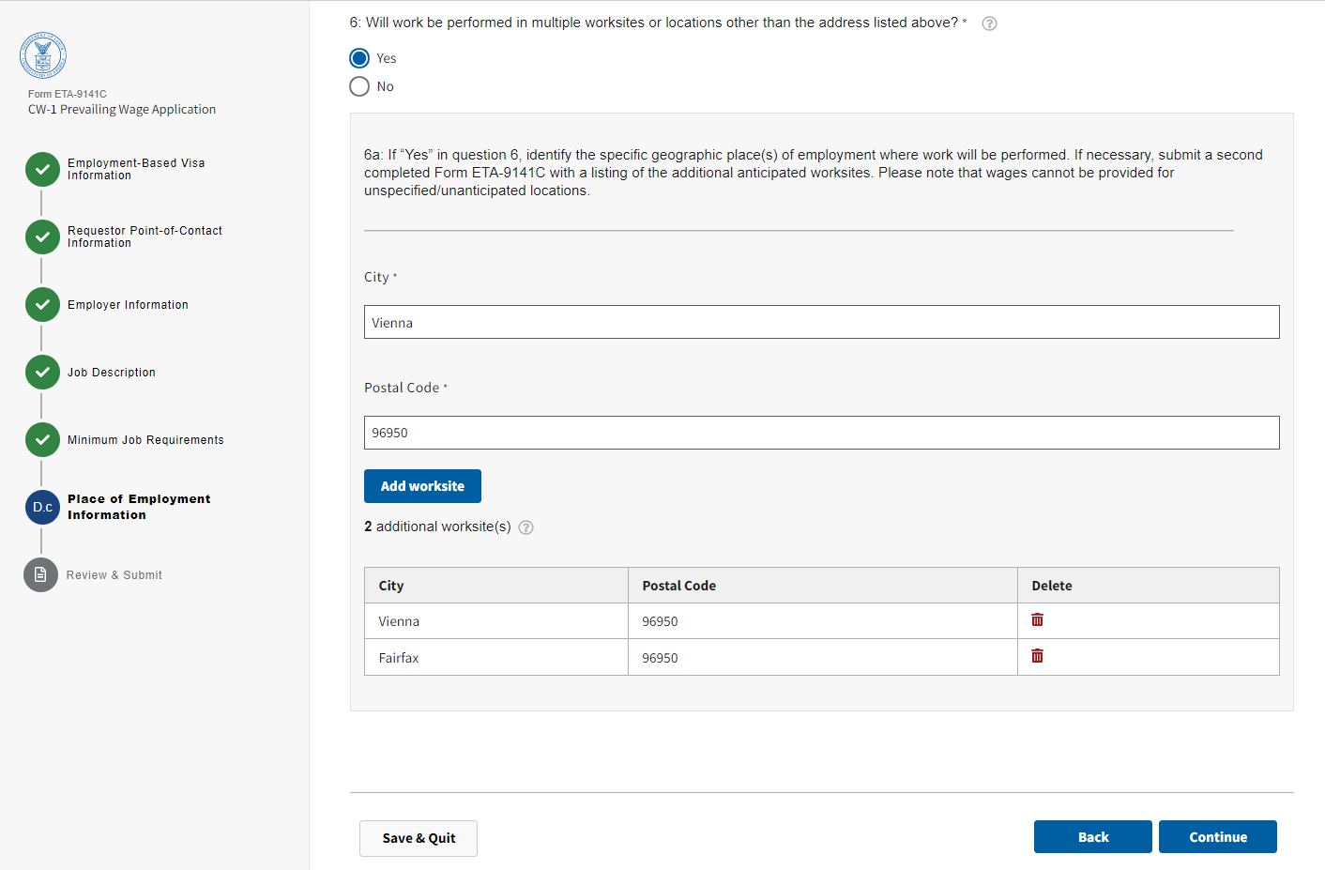

Figure 14: Section D.c: Place of Employment Information (D.c.6a)

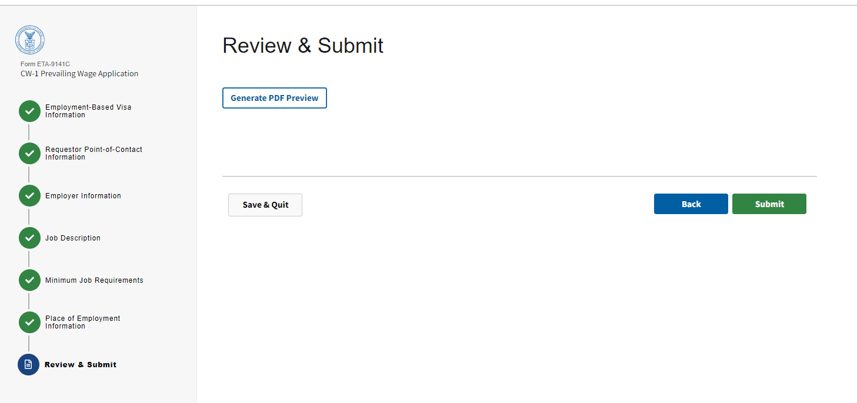

Figure 15: Review and Submit

Case Prep Generated PDF View
PDF Form (Page 1 of 4)

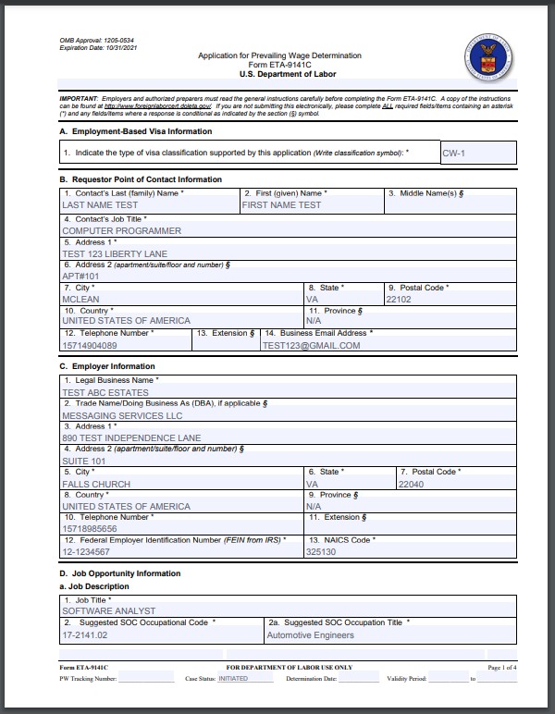

Case Prep Generated PDF View
PDF Form (Page 2 of 4)
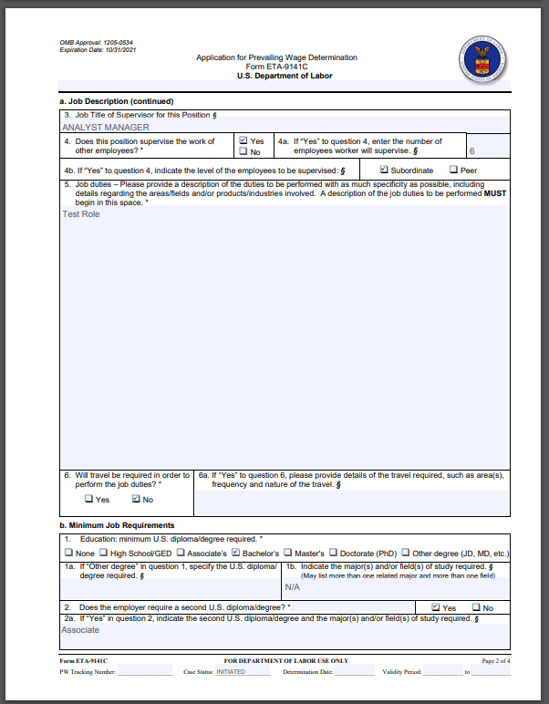

Case Prep Generated PDF View
PDF Form (Page 3 of 4)
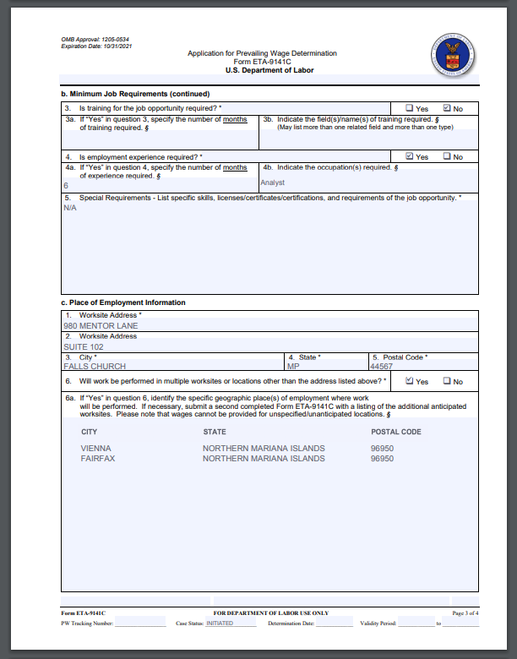

Case Prep Generated PDF View
PDF Form (Page 4 of 4)
